SUPPLEMENTARY:

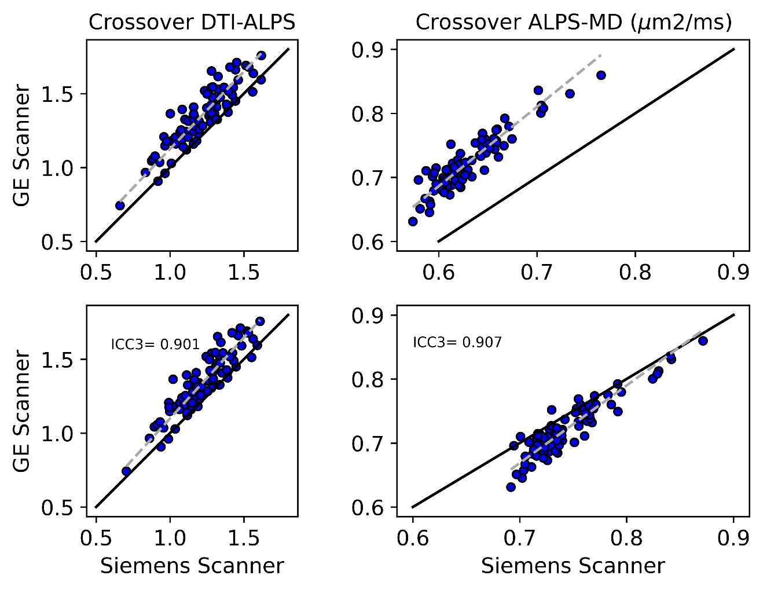
Supplemental Figure 1: [Top] DTI-ALPS and MD values between scanners with ICC3 of 0.896 and 0.897 respectively in a cohort of 81 participants. [Bottom] After single shell extraction for Siemens the ICC3 are 0.901 and 0.907. The black line corresponds to the identity line $y=x$, and the regression estimates between Siemens and GE are denoted by the gray dotted line with regression parameters estimated using orthogonal distance regression in the top left of the plot. We can see that the MD values improve after single shell extraction for Siemens scans, with minimal changes in DTI-ALPS values.

The univariate mixed effects model showing an association between midlife and late-life modifiable risk/protective factors and neuroimaging biomarkers of AD and small vessel disease (SVD) with DTI-ALPS after adjusting for age and sex are shown in Supplemental Table 1. The interactions of the main predictors with time are reported. Higher CMC, higher WMH, and greater late life hypertension were associated with a greater rate of change in DTI-ALPS ($β = 0.0015, s.e. = 0.0005, p=0.004$ for CMC, $β = 0.003, s.e. = 0.0001, p<0.001$ for WMH and $β = 0.004, s.e = 0.0013, p =0.003$for late-life hypertension, respectively) and variability explained in DTI-ALPS with total effect semi-partial r² being 18% for CMC and late life hypertension and 20% for WMH. We did not find a significant association between AD markers, PIB and Tau, with the rate of change in DTI-ALPS.

Supplemental Table 1: Univariate linear mixed effects models for predicting DTI-ALPS
Interaction with Time | Fixed Effect Model R² | Estimate (s.e.) | p-value | Semi-partial r²  [total effect]
CMC | 0.3160 | 0.0016 (0.0005) | 0.002 | 0.1816
Midlife Diabetes* | 0.2535 | -0.0031 (0.0031) | 0.31 | 0.1074
Midlife Hypertension* | 0.2605 | -0.0002 (0.0016) | 0.91 | 0.1143
Midlife Dyslipidemia* | 0.2607 | -0.0013 (0.0017) | 0.43 | 0.1147
Midlife Cog. Activity | 0.3181 | 0.0001 (0.0001) | 0.19 | 0.1843
Midlife Phy. Activity | 0.3210 | 0.00002 (0.0001) | 0.91 | 0.1872
HVa | 0.3109 | -0.0016 (0.0011) | 0.13 | 0.1767
PIB† | 0.3235 | 0.0056 (0.0041) | 0.17 | 0.1911
Tau** | 0.3482 | 0.0334 (0.0224) | 0.14 | 0.2107
WMH | 0.3393 | 0.0048 (0.0006) | <0.001 | 0.2037
Late life Diabetes | 0.3135 | 0.0001 (0.0017) | 0.52 | 0.1796
Late life Hypertension | 0.3164 | 0.0039 (0.0013) | 0.002 | 0.1822
Late life Dyslipidemia | 0.3133 | 0.0019 (0.0015) | 0.22 | 0.1792
Late life Cog Activity | 0.3181 | 0.0001 (0.0001) | 0.29 | 0.1843
Late life Phy Activity | 0.3202 | -0.0002 (0.0002) | 0.39 | 0.1862

*Missing for 387 individuals; basically 65+.
**Only 190 individuals in this analysis
†Missing for 212 individuals

To test the utility of white matter measures with cognition, we performed secondary analyses with DTI-ALPS and MD as predictors and longitudinal global cognitive z-scores as an outcome while adjusting for age, sex, and cycle number to account for learning effects. In the single predictor models (Supplemental Table 2) both DTI-ALPS and MD significantly predicted cognitive performance over time (β = 0.12, p<0.001 for DTI-ALPS and β = -0.87, p<0.001 for MD).
We built a multivariable model with DTI-ALPS and MD together, as shown by the final parsimonious model (Supplemental Table 3), both metrics contributed to the model prediction (Fixed effect $R^{2} = 31\%$). DTI-ALPS and both had a significant effect on the rate of change in z-score. Age, sex, and cycle number were also significant predictors of cognitive performance.

Supplemental Table 2: Secondary Analysis for predicting global z-score with baseline ALPS and baseline MD. The models are adjusted for age, sex, and cycle number.
Interaction with Time | Fixed Effect Model R² | Estimate (s.e.) | p-value | Semi-partial r²  [total effect]
ALPS | 0.2970 | 0.128 (0.014) | <0.001 | 0.0218
MD | 0.2946 | -0.867 (0.097) | <0.001 | 0.0191

Supplemental Table 3. Multivariable linear mixed effect models for predicting cognition after adjusting for age, sex, and time from baseline
Fixed Effect Model R2  0.3100 | Estimate (s.e.) | p-value | Semi-partial r²  [total effect]
Intercept | 22.679 (4.632) | <0.001
Follow-up Time | 0.307 (0.087) | <0.001
Age (per decade) | -0.664 (0.043) | <0.001 | 0.1401
Male | -0.188 (0.061) | 0.002 | 0.0054
Cycle Number | 0.095 (0.019) | <0.001 | 0.0155
ALPS | -12.502 (3.280) | <0.001
MD | -24.329 (6.141) | <0.001
ALPS*Time | -0.638 (0.103) | <0.001
MD*Time | 0.097 (0.015) | <0.001
ALPS*MD | 17.047 (04.385) | <0.001 | 0.0357

Supplemenal Figure 2 shows that correlation of DTI-ALPS varies with age when we change the input ROIs. The goal of this experiment was to place the ROIs farther away from the medullary veins, but still in areas with similar FA, to check whether the DTI-ALPS correlation with age was simply due to different tracts aging at different rates in different spatial directions. The first set of ROIs were placed inferior of the DTI-ALPS regions as shown. They contain both the SLFs and SCRs. The second set of ROIs placed in the superior regions to the DTI-ALPS regions only contain the SLF fibers, and hence we modify the DTI-ALPS formulae to reflect the change as
$$DTI-ALPS \left(Superior ROI\right)=\frac{\text{median}\left(D_{xx}, assoc1\right)+\text{median}\left(D_{xx}, \text{assoc2}\right)}{\text{median}\left(D_{zz}, assoc1\right)+\text{median}\left(D_{zz}, \text{assoc2}\right)}$$
where $assoc1 and assoc2$ are two of the ROIs. Direction-based voxel selection was performed as described in the paper. We see that the variants correlated poorly with age, implying that locations chosen by the original authors are indeed useful for capturing specific biological signal.

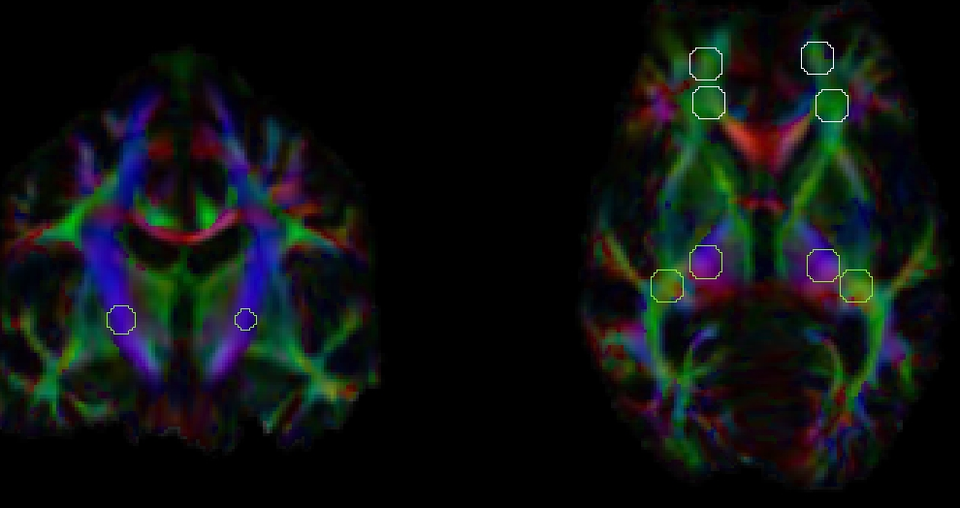
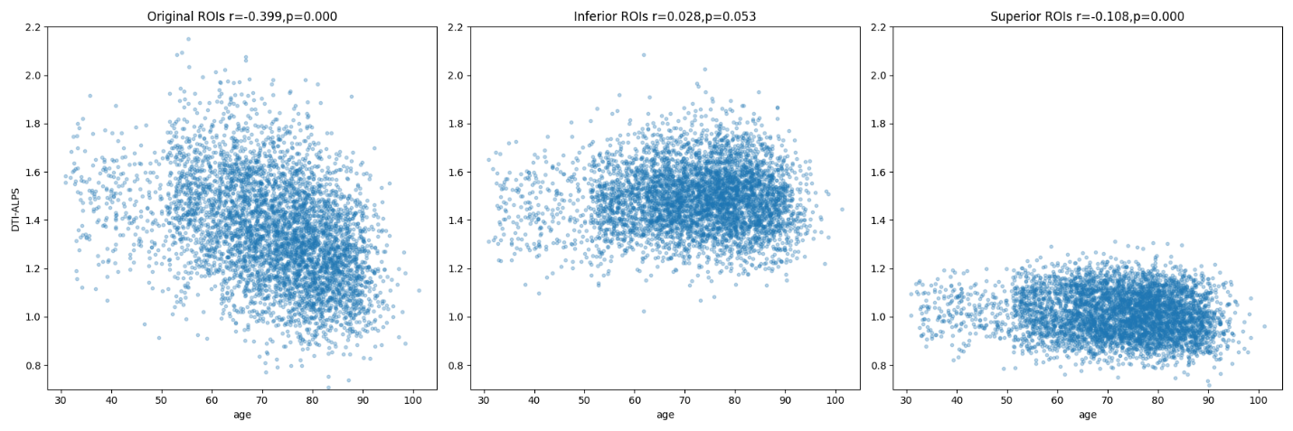
Supplemental Figure 2: DTI-ALPS computed using ROIs placed away from the ventricles but still along major fiber tracts. A. The location of superior and inferior set of ROIs B. Correlation of DTI-ALPS from the original ROIs with age and the two new set of ROIs

Supplemental Figure 3 depicts the predicted cognitive trajectories for an average 70-year-old male participant with imaging measures based on the quartiles. Interestingly, we observed that those with lower DTI-ALPS (first quartile: q1) and higher MD (third quartile: q3) had the greatest rate of cognitive decline over time. However, higher DTI-ALPS and lower MD corresponded to a relatively stable cognitive trajectory. Interestingly, both lower DTI-ALPS and lower MD (ALPS: q1 and MD: q1) and higher DTI-ALPS and higher MD (ALPS: q3 and MD: q3) had similar effects on rates of change in cognition.
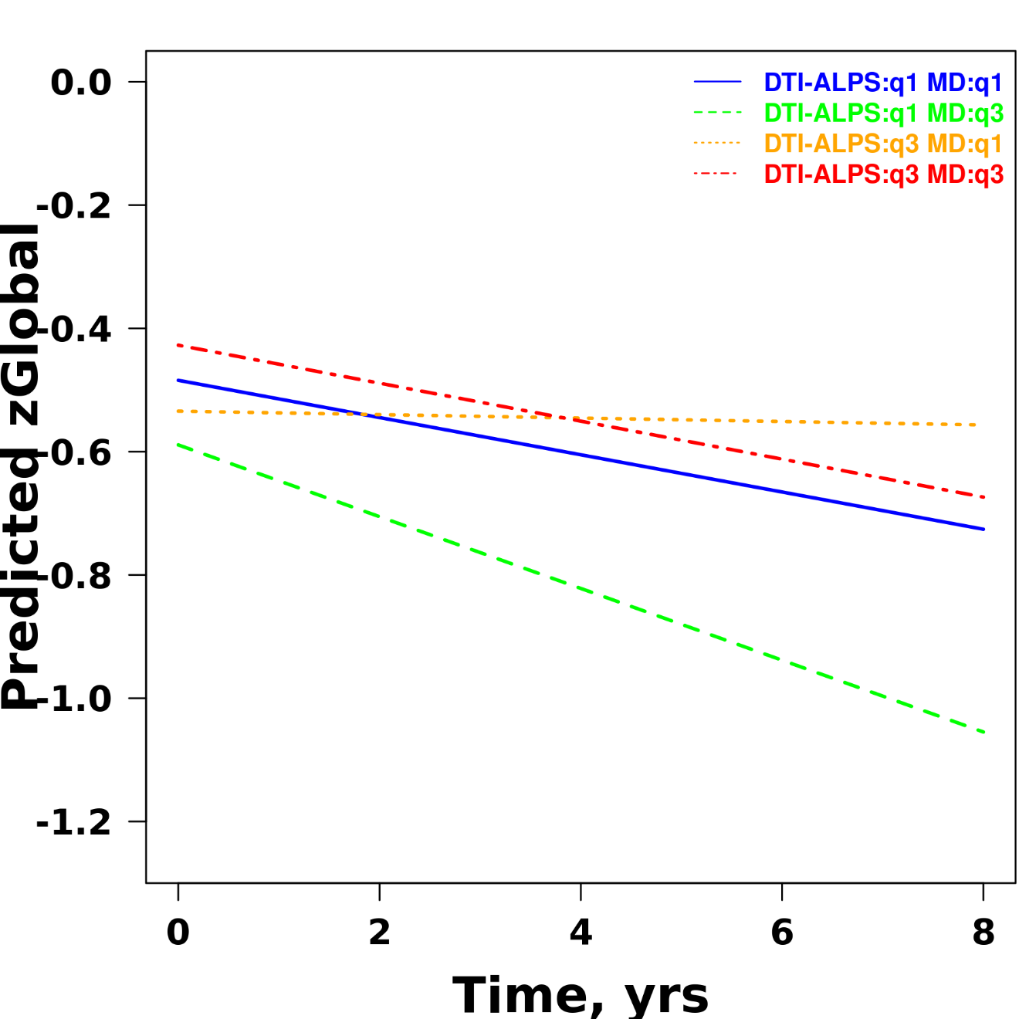
Supplemental Figure 3: The predicted cognitive trajectories of an average 70-year-old male with 25th percentile and 75th percentile of the values for DTI-ALPS and global MD.

