Supplementary Materials

List of tables and figures

eTable 1. Hyperparameters of random forests, XGBoost, and CatBoost
eTable 2. Confusion matrices derived from regression results
eTable 3. Factor rankings and importance scores of Normal_All
eTable 4. Factor rankings and importance scores of MCI_All
eTable 5. Factor rankings and importance scores of Normal_Under65
eTable 6. Factor rankings and importance scores of Normal_65Plus
eTable 7. Factor rankings and importance scores of Normal_Women
eTable 8. Factor rankings and importance scores of Normal_Men
eFigure 1. Relationship between changes in Mini-Mental State Examination scores and IADL
eFigure 2. Relationship between changes in Mini-Mental State Examination scores and social contact

1. Details on Experimentations
To choose the best hyperparameters for each algorithm, we used Bayesian optimization with the help of the 'scikit-optimize' package (https://scikit-optimize.github.io/stable/). We achieved the best hyperparameters by conducting 5-fold cross-validation with the training data. However, for linear regression, we did not perform hyperparameter selection; instead, we selected five hyperparameters carefully, which are listed in eTable 1. The descriptions of hyperparameters can be found on package websites (https://scikit-learn.org/stable/ and https://catboost.ai/).
eTable 1. Hyperparameters of random forests, XGBoost, and CatBoost
Algo. | Hyperparameter | Range | Selected
Algo. | Hyperparameter | Range | Normal_all | MCI_all | Normal_Under65 | Normal_65Plus | Normal_Women | Normal_Men
RF | n_estimators | (10, 200) | 200 | 60 | 133 | 60 | 200 | 142
 | max_depth | (1, 10) | 9 | 6 | 8 | 6 | 10 | 8
 | min_samples_leaf | (1, 10) | 8 | 4 | 10 | 4 | 1 | 10
 | min_samples_split | (2, 10) | 7 | 4 | 10 | 4 | 2 | 2
XGBoost | n_estimators | (10, 200) | 60 | 150 | 184 | 107 | 104 | 107
 | learning_rate | (0.01, 1.0) | 0.104 | 0.044 | 0.024 | 0.031 | 0.027 | 0.036
 | max_depth | (1, 10) | 4 | 3 | 5 | 3 | 5 | 3
 | min_child_weight | (1, 10) | 4 | 1 | 10 | 3 | 4 | 5
CatBoost | learning_rate | (0.01, 1.0) | 0.093 | 0.091 | 0.069 | 0.048 | 0.095 | 0.095
 | depth | (1, 10) | 6 | 8 | 10 | 6 | 10 | 3
 | l2_leaf_reg | (1, 10) | 4 | 8 | 1 | 2 | 10 | 1
 | iterations | (10, 200) | 200 | 134 | 200 | 120 | 200 | 74

2. Confusion Matrices
eTable 2. Confusion matrices derived from regression results
(a) Normal_All (Accuracy: 0.82) | (b) MCI_All (Accuracy: 0.53)
   |  | Predicted Class
   |  | Normal |  | MCI |  | Dementia
  True Class | Normal | 658 | 26 |  | 0
  True Class | MCI | 95 | 32 |  | 0
  True Class | Dementia | 16 | 8 |  | 0
   |  | Predicted Class
   |  | Normal |  | MCI |  | Dementia
  True Class | Normal | 15 | 35 |  | 0
  True Class | MCI | 4 | 55 |  | 7
  True Class | Dementia | 0 | 28 |  | 14
(c) Normal_Under65 (Accuracy: 0.92) | (d) Normal_65Plus (Accuracy: 0.65)
   |  | Predicted Class
   |  | Normal |  | MCI |  | Dementia
  True Class | Normal | 466 | 0 |  | 0
  True Class | MCI | 34 | 1 |  | 0
  True Class | Dementia | 6 | 0 |  | 0
   |  | Predicted Class
   |  | Normal |  | MCI |  | Dementia
  True Class | Normal | 177 | 48 |  | 0
  True Class | MCI | 44 | 35 |  | 0
  True Class | Dementia | 5 | 16 |  | 3
(e) Normal_Women (Accuracy: 0.79) | (f) Normal_Men (Accuracy: 0.85)
   |  | Predicted Class
   |  | Normal |  | MCI |  | Dementia
  True Class | Normal | 343 | 19 |  | 0
  True Class | MCI | 64 | 15 |  | 1
  True Class | Dementia | 7 | 7 |  | 0
   |  | Predicted Class
   |  | Normal |  | MCI |  | Dementia
  True Class | Normal | 310 | 15 |  | 0
  True Class | MCI | 34 | 10 |  | 0
  True Class | Dementia | 4 | 5 |  | 1

3. Full Results of Factor Rankings and Importance Scores
eTable 3. Factor rankings and importance scores of Normal_All
Rank | Factor | Year | Score |  | Rank | Factor | Year | Score
1 | Age | 2014 | 0.989 |  | 26 | Household size | Diff | 0.071
2 | Education | 2014 | 0.799 |  | 27 | Smoking | 2014 | 0.070
3 | Oral health | 2018 | 0.482 |  | 28 | Cerebrovascular disease | 2014 | 0.063
4 | Depression | Diff | 0.441 |  | 29 | NHI | 2014 | 0.061
5 | Household income | 2014 | 0.312 |  | 30 | Drinking | Diff | 0.061
6 | Depression | 2014 | 0.294 |  | 31 | Smoking | Diff | 0.060
7 | Social contact | 2014 | 0.273 |  | 32 | Marital status | 2014 | 0.059
8 | General Health | 2014 | 0.249 |  | 33 | Marital status | Diff | 0.057
9 | Quality of life | 2014 | 0.248 |  | 34 | Hypertension | Diff | 0.052
10 | IADL | Diff | 0.218 |  | 35 | Economic activity | Diff | 0.048
11 | Social contact | Diff | 0.211 |  | 36 | Cardiovascular disease | 2014 | 0.048
12 | General Health | Diff | 0.171 |  | 37 | Gender | 2014 | 0.041
13 | Household income | Diff | 0.160 |  | 38 | Cancer | 2014 | 0.038
14 | PHI | 2014 | 0.155 |  | 39 | IADL | 2014 | 0.037
15 | Hypertension | 2014 | 0.133 |  | 40 | Diabetes | Diff | 0.037
16 | Exercise | Diff | 0.093 |  | 41 | Cardiovascular disease | Diff | 0.035
17 | Quality of life | Diff | 0.087 |  | 42 | Cerebrovascular disease | Diff | 0.034
18 | Drinking | 2014 | 0.084 |  | 43 | ADL | 2014 | 0.018
19 | Region | 2014 | 0.082 |  | 44 | ADL | Diff | 0.017
20 | BMI | 2014 | 0.082 |  | 45 | Cancer | Diff | 0.008
21 | Diabetes | 2014 | 0.079
22 | Exercise | 2014 | 0.079
23 | Household size | 2014 | 0.078
24 | BMI | Diff | 0.076
25 | Economic activity | 2014 | 0.073

eTable 4. Factor rankings and importance scores of MCI_All
Rank | Factor | Year | Score |  | Rank | Factor | Year | Score
1 | Age | 2014 | 0.988 |  | 26 | Region | 2014 | 0.095
2 | Oral health | 2018 | 0.430 |  | 27 | Cerebrovascular disease | 2014 | 0.088
3 | IADL | Diff | 0.424 |  | 28 | Drinking | 2014 | 0.081
4 | Quality of life | 2014 | 0.416 |  | 29 | Household size | 2014 | 0.078
5 | Education | 2014 | 0.404 |  | 30 | Smoking | Diff | 0.076
6 | General Health | 2014 | 0.367 |  | 31 | Exercise | Diff | 0.075
7 | Exercise | 2014 | 0.249 |  | 32 | Economic activity | Diff | 0.073
8 | Household income | 2014 | 0.224 |  | 33 | Household size | Diff | 0.073
9 | Depression | Diff | 0.219 |  | 34 | Economic activity | 2014 | 0.072
10 | Household income | Diff | 0.219 |  | 35 | Drinking | Diff | 0.058
11 | General Health | Diff | 0.197 |  | 36 | PHI | 2014 | 0.057
12 | IADL | 2014 | 0.190 |  | 37 | Diabetes | 2014 | 0.040
13 | Quality of life | Diff | 0.188 |  | 38 | Diabetes | Diff | 0.029
14 | Depression | 2014 | 0.172 |  | 39 | NHI | 2014 | 0.020
15 | Cerebrovascular disease | Diff | 0.147 |  | 40 | Hypertension | Diff | 0.020
16 | Social contact | 2014 | 0.142 |  | 41 | Cardiovascular disease | Diff | 0.013
17 | ADL | 2014 | 0.132 |  | 42 | Cancer | 2014 | 0.011
18 | Hypertension | 2014 | 0.131 |  | 43 | Cardiovascular disease | 2014 | 0.010
19 | Marital status | 2014 | 0.127 |  | 44 | Cancer | Diff | 0.010
20 | Gender | 2014 | 0.127 |  | 45 | Smoking | 2014 | 0.010
21 | BMI | 2014 | 0.117
22 | Marital status | Diff | 0.111
23 | ADL | Diff | 0.106
24 | BMI | Diff | 0.103
25 | Social contact | Diff | 0.097
eTable 5. Factor rankings and importance scores of Normal_Under65
Rank | Factor | Year | Score |  | Rank | Factor | Year | Score
1 | Education | 2014 | 0.975 |  | 26 | Exercise | Diff | 0.109
2 | Oral health | 2018 | 0.810 |  | 27 | Gender | 2014 | 0.097
3 | Depression | Diff | 0.687 |  | 28 | Marital status | Diff | 0.094
4 | Age | 2014 | 0.560 |  | 29 | Drinking | Diff | 0.084
5 | Social contact | 2014 | 0.484 |  | 30 | NHI | 2014 | 0.077
6 | Household income | 2014 | 0.430 |  | 31 | IADL | 2014 | 0.073
7 | Social contact | Diff | 0.406 |  | 32 | Cerebrovascular disease | 2014 | 0.073
8 | Quality of life | 2014 | 0.380 |  | 33 | IADL | Diff | 0.073
9 | Hypertension | 2014 | 0.308 |  | 34 | Marital status | 2014 | 0.065
10 | Depression | 2014 | 0.297 |  | 35 | Cardiovascular disease | 2014 | 0.065
11 | Household income | Diff | 0.279 |  | 36 | Cancer | Diff | 0.062
12 | General Health | 2014 | 0.246 |  | 37 | Economic activity | Diff | 0.055
13 | General Health | Diff | 0.245 |  | 38 | Smoking | Diff | 0.053
14 | Region | 2014 | 0.225 |  | 39 | Hypertension | Diff | 0.051
15 | Quality of life | Diff | 0.200 |  | 40 | Cardiovascular disease | Diff | 0.041
16 | BMI | 2014 | 0.197 |  | 41 | Cerebrovascular disease | Diff | 0.020
17 | Household size | Diff | 0.191 |  | 42 | ADL | 2014 | 0.012
18 | PHI | 2014 | 0.183 |  | 43 | Diabetes | Diff | 0.012
19 | Drinking | 2014 | 0.169 |  | 44 | Cancer | 2014 | 0.011
20 | Diabetes | 2014 | 0.166 |  | 45 | ADL | Diff | 0.002
21 | BMI | Diff | 0.154
22 | Smoking | 2014 | 0.129
23 | Exercise | 2014 | 0.119
24 | Economic activity | 2014 | 0.118
25 | Household size | 2014 | 0.110

eTable 6. Factor rankings and importance scores of Normal_65Plus
Rank | Factor | Year | Score |  | Rank | Factor | Year | Score
1 | Education | 2014 | 0.948 |  | 26 | Hypertension | 2014 | 0.080
2 | Age | 2014 | 0.833 |  | 27 | Diabetes | 2014 | 0.080
3 | Depression | Diff | 0.593 |  | 28 | Exercise | Diff | 0.069
4 | Oral health | 2018 | 0.571 |  | 29 | Marital status | 2014 | 0.068
5 | Depression | 2014 | 0.495 |  | 30 | Economic activity | Diff | 0.067
6 | Household income | 2014 | 0.408 |  | 31 | Marital status | Diff | 0.057
7 | Quality of life | 2014 | 0.406 |  | 32 | Household size | Diff | 0.051
8 | IADL | Diff | 0.343 |  | 33 | Diabetes | Diff | 0.047
9 | Social contact | 2014 | 0.248 |  | 34 | BMI | Diff | 0.046
10 | General Health | 2014 | 0.240 |  | 35 | Hypertension | Diff | 0.042
11 | Social contact | Diff | 0.217 |  | 36 | Cerebrovascular disease | 2014 | 0.041
12 | Exercise | 2014 | 0.167 |  | 37 | ADL | 2014 | 0.040
13 | General Health | Diff | 0.166 |  | 38 | Gender | 2014 | 0.035
14 | Smoking | 2014 | 0.165 |  | 39 | Cardiovascular disease | Diff | 0.027
15 | Region | 2014 | 0.154 |  | 40 | Cancer | 2014 | 0.024
16 | PHI | 2014 | 0.150 |  | 41 | Cerebrovascular disease | Diff | 0.017
17 | Household income | Diff | 0.148 |  | 42 | Cardiovascular disease | 2014 | 0.016
18 | Household size | 2014 | 0.138 |  | 43 | Smoking | Diff | 0.015
19 | Drinking | Diff | 0.112 |  | 44 | IADL | 2014 | 0.007
20 | ADL | Diff | 0.111 |  | 45 | Cancer | Diff | 0.005
21 | Drinking | 2014 | 0.103
22 | Economic activity | 2014 | 0.102
23 | BMI | 2014 | 0.091
24 | Quality of life | Diff | 0.089
25 | NHI | 2014 | 0.085

eTable 7. Factor rankings and importance scores of Normal_Women
Rank | Factor | Year | Score |  | Rank | Factor | Year | Score
1 | Education | 2014 | 0.917 |  | 26 | Drinking | 2014 | 0.073
2 | Age | 2014 | 0.840 |  | 27 | Cardiovascular disease | 2014 | 0.071
3 | Depression | Diff | 0.388 |  | 28 | Marital status | 2014 | 0.070
4 | Oral health | 2018 | 0.368 |  | 29 | Economic activity | Diff | 0.066
5 | Household income | 2014 | 0.354 |  | 30 | Marital status | Diff | 0.064
6 | Depression | 2014 | 0.261 |  | 31 | Economic activity | 2014 | 0.059
7 | General Health | 2014 | 0.238 |  | 32 | Household size | Diff | 0.058
8 | Quality of life | 2014 | 0.237 |  | 33 | Cerebrovascular disease | 2014 | 0.055
9 | Social contact | 2014 | 0.198 |  | 34 | Drinking | Diff | 0.049
10 | IADL | Diff | 0.183 |  | 35 | Cardiovascular disease | Diff | 0.043
11 | Hypertension | 2014 | 0.172 |  | 36 | Smoking | 2014 | 0.042
12 | Region | 2014 | 0.168 |  | 37 | Cerebrovascular disease | Diff | 0.038
13 | Household income | Diff | 0.160 |  | 38 | Cancer | Diff | 0.038
14 | Quality of life | Diff | 0.159 |  | 39 | NHI | 2014 | 0.033
15 | General Health | Diff | 0.148 |  | 40 | Cancer | 2014 | 0.028
16 | Social contact | Diff | 0.145 |  | 41 | Smoking | Diff | 0.027
17 | PHI | 2014 | 0.139 |  | 42 | Diabetes | Diff | 0.026
18 | Household size | 2014 | 0.096 |  | 43 | ADL | 2014 | 0.026
19 | BMI | Diff | 0.095 |  | 44 | ADL | Diff | 0.010
20 | Diabetes | 2014 | 0.093
21 | Exercise | 2014 | 0.089
22 | BMI | 2014 | 0.087
23 | Hypertension | Diff | 0.083
24 | Exercise | Diff | 0.082
25 | IADL | 2014 | 0.078

eTable 8. Factor rankings and importance scores of Normal_Men
Rank | Factor | Year | Score |  | Rank | Factor | Year | Score
1 | Age | 2014 | 0.992 |  | 26 | Cardiovascular disease | Diff | 0.054
2 | Oral health | 2018 | 0.552 |  | 27 | BMI | 2014 | 0.051
3 | Education | 2014 | 0.382 |  | 28 | Region | 2014 | 0.049
4 | Depression | Diff | 0.369 |  | 29 | Exercise | Diff | 0.042
5 | Quality of life | 2014 | 0.306 |  | 30 | ADL | Diff | 0.033
6 | Household income | 2014 | 0.259 |  | 31 | Hypertension | Diff | 0.032
7 | Social contact | 2014 | 0.199 |  | 32 | Cancer | 2014 | 0.031
8 | Social contact | Diff | 0.184 |  | 33 | NHI | 2014 | 0.029
9 | Household income | Diff | 0.160 |  | 34 | Cerebrovascular disease | Diff | 0.027
10 | PHI | 2014 | 0.151 |  | 35 | Smoking | Diff | 0.027
11 | Depression | 2014 | 0.146 |  | 36 | Drinking | 2014 | 0.024
12 | General Health | 2014 | 0.129 |  | 37 | Diabetes | Diff | 0.023
13 | IADL | Diff | 0.124 |  | 38 | Household size | Diff | 0.021
14 | Economic activity | 2014 | 0.116 |  | 39 | IADL | 2014 | 0.018
15 | Exercise | 2014 | 0.109 |  | 40 | Cancer | Diff | 0.017
16 | General Health | Diff | 0.092 |  | 41 | ADL | 2014 | 0.017
17 | Diabetes | 2014 | 0.080 |  | 42 | Marital status | 2014 | 0.016
18 | Marital status | Diff | 0.078 |  | 43 | Economic activity | Diff | 0.005
19 | Cerebrovascular disease | 2014 | 0.077 |  | 44 | Cardiovascular disease | 2014 | 0.001
20 | Hypertension | 2014 | 0.075
21 | Quality of life | Diff | 0.074
22 | Smoking | 2014 | 0.069
23 | Drinking | Diff | 0.065
24 | BMI | Diff | 0.058
25 | Household size | 2014 | 0.055

4. Difference Factor Analysis: IADL and Social Contact
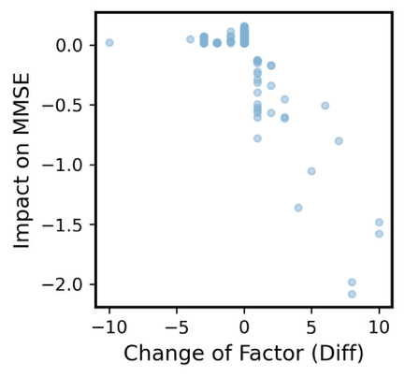  (a) Normal_All | 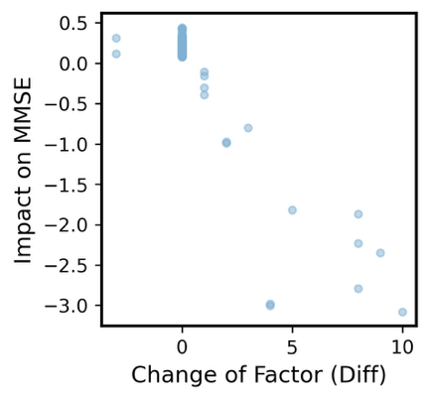  (b) MCI_All | 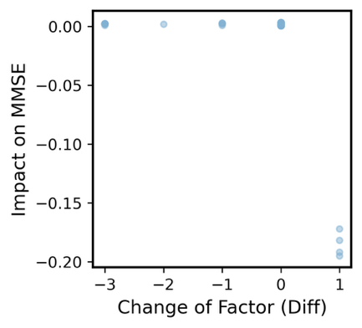  (c) Normal_Under65
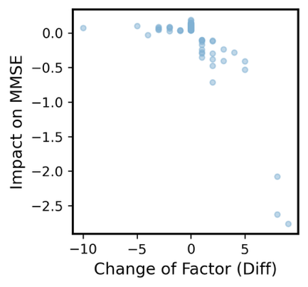  (d) Normal_65Plus | 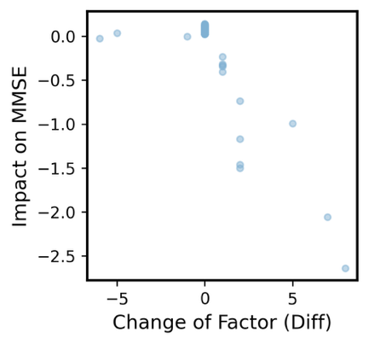  (e) Normal_Women | 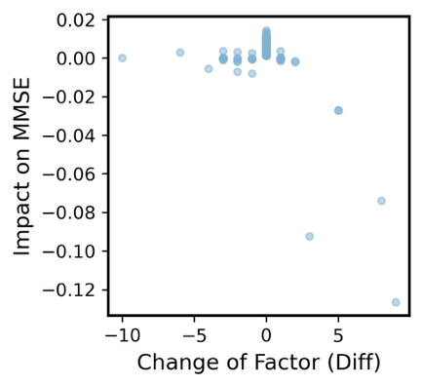  (f) Normal_Men

eFigure 1. Relationship between changes in Mini-Mental State Examination scores and IADL
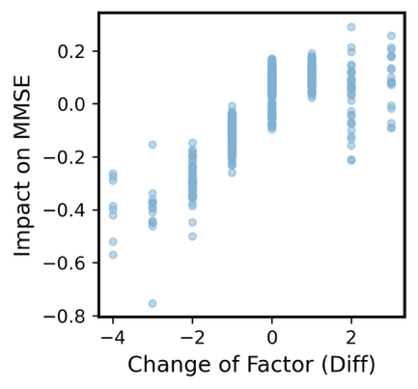  (a) Normal_All | 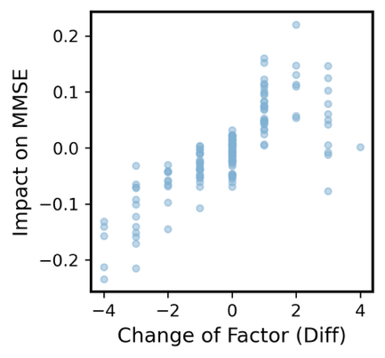  (b) MCI_All | 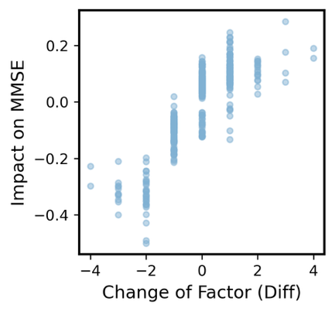  (c) Normal_Under65
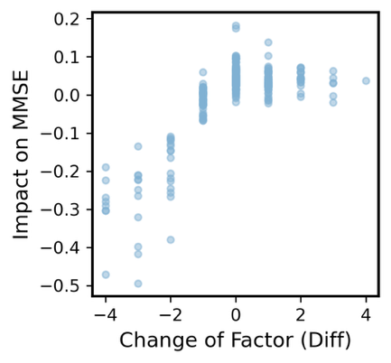  (d) Normal_65Plus | 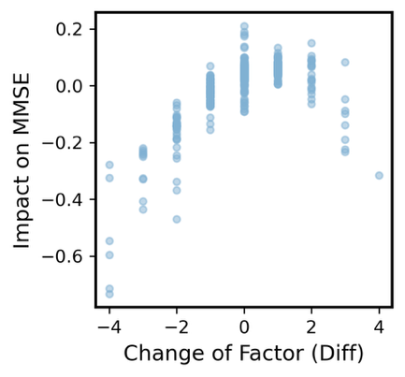(e) Normal_Women | 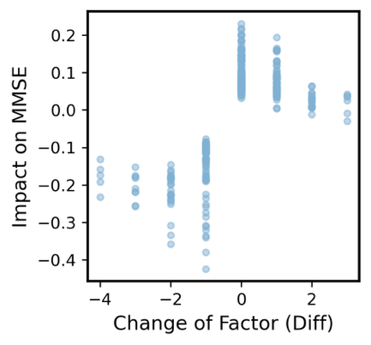  (f) Normal_Men

eFigure 2. Relationship between changes in Mini-Mental State Examination scores and social contact

