Supporting Information for

Selective agonism of GPR34 stimulates microglial uptake and clearance of amyloid β fibrils

Hayato Etani *, Sho Takatori *, Wenbo Wang, Jumpei Omi, Yusuke Amiya, Aika Akahori, Hirotaka Watanabe, Iki Sonn, Hideyuki Okano, Norikazu Hara, Mai Hasegawa, Akinori Miyashita, Masataka Kikuchi, Takeshi Ikeuchi, Maho Morishima, Yuko Saito, Shigeo Murayama, Takashi Saito, Takaomi C Saido, Toshiyuki Takai, Tomohiko Ohwada, Junken Aoki and Taisuke Tomita

(*These authors equally contributed to this work)

Corresponding author: Taisuke Tomita
Email: taisuke@mol.f.u-tokyo.ac.jp

This file includes:

Supplementary Methods
Figures S1 to S11
Tables S1 and S2
SI References

Supplementary Methods

Preparation of Aβ species
For Aβ monomer preparation, HiLyte Fluor 647-labeled human Aβ₁₋₄₀ or HiLyte Fluor 488-labeled human Aβ₁₋₄₂ (Anaspec) was dissolved in dimethyl sulfoxide (DMSO) to obtain a stock concentration of 1 mg/mL. This stock solution was stored at −80°C and, prior to use, diluted in culture medium to a final concentration of 1 µg/mL. This concentration of monomers (0.22 µM), while likely higher than physiological levels in the brain, is lower than that used in a previously established protocol (0.44 µM) [1], yet sufficient to reliably quantify potential changes in uptake (both increases and decreases) in our flow cytometry system (Fig. S2g).
For Aβ oligomer and fibril preparation, stock solutions of HiLyte Fluor 488-labeled human Aβ₁₋₄₂ and unlabeled human Aβ₁₋₄₂ (Peptide Institute) were prepared using 1,1,1,3,3,3-Hexafluoro-2-propanol (HFIP) and stored at −30°C until use. Before use, the labeled and unlabeled Aβ peptides were mixed at a molar ratio of 1:20. The HFIP was subsequently evaporated using a Speed Vac. The Aβ peptides were then reconstituted in 10 µL of DMSO per 50 µg of peptide, followed by dilution in 490 µL HBSS(+), yielding a 22 µM solution. After passing through a 0.22-µm PVDF filter, the solution was incubated overnight at 4°C (for oligomers) or 37°C (for fibrils).
For pHrodo conjugation of Aβ fibrils, a 22 µM solution of unlabeled human Aβ₁₋₄₂ peptides was fibrillized as described above. Post-fibrilization, the fibril solution was mixed with pHrodo Green STP Ester (Thermo Fisher Scientific) at a molar ratio of 1:50 (Aβ:pHrodo dye). After 30 min of incubation at room temperature, the fibrils were pelleted by centrifugation at 20,000 × g for 10 min. The supernatant was removed, and the pellet was washed with HBSS(+). This washing step was repeated once, and the fibrils were finally resuspended in HBSS(+).

Atomic force microscopy (AFM)
To characterize the structural properties of Aβ species, we performed AFM imaging. Freshly cleaved mica substrates (ALLIANCE Biosystem) were coated with poly-L-ornithine (Fujifilm-Wako). Prepared Aβ oligomers and fibrils were deposited on the coated mica surface and allowed to adsorb for 3–5 minutes. After washing three times with Dulbecco’s phosphate-buffered saline (D-PBS), the samples were imaged in liquid using a NanoWizard ULTRA Speed AFM (Bruker) with D-PBS as the imaging buffer. The acquired images were analyzed using JPK SPM Data Processing software (Bruker).

Preparation of M1
M1 was synthesized as described previously [2–4]. A series of 100× concentrated stock solutions of M1 were prepared in D-PBS containing 0.1% (w/v) protease- and fatty-acid-free bovine serum albumin (BSA; SERVA Cat#11945) and stored at −30°C until use. For in vitro experiments, the stock solutions were diluted 100-fold in the appropriate medium to achieve the desired final concentrations.

Aβ uptake assay in mouse primary microglia
Primary microglia were prepared from C57BL/6J mice as described previously [5, 6]. For Aβ uptake assays, microglial cells were seeded at a density of 5 × 10⁴ cells per well in a volume of 200 µL of 10% L929-conditioned medium (LCM) in 48-well tissue-culture-treated plates and cultured for 24 hours at 37°C. Before initiating the assay, cells were serum-starved in DMEM for 30 min. The medium was then replaced with DMEM containing 1% FBS (DMEM/FBS) and Aβ species (1 µg/mL for monomer, 1 µM for oligomer, and 2 µM for fibril), with either M1 or vehicle. After a 3-hour treatment, cells were detached by incubation with D-PBS supplemented with 0.125% trypsin and 1 µM ethylenediaminetetraacetic acid for 5 min at 37°C. The enzymatic rection was terminated by adding D-PBS containing 2% FBS. The cells were then collected by gentle pipetting, passed through a 40-µm cell strainer, and kept on ice until analysis. For experiments involving Aβ oligomers or fibrils, the cell suspension was mixed with an equal volume of 250 µg/mL trypan blue to quench any extracellular fluorescence. The fluorescence derived from internalized Aβ was measured using an MA900 flow cytometer (SONY).
For siRNA knockdown experiments, primary microglial cells were seeded in 12-well low-adherence plates at a density of 1.5 × 10⁵ cells per well in 10% LCM. After 48 hours, the cells were transfected with siRNA using Lipofectamine RNAiMAX (Thermo Fisher Scientific) according to the manufacturer’s instructions. Twenty-four hours post-transfection, the culture medium was replaced with fresh medium, and cells were incubated for an additional 48 hours before being subjected to Aβ uptake and qPCR analyses.

Quantitative real-time polymerase chain reaction
Total RNA was isolated using ISOGEN (NIPPON GENE) and stored at −80°C until use. For complementary DNA (cDNA) synthesis, the isolated RNA was reverse-transcribed using ReverTra Ace qPCR RT Master Mix with gDNA Remover (TOYOBO). The resultant cDNA was then diluted tenfold with Milli-Q water. Quantitative real-time PCR assays were performed in duplicate on a LightCycler 480 Instrument II (Roche) using THUNDERBIRD SYBR qPCR Mix (TOYOBO) and the following primer sets: Gpr34 (forward: 5'-GCAGCTTCTGAAGTATGGCCT-3', reverse: 5'-AAGCCAGCTGTCAACTGAAGTA-3') and Gapdh (forward: 5'-AGGTCGGTGTGAACGGATTTG-3', reverse: 5'-TGTAGACCATGTAGTTGAGGTCA-3'). To generate standard curves, serial dilutions of the samples were prepared at 1/5, 1/25, and 1/125 using Milli-Q water. Relative gene expression changes were assessed using the ΔCT method and normalized to Gapdh expression.

Escherichia coli BioParticles uptake assay
Primary microglial cells were incubated with Alexa Fluor 488-conjugated Escherichia coli K-12 BioParticles (Invitrogen) at a concentration of 20 µg/mL in DMEM/FBS for 20 min. Following the incubation, cells were washed with D-PBS and then detached using 0.125% trypsin and 1 µM EDTA for 5 min at 37°C. The enzymatic reaction was terminated by adding D-PBS containing 2% FBS. Cells were subsequently collected by gentle pipetting and passed through a 40-µm cell strainer. The collected cells were kept on ice until fluorescence measurement. To quench any extracellular fluorescence, an equal volume of 250 µg/mL trypan blue was added to the cell suspension immediately before analysis. The internalized fluorescence (488 nm) was quantified using a flow cytometer.

Myelin debris preparation and uptake assay
Myelin debris was prepared from the brains of C57BL/6J mice following the protocol described by Rolfe et al. [7] The myelin stock solution was adjusted to a protein concentration of 100 mg/mL in D-PBS and stored at −80°C until use. For the assay, the myelin stock was quickly thawed and resuspended using a 29-gauge needle syringe. It was then mixed with pHrodo Green STP Ester reagent (1 mg/mL) at a volume ratio of 10:1. This mixture was incubated at room temperature in the dark for 30 min. Subsequently, pHrodo-labeled myelin was isolated by centrifugation at 20,000 × g for 10 min, discarding the supernatant and resuspending the pellet in D-PBS.
For the uptake assay, cells were treated with pHrodo-labeled myelin at a concentration of 1 mg/mL in DMEM/FBS for 3 h. Following the incubation, cells were trypsinized and resuspended in a solution containing 20 mM CHES-NaOH (pH 9.0) and 150 mM NaCl. The internalized fluorescence (488 nm) was measured using a flow cytometer.

Chemotaxis assay
Primary microglia were suspended in DMEM/FBS and seeded at a density of 1.5 × 10⁵ cells/well into Cell Culture Inserts with an 8.0-µm pore size Transparent PET Membrane (Corning). These inserts were placed in a 24-well companion plate, with the lower chambers containing DMEM/FBS supplemented with either 10 nM M1 or vehicle. After 24 hours of incubation, cells on the membrane were fixed with 4% paraformaldehyde in PBS. Following several rinses with D-PBS, non-migrated cells on the upper surface of the membrane were gently removed with a cotton swab. The membranes were then excised from the inserts and mounted on glass slides using ProLong Diamond Antifade Mountant with DAPI (Invitrogen). Images were acquired with a BZ-X800 microscope (Keyence), and the number of DAPI-positive nuclei on the underside of the membrane was quantified as migrated cells using ImageJ/Fiji. For each sample, at least eight random, non-overlapping fields were imaged, and the average cell count was used for quantification.

Cyclic AMP concentration measurement
Primary microglial cells were seeded in 48-well low-adherence plates at 2.5 × 10⁴ cells/well in 100 µL of 10% LCM. After 24 hours of culturing, the cells were rinsed twice with HBSS(+) and subsequently incubated in HBSS(+) for 15 min at room temperature. The cells were then treated with 20 µL of HBSS(+) containing 100 µM forskolin (dissolved in DMSO) and/or 10 µM M1, followed by another 15-minute incubation at room temperature. The cells were lysed, and cAMP concentrations were determined using the cAMP-Glo Assay (Promega) according to the manufacturer's protocol.

Cell lysis and immunoblotting
Primary microglial cells were rinsed with ice-cold PBS, lysed and sonicated in RIPA buffer containing protease and phosphatase inhibitors. The protein concentration of the samples was determined using the bicinchoninic acid protein assay (TaKaRa). 5× SDS-PAGE sample buffer and 2-mercaptoethanol (to a final concentration of 1% (v/v)) were added to the samples, which were then heated for 5 min at 100°C.
Proteins were separated by Tris-glycine SDS polyacrylamide gel electrophoresis and transferred to PVDF membranes. The membranes were blocked for 1 h at room temperature with 3% BSA in Tris-buffered saline (TBS) containing 0.1% (v/v) Tween 20 (TBST), followed by three washes with TBST. Membranes were incubated with the appropriate dilutions of primary antibodies, including pan-Akt (clone C67E7; Cat# 4691), phospho-Akt (Ser473) (clone D9E; Cat# 4060), and pan-ERK1/2 (clone 137F5; Cat# 4695) from Cell Signaling Technology and p-ERK (clone E-4; Cat# sc-7383) from Santa Cruz Biotechnology, in TBST containing NaN₃ overnight at 4°C. After three washes with TBST, membranes were incubated with the appropriate peroxidase-conjugated secondary antibody (1:2,000) in TBST for 1 h at room temperature. After three washes with TBST, membranes were incubated with Immunostar luminescence working solution. Signals were detected using an ImageQuant LAS 4000 (GE Healthcare) and processed using Image J/Fiji (1.53c).

Primary astrocyte culture
Primary astrocytes were prepared from the same mixed glial culture used for primary microglia isolation, using a modified McCarthy & de Vellis “shake-off” method [8]. Mixed glial cultures were shaken overnight to deplete oligodendrocytes (260 rpm, 37°C, 15–18 h). The adherent layer was washed and dissociated with 0.05% trypsin–5 mM EDTA (3 min, 37°C), and microglia were reduced by two 30‑min pre‑plating steps on tissue‑culture dishes. Cells were replated onto laminin-coated wells at 5 × 10⁴ cells/cm² in DMEM/FBS and used 2–3 days after replating.

Bulk RNA sequencing and differential expression analysis
For bulk RNA sequencing, the culture medium of primary microglia and astrocytes was replaced with DMEM/FBS for a 30-minute pre-incubation. Following this, cells were treated for 6 hours: microglia received one of four treatments (vehicle, 1 µM fAβ, 10 nM M1, or a combination), while astrocytes received either vehicle or 10 nM M1. Total RNA was subsequently isolated using the RNeasy Plus Micro Kit (Qiagen) according to the manufacturer’s instructions. Total RNA-seq libraries were prepared with the FLASH-seq protocol as described previously [9]. Libraries were pooled and sequenced on an Illumina NextSeq2000, generating paired-end 2 × 36 bp reads. Raw BCL files were converted to FASTQ format, and reads were aligned to the mouse mm10 (GRCm38) reference genome using STAR (v2.7.10a). Transcript-level quantification was performed using RSEM (v1.3.3).
Differential expression analysis was conducted in R using the DESeq2 package. After filtering for genes with 10 or more reads in at least 3 samples, statistical models were adapted for each experiment. For the microglia data, a factorial model (design = ~ batch + fAbeta_treatment * M1_treatment) was used to assess the main effects of fAβ and M1, as well as their interaction. For the astrocyte data, a model comparing M1-treated to vehicle-treated samples was used (design = ~ batch + treatment). In all analyses, genes with a Benjamini-Hochberg adjusted p-value < 0.05 and an absolute log2 fold-change > 0.5 were considered significantly differentially expressed.

Nitro blue tetrazolium (NBT) reduction assay
Primary microglia (7.5 × 10⁴ cells/well) were plated in 24-well tissue-culture-treated plates. After 24–48 h, cells were rinsed twice with FBS-free DMEM, preincubated for 30 min in DMEM/FBS, and then treated for 24 h with vehicle, 10 nM M1, 1 μM fAβ, or fAβ plus M1. Cells were then incubated for 30 min at 37°C with phenol red-free, serum-free DMEM containing 0.1% NBT (or medium without NBT as a control). After two rinses, cells were lysed in 2 M KOH and solubilized with DMSO, and absorbance at 630 nm was measured. Values were normalized to the no-NBT control (=1.0).

Culture of human induced pluripotent stem cells (iPSCs)
The human iPSC lines 201B7 [10] and RPC802 (ReproCell Inc, cat# RCRP002N) were cultured in a feeder-free condition. All iPSCs were maintained in 6-well plates (Corning) coated with iMatrix-511. iPSCs were cultured in StemFit/AK02N (Ajinomoto) medium supplemented with penicillin/streptomycin in a humidified incubator (37°C, 5% CO₂), and the medium was changed every other day. The genetically engineered iPSCs expressing SPI1 in a doxycycline-dependent manner were described previously [11]. Human ethics approval was obtained from the Ethics Committee in Keio University School of Medicine (Approval Number: 20080016).

Differentiation of human induced pluripotent stem cell-derived microglia and Aβ uptake assay
Microglia derived from human induced pluripotent stem cells (hiMGLs) were generated as described previously [11]. Once differentiated, hiMGLs were seeded on poly-D-lysine-coated 48-well plates at a density of 7.5 × 10⁴ cells per well. Twenty-four hours after seeding, a half volume of the culture medium was freshly added. Following an additional 24-hour incubation, the cells were treated with 2 µM Aβ fibrils and either M1 or vehicle for 4.5 hours. The cells were then detached using Accutase at 37°C for 5 min. This enzymatic reaction was terminated by adding D-PBS. The cells were subsequently collected by gentle pipetting and passed through a 40-µm cell strainer. The internalized Aβ fluorescence was quantified as described above.

Stereotaxic injection of M1 and measurement of microglial uptake of Aβ in vivo
To assess the effect of M1 on microglial uptake of Aβ in vivo, male and female NLGF mice aged 15–17 months were used. Mice were anesthetized with a subcutaneous injection of a mixture containing 0.3 mg/kg medetomidine, 4.0 mg/kg midazolam, and 5.0 mg/kg butorphanol. After exposing the skull, 0.8 µL of 250 µM M1 was injected into one hippocampus, while an equal volume of vehicle was injected into the contralateral hippocampus. The injections were performed using the following stereotaxic coordinates: A/P: −1.7 mm, M/L: +/−1.6 mm, D/V: −1.9 mm from bregma. Before injection, the syringe needle was first inserted 0.1 mm deeper than the target to create a small pocket. The injection was performed at a flow rate of 0.2 µL/min. After the injection, the needle was left in place for an additional 2–3 min before being carefully retracted. The surgical incision was sutured, and mice were revived by a subcutaneous injection of 3.0 mg/kg atipamezole. Throughout the procedure, the mice’s body temperature was maintained using a heating pad. Post-surgery, mice had ad libitum access to food and water.
Twelve hours after M1 injection, microglial cells were isolated from the hippocampi to assess Aβ uptake. To fluorescently label Aβ fibrils in vivo, 10 mg/kg MX04 was administered intraperitoneally to the mice three hours before analysis. Mice were then anesthetized, perfused with a minimum of 20 mL ice-cold PBS, and the hippocampi were removed. A single-cell suspension was obtained using the GentleMACS Octo dissociator with heaters and the Adult Brain Dissociation Kit (Miltenyi). Subsequently, myelin debris was removed using the Debris removal solution (Miltenyi). After blocking Fc receptors with 0.5 µg/mL of CD16/32 antibody (Miltenyi #130-092-374) for at least 10 min on ice, the cell suspension was incubated with Alexa Fluor 647 anti-mouse CD45 antibody (BioLegend #103124) and REAfinity™ anti-mouse CD11B antibody (Miltenyi #130-113-805) for another 10 min on ice. After centrifugation, cells were resuspended and analyzed by flow cytometry. Two to three minutes before measurement, 1 µg/mL propidium iodide was added to stain dead cells. CD11B+ CD45+ PI− cells were gated, and the percentage of MX04-positive cells was assessed.

Intracerebral delivery of M1 using an osmotic mini-pump
Brain Infusion Kit 3 (Alzet, Cat# 0008851) and Mini-osmotic Pump Model 2004 (Alzet, Cat# 0000298) were used for continuous intracerebroventricular infusion. Pumps were filled with 500 μM M1 or vehicle, primed by incubation at 37°C in 0.9% saline for 3 days, and implanted to deliver at 0.25 μL/hour for 28 days. Mice were anesthetized with a medetomidine–midazolam–butorphanol cocktail and placed in a stereotaxic frame. A ~2 cm midline scalp incision was made and the skull exposed. A small hole was drilled over the right hemisphere at coordinates AP −0.4 mm, ML +1.0 mm relative to bregma to expose the brain surface, and the cannula tip was inserted into the lateral ventricle. The pump body was passed subcutaneously and placed in a pocket between the skin and underlying muscle; the cannula was secured to the skull with dental cement. The skin incision was closed with sutures. Atipamezole was administered to reverse anesthesia and mice were maintained on a 37°C heating pad until recovery. Four weeks after pump implantation, animals were deeply anesthetized, transcardially perfused with ice-cold PBS, the hippocampus ipsilateral to the infusion cannula was dissected, snap-frozen in liquid nitrogen, and stored at −80°C until biochemical analysis.

Sequential extraction of Aβ from hippocampi and quantification by ELISA
Frozen hippocampi were weighed and homogenized in 10 volumes (w/v) of ice-cold TBS supplemented with protease inhibitors (cOmplete, Roche) using a BioMasher II (5 rapid rotations of the pestle followed by a single up-and-down stroke, repeated for 20 sets). Homogenates were ultracentrifuged at 312,000 × g for 20 min at 4°C, and the supernatant was collected as the TBS-soluble fraction. The pellet was re-extracted with ice-cold 2% (v/v) Triton X-100 in TBS, homogenized, and ultracentrifuged as above to obtain the TX-soluble fraction. The pellet was then extracted with of 2% (w/v) SDS in TBS, homogenized, incubated at 37°C for 30 min, and ultracentrifuged to yield the SDS-soluble fraction. The remaining pellet was resuspended in 70% formic acid (FA), disrupted by brief sonication, and ultracentrifuged at 312,000 × g for 20 min at 4°C; the FA supernatant was neutralized with neutralization buffer (1 M Tris, 0.5 M Na₂HPO₄, 0.05% NaN₃) to generate the FA-soluble fraction. Aβ40 and Aβ42 in each fraction were quantified by ELISA according to the manufacturer’s instructions using the Human β-Amyloid (1–40) ELISA Kit, Wako II (FUJIFILM Wako; Cat# 298-64601) and the Human/Rat β-Amyloid (42) ELISA Kit, Wako, High Sensitive (FUJIFILM Wako; Cat# 292-64501).

Isolation of nuclei from frozen brain tissue
We isolated nuclei from approximately 20 mg of fresh frozen postmortem brain tissue using the Minute Single Nucleus Isolation Kit for Neuronal Tissues/Cells (Invent Biotechnologies) according to the manufacturer’s protocol. Isolated nuclei were stained with ReadyCount Blue Nuclear Stain (Thermo Fisher Scientific) and counted on the Countess II FL automated cell counter (Thermo Fisher Scientific).

Single-nucleus RNA sequencing
Isolated nuclei were processed for single-nucleus RNA sequencing using the Chromium Next GEM Single Cell 3' Kit v3.1 (10x Genomics) following the manufacturer’s protocol. Briefly, for each library, approximately 10,000 nuclei were partitioned into gel beads-in-emulsion on the Chromium Controller instrument (10x Genomics). Reverse transcription and cDNA amplification were performed, and Illumina-compatible adapter sequences were added to the final libraries via PCR. The libraries were sequenced on Illumina’s NextSeq2000 instrument. Raw sequencing data were processed using the Cell Ranger pipeline (v7.0.0, 10x Genomics) for demultiplexing, barcode assignment, read alignment to the human reference genome (GRCh38-2020-A), and gene counting. Subsequent analysis followed the vignettes from the R package Seurat (v5.0.1). Initially, Cell Ranger output data were imported into R (v4.3.2) via the SoupX (v1.6.2) package to eliminate ambient RNA contamination. Nuclei were excluded if the number of detected features (genes) was less than 200 or greater than 14,000 and the percentage of mitochondrial genes was greater than 5%. Count data were normalized using the SCTransform v2 function while adjusting for the proportion of mitochondrial genes, and then multiplets were removed using the DoubletFinder (v2.0.4) package. The RunPCA function (npcs = 30) was run, and all datasets were integrated using the Harmony (v1.2.0) package through the IntegrateLayers function. The functions FindNeighbors (dims = 30), FindClusters (resolution = 0.2), and RunUMAP (dims = 1:30) were performed, and clusters were visualized through the DimPlot function. To identify gene expression patterns of major cell type-specific markers, we used the FindAllMarkers function (min.pct = 0.25, logfc.threshold = 0.25, test.use = “MAST”), adjusting for the difference in diagnosis (AD or control) with the latent.vars option. We then annotated the cell types according to the expression patterns of the following genes: NRGN, SLC17A7, and CAMK2A for excitatory neuron, GAD1 and GAD2 for inhibitory neuron, AQP4 and GFAP for astrocyte, MBP, MOBP and PLP1 for oligodendrocyte, CSF1R, CD74 and C3 for microglia, VCAN, PDGFRA and CSPG4 for oligodendrocyte precursor cell, and FLT1 and CLDN5 for endothelial cell. The microglia cluster was subjected to subclustering, and the same procedure as described above was conducted. Two rounds of integration steps were repeated to remove clusters contaminated with non-microglial markers, and the cleaned microglia dataset was divided into eight clusters through FindClusters (resolution = 0.1). To identify differentially expressed genes between AD and control, we used the FindMarkers function (min.pct = 0.10, logfc.threshold = 0.1, test.use = "MAST") while adjusting for sex and APOE genotypes. P-values were adjusted using the Bonferroni correction for multiple testing, and p-values less than 0.01 were considered statistically significant.

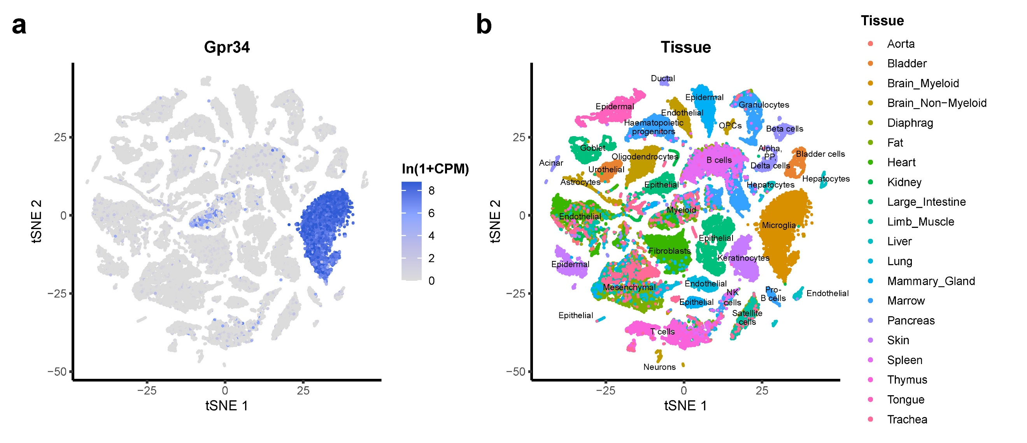

Fig. S1. Gpr34 expression in the mouse all‑tissue single‑cell atlas (Tabula Muris, FACS dataset)
The all‑tissue t‑SNE embedding downloaded from the UCSC Cell Browser [12]; the precomputed coordinates were used as provided without recomputation. Gpr34 expression is displayed as ln(1+CPM), computed from the count matrix obtained from the same source. (a) Feature plot of Gpr34 expression. A discrete cluster annotated as brain microglia shows the strongest signal, with lower‑level expression in peripheral myeloid‑lineage cells and little to no expression in major non‑microglial CNS cell types (neurons, astrocytes, oligodendrocytes) in this dataset. (b) The same embedding is colored by tissue of origin. Cell‑type labels were manually placed with reference to the Tabula Muris Consortium annotations [13].

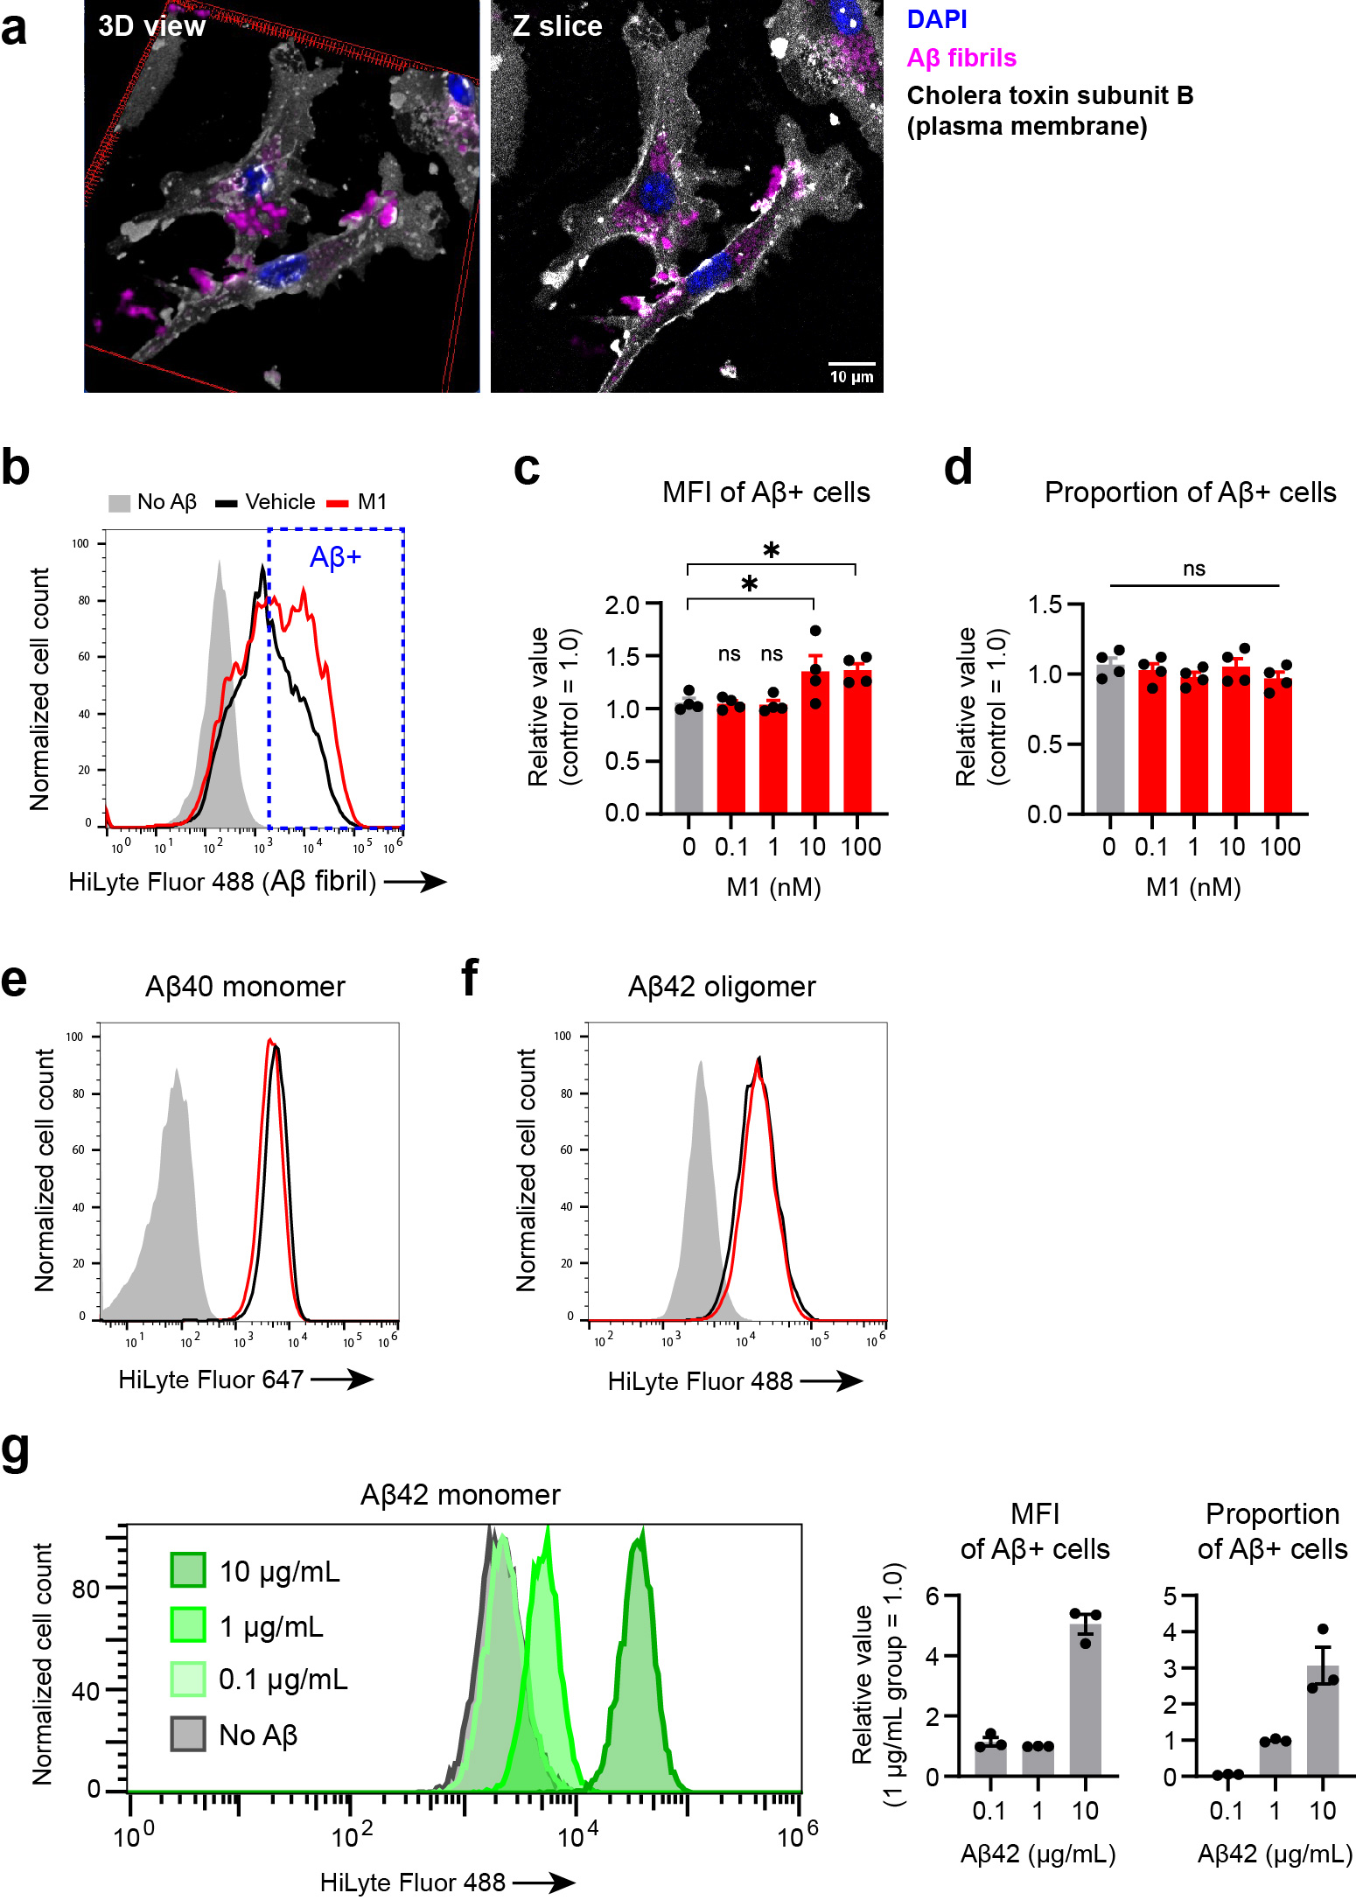

Fig. S2. Imaging and flow-cytometric analysis of microglial Aβ uptake
(a) Representative confocal fluorescence images of primary microglia exposed to 1 μM fAβ (monomer-equivalent) for 3 h. For the same cell, the left panel shows a 3D view and the right panel shows a single z‑slice. The plasma membrane is labeled with cholera toxin subunit B.
(b–d) Representative flow cytometry plots (b) and quantification of the mean fluorescence intensity (MFI) (c) and proportion (d) of fAβ+ cells, showing the effect of M1 treatment. The gated population used for quantification is highlighted with a blue dashed box in b. Data in b and c are the same as those presented in Fig. 1 b and c, respectively. Data are normalized to the values of the control cells (N=4). Bars represent the mean ± SEM. Dunnett’s test.
(e, f) Representative flow cytometry plots showing the effect of M1 on the uptake of fluorescently labeled Aβ monomers (Aβ40 in e) and oligomers (f) by primary microglia. See Fig. 1g for quantification.
(g) Representative flow cytometry plots and quantification of Aβ42 monomer uptake by primary microglia treated with 0, 0.1, 1, or 10 μg/mL Aβ42. Shown are the MFI and the proportion of Aβ+ cells. Data are normalized to the values of the 1 μg/mL Aβ42-treated cells. Bars represent the mean ± SEM (N=3).

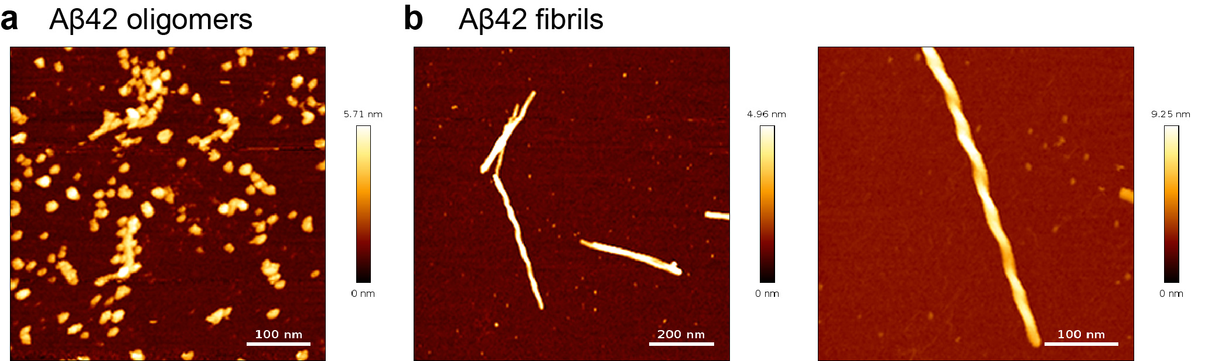

Fig. S3. Atomic force microscopy (AFM) characterization of Aβ42 oligomers and fibrils
(a) Representative AFM image of Aβ42 oligomers prepared by incubation at 4°C, showing numerous discrete, approximately spherical particles with apparent lateral diameters of ~12–25 nm. (b) AFM images of Aβ42 fibrils at two magnifications, displaying long, unbranched, helical filaments. Color indicates height with the ranges shown next to each panel. Scale bars: 100 nm (a), 200 nm (b, left), 100 nm (b, right).

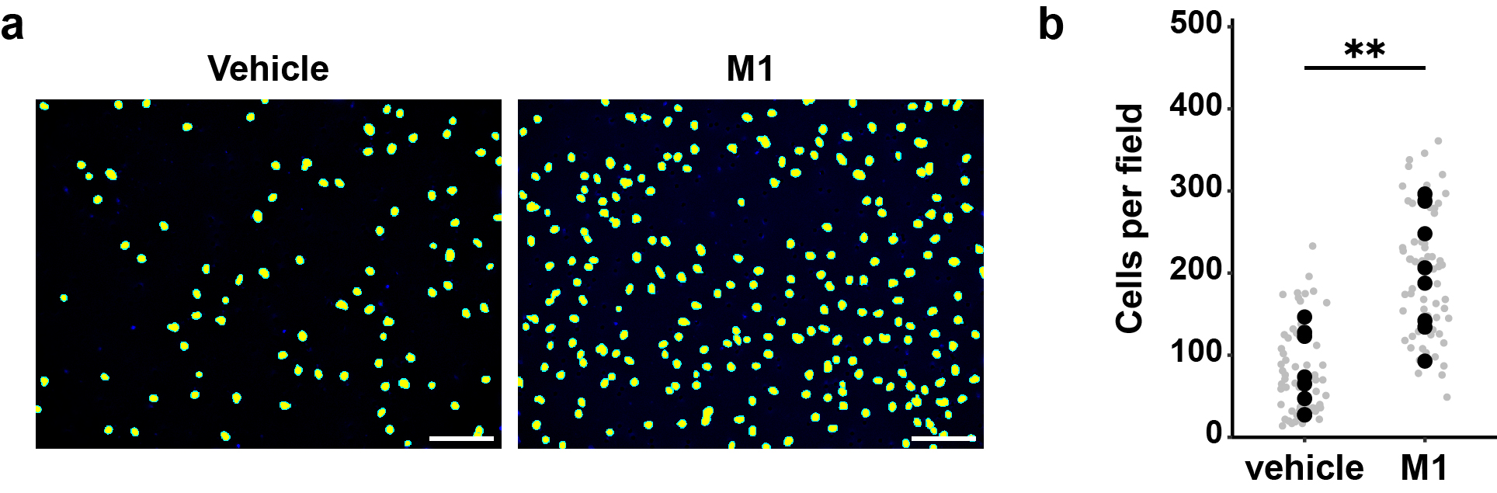

Fig. S4. M1 effect on chemotaxis in primary microglia
(a) Representative DAPI images of migrated cells on the lower side of the Transwell membrane, where vehicle or 10 nM M1 was present in the lower chamber, 24 h after seeding. Scale bar: 100 μm.
(b) Quantification of migrated cells per field. Each gray dot represents an individual imaged field (≥8 per biological replicate), and black dots indicate the average of those fields for each biological replicate (N=7–8, Student’s t-test).

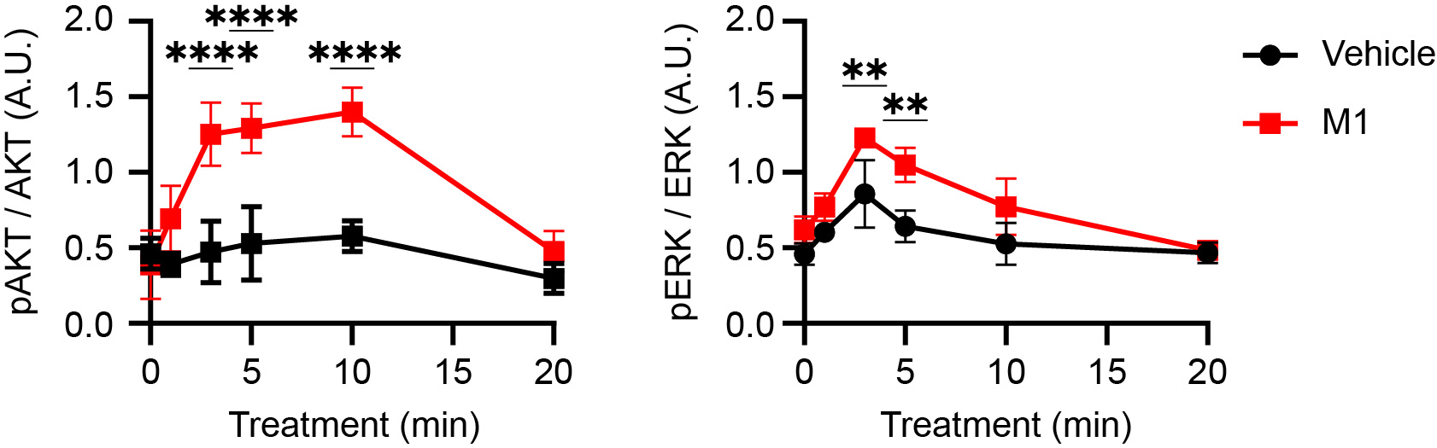

Fig. S5. M1 effects on the phosphorylation of AKT and ERK in primary microglia
Quantification of phosphorylated AKT (p-AKT) and ERK (p-ERK) levels in primary microglia treated with 10 nM M1 for the indicated times. The p-AKT and p-ERK levels were normalized to total AKT and ERK levels, respectively. Data are presented as mean ± SD (N=3). Two-way ANOVA followed by Šídák’s multiple comparisons test.

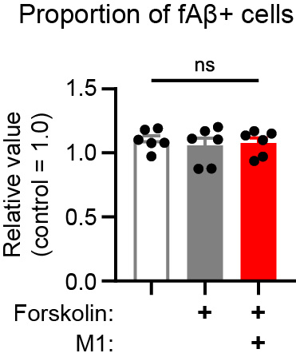

Fig. S6. Effects of forskolin and M1 on the proportion of fibrillar Aβ-positive cells
Quantification of the proportion of fibrillar Aβ (fAβ)+ cells upon treatment with vehicle, forskolin, or forskolin + M1. Data were derived from the same flow cytometry analysis as in Fig. 2c, but here the proportion of fAβ+ cells is shown. The proportion was normalized to the values of the control cells. Data are presented as mean ± SEM (N=6). One-way repeated measures ANOVA followed by Tukey’s multiple comparisons test.

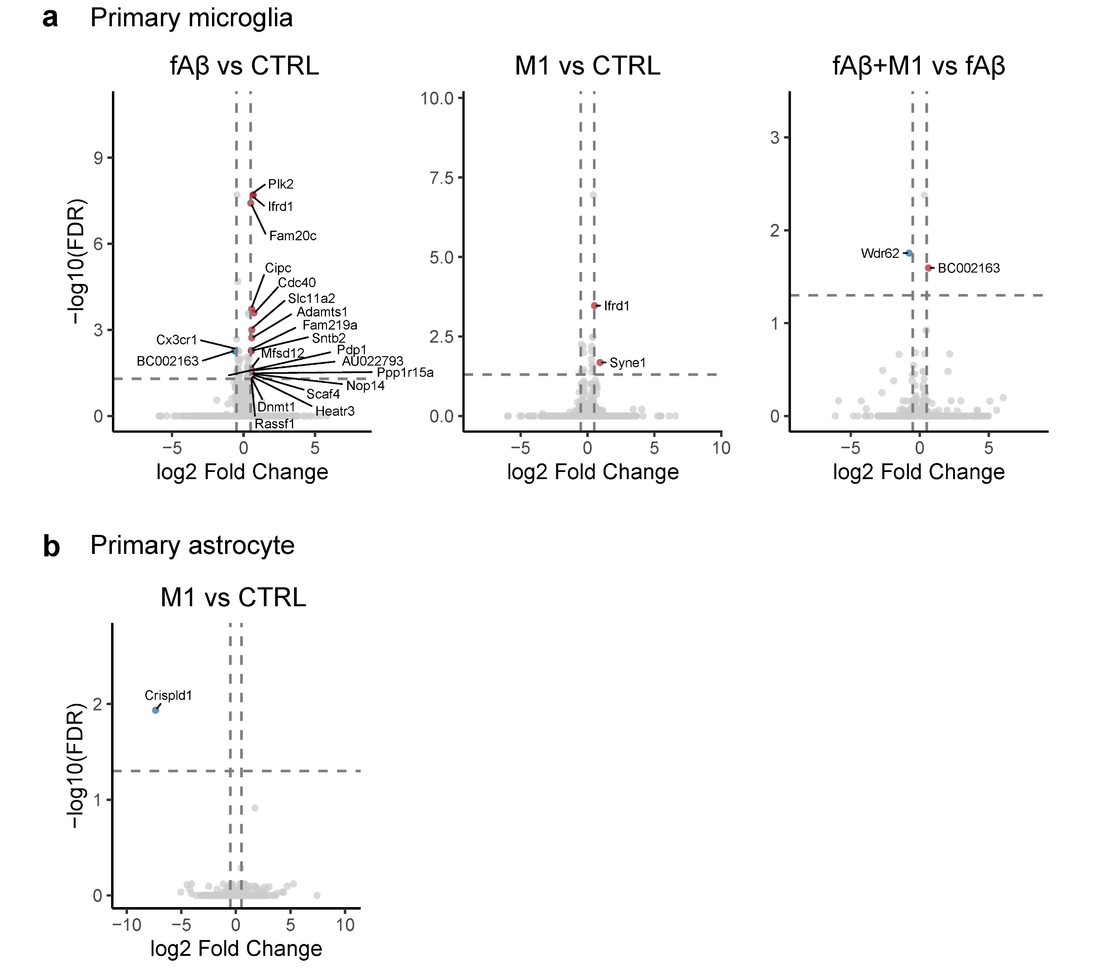

Fig. S7. Bulk RNA-seq of primary microglia and astrocytes after treatment with M1 and/or fibrillar Aβ
(a) Primary microglia. Volcano plots showing differential expression for three contrasts (left to right): fAβ vs CTRL, M1 vs CTRL, and fAβ plus M1 vs fAβ. Cells were treated with 1 µM fAβ, 10 nM M1, or both; CTRL denotes vehicle. Each point represents a gene; the x‑axis shows log2 fold-change and the y-axis shows −log10(FDR), where FDR is the Benjamini–Hochberg–adjusted p. Dashed lines indicate the cutoffs FDR = 0.05 (horizontal) and |log2FC| = 0.5 (vertical). Genes beyond both cutoffs are highlighted, and all significant genes are annotated.
(b) Primary astrocytes. Volcano plot for M1 vs CTRL. Only one gene passed the cutoffs.

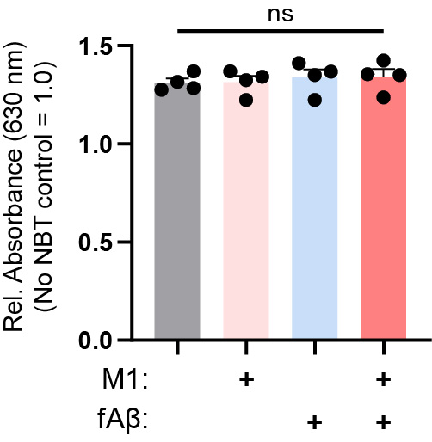

Fig. S8. Measurement of superoxide production in microglia by nitro blue tetrazolium (NBT) reduction assay
Primary microglia were treated for 24 h with vehicle, 10 nM M1, 1 μM fAβ, or fAβ plus M1, followed by incubation with NBT. Bars indicate relative NBT formazan absorbance at 630 nm, normalized to the no-NBT control (=1.0). Data represent mean ± SEM (N=4). Statistical analysis was performed using ordinary one-way ANOVA with Tukey’s multiple comparisons test; ns, not significant.

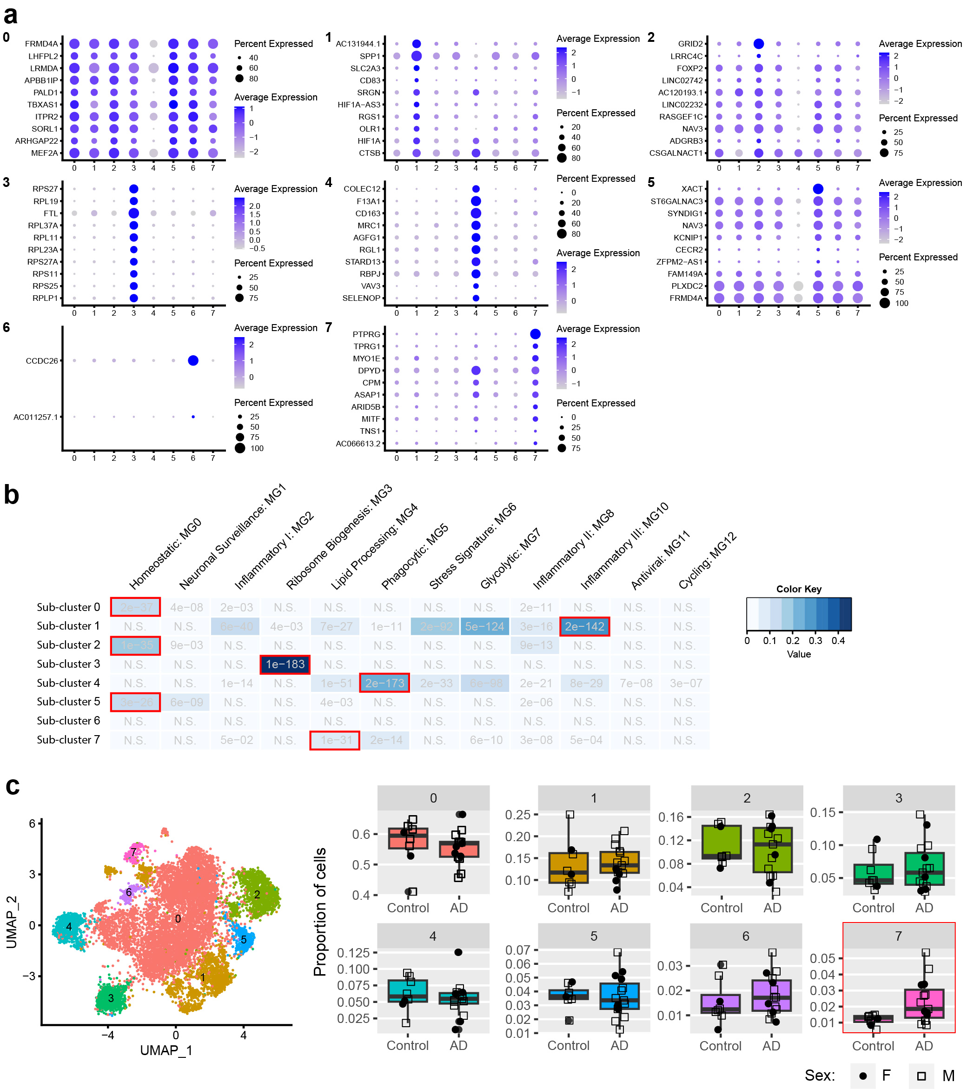

Fig. S9. Characterization of microglial sub-clusters and their changes in AD
(a) Dot plot of the top 10 DEGs for each microglial sub-cluster. Circle size indicates the percentage of cells expressing the gene; color indicates the mean expression level.
(b) Cross-label comparison between our sub-clusters and those reported by Sun et al. [14]. The heat map shows the Jaccard index (intersection/union of marker gene sets); darker blue indicates greater overlap. Red outlines highlight the highest-scoring match for each sub-cluster.
(c) Comparison of microglial sub-cluster proportions between AD and controls. Box plots show relative abundance per group; individual points denote donors (circles, female; squares, male). The lipid-processing sub-cluster (cluster 7) shows a significant expansion in AD (p = 0.02).

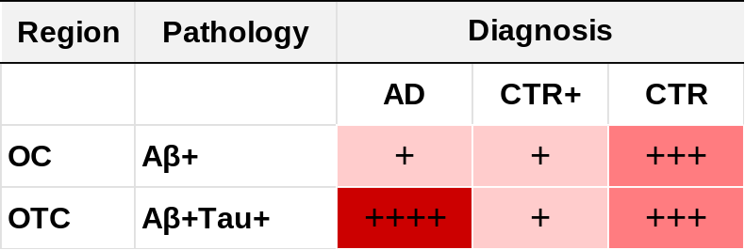

Fig. S10. Matrix summarizing the relative changes in GPR34 expression levels in microglia from the Gerrits et al. dataset, related to Table S2
The matrix shows the relative expression levels of GPR34 in microglia from the occipital cortex (OC) and occipitotemporal cortex (OTC) of control (CTR), control with Aβ pathology (CTR+), and AD patients. The relative magnitude of GPR34 expression levels is represented by the number of plus signs and the intensity of the red color within each cell. The data were obtained by reanalyzing the snRNA-seq dataset from Gerrits et al., 2021 [15]. The corresponding fold-changes and statistical significance are provided in Table S2.

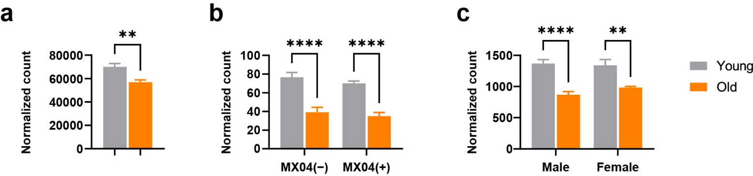

Fig. S11. Age-dependent decrease in microglial Gpr34 expression in mouse models.
(a) Gpr34 expression in microglia from young (3-month-old) and aged (20-month-old) mouse hippocampi. Data were derived from GSE127542 [16]. N = 6 per group.
(b) Gpr34 expression in microglia from young (< 3-month-old) and aged (> 18-month-old) mice, further separated based on their Aβ uptake status (MX04− or MX04+) determined by flow cytometry. Data were derived from GSE205803 [17]. N = 5 per group.
(c) Gpr34 expression in MACS-isolated microglia from young (5–6-month-old) and aged (22–25-month-old) mice, stratified by sex. Data were derived from GSE233400 [18]. N = 3–5 per group.
Data are presented as mean ± SEM. Statistical significance was determined using an unpaired t-test (a), two-way ANOVA followed by Šídák’s multiple comparisons test (b and c).

Table S1. Demographic and clinical information of the Japanese snRNA-seq cohort

ID | Diagnosis | Age | Sex | APOE
AD01 | AD | 70 | Male | 4*4
AD02 | AD | 74 | Male | 3*4
AD03 | AD | 75 | Male | 4*4
AD04 | AD | 78 | Male | 4*4
AD05 | AD | 82 | Female | 3*3
AD06 | AD | 82 | Female | 4*4
AD07 | AD | 83 | Female | 3*4
AD08 | AD | 85 | Male | 2*3
AD09 | AD | 86 | Female | 4*4
AD10 | AD | 87 | Male | 3*4
AD11 | AD | 88 | Male | 3*4
AD12 | AD | 88 | Male | 4*4
AD13 | AD | 92 | Male | 3*3
AD14 | AD | 93 | Male | 3*3
AD15 | AD | 98 | Female | 2*3
CT01 | Control | 57 | Male | 3*4
CT02 | Control | 64 | Male | 3*3
CT03 | Control | 70 | Male | 3*3
CT04 | Control | 70 | Male | 3*4
CT05 | Control | 73 | Female | 3*4
CT06 | Control | 77 | Male | 3*3
CT07 | Control | 79 | Male | 3*3
CT08 | Control | 82 | Female | 3*3

Diagnosis: pathological diagnosis (AD or normal control); Age: age at death; APOE: APOE genotype of the participant.

Table S2. Differential expression analysis of GPR34 in microglia from the Gerrits et al. dataset.

Gene | Brain region | Pathology | Comparison | Cell type | log2FC | FDR
GPR34 | OC | Aβ+ | AD vs CTR | Microglia | -0.662 | 2.0E-28
GPR34 | OC | Aβ+ | CTR+ vs CTR | Microglia | -0.178 | 2.0E-04
GPR34 | OC | Aβ+ | AD vs CTR+ | Microglia | 0.116 | 1.0E+00
GPR34 | OTC | Aβ+Tau+ | AD vs CTR | Microglia | 0.038 | 8.0E-06
GPR34 | OTC | Aβ+Tau+ | CTR+ vs CTR | Microglia | -0.216 | 4.0E-12
GPR34 | OTC | Aβ+Tau+ | AD vs CTR+ | Microglia | 0.254 | 5.0E-10

Differential expression analysis of GPR34 in microglia from the occipital cortex (OC) and occipitotemporal cortex (OTC) of control (CTR), control with Aβ pathology (CTR+), and AD patients. The data were obtained by reanalyzing the snRNA-seq dataset from Gerrits et al., 2021 [15]. Positive log2 fold-change (FC) values indicate upregulation in the comparison group relative to the reference group. FDR: false discovery rate-adjusted P-value.

SI References

1. Mandrekar S, Jiang Q, Lee CYD, Koenigsknecht-Talboo J, Holtzman DM, Landreth GE. Microglia Mediate the Clearance of Soluble Aβ through Fluid Phase Macropinocytosis. The Journal of Neuroscience. 2009;29:4252–62. https://doi.org/10.1523/JNEUROSCI.5572-08.2009.
2. Ikubo M, Inoue A, Nakamura S, Jung S, Sayama M, Otani Y, et al. Structure-activity relationships of lysophosphatidylserine analogs as agonists of G-protein-coupled receptors GPR34, P2Y10, and GPR174. J Med Chem. 2015;58:4204–19. https://doi.org/10.1021/jm5020082.
3. Sayama M, Inoue A, Nakamura S, Jung S, Ikubo M, Otani Y, et al. Probing the Hydrophobic Binding Pocket of G-Protein-Coupled Lysophosphatidylserine Receptor GPR34/LPS1 by Docking-Aided Structure-Activity Analysis. J Med Chem. 2017;60:6384–99. https://doi.org/10.1021/acs.jmedchem.7b00693.
4. Nakamura S, Sayama M, Uwamizu A, Jung S, Ikubo M, Otani Y, et al. Non-naturally Occurring Regio Isomer of Lysophosphatidylserine Exhibits Potent Agonistic Activity toward G Protein-Coupled Receptors. J Med Chem. 2020;63:9990–10029. https://doi.org/10.1021/acs.jmedchem.0c01126.
5. Iguchi A, Takatori S, Kimura S, Muneto H, Wang K, Etani H, et al. INPP5D modulates TREM2 loss-of-function phenotypes in a β-amyloidosis mouse model. iScience. 2023;26:106375. https://doi.org/10.1016/j.isci.2023.106375.
6. Kato Y, Takatori S, Akahori A, Etani H, Chu YN, Tomita T. Protocol for gene knockdown using siRNA in primary cultured neonatal murine microglia. STAR Protoc. 2024;5:102867. https://doi.org/10.1016/j.xpro.2024.102867.
7. Rolfe AJ, Bosco DB, Broussard EN, Ren Y. In Vitro Phagocytosis of Myelin Debris by Bone Marrow-Derived Macrophages. J Vis Exp. 2017;2017. https://doi.org/10.3791/56322.
8. McCarthy KD, de Vellis J. Preparation of separate astroglial and oligodendroglial cell cultures from rat cerebral tissue. J Cell Biol. 1980;85:890–902. https://doi.org/10.1083/jcb.85.3.890.
9. Hahaut V, Pavlinic D, Carbone W, Schuierer S, Balmer P, Quinodoz M, et al. Fast and highly sensitive full-length single-cell RNA sequencing using FLASH-seq. Nat Biotechnol. 2022;40:1447–51. https://doi.org/10.1038/s41587-022-01312-3.
10. Takahashi K, Tanabe K, Ohnuki M, Narita M, Ichisaka T, Tomoda K, et al. Induction of pluripotent stem cells from adult human fibroblasts by defined factors. Cell. 2007;131:861–72. https://doi.org/10.1016/j.cell.2007.11.019.
11. Sonn I, Honda-Ozaki F, Yoshimatsu S, Morimoto S, Watanabe H, Okano H. Single transcription factor efficiently leads human induced pluripotent stem cells to functional microglia. Inflamm Regen. 2022;42:20. https://doi.org/10.1186/s41232-022-00201-1.
12. Speir ML, Bhaduri A, Markov NS, Moreno P, Nowakowski TJ, Papatheodorou I, et al. UCSC Cell Browser: visualize your single-cell data. Bioinformatics. 2021;37:4578–80. https://doi.org/10.1093/BIOINFORMATICS/BTAB503.
13. Tabula Muris Consortium, Overall coordination, Logistical coordination, Organ collection and processing, Library preparation and sequencing, Computational data analysis, et al. Single-cell transcriptomics of 20 mouse organs creates a Tabula Muris. Nature. 2018;562:367–72. https://doi.org/10.1038/s41586-018-0590-4.
14. Sun N, Victor MB, Park YP, Xiong X, Scannail AN, Leary N, et al. Human microglial state dynamics in Alzheimer’s disease progression. Cell. 2023;186:4386-4403.e29. https://doi.org/10.1016/j.cell.2023.08.037.
15. Gerrits E, Brouwer N, Kooistra SM, Woodbury ME, Vermeiren Y, Lambourne M, et al. Distinct amyloid-β and tau-associated microglia profiles in Alzheimer’s disease. Acta Neuropathol. 2021;141:681–96. https://doi.org/10.1007/s00401-021-02263-w.
16. Pluvinage J V, Haney MS, Smith BAH, Sun J, Iram T, Bonanno L, et al. CD22 blockade restores homeostatic microglial phagocytosis in ageing brains. Nature. 2019;568:187–92. https://doi.org/10.1038/s41586-019-1088-4.
17. Thomas AL, Lehn MA, Janssen EM, Hildeman DA, Chougnet CA. Naturally-aged microglia exhibit phagocytic dysfunction accompanied by gene expression changes reflective of underlying neurologic disease. Sci Rep. 2022;12:19471. https://doi.org/10.1038/s41598-022-21920-y.
18. Ocañas SR, Pham KD, Cox JEJ, Keck AW, Ko S, Ampadu FA, et al. Microglial senescence contributes to female-biased neuroinflammation in the aging mouse hippocampus: implications for Alzheimer’s disease. J Neuroinflammation. 2023;20:188. https://doi.org/10.1186/s12974-023-02870-2.

