Additional file 1

Methods

Immunoassay analytical validation
The MMP7 immunoassay was commercially available while ENO2, ITGB2, DDC, and THOP1 immunoassays were developed in-house following manufacturer’s instructions on the automated Ella™ platforms (ProteinSimple, Bio-Techne, San Jose, California, USA). All immunoassays were extensively analytically validated following international guidelines for immunoassay validation (i.e., parallelism, sensitivity/lower limit of detection (LLOD), recovery, dilution linearity, and protein stability) [1]. The THOP1 and DDC immunoassays were developed and analytically validated previously [2] (Bolsewig et al., under review).

ENO2 analytical validation
The in-house automated Ella™ immunoassay for the detection of ENO2 concentrations in CSF was developed and analytically validated. Dilution linearity was tested by spiking CSF samples (n = 5) with recombinant ENO2 (5000 pg/mL), samples were diluted five times by 4-fold. Parallelism was assessed by diluting CSF samples (n = 5) five times by 2-fold, and compared to the calibrator. Recovery was tested by spiking CSF samples (n = 5) with different concentrations of the recombinant ENO2 (5000 pg/mL, 1000 pg/mL or 250 pg/mL). %Recovery was calculated by subtracting the concentration of the CSF samples without spike from the spiked samples and dividing this by the concentration of the buffer-spiked sample. Stability was assessed by CSF samples (n = 3) having 0, 1, 2, 3, 5, or 7 freeze/thaw (f/t) cycles. Each f/t cycle included thawing for 2 hours at RT and storing the aliquots at -80°C for a minimum of 12 hours. LLOD was determined by measuring nine buffer samples in triplicate. LLOD was calculated by adding 10 times the standard deviation (SD) to the mean of nine buffer samples and applying this to a five-parameter logistic (5-PL) curve fit. Additionally for our ENO2 immunoassay, selectivity and specificity were determined for proteins that were structurally similar to ENO2 (i.e., ENO1 and ENO3). Selectivity was assessed by spiking different ENO2 concentrations (either 2500 pg/mL, 312.5 pg/mL, or 0 pg/mL) in sample diluent combined with different concentrations of ENO1 or ENO3 (5000 pg/mL, 2500 pg/mL, or 312.5 pg/mL). Specificity was assessed by measuring the ENO2 signal in response to increasing concentrations of ENO1 or ENO3 (5000 pg/mL, 1250 pg/mL, and 312.5 pg/mL) recombinant protein. %Recovery was calculated by dividing the measured ENO2 concentration by the theoretical ENO2 concentration. Precision was assessed by measuring three CSF samples (high, medium, and low) over six plates; repeatability and intermediate precision were calculated (Supplementary Table 2).

ITGB2 analytical validation
Next, we developed and validated an in-house automated ELLA™ immunoassay for the detection of ITGB2 concentrations in CSF. Dilution linearity was assessed by spiking CSF samples (n = 3) with recombinant ITGB2 (60000 pg/mL), samples were diluted seven times by 2-fold. Parallelism was assessed by diluting CSF samples (n = 5) four times by 2-fold, and compared to the calibrator. Recovery was determined by spiking CSF samples (n = 5) with recombinant ITGB2 (20000 pg/mL, 5000 pg/mL, or 1250 pg/mL). %Recovery was calculated as described above. Stability was assessed by measuring CSF samples (n = 3), samples were aliquoted and provided with 0, 1, 2, 3, 5, or 7 f/t cycles. LLOD was calculated by measuring 15 buffer samples in triplicate. LLOD was calculated by adding 10 times the SD to the mean of 15 buffer samples and applying this to a 5-PL curve fit. Precision was tested by measuring three CSF samples (high, medium, and low) over nine plates; repeatability and intermediate precision were checked under stipulated conditions (Supplementary Table 2).

MMP7 analytical validation
The MMP7 ELLA™ immunoassay was analytically validated. Dilution linearity was assessed by spiking CSF sample (n = 5) with recombinant MMP7 (358800 pg/mL), all samples were diluted 2-fold seven times. Parallelism was tested in CSF samples (n = 5), samples were five times diluted in 2-fold and compared to the calibrator response. To assess the recovery of the MMP7 assay, CSF samples (n = 5) were spiked with MMP7 recombinant protein (480 pg/mL, 120 pg/mL, or 30 pg/mL). %Recovery was calculated in the same manner as described above. LLOD was calculated by measuring 13 buffer samples. LLOD was assessed by adding 10 times the SD to the mean 13 buffer samples and applying this to a 5-PL curve fit. Stability was determined with CSF samples (n = 3), that contained aliquots with 0, 1, 2, 3, 5, or 7 f/t cycles. Precision was checked by measuring three CSF samples (high, medium, and low) over five plates; mean repeatability and intermediate precision were calculated (Supplementary Table 2).
Supplementary Table 1. Overview of reagents included in the Ella immunoassays
Assays | Reagent | Description
THOP1 | Capture antibody | Polyclonal anti-human THOP1
THOP1 | Detection antibody | Biotinylated polyclonal anti-human THOP1
THOP1 | Standard curve | THOP1 recombinant human protein (aa2-aa689); range 1000 pg/mL - 15,6 pg/mL
THOP1 | Sample diluent | PBS-Casein 1.0%
THOP1 | Sample dilution | CSF was diluted 4-times
ENO2 | Capture antibody | Monoclonal anti-human ENO2
ENO2 | Detection antibody | Biotinylated polyclonal anti-human ENO2
ENO2 | Standard curve | Recombinant human enolase 2 standard; range 20.000 pg/mL - 156,3 pg/mL
ENO2 | Sample diluent | Sample diluent SD06
ENO2 | Sample dilution | CSF was diluted 4-times
ITGB2 | Capture antibody | Monoclonal anti-human ITGB2
ITGB2 | Detection antibody | Polyclonal anti-human ITGB2
ITGB2 | Standard curve | ITGB2 recombinant human protein (aa23-aa700); 40.000 pg/mL - 625 pg/mL
ITGB2 | Sample diluent | Sample diluent SD13
ITGB2 | Sample dilution | CSF was diluted 4-times
MMP7 | Commercial assay | Range: 8970 pg/mL - 14,7 pg/mL
MMP7 | Sample diluent | Sample diluent SD13
MMP7 | Sample dilution | CSF was diluted 2-times
Abbrevations: THOP1 = Thimet oligopeptidase, ENO2 = enolase 2, ITGB2 = intergrin beta 2, MMP7 = matrix metallopeptidase 7, CSF = cerebrospinal fluid, SD = sample diluent, PBS = phosphastase buffer saline, aa = amino acid

Supplementary Table 2. Overview intra- and inter-assay CV% of the immunoassays
 | LLOD | Mean concentration | Repeatability |  | Intermediate precision
Marker | pg/mL | pg/mL | S_{r} | %CV_{r} | S_{Rw} | %CV_{Rw}
THOP1  High  Medium  Low | 1,78 | 185,3  106  40,6 | 7,5  4,4  3,9 | 4,1  4,1  9,5 | 23,5  17,3  5,5 | 12,7  16,3  13,5
ENO2  High  Medium  Low | 12,92 | 19375  11914  3265 | 1578,2  588,7  403,6 | 8,1  4,9  12,4 | 1696,1  1913,8  608,2 | 8,8  16,1  18,6
DDC  High  Medium  Low | 5,24 | 74,2  21,8  13,0 | 7,7  1,8  0,9 | 10,4  8,1  7,3 | 17,5  4,8  2,4 | 23,7  22,2  18,6
ITGB2  High  Medium  Low | 2,32 | 1652,9  1602,0  936,1 | 158,0  89,3  76,1 | 9,6  5,6  8,1 | 298,4  310,7  172,1 | 18,1  19,4  18,4
MMP7  High  Medium  Low | 3,67 | 180,6  118,4  56,4 | 9,5  8,7  3,3 | 5,3  7,4  5,8 | 12,6  10,8  5,1 | 7,0  9,1  9,0
Abbrevations: THOP1 =thimet oligopeptidase, ENO2 = enolase 2, DDC = dopa decarboxylase, ITGB2 = intergrin beta 2, MMP7 = matrix metallopeptidase 7, LLOD = lower limit of detection, S = standard deviation, %CV = coefficient of variation, r = repeatability, Rw = intermediate precision

Results

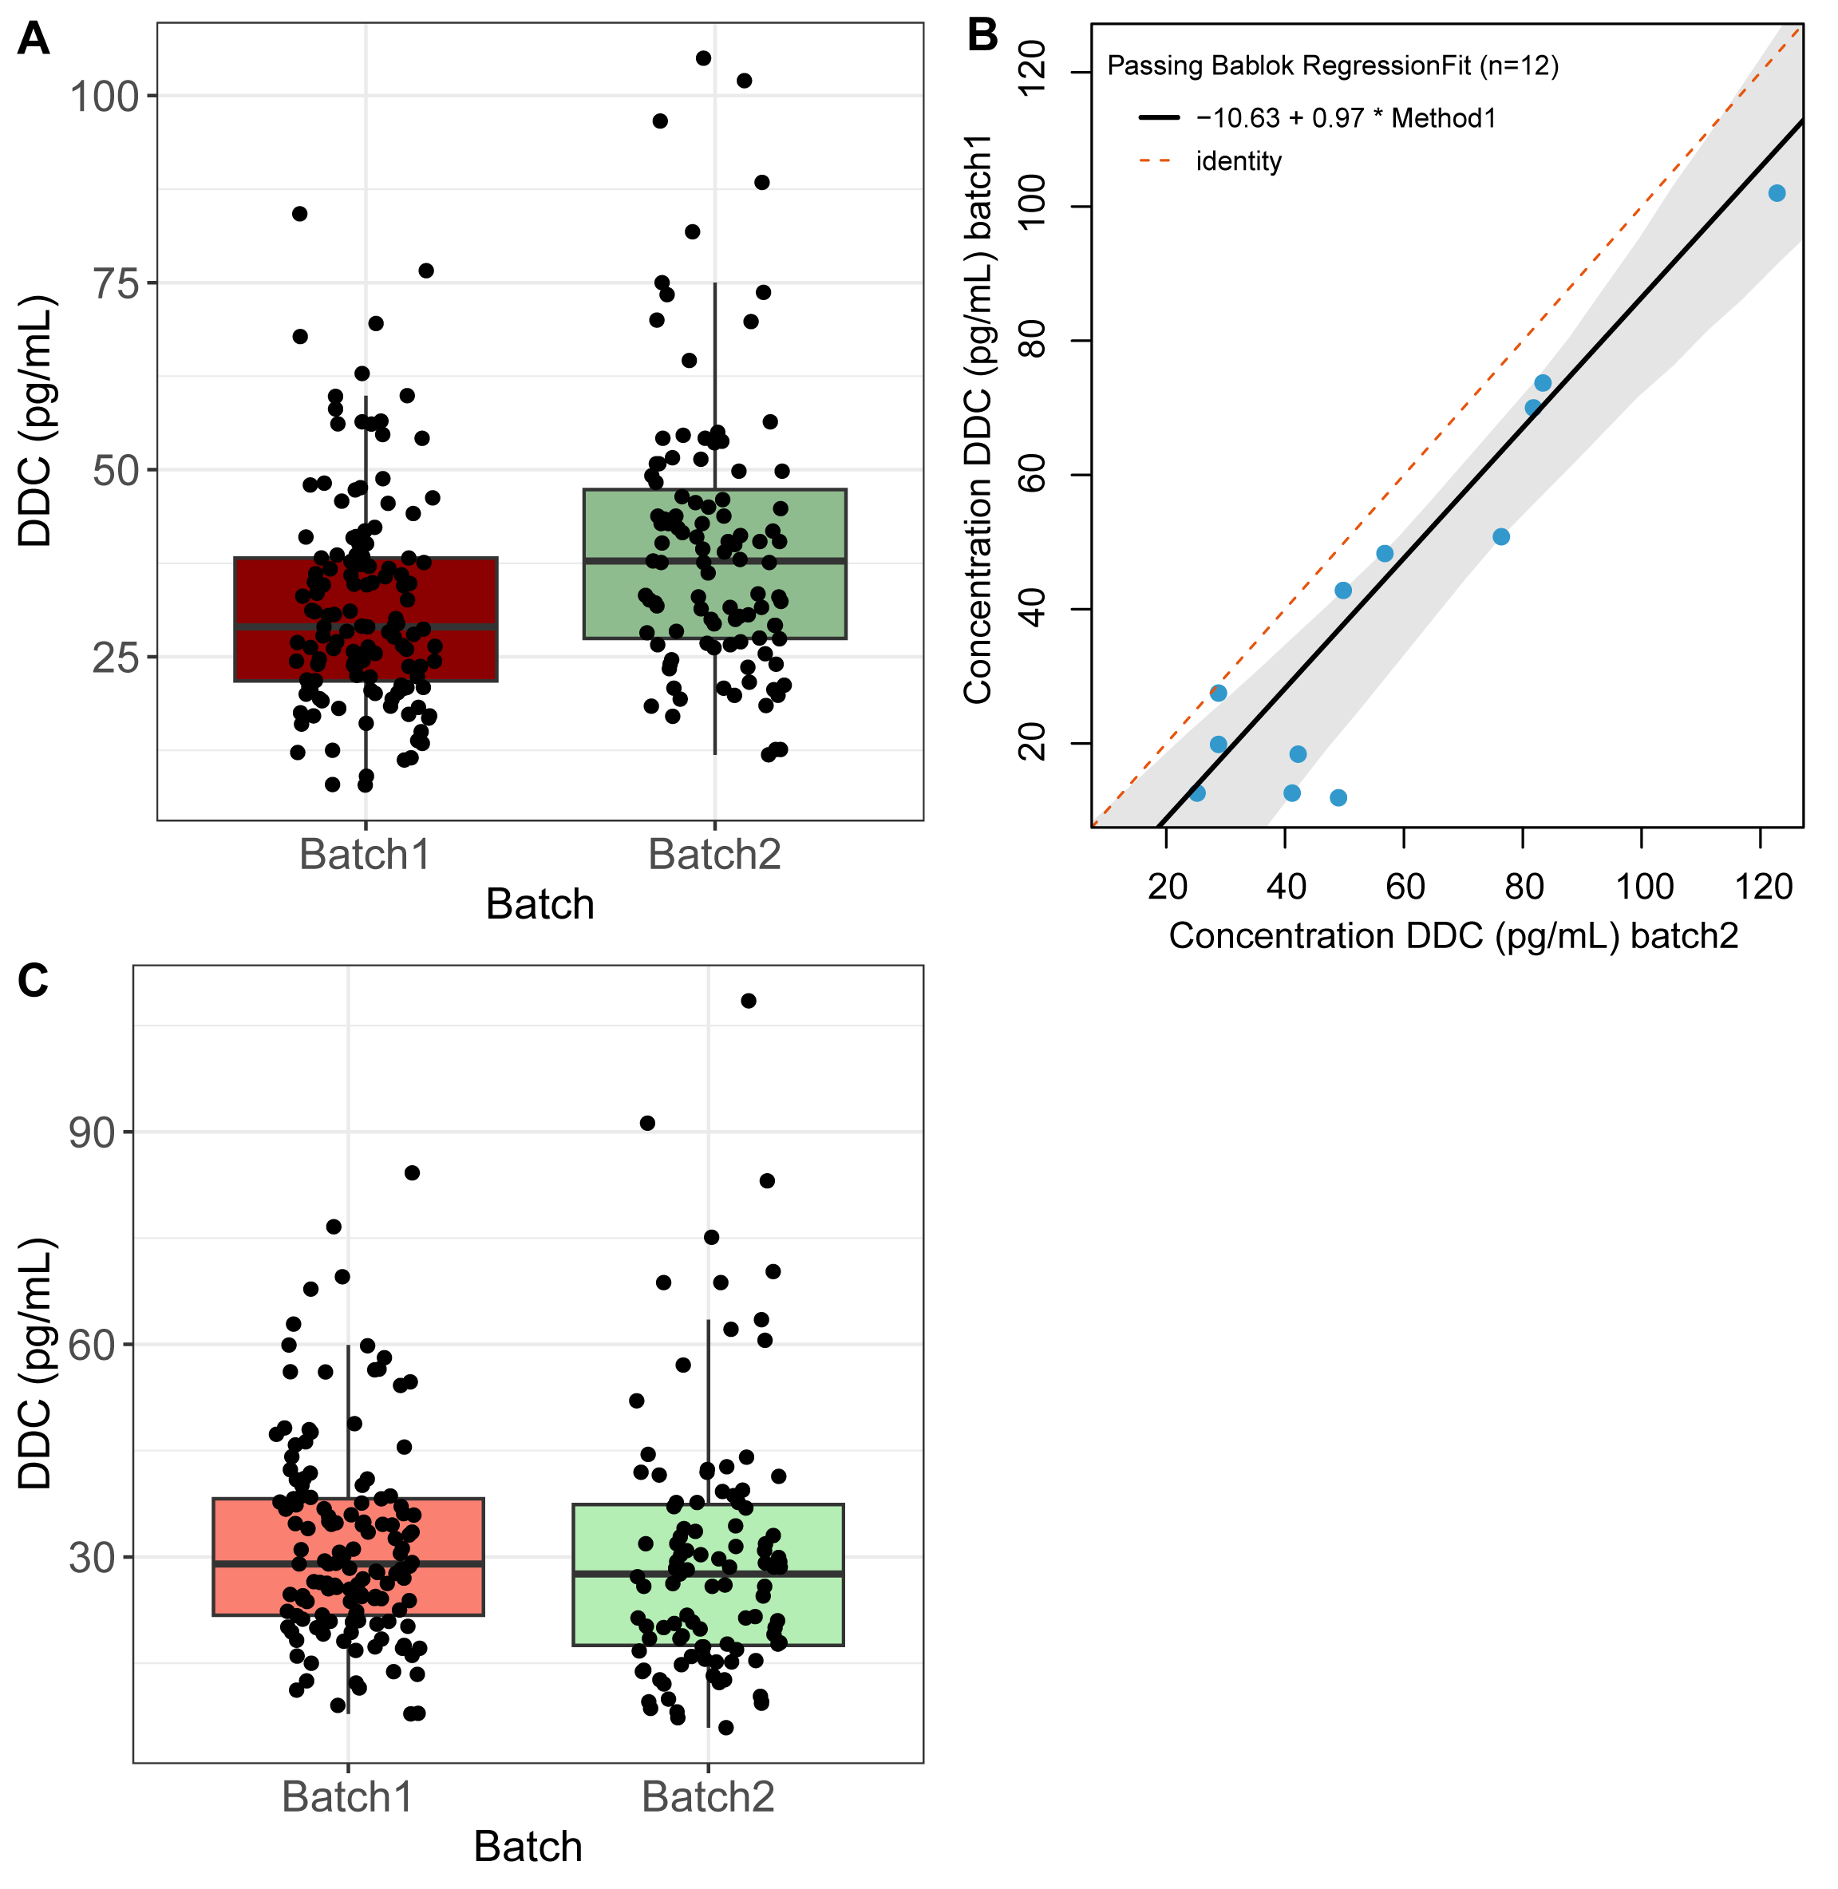
Figure S1. Conversion of DDC concentrations across two rounds of measurements
DDC concentrations were measured in clinical samples in two separate batches (A). From bridging samples, Passing Bablok regression formulas were used to transform values from round two to round one (B). After transformation, CSF concentrations from round two are in a similar range as round one (C).
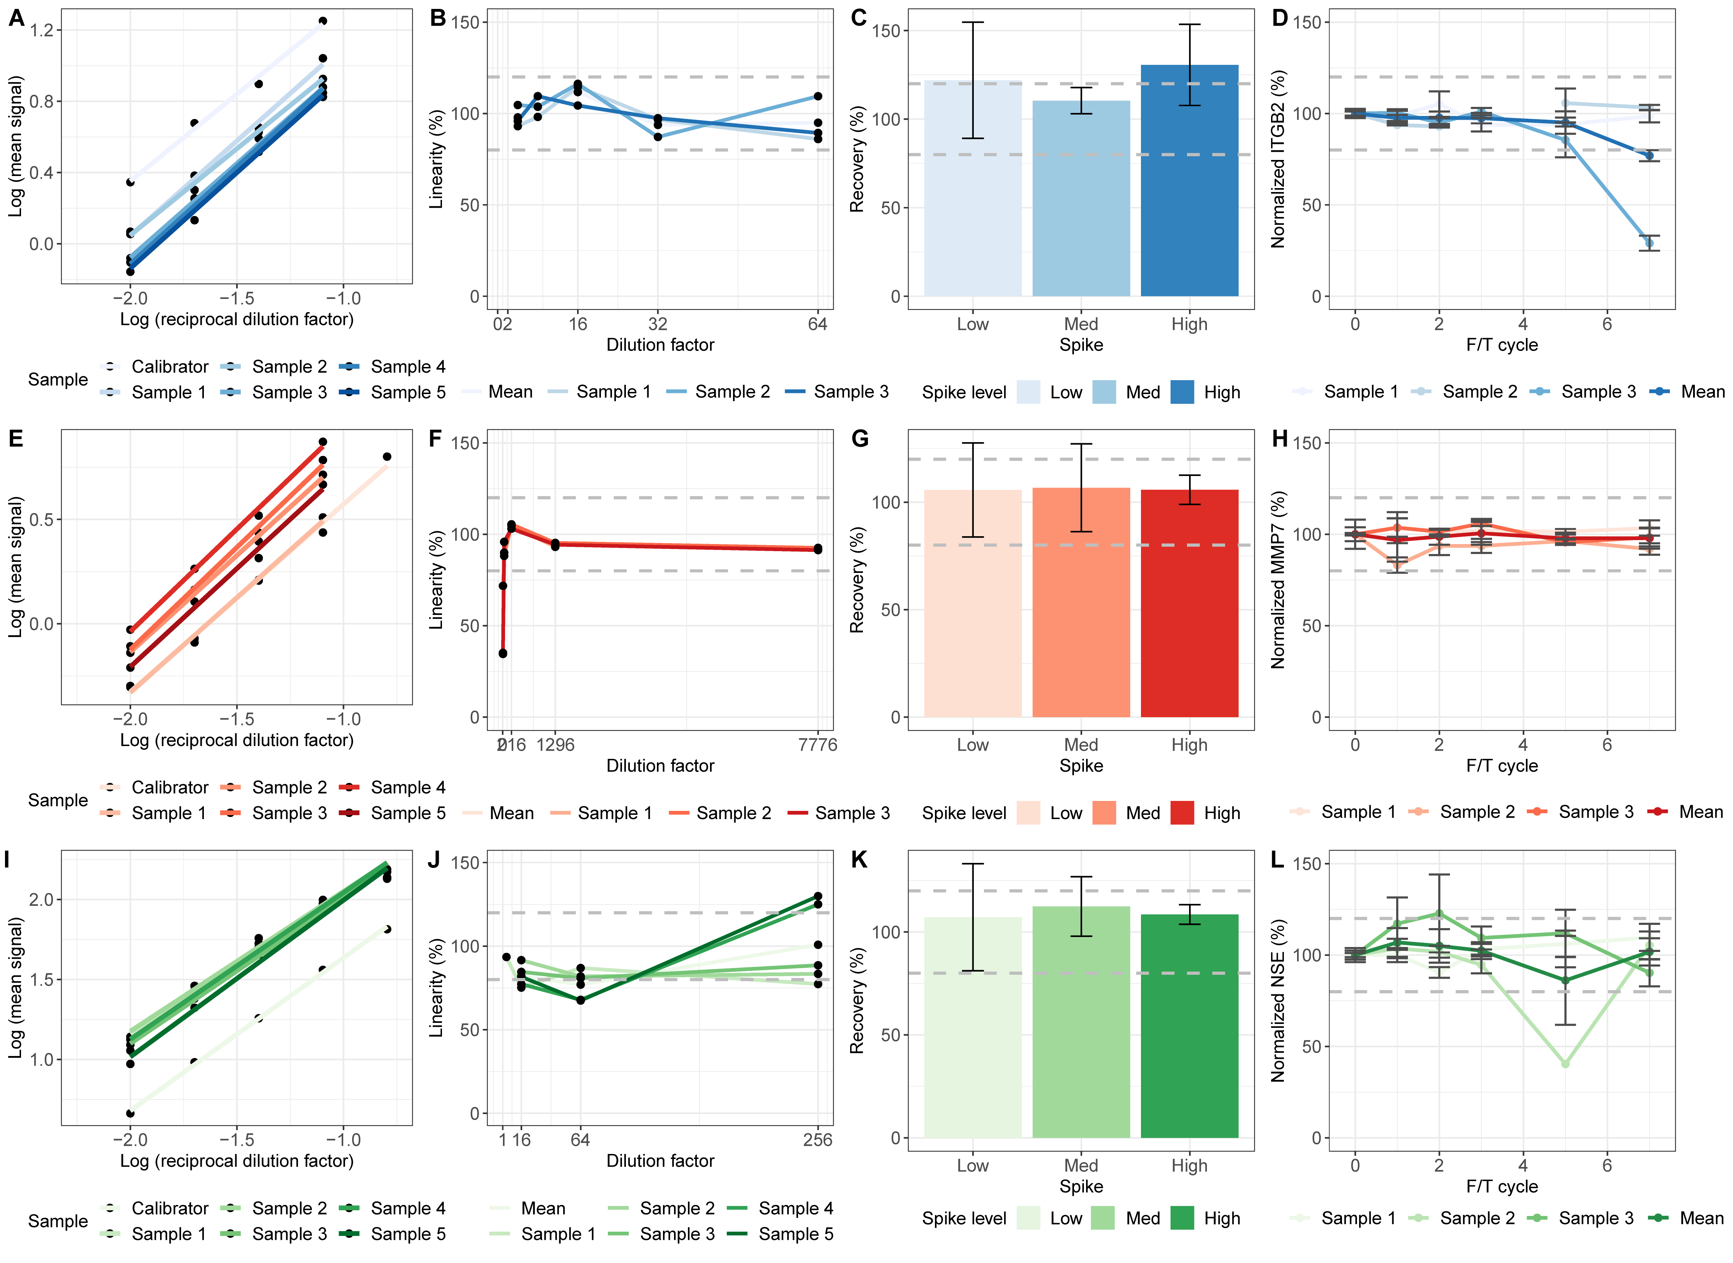
Figure S2. ITGB2, MMP7, and ENO2 immunoassays show good analytical performance
The ITGB2 immunoassay (blue) showed: (A) parallelism within the acceptable criteria (85%-115%), and (B) linearity % across the dilutions is within the acceptable range. The mean recovery % (C) of samples with low and medium spiked concentrations were within the acceptable range while spiked with high concentrations was slightly out of range. ITGB2 CSF concentrations were stable up to 5 f/t cycles (D). The MMP7 immunoassay (red) showed: (E) parallelism within the acceptable criteria, (F) linearity % between 36- and 1296-times diluted was within the acceptable criteria. The mean recovery % (G) of spiked CSF samples was within the acceptable range and MMP7 remained stable up to 7 f/t/ cycles (H). The ENO2 immunoassay (green) showed: (I) parallelism within the acceptable criteria, (J) linearity % between 4- and 256-times dilutions, and mean recovery % (K) of all samples were within the acceptable ranges.

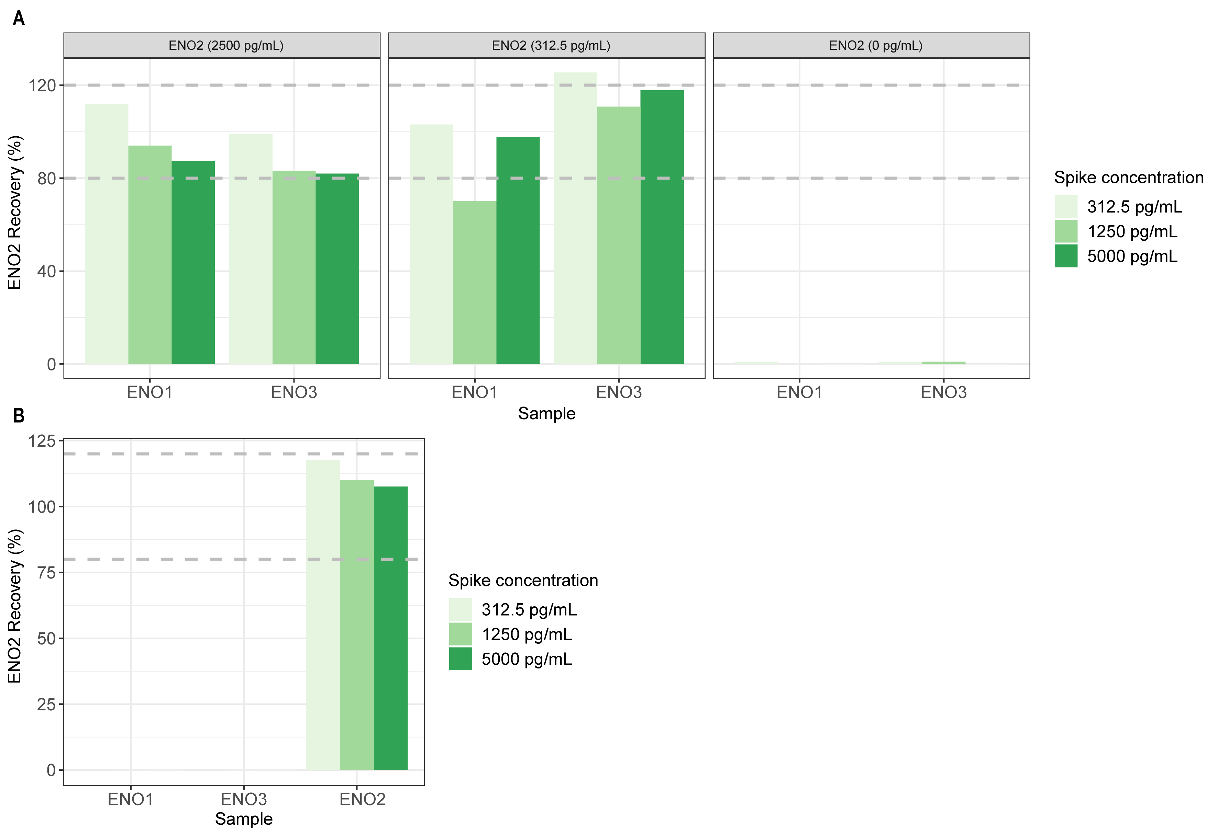
Figure S3. The ENO2 immunoassay showed no cross-reactivity with structurally similar proteins
Selectivity was measured by adding (A) 2500 pg/mL, 312.5 pg/mL, or 0 pg/mL of ENO2 recombinant protein with different concentrations (312.5 pg/mL, 1250 pg/mL, or 5000 pg/mL) of ENO1 and ENO3 recombinant protein in our ENO2 immunoassay. Below 5% of ENO3 at 312.5pg/mL was measured in combination with ENO2 at 312.5 pg/mL. No signal was present in any other concentrations of either ENO1 or ENO3 in combination with ENO2 recombinant protein (B) Specificity experiment showed that our ENO2 immunoassay did not measure ENO1 and ENO3 proteins at different concentrations.

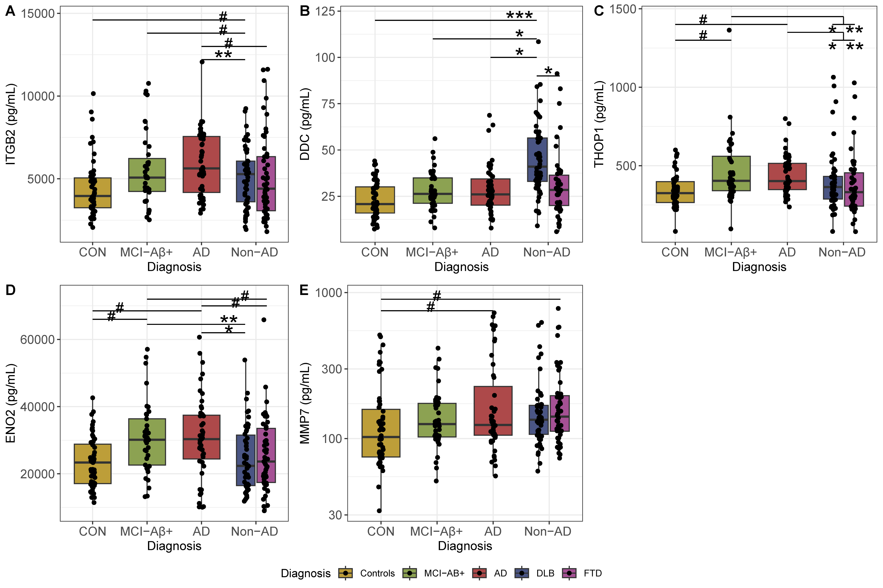
Figure S4. CSF proteins from the differential diagnostic panel are dysregulated across groups upon excluding AD co-pathology in non-AD group
As a sensitivity analysis, patients in the non-AD group with a positive AD-CSF profile were excluded from the analysis. Protein concentrations in CSF from (A) ITGB2, (B) DDC, (C) THOP1, (D) ENO2, and (E) MMP7 were sequentially measured on the Ella platform. THOP1 and ENO2 are dysregulated across the different AD stages. ITGB2 and ENO2 are increased in AD compared with the DLB and FTD. In addition, MMP7 was nominally increased in patients with AD and FTD compared to controls. Abbreviations: CON, controls; MCI-Aβ+, mild cognitive impairment with amyloid pathology; AD, Alzheimer’s disease; DLB, dementia with Lewy bodies; FTD, Frontotemporal dementia; ITGB2, integrin subunit beta 2; DDC, dopa decarboxylase; THOP1, thimet oligopeptidase; ENO2, enolase 2; MMP7, Matrix metallopeptidase 7. # p < 0.05 (nominal significance), * q < 0.05, ** q < 0.01, *** q < 0.001 (significant after post-hoc analysis).

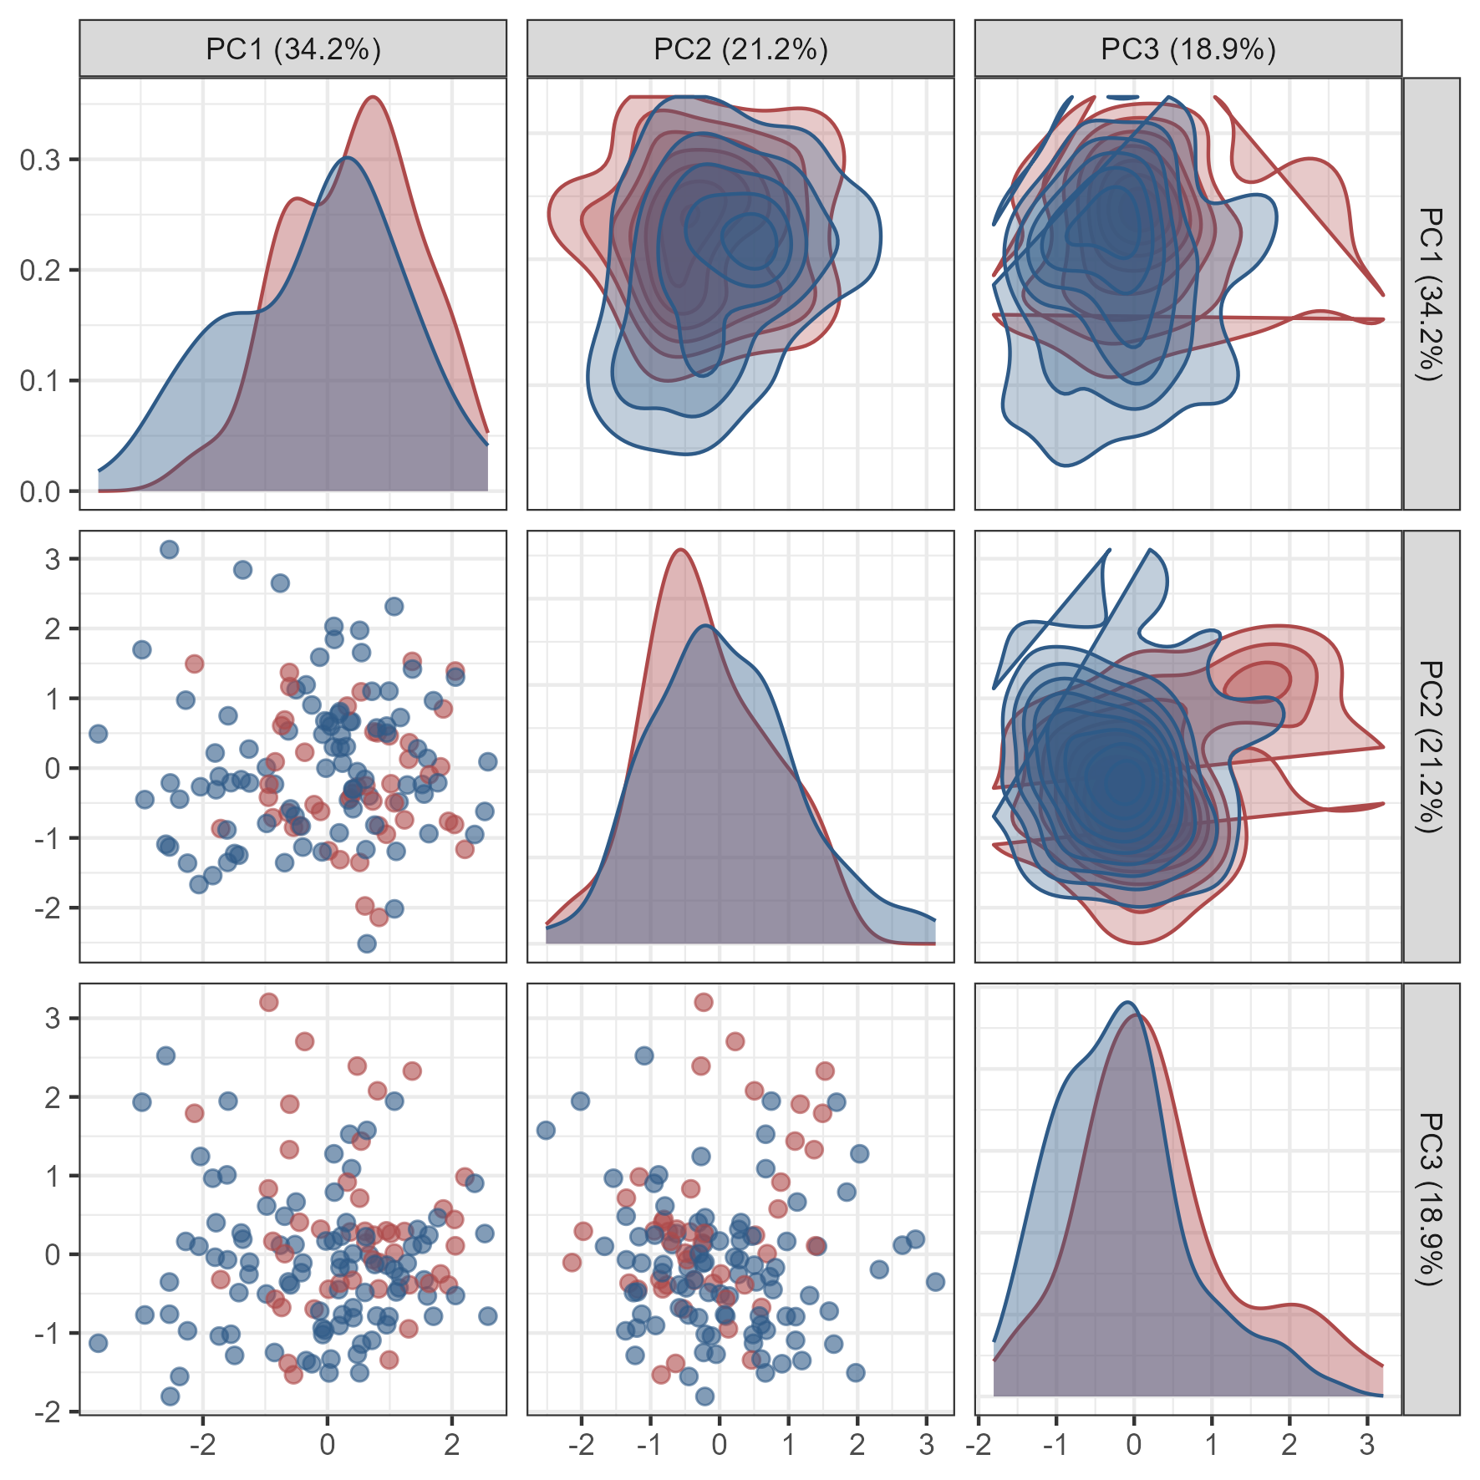
Figure S5. Principal component analysis of the CSF panel
Principal component analysis of the CSF panel in AD and non-AD individuals. The results show that Principal Component 1 (PC1) capture the most variance in the data (34%), Principal Component 2 (PC2) captures 21% and Principal Component 3 (PC3) captures 19% of the variance. Different diagnostic groups are represented by different colors(red for AD and blue non-AD dementia group). The plot shows some clustering of the groups in PC1, indicating differences in their protein levels for the AD CSF differential diagnostic panel.

Figure S6. NfL is increased across dementia groups and has similar performance as the CSF panel
In a subset of the cohort (6 controls, 15 AD and 21 FTD patients) NfL was measured in CSF. CSF NfL was increased in AD and FTD compared to controls. The highest concentrations were observed in FTD group. In addition, ROC curve analysis showed that CSF NfL (AUC: 0.767, 95% CI: 0.589 – 0.944) and the CSF panel (AUC: 0.811, 95% CI: 0.659 – 0.962) both had moderate performance. Abbreviations: CON, controls; AD, Alzheimer’s disease; FTD, Frontotemporal dementia; CSF, cerebrospinal fluid; NfL, Neurofilament light chain. ** p < 0.01, *** p < 0.001

References
1. Andreasson, U., et al., A Practical Guide to Immunoassay Method Validation. Front Neurol, 2015. 6: p. 179.
2. Hok-A-Hin, Y.S., et al., Thimet oligopeptidase as a potential CSF biomarker for Alzheimer's disease: A cross-platform validation study. Alzheimers Dement (Amst), 2023. 15(3): p. e12456.

