Additional file 3:

- Prevalence of autonomic and neurosensory disorders at 36 months stratified on clinical stage
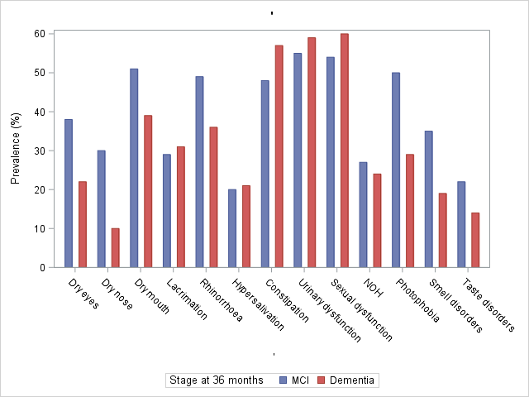

 |  | Total  (N=83) | MCI  (N=41) | Dementia  (N=42) | p-value
Dry eyes | Missing data | 5 (6.0%) | 4 (9.8%) | 1 (2.4%) | p = 0.12
 | No | 55 (70.5%) | 23 (62.2%) | 32 (78.0%)
 | Yes | 23 (29.5%) | 14 (37.8%) | 9 (22.0%)
Dry nose | Missing data | 5 (6.0%) | 4 (9.8%) | 1 (2.4%) | p = 0.03
 | No | 63 (80.8%) | 26 (70.3%) | 37 (90.2%)
 | Yes | 15 (19.2%) | 11 (29.7%) | 4 (9.8%)
Dry mouth | Missing data | 5 (6.0%) | 4 (9.8%) | 1 (2.4%) | p = 0.27
 | No | 43 (55.1%) | 18 (48.6%) | 25 (61.0%)
 | Yes | 35 (44.9%) | 19 (51.4%) | 16 (39.0%)
Lacrimation | Missing data | 0 (0.0%) | 0 (0.0%) | 0 (0.0%) | p = 0.87
 | No | 58 (69.9%) | 29 (70.7%) | 29 (69.0%)
 | Yes | 25 (30.1%) | 12 (29.3%) | 13 (31.0%)
Rhinorrhoea | Missing data | 0 (0.0%) | 0 (0.0%) | 0 (0.0%) | p = 0.23
 | No | 48 (57.8%) | 21 (51.2%) | 27 (64.3%)
 | Yes | 35 (42.2%) | 20 (48.8%) | 15 (35.7%)
Hypersalivation | Missing data | 0 (0.0%) | 0 (0.0%) | 0 (0.0%) | p = 0.82
 | No | 66 (79.5%) | 33 (80.5%) | 33 (78.6%)
 | Yes | 17 (20.5%) | 8 (19.5%) | 9 (21.4%)
Constipation | Missing data | 1 (1.2%) | 1 (2.4%) | 0 (0.0%) | p = 0.38
 | No | 39 (47.6%) | 21 (52.5%) | 18 (42.9%)
 | Yes | 43 (52.4%) | 19 (47.5%) | 24 (57.1%)
Sexual dysfunction | Missing data | 23 (27.7%) | 6 (14.6%) | 17 (40.5%) | p = 0.66
 | No | 26 (43.3%) | 16 (45.7%) | 10 (40.0%)
 | Yes | 34 (56.7%) | 19 (54.3%) | 15 (60.0%)
Urinary dysfunction | Missing data | 18 (21.7%) | 8 (19.5%) | 10 (23.8%) | p = 0.69
 | No | 28 (43.1%) | 15 (45.5%) | 13 (40.6%)
 | Yes | 37 (56.9%) | 18 (54.5%) | 19 (59.4%)
NOH | Missing data | 20 (24.1%) | 11 (26.8%) | 9 (21.4%) | p = 0.83
 | No | 47 (74.6%) | 22 (73.3%) | 25 (75.8%)
 | Yes | 16 (25.4%) | 8 (26.7%) | 8 (24.2%)
Photophobia | Missing data | 1 (1.2%) | 1 (2.4%) | 0 (0.0%) | p = 0.046
 | No | 50 (61.0%) | 20 (50.0%) | 30 (71.4%)
 | Yes | 32 (39.0%) | 20 (50.0%) | 12 (28.6%)
Smell disorders | Missing data | 4 (4.8%) | 4 (9.8%) | 0 (0.0%) | p = 0.11
 | No | 58 (73.4%) | 24 (64.9%) | 34 (81.0%)
 | Yes | 21 (26.6%) | 13 (35.1%) | 8 (19.0%)
Taste disorders | Missing data | 4 (4.8%) | 4 (9.8%) | 0 (0.0%) | p = 0.39
 | No | 65 (82.3%) | 29 (78.4%) | 36 (85.7%)
 | Yes | 14 (17.7%) | 8 (21.6%) | 6 (14.3%)

- Prevalence of autonomic and neurosensory disorders at 24 months in 15 healthy controls included in the AlphaLewyMA cohort

Prevalence at 24 months
(n=15)
 | Missing | Present
Dry eyes | 0 (0.0%) | 2 (13.3%)
Dry nose | 0 (0.0%) | 0 (0.0%)
Dry mouth | 0 (0.0%) | 1 (6.7%)
Lacrimation | 0 (0.0%) | 0 (0.0%)
including severe grade |  | 0 (0.0%)
Rhinorrhoea | 0 (0.0%) | 1 (6.7%)
including severe grade |  | 1 (6.7%)
Hypersalivation | 0 (0.0%) | 0 (0.0%)
including severe grade |  | 0 (0.0%)
Constipation | 0 (0.0%) | 0 (0.0%)
including severe grade |  | 0 (0.0%)
Sexual dysfunction | 1 (6.7%) | 2 (14.3%)
including severe grade |  | 2 (14.3%)
Neurogenic orthostatic hypotension | 0 (0.0%) | 3 (20.0%)
including severe grade |  | 0 (0.0%)
Photophobia | 0 (0.0%) | 1 (6.7%)
including severe grade |  | 1 (6.7%)
Smell disorders | 0 (0.0%) | 0 (0.0%)
including severe grade |  | 0 (0.0%)
Taste disorders | 0 (0.0%) | 1 (6.7%)
including severe grade |  | 1 (6.7%)

- Mean number of autonomic and neurosensory disorders at each follow-up

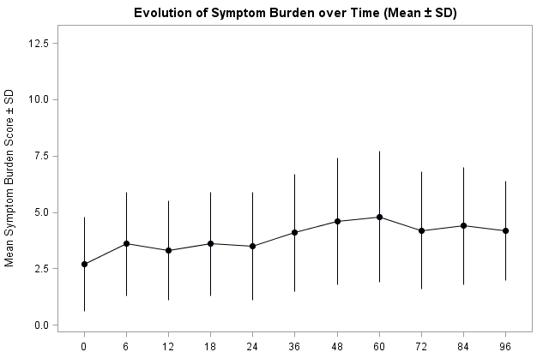
- Prevalence of autonomic and neurosensory disorders during the follow-up stratified by the intake of antidepressants
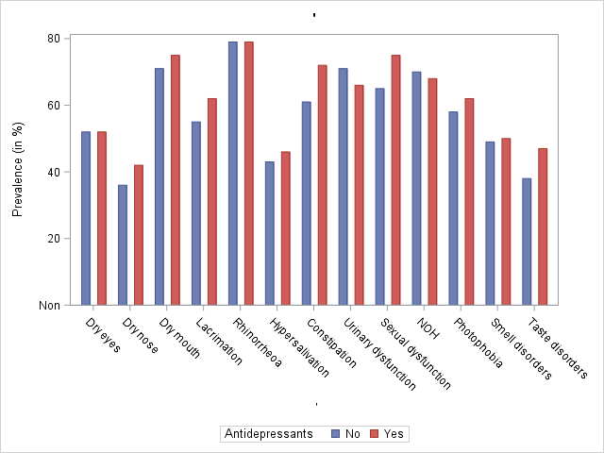
 |  | Total  (N=142) | No antidepressants  (N=64) | Antidepressants  (N=78) | p-value
Dry eyes | Missing data | 11 (7.7%) | 6 (9.4%) | 5 (6.4%) | p = 0.97
 | No | 63 (48.1%) | 28 (48.3%) | 35 (47.9%)
 | Yes | 68 (51.9%) | 30 (51.7%) | 38 (52.1%)
Dry nose | Missing data | 11 (7.7%) | 6 (9.4%) | 5 (6.4%) | p = 0.47
 | No | 79 (60.3%) | 37 (63.8%) | 42 (57.5%)
 | Yes | 52 (39.7%) | 21 (36.2%) | 31 (42.5%)
Dry mouth | Missing data | 11 (7.7%) | 6 (9.4%) | 5 (6.4%) | p = 0.55
 | No | 35 (26.7%) | 17 (29.3%) | 18 (24.7%)
 | Yes | 96 (73.3%) | 41 (70.7%) | 55 (75.3%)
Lacrimation | Missing data | 10 (7.0%) | 6 (9.4%) | 4 (5.1%) | p = 0.42
 | No | 54 (40.9%) | 26 (44.8%) | 28 (37.8%)
 | Yes | 78 (59.1%) | 32 (55.2%) | 46 (62.2%)
Rhinorrhoea | Missing data | 2 (1.4%) | 2 (3.1%) | 0 (0.0%) | p = 0.95
 | No | 29 (20.7%) | 13 (21.0%) | 16 (20.5%)
 | Yes | 111 (79.3%) | 49 (79.0%) | 62 (79.5%)
Hypersalivation | Missing data | 6 (4.2%) | 4 (6.3%) | 2 (2.6%) | p = 0.75
 | No | 75 (55.1%) | 34 (56.7%) | 41 (53.9%)
 | Yes | 61 (44.9%) | 26 (43.3%) | 35 (46.1%)
Constipation | Missing data | 5 (3.5%) | 3 (4.7%) | 2 (2.6%) | p = 0.15
 | No | 45 (32.8%) | 24 (39.3%) | 21 (27.6%)
 | Yes | 92 (67.2%) | 37 (60.7%) | 55 (72.4%)
Sexual dysfunction | Missing data | 16 (11.3%) | 7 (10.9%) | 9 (11.5%) | p = 0.20
 | No | 37 (29.4%) | 20 (35.1%) | 17 (24.6%)
 | Yes | 89 (70.6%) | 37 (64.9%) | 52 (75.4%)
Urinary dysfunction | Missing data | 42 (29.6%) | 26 (40.6%) | 16 (20.5%) | p = 0.61
 | No | 32 (32.0%) | 11 (28.9%) | 21 (33.9%)
 | Yes | 68 (68.0%) | 27 (71.1%) | 41 (66.1%)
NOH | Missing data | 23 (16.2%) | 14 (21.9%) | 9 (11.5%) | p = 0.83
 | No | 37 (31.1%) | 15 (30.0%) | 22 (31.9%)
 | Yes | 82 (68.9%) | 35 (70.0%) | 47 (68.1%)
Photophobia | Missing data | 0 (0.0%) | 0 (0.0%) | 0 (0.0%) | p = 0.65
 | No | 57 (40.1%) | 27 (42.2%) | 30 (38.5%)
 | Yes | 85 (59.9%) | 37 (57.8%) | 48 (61.5%)
Smell disorders | Missing data | 1 (0.7%) | 1 (1.6%) | 0 (0.0%) | p = 0.93
 | No | 71 (50.4%) | 32 (50.8%) | 39 (50.0%)
 | Yes | 70 (49.6%) | 31 (49.2%) | 39 (50.0%)
Taste disorders | Missing data | 1 (0.7%) | 1 (1.6%) | 0 (0.0%) | p = 0.27
 | No | 80 (56.7%) | 39 (61.9%) | 41 (52.6%)
 | Yes | 61 (43.3%) | 24 (38.1%) | 37 (47.4%)

- Prevalence of autonomic and neurosensory disorders during the follow-up stratified by the intake of cholinesterase inhibitors
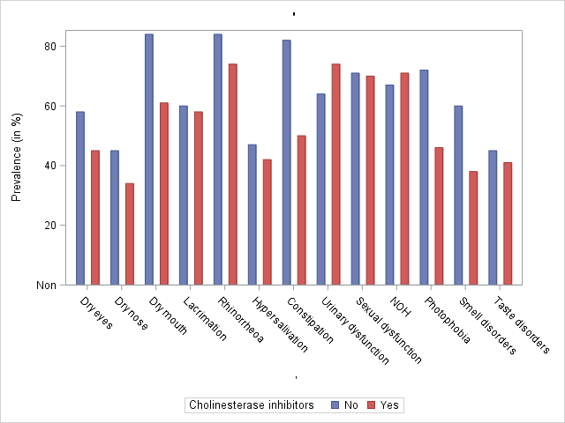

 |  | Total  (N=142) | No cholinesterase inhibitors  (N=75) | Cholinesterase inhibitors  (N=67) | p-value
Dry eyes | Missing data | 11 (7.7%) | 6 (8.0%) | 5 (7.5%) | p = 0.14
 | No | 63 (48.1%) | 29 (42.0%) | 34 (54.8%)
 | Yes | 68 (51.9%) | 40 (58.0%) | 28 (45.2%)
Dry nose | Missing data | 11 (7.7%) | 6 (8.0%) | 5 (7.5%) | p = 0.20
 | No | 79 (60.3%) | 38 (55.1%) | 41 (66.1%)
 | Yes | 52 (39.7%) | 31 (44.9%) | 21 (33.9%)
Dry mouth | Missing data | 11 (7.7%) | 6 (8.0%) | 5 (7.5%) | p = 0.003
 | No | 35 (26.7%) | 11 (15.9%) | 24 (38.7%)
 | Yes | 96 (73.3%) | 58 (84.1%) | 38 (61.3%)
Lacrimation | Missing data | 10 (7.0%) | 5 (6.7%) | 5 (7.5%) | p = 0.82
 | No | 54 (40.9%) | 28 (40.0%) | 26 (41.9%)
 | Yes | 78 (59.1%) | 42 (60.0%) | 36 (58.1%)
Rhinorrhoea | Missing data | 2 (1.4%) | 1 (1.3%) | 1 (1.5%) | p = 0.16
 | No | 29 (20.7%) | 12 (16.2%) | 17 (25.8%)
 | Yes | 111 (79.3%) | 62 (83.8%) | 49 (74.2%)
Hypersalivation | Missing data | 6 (4.2%) | 3 (4.0%) | 3 (4.5%) | p = 0.56
 | No | 75 (55.1%) | 38 (52.8%) | 37 (57.8%)
 | Yes | 61 (44.9%) | 34 (47.2%) | 27 (42.2%)
Constipation | Missing data | 5 (3.5%) | 2 (2.7%) | 3 (4.5%) | p < 0.0001
 | No | 45 (32.8%) | 13 (17.8%) | 32 (50.0%)
 | Yes | 92 (67.2%) | 60 (82.2%) | 32 (50.0%)
Sexual dysfunction | Missing data | 16 (11.3%) | 6 (8.0%) | 10 (14.9%) | p = 0.92
 | No | 37 (29.4%) | 20 (29.0%) | 17 (29.8%)
 | Yes | 89 (70.6%) | 49 (71.0%) | 40 (70.2%)
Urinary dysfunction | Missing data | 42 (29.6%) | 17 (22.7%) | 25 (37.3%) | p = 0.29
 | No | 32 (32.0%) | 21 (36.2%) | 11 (26.2%)
 | Yes | 68 (68.0%) | 37 (63.8%) | 31 (73.8%)
NOH | Missing data | 23 (16.2%) | 12 (16.0%) | 11 (16.4%) | p = 0.58
 | No | 37 (31.1%) | 21 (33.3%) | 16 (28.6%)
 | Yes | 82 (68.9%) | 42 (66.7%) | 40 (71.4%)
Photophobia | Missing data | 0 (0.0%) | 0 (0.0%) | 0 (0.0%) | p = 0.002
 | No | 57 (40.1%) | 21 (28.0%) | 36 (53.7%)
 | Yes | 85 (59.9%) | 54 (72.0%) | 31 (46.3%)
Smell disorders | Missing data | 1 (0.7%) | 0 (0.0%) | 1 (1.5%) | p = 0.009
 | No | 71 (50.4%) | 30 (40.0%) | 41 (62.1%)
 | Yes | 70 (49.6%) | 45 (60.0%) | 25 (37.9%)
Taste disorders | Missing data | 1 (0.7%) | 0 (0.0%) | 1 (1.5%) | p = 0.60
 | No | 80 (56.7%) | 41 (54.7%) | 39 (59.1%)
 | Yes | 61 (43.3%) | 34 (45.3%) | 27 (40.9%)

