Supplementary Figure 1. Cross-species identification of the murine homolog of human lncRNA-9969. (A) BLAT alignment of human lncRNA-9969 (ENST00000629969) against the mouse genome showing 99.46% sequence similarity, identifying the corresponding mouse genomic region.
(B) BLAST analysis of the matched mouse sequence in the NONCODE database confirming its annotation as ENSMUST00000200021 (lncRNA-0021).
A
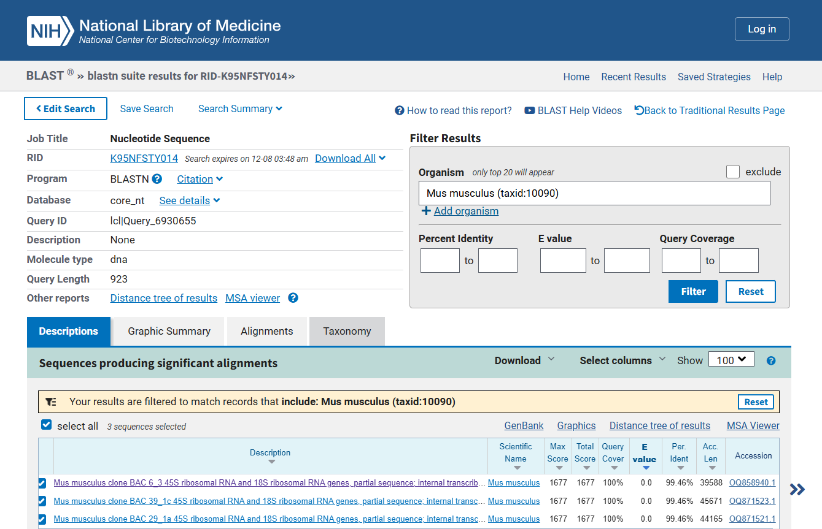
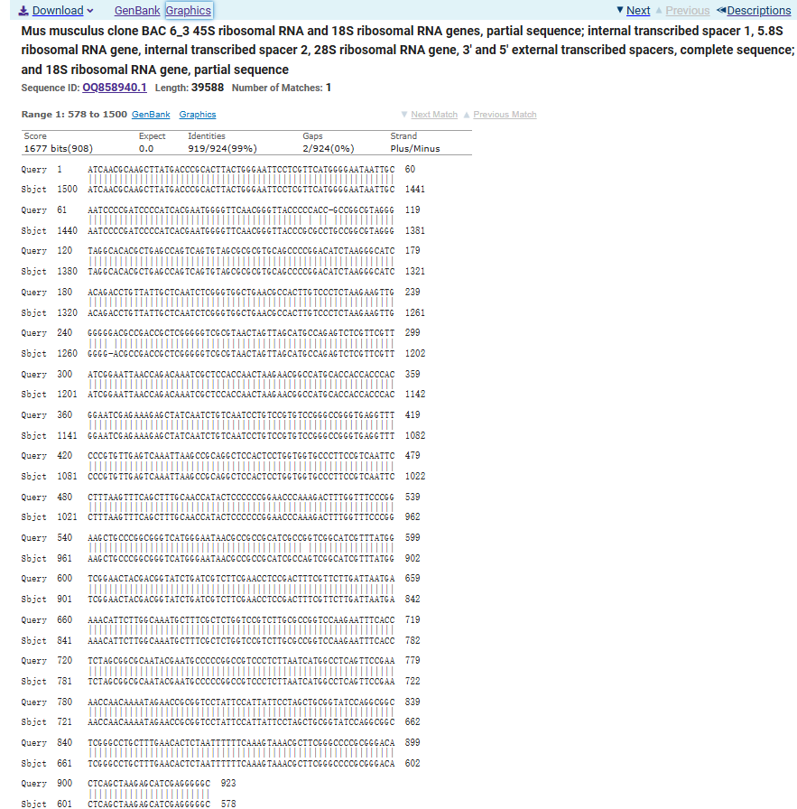

B
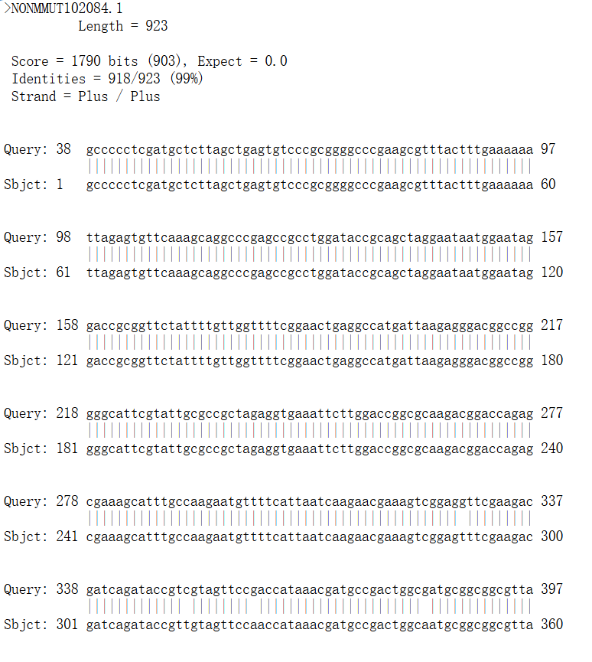
Supplementary Figure 2 The candidate lncRNA ENST00000629969 is highly expressed in hUC-MSC-derived exosomes. Transcriptome sequencing analysis of exosomes derived from human umbilical cord mesenchymal stem cells (hUC-MSCs) reveals the expression level of lncRNA ENST00000629969 is among the highest of all 1058 detected lncRNAs.
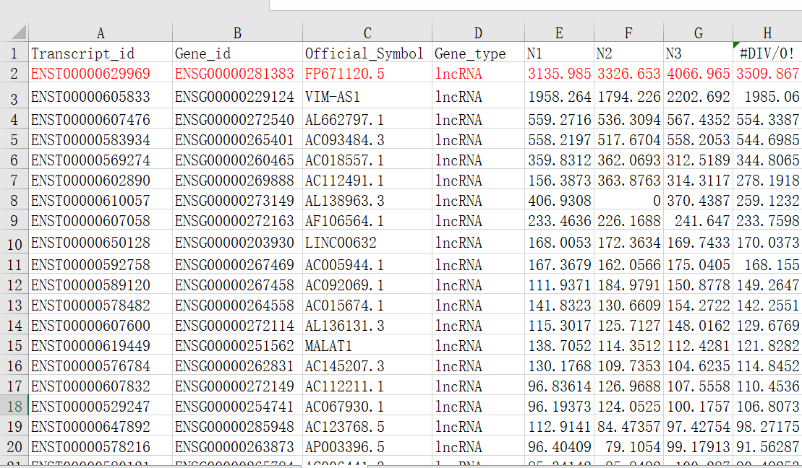
Supplementary Figure 3 lncRNA-0021 expression is upregulated in APP/PS1 mice after exosome treatment. Relative expression levels of lncRNA-0021 in the hippocampus of APP/PS1 mice, as determined by RNA-seq, showing a significant increase in the exosome-injected group compared to the APP/PS1 control group.
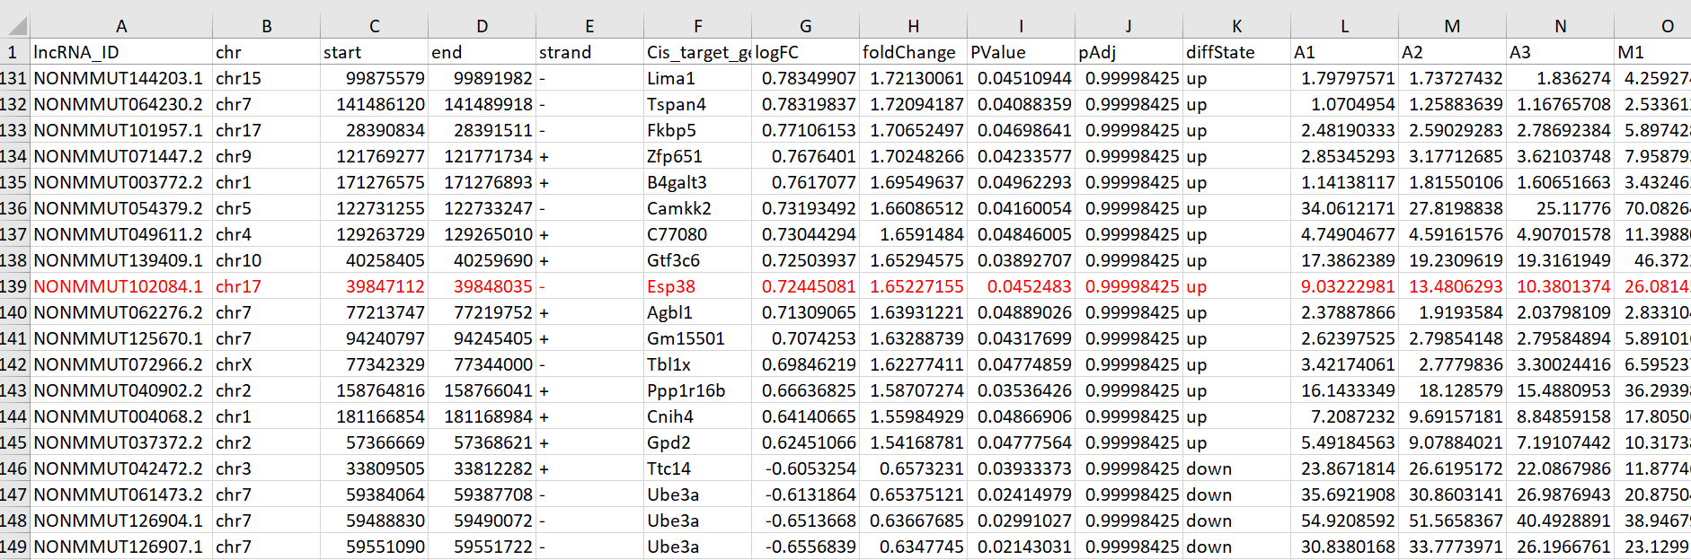Supplementary Figure 4 lncRNA-0021 exhibits high complementarity with miR-6361. Bioinformatic prediction using the lncRNAsnp2 platform identifies miR-6361 as the top candidate miRNA that may interact with lncRNA-0021, suggesting a potential ceRNA mechanism in Alzheimer's disease.
