Supplementary Table 1 Characteristics of CDR sum of boxes and MoCA scores used in analyses examining associations with global cognition and functional performance
 | All participants | CN | MCI | P†
Baseline MoCA score, mean (SD) | 26.72 (2.73) (n = 173) | 27.75 (1.97) (n = 122) | 24.27 (2.74) (n = 51) | <0.0001*
MoCA score follow-up duration in months, median (IQR)‡ | 16.00 (8.25) (n = 77) | 17.00 (9.75) (n = 55) | 14.00 (5.00) (n = 22) | 0.0048*
Number of MoCA score follow-up visits (1/2 visits) | 56/21 | 37/18 | 19/3 | 0.0893
Baseline CDR SOB, mean (SD) | 0.45 (0.85) (n = 175) | 0.10 (0.30) (n = 125) | 1.32 (1.12) (n = 50) | <0.0001*
CDR SOB follow-up duration in months, median (IQR)‡ | 16.50 (8.00) (n = 80) | 17.00 (10.00) (n = 57) | 14.00 (4.75) (n = 23) | 0.0057*
Number of CDR SOB follow-up visits (1/2 visits) | 56/24 | 37/20 | 19/4 | 0.1180
CDR SOB = Clinical Dementia Rating sum of boxes; MoCA = Montreal Cognitive Assessment; CN = cognitively normal; MCI = mild cognitive impairment; SD = standard deviation; IQR = interquartile range.
†P-values for group differences between CN and MCI. Group differences in continuous variables were assessed using non-parametric Wilcoxon rank sum tests, while group differences in categorical variables were assessed using chi-squared tests.
‡Only follow-up visits with MoCA or CDR SOB scores at least six months from baseline were considered.
*P < 0.05

Supplementary Table 2 Extent of contribution of each region to the MBI-related functional network phenotype derived from the partial least squares correlation analysis
Network | Region | Extent of contribution
Control | LH lateral ventral prefrontal cortex | 134.33
Control | RH inferior parietal lobule | 131.57
Control | RH temporal cortex | 131.35
Salience/ventral attention | RH medial frontal cortex | 127.79
Salience/ventral attention | LH medial frontal cortex | 116.44
Salience/ventral attention | RH lateral ventral prefrontal cortex | 110.99
Salience/ventral attention | RH inferior parietal lobule | 108.14
Salience/ventral attention | RH lateral prefrontal cortex | 107.08
Control | LH dorsal prefrontal cortex | 105.08
Default | RH precuneus posterior cingulate cortex | 104.50
Default | RH medial prefrontal cortex | 100.32
Dorsal attention | RH precentral ventral gyrus | 99.77
Salience/ventral attention | RH parietal operculum | 98.32
Default | RH retrosplenial cortex | 97.19
Default | LH dorsal prefrontal cortex | 96.99
Salience/ventral attention | RH posterior insula/frontal operculum | 95.47
Default | LH retrosplenial cortex | 95.09
Default | LH medial prefrontal cortex | 92.96
Control | LH inferior parietal lobule | 92.41
Control | RH lateral ventral prefrontal cortex | 90.79
Default | LH inferior parietal lobule | 88.73
Salience/ventral attention | RH dorsal prefrontal cortex | 87.48
Dorsal attention | RH superior parietal lobule | 87.39
Dorsal attention | LH precentral ventral gyrus | 86.44
Default | RH temporal cortex | 86.26
Salience/ventral attention | LH posterior insula | 85.21
Dorsal attention | RH post central gyrus | 83.01
Dorsal attention | RH temporal occipital cortex | 82.98
Salience/ventral attention | LH lateral prefrontal cortex | 81.87
Salience/ventral attention | LH parietal operculum | 81.35
Visual | LH striate cortex | 80.07
Default | RH dorsal prefrontal cortex | 78.33
Visual | RH striate calcarine cortex | 78.08
Default | LH temporal cortex | 77.49
Control | RH lateral dorsal prefrontal cortex | 76.22
Somatomotor | RH primary somatosensory cortex | 76.11
Control | LH lateral prefrontal cortex | 75.90
Somatomotor | RH central sulcus | 75.75
Salience/ventral attention | RH precentral gyrus | 74.95
Somatomotor | LH central sulcus | 74.63
Somatomotor | LH primary somatosensory cortex | 73.11
Salience/ventral attention | LH posterior insula/frontal operculum | 72.53
Default | RH temporal cortex | 72.05
Default | RH parahippocampal cortex | 70.99
Visual | LH striate calcarine cortex | 70.61
Control | LH lateral ventral prefrontal cortex | 69.97
Control | LH temporal cortex | 69.15
Dorsal attention | LH temporal occipital cortex | 67.92
Salience/ventral attention | RH posterior insula | 67.36
Subcortical | RH thalamus | 66.58
Salience/ventral attention | LH inferior parietal lobule | 65.60
Subcortical | RH thalamus | 64.20
Default | LH precuneus posterior cingulate cortex | 62.53
Limbic | LH orbital frontal cortex | 62.08
Subcortical | LH hippocampus | 60.27
Default | RH anterior temporal cortex | 59.98
Default | LH dorsal prefrontal cortex | 58.04
Default | LH parahippocampal cortex | 57.64
Salience/ventral attention | RH anterior cingulate sulcus | 57.52
Default | RH inferior parietal lobule | 56.73
Temporoparietal | RH temporoparietal junction | 55.82
Visual | RH extrastriate cortex | 55.61
Visual | RH inferior extrastriate cortex | 55.18
Control | RH temporal cortex | 54.92
Visual | LH inferior extrastriate cortex | 54.65
Control | LH temporal cortex | 54.32
Dorsal attention | RH frontal eye fields | 53.08
Somatomotor | LH secondary somatosensory cortex | 52.62
Control | RH dorsal prefrontal cortex | 52.53
Subcortical | RH hippocampus | 52.26
Subcortical | RH striatum | 51.87
Subcortical | RH thalamus | 51.52
Subcortical | LH amygdala | 51.34
Salience/ventral attention | LH anterior insula | 49.66
Control | RH posterior cingulate cortex | 49.23
Subcortical | LH thalamus | 49.00
Default | LH inferior parietal lobule | 48.16
Control | RH mid-cingulate cortex | 48.13
Limbic | RH orbital frontal cortex | 47.78
Dorsal attention | LH frontal eye fields | 47.27
Default | LH lateral prefrontal cortex | 46.99
Control | RH medial posterior prefrontal cortex | 46.91
Salience/ventral attention | RH midcingulate/medial parietal cortex | 45.88
Subcortical | RH thalamus | 45.78
Somatomotor | LH auditory cortex | 45.53
Visual | LH extrastriate cortex | 45.26
Subcortical | RH thalamus | 44.98
Subcortical | LH thalamus | 44.72
Default | RH inferior parietal lobule | 44.44
Visual | RH striate cortex | 43.42
Subcortical | RH amygdala | 42.78
Control | LH intraparietal sulcus | 42.66
Subcortical | RH striatum | 41.71
Subcortical | LH striatum | 41.46
Somatomotor | RH auditory cortex | 40.80
Default | RH dorsal prefrontal cortex | 39.93
Dorsal attention | LH parietal occipital cortex | 38.57
Temporoparietal | LH temporoparietal junction | 37.25
Salience/ventral attention | LH midcingulate/medial parietal cortex | 36.38
Control | RH lateral prefrontal cortex | 35.17
Subcortical | LH striatum | 33.95
Subcortical | RH striatum | 33.28
Dorsal attention | RH parietal occipital cortex | 32.59
Subcortical | LH thalamus | 32.48
Control | LH mid-cingulate cortex | 32.03
Visual | LH superior extrastriate cortex | 31.99
Dorsal attention | RH temporal occipital cortex | 31.83
Control | LH dorsal prefrontal cortex | 31.82
Limbic | LH temporal pole | 31.61
Control | LH medial posterior prefrontal cortex | 31.17
Subcortical | LH thalamus | 30.65
Subcortical | LH striatum | 30.05
Limbic | RH temporal pole | 29.58
Visual | RH superior extrastriate cortex | 28.34
Dorsal attention | LH temporal occipital cortex | 28.15
Salience/ventral attention | RH anterior insula | 27.76
Salience/ventral attention | LH orbital frontal cortex | 27.25
Salience/ventral attention | LH dorsal prefrontal cortex | 26.41
Salience/ventral attention | RH medial posterior prefrontal cortex | 26.07
Somatomotor | RH insular cortex | 25.97
Subcortical | LH thalamus | 25.30
Default | RH ventral prefrontal cortex | 23.84
Somatomotor | RH secondary somatosensory cortex | 23.66
Salience/ventral attention | LH medial posterior prefrontal cortex | 23.58
Dorsal attention | LH post central gyrus | 23.52
Dorsal attention | LH superior parietal lobule | 23.52
Default | LH ventral prefrontal cortex | 22.85
Subcortical | RH striatum | 22.72
Subcortical | RH thalamus | 22.63
Control | LH lateral prefrontal cortex | 21.70
Subcortical | RH striatum | 21.09
Default | LH inferior parietal lobule | 20.39
Subcortical | RH striatum | 19.68
Control | LH precuneus | 18.59
Subcortical | RH thalamus | 18.58
Subcortical | LH striatum | 17.50
Subcortical | RH striatum | 17.37
Control | LH posterior cingulate cortex | 15.15
Control | RH intraparietal sulcus | 13.33
Subcortical | LH striatum | 13.00
Somatomotor | LH insular cortex | 12.20
Subcortical | LH thalamus | 9.27
Control | RH precuneus | 6.92
Subcortical | LH thalamus | 2.00
RH = right hemisphere; LH = left hemisphere.
Supplementary Table 3 Similarity between the FC dysfunction patterns from the univariate analyses and the FC dysfunction pattern derived from partial least squares correlation analysis
Univariate analysis | Cosine similarity | P
Effect of MBI-C total score on FC | 0.8341 | <0.0001*
Effect of MBI diagnosis on FC | 0.6880 | <0.0001*
Effect of MBI-C abnormal perception score on FC | 0.2430 | <0.0001*
Effect of MBI-C decreased motivation score on FC | 0.4940 | <0.0001*
Effect of MBI-C emotional dysregulation score on FC | 0.7097 | <0.0001*
Effect of MBI-C impulse dyscontrol score on FC | 0.6844 | <0.0001*
Effect of MBI-C social inappropriateness score on FC | 0.3043 | <0.0001*
FC = functional connectivity; MBI-C = Mild Behavioural Impairment Checklist.
*P < 0.05

Supplementary Table 4 Coefficient estimates for the effects of connectome score and connectome score × temporal meta-ROI tau SUVR on the longitudinal rate of change in MoCA score in amyloid-positive and amyloid-negative groups separately
Measure | Predictor | n | Coefficient | SE | t | P
Amyloid-positive group
Rate of change in MoCA score | Connectome score | 25 | -6.70e⁻³ | 2.92e-3 | -2.30 | 0.0356*
Rate of change in MoCA score | Connectome score × tau SUVR |  | 1.23e⁻² | 1.52e-2 | 0.81 | 0.4297
Amyloid-negative group
Rate of change in MoCA score | Connectome score | 52 | 4.66e⁻³ | 1.82e-3 | 2.56 | 0.0141*
Rate of change in MoCA score | Connectome score × tau SUVR |  | 3.29e⁻² | 3.46e-2 | 0.95 | 0.3470
ROI = region-of-interest; SUVR = standardized uptake value ratio; MoCA = Montreal Cognitive Assessment; SE = standard error.
*P < 0.05

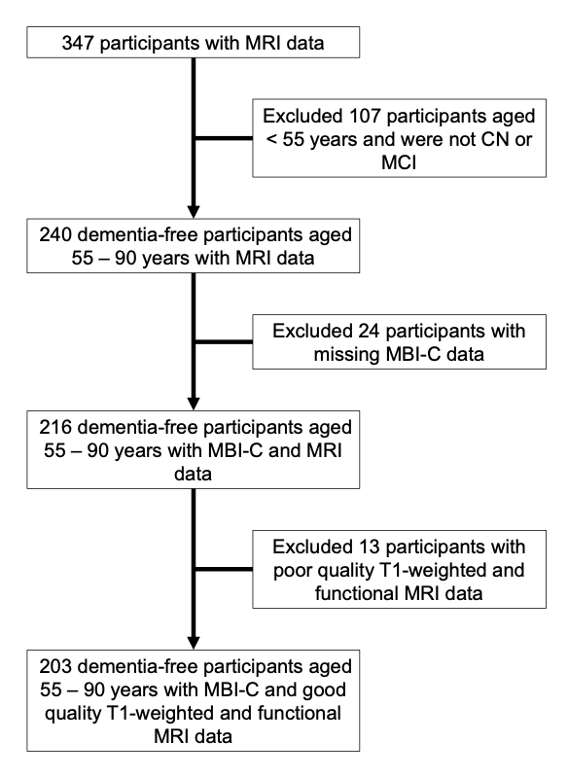
Supplementary Figure 1: Participant flowchart. Flowchart illustrates how participants were selected for inclusion in this study. CN = cognitively normal; MCI = mild cognitive impairment; MBI-C = Mild Behavioural Impairment Checklist.
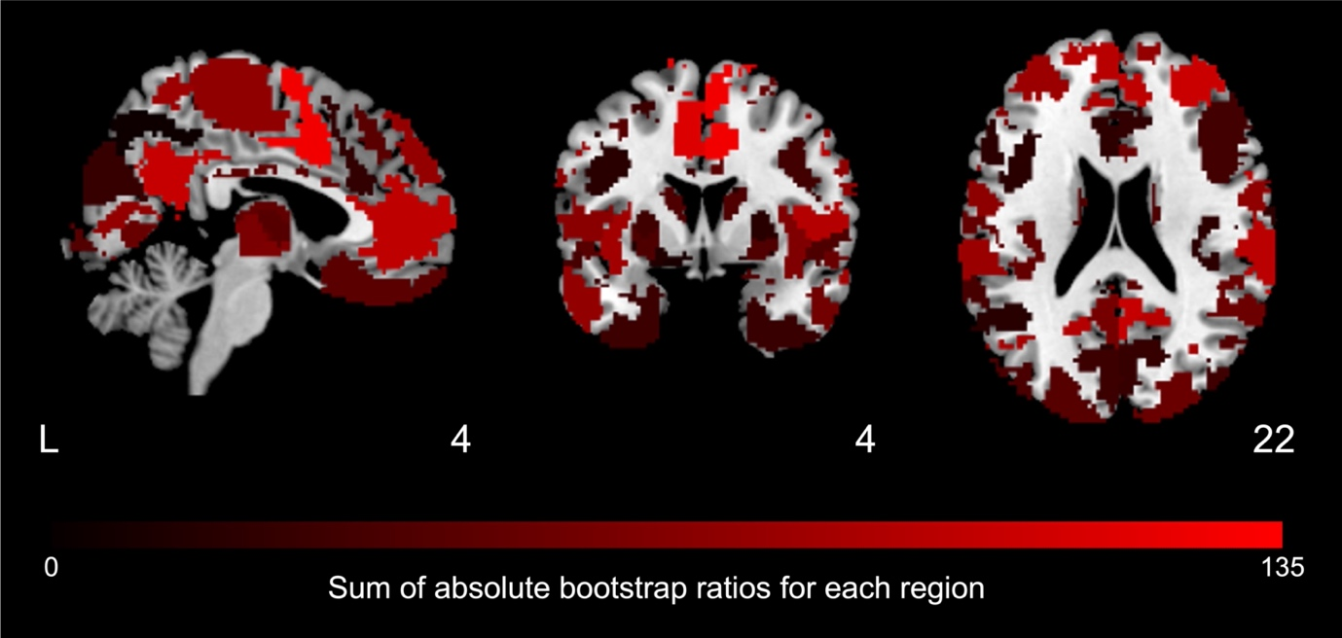
Supplementary Figure 2. Extent of contribution of each region to the MBI-related functional network phenotype derived from the partial least squares correlation analysis. The extent to which each region contributed to the MBI-related network phenotype, calculated as the sum of the absolute bootstrap ratio values across all functional connections associated with each region, is overlaid on a brain template in Montreal Neurological Institute (MNI) 152 space. Brighter colour indicates greater contribution, while darker colour indicates lower contribution to the MBI-related network phenotype. MBI = mild behavioural impairment.

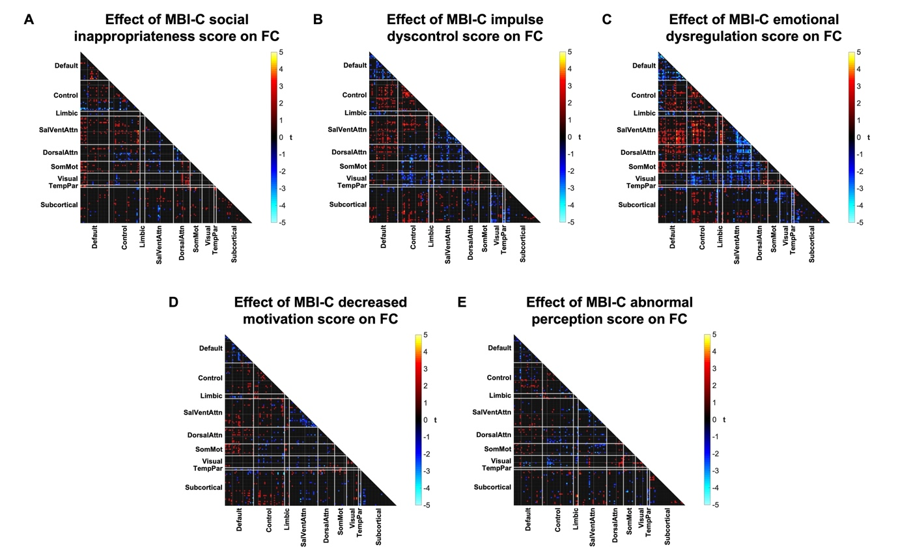
Supplementary Figure 3: MBI-C subdomain scores are associated with similar patterns of whole-brain FC dysfunction. FC matrices display the T-scores of functional connections showing significant (uncorrected P < 0.05) associations (hot colour: positive association; cool colour: negative association) with (A) MBI-C social appropriateness score, (B) MBI-C impulse dyscontrol score, (C) MBI-C emotional dysregulation score, (D) MBI-C decreased motivation score, and (E) MBI-C abnormal perception score. Higher scores across all MBI-C subdomains were linked to whole-brain FC disruptions similar to the pattern observed in the partial least squares correlation analyses examining multivariate associations between MBI-C subdomain scores and FC. In particular, emotional dysregulation showed the strongest influence on whole-brain FC, followed by impulse dyscontrol and then decreased motivation, mirroring the contributions of the MBI-C subdomains to the latent variable identified in the partial least squares correlation. MBI-C = Mild Behavioural Impairment Checklist; FC = functional connectivity; SalVentAttn = salience/ventral attention; DorsalAttn = dorsal attention; SomMot = somatomotor; TempPar = temporoparietal.

