Supplementary materials
Defining physical activity sessions at varying cadence thresholds
To validate our chosen session cadence threshold of ≥40 steps/min, and to understand how engagement in physical activity sessions differed depending on the cadence threshold used, we iteratively tested different definitions of physical activity sessions using minimum cadence thresholds of 60, 80, 100 and 120 steps/min (i.e., at least 10 minutes where step cadence ≥60 steps/min, and so on). ANCOVAs compared cognitive and neuroimaging outcomes in participants who did and did not engage in at least one physical activity session defined by these different thresholds.
These analyses revealed that when the cadence threshold for defining a physical activity session was incrementally increased (i.e., from 40 to 60 steps/min and so on; Table S1), the association between physical activity sessions and lower WMH burden persisted regardless of threshold, though this relationship weakened at the highest cadence threshold of 120 steps/min. The relationship between engagement in sessions and global FA was not significant at lower cadence thresholds (40-80 steps/min), but showed a significant positive effect when sessions were defined with higher cadence thresholds of 100 and 120 steps/min. In addition, there was only a significant positive relationship between engagement in sessions and medial temporal lobe volume when sessions were defined at the highest cadence threshold of 120 steps/min. There was no statistically significant relationship between engagement in sessions at any cadence threshold for memory (all p >0.346), executive function (all p >0.133), processing speed (all p >0.447) or frontal lobe volume (all p >0.111).

Table S1
Differential relationships between engagement in physical activity sessions with brain health outcomes at varying session cadence thresholds
 | Physical activity session cadence threshold (steps/min)
 | Cadence = 40 | Cadence = 60 | Cadence = 80 | Cadence = 100 | Cadence = 120
Memory  (n = 197) | n(S) = 150  M(diff) = 0.076  ηp² = 0.004  p = 0.793 | n(S) = 138  M(diff) = 0.080  ηp² = 0.001  p = 0.806 | n(S) = 121  M(diff) = 0.161  ηp² = 0.008  p = 0.346 | n(S) = 65  M(diff) = 0.163  ηp² = < 0.001  p = 0.680 | n(S) = 20  M(diff) = 0.304  ηp² = 0.008  p = 0.361
Executive function  (n = 266) | n(S) = 212  M(diff) = 0.158  ηp² = 0.004  p = 0.687 | n(S) = 200  M(diff) = 0.133  ηp² = 0.004  p = 0.791 | n(S) = 176  M(diff) = 0.148  ηp² = 0.008  p = 0.555 | n(S) = 113  M(diff) = 0.355  ηp² = 0.025  p = 0.133 | n(S) = 39  M(diff) = 0.302  ηp² = 0.012  p = 0.202
Processing  speed (n = 203) | n(S) = 156  M(diff) = -0.019  ηp² = < 0.001  p = 0.842 | n(S) = 147  M(diff) = 0.088  ηp² = < 0.001  p = 0.917 | n(S) = 132  M(diff) = -0.191  ηp² = 0.006  p = 0.447 | n(S) = 68  M(diff) = -0.137  ηp² = 0.001  p = 0.759 | n(S) = 21  M(diff) = -0.077  ηp² = < 0.001  p = 0.498
MTL volume  (n = 182) | n(S) = 147  M(diff) = 607.64  ηp² = 0.108  p = 0.228 | n(S) = 139  M(diff) = 517.25  ηp² = 0.094  p = 0.384 | n(S) = 123  M(diff) = 309.42  ηp² = 0.044  p = 0.351 | n(S) = 92  M(diff) = 222.80  ηp² = 0.009  p = 0.703 | n(S) = 28  M(diff) = 348.34  ηp² = 0.063  p = 0.022
Frontal lobe volume (n = 182) | n(S) = 147  M(diff) = 4432.44  ηp² = 0.121  p = 0.121 | n(S) = 139  M(diff) = 3261.28  ηp² = 0.080  p = 0.647 | n(S) = 123  M(diff) = 2844.48  ηp² = 0.071  p = 0.111 | n(S) = 92  M(diff) = 1739.79  ηp² = 0.014  p = 0.792 | n(S) = 28  M(diff) = -508.05  ηp² = < 0.001  p = 0.848
Total WMH burden* (n = 162) | n(S) = 130  M(diff) = -0.913  ηp² = 0.126  p = 0.005 | n(S) = 123  M(diff) = -0.757  ηp² = 0.096  p = 0.011 | n(S) = 110  M(diff) = -0.833  ηp² = 0.138  p = 0.001 | n(S) = 82  M(diff) = -0.817  ηp² = 0.134  p = 0.005 | n(S) = 26  M(diff) = -0.313  ηp² = 0.045  p = 0.207
Global FA  (n = 149) | n(S) = 116  M(diff) = 0.005  ηp² = 0.009  p = 0.139 | n(S) = 108  M(diff) = 0.002  ηp² = 0.002  p = 0.237 | n(S) = 96  M(diff) = 0.005  ηp² = 0.014  p = 0.135 | n(S) = 66  M(diff) = 0.017  ηp² = 0.099  p = 0.005 | n(S) = 21  M(diff) = 0.017  ηp² = 0.106  p = 0.003

ANCOVA analyses controlled for age, sex, education and total intracranial volume where appropriate. n(S): number of participants who engaged in at least one session defined with the cadence threshold criteria; M(diff): mean group difference. Positive difference values indicate higher values in participants who engaged in sessions compared to those who did not. *Total WMH burden values were log transformed due to distribution skew. Statistically significant group differences (p<0.05) are shaded in grey.

Table S2
Linear regression analyses between PA features and brain health outcomes
 | Medial temporal lobe volume |  |  | Frontal lobe volume
Predictor | β (SE) | p | p^{FDR} | β (SE) | p | p^{FDR}
Daily out-of-session steps | 0.12 (0.05) | 0.023 | 0.059 | 0.10 (0.05) | 0.063 | 0.219
Daily in-session steps | 0.11 (0.06) | 0.035 | 0.059 | 0.02 (0.05) | 0.759 | 0.759
Daily vigorous out-of-session steps | 0.07 (0.05) | 0.201 | 0.235 | 0.05 (0.05) | 0.350 | 0.490
Daily vigorous in-session steps | 0.13 (0.05) | 0.008 | 0.059 | 0.07 (0.05) | 0.120 | 0.280
Avg session duration | 0.05 (0.05) | 0.329 | 0.329 | 0.07 (0.05) | 0.215 | 0.377
Avg session cadence | 0.12 (0.06) | 0.042 | 0.059 | 0.12 (0.06) | 0.047 | 0.219
Avg session frequency | 0.13 (0.06) | 0.030 | 0.059 | 0.03 (0.06) | 0.605 | 0.706
 | Total WMH burden* |  |  | Global fractional anisotropy
Daily out-of-session steps | -0.08 (0.06) | 0.177 | 0.206 | 0.06 (0.08) | 0.466 | 0.543
Daily in-session steps | -0.12 (0.06) | 0.031 | 0.054 | 0.22 (0.08) | 0.009 | 0.030
Daily vigorous out-of-session steps | -0.04 (0.05) | 0.416 | 0.416 | -0.04 (0.12) | 0.734 | 0.734
Daily vigorous in-session steps | -0.09 (0.05) | 0.074 | 0.103 | 0.18 (0.07) | 0.013 | 0.030
Avg session duration | -0.17 (0.06) | 0.006 | 0.040 | 0.22 (0.08) | 0.006 | 0.030
Avg session cadence | -0.15 (0.06) | 0.019 | 0.054 | 0.20 (0.08) | 0.019 | 0.034
Avg session frequency | -0.14 (0.06) | 0.029 | 0.054 | 0.16 (0.08) | 0.065 | 0.091
 | Memory |  |  | Executive function
Daily out-of-session steps | 0.13 (0.07) | 0.083 | 0.193 | 0.01 (0.06) | 0.818 | 0.818
Daily in-session steps | 0.09 (0.08) | 0.279 | 0.488 | 0.21 (0.06) | <0.001 | 0.001
Daily vigorous out-of-session steps | 0.27 (0.11) | 0.015 | 0.108 | 0.12 (0.06) | 0.039 | 0.054
Daily vigorous in-session steps | 0.18 (0.08) | 0.036 | 0.126 | 0.20 (0.05) | <0.001 | 0.001
Avg session duration | 0.05 (0.07) | 0.501 | 0.585 | 0.08 (0.06) | 0.196 | 0.229
Avg session cadence | 0.05 (0.08) | 0.497 | 0.585 | 0.18 (0.06) | 0.006 | 0.010
Avg session frequency | 0.02 (0.08) | 0.809 | 0.809 | 0.18 (0.06) | 0.003 | 0.007
 | Spatial info processing speed
Daily out-of-session steps | -0.04 (0.07) | 0.624 | 0.728
Daily in-session steps | -0.09 (0.08) | 0.235 | 0.412
Daily vigorous out-of-session steps | -0.20 (0.10) | 0.047 | 0.155
Daily vigorous in-session steps | -0.13 (0.07) | 0.056 | 0.155
Avg session duration | -0.02 (0.07) | 0.785 | 0.785
Avg session cadence | -0.15 (0.08) | 0.066 | 0.155
Avg session frequency | -0.06 (0.07) | 0.391 | 0.547
Each model statistic was obtained from the result of a separate linear regression analysis examining the relationship between a single predictor and the outcome. Models covaried for age and sex (all outcomes), education (cognitive outcomes) and total intracranial volume (neuroimaging outcomes). p values are presented with and without false discovery rate (FDR) correction. Bolded p values represent statistical significance of p < 0.05. *Total WMH burden values were log transformed due to distribution skew.

Table S3
Coefficient rankings from ridge regression models excluding interaction terms

WMH burden | Global FA | MTL volume
Model R² = 0.042, MAE = 0.688  Feature ranking:  - Session frequency  - Session cadence  - Session duration  - In-session vig steps  - Out-of-session vig steps  - Total in-session steps  - Total out-of-session steps | Model R² = 0.107, MAE = 0.652  Feature ranking:  - Session cadence  - Session duration  - Session frequency  - Out-of-session vig steps  - In-session vig steps  - Total in-session steps  - Total out-of-session steps | Model R² = 0.050, MAE = 0.766  Feature ranking:  - Session frequency  - Session cadence  - Session duration  - Out-of-session vig steps  - In-session vig steps  - Total in-session steps  - Total out-of-session steps
Frontal volume | Executive Function | Memory
Model R² = 0.038, MAE = 0.799  Feature ranking:  - Session cadence  - Session duration  - Session frequency  - Out-of-session vig steps  - In-session vig steps  - Total out-of-session steps  - Total in-session steps | Model R² = 0.077, MAE = 0.519  Feature ranking:  - Session frequency  - Session cadence  - Session duration  - Out-of-session vig steps  - In-session vig steps  - Total in-session steps  - Total out-of-session steps | Model R² = 0.056, MAE = 0.609  Feature ranking:  - Session frequency  - Session duration  - Out-of-session vig steps  - Session cadence  - In-session vig steps  - Total out-of-session steps  - Total in-session steps
Processing speed
Model R² = 0.029, MAE = 0.773
Feature ranking:
- Session frequency
- Session cadence
- Session duration
- Out-of-session vig steps
- In-session vig steps
- Total in-session steps
- Total out-of-session steps
In sensitivity analyses, each ridge regression model was run with only the seven core physical activity features excluding interaction terms with age and sex. Vig: vigorous
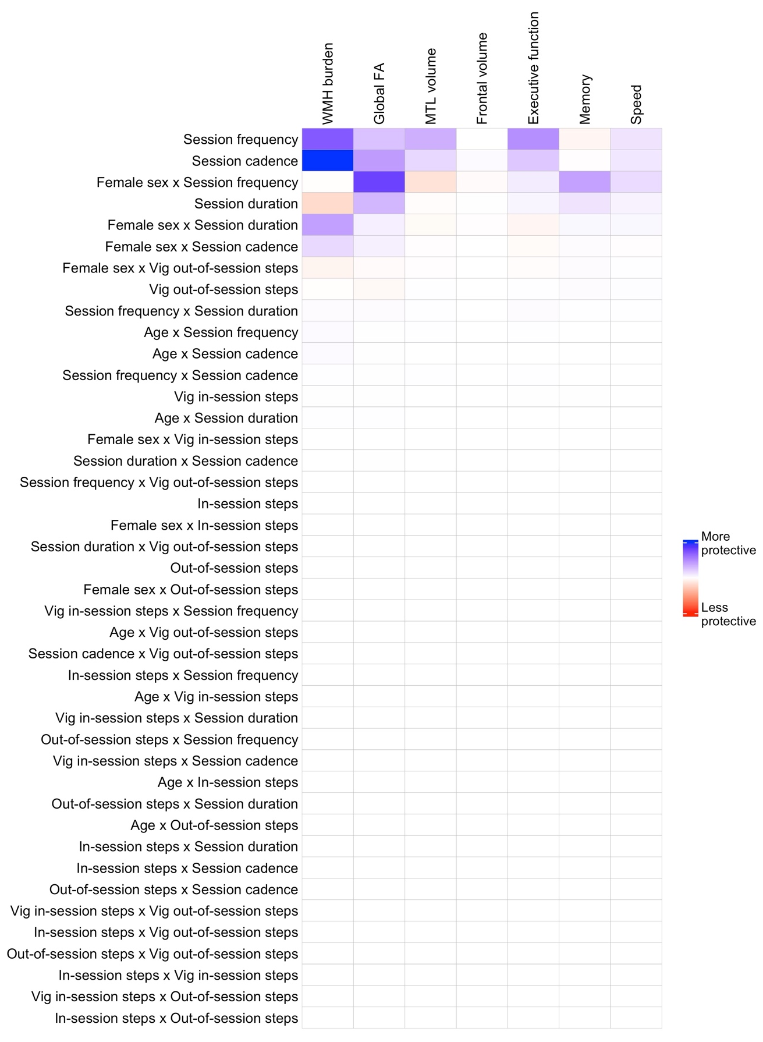

Figure S1. A full heat map of standardized coefficients from ridge regression models examining the importance of PA features on brain health outcomes in exercisers. Numerical standardized coefficient values are uninterpretable in ridge regression models due to regularization and are therefore not presented. Instead, the strength of standardized coefficients is interpretable relative to other coefficients in the model (i.e. rank order). Rows of the heatmap are ordered to reflect the average importance ranking of PA session features across outcomes in descending order (top to bottom). Outcomes were pre-adjusted for demographic covariates including age, sex, education and total intracranial volume. WMH: white matter hyperintensity; FA: fractional anisotropy; Vig: vigorous.

