Supplementary Materials
Supplementary Figure 1. Flow diagram for study participants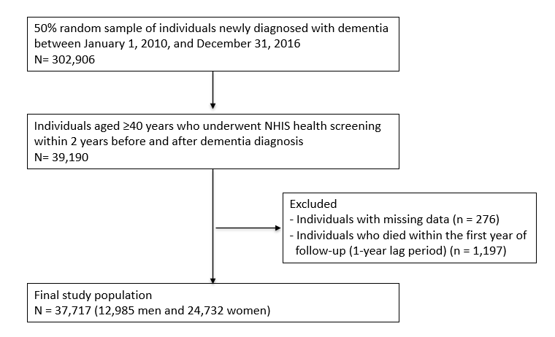

Supplementary Figure 2. Kaplan-Meier curves for association between BMI status after dementia diagnosis and all-cause mortality (A) All-cause dementia, B) Alzheimer’s disease, C) Vascular dementia)
Abbreviations: BMI, body mass index
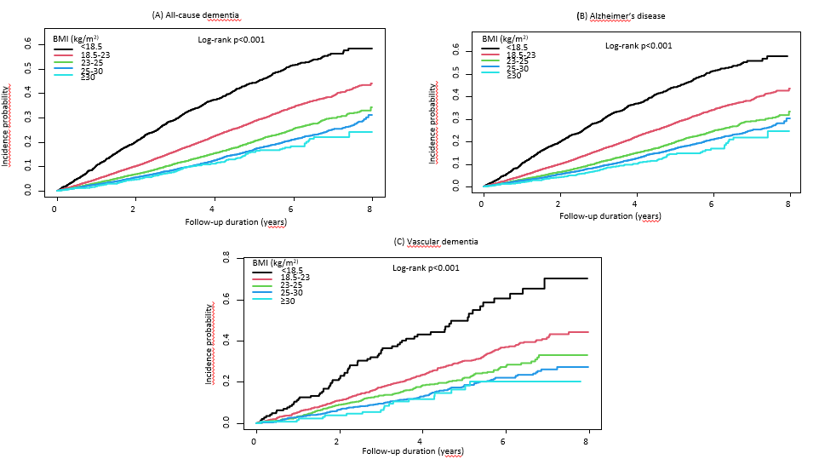

Supplementary Figure 3. Associations between body mass index and all-cause mortality risk using cubic splines (A) all-cause dementia, B) Alzheimer’s disease, and C) vascular dementia)
Abbreviations: BMI, body mass index; HR, hazard ratio.
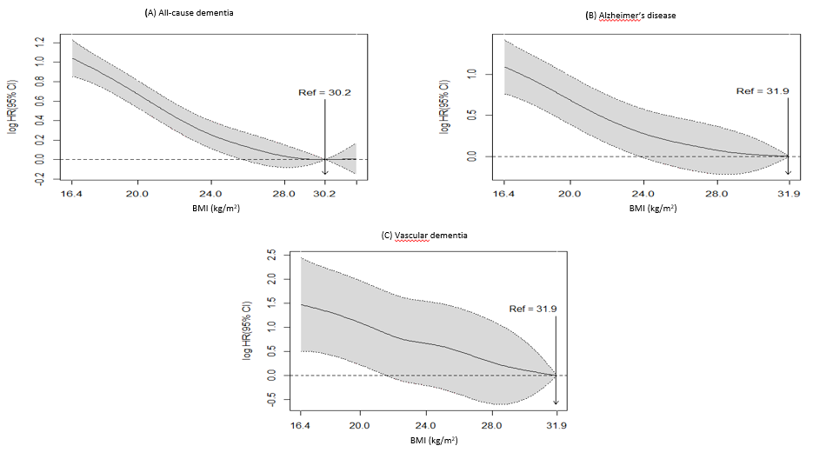
Supplementary Figure 4. Associations between body mass index change rate and all-cause mortality risk using cubic splines (A) all-cause dementia, B) Alzheimer’s disease, and C) vascular dementia)
Abbreviations: BMI, body mass index; HR, hazard ratio.
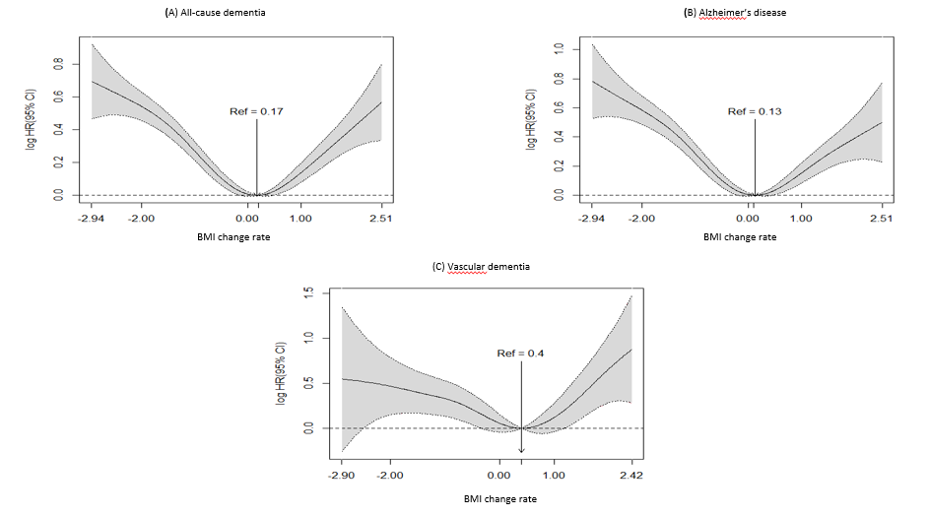
Supplementary Table 1. Baseline characteristics of excluding participants
 | Excluding participants
N | 265,189
Sex (men) | 82,340 (31.1)
Residential area (urban) | 98,460 (37.1)
Income (low) | 83,846 (31.6)
Disability (yes) | 59,606 (22.5)
Type of dementia
Alzheimer’s disease | 212,220 (80.0)
Vascular dementia | 24,268 (9.2)
Others | 28,701 (10.8)
Number of anti-dementia medication
1 | 228,151 (86.0)
2 | 34,262 (12.9)
≥3 | 2776 (1.1)
Values are presented as numbers (percentages).

Supplementary Table 2. Associations between 16 groups in BMI changes before and after dementia diagnosis and all-cause mortality
16 groups in BMI changes | N | Event | Person–years | IRª | HR (95% CI)
 |  |  |  |  | Model 1^{b} | Model 2^{c} | Model 3^{d}
In all–cause dementia
Underweight Underweight | 979 | 388 | 3,503 | 110.8 | 1.79 (1.61–1.99) | 1.59 (1.43–1.77) | 1.60 (1.43–1.78)
Underweight Normal | 612 | 199 | 2,294 | 86.8 | 1.40 (1.21–1.61) | 1.33 (1.16–1.54) | 1.33 (1.15–1.54)
Underweight Overweight | 29 | 15 | 94 | 159.3 | 2.63 (1.58–4.37) | 2.15 (1.29–3.57) | 2.15 (1.30–3.58)
Underweight Obesity | 12 | 5 | 44 | 113.3 | 1.85 (0.77–4.44) | 1.52 (0.63–3.66) | 1.53 (0.64–3.68)
Normal Underweight | 1,095 | 446 | 3,860 | 115.5 | 1.87 (1.69–2.07) | 1.58 (1.43–1.75) | 1.58 (1.43–1.74)
Normal Normal | 10,873 | 2,736 | 43,558 | 62.8 | 1 (Ref.) | 1 (Ref.) | 1 (Ref.)
Normal Overweigh | 2,122 | 451 | 8,549 | 52.8 | 0.84 (0.76–0.93) | 0.91 (0.82–1.00) | 0.91 (0.82–1.00)
Normal Obesity | 416 | 109 | 1,575 | 69.2 | 1.11 (0.92–1.35) | 1.09 (0.90–1.32) | 1.07 (0.89–1.30)
Overweight Underweight | 71 | 42 | 216 | 194.9 | 3.18 (2.34–4.31) | 2.50 (1.84–3.39) | 2.47 (1.82–3.35)
Overweight Normal | 2,786 | 721 | 11,310 | 63.7 | 1.01 (0.93–1.10) | 1.00 (0.92–1.09) | 0.99 (0.91–1.08)
Overweight Overweight | 4,727 | 760 | 20,279 | 37.5 | 0.59 (0.55–0.64) | 0.67 (0.62–0.72) | 0.67 (0.61–0.72)
Overweight Obesity | 1,939 | 315 | 8,006 | 39.3 | 0.63 (0.56–0.70) | 0.70 (0.62–0.79) | 0.70 (0.62–0.784)
Obesity Underweight | 28 | 15 | 92 | 163.1 | 2.67 (1.61–4.43) | 1.97 (1.19–3.28) | 1.92 (1.16–3.20)
Obesity Normal | 657 | 232 | 2,502 | 92.7 | 1.48 (1.30–1.70) | 1.37 (1.20–1.57) | 1.34 (1.17–1.53)
Obesity Overweight | 2,281 | 476 | 9,576 | 49.7 | 0.79 (0.71–0.87) | 0.80 (0.73–0.89) | 0.80 (0.72–0.88)
Obesity Obesity | 9,090 | 1,289 | 38,561 | 33.4 | 0.53 (0.49–0.56) | 0.63 (0.59–0.68) | 0.63 (0.59–0.68)
In Alzheimer’s disease
Underweight Underweight | 791 | 291 | 2,856 | 101.9 | 1.67 (1.48–1.89) | 1.50 (1.32–1.69) | 1.50 (1.33–1.70)
Underweight Normal | 479 | 152 | 1,760 | 86.4 | 1.42 (1.21–1.68) | 1.35 (1.15–1.59) | 1.35 (1.15–1.59)
Underweight Overweight | 18 | 9 | 51 | 176.0 | 3.06 (1.59–5.90) | 2.86 (1.49–5.52) | 2.90 (1.51–5.59)
Underweight Obesity | 10 | 4 | 36 | 111.9 | 1.88 (0.70–5.00) | 1.66 (0.62–4.44) | 1.66 (0.62–4.43)
Normal Underweight | 886 | 367 | 3,045 | 120.5 | 2.00 (1.79–2.23) | 1.73 (1.55–1.93) | 1.72 (1.54–1.92)
Normal Normal | 8,714 | 2,129 | 34,596 | 61.5 | 1 (Ref.) | 1 (Ref.) | 1 (Ref.)
Normal Overweight | 1,659 | 334 | 6,703 | 49.8 | 0.81 (0.72–0.91) | 0.89 (0.80–1.00) | 0.89 (0.80–1.00)
Normal Obesity | 312 | 72 | 1,176 | 61.2 | 1.01 (0.80–1.27) | 0.98 (0.77–1.24) | 0.96 (0.76–1.22)
Overweight Underweight | 54 | 34 | 156 | 217.9 | 3.65 (2.60–5.12) | 2.98 (2.12–4.18) | 2.96 (2.11–4.15)
Overweight Normal | 2,188 | 542 | 8,774 | 61.8 | 1.00 (0.91–1.10) | 1.01 (0.92–1.11) | 1.00 (0.91–1.10)
Overweight Overweight | 3,813 | 609 | 16,188 | 37.6 | 0.61 (0.55–0.66) | 0.69 (0.63–0.75) | 0.68 (0.63–0.75)
Overweight Obesity | 1,542 | 245 | 6,310 | 38.8 | 0.63 (0.55–0.72) | 0.71 (0.62–0.81) | 0.71 (0.62–0.81)
Obesity Underweight | 23 | 12 | 71 | 169.2 | 2.84 (1.61– 5.01) | 1.79 (1.02–3.17) | 1.75 (0.99–3.098)
Obesity Normal | 524 | 179 | 1,996 | 89.7 | 1.46 (1.25–1.70) | 1.35 (1.16–1.57) | 1.32 (1.13–1.54)
Obesity Overweight | 1,759 | 350 | 7,407 | 47.3 | 0.76 (0.68–0.85) | 0.79 (0.70–0.88) | 0.78 (0.70–0.88)
Obesity Obesity | 7,210 | 1,001 | 30,214 | 33.1 | 0.54 (0.50–0.58) | 0.64 (0.59–0.69) | 0.64 (0.59–0.69)
In vascular dementia
Underweight Underweight | 63 | 34 | 219 | 155.1 | 2.46 (1.71– 3.52) | 2.36 (1.64–3.40) | 2.40 (1.66–3.45)
Underweight Normal | 36 | 13 | 128 | 101.9 | 1.65 (0.94–2.89) | 1.55 (0.88–2.72) | 1.53 (0.87–2.69)
Underweight Overweight | 4 | 1 | 20 | 49.8 | 0.77 (0.11–5.50) | 0.47 (0.07–3.36) | 0.46 (0.06–3.32)
Underweight Obesity | 1 | 1 | 2 | 459.1 | 8.39 (1.17–59.88) | 9.21 (1.28–66.35) | 9.76 (1.35–70.41)
Normal Underweight | 70 | 31 | 239 | 129.6 | 2.09 (1.44–3.05) | 1.63 (1.12–2.39) | 1.63 (1.11–2.38)
Normal Normal | 851 | 223 | 3,489 | 63.9 | 1 (Ref.) | 1 (Ref.) | 1 (Ref.)
Normal Overweight | 191 | 46 | 721 | 63.8 | 1.02 (0.74–1.39) | 0.99 (0.72–1.36) | 0.99 (0.72–1.36)
Normal Obesity | 45 | 19 | 163 | 116.9 | 1.86 (1.16–2.97) | 1.85 (1.16–2.97) | 1.80 (1.12–2.88)
Overweight Underweight | 6 | 3 | 18 | 164.5 | 2.71 (0.87–8.46) | 2.57 (0.82–8.08) | 2.44 (0.77–7.68)
Overweight Normal | 248 | 83 | 1,004 | 82.6 | 1.29 (1.00–1.65) | 1.15 (0.89–1.49) | 1.14 (0.88–1.47)
Overweight Overweight | 380 | 60 | 1,635 | 36.7 | 0.57 (0.43–0.76) | 0.65 (0.49–0.87) | 0.65 (0.48–0.86)
Overweight Obesity | 186 | 31 | 774 | 40.0 | 0.63 (0.43–0.92) | 0.62 (0.42–0.90) | 0.62 (0.42–0.90)
Obesity Underweight | 4 | 3 | 16 | 187.2 | 2.98 (0.95–9.32) | 5.23 (1.65–16.54) | 5.30 (1.68–16.77)
Obesity Normal | 51 | 17 | 178 | 95.3 | 1.53 (0.93–2.51) | 1.38 (0.84–2.27) | 1.34 (0.81–2.20)
Obesity Overweight | 233 | 59 | 947 | 62.3 | 0.98 (0.73–1.30) | 0.98 (0.73–1.31) | 0.96 (0.72–1.28)
Obesity Obesity | 851 | 125 | 3,732 | 33.5 | 0.52 (0.42–0.65) | 0.62 (0.49–0.77) | 0.62 (0.49–0.77)
Abbreviations: BMI, body mass index; IR, incidence rate; HR, hazard ratio; CI, confidence interval.
ªIncidence per 1000 person-years.
^{b}Model 1 was not adjusted for any variables.
^{c}Model 2 was adjusted for age, sex, place of residence, income, smoking status, alcohol consumption, physical activity, hypertension, type 2 diabetes, dyslipidemia, and chronic kidney disease.
^{d}Model 3 was adjusted for age, sex, place of residence, income, smoking status, alcohol consumption, physical activity, hypertension, type 2 diabetes, dyslipidemia, chronic kidney disease, disability, number of anti-dementia medications, and interval between two health screenings.

Supplementary Table 3. Sensitivity analysis of all-cause mortality by BMI status after dementia diagnosis, excluding all-cause mortality within 2, 3, and 5 years of follow-up.
BMI (kg/m²) | 2 years | 3 years | 5 years
In all-cause dementia
<18.5 | 1.41 (1.28–1.56) | 1.34 (1.17–1.52) | 1.29 (1.00–1.66)
18.5–22.9 | 1 (Ref.) | 1 (Ref.) | 1 (Ref.)
23.0–24.9 | 0.74 (0.69–0.80) | 0.75 (0.68–0.82) | 0.82 (0.70–0.97)
25.0–29.9 | 0.65 (0.60–0.70) | 0.68 (0.62–0.75) | 0.72 (0.61–0.85)
≥30.0 | 0.67 (0.54–0.82) | 0.67 (0.52–0.87) | 0.55 (0.32–0.95)
In Alzheimer’s disease
<18.5 | 1.44 (1.29–1.62) | 1.39 (1.20–1.61) | 1.30 (0.97–1.74)
18.5–22.9 | 1 (Ref.) | 1 (Ref.) | 1 (Ref.)
23.0–24.9 | 0.75 (0.69–0.81) | 0.76 (0.69–0.84) | 0.82 (0.68–0.99)
25.0–29.9 | 0.65 (0.60–0.71) | 0.69 (0.62–0.77) | 0.72 (0.60–0.88)
≥30.0 | 0.65 (0.51–0.83) | 0.68 (0.51–0.91) | 0.67 (0.38–1.21)
In vascular dementia
<18.5 | 2.07 (1.46–2.92) | 2.08 (1.34–3.25) | 3.01 (1.44–6.29)
18.5–22.9 | 1 (Ref.) | 1 (Ref.) | 1 (Ref.)
23.0–24.9 | 0.71 (0.55–0.90) | 0.69 (0.51–0.94) | 0.85 (0.50–1.44)
25.0–29.9 | 0.61 (0.47–0.78) | 0.63 (0.47–0.85) | 0.65 (0.39–1.09)
≥30.0 | 0.66 (0.38–1.16) | 0.72 (0.38–1.38) | 0.51 (0.12–2.11)
Abbreviations: BMI, body mass index.
Data are expressed as hazard ratios (95% confidence intervals) calculated using a multivariable Cox hazards regression model adjusted for age, sex, place of residence, income, smoking status, alcohol consumption, physical activity, hypertension, type 2 diabetes, dyslipidemia, chronic kidney disease, disability, and the number of anti-dementia medications.
Supplementary Table 4. Sensitivity analysis of all-cause mortality by changes in BMI status before and after dementia diagnosis, excluding all-cause mortality within 2, 3, and 5 years of follow-up.
Changes in BMI status | 2 years | 3 years | 5 years
In all-cause dementia
Underweight Underweight | 1.61 (1.40–1.86) | 1.54 (1.29–1.85) | 1.48 (1.05–2.10)
Underweight Normal or overweight | 1.41 (1.17–1.69) | 1.47 (1.18–1.84) | 1.72 (1.15–2.57)
Underweight Obesity | 2.24 (0.84–5.98) | 0.85 (0.12–6.01) | -
Normal or overweight Underweight | 1.52 (1.33–1.73) | 1.41 (1.19–1.68) | 1.33 (0.95–1.86)
Normal or overweight Normal or overweight | 1 (Ref.) | 1 (Ref.) | 1 (Ref.)
Normal or overweight Obesity | 0.85 (0.75–0.97) | 0.95 (0.82–1.10) | 1.03 (0.79–1.35)
Obesity Underweight | 1.93 (0.96–3.87) | 2.16 (0.97–4.82) | 3.65 (0.91–14.71)
Obesity Normal or overweight | 0.97 (0.87–1.07) | 0.95 (0.84–1.08) | 1.12 (0.89–1.39)
Obesity Obesity | 0.69 (0.64–0.75) | 0.72 (0.65–0.79) | 0.73 (0.61–0.86)
In Alzheimer’s disease
Underweight Underweight | 1.51 (1.29–1.78) | 1.43 (1.16–1.77) | 1.38 (0.92–2.07)
Underweight Normal or overweight | 1.42 (1.15–1.76) | 1.50 (1.16–1.95) | 2.05 (1.32–3.19)
Underweight Obesity | 2.49 (0.80–7.74) | 1.37 (0.19–9.71) | -
Normal or overweight Underweight | 1.66 (1.43–1.92) | 1.61 (1.33–1.95) | 1.51 (1.02–2.22)
Normal or overweight Normal or overweight | 1 (Ref.) | 1 (Ref.) | 1 (Ref.)
Normal or overweight Obesity | 0.80 (0.69–0.93) | 0.87 (0.73–1.04) | 1.06 (0.78–1.45)
Obesity Underweight | 1.67 (0.75–3.73) | 1.68 (0.63–4.49) | 2.00 (0.28–14.31)
Obesity Normal or overweight | 0.96 (0.85–1.08) | 0.92 (0.79–1.06) | 1.10 (0.85–1.43)
Obesity Obesity | 0.70 (0.64–0.77) | 0.74 (0.66–0.82) | 0.74 (0.61–0.91)
In vascular dementia
Underweight Underweight | 2.57 (1.58–4.19) | 2.94 (1.65–5.24) | 2.73 (0.96–7.78)
Underweight Normal or overweight | 1.57 (0.80–3.08) | 1.11 (0.41–3.02) | 1.49 (0.20–11.13)
Underweight Obesity | 125.39 (16.68–942.55) | - | -
Normal or overweight Underweight | 2.06 (1.30–3.28) | 1.61 (0.82–3.18) | 3.05 (1.07–8.68)
Normal or overweight Normal or overweight | 1 (Ref.) | 1 (Ref.) | 1 (Ref.)
Normal or overweight Obesity | 1.02 (0.72–1.45) | 1.01 (0.66–1.55) | 0.71 (0.28–1.80)
Obesity Underweight | 5.89 (1.44–24.04) | 6.93 (1.68–28.55) | 131.82 (14.90–1165.87)
Obesity Normal or overweight | 0.97 (0.69–1.35) | 0.93 (0.61–1.40) | 1.24 (0.62–2.46)
Obesity Obesity | 0.60 (0.46–0.78) | 0.64 (0.47–0.88) | 0.70 (0.41–1.18)
Abbreviations: BMI, body mass index.
Data are expressed as hazard ratios (95% confidence intervals) calculated using a multivariable Cox hazards regression model adjusted for age, sex, place of residence, income, smoking status, alcohol consumption, physical activity, hypertension, type 2 diabetes, dyslipidemia, chronic kidney disease, disability, the number of anti-dementia medications, and interval between two health screenings.

Supplementary Table 5. All-cause mortality during 1–3 and 3–5 years after dementia diagnosis by BMI status.
BMI (kg/m²) | 1–3 years | 3–5 years
In all-cause dementia
<18.5 | 1.61 (1.48–1.80) | 1.35 (1.16–1.57)
18.5–22.9 | 1 (Ref.) | 1 (Ref.)
23.0–24.9 | 0.73 (0.67–0.80) | 0.72 (0.64–0.80)
25.0–29.9 | 0.60 (0.55–0.66) | 0.67 (0.60–0.75)
≥30.0 | 0.68 (0.53–0.87) | 0.71 (0.54–0.95)
In Alzheimer’s disease
<18.5 | 1.62 (1.43–1.84) | 1.42 (1.20–1.68)
18.5–22.9 | 1 (Ref.) | 1 (Ref.)
23.0–24.9 | 0.73 (0.65–0.804) | 0.74 (0.65–0.83)
25.0–29.9 | 0.60 (0.54–0.67) | 0.68 (0.60–0.77)
≥30.0 | 0.60 (0.44–0.81) | 0.68 (0.49–0.96)
In vascular dementia
<18.5 | 1.82 (1.22–2.70) | 1.75 (1.00–3.06)
18.5–22.9 | 1 (Ref.) | 1 (Ref.)
23.0–24.9 | 0.90 (0.68–1.19) | 0.63 (0.43–0.91)
25.0–29.9 | 0.63 (0.46–0.87) | 0.65 (0.45–0.92)
≥30.0 | 0.51 (0.22–1.15) | 0.85 (0.41–1.77)
Abbreviations: BMI, body mass index.
Data are expressed as hazard ratios (95% confidence intervals) calculated using a multivariable Cox hazards regression model adjusted for age, sex, place of residence, income, smoking status, alcohol consumption, physical activity, hypertension, type 2 diabetes, dyslipidemia, chronic kidney disease, disability, and the number of anti-dementia medications.
Supplementary Table 6. All-cause mortality during 1–3 and 3–5 years after dementia diagnosis by changes in BMI status before and after dementia diagnosis.
Changes in BMI status | 1–3 years | 3–5 years
In all-cause dementia
Underweight Underweight | 1.66 (1.41–1.95) | 1.56 (1.26–1.93)
Underweight Normal or overweight | 1.50 (1.21–1.85) | 1.38 (1.06–1.81)
Underweight Obesity | 3.21 (1.20–8.56) | 1.09 (0.15–7.77)
Normal or overweight Underweight | 1.92 (1.67–2.21) | 1.44 (1.18–1.76)
Normal or overweight Normal or overweight | 1 (Ref.) | 1 (Ref.)
Normal or overweight Obesity | 0.71 (0.60–0.84) | 0.91 (0.77–1.09)
Obesity Underweight | 1.68 (0.70–4.05) | 1.78 (0.67–4.75)
Obesity Normal or overweight | 1.04 (0.92–1.17) | 0.89 (0.76–1.03)
Obesity Obesity | 0.68 (0.62–0.75) | 0.71 (0.63–0.80)
In Alzheimer’s disease
Underweight Underweight | 1.53 (1.27–1.85) | 1.45 (1.13–1.85)
Underweight Normal or overweight | 1.49 (1.18–1.90) | 1.31 (0.94–1.81)
Underweight Obesity | 3.03 (0.98–9.39) | 1.54 (0.22–10.96)
Normal or overweight Underweight | 2.08 (1.78–2.43) | 1.64 (1.32–2.03)
Normal or overweight Normal or overweight | 1 (Ref.) | 1 (Ref.)
Normal or overweight Obesity | 0.75 (0.62–0.90) | 0.80 (0.64–0.99)
Obesity Underweight | 1.51 (0.57–4.04) | 1.61 (0.52–5.01)
Obesity Normal or overweight | 1.05 (0.91–1.21) | 0.84 (0.70–1.01)
Obesity Obesity | 0.67 (0.60–0.75) | 0.74 (0.65–0.84)
In vascular dementia
Underweight Underweight | 2.18 (1.23–3.88) | 2.95 (1.46–5.96)
Underweight Normal or overweight | 2.03 (1.03–4.02) | 0.91 (0.28–2.94)
Underweight Obesity | 17.72 (2.42–129.86) | -
Normal or overweight Underweight | 1.80 (1.09–2.99) | 1.19 (0.48–2.94)
Normal or overweight Normal or overweight | 1 (Ref.) | 1 (Ref.)
Normal or overweight Obesity | 0.71 (0.43–1.19) | 1.16 (0.72–1.87)
Obesity Underweight | 6.83 (0.94–49.68) | 4.01 (0.55–29.39)
Obesity Normal or overweight | 1.23 (0.85–1.78) | 0.81 (0.48–1.35)
Obesity Obesity | 0.66 (0.48–0.92) | 0.64 (0.43–0.94)
Abbreviations: BMI, body mass index.
Data are expressed as hazard ratios (95% confidence intervals) calculated using a multivariable Cox hazards regression model adjusted for age, sex, place of residence, income, smoking status, alcohol consumption, physical activity, hypertension, type 2 diabetes, dyslipidemia, chronic kidney disease, disability, the number of anti-dementia medications, and interval between two health screenings.

