Fig. S1 The workflow of identifying AD risk genes
The flowchart shows the process of identifying AD risk genes in the ADSP cohort. VCF, variant call format; pLOF, putative loss-of-function; MAC, minor allele count; GVB, gene-wise variant burden; FDR, false discovery rate.

Fig. S2 The distribution of GVB values and their association with AD onset
A-B The distribution of all GVB values (A) and GVB values excluding 1 (B) in case and control groups. C-D Kaplan-Meier plots comparing AD-free probability between high GVB (GVB ≥ 0.2) and low GVB (GVB < 0.2) groups for well-known AD risk genes, APOE (C) and TREM2 (D). Each group is annotated with (The number of AD patients in the group / The total number of individuals in the group). Cox proportional hazard regression adjusting for sex, sequencing center and the top 10 PCs was used to obtain the HR and the p-value.

Fig. S3 GVB analysis results in the ADSP cohort
The boxplots show the distribution of GVB values for genes identified by GVB analysis. Black dots represent the mean of GVB in each group. P-values are obtained from multivariable logistic regression.
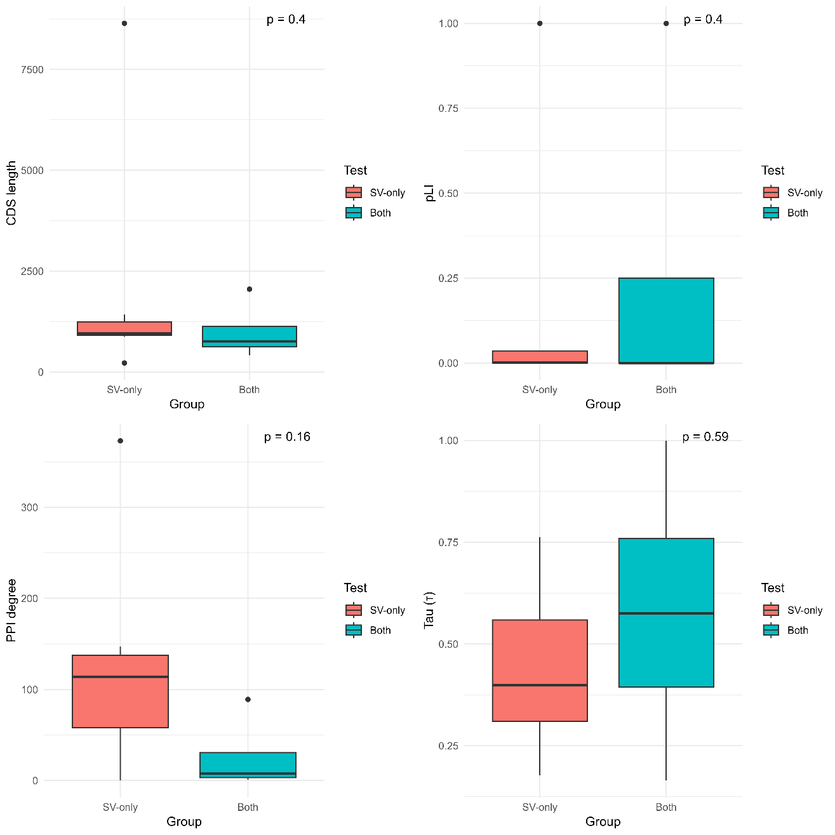
Fig. S4 The molecular genetic features of AD risk genes identified by two different methods
Boxplots comparing the molecular genetic features of genes identified exclusively by single-variant analysis (SV-only, red) and genes identified by both single-variant and GVB analyses (Both, blue). Four features indicating gene essentiality are shown: CDS length (top left), pLI score (top right), PPI degree (bottom left), and Tau (bottom right). P-values were calculated using the Wilcoxon rank-sum test.

(Continued on next page)
Fig. S5 Age of onset analysis-significant SR gene pairs
Kaplan-Meier plots showing 27 SR gene pairs that were significant (HR < 1, FDR < 0.05) in age of onset analysis. Cox proportional hazards regression was used to obtain the HRs and the p-values. Each group is annotated with (The number of AD patients in the group / The total number of individuals in the group).
Fig. S6 Additive effect of rescuer genes on AD onset in APOE-damaged individuals
Forest plot from Cox proportional hazards regression showing the effect of the number of SR pairs for APOE on AD onset. Only 2,761 rs429358 carriers (classified as APOE-damaged) were included.

Fig. S7 Sensitivity analysis of SR pairs across alternative GVB thresholds
SR pairs identified at GVB threshold of 0.2 were evaluated for their replication at alternative thresholds of 0.1 and 0.3. Only significant HRs obtained from age of onset analysis are shown. *Primary GVB threshold.

