Supplementary information
Supplementary Tables 2
Table S1. Baseline characteristics of participants by included or not included in the analysis. 2
Table S2. Goodness-of-fit statistics for alternative clustering solutions in the sequence analysis. 4
Table S3. Intrinsic capacity domains and items used in the study. 5
Table S4. Association of individual reproductive factors with all-cause and cause-specific dementia. 6
Table S5. Association of intrinsic capacity impairments with all-cause dementia and cause-specific dementia. 11
Table S6. Association between reproductive life patterns and intrinsic capacity in women’s mid-late life. 13
Table S7. Sensitivity analysis for the association between reproductive life patterns and all-cause and cause-specific dementia. 14
Supplementary Figures 18
Figure S1. Examples of reproductive life sequence data for nulliparous women, primiparous women, and multiparous women. 18
Figure S2. Association of reproductive life sequences with Alzheimer’s disease stratified by impairment of specific IC domains. 19
Figure S3. Association of reproductive life sequences with vascular dementia stratified by impairment of specific IC domains. 20
Figure S4. Association of reproductive life sequences with non-AD and non-VD dementia stratified by impairment of specific IC domains. 21
Figure S5. Association of number of IC impairments with the incidence of all-cause dementia stratified by different reproductive patterns. 22
Figure S6. Subgroup analysis of the association between reproductive life patterns with the incidence of all-cause dementia. 23

Supplementary Tables

Table S1. Baseline characteristics of participants by included or not included in the analysis.
 | Total  (N=273294) | Whether included in the main analysis |  | P value
 | Total  (N=273294) | Included  (N=153909) | Not included  (N=119385) | P value
Age at baseline, mean (SD) | 56.3 (8.0) | 59.7 (5.7) | 52.0 (8.4) | <0.001
Ethnicity, n (%) |  |  |  | <0.001
White | 257360 (94.2) | 148182 (96.3) | 109178 (91.5)
Non-white | 14668 (5.4) | 5407 (3.5) | 9261 (7.8)
Unknown | 1266 (0.5) | 320 (0.2) | 946 (0.8)
Educational level, n (%) |  |  |  | <0.001
College or above | 84497 (30.9) | 44325 (28.8) | 40172 (33.6)
Below high school | 151464 (55.4) | 91408 (59.4) | 60056 (50.3)
Unknown | 37333 (13.7) | 18176 (11.8) | 19157 (16.0)
Employment status, n (%) |  |  |  | <0.001
Unemployed | 23165 (8.5) | 10062 (6.5) | 13103 (11.0)
Employed | 247099 (90.4) | 142647 (92.7) | 104452 (87.5)
Unknown | 3030 (1.1) | 1200 (0.8) | 1830 (1.5)
Total household income before tax, n (%) |  |  |  | <0.001
Less than £18000 | 55399 (20.3) | 34969 (22.7) | 20430 (17.1)
£18000-£30999 | 58801 (21.5) | 37280 (24.2) | 21521 (18.0)
£31000-£51999 | 56748 (20.8) | 30652 (19.9) | 26096 (21.9)
£52000-£100000 | 41613 (15.2) | 19244 (12.5) | 22369 (18.7)
>£100000 | 10719 (3.9) | 4588 (3.0) | 6131 (5.1)
Unknown | 50014 (18.3) | 27176 (17.7) | 22838 (19.1)
Current smoking status, n (%) |  |  |  | <0.001
Never | 162003 (59.3) | 88868 (57.7) | 73135 (61.3)
Previous | 85419 (31.3) | 52070 (33.8) | 33349 (27.9)
Current | 24359 (8.9) | 12528 (8.1) | 11831 (9.9)
Unknown | 1513 (0.6) | 443 (0.3) | 1070 (0.9)
Current alcohol drinking status, n (%) |  |  |  | <0.001
Never | 15973 (5.8) | 8527 (5.5) | 7446 (6.2)
Previous | 9974 (3.6) | 5672 (3.7) | 4302 (3.6)
Current | 246518 (90.2) | 139617 (90.7) | 106901 (89.5)
Unknown | 829 (0.3) | 93 (0.1) | 736 (0.6)
Physical activity, n (%) |  |  |  | <0.001
Low | 36462 (13.3) | 20038 (13.0) | 16424 (13.8)
Moderate | 85763 (31.4) | 50276 (32.7) | 35487 (29.7)
High | 78469 (28.7) | 46147 (30.0) | 32322 (27.1)
Unknown | 72600 (26.6) | 37448 (24.3) | 35152 (29.4)
Body mass index, n (%) |  |  |  | <0.001
Underweight | 98416 (36.0) | 53690 (34.9) | 44726 (37.5)
Healthy weight | 9358 (3.4) | 4665 (3.0) | 4693 (3.9)
Overweight | 99817 (36.5) | 59122 (38.4) | 40695 (34.1)
Obese | 64244 (23.5) | 36432 (23.7) | 27812 (23.3)
Unknown | 1459 (0.5) | 0 (0.0) | 1459 (1.2)
Ever usage of hormone replacement therapy, n (%) |  |  |  | <0.001
Never | 167818 (61.4) | 78474 (51.0) | 89344 (74.8)
Ever | 103901 (38.0) | 75193 (48.9) | 28708 (24.0)
Unknown | 1575 (0.6) | 242 (0.2) | 1333 (1.1)
Baseline CVD, n (%) | 93620 (34.3) | 59408 (38.6) | 34212 (28.7) | <0.001
Baseline type 2 diabetes, n (%) | 9765 (3.6) | 5892 (3.8) | 3873 (3.2) | <0.001
Baseline cancer, n (%) | 30439 (11.1) | 19747 (12.8) | 10692 (9.0) | <0.001

Table S2. Goodness-of-fit statistics for alternative clustering solutions in the sequence analysis.
Number of clusters | PBC | HG | HGSD | ASW | CH | R² | CHsq | R²sq | HC
2 | 0.58 | 0.8 | 0.79 | 0.45 | 0.45 | 26082.21 | 0.14 | 60091.62 | 0.28
3 | 0.45 | 0.54 | 0.53 | 0.23 | 0.23 | 21101.37 | 0.22 | 48744.32 | 0.39
4 | 0.44 | 0.58 | 0.57 | 0.24 | 0.24 | 20237.92 | 0.28 | 47269.2 | 0.48
5 | 0.52 | 0.72 | 0.71 | 0.27 | 0.27 | 19881.98 | 0.34 | 51590.28 | 0.57
6 | 0.44 | 0.7 | 0.69 | 0.23 | 0.23 | 18954.85 | 0.38 | 48905.41 | 0.61
7 | 0.43 | 0.73 | 0.72 | 0.23 | 0.23 | 17469.97 | 0.41 | 46004.75 | 0.64
8 | 0.41 | 0.74 | 0.73 | 0.22 | 0.23 | 16020.63 | 0.42 | 42675.15 | 0.66
9 | 0.4 | 0.75 | 0.74 | 0.22 | 0.22 | 14918.19 | 0.44 | 40210.04 | 0.68
10 | 0.37 | 0.73 | 0.72 | 0.19 | 0.19 | 13806.58 | 0.45 | 37037.35 | 0.68
PBC: Point Biserial Correlation, Capacity of the clustering to reproduce the original distance matrix.
HG: Hubert’s Gamma, Capacity of the clustering to reproduce the original distance matrix (Order of magnitude).
HGSD: Hubert’s Somers D, Same as above, taking into account ties in the distance matrix.
ASW: Average Silhouette Width, Coherence of the assignments. A high coherence indicates high between groups distances and high intra group homogeneity.
CH: Calinski-Harabasz index, Pseudo F computed from the distances.
R2: Pseudo R2, Share of the discrepancy explained by the clustering.
CHsq: Calinski-Harabasz index, Idem, using the squared distances.
R2sq: Pseudo R2, Idem, using the squared distances.
HC: Hubert’s C, Gap between the current quality of clustering and the best possible quality for this distance matrix and number of groups.

Table S3. Intrinsic capacity domains and items used in the study.
Domain | Items | UK Biobank criteria
Psychology | Exhaustion | Self-reported: “Over the past two weeks, how often have you felt tired or had little energy” (Response: more than half the days, nearly every day = 1 point; not at all, several days = 0 point)
Psychology | Unhealthy sleep duration | Self-reported: “About how many hours sleep do you get in every 24 hours? (Include naps)” (Response: short <7 h/d or long >9 h/d = 1 point, healthy 7-9 h = point)
Sensory | Eye problems | Self-reported: non-cancer illness, self-reported considering eye/eyelid problem category
Sensory | Hearing difficulty | Self-reported: “Do you have any difficulty with your hearing?” (Response: yes, I am completely deaf = 1 point; no = 0 point)
Vitality | Recent weight loss | Self-reported: “Compared with one year ago, has your weight changed?” (Response: yes - lost weight = 1 point; no - weight the same, yes - gain weight = 0 point)
Vitality | Low grip strength | Measured grip strength (sex and body-mass index adjusted cut-offs taken from Fried and colleagues¹)
Locomotion | Slow walking pace | Self-reported: “How would you describe your usual walking pace?” (Response: slow pace = 1 point; steady average pace or brisk pace = 0 point)

1. Fried LP, Tangen CM, Walston J, et al. Frailty in older adults: Evidence for a phenotype. J Gerontol a-Biol. 2001;56(3):M146-M156.

Table S4. Association of individual reproductive factors with all-cause and cause-specific dementia.
 | All-cause dementia |  |  |  | Alzheimer’s disease |  |  |  | Vascular dementia |  |  |  | Non-AD and non-VD dementia
 | Events (IR) | HR (95% CI) | P value | FDR q value | Events (IR) | HR (95% CI) | P value | FDR q value | Events (IR) | HR (95% CI) | P value | FDR q value | Events (IR) | HR (95% CI) | P value | FDR q value
Age at menarche, years (n=153909) |  |  | 0.932 | 0.944 |  |  | 0.700 | 0.867 |  |  | 0.143 | 0.370 |  |  | 0.335 | 0.546
<12 | 593 (13.5) | 1.01 (0.92-1.12) |  |  | 308 (7.0) | 1.04 (0.90-1.20) |  |  | 131 (3.0) | 1.26 (1.00-1.58) |  |  | 183 (4.1) | 0.86 (0.71-1.05)
12-13 | 1215 (12.8) | 1.00 (reference) |  |  | 609 (6.4) | 1.00 (reference) |  |  | 225 (2.4) | 1.00 (reference) |  |  | 430 (4.5) | 1.00 (reference)
>13 | 1132 (14.5) | 1.01 (0.93-1.10) |  |  | 592 (7.6) | 1.05 (0.93-1.18) |  |  | 221 (2.8) | 1.07 (0.88-1.31) |  |  | 378 (4.8) | 0.95 (0.81-1.11)
Number of live births (n=153909) |  |  | 0.249 | 0.482 |  |  | 0.087 | 0.252 |  |  | 0.092 | 0.252 |  |  | 0.749 | 0.867
0 | 379 (10.8) | 1.01 (0.90-1.13) |  |  | 216 (6.2) | 1.17 (1.00-1.37) |  |  | 68 (1.9) | 1.00 (0.75-1.33) |  |  | 120 (3.4) | 0.92 (0.74-1.14)
1-2 | 1624 (12.8) | 1.00 (reference) |  |  | 810 (6.4) | 1.00 (reference) |  |  | 305 (2.4) | 1.00 (reference) |  |  | 572 (4.5) | 1.00 (reference)
3-4 | 857 (16.6) | 1.08 (0.99-1.17) |  |  | 450 (8.7) | 1.12 (1.00-1.27) |  |  | 186 (3.6) | 1.27 (1.05-1.54) |  |  | 266 (5.1) | 0.95 (0.80-1.12)
>4 | 80 (23.6) | 1.13 (0.90-1.42) |  |  | 33 (9.7) | 0.92 (0.63-1.34) |  |  | 18 (5.3) | 0.98 (0.55-1.76) |  |  | 33 (9.7) | 1.13 (0.73-1.75)
Age at first live birth, years (n=128988) |  |  | 0.002 | 0.027 |  |  | 0.333 | 0.546 |  |  | 0.021 | 0.100 |  |  | 0.191 | 0.420
<21 | 470 (17.4) | 1.26 (1.10-1.44) |  |  | 227 (8.4) | 1.15 (0.94-1.40) |  |  | 102 (3.7) | 1.47 (1.06-2.05) |  |  | 164 (6.0) | 1.34 (1.03-1.74)
21-22 | 468 (18.8) | 1.15 (1.01-1.31) |  |  | 233 (9.3) | 1.09 (0.90-1.33) |  |  | 107 (4.3) | 1.42 (1.03-1.95) |  |  | 155 (6.2) | 1.19 (0.92-1.55)
23-24 | 493 (16.6) | 1.10 (0.97-1.26) |  |  | 253 (8.5) | 1.09 (0.90-1.32) |  |  | 103 (3.5) | 1.29 (0.94-1.78) |  |  | 159 (5.3) | 1.11 (0.86-1.44)
25-26 | 403 (13.1) | 1.00 (reference) |  |  | 214 (7.0) | 1.00 (reference) |  |  | 69 (2.2) | 1.00 (reference) |  |  | 136 (4.4) | 1.00 (reference)
27-29 | 426 (11.7) | 1.03 (0.90-1.18) |  |  | 217 (6.0) | 1.00 (0.82-1.22) |  |  | 77 (2.1) | 1.10 (0.79-1.55) |  |  | 146 (4.0) | 1.02 (0.78-1.33)
>29 | 301 (9.0) | 0.95 (0.82-1.10) |  |  | 149 (4.5) | 0.91 (0.73-1.13) |  |  | 51 (1.5) | 0.84 (0.57-1.25) |  |  | 111 (3.3) | 1.00 (0.75-1.33)
Age at last live birth, years (n=109679) |  |  | 0.207 | 0.433 |  |  | 0.368 | 0.578 |  |  | 0.554 | 0.754 |  |  | 0.808 | 0.867
<26 | 487 (17.0) | 1.07 (0.95-1.21) |  |  | 240 (8.3) | 1.00 (0.84-1.20) |  |  | 113 (3.9) | 1.22 (0.91-1.62) |  |  | 158 (5.5) | 1.16 (0.91-1.47)
26-28 | 546 (15.7) | 0.98 (0.87-1.10) |  |  | 285 (8.2) | 0.99 (0.83-1.17) |  |  | 109 (3.1) | 1.04 (0.79-1.37) |  |  | 181 (5.2) | 1.06 (0.84-1.34)
29-31 | 562 (14.7) | 1.00 (reference) |  |  | 298 (7.8) | 1.00 (reference) |  |  | 106 (2.8) | 1.00 (reference) |  |  | 180 (4.7) | 1.00 (reference)
32-35 | 396 (11.9) | 0.94 (0.83-1.07) |  |  | 196 (5.9) | 0.88 (0.73-1.06) |  |  | 79 (2.4) | 1.03 (0.76-1.39) |  |  | 137 (4.1) | 1.02 (0.79-1.31)
>35 | 213 (10.8) | 0.90 (0.77-1.06) |  |  | 101 (5.1) | 0.84 (0.66-1.06) |  |  | 40 (2.0) | 0.90 (0.60-1.33) |  |  | 81 (4.1) | 1.02 (0.75-1.37)
Birth interval, years (n=108714) |  |  | 0.263 | 0.482 |  |  | 0.543 | 0.754 |  |  | 0.300 | 0.528 |  |  | 0.708 | 0.867
<2 | 118 (15.5) | 1.08 (0.89-1.31) |  |  | 56 (7.3) | 1.08 (0.81-1.43) |  |  | 29 (3.8) | 1.17 (0.75-1.84) |  |  | 38 (5.0) | 1.04 (0.72-1.51)
2-3 | 839 (12.6) | 1.00 (reference) |  |  | 418 (6.3) | 1.00 (reference) |  |  | 155 (2.3) | 1.00 (reference) |  |  | 296 (4.4) | 1.00 (reference)
4-5 | 475 (14.5) | 1.03 (0.92-1.15) |  |  | 255 (7.7) | 1.11 (0.95-1.31) |  |  | 100 (3.0) | 1.12 (0.86-1.47) |  |  | 144 (4.4) | 0.91 (0.73-1.14)
6-7 | 270 (14.7) | 1.00 (0.88-1.15) |  |  | 139 (7.5) | 1.02 (0.83-1.24) |  |  | 52 (2.8) | 1.02 (0.73-1.42) |  |  | 94 (5.1) | 0.93 (0.71-1.21)
8-10 | 264 (17.7) | 1.17 (1.02-1.34) |  |  | 138 (9.2) | 1.20 (0.98-1.47) |  |  | 61 (4.1) | 1.46 (1.07-1.99) |  |  | 79 (5.3) | 1.03 (0.79-1.36)
>10 | 221 (16.8) | 1.11 (0.96-1.30) |  |  | 103 (7.8) | 1.04 (0.83-1.31) |  |  | 43 (3.2) | 1.07 (0.73-1.55) |  |  | 85 (6.4) | 1.17 (0.88-1.55)
Age at natural menopause, years (n=129168) |  |  | <0.001 | 0.004 |  |  | 0.007 | 0.064 |  |  | 0.566 | 0.754 |  |  | 0.048 | 0.175
<40 | 103 (20.2) | 1.31 (1.06-1.61) |  |  | 60 (11.8) | 1.37 (1.03-1.83) |  |  | 16 (3.1) | 0.87 (0.48-1.58) |  |  | 33 (6.4) | 1.33 (0.88-2.00)
40-44 | 254 (15.6) | 1.05 (0.90-1.22) |  |  | 124 (7.6) | 0.88 (0.71-1.09) |  |  | 48 (2.9) | 1.01 (0.70-1.46) |  |  | 87 (5.3) | 1.10 (0.83-1.46)
45-49 | 611 (13.9) | 1.07 (0.96-1.20) |  |  | 301 (6.8) | 0.91 (0.77-1.07) |  |  | 128 (2.9) | 1.16 (0.88-1.52) |  |  | 205 (4.6) | 1.06 (0.85-1.32)
50-51 | 585 (13.5) | 1.00 (reference) |  |  | 327 (7.5) | 1.00 (reference) |  |  | 108 (2.5) | 1.00 (reference) |  |  | 186 (4.3) | 1.00 (reference)
52-53 | 404 (11.7) | 0.90 (0.80-1.02) |  |  | 219 (6.3) | 0.89 (0.74-1.06) |  |  | 74 (2.1) | 0.94 (0.69-1.28) |  |  | 132 (3.8) | 0.88 (0.69-1.12)
>53 | 513 (13.3) | 0.87 (0.77-0.98) |  |  | 267 (6.9) | 0.80 (0.68-0.95) |  |  | 104 (2.7) | 0.90 (0.67-1.20) |  |  | 167 (4.3) | 0.79 (0.63-1.00)
History of hysterectomy (n=153909) | 797 (15.5) | 0.99 (0.81-1.21) | 0.163 | 0.383 | 379 (7.3) | 0.96 (0.85-1.09) | 0.561 | 0.754 | 156 (3.0) | 0.99 (0.81-1.21) | 0.901 | 0.944 | 294 (5.7) | 1.21 (1.03-1.43) | 0.020 | 0.100
Age at hysterectomy (n=36601) |  |  | 0.028 | 0.113 |  |  | 0.028 | 0.113 |  |  | 0.748 | 0.867 |  |  | 0.724 | 0.867
<40 | 197 (14.4) | 1.04 (0.79-1.38) |  |  | 94 (6.9) | 0.93 (0.62-1.40) |  |  | 43 (3.1) | 1.29 (0.64-2.60) |  |  | 71 (5.2) | 1.06 (0.62-1.84)
40-44 | 187 (14.0) | 0.91 (0.69-1.21) |  |  | 79 (5.9) | 0.71 (0.47-1.07) |  |  | 39 (2.9) | 1.22 (0.61-2.46) |  |  | 75 (5.6) | 1.00 (0.57-1.74)
45-49 | 152 (12.2) | 0.78 (0.58-1.03) |  |  | 67 (5.4) | 0.64 (0.42-0.97) |  |  | 30 (2.4) | 0.89 (0.43-1.85) |  |  | 60 (4.8) | 0.97 (0.56-1.69)
50-51 | 68 (17.9) | 1.00 (reference) |  |  | 37 (9.7) | 1.00 (reference) |  |  | 11 (2.9) | 1.00 (reference) |  |  | 22 (5.8) | 1.00 (reference)
52-53 | 39 (16.5) | 0.92 (0.62-1.37) |  |  | 20 (8.5) | 0.88 (0.50-1.55) |  |  | 8 (3.4) | 0.94 (0.34-2.58) |  |  | 13 (5.5) | 0.97 (0.44-2.13)
>53 | 154 (26.1) | 1.12 (0.84-1.49) |  |  | 82 (13.8) | 1.06 (0.70-1.59) |  |  | 25 (4.2) | 1.11 (0.52-2.35) |  |  | 53 (8.9) | 1.34 (0.75-2.37)
History of oophorectomy (n=153909) | 339 (14.4) | 0.76 (0.57-1.03) | 0.807 | 0.867 | 163 (6.9) | 0.95 (0.80-1.13) | 0.561 | 0.754 | 57 (2.4) | 0.76 (0.57-1.03) | 0.076 | 0.238 | 132 (5.6) | 1.22 (0.99-1.51) | 0.061 | 0.206
Age at oophorectomy (n=16824) |  |  | 0.003 | 0.035 |  |  | 0.018 | 0.100 |  |  | 0.798 | 0.867 |  |  | 0.944 | 0.944
<40 | 47 (16) | 1.29 (0.87-1.92) |  |  | 23 (7.8) | 1.11 (0.62-1.99) |  |  | 7 (2.4) | 1.35 (0.43-4.28) |  |  | 17 (5.8) | 0.93 (0.44-1.99)
40-44 | 37 (8.7) | 0.68 (0.44-1.04) |  |  | 13 (3.1) | 0.43 (0.22-0.86) |  |  | 7 (1.6) | 1.05 (0.34-3.17) |  |  | 19 (4.5) | 0.84 (0.40-1.76)
45-49 | 64 (9) | 0.63 (0.44-0.91) |  |  | 30 (4.2) | 0.52 (0.31-0.88) |  |  | 10 (1.4) | 0.76 (0.27-2.12) |  |  | 27 (3.8) | 0.75 (0.39-1.44)
50-51 | 51 (17.8) | 1.00 (reference) |  |  | 27 (9.4) | 1.00 (reference) |  |  | 7 (2.4) | 1.00 (reference) |  |  | 18 (6.3) | 1.00 (reference)
52-53 | 31 (17) | 0.93 (0.59-1.46) |  |  | 13 (7.1) | 0.71 (0.36-1.39) |  |  | 8 (4.4) | 1.41 (0.45-4.44) |  |  | 12 (6.6) | 1.05 (0.47-2.34)
>53 | 109 (23.8) | 0.97 (0.68-1.36) |  |  | 57 (12.4) | 0.85 (0.53-1.39) |  |  | 18 (3.9) | 1.28 (0.50-3.30) |  |  | 39 (8.5) | 0.93 (0.48-1.79)
Reproductive life span, years (n=153909) |  |  | <0.001 | 0.004 |  |  | 0.257 | 0.482 |  |  | 0.165 | 0.383 |  |  | 0.013 | 0.096
<33 | 811 (15.3) | 1.16 (1.05-1.29) |  |  | 387 (7.3) | 1.00 (0.86-1.16) |  |  | 157 (2.9) | 1.12 (0.87-1.43) |  |  | 297 (5.6) | 1.31 (1.07-1.60)
33-35 | 470 (14.1) | 1.13 (1.00-1.27) |  |  | 232 (6.9) | 1.00 (0.84-1.18) |  |  | 99 (3.0) | 1.22 (0.93-1.61) |  |  | 157 (4.7) | 1.24 (0.99-1.55)
36-38 | 676 (12.6) | 1.00 (reference) |  |  | 376 (7.0) | 1.00 (reference) |  |  | 134 (2.5) | 1.00 (reference) |  |  | 209 (3.9) | 1.00 (reference)
39-41 | 577 (12.2) | 0.96 (0.86-1.08) |  |  | 314 (6.6) | 0.97 (0.83-1.13) |  |  | 101 (2.1) | 0.86 (0.65-1.14) |  |  | 191 (4.0) | 0.97 (0.78-1.21)
>41 | 406 (13.6) | 0.93 (0.82-1.05) |  |  | 200 (6.7) | 0.83 (0.69-0.99) |  |  | 86 (2.9) | 1.01 (0.76-1.35) |  |  | 137 (4.6) | 1.02 (0.80-1.29)
IR: Incidence rate (per 10, 000 person-years)
All models were adjusted for age at baseline, ethnicity, educational levels, employment status, income levels, smoking status, alcohol drinking status, physical activity, body mass index categories, ever usage of hormone-replacement therapy, disease history of cardiovascular disease, type 2 diabetes, and cancer, and polygenic risk score for Alzheimer’s disease.
FDR q values were derived using the Benjamini-Hochberg false discovery rate correction across 44 overall tests.

Table S5. Association of intrinsic capacity impairments with all-cause dementia and cause-specific dementia.
 | All-cause dementia |  |  |  | Alzheimer’s disease |  |  |  | Vascular dementia |  |  |  | Non-AD and non-VD dementia
 | IR | HR (95% CI) | P value | FDR q value | IR | HR (95% CI) | P value | FDR q value | IR | HR (95% CI) | P value | FDR q value | IR | HR (95% CI) | P value | FDR q value
Impairment of intrinsic capacity |  |  | <0.001 | <0.001 |  |  | <0.001 | <0.001 |  |  | <0.001 | <0.001 |  |  | <0.001 | <0.001
No | 12.9 | 1.00 (reference) |  |  | 6.7 | 1.00 (reference) |  |  | 2.5 | 1.00 (reference) |  |  | 4.3 | 1.00 (reference)
Yes | 34.6 | 1.79 (1.54-2.07) |  |  | 13.8 | 1.38 (1.08-1.75) |  |  | 9.3 | 2.03 (1.47-2.80) |  |  | 13.1 | 1.96 (1.49-2.58)
Specific impairment domains of intrinsic capacity
Psychology |  |  | <0.001 | <0.001 |  |  | 0.005 | 0.007 |  |  | <0.001 | <0.001 |  |  | <0.001 | <0.001
No | 12.3 | 1.00 (reference) |  |  | 6.5 | 1.00 (reference) |  |  | 2.2 | 1.00 (reference) |  |  | 4.0 | 1.00 (reference)
Yes | 16.0 | 1.28 (1.19-1.38) |  |  | 7.6 | 1.17 (1.05-1.30) |  |  | 3.4 | 1.40 (1.17-1.67) |  |  | 5.6 | 1.30 (1.13-1.50)
Sensory |  |  | 0.002 | 0.002 |  |  | 0.591 | 0.591 |  |  | 0.277 | 0.296 |  |  | <0.001 | <0.001
No | 12.2 | 1.00 (reference) |  |  | 6.4 | 1.00 (reference) |  |  | 2.3 | 1.00 (reference) |  |  | 4.0 | 1.00 (reference)
Yes | 17.3 | 1.13 (1.05-1.22) |  |  | 8.5 | 1.03 (0.92-1.16) |  |  | 3.5 | 1.11 (0.92-1.34) |  |  | 6.0 | 1.30 (1.12-1.50)
Vitality |  |  | <0.001 | <0.001 |  |  | <0.001 | <0.001 |  |  | <0.001 | <0.001 |  |  | 0.092 | 0.113
No | 11.2 | 1.00 (reference) |  |  | 5.8 | 1.00 (reference) |  |  | 2.0 | 1.00 (reference) |  |  | 4.0 | 1.00 (reference)
Yes | 18.7 | 1.29 (1.20-1.39) |  |  | 9.5 | 1.31 (1.18-1.46) |  |  | 4.0 | 1.46 (1.22-1.74) |  |  | 5.9 | 1.14 (0.98-1.32)
Locomotion |  |  | <0.001 | <0.001 |  |  | 0.101 | 0.115 |  |  | <0.001 | <0.001 |  |  | <0.001 | <0.001
No | 12.4 | 1.00 (reference) |  |  | 6.6 | 1.00 (reference) |  |  | 2.3 | 1.00 (reference) |  |  | 4.0 | 1.00 (reference)
Yes | 26.5 | 1.49 (1.34-1.66) |  |  | 10.4 | 1.15 (0.97-1.37) |  |  | 6.6 | 1.62 (1.26-2.09) |  |  | 10.4 | 1.78 (1.45-2.18)
IR: Incidence rate (per 10, 000 person-years).
FDR q values were estimated using the Benjamini-Hochberg method separately for the overall intrinsic capacity impairment analyses (4 tests across dementia outcomes) and the domain-specific intrinsic capacity analyses (16 tests across 4 domains and 4 dementia outcomes).
All models were adjusted for age at baseline, ethnicity, educational levels, employment status, income levels, smoking status, alcohol drinking status, physical activity, body mass index categories, ever usage of hormone-replacement therapy, disease history of cardiovascular disease, type 2 diabetes, and cancer, and polygenic risk score for Alzheimer’s disease.

Table S6. Association between reproductive life patterns and intrinsic capacity in women’s mid-late life.
 | Standard sequence | Early childbearing and oophorectomy menopause | Short reproductive span with natural menopause | Early childbearing and hysterectomy menopause | High parity with long birth span
Intrinsic capacity impairment (+) | 1.00 (reference) | 1.10 (1.05-1.15) | 1.05 (1.02-1.08) | 1.18 (1.14-1.23) | 1.01 (0.98-1.04)
Psychology | 1.00 (reference) | 1.10 (1.05-1.15) | 1.07 (1.04-1.11) | 1.18 (1.14-1.22) | 1.03 (1.00-1.06)
Sensory | 1.00 (reference) | 0.98 (0.93-1.03) | 0.97 (0.94-1.01) | 1.02 (0.98-1.06) | 1.01 (0.98-1.05)
Vitality | 1.00 (reference) | 1.16 (1.10-1.21) | 1.02 (0.99-1.06) | 1.15 (1.11-1.20) | 0.99 (0.96-1.02)
Locomotor | 1.00 (reference) | 1.18 (1.09-1.28) | 1.19 (1.12-1.26) | 1.20 (1.13-1.28) | 1.05 (0.99-1.11)
All models were adjusted for age at baseline, ethnicity, educational levels, employment status, income levels, smoking status, alcohol drinking status, physical activity, body mass index categories, ever usage of hormone-replacement therapy, disease history of cardiovascular disease, type 2 diabetes, and cancer, and polygenic risk score for Alzheimer’s disease. Odds ratios and 95% confidence intervals were shown in this table.

Table S7. Sensitivity analysis for the association between reproductive life patterns and all-cause and cause-specific dementia.
 | All-cause dementia | Alzheimer’s disease | Vascular dementia | Non-AD and non-VD dementia
Sensitivity analysis 1
Standard sequence | 1.00 (reference) | 1.00 (reference) | 1.00 (reference) | 1.00 (reference)
Early childbearing and oophorectomy menopause | 0.97 (0.81-1.15) | 0.92 (0.71-1.18) | 0.80 (0.51-1.25) | 1.03 (0.75-1.42)
Short reproductive span with natural menopause | 1.29 (1.17-1.43) | 1.27 (1.10-1.46) | 1.40 (1.10-1.78) | 1.18 (0.97-1.43)
Early childbearing and hysterectomy menopause | 0.97 (0.81-1.15) | 0.96 (0.80-1.15) | 1.33 (1.02-1.75) | 1.26 (1.01-1.58)
High parity with long birth span | 1.29 (1.17-1.43) | 1.13 (0.98-1.30) | 1.26 (1.00-1.59) | 1.06 (0.88-1.28)
Sensitivity analysis 2
Standard sequence | 1.00 (reference) | 1.00 (reference) | 1.00 (reference) | 1.00 (reference)
Early childbearing and oophorectomy menopause | 0.96 (0.81-1.14) | 0.91 (0.70-1.17) | 0.81 (0.51-1.27) | 1.02 (0.73-1.41)
Short reproductive span with natural menopause | 1.30 (1.17-1.43) | 1.27 (1.10-1.47) | 1.40 (1.10-1.78) | 1.17 (0.96-1.42)
Early childbearing and hysterectomy menopause | 1.15 (1.02-1.30) | 0.97 (0.81-1.16) | 1.33 (1.01-1.74) | 1.25 (1.00-1.57)
High parity with long birth span | 1.12 (1.02-1.24) | 1.13 (0.98-1.29) | 1.24 (0.98-1.57) | 1.07 (0.88-1.29)
Sensitivity analysis 3
Standard sequence | 1.00 (reference) | 1.00 (reference) | 1.00 (reference) | 1.00 (reference)
Early childbearing and oophorectomy menopause | 0.94 (0.79-1.12) | 0.92 (0.71-1.19) | 0.74 (0.46-1.19) | 1.00 (0.71-1.39)
Short reproductive span with natural menopause | 1.30 (1.17-1.44) | 1.29 (1.11-1.49) | 1.41 (1.11-1.80) | 1.16 (0.95-1.42)
Early childbearing and hysterectomy menopause | 1.15 (1.02-1.30) | 0.95 (0.79-1.14) | 1.36 (1.04-1.79) | 1.23 (0.98-1.55)
High parity with long birth span | 1.14 (1.03-1.26) | 1.14 (0.99-1.31) | 1.27 (1.01-1.60) | 1.08 (0.89-1.30)
Sensitivity analysis 4
Standard sequence | 1.00 (reference) | 1.00 (reference) | 1.00 (reference) | 1.00 (reference)
Early childbearing and oophorectomy menopause | 0.90 (0.69-1.17) | 1.02 (0.70-1.47) | 0.68 (0.35-1.33) | 0.99 (0.59-1.67)
Short reproductive span with natural menopause | 1.28 (1.10-1.48) | 1.37 (1.11-1.68) | 1.36 (0.96-1.92) | 1.07 (0.78-1.45)
Early childbearing and hysterectomy menopause | 1.24 (1.04-1.47) | 1.08 (0.83-1.40) | 0.96 (0.63-1.48) | 1.59 (1.15-2.20)
High parity with long birth span | 1.13 (0.98-1.30) | 1.20 (0.98-1.47) | 1.23 (0.89-1.71) | 0.98 (0.73-1.32)
Sensitivity analysis 5
Standard sequence | 1.00 (reference) | 1.00 (reference) | 1.00 (reference) | 1.00 (reference)
Early childbearing and oophorectomy menopause | 0.98 (0.82-1.16) | 0.93 (0.72-1.2) | 0.8 (0.51-1.26) | 1.04 (0.76-1.44)
Short reproductive span with natural menopause | 1.3 (1.18-1.43) | 1.27 (1.1-1.47) | 1.4 (1.10-1.78) | 1.18 (0.97-1.44)
Early childbearing and hysterectomy menopause | 1.18 (1.04-1.32) | 0.97 (0.81-1.17) | 1.35 (1.03-1.77) | 1.28 (1.03-1.61)
High parity with long birth span | 1.14 (1.03-1.25) | 1.14 (0.99-1.31) | 1.27 (1.01-1.60) | 1.07 (0.88-1.29)
Sensitivity analysis 6
Standard sequence | 1.00 (reference) | 1.00 (reference) | 1.00 (reference) | 1.00 (reference)
Early childbearing and oophorectomy menopause | 0.97 (0.81-1.15) | 0.92 (0.71-1.18) | 0.80 (0.51-1.25) | 1.03 (0.75-1.43)
Short reproductive span with natural menopause | 1.29 (1.17-1.43) | 1.27 (1.10-1.46) | 1.40 (1.10-1.78) | 1.18 (0.97-1.43)
Early childbearing and hysterectomy menopause | 1.16 (1.03-1.30) | 0.96 (0.80-1.15) | 1.34 (1.02-1.75) | 1.26 (1.01-1.58)
High parity with long birth span | 1.13 (1.03-1.25) | 1.13 (0.99-1.30) | 1.26 (1.00-1.59) | 1.06 (0.88-1.28)
Sensitivity analysis 7
Standard sequence | 1.00 (reference) | 1.00 (reference) | 1.00 (reference) | 1.00 (reference)
Early childbearing and oophorectomy menopause | 0.97 (0.81-1.15) | 0.92 (0.71-1.18) | 0.80 (0.51-1.25) | 1.03 (0.75-1.42)
Short reproductive span with natural menopause | 1.29 (1.17-1.43) | 1.27 (1.10-1.46) | 1.40 (1.10-1.78) | 1.18 (0.97-1.43)
Early childbearing and hysterectomy menopause | 1.16 (1.03-1.31) | 0.96 (0.80-1.15) | 1.34 (1.02-1.75) | 1.26 (1.01-1.58)
High parity with long birth span | 1.13 (1.03-1.24) | 1.13 (0.99-1.30) | 1.26 (1.00-1.59) | 1.06 (0.88-1.28)
Sensitivity analysis 8
Standard sequence | 1.00 (reference) | 1.00 (reference) | 1.00 (reference) | 1.00 (reference)
Early childbearing and oophorectomy menopause | 0.98 (0.82-1.16) | 0.93 (0.72-1.21) | 0.84 (0.53-1.32) | 1.02 (0.73-1.41)
Short reproductive span with natural menopause | 1.30 (1.17-1.43) | 1.27 (1.10-1.46) | 1.40 (1.10-1.78) | 1.19 (0.97-1.44)
Early childbearing and hysterectomy menopause | 1.17 (1.04-1.32) | 0.97 (0.81-1.16) | 1.36 (1.04-1.78) | 1.27 (1.02-1.60)
High parity with long birth span | 1.13 (1.03-1.25) | 1.13 (0.98-1.30) | 1.26 (1.00-1.59) | 1.06 (0.88-1.28)
Sensitivity analysis 9
Standard sequence | 1.00 (reference) | 1.00 (reference) | 1.00 (reference) | 1.00 (reference)
Early childbearing and oophorectomy menopause | 0.96 (0.80-1.14) | 0.90 (0.70-1.17) | 0.75 (0.47-1.21) | 1.04 (0.75-1.43)
Short reproductive span with natural menopause | 1.29 (1.17-1.43) | 1.28 (1.11-1.47) | 1.39 (1.09-1.78) | 1.15 (0.95-1.41)
Early childbearing and hysterectomy menopause | 1.18 (1.05-1.33) | 0.98 (0.82-1.18) | 1.33 (1.01-1.75) | 1.29 (1.03-1.62)
High parity with long birth span | 1.13 (1.02-1.25) | 1.13 (0.99-1.30) | 1.26 (1.00-1.60) | 1.06 (0.88-1.28)
All models were adjusted for age at baseline, ethnicity, educational levels, employment status, income levels, smoking status, alcohol drinking status, physical activity, body mass index categories, ever usage of hormone-replacement therapy, disease history of cardiovascular disease, type 2 diabetes, and cancer, and polygenic risk score for Alzheimer’s disease.
Sensitivity analysis 1: repeat the analysis by including IC impairment as a covariate;
Sensitivity analysis 2: repeat the analysis by excluding participants who have developed dementia during the first two years of follow-up;
Sensitivity analysis 3: repeat the analysis among participants aged ≥55 years at baseline;
Sensitivity analysis 4: repeat the analysis by excluding participants with missing covariates;
Sensitivity analysis 5: repeat the analysis by imputing covariates using multiple imputation;
Sensitivity analysis 6: repeat the analysis by including the history of PCOS and female infertility in the covariates;
Sensitivity analysis 7: repeat the analysis by including the history of diabetes mellitus in pregnancy and hypertensive disorders in pregnancy in the covariates;
Sensitivity analysis 8: repeat the analysis by including the history of endometriosis, uterine fibroids, and ovarian cysts in the covariates.
Sensitivity analysis 9: repeat the analysis by including cognitive performance of reaction time and pairs matching in the covariates.

Supplementary Figures
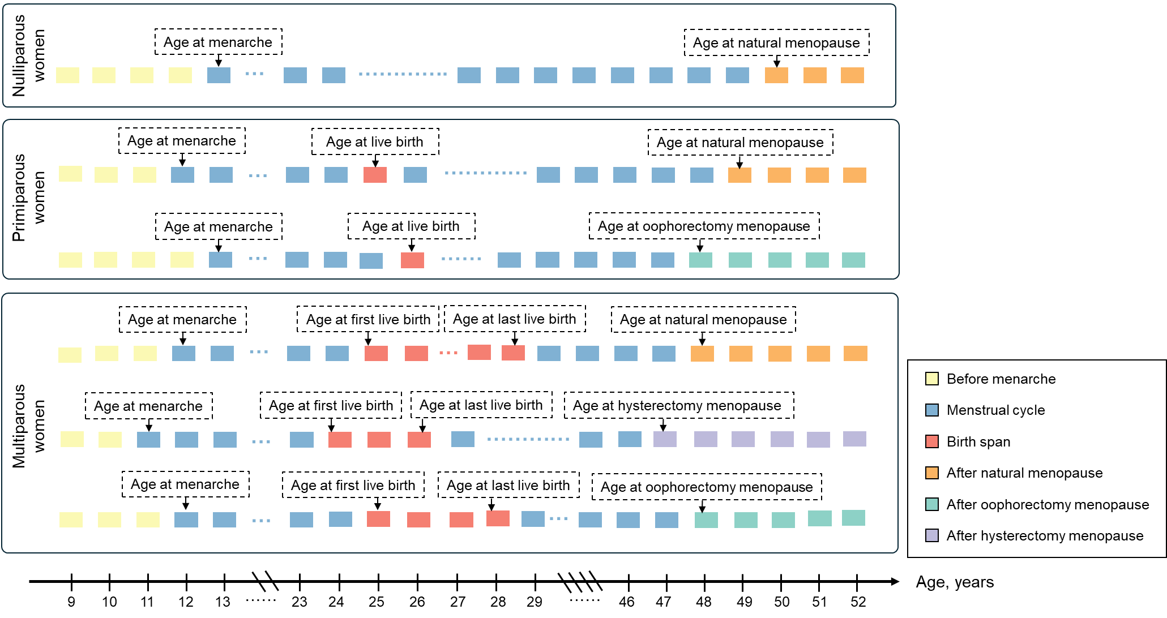

Figure S1. Examples of reproductive life sequence data for nulliparous women, primiparous women, and multiparous women.
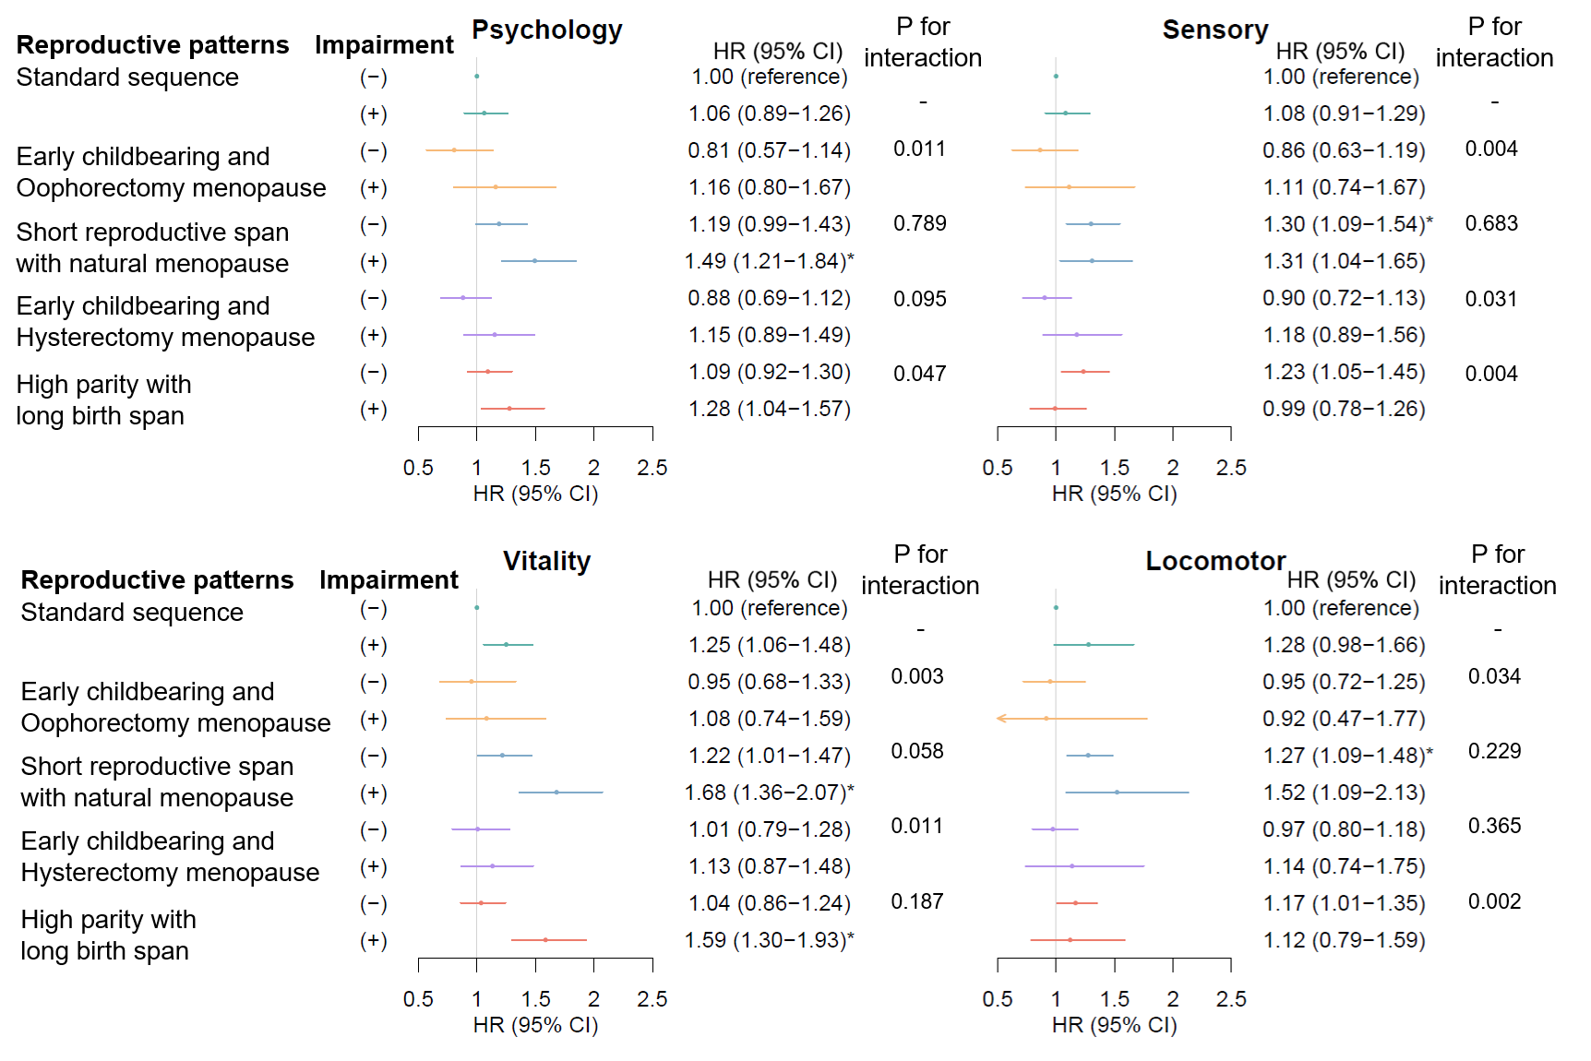

Figure S2. Association of reproductive life sequences with Alzheimer’s disease stratified by impairment of specific IC domains.

All models were adjusted for age at baseline, ethnicity, educational levels, employment status, income levels, smoking status, alcohol drinking status, physical activity, body mass index categories, ever usage of hormone-replacement therapy, disease history of cardiovascular disease, type 2 diabetes, and cancer, and polygenic risk score for Alzheimer’s disease.
* indicates false discovery rate-adjusted q<0.05 within each dementia outcome, based on Benjamini-Hochberg correction across 36 comparisons (4 intrinsic capacity domains × 9 non-reference joint groups).

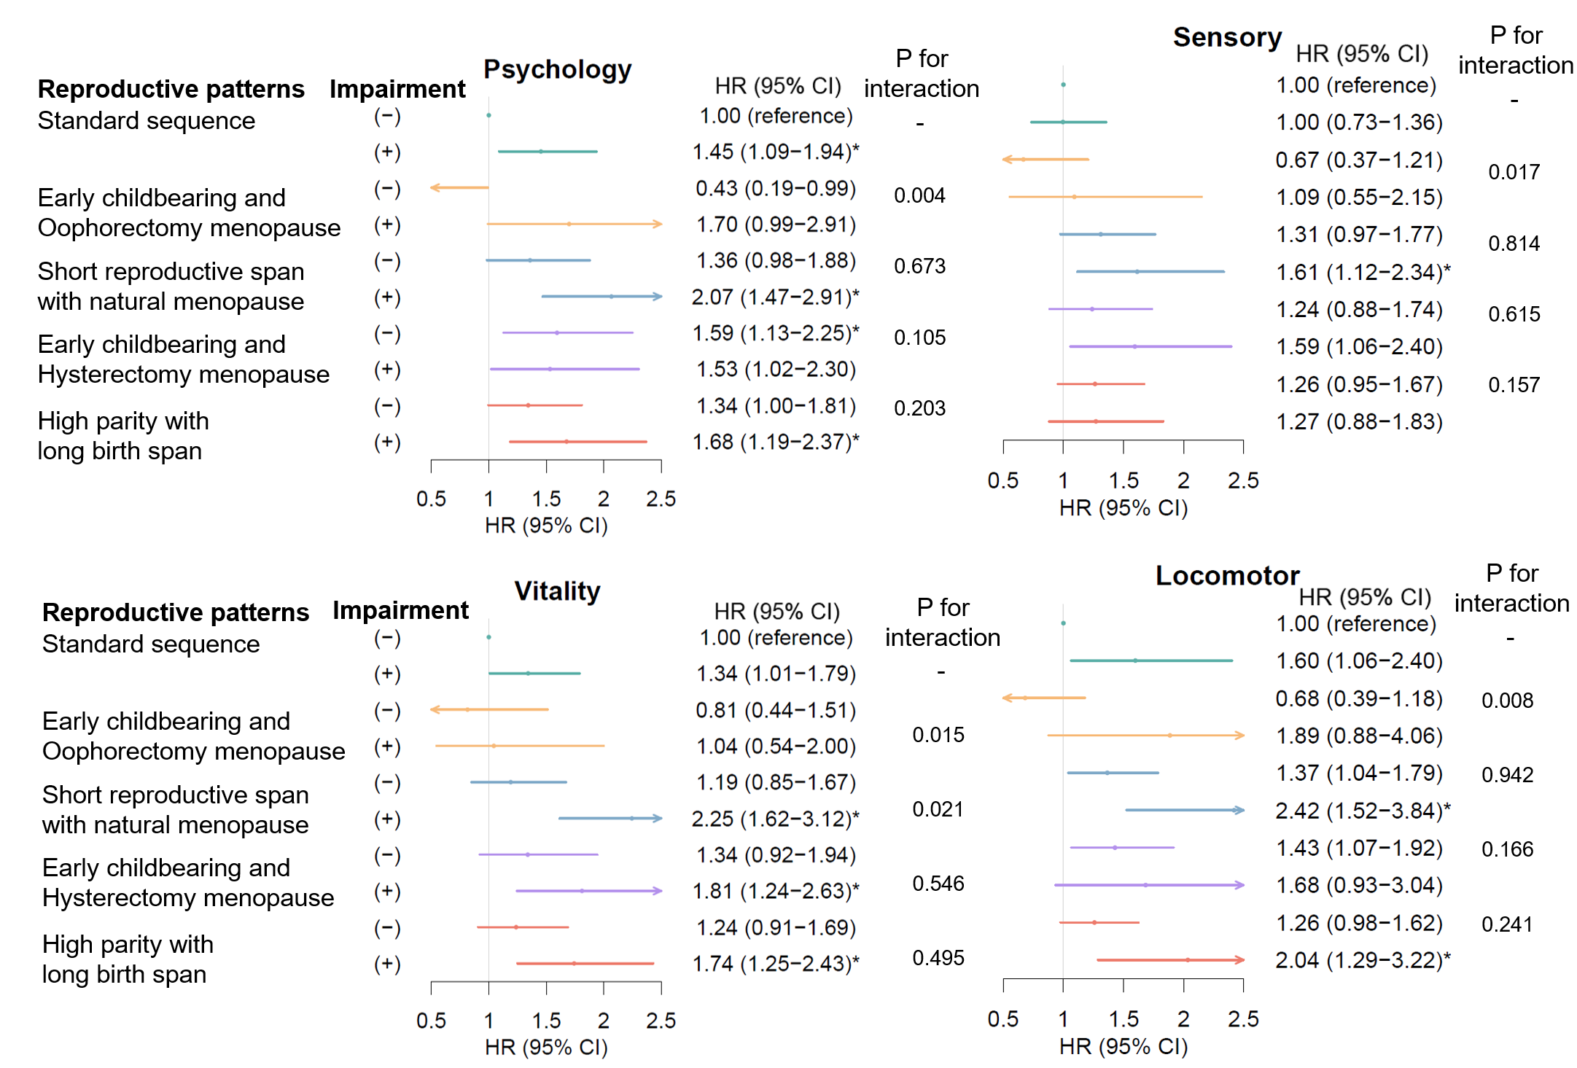

Figure S3. Association of reproductive life sequences with vascular dementia stratified by impairment of specific IC domains.

All models were adjusted for age at baseline, ethnicity, educational levels, employment status, income levels, smoking status, alcohol drinking status, physical activity, body mass index categories, ever usage of hormone-replacement therapy, disease history of cardiovascular disease, type 2 diabetes, and cancer, and polygenic risk score for Alzheimer’s disease.
* indicates false discovery rate-adjusted q<0.05 within each dementia outcome, based on Benjamini-Hochberg correction across 36 comparisons (4 intrinsic capacity domains × 9 non-reference joint groups).

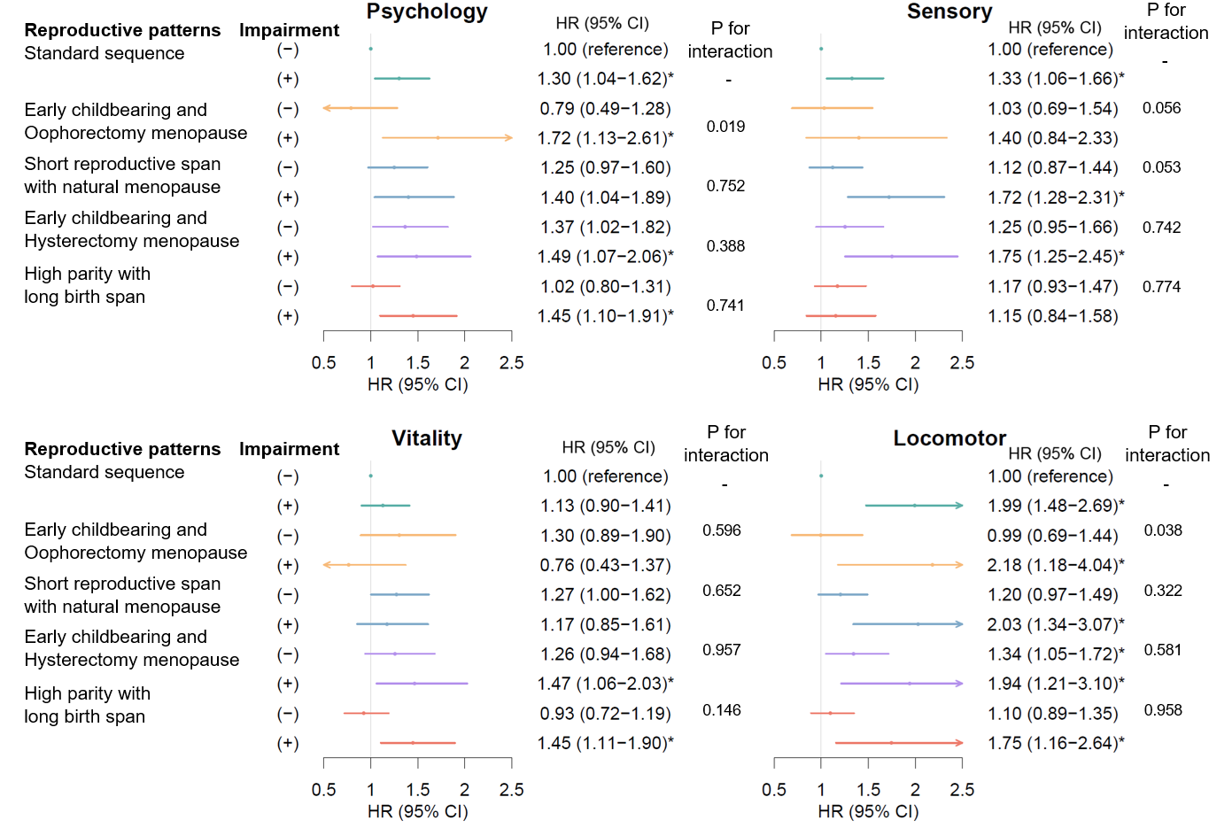

Figure S4. Association of reproductive life sequences with non-AD and non-VD dementia stratified by impairment of specific IC domains.

All models were adjusted for age at baseline, ethnicity, educational levels, employment status, income levels, smoking status, alcohol drinking status, physical activity, body mass index categories, ever usage of hormone-replacement therapy, disease history of cardiovascular disease, type 2 diabetes, and cancer, and polygenic risk score for Alzheimer’s disease.
* indicates false discovery rate-adjusted q<0.05 within each dementia outcome, based on Benjamini-Hochberg correction across 36 comparisons (4 intrinsic capacity domains × 9 non-reference joint groups).

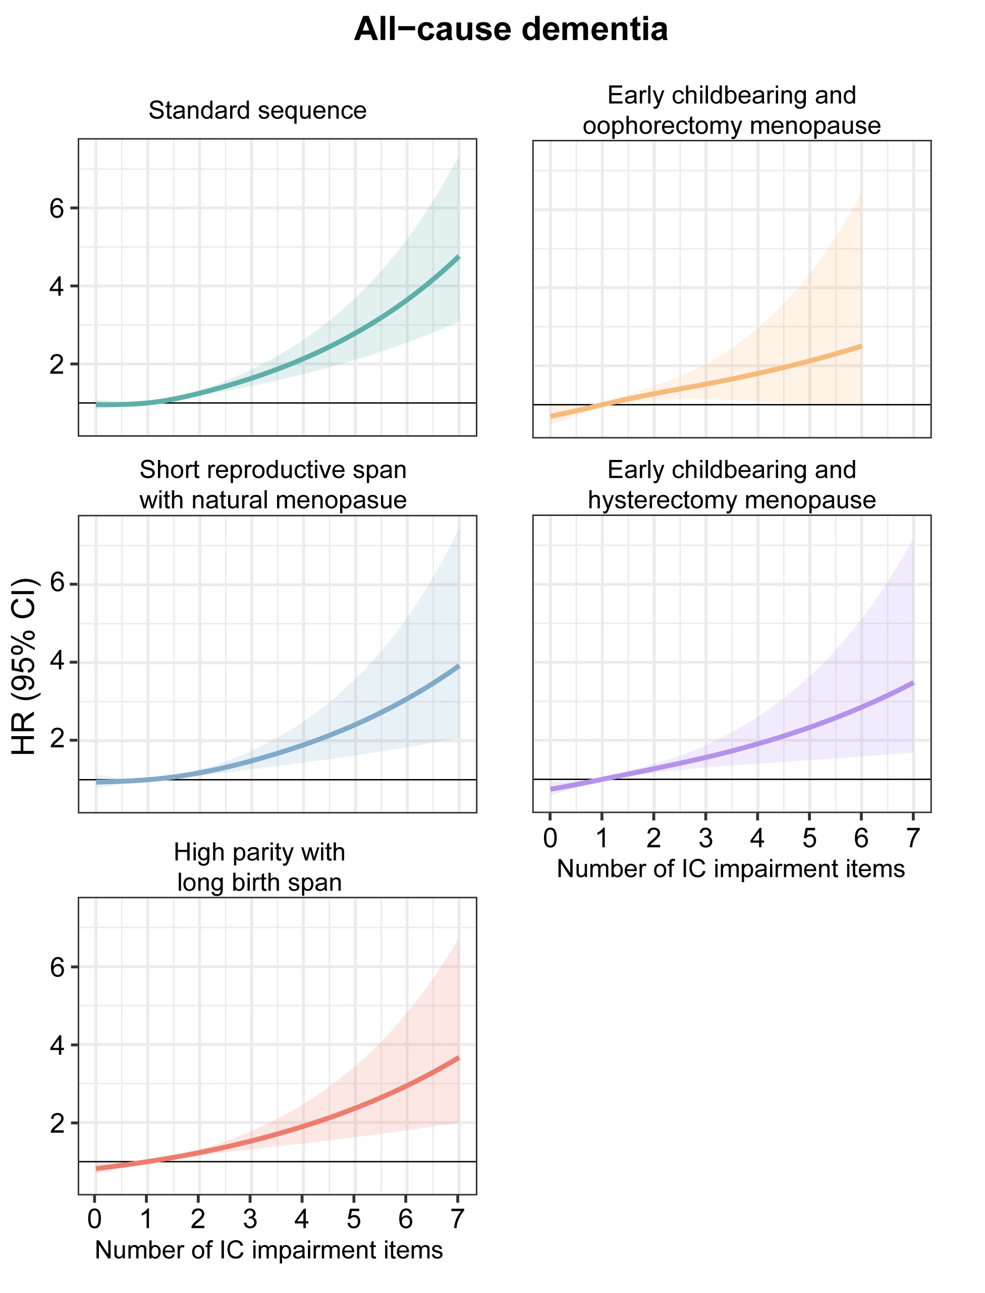

Figure S5. Association of number of IC impairments with the incidence of all-cause dementia stratified by different reproductive patterns.
All models were adjusted for age at baseline, ethnicity, educational levels, employment status, income levels, smoking status, alcohol drinking status, physical activity, body mass index categories, ever usage of hormone-replacement therapy, disease history of cardiovascular disease, type 2 diabetes, and cancer, and polygenic risk score for Alzheimer’s disease. The incidence rate was calculated as per 10,000 person-years.

Figure S6. Subgroup analysis of the association between reproductive life patterns with the incidence of all-cause dementia.
All models were adjusted for age at baseline, ethnicity, educational levels, employment status, income levels, smoking status, alcohol drinking status, physical activity, body mass index categories, ever usage of hormone-replacement therapy, disease history of cardiovascular disease, type 2 diabetes, and cancer, and polygenic risk score for Alzheimer’s disease. The standard sequence was used as the reference group.

