Supplementary figures
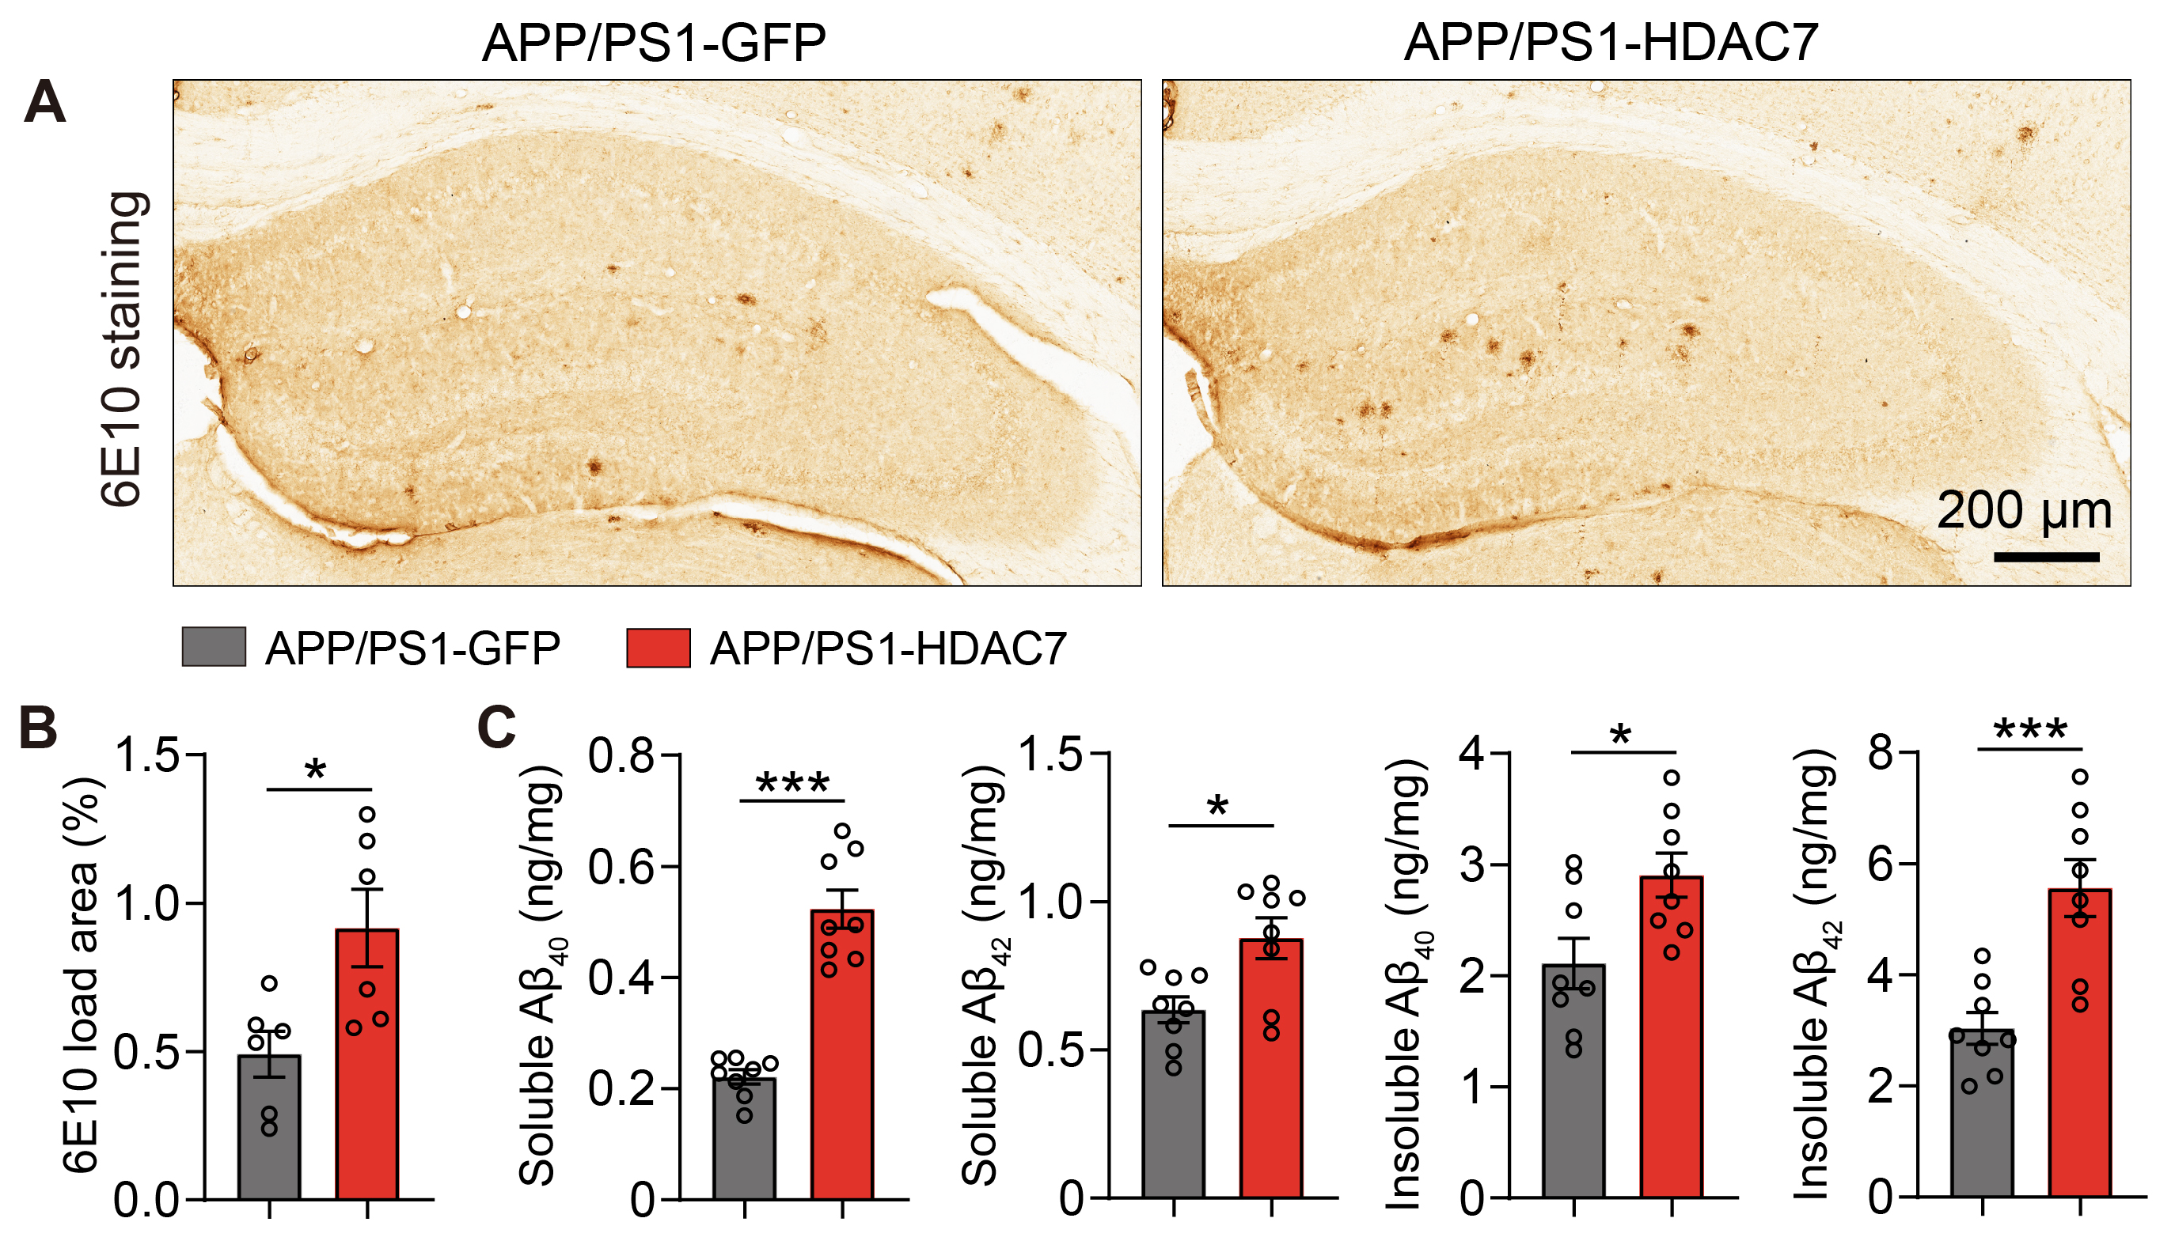
Supplementary Figure S1 Effects of astrocytic HDAC7 overexpression on Aβ pathology in APP/PS1 mice.
(A) Representative immunohistochemistry staining images with anti-6E10 antibody in the hippocampus of APP/PS1 mice. (B) quantification of 6E10-positive plaque load area in the hippocampus of APP/PS1 mice. n = 6 mice per group. (C) ELISA analysis of soluble and insoluble Aβ₄₀ and Aβ₄₂ in the hippocampal tissues from APP/PS1 mice. Statistical significance was determined by unpaired Student’s t test. Data are shown as mean ± SEM, *p < 0.05, **p < 0.01, ***p < 0.001.

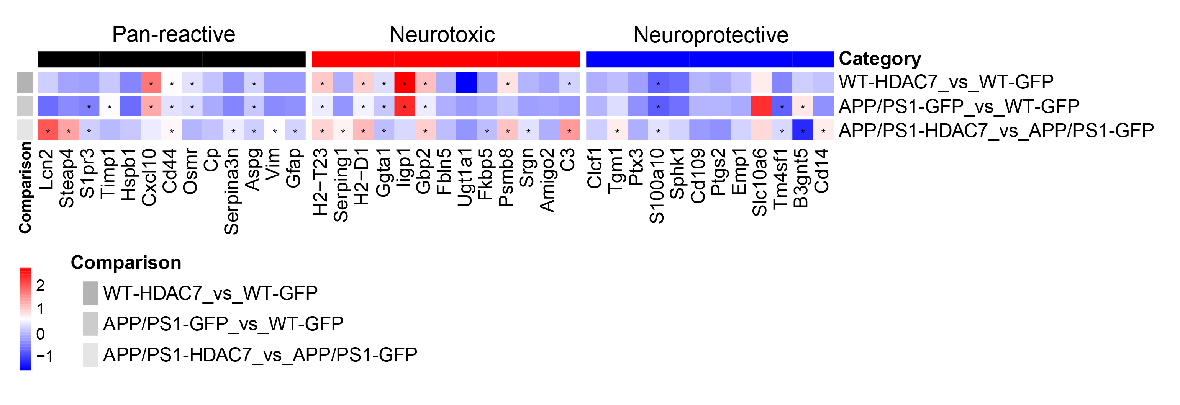
Supplementary Figure S2 Expression pattern of astrocyte substate marker genes based on RNA-seq in WT and APP/PS1 mice with astrocytic HDAC7 overexpression.
Heatmap showing the expression patterns of makers genes involving pan-reactive astrocyte, neurotoxic reactive astrocyte and neuroprotective astrocyte in the hippocampal tissues of WT and APP/PS1 mice with astrocytic HDAC7 overexpression.

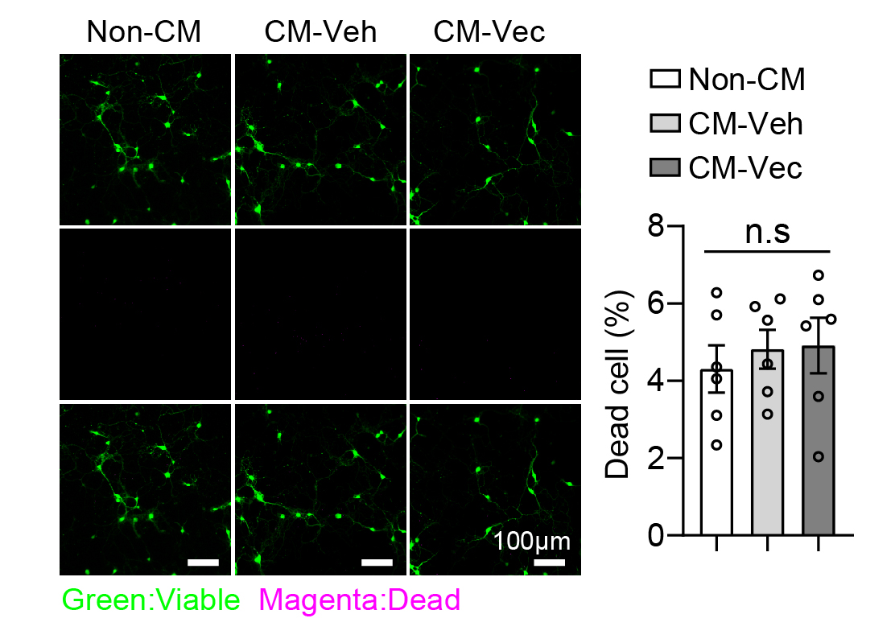
Supplementary Figure S3 Effects of resting astrocyte-conditioned medium on neuronal viability.
Calcein AM/EthD-1 staining showing cell viability (green: live cells) and death (megenta: dead cells) of primary neurons treated with non-conditioned medium (Non-CM), conditioned medium from vehicle-treated wildtype astrocytes (CM-veh), and conditioned medium from vector-expressing wildtype astrocytes (CM-Vec). n = 6 dishes per group. Statistical significance was determined by one-way ANOVA with Tukey’s post hoc analysis. Data are shown as mean ± SEM, n. s, not significant.

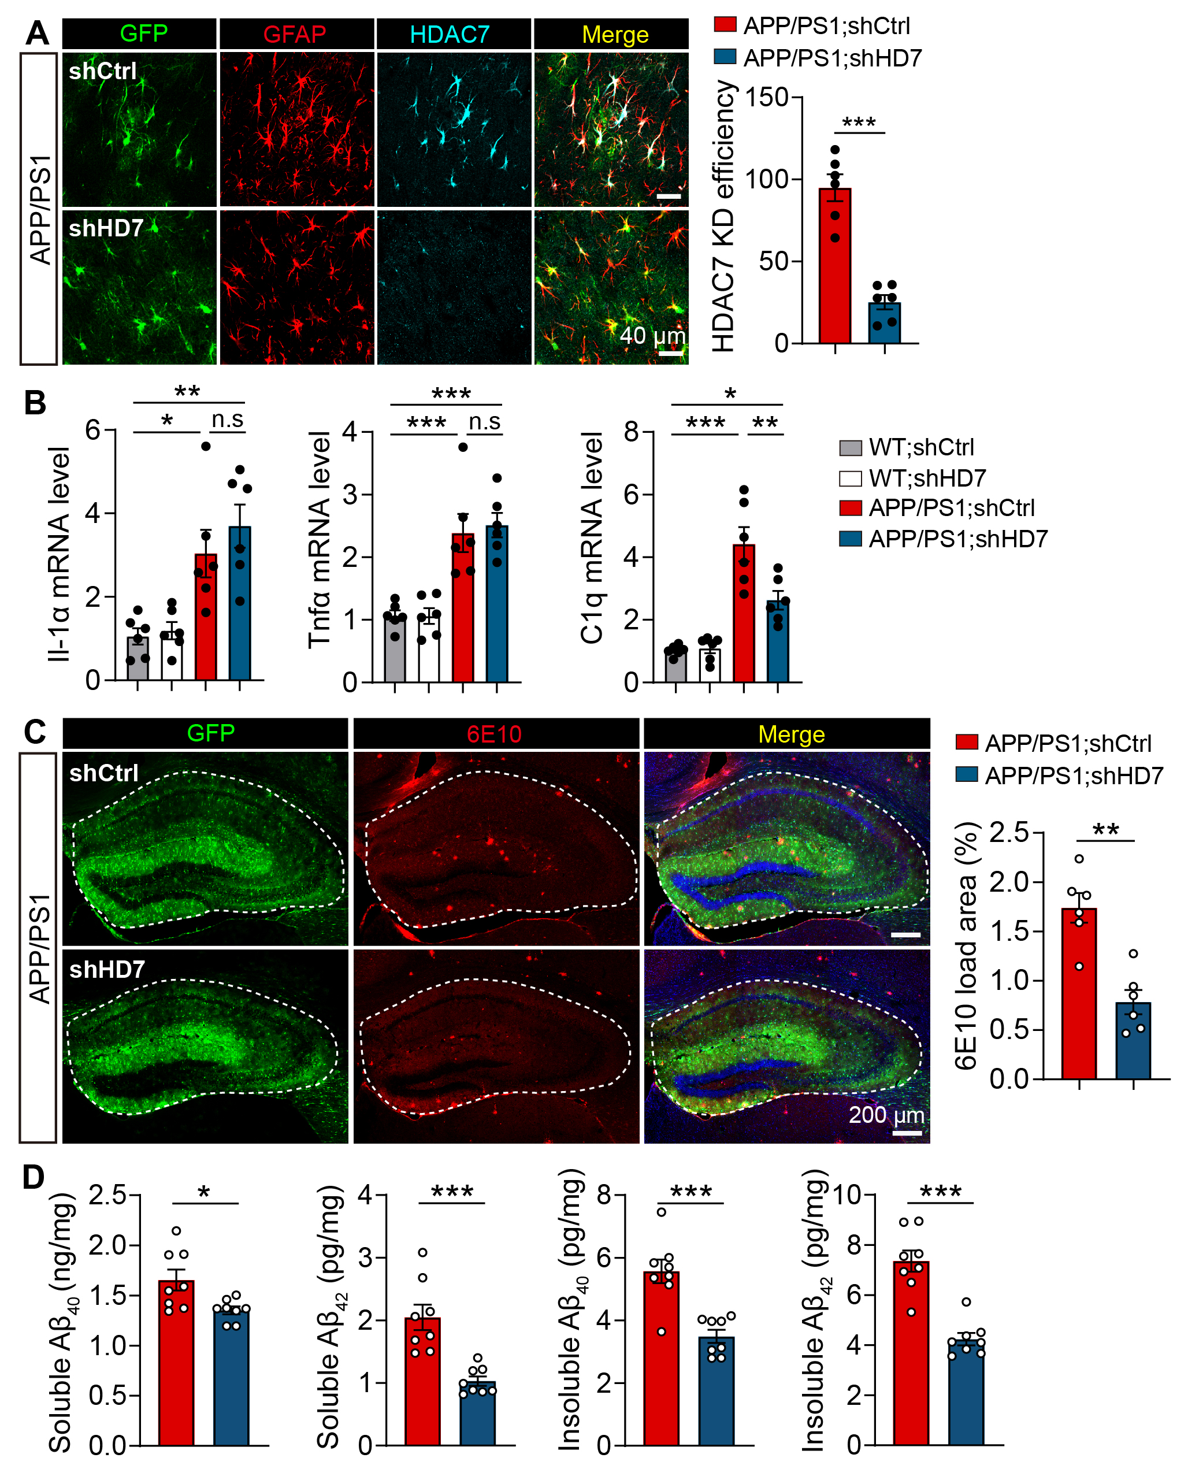 Supplementary Figure S4 Effects of astrocytic HDAC7 knockdown on the expression levels of Il-1α, Tnfα and C1q, and Aβ pathology in APP/PS1 mice.
(A) Representative immunostaining images and quantification of HDAC7 knockdown efficiency in the hippocampus of APP/PS1 mice after AAV injection, n = 6 mice per group. (B) RT-qPCR analysis of Il-1α, Tnfα and C1q in the hippocampus of WT and APP/PS1 mice with astrocytic HDAC7 knockdown, n = 6 mice per group. (C) Immunostaining analysis of Aβ plaques using anti-6E10 antibody in the hippocampal region of AAV-injected APP/PS1 mice, n = 6 mice per group. (D) ELISA analysis of soluble and insoluble Aβ₄₀ and Aβ₄₂ in the hippocampal tissues from AAV-injected APP/PS1 mice, n = 8 mice per group. Statistical significance was determined by unpaired Student’s t test. Data are shown as mean ± SEM, *p < 0.05, **p < 0.01, ***p < 0.001.

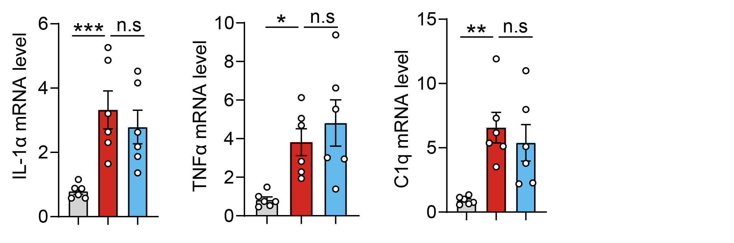Supplementary Figure S5 The expression levels of Il-1α, Tnfα and C1q in WT and APP/PS1 mice treated with TMP195.
RT-qPCR analysis of Il-1α, Tnfα and C1q in the hippocampus of WT and APP/PS1 mice treated with TMP195 or vehicle, n = 6 mice per group.

