Supplementary Figures

Fig. S1. AD-PRS from Lambert et al. applied to the TGEN2 cohort.
- Plots showing the difference between TGEN2-AD and TGEN2-CTL across a wide range of cutoffs for SNPs selection in the base dataset (from Benjamini-Hochberg adjusted-p (BHP) 5.0 x 10⁻⁰⁸ to BHP = 0.05). The best separation was observed at BHP = 0.05.
- Comparison of AD-PRS between TGEN-AD and TGEN2-CTL using the optimal cutoff (BHP = 0.05). The difference was statistically significant (P = 8.0 x 10⁻³⁹; OR = 2.50; number of independent SNPs = 182).
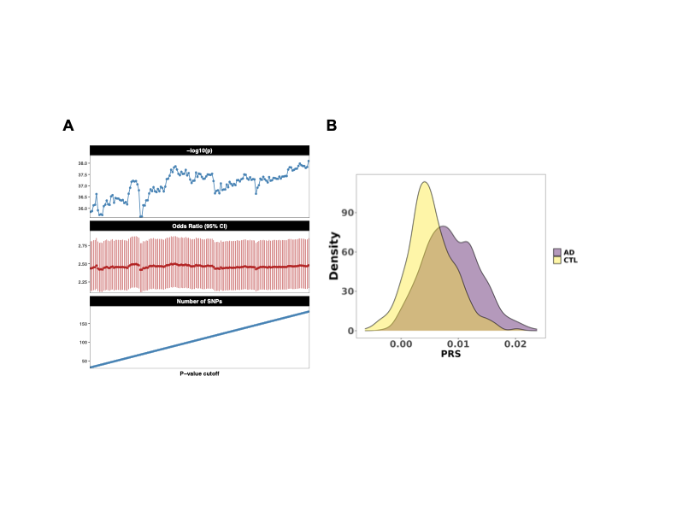

Fig. S2. AD-PRS from Wightman et al. applied to the TGEN2 cohort.
- Plots showing the difference between TGEN2-AD and TGEN2-CTL across a wide range of cutoffs for SNPs selection in the base dataset (from BHP 5.0 x 10⁻⁰⁸ to BHP = 0.05). The best separation was observed at BHP = 5.0 x 10⁻⁰⁸.
- Comparison of AD-PRS between TGEN-AD and TGEN2-CTL using the optimal cutoff (BHP = 0.05). The difference was statistically significant (P = 3.6 x 10⁻³⁷; OR = 2.43; number of independent SNPs = 63).
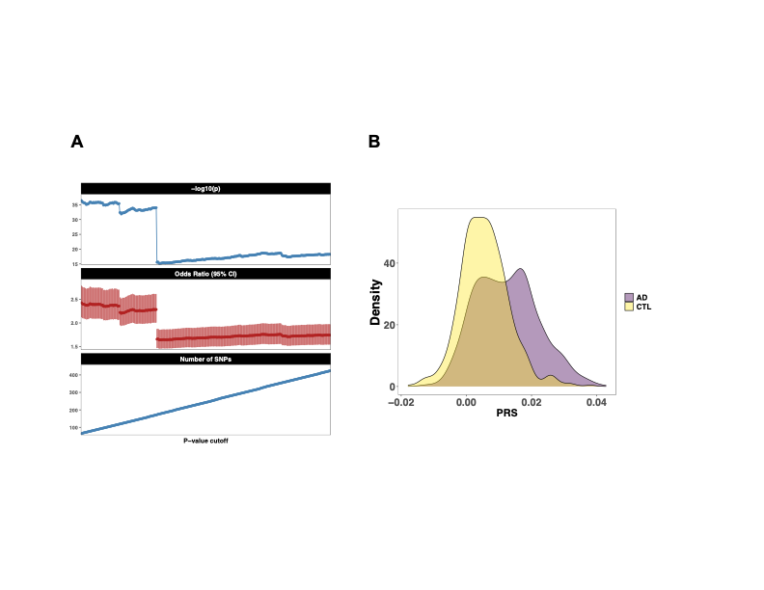

Fig. S3. AD-PRS from Bellenguez et al. applied to the TGEN2 cohort.
- Plots showing the difference between TGEN2-AD and TGEN2-CTL across a wide range of cutoffs for SNPs selection in the base dataset (from BHP 5.0 x 10⁻⁰⁸ to BHP = 0.05). The best separation was observed at BHP = 9.3 x 10⁻⁰³.
- Comparison of AD-PRS between TGEN-AD and TGEN2-CTL using the optimal cutoff (BHP = 0.05). The difference was statistically significant (P = 6.3 x 10⁻²⁶; OR = 1.92; number of independent SNPs = 219).
