Supplementary Materials
Supplementary Methods 2
Aβ PET Acquisition and definition of Aβ positivity 2
Dementia Prevalence Estimation 2
Supplementary Results 3
Infusion-Related Reactions 3
Supplementary Figure 1. Heatmap of biweekly lecanemab infusion doses, amyloid-related imaging abnormalities (ARIA) events, and treatment decisions 4
Supplementary Figure 2. Comparison of cerebral microbleed detection between SWI and T2*-GRE sequences in a representative ARIA-H case 5
Supplementary Table 1. CSF profiles of cases with BAPL 2 on florbetabetan PET scans 6
Supplementary Table 2. Individual-level comparison of hemorrhagic markers detected on T2*-GRE and SWI sequences in patients with ARIA-H. 7
Supplementary Table 3. Dementia Prevalence Status in 2024 (Unit: persons, %) 10
Supplementary Table 4. Comparison of Reimbursement Structures and Key Challenges in Lecanemab Treatment Across Countries 12

Supplementary Methods

Aβ PET Acquisition and definition of Aβ positivity
Brain amyloid PET imaging was performed using a Discovery 690, Discovery 710, or Discovery 690 Elite PET/CT scanner (GE Healthcare) or a Biograph Vision 600 PET/CT scanner (Siemens Healthineers). At Asan Medical Center, scans were acquired 90–110 minutes after intravenous administration of 300 ± 30 MBq of [¹⁸F]florbetaben. For data obtained from external sites, [¹⁸F]florbetaben or [¹⁸F]flutemetamol PET scans were acquired according to each site’s routine clinical imaging procedures. All scans were reviewed by nuclear medicine specialist (M.Y.O) and neurologist. Treatment decisions were primarily based on visual reads. For [¹⁸F]florbetaben PET scans, each of the predefined cortical regions (lateral temporal, frontal, posterior cingulate/precuneus, and parietal cortex) was visually rated using a regional cortical tracer uptake (RCTU) scale. Based on these regional ratings, scans were classified at the subject level as amyloid-positive or amyloid-negative using a binary assessment reflecting overall brain amyloid plaque load (BAPL). A scan was considered negative when cortical uptake was lower than white matter across all regions, indicating sparse or absent amyloid deposition. In contrast, a scan was considered positive when one or more regions showed tracer uptake equal to or exceeding that of white matter, reflecting moderate to frequent amyloid deposition[1]. Similarly, [¹⁸F]flutemetamol PET scans were regarded as positive when one of the five brain regions (frontal, parietal, posterior cingulate and precuneus, striatum, and lateral temporal lobes) was positive in either hemisphere[2]. In case of disagreement, consensus between the two was reached through discussion. In cases with borderline findings, centiloid values were additionally considered.

Dementia Prevalence Estimation
Estimates were calculated by the Central Dementia Center using sex- and age-specific prevalence rates from the 2023 Dementia Epidemiological Survey (Ministry of Health and Welfare & Central Dementia Center), applied to the Resident Registered Mid-Year Population (Statistics Korea) of each corresponding year (https://www.data.go.kr/data/15073342/fileData.do?utm_source).
Because estimates are derived by multiplying the Resident Registered Mid-Year Population by prevalence rates, rounding may cause slight discrepancies in the total (differences of 1 or more persons).
* The Resident Registered Mid-Year Population is calculated by Statistics Korea as the mid-point population of the year, using the arithmetic mean of the registered population at the end of the previous year and at the end of the current year.
Example: 2023 Resident Registered Mid-Year Population
= (Registered population as of Dec 31, 2022 + Registered population as of Dec 31, 2023) / 2

Supplementary Results

Infusion-Related Reactions
The most common symptom was fever (32/41, 78%), often accompanied by chills (15/41, 37%), headache (8/41, 20%), myalgia (7/41, 17%), and skin rash (5/41, 12%). Among patients without fever, non-febrile events included skin rash (3/41, 7%), acute confusion (1/41, 2%), headache (1/41, 2%), chills (1/41, 2%), and hypotension (2/41, 4%; one asymptomatic, one symptomatic). Most reactions were mild to moderate (39/41, 95%), while two patients (5%) experienced severe reactions requiring lecanemab discontinuation, which are described in detail later in the Results section. Premedication was not routinely used; however, patients with prior fever received acetaminophen before the second and third infusions, which was discontinued if fever did not recur. Two patients with recurrent rash after the third infusion were treated with oral prednisolone.

Supplementary Figure 1. Heatmap of biweekly lecanemab infusion doses, amyloid-related imaging abnormalities (ARIA) events, and treatment decisions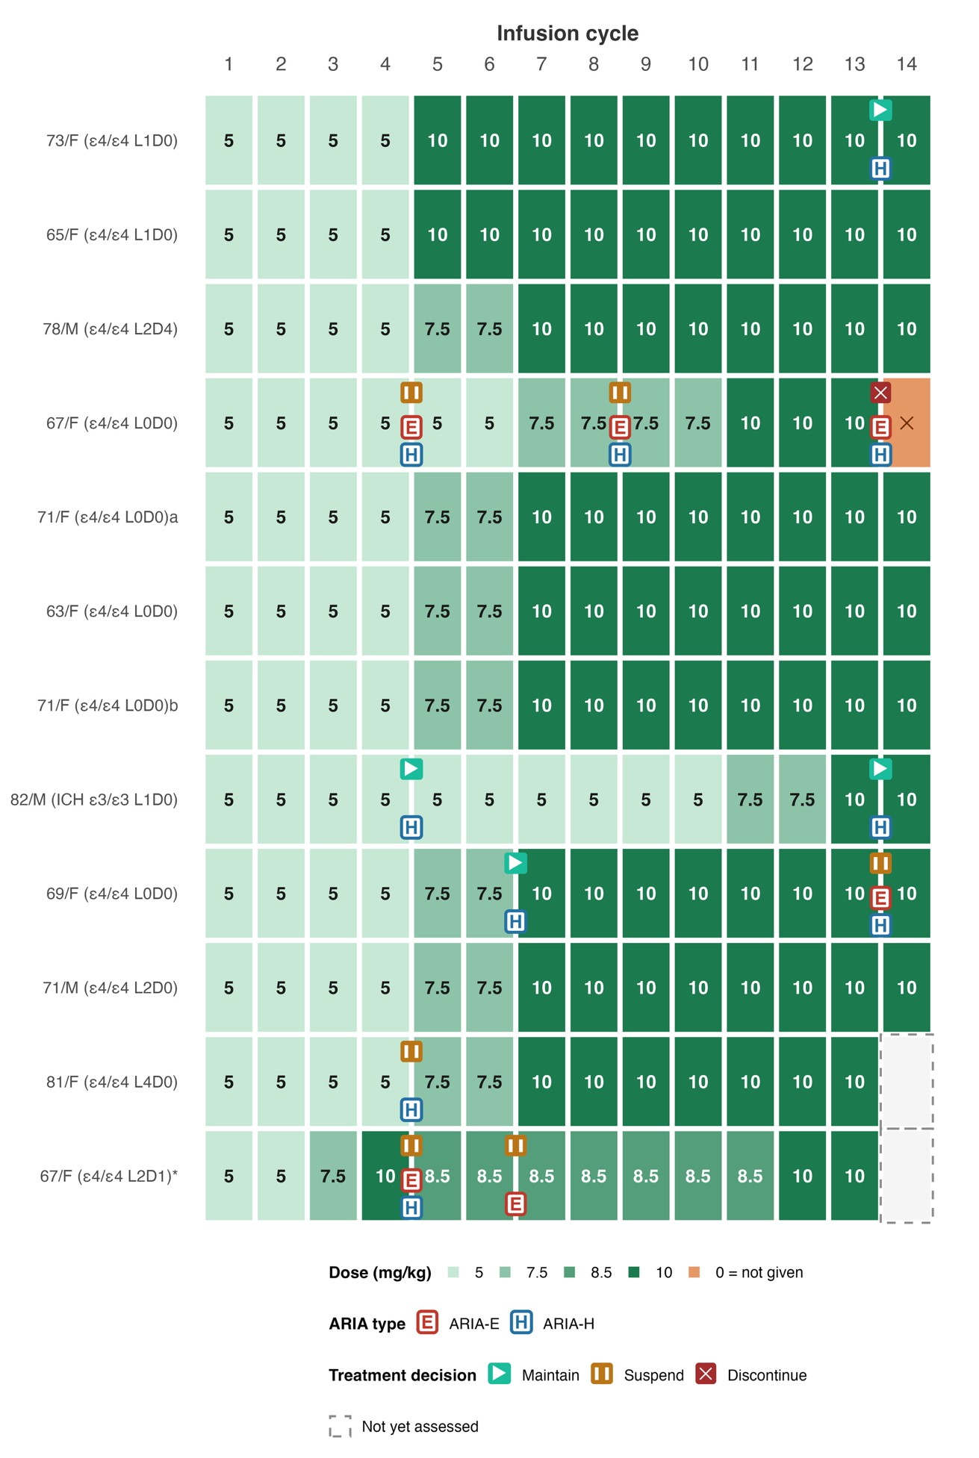
Each row represents a dose-titrated patient (all APOE ε4/ε4 homozygotes and the patient with prior intracerebral hemorrhage), ordered from top to bottom by the chronological sequence of treatment initiation (earliest at the top), and columns indicate successive infusion numbers rather than proportional calendar time; therefore, temporary suspension intervals are indicated by the treatment-decision icons and subsequent resumption pattern, not by proportional time gaps between cells. Cell shading intensity corresponds to the dose administered at each cycle (5, 7.5, 8.5, or 10 mg/kg), as indicated in the legend, with the numeric dose printed within each cell; orange cells denote cycles in which lecanemab was not given (0 mg/kg), and cells outlined with a dashed border indicate cycles not yet assessed at the time of analysis. ARIA-E (red, boxed "E") and ARIA-H (blue, boxed "H") markers are positioned on the gridline between two infusion cycles to indicate detection on surveillance MRI performed prior to the subsequent infusion (e.g., a marker between cycles 4 and 5 indicates ARIA detected on MRI before the 5th infusion). Treatment decisions made at each MRI time point are shown above the ARIA markers: maintain (green triangle), suspend (orange double bar), and discontinue (red cross). Patient labels on the y-axis display age, sex, APOE genotype, and baseline counts of lobar (L) and deep (D) cerebral microbleeds (CMBs); a history of intracerebral hemorrhage (ICH) is additionally noted where present. Superscripts a and b distinguish two patients sharing identical demographic and CMB labels.
*Case 67/F (ε4/ε4, L2D1) received a reduced dose (400 mg; 8.5 mg/kg) based on individualized clinical decision-making considering recurrent ARIA risk and treatment cost.
Abbreviations: ARIA-E, amyloid-related imaging abnormalities–edema/effusion; ARIA-H, amyloid-related imaging abnormalities–hemorrhage/hemosiderin deposition; APOE, apolipoprotein E; CMBs, cerebral microbleeds; ICH, intracerebral hemorrhage

Supplementary Figure 2. Comparison of cerebral microbleed detection between SWI and T2*-GRE sequences in a representative ARIA-H case
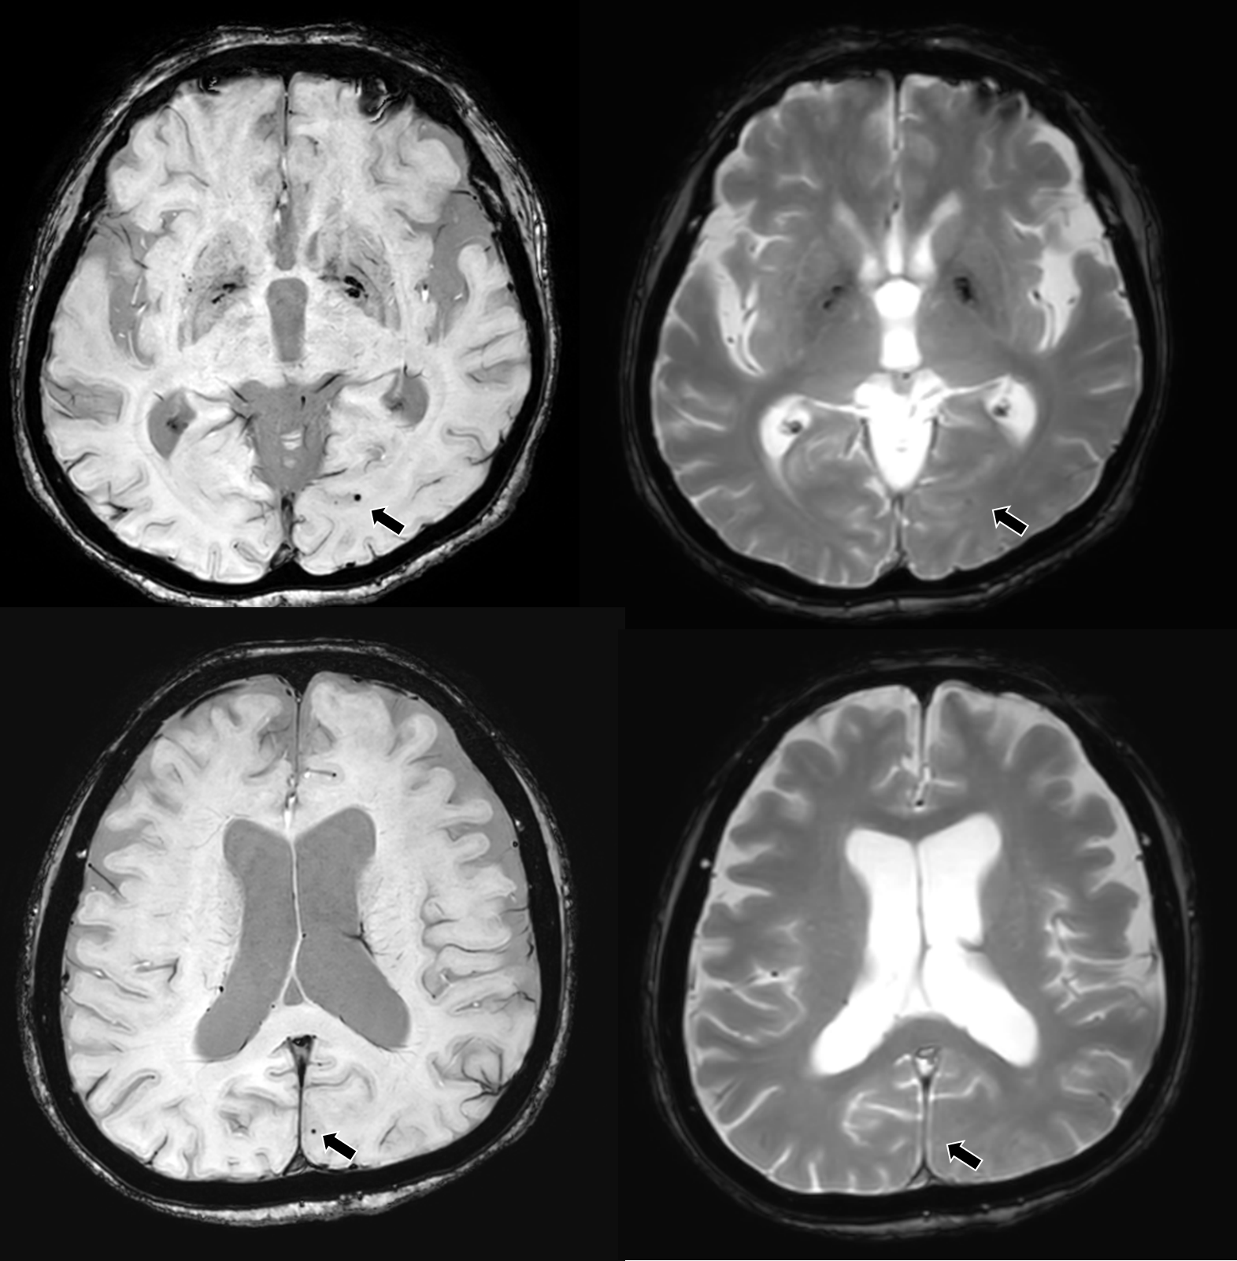
Axial SWI (left) and T2*-GRE (right) images obtained at the same time point in two different slice levels (upper and lower rows). Black arrows indicate cerebral microbleeds that are clearly visualized as hypointense foci on SWI but are less conspicuous or barely discernible on the corresponding T2*-GRE images. This case illustrates the superior sensitivity of SWI for detecting small hemorrhagic lesions associated with ARIA-H.
Abbreviations: SWI, Susceptibility-Weighted Imaging; GRE, Gradient Echo

Supplementary Table 1. CSF profiles of cases with BAPL 2 on florbetabetan PET scans
No | age | sex | Education years | APOE | MMSE | CDR-GS  (CDR-SB) | CSF AD risk | pTau181/Abeta Ratio | Abeta42 | pTau181
1 | 69 | F | 18 | E3/E3 | 28 | 0.5 (1) | high | 0.04 | 1074 | 43
2 | 73 | F | 9 | E3/E4 | 27 | 0.5 (0.5) | high | 0.035 | 1697 | 59
3 | 77 | M | 1 | E3/E3 | 19 | 0.5 (2.5) | high | 0.051 | 35 | 17
Abbreviations: MMSE, Mini-Mental State Examination; CDR-GS, clinical dementia rating – global scores; CDR-SB, clinical dementia rating – sum of boxes; CSF, cerebrospinal fluid; AD, Alzheimer's disease; ptau, phosphorylated-tau

Supplementary Table 2. Individual-level comparison of hemorrhagic markers newly detected on T2*-GRE and SWI sequences in patients with ARIA-H.
 |  |  |  |  |  |  |  |  | T2*-GRE |  | SWI
Age/Sex | APOE | Baseline CMB | Baseline CDR/CDRSB | ARIA class | Severity | First ARIAª | Course & outcome | MRI for GRE and SWI comparison^{b} | CMB | cSS | CMB | cSS
67/F | E4/E4 | 0 | 0.5/2.5 | ARIA-E/H | Moderate | 5th | Discontinued; Moderate ARIA-E/H before the 5th infusion, prompting temporary treatment suspension; recurrent ARIA-E/H before the 9^{th &} 14th infusion | 5th | 0 | – | 0 | 1
58/F | E3/E4 | 0 | 1/8 | ARIA-E/H | Mild | 5th | Suspended; Mild ARIA-E/H before the 5th infusion, prompting temporary treatment suspension; recurrent ARIA-E before the 9th infusion | 5th | 0 | – | 3 | –
69/F | E4/E4 | 0 | 1/7 | ARIA-E/H | Moderate | 7th | Suspended; Mild ARIA-H before the 7th infusion, continuation led to moderate ARIA-E/H before the 14th infusion | 14th | 1 | – | 5 | –
62/F | E3/E3 | 0 | 0.5/3 | ARIA-E/H | Moderate | 5th | Suspended; Mild ARIA-E before the 5th infusion, prompting temporary treatment suspension; re-initiation led to moderate ARIA-E/H at the 14th infusion. | 14th | 4 | – | 4 | –
77/M | E3/E3 | 0 | 0.5/2.5 | ARIA-E/H | Mild | 7th | Discontinued; Mild ARIA-E/H, but discontinued treatment due to new onset parkinsonism | 7th | 0 | – | 2 | 1
67/F | E4/E4 | 3 | 0.5/2 | ARIA-E/H | Mild | 5th | Temporarily suspended but subsequently resumed; mild ARIA-E/H before the 5th infusion and recurrent ARIA-E before the 7th infusion | 5th | 2 | – | 3 | –
80/F | E2/E3 | 0 | 0.5/0.5 | ARIA-H | Mild | 7th | Temporarily suspended, but subsequently resumed | 7th | 0 | 1 | 0 | 1
67/F | E3/E4 | 8 | 0.5/0.5 | ARIA-H | Mild | 14th | Continued | 14th | 1 | – | 4 | –
73/F | E4/E4 | 1 | 0.5/1.5 | ARIA-H | Mild | 14th | Continued | 14th | 1 | – | 1 | –
84/M | E3/E4 | 9 | 0.5/3 | ARIA-H | Severe | 5th | Discontinued; Mild ARIA-H before the 5th infusion; treatment continuation led to severe ARIA-H at the 14th infusion | 14th | 4 | Multiple | 17 | Multiple
75/F | E3/E4 | 0 | 0.5/2.5 | ARIA-H | Mild | 5th | Continued | 5th | 0 | – | 2 | –
79/F | E3/E4 | 0 | 1/5 | ARIA-H | Mild | 5th | Continued | 5th | 1 | – | 1 | –
80/M | E3/E4 | 1 | 0.5/3.5 | ARIA-H | Mild | 5th | Continued | 5th | 0 | – | 1 | –
76/F | E3/E4 | 0 | 0.5/1.5 | ARIA-H | Mild | 5th | Continued | 5th | 1 | – | 1 | –
85/M | E3/E4 | 3 | 1.5/4.5 | ARIA-H | Mild | 7th | Continued | 7th | 1 | – | 1 | –
82/M | E3/E3 | 1 | 0.5/2.5 | ARIA-H | Mild | 5th | Continued with dose reduction; mild ARIA-H before the 5th infusion and recurrent mild ARIA-H before the 14th infusion | 5th | 1 | 1 | 2 | 1
77/F | E3/E4 | 3 | 1/6 | ARIA-H | Mild | 5th | Continued | 5th | 0 | – | 1 | –
81/F | E4/E4 | 4 | 0.5/2 | ARIA-H | Moderate | 5th | Temporarily suspended, but subsequently resumed | 5th | 6 | – | 10 | –
70/M | E3/E4 | 2 | 0.5/1 | ARIA-H | Mild | 5th | Continued | 5th | 2 | – | 2 | –
78/F | E3/E3 | 3 | 0.5/4 | ARIA-H | Mild | 5th | Continued | 5th | 1 | – | 1 | –

ARIA-H severity was graded according to the criteria proposed by Sperling et al.: mild (<5 new incident microhemorrhages, ≤2 areas of superficial siderosis), moderate (5–9 new incident microhemorrhages, >2 areas of superficial siderosis), and severe (≥10 new incident microhemorrhages or symptomatic ARIA-H). CMB and cSS counts represent new incident lesions detected at the time of ARIA-H identification
Abbreviations: ARIA, amyloid-related imaging abnormalities; ARIA-E, ARIA with edema/effusion; ARIA-H, ARIA with hemosiderin deposition (microhemorrhage and/or superficial siderosis); CMB, cerebral microbleed; cSS, cortical superficial siderosis; GRE, gradient-recalled echo; SWI, susceptibility-weighted imaging; APOE, apolipoprotein E genotype; – = absent
ªThe infusion number at which ARIA was first detected.
^{b}The infusion number at which the MRI for the GRE and SWI comparison was performed

Supplementary Table 3. Dementia Prevalence Status in 2024 (Unit: persons, %)
City/Province | Population aged 60 years and older | Estimated number of people with dementia | Estimated dementia prevalence (%) | Estimated number of mild dementia cases | Estimated number of moderate dementia cases | Estimated number of severe dementia cases | Estimated number of individuals diagnosed with MCI | Estimated MCI prevalence (%) | Early AD (mild dementia & MCI)
Nationwide | 14,132,875 | 954,789 | 6.76 | 646,392 | 281,663 | 26,734 | 3,931,491 | 27.82 | 4,577,883
Seoul | 2,450,887 | 162,630 | 6.64 | 110,100 | 47,976 | 4,554 | 680,189 | 27.75 | 790,289
Busan | 1,049,327 | 69,257 | 6.6 | 46,887 | 20,431 | 1,939 | 289,894 | 27.63 | 336,781
Daegu | 681,200 | 45,108 | 6.62 | 30,538 | 13,307 | 1,263 | 188,584 | 27.68 | 219,122
Incheon | 764,246 | 47,883 | 6.27 | 32,417 | 14,125 | 1,341 | 211,142 | 27.63 | 243,558
Gwangju | 344,397 | 22,869 | 6.64 | 15,482 | 6,746 | 640 | 95,607 | 27.76 | 111,090
Daejeon | 362,753 | 23,515 | 6.48 | 15,920 | 6,937 | 658 | 100,385 | 27.67 | 116,304
Ulsan | 278,660 | 15,874 | 5.7 | 10,747 | 4,683 | 444 | 76,478 | 27.45 | 87,225
Sejong | 64,851 | 4,134 | 6.37 | 2,799 | 1,220 | 116 | 17,931 | 27.65 | 20,730
Gyeonggi | 3,229,747 | 206,317 | 6.39 | 139,677 | 60,864 | 5,777 | 896,213 | 27.75 | 1,035,890
Gangwon | 520,150 | 37,108 | 7.13 | 25,122 | 10,947 | 1,039 | 145,608 | 27.99 | 170,730
Chungcheongbuk-do (Chungbuk) | 479,937 | 33,505 | 6.98 | 22,683 | 9,884 | 938 | 134,052 | 27.93 | 156,735
Chungcheongnam-do (Chungnam) | 642,790 | 47,696 | 7.42 | 32,290 | 14,070 | 1,335 | 180,841 | 28.13 | 213,131
Jeollabuk-do (Jeonbuk) | 583,647 | 44,418 | 7.61 | 30,071 | 13,103 | 1,244 | 164,246 | 28.14 | 194,317
Jeollanam-do (Jeonnam) | 644,158 | 50,855 | 7.89 | 34,429 | 15,002 | 1,424 | 182,337 | 28.31 | 216,766
Gyeongsangbuk-do (Gyeongbuk) | 885,202 | 64,778 | 7.32 | 43,855 | 19,110 | 1,814 | 247,934 | 28.01 | 291,788
Gyeongsangnam-do (Gyeongnam) | 975,225 | 66,360 | 6.8 | 44,925 | 19,576 | 1,858 | 270,872 | 27.78 | 315,797
Jeju | 175,703 | 12,482 | 7.1 | 8,450 | 3,682 | 350 | 49,179 | 27.99 | 57,629
Abbreviations: AD, Alzheimer's disease; MCI, mild cognitive impairment

Supplementary Table 4. Comparison of Reimbursement Structures and Key Challenges in Lecanemab Treatment Across Countries
 | Korea | U.S. | Japan
Approval | Traditional Full Approval granted in May 2024 | Traditional Full Approval granted in July 2023 | Approved in September 2023
Reimbursement Structure | Not reimbursed by national health insurance system | Medicare reimbursement under CMS Coverage with Evidence Development (CED), including registry participation | Reimbursed by national health insurance system with specific age-based co-payment rates (e.g., 10–30%) and price-capping mechanisms.
Clinical eligibility / prescribing framework | Approved indication required; K-AUR-guided eligibility without a fixed lower MMSE cutoff, with final treatment decisions made by the treating physician | Approved indication required; prespecified CMS clinical eligibility criteria apply for Medicare-covered use | Approved indication required; prespecified national clinical eligibility criteria apply, including cognitive-severity thresholds
Key challenges | - High out-of-pocket burden  - Patient overconcentration at tertiary care centers and insufficient infusion infrastructure  - No dedicated reimbursement for treatment infrastructures or safety monitoring. | - Substantial financial burden due to high drug cost and ancillary service requirement  - Administrative barriers from registry participation | - Balancing the high cost with the sustainability of the universal health insurance system  - Absence of APOE testing coverage under national health insurance  - Requirement for infusion infrastructure, resulting in regional disparities
Sources: Country-specific reimbursement structures and key challenges were informed by published literature. Cost and ancillary service data for the U.S. were referenced from Arbanas et al. [3]. Infrastructure barriers and reimbursement challenges in Japan were referenced from Sato et al. [4] and Ohashi et al. [5]. Information for Korea was based on the national health insurance reimbursement guidelines and the authors' institutional experience.

References
1. Barthel H, Gertz HJ, Dresel S, Peters O, Bartenstein P, Buerger K, et al. Cerebral amyloid-beta PET with florbetaben (18F) in patients with Alzheimer's disease and healthy controls: a multicentre phase 2 diagnostic study. The Lancet Neurology. 2011;10:424–35.
2. Kim SE, Woo S, Kim SW, Chin J, Kim HJ, Lee BI, et al. A Nomogram for Predicting Amyloid PET Positivity in Amnestic Mild Cognitive Impairment. J Alzheimers Dis. 2018;66:681–91.
3. Arbanas JC, Damberg CL, Leng M, Harawa N, Sarkisian CA, Landon BE, et al. Estimated Annual Spending on Lecanemab and Its Ancillary Costs in the US Medicare Program. JAMA Intern Med. 2023;183:885–9.
4. Sato K, Niimi Y, Ihara R, Iwata A, Nemoto K, Arai T, et al. Real-world lecanemab adoption in Japan 1 year after launch: Insights from 311 specialists on infrastructure and reimbursement barriers. Alzheimers Dement. 2025;21:e70652.
5. Ohashi K, Takahashi-Iwata I, Jieyu Z, Sakushima K, Yabe I, Ogasawara K. Are There Shortages and Regional Disparities in Lecanemab Treatment Facilities? A Cross-Sectional Study. Health Serv Insights. 2024;17:11786329241299312.

