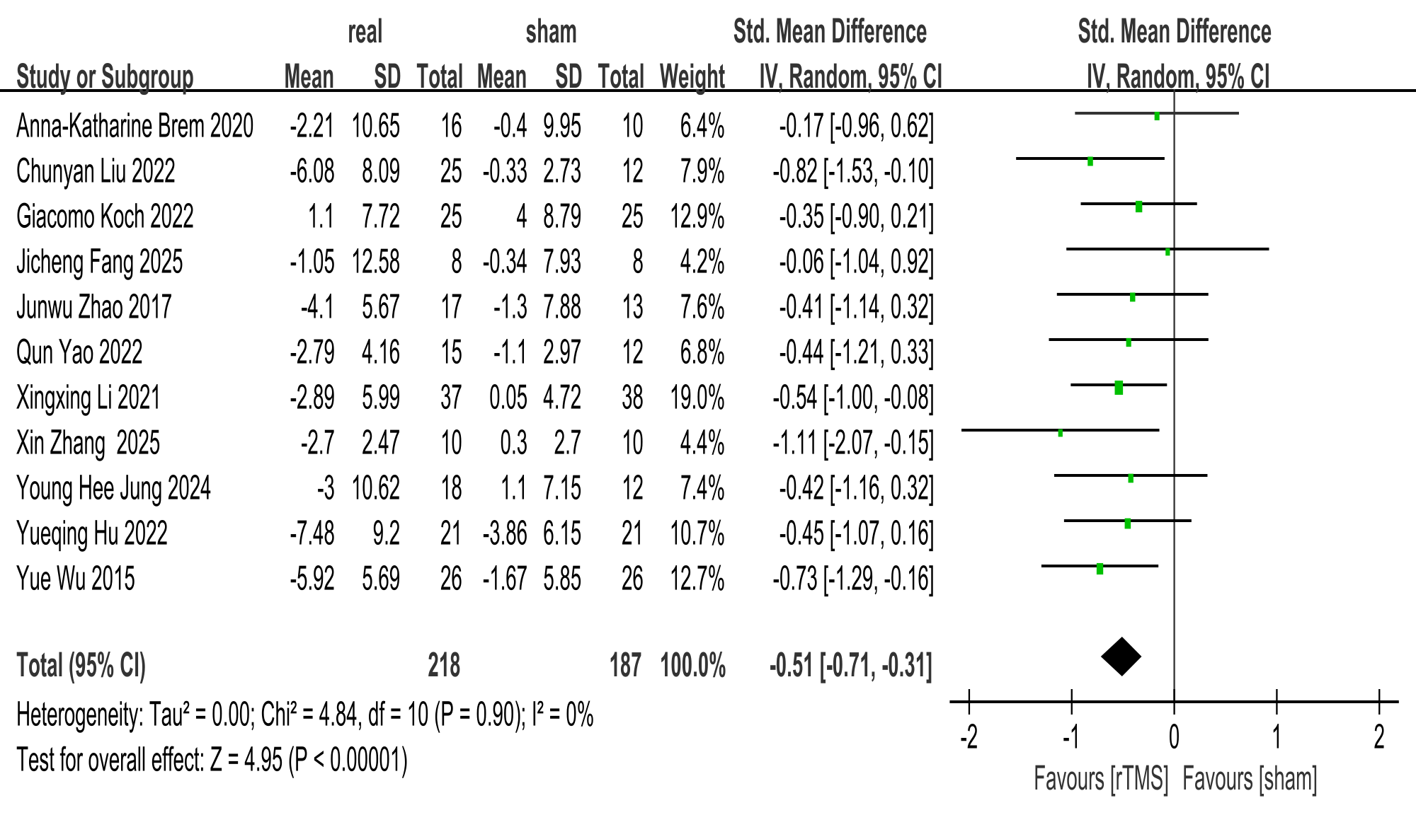
Supplementary Figure S2A. Forest plot of immediate ADAS-cog improvement.

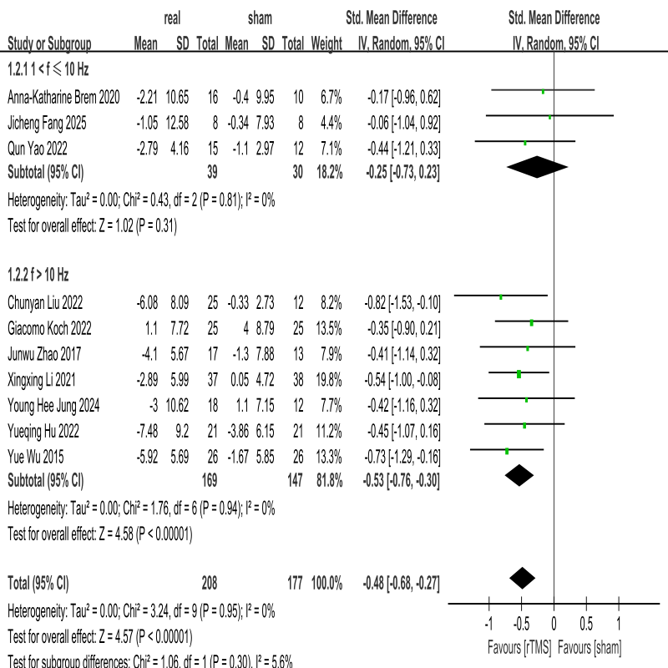
Supplementary Figure S2B. Subgroup analysis of ADAS-cog by stimulation frequency (1< f ≤10 Hz vs. f > 10 Hz).

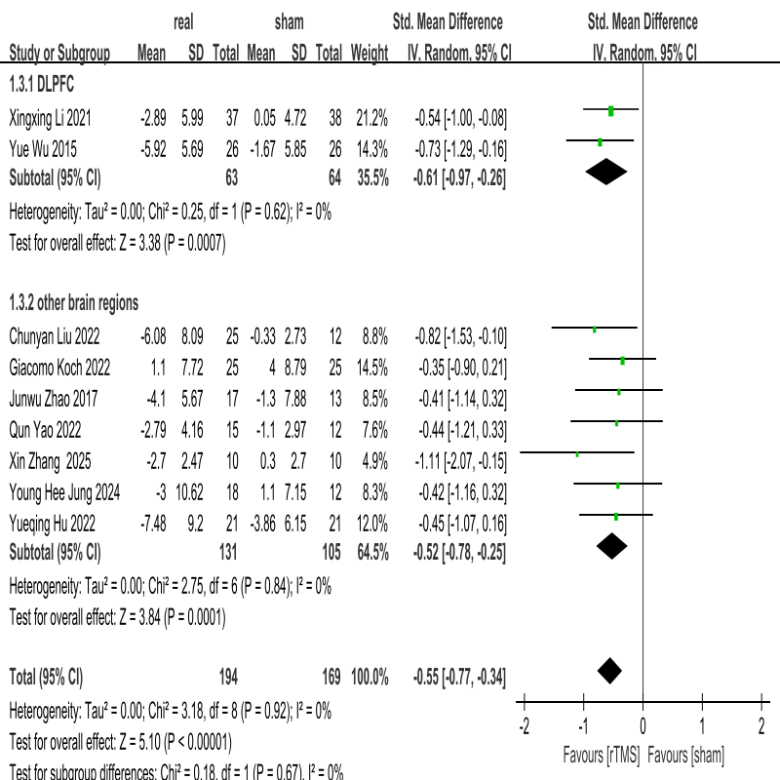
Supplementary Figure S2C. Subgroup analysis of ADAS-cog by stimulation target (DLPFC vs. other brain regions).

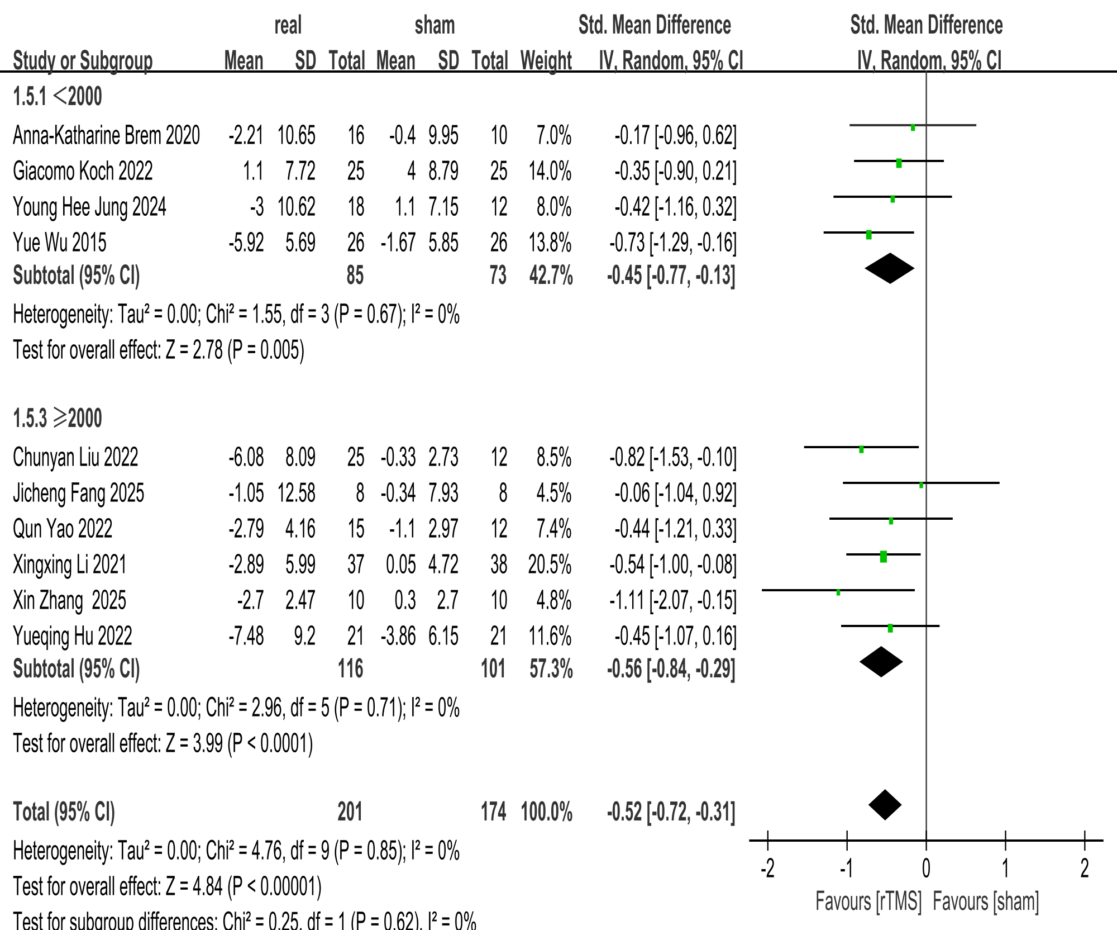
Supplementary Figure S2D. Subgroup analysis of ADAS-cog by pulses per session (<2000 vs. ≥2000).

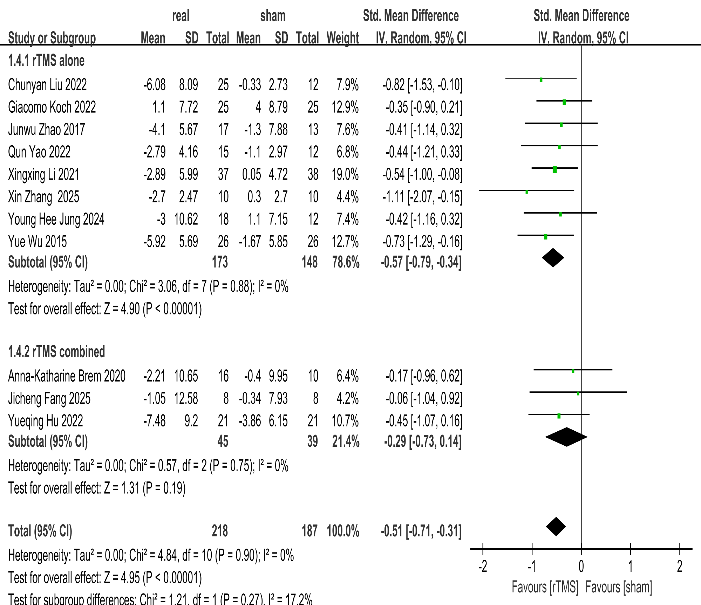
Supplementary Figure S2E. Subgroup analysis of ADAS-cog by intervention modality (rTMS alone vs. rTMS combined).

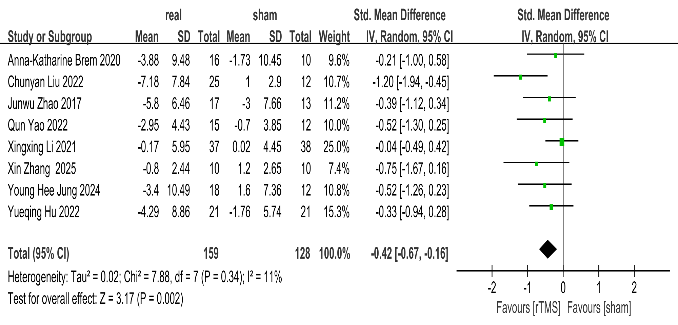
Supplementary Figure S2F. Forest plots of rTMS effects on follow-up outcomes (ADAS-cog).

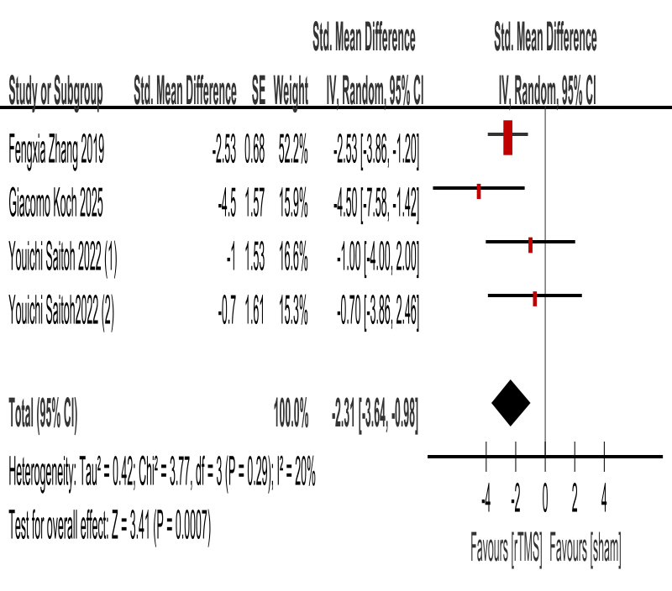
Supplementary Figure S2G. Forest plot of immediate ADAS-cog improvement (mean±SE).

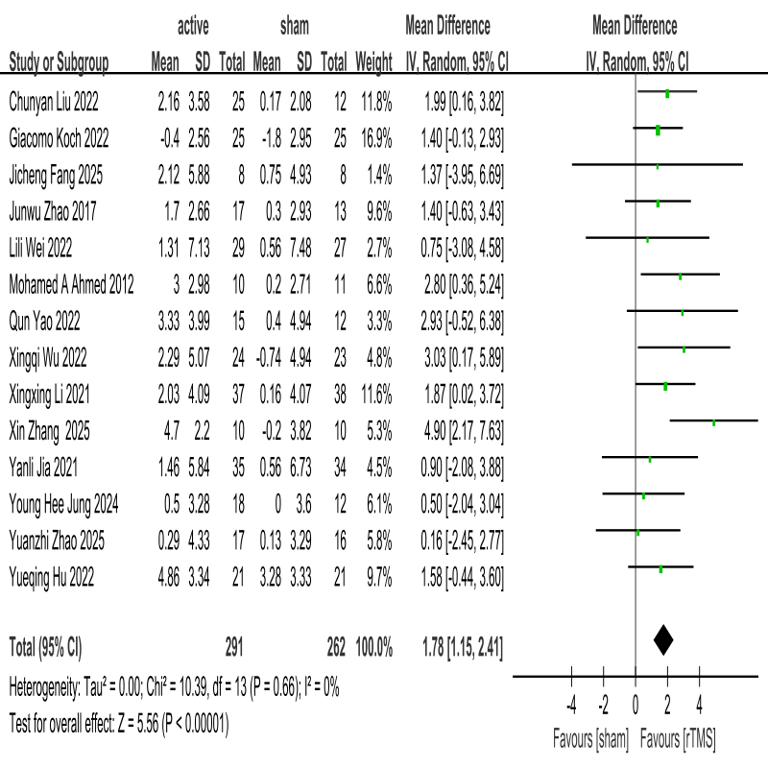
Supplementary Figure S2H. Forest plot of immediate MMSE improvement.

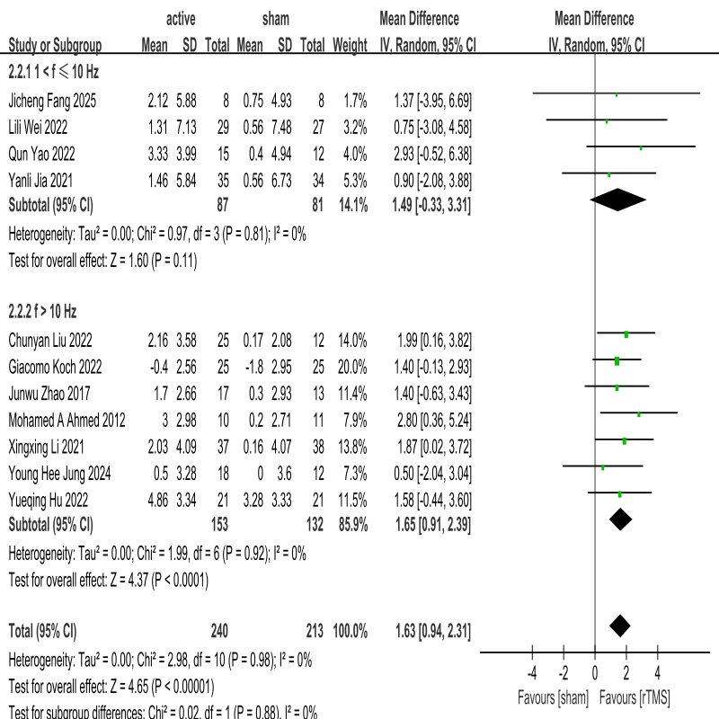
Supplementary Figure S2I. Subgroup analysis of MMSE by stimulation frequency (1< f ≤10 Hz vs. f > 10 Hz).

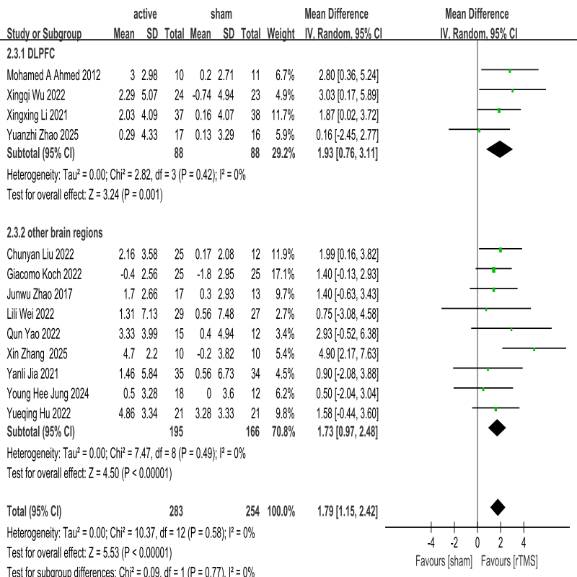

Supplementary Figure S2J. Subgroup analysis of MMSE by stimulation target (DLPFC vs. other brain regions).

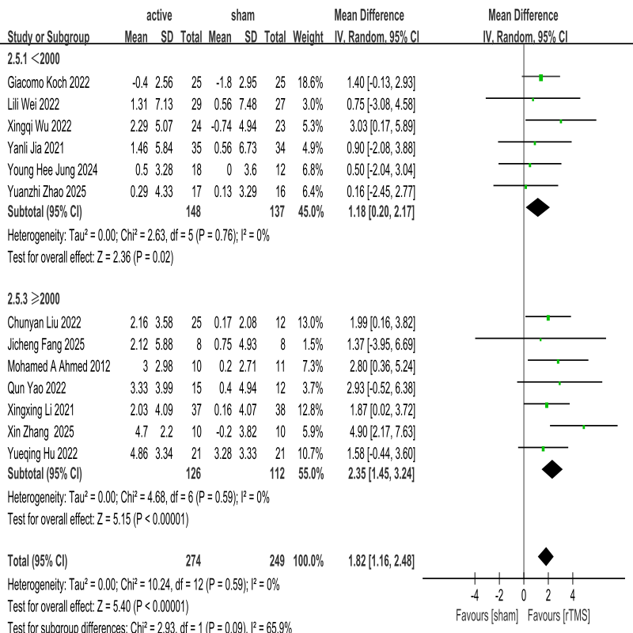
Supplementary Figure S2K. Subgroup analysis of MMSE by pulses per session (<2000 vs. ≥2000).

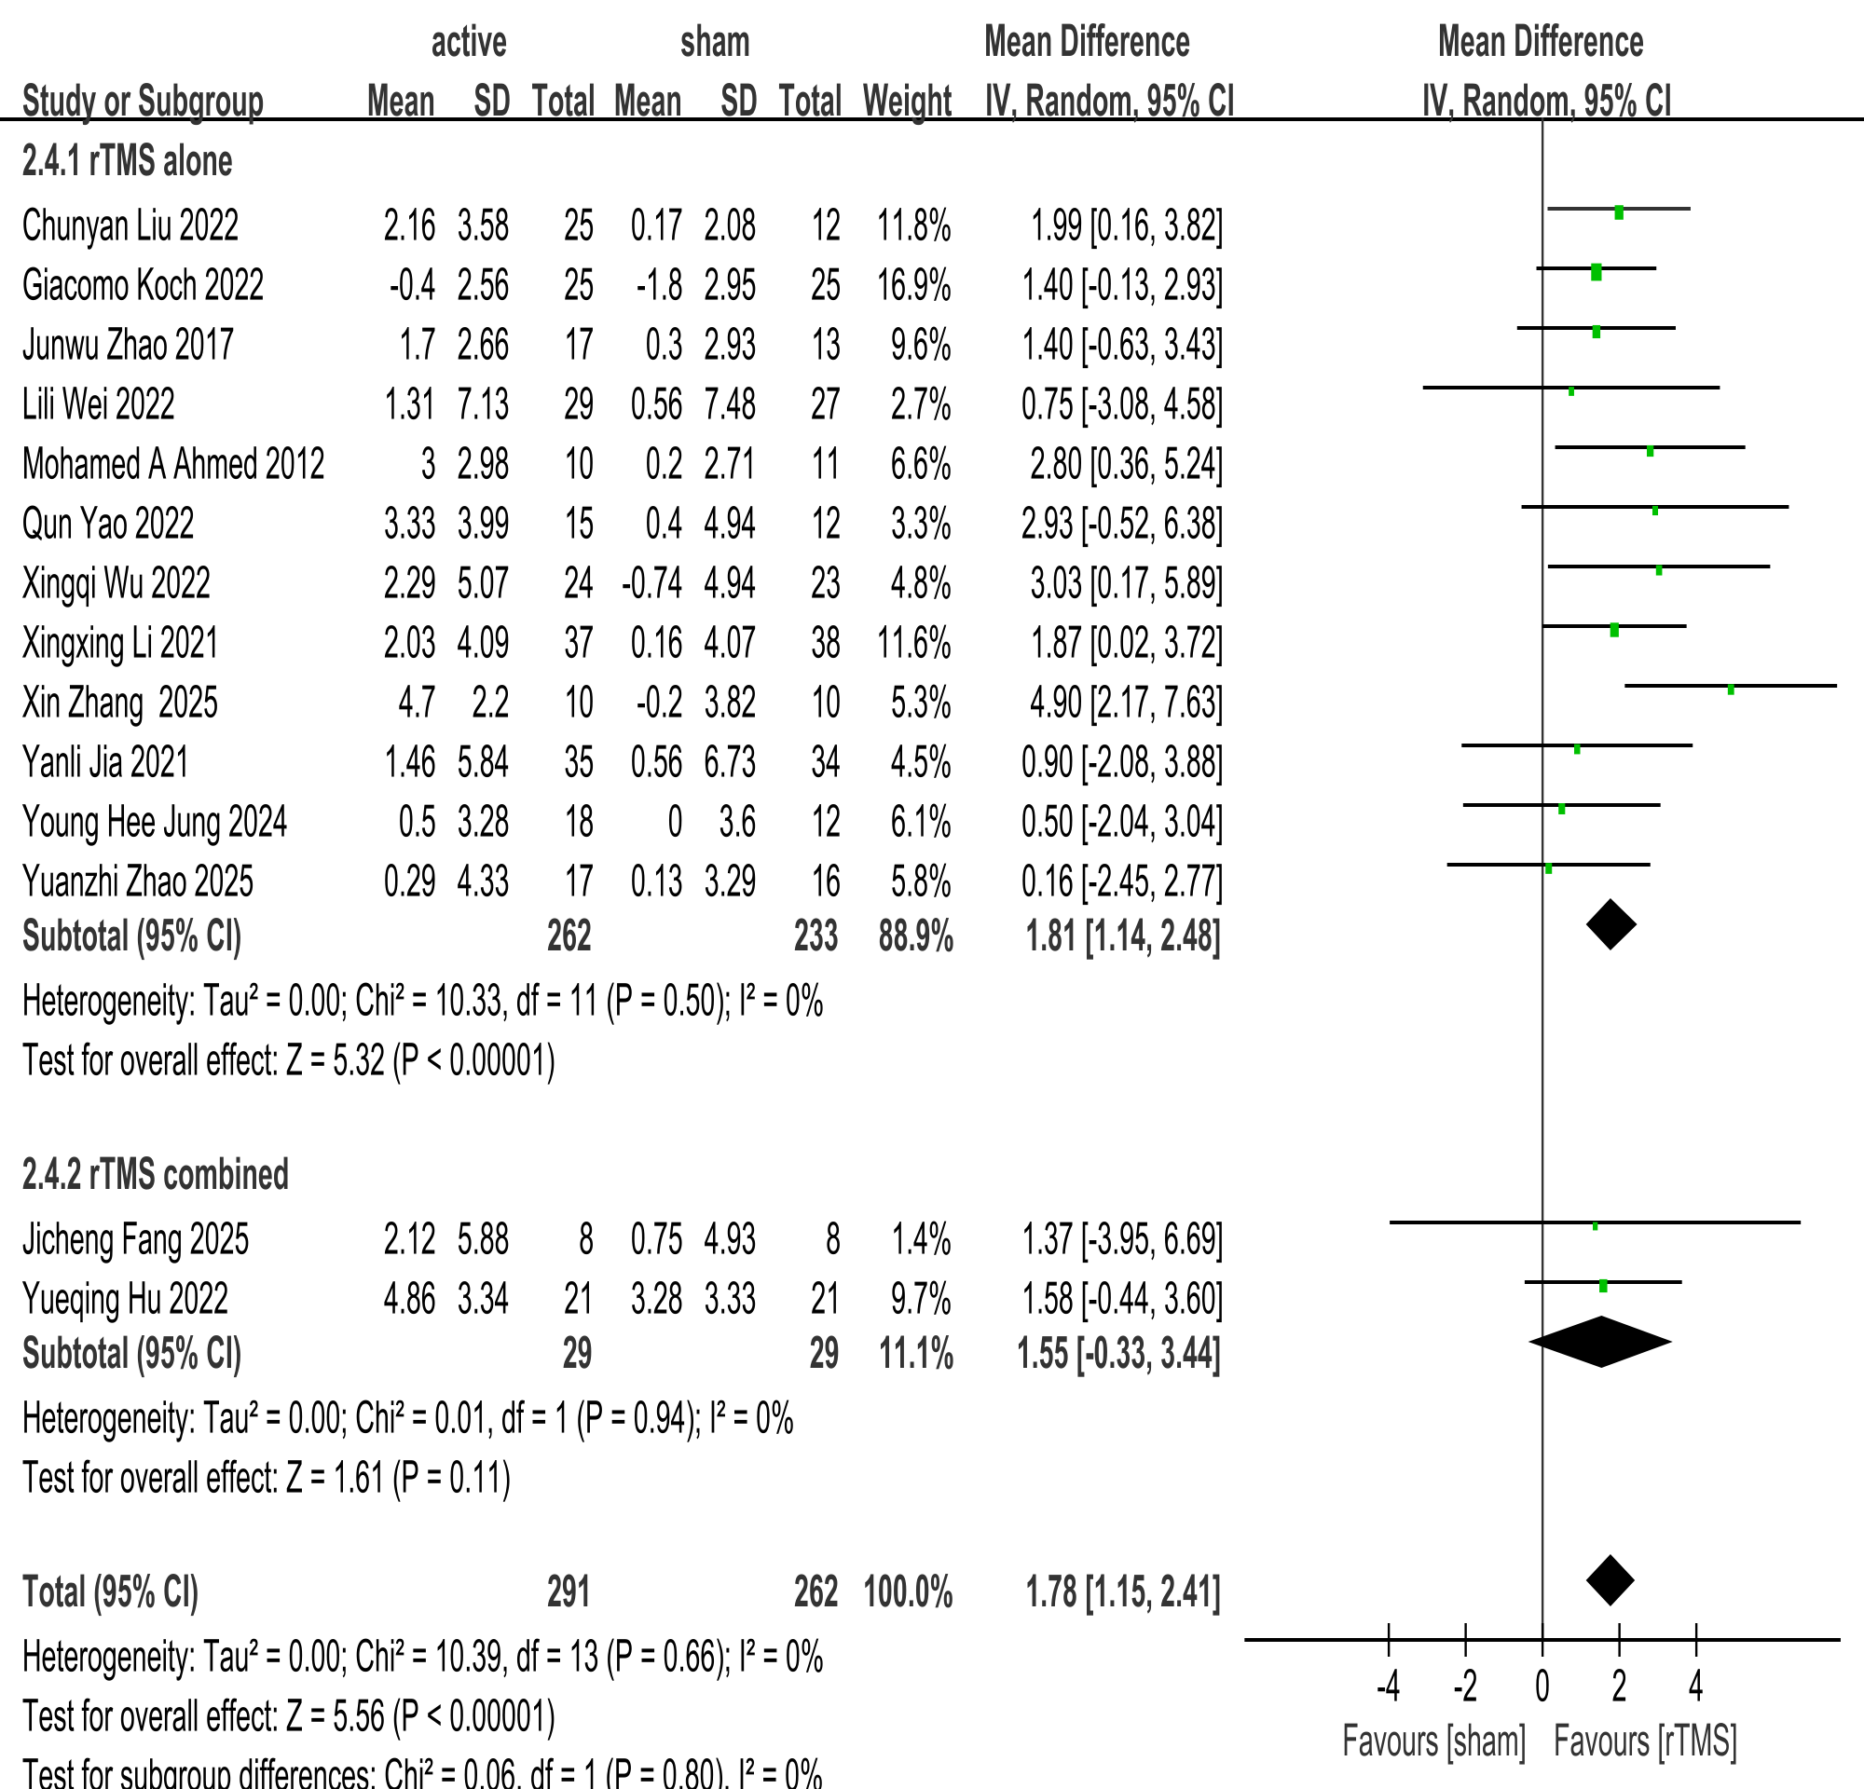
Supplementary Figure S2M. Subgroup analysis of MMSE by intervention modality (rTMS alone vs. rTMS combined).

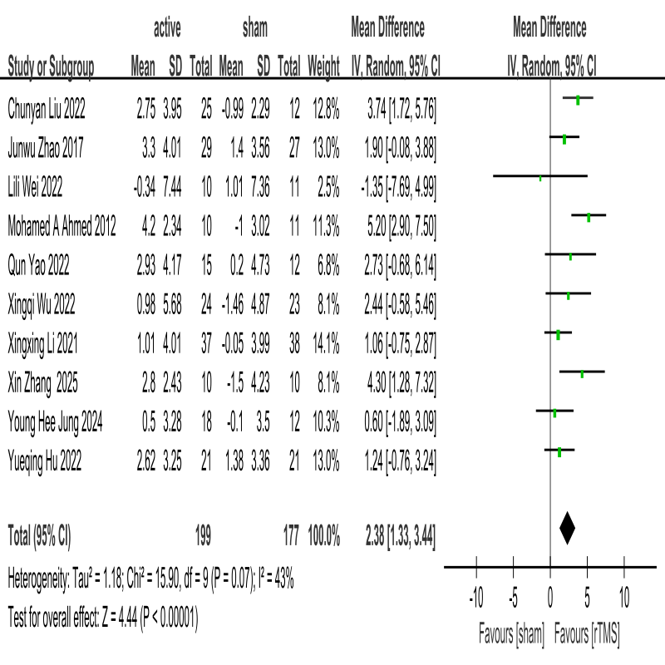
Supplementary Figure S3N. Forest plots of rTMS effects on follow-up outcomes (MMSE).

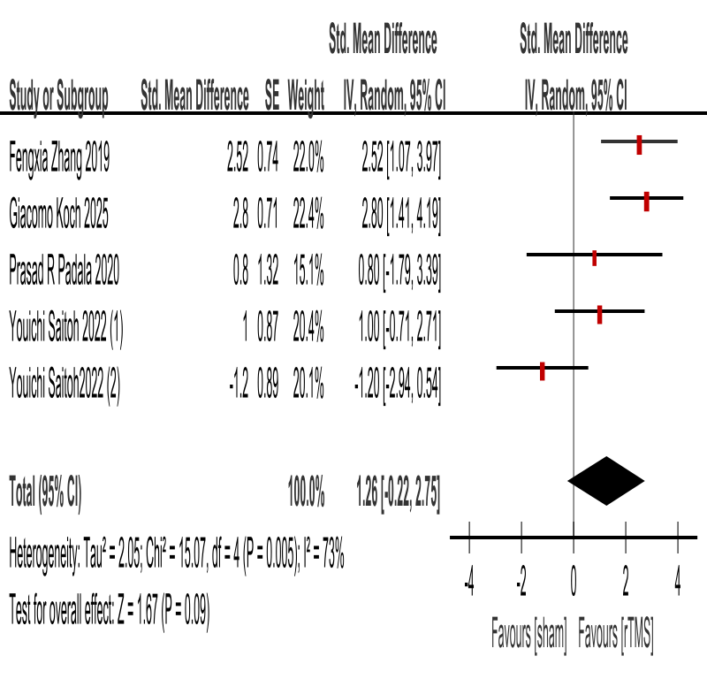
Supplementary Figure S2O. Forest plot of immediate MMSE improvement (mean±SE).

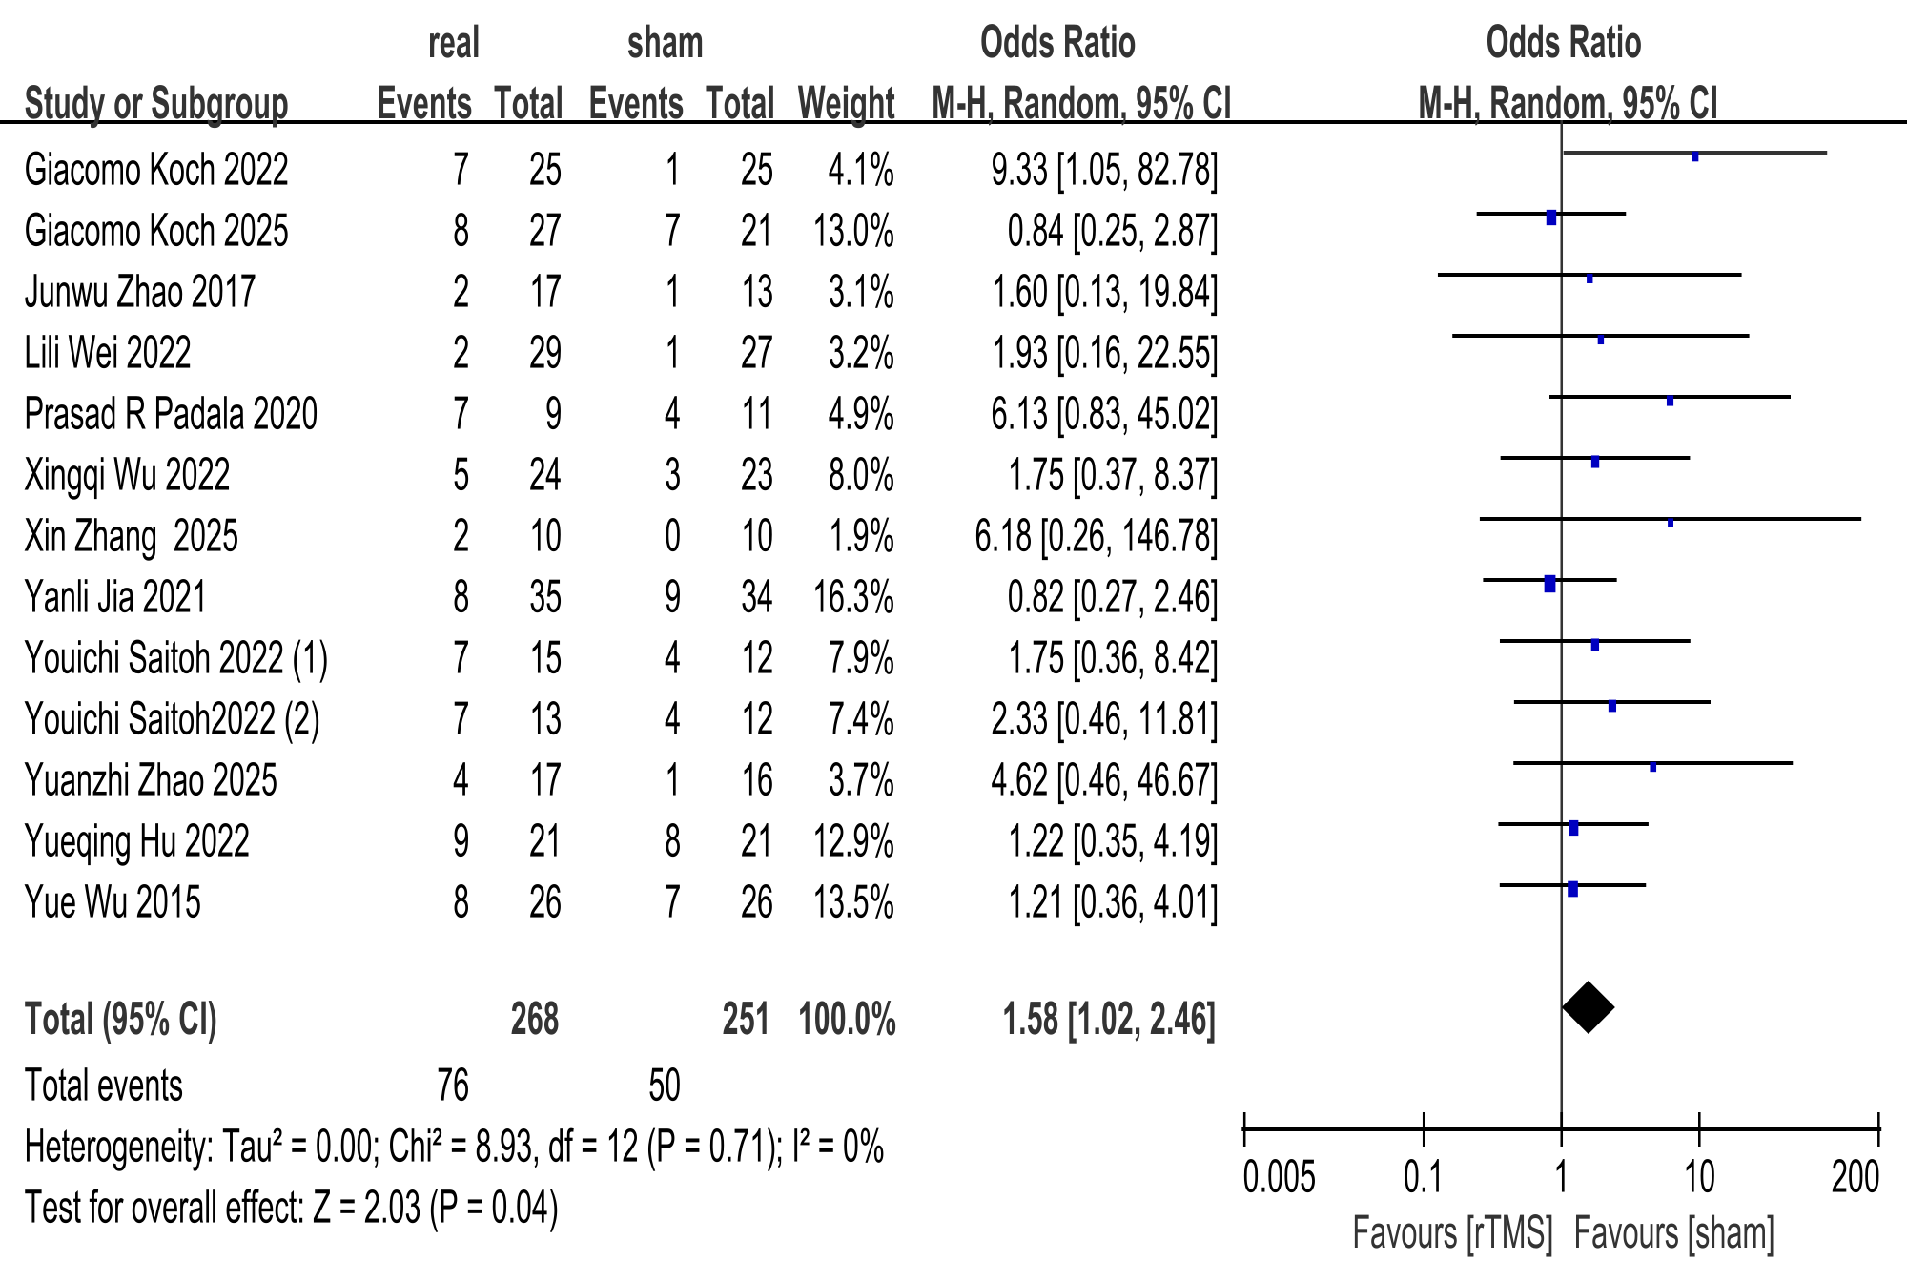
Supplementary Figure S2P. Side effects caused by rTMS.

