Supplementary Material

Transcriptome Signatures Associated with Cognitive Unimpaired Individuals with Pathologically Confirmed Alzheimer Disease
Donghe Li¹, Xudong Han^{1,2}, Ting F.A. Ang³⁻⁵, Joseph N Palmisano^{6,7}, Yorghos Tripodis^{6,8}, Katherine W. Turk^{6,9,10}, Maureen K. O’Connor^{6,11}, Lee E. Goldstein^{6,12}, Andrew E. Budson^{6,9,10}, Wei Qiao Qiu^{3,6,12}, Michael L. Alosco^{6,9}, Rhoda Au^{1,3-6,9}, Ann C. McKee^{6,9-11,13}, Jesse Mez^{3,6,9}, Thor D. Stein^{3,6,10,11,13}, Lindsay A. Farrer^{1-3,6,8,9,14}, Gyungah R. Jun^{1-3,6,*}

¹Department of Medicine (Biomedical Genetics), Boston University Chobanian and Avedisian School of Medicine, Boston, MA 02118
²Bioinformatics Program, Boston University, Boston, MA 02215
³Framingham Heart Study Brain Aging Program, Boston University Chobanian and Avedisian School of Medicine, Boston, MA 02118
⁴Department of Anatomy & Neurobiology, Boston University Chobanian & Avedisian School of Medicine, Boston, MA 02118
⁵Department of Epidemiology, Boston University School of Public Health, Boston, MA 02118
⁶Boston University Alzheimer’s Disease Research Center, Boston University Chobanian and Avedisian School of Medicine, Boston, MA 02118
⁷Center for Health Data Science (CHDS), Boston University School of Public Health, Boston, MA 02118
⁸Department of Biostatistics, Boston University School of Public Health, Boston, MA 02118
⁹Department of Neurology, Boston University Chobanian and Avedisian School of Medicine, Boston, MA 02118
¹⁰Veterans Affairs Boston Healthcare System, Boston, MA 02130
¹¹Veterans Affairs Bedford Healthcare System, Bedford, MA 01730
¹²Department of Psychiatry, Boston University Chobanian and Avedisian School of Medicine, Boston, MA 02118
¹³Department of Pathology & Laboratory Medicine, Boston University Chobanian and Avedisian School of Medicine, Boston, MA 02118
¹⁴Department of Ophthalmology, Boston University Chobanian and Avedisian School of Medicine, Boston, MA 02118

* Address Correspondence to:
Gyungah R. Jun, PhD, Department of Medicine (Biomedical Genetics), Boston University Chobanian and Avedisian School of Medicine, 72 East Concord Street, Boston MA 02118
Email: gyungah@bu.edu.

Supplementary Table 1. Mean cognitive scores in SymAD cases, AsymAD cases, and controls by dataset. Standard deviations are indicated in parentheses.

Domain | ROSMAP |  |  |  | Framingham Heart Study |  |  |  | Boston University ADRC
Domain | All (n=404) | SymAD (n=205) | AsymAD (n=79) | Control (n=120) | All (n=93) | SymAD (n=42) | AsymAD (n=6) | Control (n=45) | All (n=54) | SymAD (n=30) | AsymAD (n=5) | Control (n=19)
Memory | -0.57 (1.13) | -1.55 (0.65) | 0.30 (0.45) | 0.46 (0.45) | -0.02 (0.88) | -0.90 (0.61) | 0.64 (0.39) | 0.56 (0.42) | -0.72 (1.31) | -1.52 (0.84) | -0.31 (1.42) | 0.41 (0.98)
Language | -0.61 (1.05) | -1.46 (0.74) | 0.07 (0.58) | 0.30 (0.48) | -0.04 (0.70) | -0.74 (0.32) | 0.39 (0.50) | 0.34 (0.54) | -0.51 (1.06) | -1.22 (0.71) | -0.04 (1.08) | 0.39 (0.68)
Executive Function | -0.30 (0.85) | -1.02 (0.60) | 0.19 (0.44) | 0.39 (0.43) | -0.21 (0.62) | -0.69 (0.58) | -0.13 (0.32) | 0.07 (0.50) | -0.73 (0.94) | -1.26 (0.74) | -0.70 (0.64) | -0.26 (0.95)

Supplementary Table 2. Summary of neuropathological trait scores in SymAD cases, AsymAD cases, and controls by dataset.

 |  | Framingham Heart Study |  |  |  | Boston University Alzheimer Disease Research Center
Pathology | Trait | All (n=93) | SymAD (n=42) | AsymAD (n=6) | Control (n=45) | All (n=54) | SymAD (n=30) | AsymAD (n=5) | Control (n=19)
 |  | Median (Range) /Mean (SD) | Median (Range) /Mean (SD) | Median (Range) /Mean (SD) | Median (Range) /Mean (SD) | Median (Range) /Mean (SD) | Median (Range) /Mean (SD) | Median (Range) /Mean (SD) | Median (Range) /Mean (SD)
Tau | Braak Stage (0-6) | 3 (0~6) | 5 (3~6) | 4 (3~6) | 2 (0~3) | 5 (0~6) | 6 (3~6) | 5 (3~6) | 2 (0~4)
Tau | AT8 (positive pixels/mm2) | 24497 (64692) | 50247 (88005) | 11798 (23375) | 605 (539) | 33668 (61746) | 55790 (74930) | 29188 (36843) | 501 (442)
Tau | pTau181 (U/g) | 12605 (6574) | 13868 (6827) | 9658 (4544) | 11820 (6422) | 64345 (41308) | 74314 (43707) | 92871 (48436) | 41097 (21518)
Tau | pTau396 (U/g) | 17065 (31810) | 26114 (40218) | 22592 (33665) | 7666 (17148) | 112961 (255125) | 191711 (324550) | 71915 (69879) | 3566 (2552)
amyloid-β | CERAD score(0-3) | 2 (0~3) | 3 (1~3) | 2 (1~3) | 0 (0~3) | 2 (0~3) | 3 (1~3) | 2 (1~2) | 0 (0~2)
amyloid-β | Aβ40 (pg/mg) | 262 (630) | 448 (839) | 148 (114) | 103 (336) | 1028 (2122) | 1633 (2568) | 1090 (2138) | 57 (77)
amyloid-β | Aβ42 (pg/mg) | 982 (840) | 1333 (846) | 1295 (520) | 613 (712) | 1230 (1070) | 1488 (909) | 1595 (778) | 725 (1221)
Vascular | ICAM | 2952477  (264097) | 4117927 (2479925) | 2063785 (987272) | 1983216 (1584853) | / | / | / | /
Synaptic density | α-synuclein  (ug/ml) | 14 (7) | 14 (6) | 14 (1) | 15 (8) | 13 (5) | 13 (5) | 13 (4) | 12 (3)
Neuro-inflammation | Iba1 (cells/mm²) | 183 (49) | 197 (47) | 193 (31) | 168 (50) | 166 (51) | 157 (52) | 181 (32) | 176 (52)

Supplementary Table 3. Differential gene expression among control, SymAD cases and AsymAD cases in the combined datasets. Results shown for transcriptome-wide significant DEGs between SymAD and AsymAD cases. Nominally significant DEGs between AsymAD cases and controls are highlighted in bold.

Gene | SymAD vs AsymAD |  |  | AsymAD vs Control |  |  | SymAD vs Control
Gene | Log2FC | LfcSE | P-value | Log2FC | LfcSE | P-value | Log2FC | LfcSE | P-value
ADAMTS2 | 0.506 | 0.083 | 9.01E-10 | 0.201 | 0.095 | 3.42E-02 | 0.635 | 0.075 | 1.54E-17
ARRDC2 | 0.286 | 0.049 | 6.75E-09 | 0.009 | 0.048 | 8.52E-01 | 0.283 | 0.044 | 1.89E-10
PAFAH1B3 | 0.186 | 0.034 | 3.18E-08 | 0.067 | 0.037 | 6.82E-02 | 0.229 | 0.029 | 1.20E-15
MYOT | 0.398 | 0.072 | 3.73E-08 | -0.041 | 0.069 | 5.52E-01 | 0.366 | 0.062 | 4.33E-09
LIMD2 | -0.151 | 0.029 | 1.48E-07 | 0.030 | 0.031 | 3.34E-01 | -0.127 | 0.027 | 1.70E-06
TMCC2 | 0.187 | 0.036 | 1.94E-07 | 0.032 | 0.037 | 3.89E-01 | 0.239 | 0.033 | 5.25E-13
PRELP | 0.284 | 0.055 | 2.64E-07 | 0.065 | 0.055 | 2.36E-01 | 0.344 | 0.048 | 1.12E-12
CLIP2 | 0.166 | 0.032 | 2.69E-07 | 0.037 | 0.026 | 1.44E-01 | 0.211 | 0.030 | 9.39E-13
CIC | 0.147 | 0.029 | 2.84E-07 | 0.011 | 0.030 | 7.16E-01 | 0.144 | 0.026 | 1.65E-08
DMAC1 | -0.113 | 0.022 | 3.18E-07 | -0.028 | 0.028 | 3.19E-01 | -0.129 | 0.021 | 5.04E-10
CPT2 | -0.156 | 0.031 | 3.22E-07 | -0.009 | 0.039 | 8.19E-01 | -0.164 | 0.028 | 3.75E-09
SLC38A2 | 0.327 | 0.064 | 3.86E-07 | 0.091 | 0.061 | 1.36E-01 | 0.415 | 0.057 | 2.48E-13
SCGN | 0.592 | 0.117 | 4.11E-07 | 0.023 | 0.122 | 8.49E-01 | 0.560 | 0.102 | 3.58E-08
MXI1 | 0.139 | 0.028 | 5.33E-07 | 0.018 | 0.026 | 4.99E-01 | 0.166 | 0.025 | 1.21E-11
CAB39L | 0.199 | 0.040 | 6.63E-07 | 0.015 | 0.040 | 7.02E-01 | 0.239 | 0.038 | 3.08E-10
HMGN2 | -0.240 | 0.049 | 7.09E-07 | -0.114 | 0.046 | 1.32E-02 | -0.369 | 0.040 | 7.25E-20
NRIP2 | 0.336 | 0.068 | 8.88E-07 | 0.076 | 0.058 | 1.88E-01 | 0.421 | 0.058 | 3.63E-13
CARHSP1 | 0.183 | 0.037 | 8.99E-07 | -0.007 | 0.035 | 8.37E-01 | 0.161 | 0.031 | 1.43E-07
SAP30L | 0.150 | 0.031 | 1.03E-06 | 0.011 | 0.028 | 6.98E-01 | 0.183 | 0.026 | 1.10E-12
RABGGTA | 0.142 | 0.029 | 1.29E-06 | 0.063 | 0.027 | 1.91E-02 | 0.184 | 0.025 | 4.05E-13
FFAR4 | -0.273 | 0.056 | 1.35E-06 | 0.028 | 0.059 | 6.39E-01 | -0.220 | 0.049 | 7.54E-06
EPB41L1 | 0.104 | 0.022 | 1.41E-06 | 0.050 | 0.029 | 8.09E-02 | 0.153 | 0.021 | 6.58E-14
CEP83 | -0.172 | 0.036 | 1.43E-06 | -0.004 | 0.036 | 9.12E-01 | -0.141 | 0.030 | 1.97E-06
KIF1B | 0.096 | 0.020 | 1.49E-06 | -0.021 | 0.023 | 3.66E-01 | 0.085 | 0.020 | 1.24E-05
CCDC69 | 0.220 | 0.046 | 1.52E-06 | 0.020 | 0.048 | 6.80E-01 | 0.246 | 0.041 | 2.26E-09
ZNF334 | -0.240 | 0.050 | 1.59E-06 | -0.062 | 0.044 | 1.58E-01 | -0.315 | 0.041 | 1.60E-14
MON1B | -0.086 | 0.018 | 1.61E-06 | 0.034 | 0.020 | 9.45E-02 | -0.037 | 0.015 | 1.60E-02
STAU1 | 0.077 | 0.016 | 1.73E-06 | 0.008 | 0.015 | 5.89E-01 | 0.086 | 0.015 | 2.34E-09
ARG2 | 0.316 | 0.066 | 1.74E-06 | 0.045 | 0.061 | 4.54E-01 | 0.325 | 0.057 | 1.03E-08
SACS | 0.104 | 0.022 | 1.77E-06 | -0.007 | 0.026 | 7.89E-01 | 0.102 | 0.020 | 4.65E-07
ALDH1A1 | -0.347 | 0.073 | 1.82E-06 | -0.083 | 0.067 | 2.15E-01 | -0.444 | 0.060 | 1.90E-13
ANKRD40 | 0.171 | 0.036 | 2.15E-06 | -0.027 | 0.040 | 4.97E-01 | 0.170 | 0.034 | 3.79E-07
MEIS3 | -0.221 | 0.047 | 2.20E-06 | -0.004 | 0.049 | 9.41E-01 | -0.218 | 0.041 | 1.38E-07
RGPD3 | -0.423 | 0.089 | 2.25E-06 | 0.062 | 0.086 | 4.75E-01 | -0.318 | 0.074 | 1.88E-05
POU6F1 | 0.098 | 0.021 | 2.50E-06 | 0.008 | 0.022 | 7.30E-01 | 0.116 | 0.019 | 8.13E-10
MTMR10 | 0.144 | 0.031 | 2.60E-06 | 0.011 | 0.037 | 7.57E-01 | 0.155 | 0.029 | 9.78E-08
EMP3 | 0.268 | 0.057 | 2.66E-06 | 0.103 | 0.071 | 1.45E-01 | 0.300 | 0.057 | 1.08E-07
PALM3 | 0.218 | 0.047 | 2.82E-06 | 0.141 | 0.052 | 6.96E-03 | 0.381 | 0.040 | 1.23E-21
RFX5 | 0.125 | 0.027 | 2.84E-06 | -0.011 | 0.032 | 7.25E-01 | 0.110 | 0.026 | 2.05E-05

Supplementary Table 4. Comparison of 16 DEGs from SymAD and AsymAD differential expression model with BRAAK and CERAD adjusted model.

 | Original model |  |  | Adjusted model
Gene | Log2FC | LfcSE | P-value | Log2FC | LfcSE | P-value
ADAMTS2 | 0.5059 | 0.0826 | 9.01E-10 | 0.3704 | 0.0879 | 2.50E-05
ARRDC2 | 0.2864 | 0.0494 | 6.75E-09 | 0.2113 | 0.0531 | 7.00E-05
PAFAH1B3 | 0.1855 | 0.0335 | 3.18E-08 | 0.1621 | 0.0364 | 8.52E-06
MYOT | 0.3978 | 0.0723 | 3.73E-08 | 0.2541 | 0.0772 | 1.00E-03
LIMD2 | -0.1506 | 0.0287 | 1.48E-07 | -0.1224 | 0.0313 | 9.42E-05
TMCC2 | 0.187 | 0.0359 | 1.94E-07 | 0.1514 | 0.0391 | 1.08E-04
PRELP | 0.2839 | 0.0552 | 2.64E-07 | 0.2052 | 0.0604 | 6.79E-04
CLIP2 | 0.1658 | 0.0322 | 2.69E-07 | 0.1223 | 0.0351 | 4.94E-04
CIC | 0.1467 | 0.0286 | 2.84E-07 | 0.1177 | 0.0311 | 1.52E-04
DMAC1 | -0.1133 | 0.0222 | 3.18E-07 | -0.0981 | 0.0243 | 5.56E-05
CPT2 | -0.1563 | 0.0306 | 3.22E-07 | -0.1272 | 0.0332 | 1.25E-04
SLC38A2 | 0.3268 | 0.0644 | 3.86E-07 | 0.2031 | 0.0688 | 3.15E-03
SCGN | 0.5918 | 0.1169 | 4.11E-07 | 0.4271 | 0.1272 | 7.90E-04
HMGN2 | -0.2403 | 0.0485 | 7.09E-07 | -0.1844 | 0.0523 | 4.26E-04
RABGGTA | 0.1423 | 0.0294 | 1.29E-06 | 0.0992 | 0.0314 | 1.56E-03
PALM3 | 0.2184 | 0.0466 | 2.82E-06 | 0.2097 | 0.0509 | 3.82E-05

Supplementary Table 5. Cell-type-specific differential expression of candidate genes in SymAD versus AsymAD using ROSMAP single-nucleus RNA-sequencing data. Only results with an adjusted P-value < 0.05 are shown.
Gene | CellType | log2FC | lfcSE | P-value | Padj
ADAMTS2 | Exc | 0.499 | 0.120 | 3.27E-05 | 1.75E-02
TMCC2 | Exc | 0.214 | 0.057 | 1.76E-04 | 3.71E-02
PRELP | Exc | 0.583 | 0.159 | 2.58E-04 | 4.31E-02
SLC38A2 | Exc | 0.302 | 0.083 | 2.77E-04 | 4.58E-02
SLC38A2 | Ast | 0.723 | 0.181 | 6.32E-05 | 2.52E-02
SCGN | Exc | 0.822 | 0.177 | 3.50E-06 | 5.08E-03
HMGN2 | Ast | -0.488 | 0.114 | 1.88E-05 | 1.46E-02
Exc = excitatory neurons; Ast = astrocytes; log2FC = log2 fold change; Padj=FDR Adjusted P-value.

Supplementary Table 6. Association of cognitive domain scores with expression of top-ranked DEGs between SymAD and AysmAD cases with by dataset. FDR indicates p- value corrected for the number of genes tested.
Domain | Gene | Total |  |  |  | ROSMAP |  |  | FHS |  |  | BUADRC
Domain | Gene | Effect | StdErr | P.value | FDR | Effect | StdErr | P.value | Effect | StdErr | P.value | Effect | StdErr | P.value
Memory | ADAMTS2 | -0.0030 | 0.0005 | 2.22E-10 | 1.30E-08 | -0.0033 | 0.0005 | 2.15E-10 | -0.0031 | 0.0051 | 5.53E-01 | 0.0005 | 0.0018 | 7.88E-01
Memory | ARRDC2 | -0.0007 | 0.0001 | 2.69E-07 | 1.57E-06 | -0.0009 | 0.0002 | 3.17E-07 | -0.0002 | 0.0004 | 6.27E-01 | -0.0004 | 0.0002 | 9.70E-02
Memory | PAFAH1B3 | -0.0025 | 0.0005 | 1.96E-06 | 5.87E-06 | -0.0027 | 0.0006 | 1.92E-06 | -0.0058 | 0.0029 | 5.81E-02 | 0.0014 | 0.0019 | 4.63E-01
Memory | MYOT | -0.0047 | 0.0011 | 2.35E-05 | 4.99E-05 | -0.0080 | 0.0018 | 1.14E-05 | -0.0038 | 0.0024 | 1.40E-01 | -0.0020 | 0.0018 | 2.63E-01
Memory | LIMD2 | 0.0026 | 0.0005 | 7.36E-08 | 5.06E-07 | 0.0025 | 0.0005 | 2.10E-06 | 0.0062 | 0.0022 | 1.20E-02 | 0.0015 | 0.0019 | 4.40E-01
Memory | TMCC2 | -0.0005 | 0.0001 | 2.86E-07 | 1.59E-06 | -0.0005 | 0.0001 | 1.50E-06 | -0.0005 | 0.0005 | 3.09E-01 | -0.0004 | 0.0004 | 3.35E-01
Memory | PRELP | -0.0007 | 0.0001 | 4.32E-06 | 1.12E-05 | -0.0009 | 0.0002 | 1.21E-07 | -0.0004 | 0.0004 | 3.09E-01 | 0.0006 | 0.0004 | 1.73E-01
Memory | CLIP2 | -0.0002 | 0.0001 | 3.10E-06 | 8.63E-06 | -0.0002 | 0.0001 | 1.46E-05 | -0.0003 | 0.0002 | 2.82E-01 | -0.0002 | 0.0002 | 3.11E-01
Memory | CIC | -0.0008 | 0.0001 | 4.08E-08 | 3.26E-07 | -0.0008 | 0.0001 | 2.73E-08 | -0.0006 | 0.0007 | 4.56E-01 | 0.0001 | 0.0005 | 8.98E-01
Memory | DMAC1 | 0.0036 | 0.0008 | 3.98E-06 | 1.06E-05 | 0.0040 | 0.0008 | 2.25E-06 | 0.0015 | 0.0035 | 6.75E-01 | -0.0005 | 0.0031 | 8.78E-01
Memory | CPT2 | 0.0030 | 0.0008 | 1.36E-04 | 2.21E-04 | 0.0037 | 0.0008 | 1.52E-05 | 0.0005 | 0.0039 | 9.03E-01 | -0.0058 | 0.0034 | 9.84E-02
Memory | SLC38A2 | -0.0003 | 0.0001 | 8.99E-07 | 3.24E-06 | -0.0004 | 0.0001 | 3.91E-07 | -0.0001 | 0.0001 | 3.50E-01 | 0.0000 | 0.0003 | 9.07E-01
Memory | SCGN | -0.0161 | 0.0042 | 1.12E-04 | 1.93E-04 | -0.0156 | 0.0043 | 3.08E-04 | -0.0727 | 0.0362 | 6.07E-02 | -0.0072 | 0.0236 | 7.63E-01
Memory | HMGN2 | 0.0006 | 0.0001 | 5.81E-08 | 4.25E-07 | 0.0007 | 0.0001 | 2.45E-08 | 0.0003 | 0.0003 | 3.53E-01 | -0.0002 | 0.0005 | 6.64E-01
Memory | RABGGTA | -0.0037 | 0.0006 | 2.82E-09 | 6.59E-08 | -0.0039 | 0.0007 | 1.21E-08 | -0.0037 | 0.0029 | 2.28E-01 | -0.0008 | 0.0029 | 7.71E-01
Memory | PALM3 | -0.0034 | 0.0009 | 1.55E-04 | 2.48E-04 | -0.0034 | 0.0009 | 3.47E-04 | 0.0023 | 0.0078 | 7.71E-01 | -0.0052 | 0.0038 | 1.89E-01
Language | ADAMTS2 | -0.0032 | 0.0005 | 8.32E-12 | 9.74E-10 | -0.0033 | 0.0005 | 7.32E-11 | -0.0068 | 0.0044 | 1.48E-01 | -0.0010 | 0.0017 | 5.78E-01
Language | ARRDC2 | -0.0004 | 0.0001 | 6.12E-04 | 8.63E-04 | -0.0006 | 0.0002 | 1.30E-03 | -0.0003 | 0.0004 | 4.32E-01 | -0.0003 | 0.0002 | 2.20E-01
Language | PAFAH1B3 | -0.0025 | 0.0005 | 3.00E-06 | 8.55E-06 | -0.0026 | 0.0006 | 6.44E-06 | -0.0016 | 0.0028 | 5.78E-01 | -0.0015 | 0.0018 | 4.16E-01
Language | MYOT | -0.0027 | 0.0010 | 7.83E-03 | 9.16E-03 | -0.0058 | 0.0018 | 1.47E-03 | -0.0015 | 0.0018 | 3.95E-01 | -0.0010 | 0.0017 | 5.62E-01
Language | LIMD2 | 0.0023 | 0.0005 | 7.72E-07 | 3.11E-06 | 0.0023 | 0.0005 | 2.90E-06 | 0.0024 | 0.0024 | 3.47E-01 | 0.0015 | 0.0018 | 4.00E-01
Language | TMCC2 | -0.0005 | 0.0001 | 9.42E-07 | 3.24E-06 | -0.0005 | 0.0001 | 3.95E-06 | -0.0003 | 0.0003 | 3.84E-01 | -0.0004 | 0.0004 | 2.83E-01
Language | PRELP | -0.0004 | 0.0001 | 5.21E-03 | 6.15E-03 | -0.0008 | 0.0002 | 8.00E-06 | 0.0003 | 0.0003 | 4.20E-01 | 0.0007 | 0.0004 | 8.04E-02
Language | CLIP2 | -0.0002 | 0.0000 | 5.38E-05 | 1.05E-04 | -0.0002 | 0.0001 | 5.99E-05 | 0.0000 | 0.0002 | 9.56E-01 | -0.0002 | 0.0002 | 3.47E-01
Language | CIC | -0.0007 | 0.0001 | 3.52E-08 | 3.17E-07 | -0.0008 | 0.0001 | 5.33E-08 | 0.0000 | 0.0006 | 9.40E-01 | -0.0004 | 0.0005 | 3.88E-01
Language | DMAC1 | 0.0034 | 0.0007 | 3.97E-06 | 1.06E-05 | 0.0038 | 0.0008 | 3.55E-06 | 0.0021 | 0.0025 | 4.06E-01 | -0.0001 | 0.0029 | 9.67E-01
Language | CPT2 | 0.0024 | 0.0008 | 1.52E-03 | 1.93E-03 | 0.0028 | 0.0008 | 6.75E-04 | 0.0016 | 0.0031 | 6.14E-01 | -0.0030 | 0.0034 | 3.89E-01
Language | SLC38A2 | -0.0002 | 0.0001 | 1.09E-04 | 1.91E-04 | -0.0003 | 0.0001 | 1.06E-04 | -0.0001 | 0.0001 | 4.29E-01 | -0.0002 | 0.0003 | 3.90E-01
Language | SCGN | -0.0195 | 0.0043 | 6.82E-06 | 1.70E-05 | -0.0186 | 0.0045 | 4.64E-05 | -0.0476 | 0.0303 | 1.38E-01 | -0.0275 | 0.0218 | 2.19E-01
Language | HMGN2 | 0.0004 | 0.0001 | 1.93E-04 | 3.01E-04 | 0.0006 | 0.0001 | 1.03E-05 | -0.0001 | 0.0003 | 6.60E-01 | -0.0001 | 0.0004 | 8.59E-01
Language | RABGGTA | -0.0029 | 0.0006 | 2.25E-06 | 6.57E-06 | -0.0031 | 0.0007 | 6.61E-06 | -0.0018 | 0.0025 | 4.82E-01 | -0.0025 | 0.0027 | 3.55E-01
Language | PALM3 | -0.0030 | 0.0009 | 7.36E-04 | 1.01E-03 | -0.0032 | 0.0009 | 6.05E-04 | 0.0062 | 0.0066 | 3.63E-01 | -0.0025 | 0.0037 | 5.11E-01
Executive  Function | ADAMTS2 | -0.0024 | 0.0004 | 2.72E-09 | 6.59E-08 | -0.0025 | 0.0004 | 3.48E-08 | -0.0043 | 0.0030 | 1.85E-01 | -0.0015 | 0.0012 | 2.16E-01
Executive  Function | ARRDC2 | -0.0004 | 0.0001 | 2.01E-03 | 2.48E-03 | -0.0004 | 0.0001 | 2.92E-03 | -0.0003 | 0.0003 | 3.15E-01 | -0.0001 | 0.0005 | 8.74E-01
Executive  Function | PAFAH1B3 | -0.0018 | 0.0004 | 5.83E-05 | 1.11E-04 | -0.0019 | 0.0005 | 1.01E-04 | 0.0009 | 0.0020 | 6.73E-01 | -0.0021 | 0.0014 | 1.66E-01
Executive  Function | MYOT | -0.0027 | 0.0011 | 1.52E-02 | 1.63E-02 | -0.0043 | 0.0016 | 6.53E-03 | -0.0014 | 0.0016 | 4.09E-01 | 0.0007 | 0.0041 | 8.64E-01
Executive  Function | LIMD2 | 0.0015 | 0.0004 | 1.26E-04 | 2.08E-04 | 0.0016 | 0.0004 | 1.46E-04 | 0.0021 | 0.0016 | 2.08E-01 | -0.0002 | 0.0013 | 8.54E-01
Executive  Function | TMCC2 | -0.0003 | 0.0001 | 1.15E-04 | 1.94E-04 | -0.0003 | 0.0001 | 1.14E-04 | -0.0001 | 0.0003 | 7.89E-01 | -0.0002 | 0.0004 | 6.47E-01
Executive  Function | PRELP | -0.0005 | 0.0001 | 1.57E-04 | 2.48E-04 | -0.0006 | 0.0001 | 7.16E-06 | 0.0001 | 0.0004 | 8.68E-01 | 0.0002 | 0.0004 | 5.68E-01
Executive  Function | CLIP2 | -0.0001 | 0.0000 | 1.03E-03 | 1.36E-03 | -0.0001 | 0.0000 | 3.03E-03 | -0.0002 | 0.0002 | 1.57E-01 | -0.0001 | 0.0002 | 7.95E-01
Executive  Function | CIC | -0.0005 | 0.0001 | 5.90E-05 | 1.11E-04 | -0.0005 | 0.0001 | 2.39E-05 | 0.0005 | 0.0004 | 3.01E-01 | -0.0004 | 0.0004 | 2.50E-01
Executive  Function | DMAC1 | 0.0025 | 0.0006 | 7.45E-05 | 1.32E-04 | 0.0026 | 0.0007 | 1.73E-04 | 0.0004 | 0.0020 | 8.49E-01 | 0.0031 | 0.0021 | 1.56E-01
Executive  Function | CPT2 | 0.0016 | 0.0006 | 1.22E-02 | 1.38E-02 | 0.0020 | 0.0007 | 4.34E-03 | -0.0037 | 0.0027 | 2.00E-01 | 0.0011 | 0.0024 | 6.42E-01
Executive  Function | SLC38A2 | -0.0001 | 0.0001 | 1.04E-02 | 1.20E-02 | -0.0002 | 0.0001 | 1.27E-03 | 0.0000 | 0.0001 | 8.91E-01 | -0.0001 | 0.0002 | 7.18E-01
Executive  Function | SCGN | -0.0186 | 0.0037 | 4.38E-07 | 2.14E-06 | -0.0188 | 0.0038 | 1.78E-06 | -0.0067 | 0.0235 | 7.79E-01 | -0.0203 | 0.0160 | 2.28E-01
Executive  Function | HMGN2 | 0.0002 | 0.0001 | 2.19E-02 | 2.33E-02 | 0.0004 | 0.0001 | 1.09E-03 | -0.0002 | 0.0002 | 3.01E-01 | 0.0000 | 0.0004 | 9.30E-01
Executive  Function | RABGGTA | -0.0018 | 0.0005 | 7.93E-04 | 1.06E-03 | -0.0018 | 0.0006 | 1.75E-03 | -0.0009 | 0.0018 | 6.49E-01 | -0.0024 | 0.0021 | 2.62E-01
Executive  Function | PALM3 | -0.0023 | 0.0007 | 1.64E-03 | 2.06E-03 | -0.0026 | 0.0008 | 8.19E-04 | 0.0070 | 0.0050 | 1.88E-01 | -0.0012 | 0.0027 | 6.50E-01

Supplementary Table 7. Significant associations (P<0.05) of neuropathological traits with expression of 16 top-DEGs between SymAD and AsymAD cases.

Trait | Gene | Combined Datasets |  |  | Framingham Heart Study |  |  | Boston University ADRC
Trait | Gene | Effect | StdErr | P.value | Effect | StdErr | P.value | Effect | StdErr | P.value
Braak Stage | ADAMTS2 | 0.0033 | 0.0014 | 1.59E-02 | 0.00680 | 0.00277 | 1.82E-02 | 0.00217 | 0.00157 | 1.78E-01
Braak Stage | PAFAH1B3 | 0.0028 | 0.0014 | 4.60E-02 | 0.00477 | 0.00254 | 6.69E-02 | 0.00194 | 0.00170 | 2.62E-01
Braak Stage | SLC38A2 | 0.0003 | 0.0001 | 4.59E-03 | 0.00031 | 0.00011 | 6.18E-03 | 0.00012 | 0.00024 | 6.18E-01
Braak Stage | RABGGTA | 0.0055 | 0.0015 | 2.89E-04 | 0.00692 | 0.00190 | 7.29E-04 | 0.00302 | 0.00257 | 2.49E-01
AT8 | PRELP | 0.0005 | 0.0003 | 4.69E-02 | 0.00067 | 0.00034 | 5.89E-02 | 0.00031 | 0.00038 | 4.25E-01
pTau396 | MYOT | 0.0024 | 0.0011 | 3.35E-02 | 0.00530 | 0.00162 | 2.13E-03 | -0.00044 | 0.00163 | 7.86E-01
 | CLIP2 | 0.0003 | 0.0001 | 2.74E-02 | 0.00052 | 0.00017 | 4.46E-03 | 0.00002 | 0.00017 | 9.17E-01
CERAD score | CIC | 0.0007 | 0.0003 | 4.19E-02 | 0.00008 | 0.00053 | 8.82E-01 | 0.00100 | 0.00041 | 2.03E-02
CERAD score | SLC38A2 | 0.0002 | 0.0001 | 2.01E-02 | 0.00020 | 0.00012 | 9.25E-02 | 0.00040 | 0.00023 | 9.09E-02
CERAD score | HMGN2 | -0.0006 | 0.0002 | 1.89E-02 | -0.00068 | 0.00030 | 2.80E-02 | -0.00036 | 0.00044 | 4.13E-01
CERAD score | RABGGTA | 0.0042 | 0.0016 | 9.48E-03 | 0.00522 | 0.00208 | 1.59E-02 | 0.00263 | 0.00259 | 3.18E-01
Aβ42/40 ratio | ADAMTS2 | -0.0031 | 0.0014 | 2.24E-02 | -0.00557 | 0.00310 | 7.94E-02 | -0.00255 | 0.00154 | 1.08E-01
Aβ42/40 ratio | PRELP | -0.0006 | 0.0003 | 1.43E-02 | -0.00042 | 0.00037 | 2.65E-01 | -0.00080 | 0.00035 | 2.86E-02
Aβ42/40 ratio | RABGGTA | -0.0038 | 0.0017 | 2.47E-02 | -0.00266 | 0.00233 | 2.58E-01 | -0.00501 | 0.00244 | 4.88E-02
α-synuclein | ADAMTS2 | 0.0025 | 0.0012 | 4.01E-02 | 0.00216 | 0.00302 | 4.78E-01 | 0.00259 | 0.00134 | 6.37E-02
α-synuclein | PAFAH1B3 | 0.0031 | 0.0013 | 1.47E-02 | 0.00314 | 0.00274 | 2.60E-01 | 0.00310 | 0.00144 | 3.96E-02
α-synuclein | LIMD2 | -0.0028 | 0.0014 | 3.93E-02 | -0.00524 | 0.00242 | 3.71E-02 | -0.00169 | 0.00167 | 3.19E-01

Supplementary Figure 1. Differentially expressed genes identified between SymAD and AsymAD cases in (A) ROSMAP, (B) FHS, (C) BUADRC, (D) total sample.The P-value cutoff is 0.05 and the log2 fold change cutoff is 0.4.

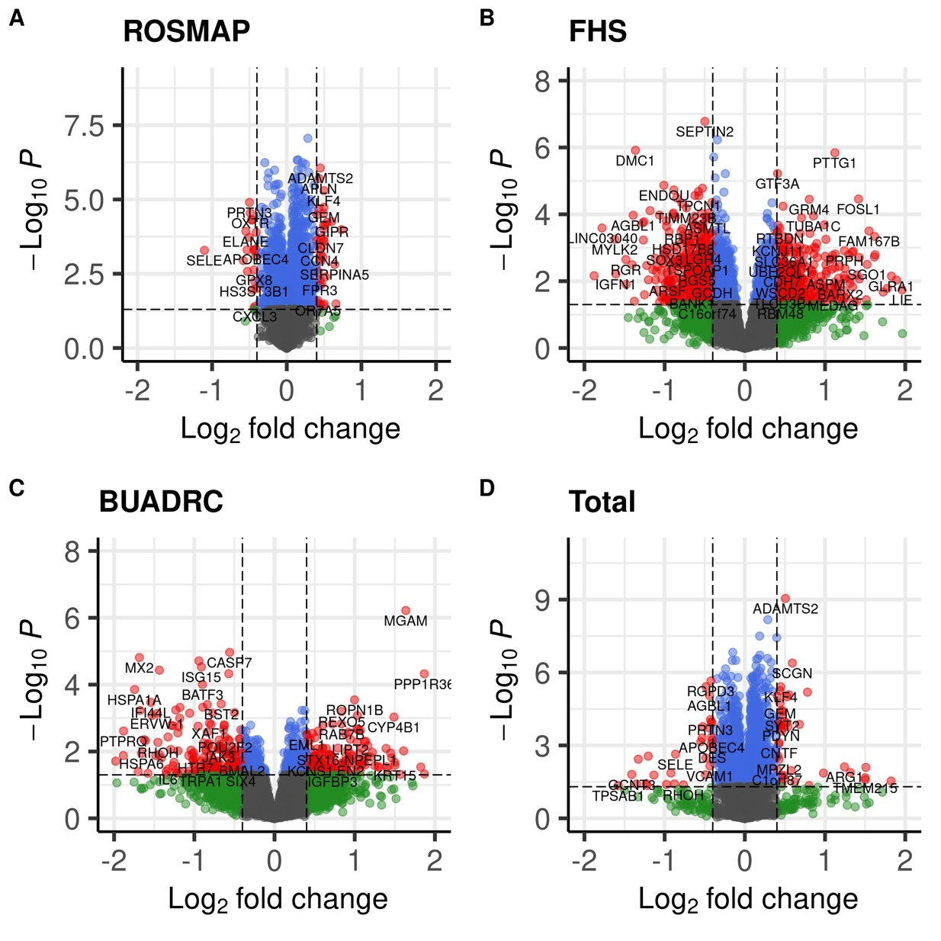
Supplementary Figure 2. Differential expression of 16 candidate genes across six major brain cell types between SymAD and AsymAD groups in ROSMAP single-nucleus RNA-sequencing data.

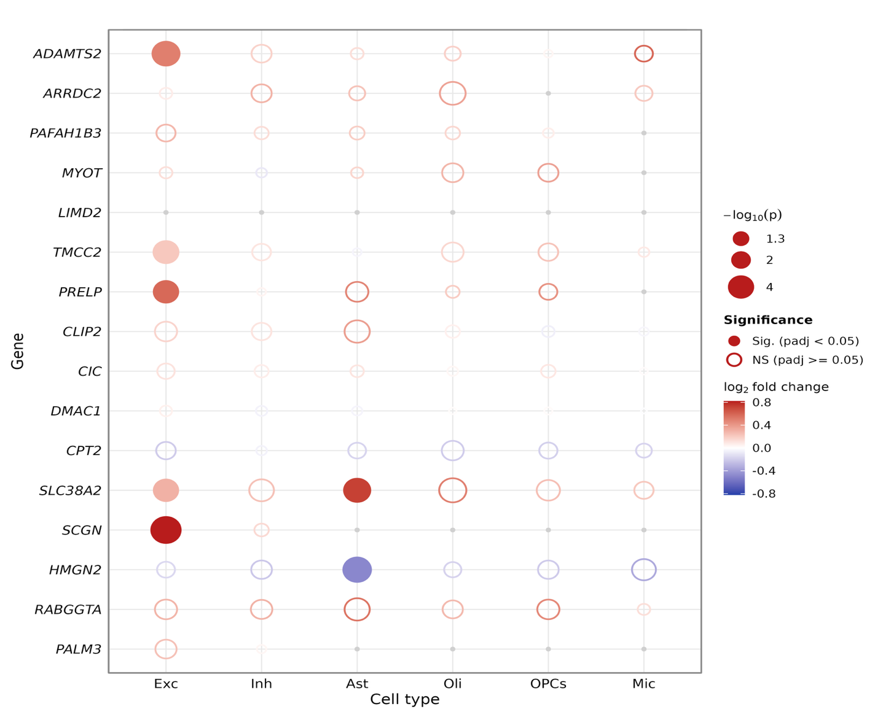

Supplementary Figure 3. WGCNA co-expression network analysis in the ROSMAP dataset. (A) Gene clustering dendrogram with color-coded module assignments identified by hierarchical clustering of the topological overlap matrix. (B) Heatmap of Pearson correlations between module eigengenes (MEs) and clinical traits. Correlation coefficients are shown in each cell ( *, p < 0.05; ** p < 0.01).
A
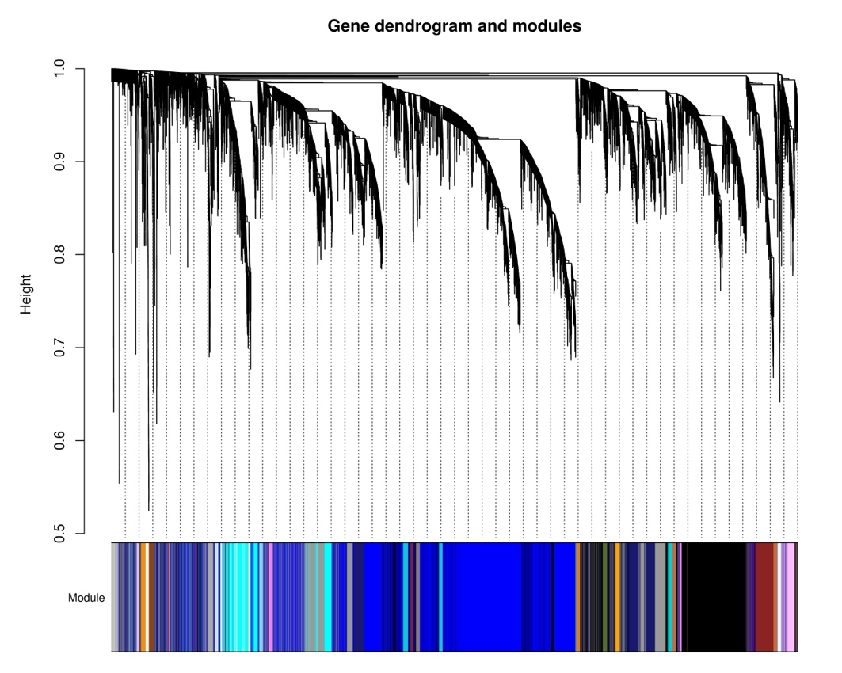
B
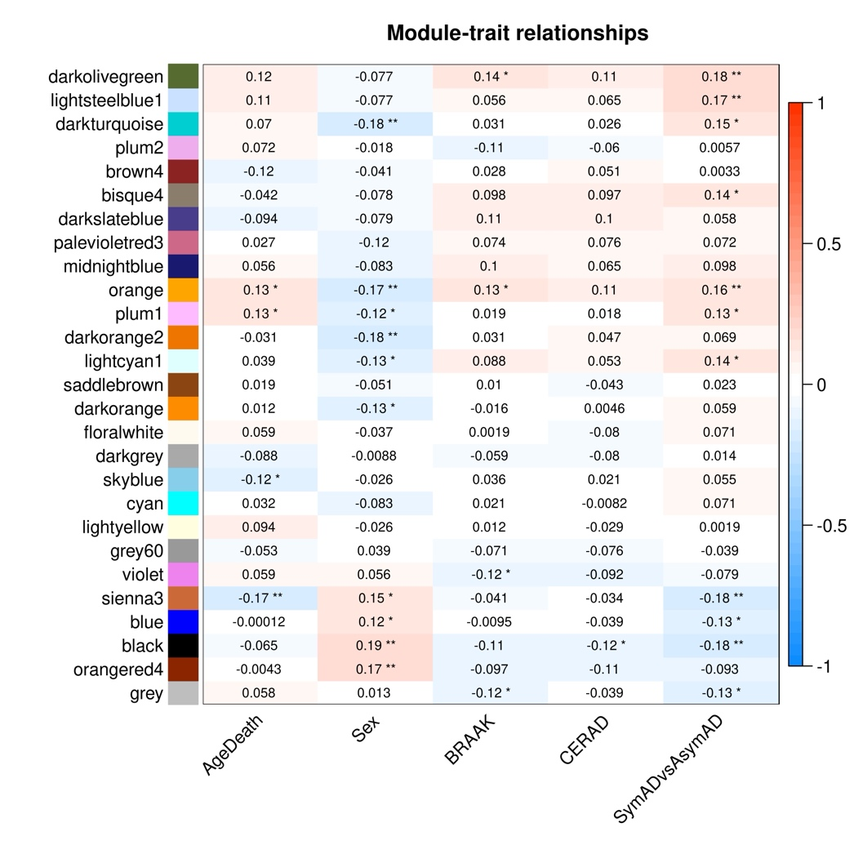
Supplementary Figure 4. Transcriptomic risk scores (TRSs) using DEGs identified from the ROSMAP dataset under five different significance thresholds and evaluated their predictive performance in the independent FHS cohort.

- SymAD vs Ctrl
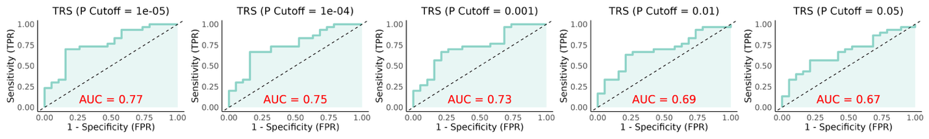
- AsymAD vs Ctrl
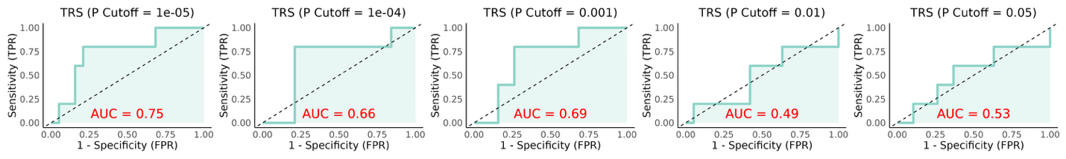
- SymAD vs AsymAD
