Supplementary Materials

The Amyloid Plaque Proteomes of Alzheimer’s Disease and Mild Cognitive Impairment

Authors: Dominique Leitner^{1,2}, Evgeny Kanshin³, Kaleah Balcomb⁴, Manor Askenazi⁵, Jianina I. Suazo¹, Mitchell Marta-Ariza¹, Julie Schneider^{6,7,8}, Beatrix Ueberheide^{1,3} Eleanor Drummond^{1,4}, Thomas Wisniewski^{1,9}

Affiliations:
¹Center for Cognitive Neurology, Department of Neurology, New York University Grossman School of Medicine, New York, NY 10016, USA
²Comprehensive Epilepsy Center, Department of Neurology, New York University Grossman School of Medicine, New York, NY 10016, USA
³Proteomics Laboratory, Division of Advanced Research Technologies and Department of Biochemistry and Molecular Pharmacology, New York University Grossman School of Medicine, New York, NY 10016, USA
⁴Brain and Mind Centre and School of Medical Sciences, University of Sydney, Camperdown, NSW, 2050, Australia
⁵Biomedical Hosting LLC, Arlington, MA 02140, USA
⁶Department Rush Alzheimer’s Disease Center, Rush University Medical Center, 1750 W Harrison Street, Suite 1000, Chicago, IL 60612, USA
⁷Department of Neurological Sciences, Rush University Medical Center, Chicago, IL, USA
⁸Department of Pathology, Rush University Medical Center, Chicago, IL, USA
⁹Departments of Pathology and Psychiatry, New York University Grossman School of Medicine, New York, NY 10016, USA

Supplementary Figure Legends
Supplementary Figure 1. APP peptide detection. All detected APP peptides are indicated.
Supplementary Figure 2. Top plaque proteins in MCI and AD. a-i) The top 10 significantly enriched proteins in MCI include those depicted as well as the Aβ peptide. Proteins are indicated by decreasing significance. j-l) The top 10 significantly enriched proteins in AD included 7 of these same proteins from MCI as well as PBXIP1, CAPG, and LRP1 (PTN, CLU, MDK were not among the top 10 in AD but were also significantly enriched).
Supplementary Figure 3. TMEFF2 histological characterization of CAA. a) Quantification of CAA vessels (4G8 positive) in temporal cortex sections from progressive stages of disease, Control (n = 12), Preclinical AD (n = 10), MCI (n = 12), and AD (n = 12), showed enrichment for 4G8 in vessels of MCI and AD cases. b) Quantification of TMEFF2 immunoreactive area in CAA vessels, showed enrichment for TMEFF2 in CAA vessels of AD cases. c) Representative images show TMEFF2 immunoreactivity at progressive stages of disease in CAA and plaque tissue. Significant pairwise comparisons are indicated for those analyses that were performed, * p < 0.05, ** p < 0.01. Scale bar 200 um.

Supplementary Tables
Supplementary Table 1. Detailed Case History
Supplementary Table 2. LC-MS/MS Data and T-tests
Supplementary Table 3. GO Terms MCI Plaque vs MCI Non-Plaque
Supplementary Table 4. GO Terms AD Plaque vs AD Non-Plaque
Supplementary Table 5. GO Terms MCI Non-Plaque vs Control Non-Plaque
Supplementary Table 6. GO Terms AD Non-Plaque vs Control Non-Plaque
Supplementary Table 7. Plaque and NeuroPro Proteome Comparison - Previously Unreported Proteins
Supplementary Table 8. Plaque vs GNPC Biofluid Proteome Comparison
Supplementary Table 9. WGCNA GO anRichment Analysis Control Non-Plaque
Supplementary Table 10. WGCNA GO anRichment Analysis MCI Plaque
Supplementary Table 11. WGCNA GO anRichment Analysis MCI Non-Plaque
Supplementary Table 12. WGCNA GO anRichment Analysis AD Plaque
Supplementary Table 13. WGCNA GO anRichment Analysis AD Non-Plaque

Supplementary Figure 1.
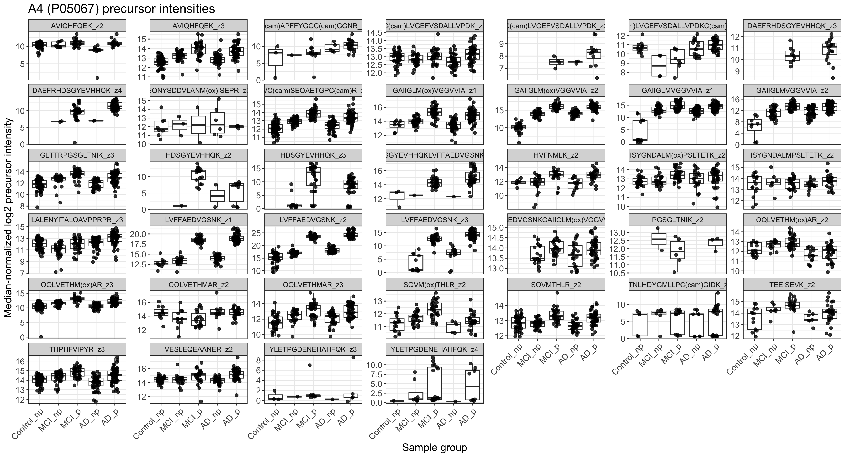
Supplementary Figure 2.
Supplementary Figure 3.

