SUPPLEMENTARY MATERIALS
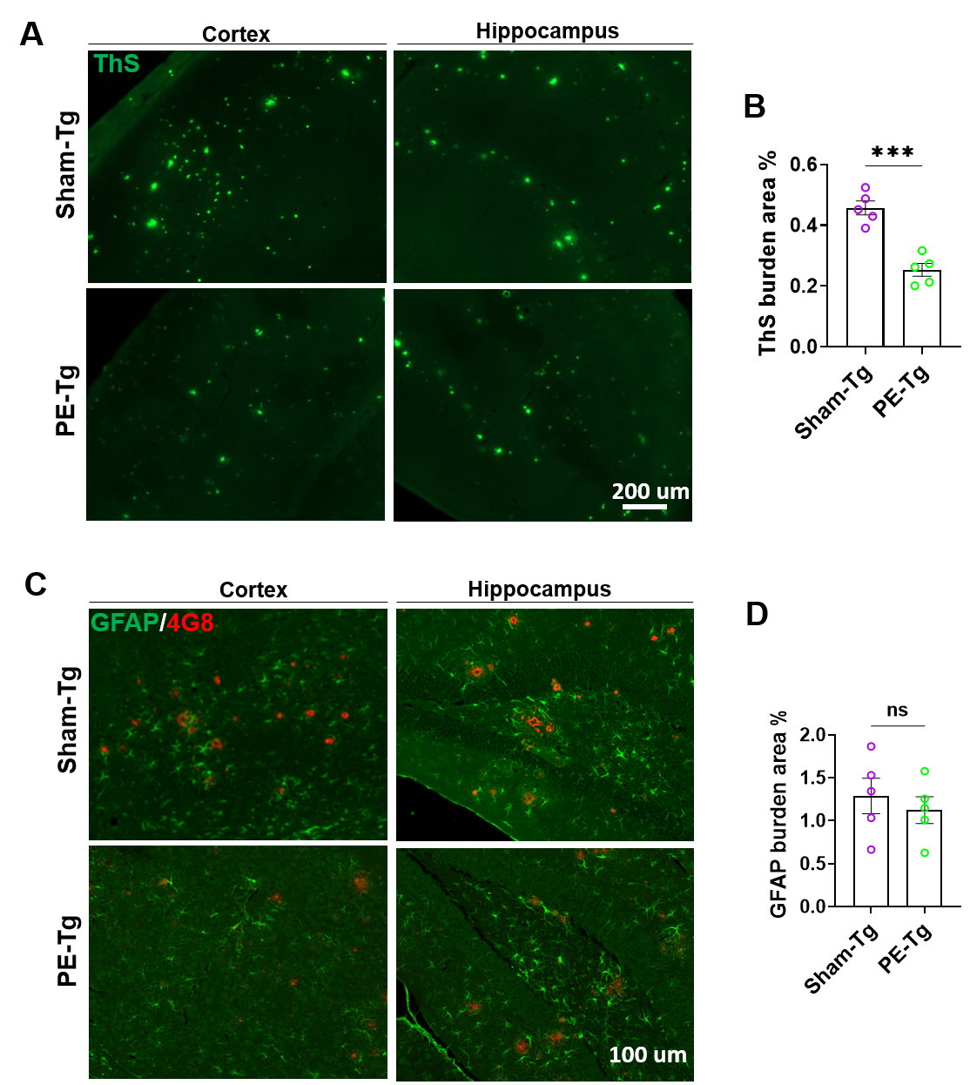

Supplementary Figure 1. Histological analysis of astrogliosis by GFAP staining and amyloid burden by Thioflavin-S and 4G8 staining.
- Representative Thioflavin-S–stained sections of Sham-Tg and PE-Tg mice, showing the cortex and hippocampus. Because Thioflavin-S binds the cross-β-sheet conformation of fibrillar amyloid directly, its signal requires no antigen retrieval and is independent of epitope accessibility, providing an antibody-independent validation of the 4G8 immunostaining in Fig. 2. Scale bar, 200 µm. (B) Quantification of Thioflavin-S burden, expressed as the threshold of ThS-positive area as a percentage of the region of interest and calculated as the mean of the cortical and hippocampal values per animal. ThS burden was reduced in PE-Tg mice (Sham-Tg 0.457 ± 0.023 % vs PE-Tg 0.254 ± 0.021 %; p = 0.0002; Sham-Tg n = 5, PE-Tg n = 5), confirming the reduction in amyloid burden seen with 4G8 by a conformation-dependent, antibody-independent method. Data are presented as mean ± SEM; each point represents one animal. Groups were compared by unpaired two-tailed t-test (***p < 0.001). (C) Representative photomicrographs of brain sections co-stained for GFAP (green) and 4G8 (red) in Sham-Tg and PE-Tg mice, showing the cortex and hippocampus. Scale bar, 100 µm. (D) Quantification of brain GFAP immunoreactive burden, expressed as the thresholded GFAP-positive area as a percentage of the region of interest and calculated as the mean of the cortical and hippocampal values per animal. GFAP burden did not differ between groups (Sham-Tg 1.28 ± 0.2 % vs PE-Tg 1.12 ± 0.15 %; p = 0.54; n = 5 per group), indicating that reactive astrogliosis is not altered by PE at the tissue level and independently confirming the GFAP ELISA shown in Fig. 4B. WT, wild-type littermates; Sham-Tg, sham-operated APP/PS1 mice; PE-Tg, plasma exchange–treated APP/PS1 mice; GFAP, glial fibrillary acidic protein; ThS, Thioflavin-S.

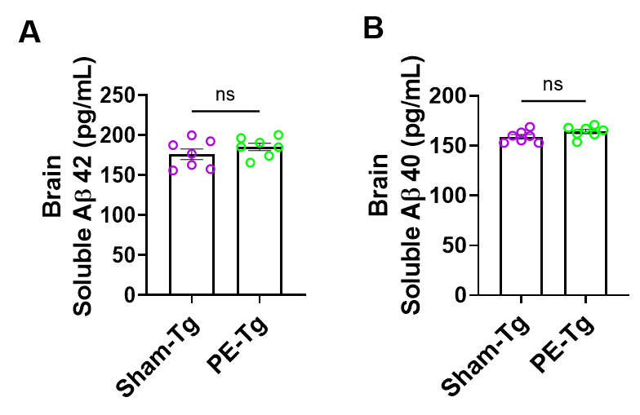

Supplementary Figure 2. The PBS-soluble brain Aβ pool is unchanged by PE. (A) PBS-soluble brain Aβ₄₂ and (B) PBS-soluble brain Aβ₄₀, measured by ELISA in the same brain homogenates from which the insoluble fractions shown in Fig. 2E–F were obtained. Neither soluble species differed between groups (Aβ₄₂: Sham-Tg 176.1 ± 6.7 vs PE-Tg 185.4 ± 4.6 pg/mL, p = 0.28; Aβ40: Sham-Tg 159.0 ± 2.2 vs PE-Tg 164.2 ± 2.2 pg/mL, p = 0.12; n = 7 per group), indicating that the marked reduction in deposited Aβ after PE is not accompanied by a depletion of the soluble pool. Groups were compared by unpaired two-tailed t-test. Data are mean ± SEM; each point represents one animal. Sham-Tg, sham-operated APP/PS1 mice; PE-Tg, plasma exchange–treated APP/PS1 mice.

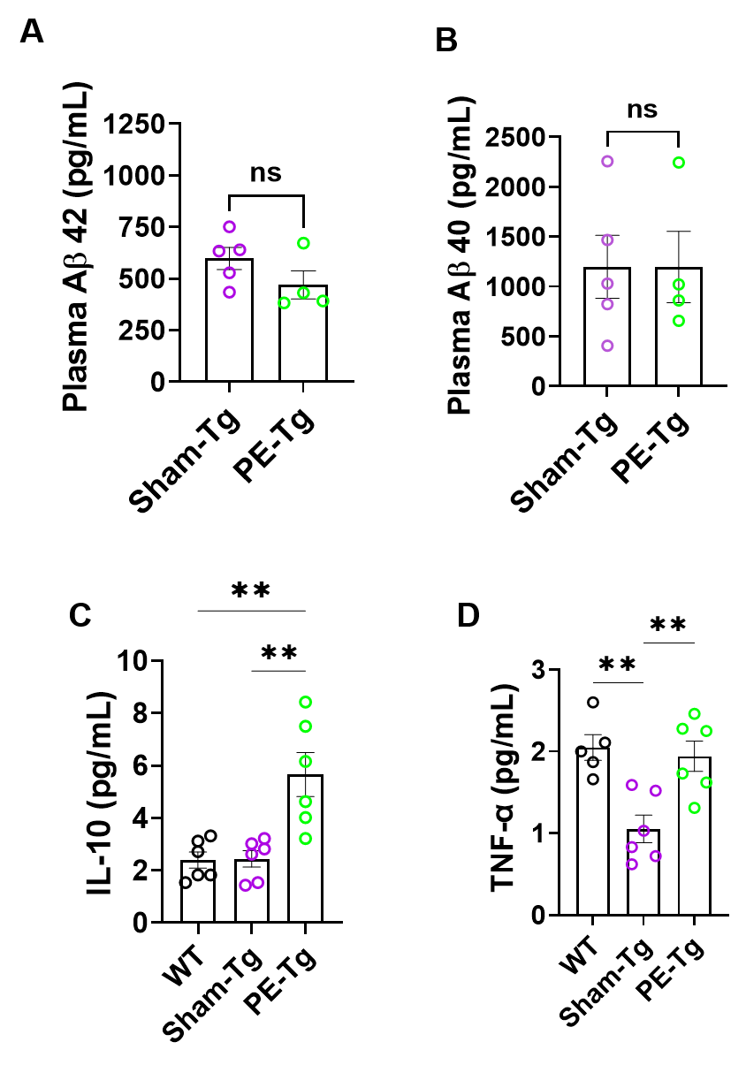
Supplementary Figure 3. Plasma levels of Aβ and cytokines after PE. (A, B) Plasma Aβ₄₂ (A) and Aβ₄₀ (B) measured by ELISA in the first plasma sample collected at the onset of treatment, before any exchange had taken effect. Neither analyte differed between groups at baseline (Aβ₄₂: Sham-Tg 597.9 ± 53.9 vs PE-Tg 469.6 ± 68.3 pg/mL, p = 0.18; Aβ₄₀: Sham-Tg 1197.3 ± 315.3 vs PE-Tg 1196.2 ± 357.4 pg/mL, p = 0.998; Sham-Tg n = 5, PE-Tg n = 4), confirming that the two transgenic groups were comparable for circulating Aβ prior to treatment and that the elevated terminal plasma Aβ in PE-Tg mice arose over the course of the intervention. (C) Plasma IL-10 was significantly elevated in PE-Tg mice relative to both WT and Sham-Tg (one-way ANOVA F (2,15) = 12.59, p < 0.001; WT vs Sham-Tg p = 0.993; WT vs PE-Tg p = 0.0018; Sham-Tg vs PE-Tg p = 0.0014; n = 6 per group). WT 2.393 ± 0.309; Sham-Tg 2.310 ± 0.272; PE-Tg 5.660 ± 0.837 pg/mL. (D) Plasma TNF-α was significantly reduced in Sham-Tg mice relative to WT, with PE-Tg levels restored to WT values (F (2,14) = 10.17, p = 0.002; WT vs Sham-Tg p = 0.0036; WT vs PE-Tg p = 0.905; Sham-Tg vs PE-Tg p = 0.0058; WT n = 5, Sham-Tg and PE-Tg n = 6). WT 2.048 ± 0.157; Sham-Tg 1.052 ± 0.169; PE-Tg 1.942 ± 0.185 pg/mL. Panels A and B were analyzed by unpaired two-tailed t-test. Panels C and D were compared by one-way ANOVA with Tukey's multiple comparisons test. Data are mean ± SEM; each point represents one animal. WT, wild-type littermates; Sham-Tg, sham-operated APP/PS1 mice; PE-Tg, plasma exchange–treated APP/PS1 mice.

