Supplementary data
Figure S1. The conserved sequence of xynA

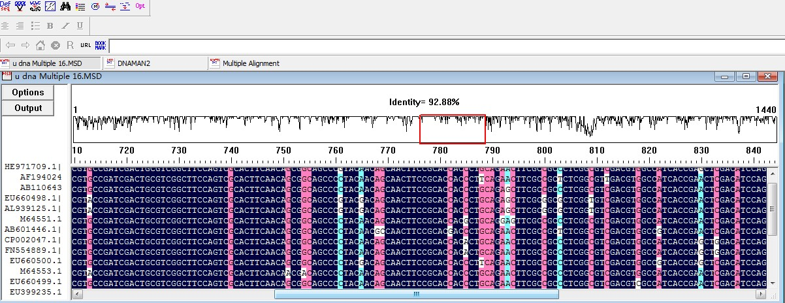

Figure S2. The sequence of xynA-Core
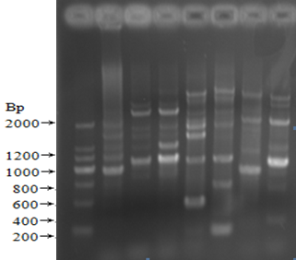

M 1 2 3 4 5 6 7
M: marker, 1: Pn15 and Pr929(62°C annealing),2：Pn15 and Pr1035 (62°C annealing), 3: Pn15 and Pr1035 (57°C annealing), 4: Pn15 and Pr725 (57°C annealing), 5:Pf244 and Pr725 (57°C annealing), 6: Pf244 and Pr929 (57°C annealing), 7: Pf244 and Pr1035 (57°C annealing)
Figure S3. The schematic approach to distinguish specific and nonspecific binding between enzyme and substrate.
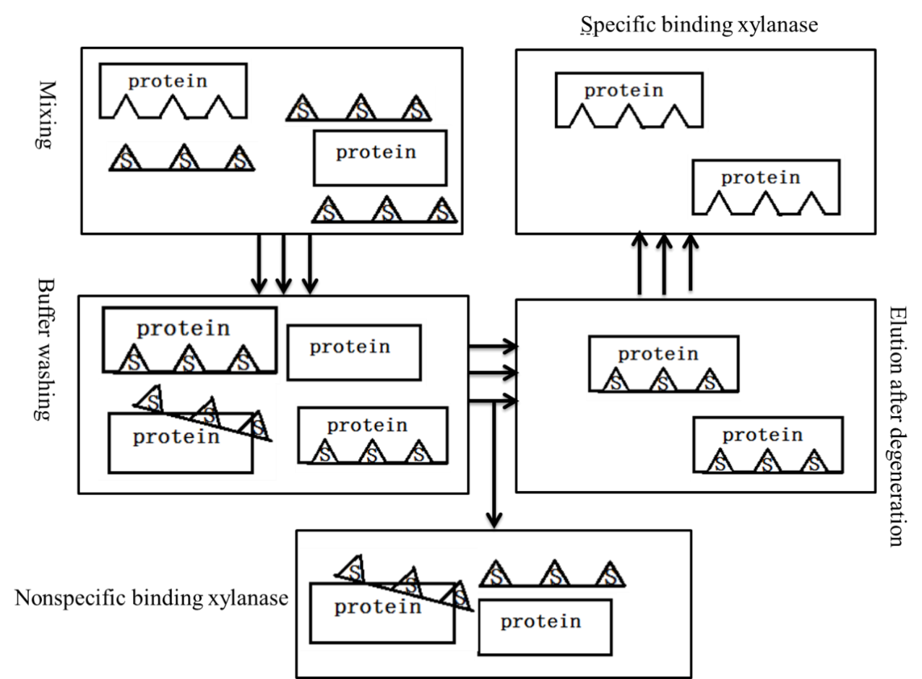
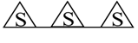
Substrate

Figure S4. The chromatogram of Xylooligosaccharide in the hydrolysate using (a) oat spelt xylan and (b) beechwood xylan as the substrate.
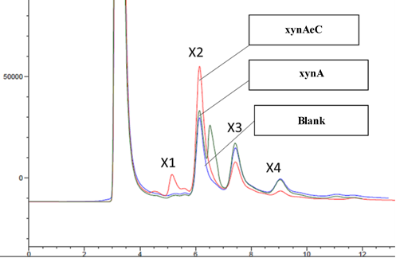
xynADCBM

(a)
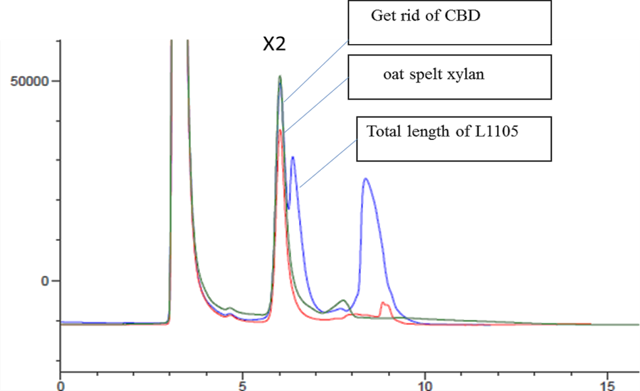
xynADCBM
xynA
Blank
X4
X3

(b)
Table S1. Degenerate primers for the core sequence of xynA
Primer |  |  | Sequence(5’-3’) | Restriction site
Forward primer |  | Pn15 | CGCCGAGAAGGGCCGCTACT
Forward primer |  | PF244 | GTGACSSCCGAGAACGAGAT
 |  | XynF | CCGAATTCATGGCGACCCGCACATCCAT | EcoRⅠ
Reverse primer |  | PR725 | AGTGCGACTGGAAGCCGAC
Reverse primer |  | Pr929 | CARCGSGDSACSGCCAGGCAG
Reverse primer |  | Pr1035 | GCGKDRTASGCGGSCTTCTTG
 |  |  | CCCTCGAGTCAGGACGCCGTGCAGGAAC | XhoⅠ
Tip：R=A/G，S=C/G，W= A/T，B= C/G/T，N=A/C/G/T

Table S2. HiTail-PCR reaction system
Reaction system(μL) | Pre-amplification | Primary | Secondary
2×GC buffer Ⅰ  dNTP Mixture(2mM) | 12.5  2.5 | 12.5  2.5 | 12.5  2.5
Template DNA | 1 | 1 | 1
LAD/AC1 | 1 | 0.3 | 0.3
SP | 0.3 | 0.3 | 0.3
ddH₂O | 7.4 | 8.1 | 8.1
LA-Taq | 0.3 | 0.3 | 0.3
Total | 25 | 25 | 25

Table S3. Thermal Conditions for HiTAIL-PCR
Pre-amplification |  |  | Primary |  |  | Second
Step | Temperature  ( °C) | Time  (min:s) | Step | Temperature  ( °C) | Time  (min:s) | Step | Temperature  ( °C) | Time  (min:s)
1 | 93 | 2:00 | 1 | 94 | 0:20 | 1 | 94 | 0:20
2 | 95 | 1:00 | 2 | 65 | 1:00 | 2 | 68 | 1:00
3 | 94 | 0:30 | 3 | 72 | 3:00 | 3 | 72 | 3:00
4 | 60 | 1:00 | 4 | Go to step 1 | 1 times | 4 | 94 | 0:20
5 | 72 | 3:00 | 5 | 94 | 0:20 | 5 | 68 | 1:00
6 | Go to step 3 | 10 times | 6 | 68 | 1:00 | 6 | 72 | 3:00
7 | 94 | 0:30 | 7 | 72 | 3:00 | 7 | 94 | 0:20
8 | 25 | 2:00 | 8 | 94 | 0:20 | 8 | 50 | 1:00
9 | Ramping to 72 | 0.5 °C/s | 9 | 68 | 1:00 | 9 | 72 | 3:00
0 | 72 | 3:00 | 0 | 72 | 3:00 | 0 | Go to step 1 | 6-7times
1 | 94 | 0:20 | 1 | 94 | 0:20 | 1 | 72 | 5:00
2 | 58 | 1:00 | 2 | 50 | 1:00 | 2 | End
3 | 72 | 3:00 | 3 | 72 | 3:00 | 3
4 | Go to step 13 | 25 times | 4 | Go to step 5 | 13 times | 4
5 | 72 | 5:00 | 5 | 72 | 5:00 | 5
6 | End |  | 6 | End |  | 6

Table S4 Summary of xylanase purification of xynA and xynADCBM
 | xynA |  |  | xynADCBM
Purification steps | Crude enzyme solution | 50-80% ammonium sulfate precipitation | CM column | Crude enzyme solution | 50-80% ammonium sulfate precipitation | CM column
Total enzyme activity (U) | 4507 | 3550.84 | 1227.3 | 3567 | 2474.52 | 766.6
Protein content (mg) | 42.9 | 26.7 | 5.38 | 28.51 | 16.17 | 2.32
Relative enzyme activity (U/mg) | 105.06 | 133.94 | 228.12 | 125.11 | 153.03 | 330.43
Purification factor | 1.00 | 1.27 | 2.17 | 1.00 | 1.22 | 2.64
Recovery (%) | 100 | 78.79 | 27.23 | 100 | 69.37 | 21.49

