Accumulation of Beneficial Bacteria in the Rhizosphere of Maize (Zea mays L.) Grown in a Saline Soil in Responding to a Consortium of Plant Growth Promoting Rhizobacteria

Jieli Peng¹, Jia Ma¹, Xiaoyan Wei¹, Cuimian Zhang¹, Nan Jia¹, Xu Wang¹, En Tao Wang², Dong Hu¹*, Zhanwu Wang¹*

¹ Institute of Agro-resources and Environment (Hebei Fertilizer Technology Innovation Center), Hebei Academy of Agriculture and Forestry Sciences, Shijiazhuang, Hebei, P. R. China
²Departamento de Microbiología, Escuela Nacional de Ciencias Biológicas, Instituto Politécnico Nacional, C.P. 11340, Ciudad de México, México

*Correspondence authors

Email: donghu1983@163.com, zhanwuw@126.com

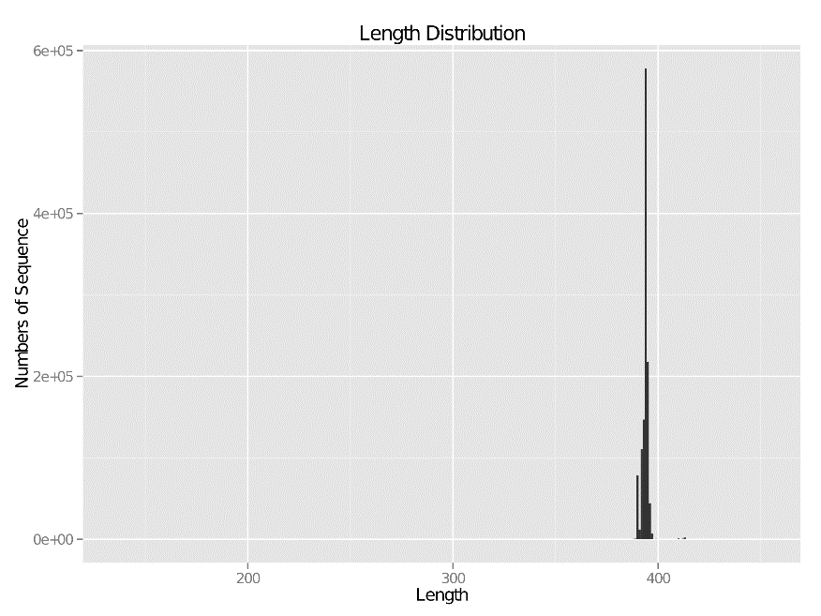
Fig. S1. The Length Distribution of sequences

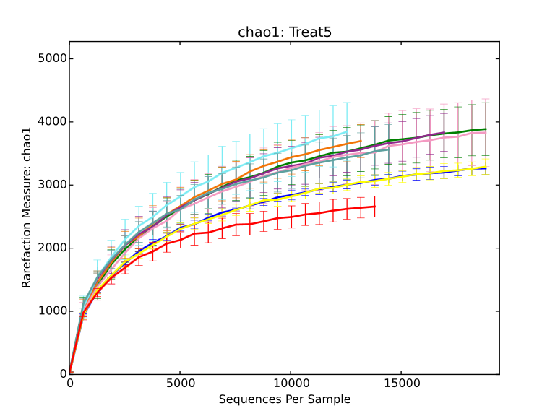
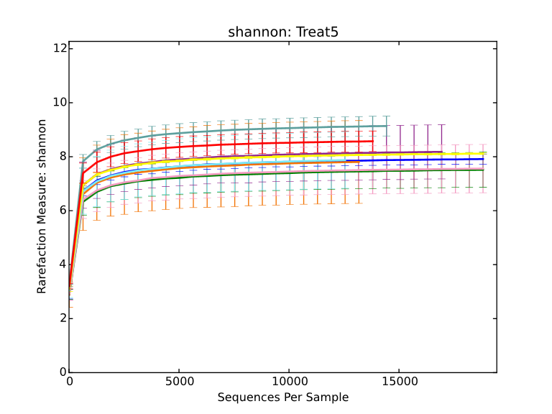
Fig. S2. The OTU Shannon rarefaction curve
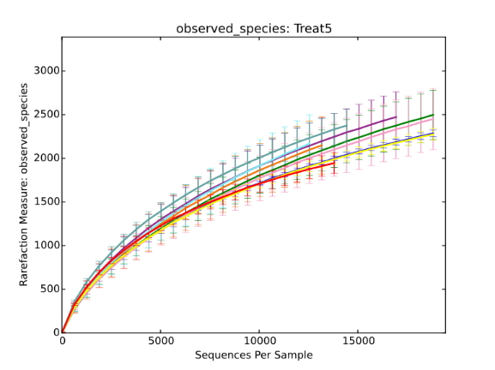
Fig. S3. The OTU chao1 rarefaction curve
Fig. S4. The OTU observed species rarefaction curve
Suppl. Table S1. Details for antagonistic ability of consortium strains to phytopathogenic fungi
Strains | CR | Pseudomonas sp. P8 |  | Peribacillus sp.  P10 |  | Streptomyces sp. X52
Strains | CR | TR | IR/% | TR | IR/% | TR | IR/%
Pythium sp. | 2.91±0.51^{A} | 1.71±0.27^{B} | 41.24 | 1.87±0.30^{B} | 35.74 | 0.93±0.37^{B} | 68.04
Fusarium sp. | 4.00±0.33^{A} | 3.08±0.14^{B} | 23.00 | 1.22±0.20^{C} | 69.50 | 2.28±0.18^{D} | 43.00
Curvularia lunata | 2.88±0.07^{A} | 1.25±0.26^{B} | 56.60 | 1.31±0.31^{B} | 54.51 | 0.63±0.26^{B} | 78.13
Bipolaria maydis | 3.29±0.10^{A} | 1.61±0.24^{B} | 51.06 | 1.30±0.11^{B} | 60.49 | 0.56±0.08^{C} | 82.98
Phytophthora sp. | 3.84±0.01^{A} | 1.74±0.38^{B} | 54.69 | 2.00±0.05^{B} | 47.92 | 1.45±0.31^{B} | 62.24
CR. Control experiments of colony radius; TR. Treatment experiments of colony radius; IR. Inhibition rates of mycelium growth. IR(%)=(CR-TR)/CR×100; The mean±SD, n = 3, one-way ANOVA, different alphabets represent statistically significant differences between the treatments (TR) compared with control (CR) (p < 0.01)

Suppl. Table S2. The Alpha diversity index of rhizosphere bacteria in the treatments
Sample/stage | Type | Simpson | Chao1 | ACE | Shannon
Soil at beginning | 101 | 0.985710 | 1326 | 1744.14 | 8.47
Soil at beginning | 102 | 0.945147 | 1363 | 2238.37 | 7.75
Soil at beginning | 103 | 0.991413 | 1179 | 1453.09 | 8.52
Control/three-leaf stage | 111 | 0.963302 | 1503 | 2367.13 | 7.76
Control/three-leaf stage | 112 | 0.922664 | 1436 | 2171.68 | 7.28
Control/three-leaf stage | 113 | 0.949780 | 1408 | 2431.53 | 7.46
Inoculation treatment/three-leaf stage | 311 | 0.957568 | 1493 | 2568.82 | 7.69
Inoculation treatment/three-leaf stage | 312 | 0.974971 | 1319 | 2349.01 | 7.77
Inoculation treatment/three-leaf stage | 313 | 0.971440 | 1331 | 2299.31 | 7.73
Control/jointing stage | 121 | 0.988999 | 1382 | 1870.75 | 8.59
Control/jointing stage | 122 | 0.760602 | 719 | 1062.14 | 4.91
Control/jointing stage | 123 | 0.978768 | 1551 | 2922.53 | 8.27
Inoculation treatment/jointing stage | 321 | 0.968613 | 1120 | 1574.52 | 7.41
Inoculation treatment/jointing stage | 322 | 0.987488 | 1258 | 1851.77 | 8.40
Inoculation treatment/jointing stage | 323 | 0.855048 | 943 | 1398.56 | 5.88
Control/tasseling stage | 131 | 0.865306 | 974 | 1577.66 | 6.01
Control/tasseling stage | 132 | 0.952721 | 1532 | 2728.41 | 7.66
Control/tasseling stage | 133 | 0.935814 | 1379 | 2659.04 | 7.04
Inoculation treatment/ tasseling stage | 331 | 0.871847 | 959 | 1519.74 | 6.06
Inoculation treatment/ tasseling stage | 332 | 0.979623 | 1760 | 3173.83 | 8.31
Inoculation treatment/ tasseling stage | 333 | 0.915482 | 1232 | 1910.70 | 6.44
Control/maturity stage | 141 | 0.980639 | 1347 | 2358.91 | 8.00
Control/maturity stage | 142 | 0.863879 | 1321 | 2249.44 | 6.32
Control/maturity stage | 143 | 0.986567 | 1641 | 2628.48 | 8.79
Inoculation treatment/ maturity stage | 341 | 0.982346 | 1262 | 1657.84 | 8.22
Inoculation treatment/ maturity stage | 342 | 0.994385 | 1470 | 1969.62 | 9.06
Inoculation treatment/ maturity stage | 343 | 0.992307 | 1420 | 1858.65 | 8.80

