Sustainable Municipal Wastewater Treatment Using an Innovative Integrated Compact Unit: Microbial Communities, Parasite Removal, and Techno-Economic Analysis

Mohamed El-Khateeb¹, Gamal Hassan¹, Mohamed Azab El-Liethy², Kamel M. El-Khatib³, Hussein Abdel-Shafy¹, Anyi Hu⁴, Mahmoud Gad⁵*

¹Water Pollution Research Department, National Research Centre, Dokki, 12622, Giza, Egypt
²Environmental Microbiology Lab., Water Pollution Research Department, National Research Centre, Dokki, 12622, Giza, Egypt
³Chemical Engineering & Pilot Plant Department, Engineering Research and Renewable Energy Institute, National Research Centre, Dokki, 12622, Giza, Egypt
⁴ CAS Key Laboratory of Urban Pollutant Conversion, Institute of Urban Environment, Chinese Academy of Sciences, Xiamen 361021, China; ayhu@iue.ac.cn
⁵Environmental Parasitology Lab., Water Pollution Research Department, National Research Centre, Dokki, 12622, Giza, Egypt
* Correspondence: mi.saleh@nrc.sci.eg or mahmoudafw@yahoo.com; Tel.: +20-106-113-2911

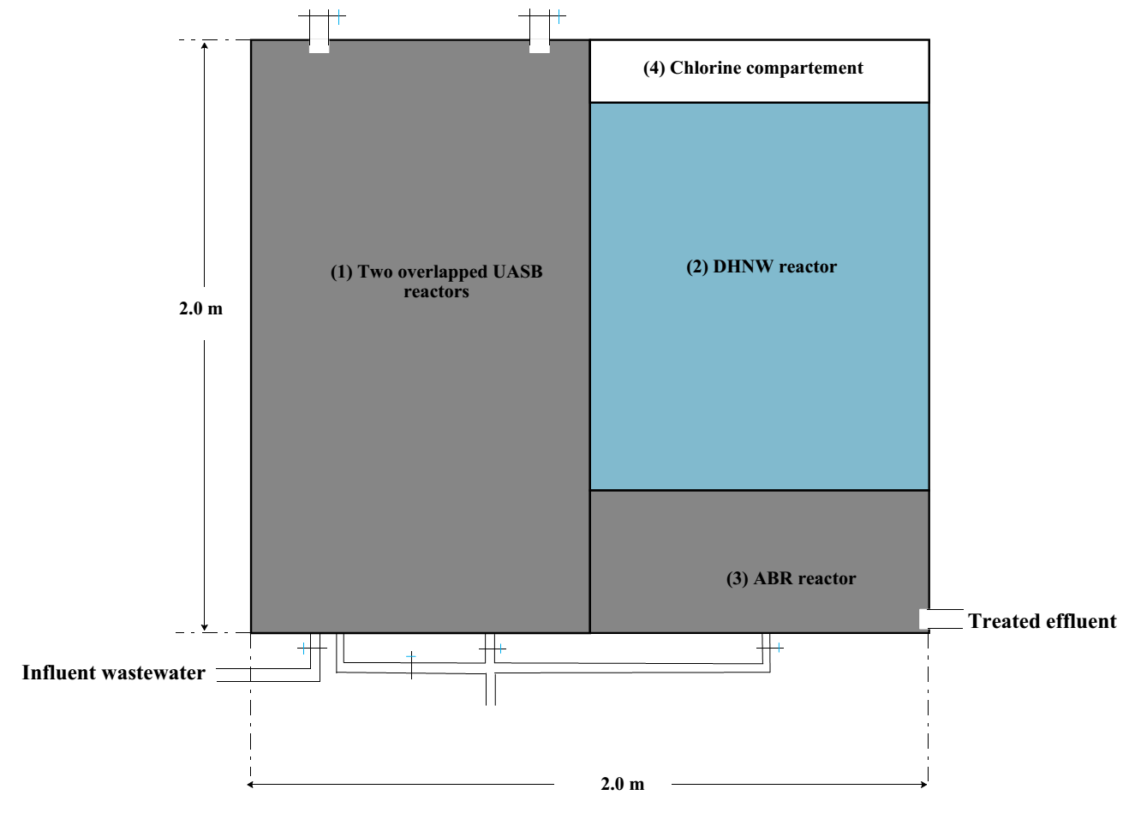
Figure S1. Schematic diagram of the compact unit for 100 persons; 1) two overlapped UASB reactors (anaerobic stage); DHNW reactor (aerobic stage); ABR reactor, and chlorine unit.

Table S1. Operating conditions of the compact unit during one year working (Junrary-December 2022)
Primary treatment step (UASB)
Parameter | Unit | Value
Length | m | 1.25
Width | m | 1.0
Height | m | 2.0
Detention time (DT) | Hr | 5.0
Organic loading rate (OLR) | Kg COD/m³/d  Kg BOD/ m³/d | 1.8  1.4
Hydraulic loading rate (HLR) | m³/m³/d | 4.8
Secondary treatment step (DHNW)
Parameter | Unit | Value
Length | m | 0.75
Width | m | 1.0
Height | m | 2.0
No. of pieces of packing material | No. | 40,000
Detention time (DT) | Hr | 5
Total Surface area of packing material | m²/m³ | 293.3
Hydraulic loading rate (HLR) | m/h | 0.5
Organic loading rate (OLR) | Kg COD/m³.packing material/d  Kg BOD/m³.packing material/d | 3.4  2.4
Ammonia loading rate (ALR) | Kg N/m³.packing material/d | 0.7
Hydraulic loading rate (HLR) | m³/m³. packing material/d | 24

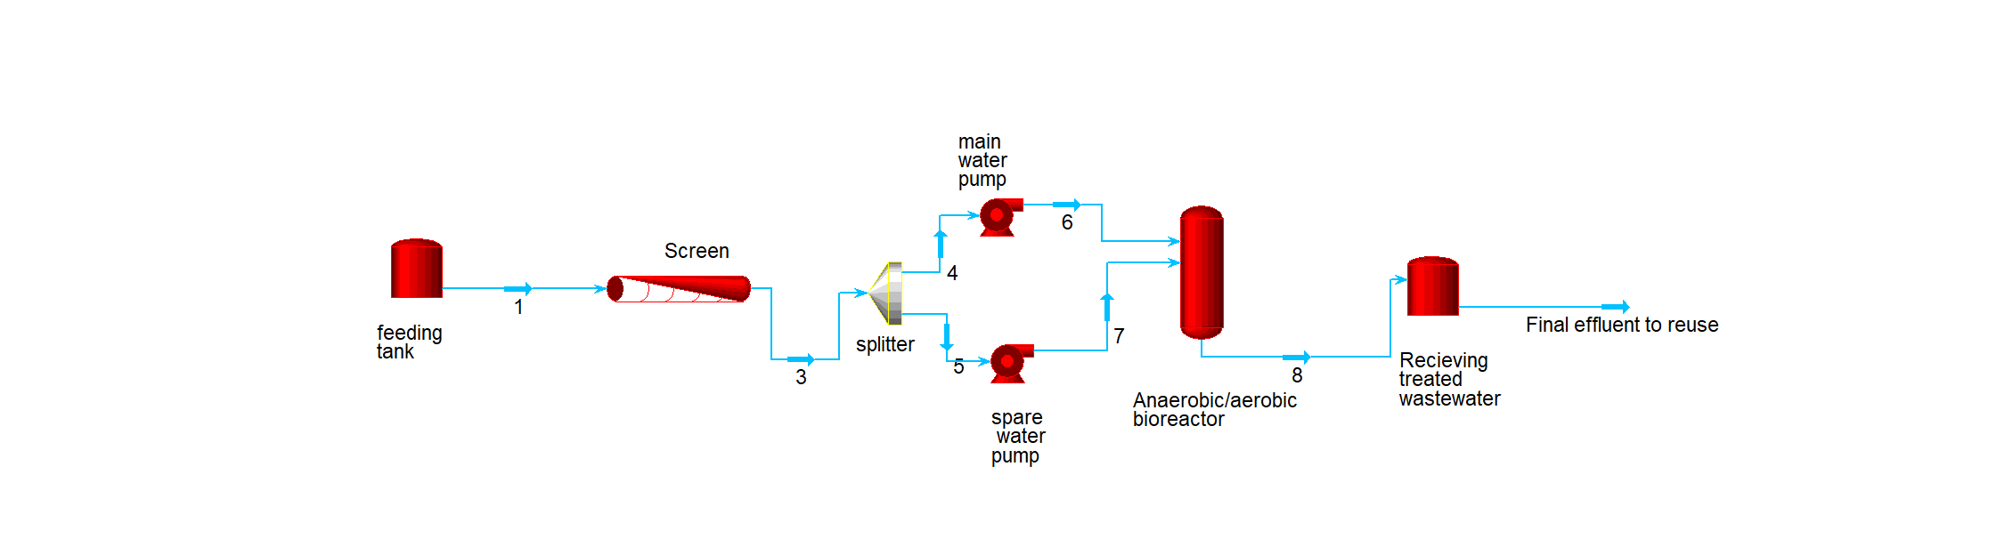
Figure S2: Process flow sheet of the Anaerobic/aerobic bioreactor compact unit wastewater treatment plant

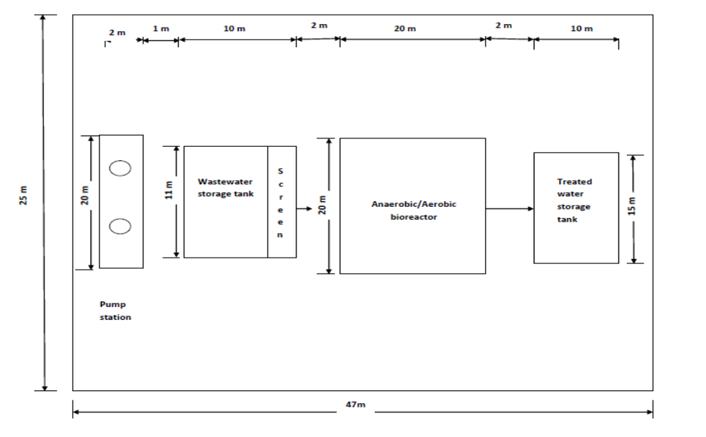
Figure S3: Layout of the aerobic/anaerobic wastewater treatment compact unit

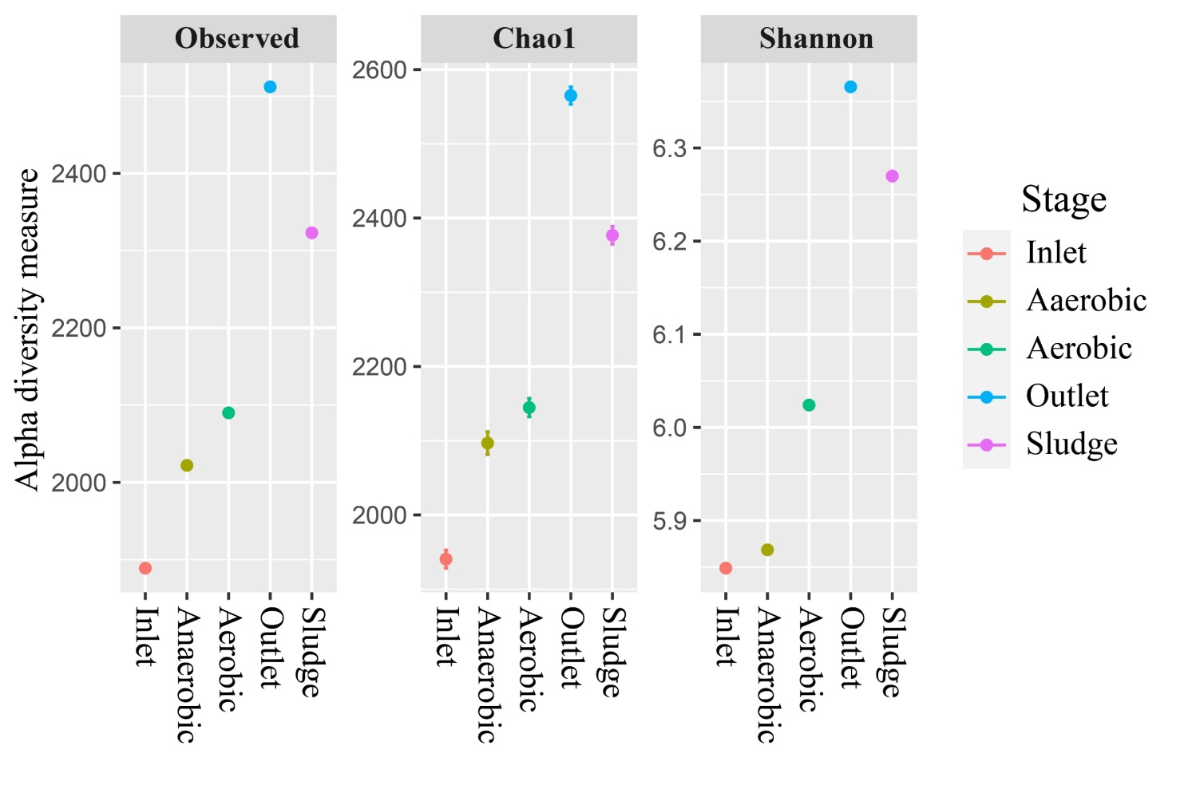
Figure S4. Alpha diversity measurements of microbial communities in the different treatment stages.

