Supplementary Information

Process analysis of the anaerobe Phocaeicola vulgatus in shake flask and fermenter reveals pH and product inhibition

Laura Keitel^{1*}, Katharina Miebach^{1*}, Stanislav Yordanov¹, Lea Rummel¹ and Jochen Büchs^{1**}

¹ RWTH Aachen University, Chair of Biochemical Engineering (AVT.BioVT), Forckenbeckstraße 51, 52074 Aachen, Germany
* Both authors contributed equally to this work
** Corresponding author: Jochen Büchs, RWTH Aachen University, Biochemical Engineering (AVT.BioVT), Forckenbeckstraße 51, 52074 Aachen, Germany, Tel.: +49 241 80 24633, Fax: +49 241 80 22635, E mail: jochen.buechs@avt.rwth-aachen.de

Email addresses:
LK: laura.keitel@avt.rwth-aachen.de
KM: katharina.miebach@avt.rwth-aachen.de
SY: stanislav.yordanov@rwth-aachen.de
LR: lea.rummel@online.de
JB: jochen.buechs@avt.rwth-aachen.de

Supplementary Materials and Methods
Name | Final concentration in DMM-G medium
α-lipoic acid | 0.05 mg L⁻¹
Ammonium chloride | 0.75 g L⁻¹
Biotin | 0.02 mg L⁻¹
Boric acid | 0.6 mg L⁻¹
Butyric acid | 0.176 mg L⁻¹
Calcium chloride | 0.026 g L⁻¹
Cobalt(II)chloride hexahydrate | 0.4 mg L⁻¹
Copper(II)chloride dihydrate | 0.02 mg L⁻¹
Dipotassium phosphate | 2.2 g L⁻¹
Folate | 0.02 mg L⁻¹
Glucose | 6.0 g L⁻¹
Hemin | 1.0 mg L⁻¹
Iron(II) sulphate | 1.39 mg L⁻¹
L-cysteine hydrochloride | 484 mg L⁻¹
Magnesium chloride | 0.1 g L⁻¹
Manganese(II) chloride tetrahydrate | 0.06 mg L⁻¹
Monopotassium phosphate | 1.7 g L⁻¹
MOPS buffer  (3-(N-morpholino)propanesulfonic acid) | 0 – 150 mM
Nickel(II)chloride hexahydrate | 0.04 mg L⁻¹
Nicotinamide | 0.05 mg L⁻¹
P-aminobenzoic acid | 0.05 mg L⁻¹
Pantothenic acid | 0.05 mg L⁻¹
Pyridoxine hydrochloride | 0.1 mg L⁻¹
Riboflavin | 0.05 mg L⁻¹
Sodium chloride | 0.9 g L⁻¹
Sodium molybdate dihydrate | 0.06 mg L⁻¹
Thiamine hydrochloride | 0.05 mg L⁻¹
Vitamin B12 | 0.001 mg L⁻¹
Vitamin K1 | 9.95 ·10⁻⁵ % v/v
Zinc sulfate heptahydrate | 0.2 mg L⁻¹

Table S1 Final concentrations of DMM-G medium components used in this work in alphabetical order. The concentrations are based on weighed-in and subsequently completely dissolved amounts before heat-sterilization or filtration.

Name | Symbol | Value and unit
Shaking frequency | n | 100 min⁻¹ = 1.67 s⁻¹
Water density at 37 °C | ρ | 993.37 kg m³ ⁻¹
Water viscosity at 37 °C | η | kg m⁻¹ s
Inner diameter of the shake flask | d | 0.077 m
Reynolds number | $$Re=\frac{ρnd^{2}}{η}$$ | 14181.09
Constant | C₃ | 1.94
Liquid volume | V_{L} | 0.00005 m³
Volume-specific Power input | $$\frac{P}{V_{L}}=C_{3}ρ{\frac{n^{3}d^{4}}{{V_{L}}^{2/3}}Re}^{-0.2}$$ | 0.034 kW m³ ⁻¹
Table S2: Parameters and formula for power input calculations of shake flask cultivations. Constants and formula are adapted from Büchs et al. (2000).

Name | Symbol | Value and unit
Stirring frequency | n | 600 min⁻¹ = 10 s⁻¹
Water density at 37 °C | ρ | 993.37 kg m³ ⁻¹
Water viscosity at 37 °C | η | kg m⁻¹ s
Impeller diameter | d_{i} | 0.04548 m
Impeller power number | N_{p} | 4.17 (Kaiser et al. 2017)
Liquid volume | V_{L} | 0.0015 m³
Volume-specific Power input | $$\frac{P}{V_{L}}=ρ\frac{{N_{p}n}^{3}{d_{i}}^{5}}{V_{L}}$$ | 0.537 kW m³ ⁻¹
Table S3: Parameters and formula for power input calculations of bioreactor cultivations.

Supplementary Figures
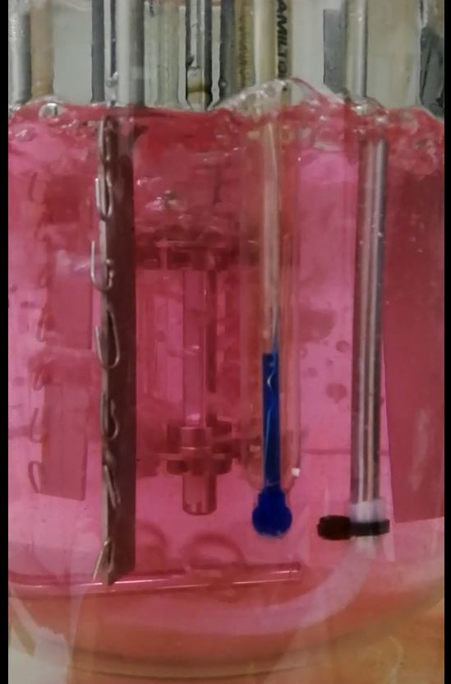
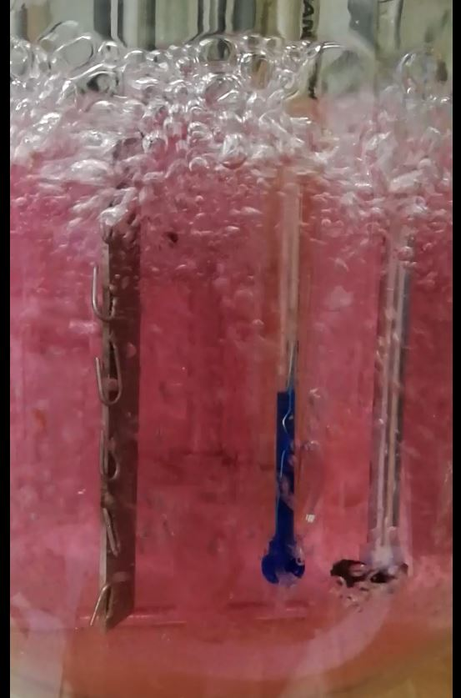
400 min⁻¹
600 min⁻¹

Fig. S1 Screenshots of slow-motion videos at 400 and 600 rpm in the stirred tank bioreactor. Medium = DMM-G, n = 400 or 600 min⁻¹, V_{L} = 1500 mL, vvm = 0.2 min⁻¹, gas = N₂.

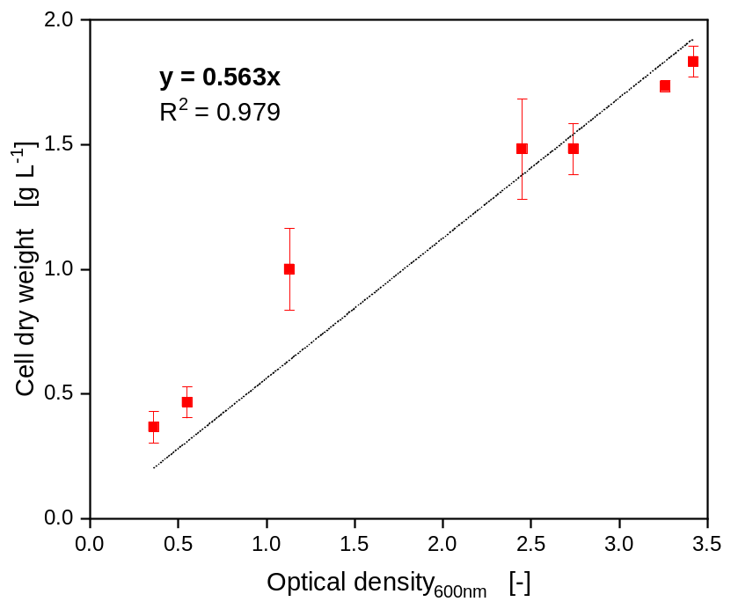

Fig. S2 Optical density and cell dry weight correlation. P. vulgatus, V_{L} = 1500 mL, n = 500 rpm, V_{reactor} = 2000 mL, T = 37 °C, DMMG medium w/o bicarbonate, c_{glc} = 6 g/L, pH_{set} of a pH-controlled fermentation = 7.0 (3 M NaOH), vvm = 0.2 min⁻¹, gas mix = 1 % CO₂ and 99 % N₂, N = 3
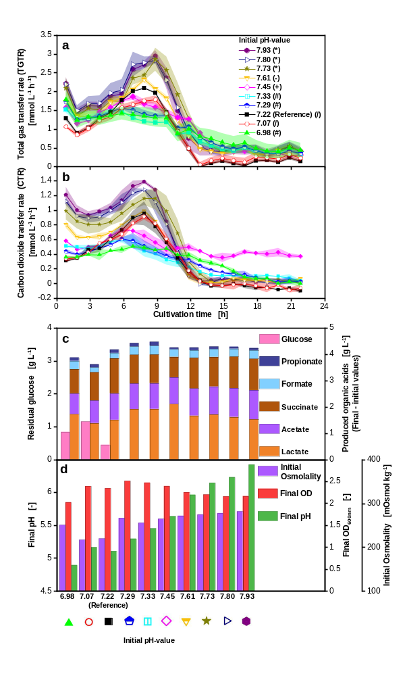
Fig. S3 Effect of changing the initial pH-value on P. vulgatus shake flask cultivations. Medium = DMMG, c_{Glucose} = 6 g L⁻¹, c_{buffer} = 50 mM MOPS, T = 37 °C, n = 100 rpm, V_{L} = 50 mL, initial OD = 0.3, different initial pH, vvm = 0.2 min⁻¹, gas mix = 1% CO₂ and 99 % N₂, N = 2, tested initial pH-values: 6.98, 7.07, 7.22, 7.29, 7.33, 7.45, 7.61, 7.73, 7.80, 7.93. Online data of (a) Total gas transfer rate (TGTR) and (b) Carbon dioxide transfer rate (CTR), shadows indicate maximum and minimum values of duplicates. Corresponding to Fig. 5.

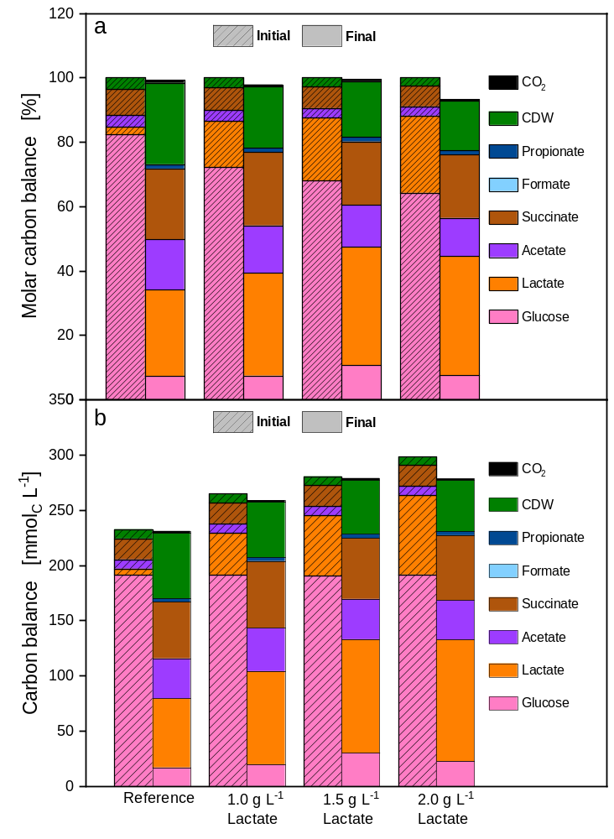
Fig. S4 Carbon balance of P. vulgatus cultivations in shake flasks with increasing initial lactate addition. Medium = DMMG, c_{Glucose} = 6 g L⁻¹, c_{buffer} = 50 mM MOPS, T = 37 °C, n = 100 rpm, V_{L} = 50 mL, initial OD = 0.35, initial pH after inoculation = 7.23, vvm = 0.2 min⁻¹, gas mix = 1 % CO₂ and 99 % N₂, N = 2. (a) Carbon balance in %. The start of the fermentation was set to 100 %. (b) Carbon balance in mmol_{C} L⁻¹. Corresponding to Fig. 6.

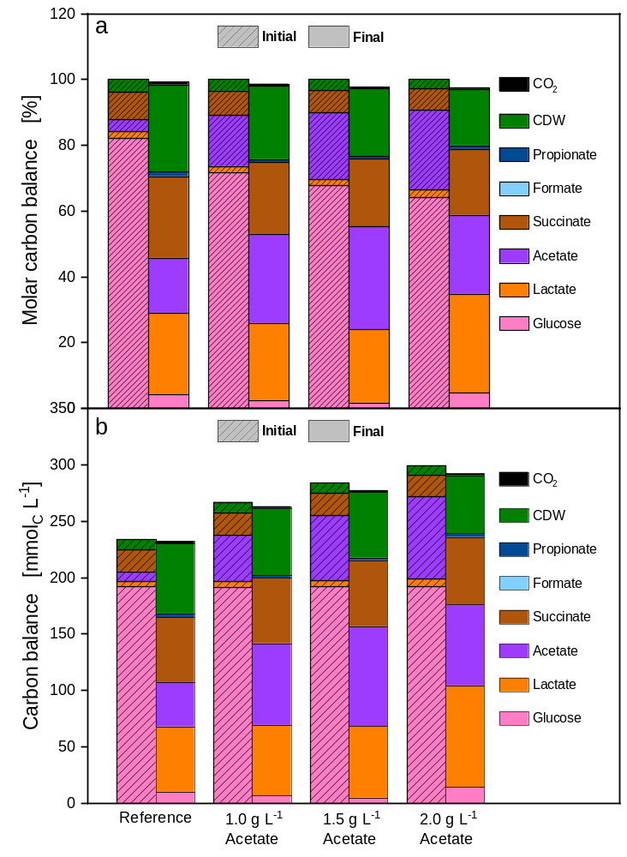
Fig. S5 Carbon balance of P. vulgatus cultivations in shake flasks with increasing initial acetate addition. Medium = DMMG, c_{Glucose} = 6 g L⁻¹, c_{buffer} = 50 mM MOPS, T = 37 °C, n = 100 rpm, V_{L} = 50 mL, initial OD = 0.40, initial pH after inoculation = 7.20, vvm = 0.2 min⁻¹, gas mix = 1 % CO₂ and 99 % N₂, N = 2. (a) Carbon balance in %. The start of the fermentation was set to 100 %. (b) Carbon balance in mmol_{C} L⁻¹. Corresponding to Fig. 7

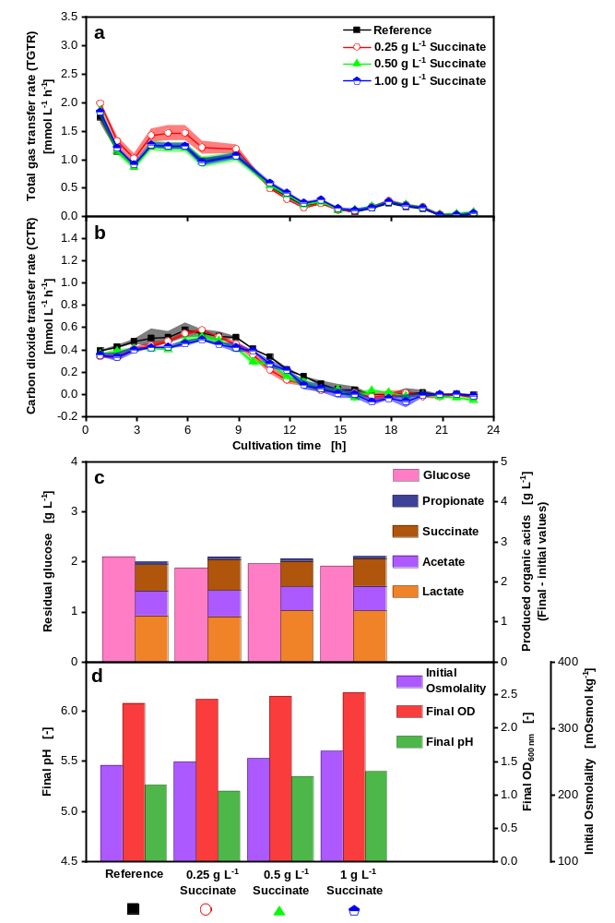
Fig. S6 Effect of initial succinate addition to P. vulgatus shake flask cultivations. Medium = DMMG, c_{Glucose} = 6 g L⁻¹, c_{buffer} = 50 mM MOPS, T = 37 °C, n = 100 rpm, V_{L} = 50 mL, initial OD = 0.33, initial pH after inoculation = 6.95, vvm = 0.2 min⁻¹, gas mix = 1 % CO₂ and 99 % N₂, N = 2. Online data of (a) TGTR and (b) CTR. Shadows indicate maximum and minimum values of duplicates. Offline data of (c) produced organic acids including propionate, succinate, acetate and lactate and remaining glucose, (d) initial osmolality, final OD_{600nm} and final pH. Corresponding molar carbon balance in % of the initial carbon can be found in Supplementary Figure S7.

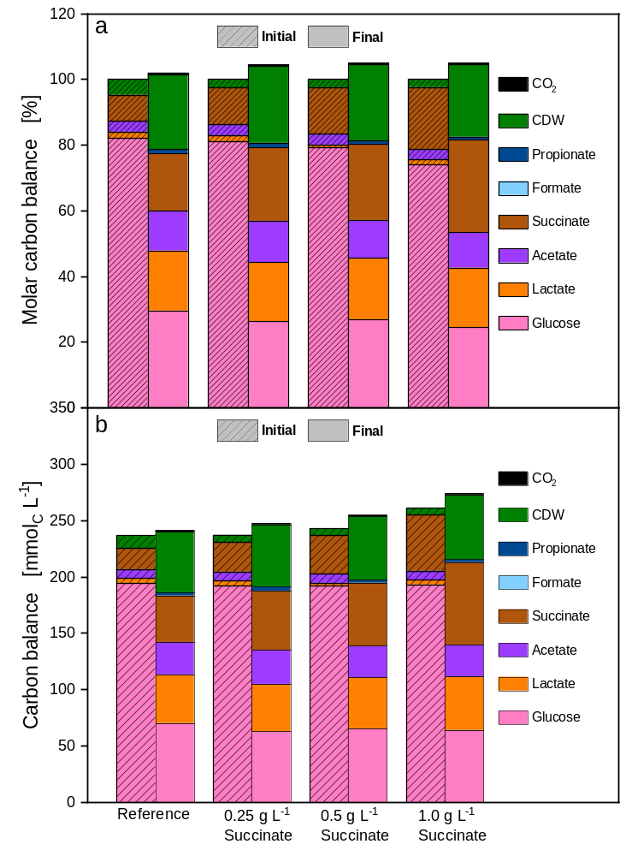
Fig. S7 Carbon balance of P. vulgatus cultivations in shake flasks with increasing initial succinate addition. Medium = DMMG, c_{Glucose} = 6 g L⁻¹, c_{buffer} = 50 mM MOPS, T = 37 °C, n = 100 rpm, V_{L} = 50 mL, initial OD = 0.33, initial pH after inoculation = 6.95, vvm = 0.2 min⁻¹, gas mix = 1 % CO₂ and 99 % N₂, N = 2. (a) Carbon balance in %. The start of the fermentation was set to 100 %. (b) Carbon balance in mmol_{C} L⁻¹. Corresponding to Fig. S6
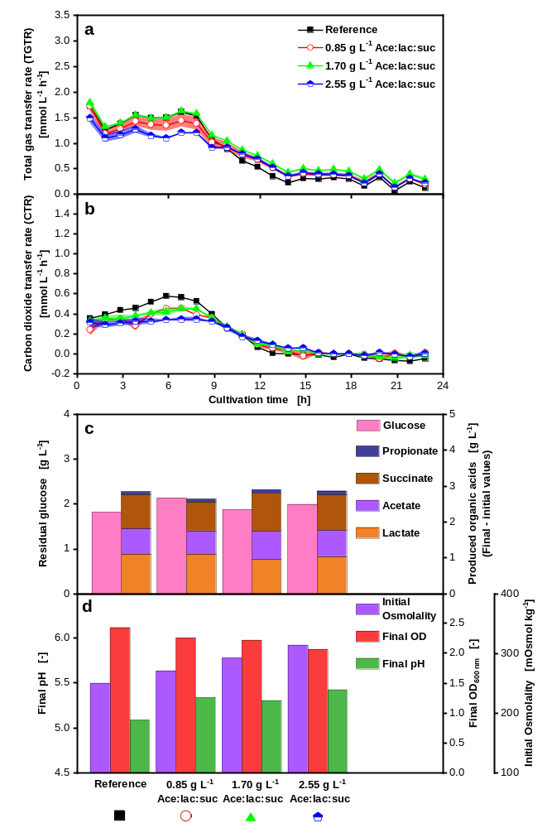
Fig. S8 Effect of a low initial acid mix addition to P. vulgatus shake flask cultivations. Medium = DMMG, c_{Glucose} = 6 g L⁻¹, c_{buffer} = 50 mM MOPS, T = 37 °C, n = 100 rpm, V_{L} = 50 mL, initial OD = 0.27, initial pH after inoculation = 6.91, vvm = 0.2 min⁻¹, gas mix = 1 % CO₂ and 99 % N₂, N = 2. The ratio of added organic acids was 1.5:1.75:1 for acetate:lactate:succinate. Online data of (a) TGTR and (b) CTR. Shadows indicate maximum and minimum values of duplicates. Offline data of (c) produced organic acids including propionate, succinate, acetate and lactate and remaining glucose, (d) initial osmolality, final OD_{600nm} and final pH. Results of a high initial acid mix can be found in Fig. S9. Corresponding molar carbon balance in % of the initial carbon can be found in Supplementary Figure S10.
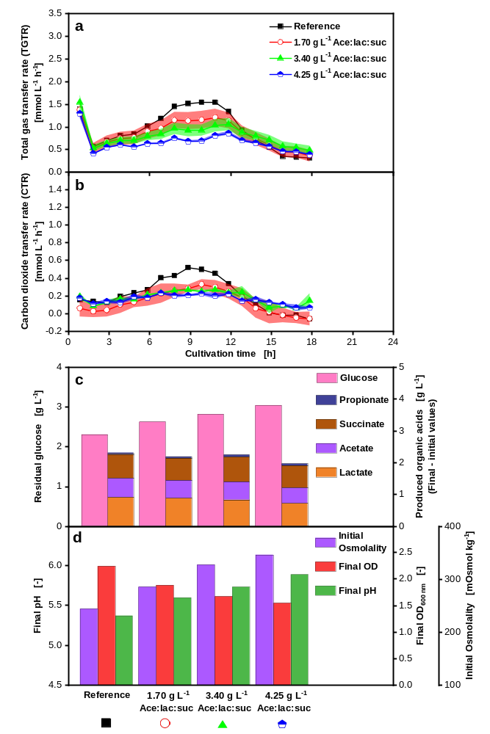
Fig. S9 Effect of a high initial acid mix addition to P. vulgatus shake flask cultivations. Medium = DMMG, c_{Glucose} = 6 g L⁻¹, c_{buffer} = 50 mM MOPS, T = 37 °C, n = 100 rpm, V_{L} = 50 mL, initial OD = 0.21, initial pH after inoculation = 6.94, vvm = 0.2 min⁻¹, gas mix = 1 % CO₂ and 99 % N₂, N = 2. The ratio of added organic acids was 1.5:1.75:1 for acetate:lactate:succinate. Online data of (a) TGTR and (b) CTR. Shadows indicate maximum and minimum values of duplicates. Offline data of (c) produced organic acids including propionate, succinate, acetate and lactate and remaining glucose, (d) initial osmolality, final OD_{600nm} and final pH. Results of a low initial acid mix can be found in Fig. S8. Corresponding molar carbon balance in % of the initial carbon can be found in Supplementary Figure S10.
Fig. S10 Molar carbon balance of P. vulgatus cultivations in shake flasks with increasing initial acid mix addition. Medium = DMMG, c_{Glucose} = 6 g L⁻¹, c_{buffer} = 50 mM MOPS, T = 37 °C, n = 100 rpm, V_{L} = 50 mL, initial OD* = 0.21, initial pH after inoculation* = 6.94, initial OD** = 0.27, initial pH after inoculation** = 6.91, vvm = 0.2 min⁻¹, gas mix = 1 % CO₂ and 99 % N₂, N = 2. The ratio of added organic acids was 1.5:1.75:1 for acetate:lactate:succinate. Asterisks indicate experiment number one (*) and two (**). (a) Molar carbon balance in % of initial total carbon. Molar carbon from CO₂ was calculated from the CTR integral. (b) Carbon balance in mmol_{C} L⁻¹. Corresponding to Fig. S8 and Fig. S9.
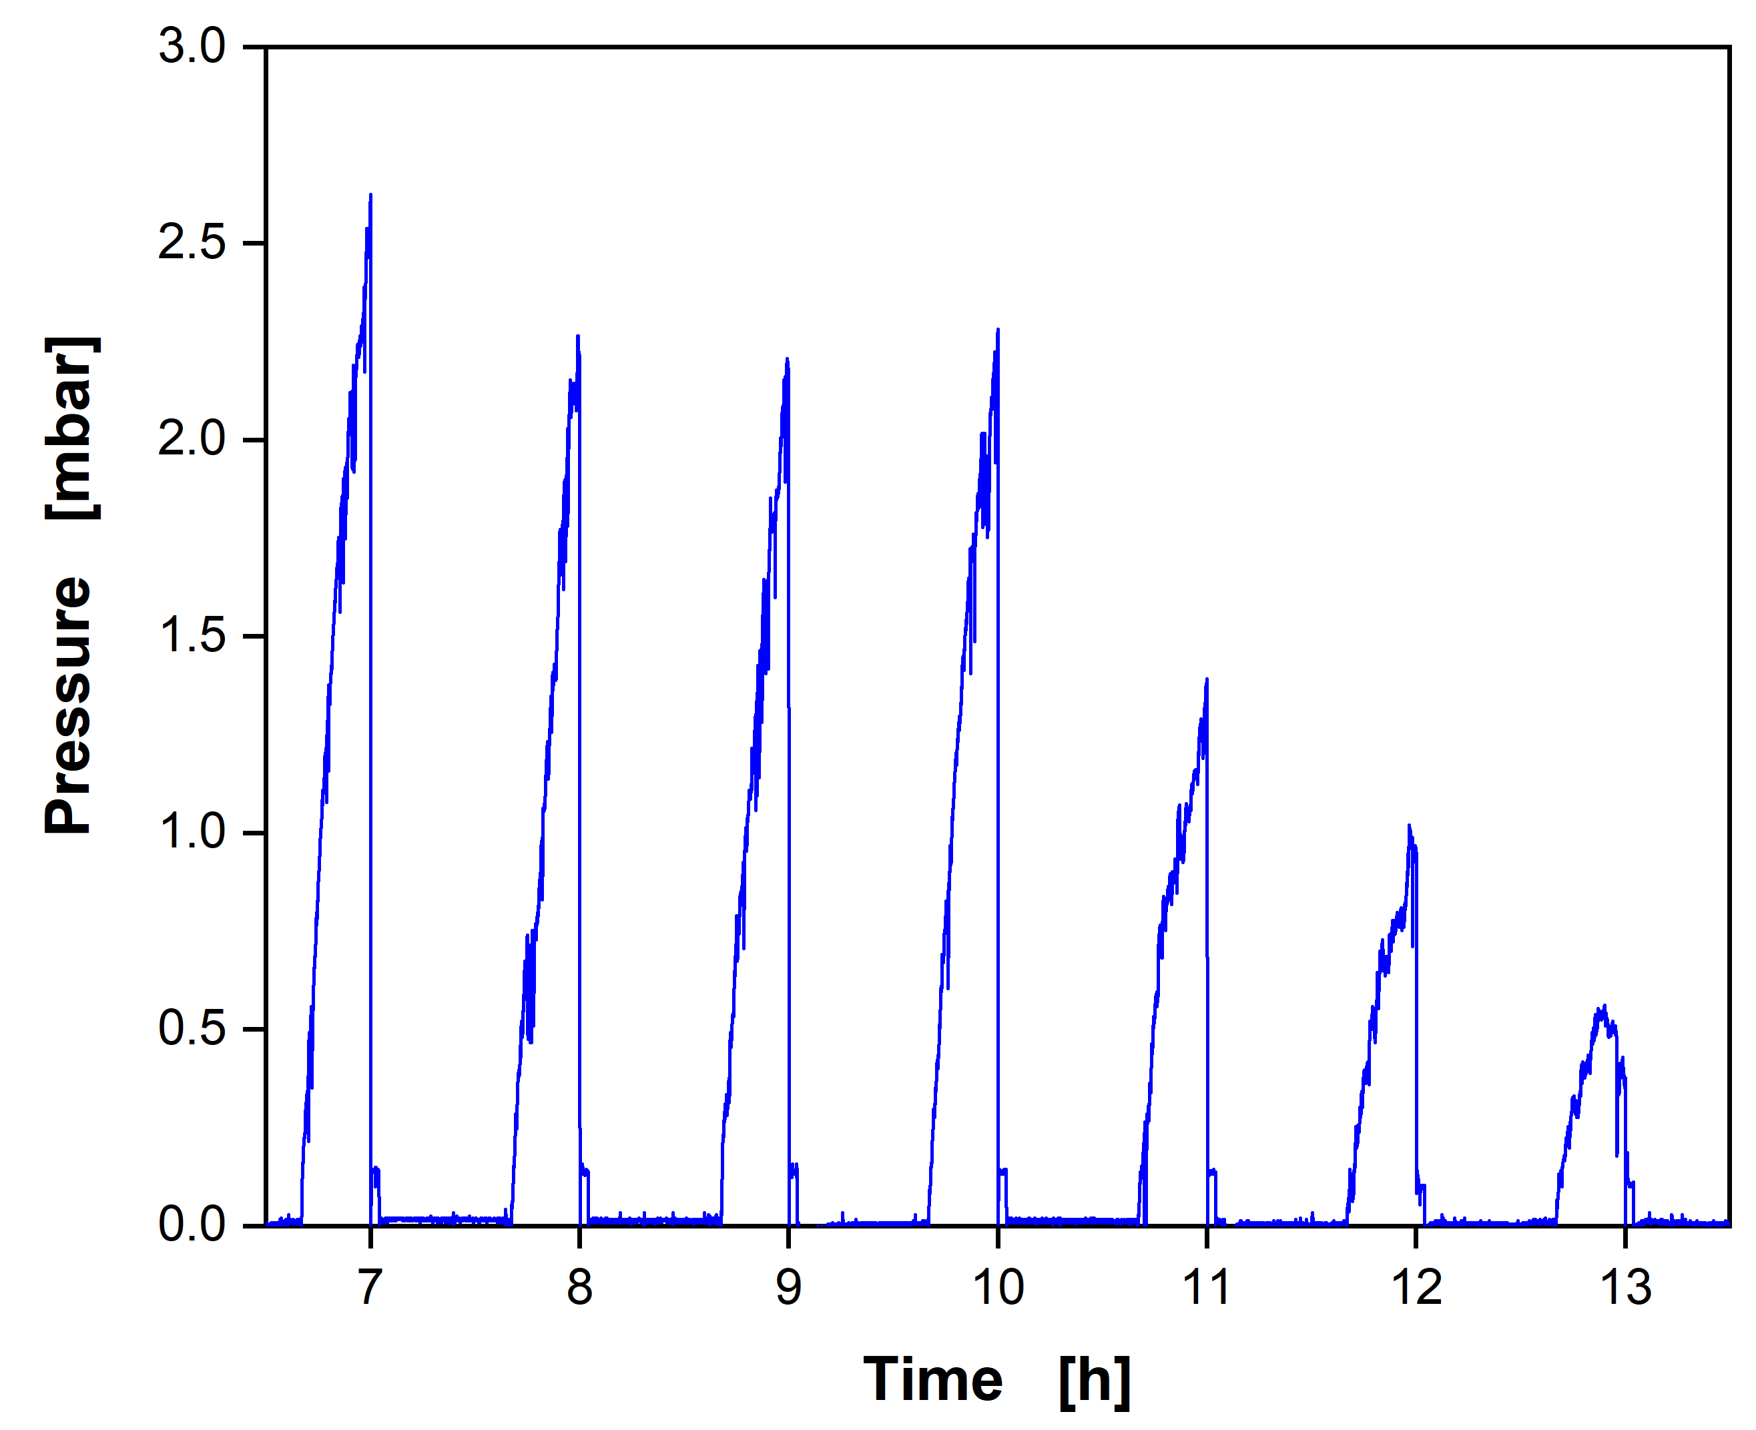
Fig. S11: Pressure raw data of the P. vulgatus cultivation from Fig. 1 between 6.5 h to 13.5 h. Medium = DMMG, c_{Glucose} = 6 g L⁻¹, c_{buffer} = 50 mM MOPS, T = 37 °C, n = 100 rpm, V_{L} = 50 mL, initial OD = 0.3, initial pH after inoculation = 7.23, vvm = 0.2 min⁻¹, gas mix = 1% CO₂ and 99% N₂.

Abbreviations
AnaRAMOS Anaerobic Respiration Activity MOnitoring System
BHI Brain heart infusion medium
CDW Cell dry weight
CTR Carbon dioxide transfer rate
DI water Deionized water
DMM-G Defined minimal medium glucose
HPLC High-performance liquid chromatography
IQR Interquartile range
k_{L}a Volumetric mass transfer coefficient
OD_{600nm} Optical density measured at 600 nm wavelength
PEP Phosphoenolpyruvate
SCFA Short-chain fatty acids
STY Space-time-yield
TGTR Total gas transfer rate
V_{L} Liquid filling volume
vvm Volume-specific gas flow

Publication bibliography
Büchs, J, Maier, U, Milbradt, C, Zoels, B (2000) Power consumption in shaking flasks on rotary shaking machines: I. Power consumption measurement in unbaffled flasks at low liquid viscosity. Biotechnol Bioeng 68 (6), pp. 589–593. DOI: 10.1002/(sici)1097-0290(20000620)68:6<589::aid-bit1>3.0.co;2-j.
Kaiser, S C., Werner, S, Jossen, V, Kraume, M, Eibl, D (2017) Development of a method for reliable power input measurements in conventional and single-use stirred bioreactors at laboratory scale. Eng Life Sci 17 (5), pp. 500–511. DOI: 10.1002/elsc.201600096.

