Supplementary information
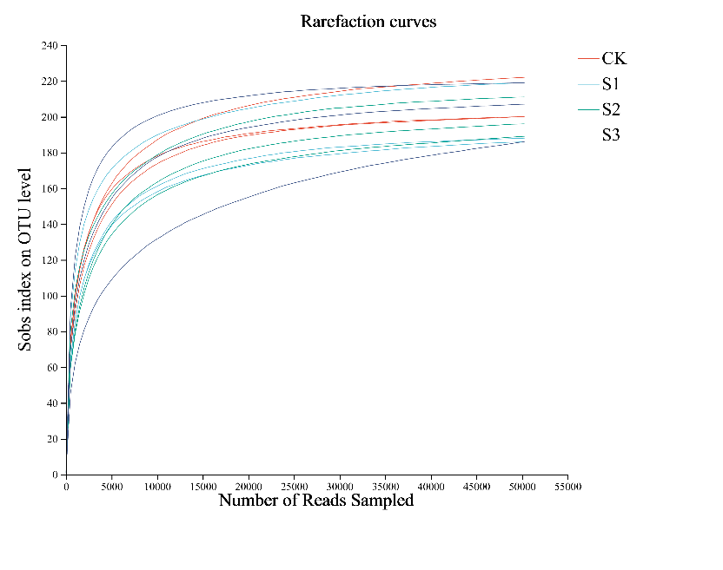A
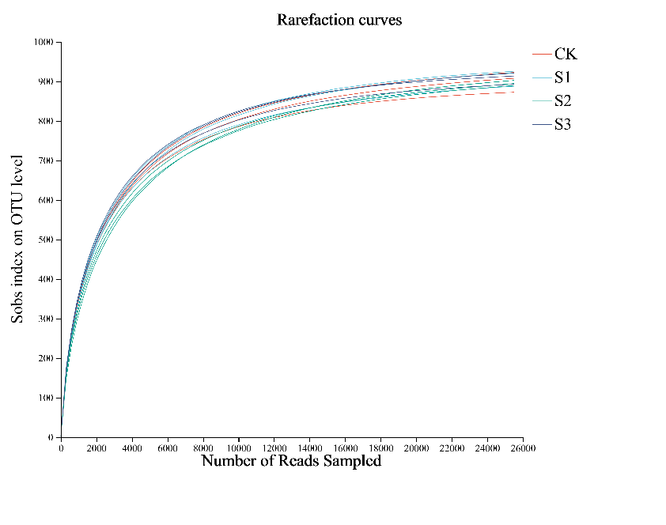 aaaaaBB
Supplementary Fig. S1: High-throughput sequencing of soil bacteria (A) 16S rRNA and fungal (B) ITS amplification curves. CK (no biochar), S1 (2.5% w/w biochar + soil), S2 (5% w/w biochar + soil), S3 (7.5% w/w biochar + soil). Library coverage at the OTU level exceeded 97% in all samples, and the rarefaction curves gradually plateaued with increasing sequence numbers, indicating the reliability of the results and sufficient sequencing depth to cover the majority of bacterial and fungal species present in the samples. The bacterial sequences obtained were classified into 37 phyla, 969 genera, and 1,879 OTUs, while the fungal sequences were classified into 11 phyla, 401 genera, and 256 OTUs. To ensure the accuracy and comparability of subsequent data analyses, we rarefied the OTUs based on the minimum sample sequence count.

