Supplementary Information
What lies beneath: Microbial quality of rural groundwater explored by shotgun metagenomics

Manar-Aleslam M. Mattar¹, Walaa A. Eraqi ², Mohamed Bakr Zaki ^{3,4}, Akram M. Elkashlan ³, Khaled A. M. Abouzid ⁵, Ramy K. Aziz ^{2,6}, Aymen S. Yassin ²*, Ali H. A. Elbehery ¹*

¹ Department of Microbiology and Immunology, Faculty of Pharmacy, University of Sadat City, Sadat City, Egypt
² Department of Microbiology and Immunology, Faculty of Pharmacy, Cairo University, Cairo, Egypt
³ Department of Biochemistry, Faculty of Pharmacy, University of Sadat City, Sadat City, Egypt
⁴ Department of Biochemistry, Faculty of Pharmacy, Menoufia National University, km Cairo-Alexandria Agricultural Road, Menofia, Egypt
⁵ Department of Pharmaceutical Chemistry, Faculty of Pharmacy, Ain Shams University, Cairo, Egypt
⁶ MARC Biosciences Research Laboratories, 6 October City, Egypt

*Corresponding authors:
ali.elbehery@fop.usc.edu.eg
aymen.yassin@pharma.cu.edu.eg

Table of Contents
Supplementary Table 1 2
Supplementary Table 2 2
Supplementary Table 3 2
Supplementary Figure 1 4
Supplementary Figure 2 6
Supplementary Figure 3 7
Supplementary Figure 4 8

Supplementary Table 1: Raw data statistics
Reads statistics before quality control
Sample ID | Total reads | Total bases (G) | Q20% | Q30% | GC%
Pump1_1 | 44,173,206 | 6.700062 | 98.16% | 94.77% | 52.04%
Pump1_2 | 57,244,446 | 8.586667 | 97.91% | 94.24% | 55.33%
Pump1_3 | 71,467,266 | 10.720090 | 97.80% | 93.99% | 56.33%
Pump2_1 | 71,356,188 | 10.703428 | 97.74% | 93.99% | 61.59%
Pump2_2 | 53,810,378 | 8.071557 | 97.87% | 94.22% | 57.51%
Pump2_3 | 71,668,876 | 10.750331 | 97.78% | 94.07% | 57.41%
Pump3_1 | 51,806,394 | 7.770959 | 97.66% | 93.66% | 53.78%
Pump3_2 | 57,980,442 | 8.697066 | 97.88% | 94.28% | 56.75%
Pump3_3 | 50,936,142 | 7.640421 | 97.64% | 93.69% | 56.67%
Reads statistics after quality control
Pump1_1 | 43,923,060 | 6.660043 | 98.32% | 94.98% | 51.99%
Pump1_2 | 56,879,686 | 8.528257 | 98.10% | 94.48% | 55.28%
Pump1_3 | 71,014,100 | 10.648025 | 97.99% | 94.24% | 56.30%
Pump2_1 | 70,743,452 | 10.606736 | 97.99% | 94.31% | 61.55%
Pump2_2 | 53,448,270 | 8.013835 | 98.07% | 94.48% | 57.46%
Pump2_3 | 71,152,334 | 10.667240 | 98% | 94.36% | 60.38%
Pump3_1 | 51,435,488 | 7.709776 | 97.89% | 93.96% | 53.74%
Pump3_2 | 57,553,418 | 8.627044 | 98.10% | 94.57% | 56.71%
Pump3_3 | 50,533,512 | 7.574885 | 97.89% | 94% | 56.63%

Supplementary Table 2: Assembly statistics
Sample ID | Number of Contigs | Minimum Contig Length (bp) | Maximum Contig Length (bp) | Contig N50 (bp)
Pump1 | 918,831 | 202 | 260,475 | 894
Pump2 | 812,100 | 215 | 236,590 | 876
Pump3 | 1,377,927 | 269 | 166,742 | 630

Supplementary Table 3: Taxonomy statistics
Sample ID | Phyla | Families | Genera | Species | Unclassified reads (%)
Pump1 | 85 | 699 | 2,590 | 10,362 | 49,736,193 (55.70)
Pump2 | 85 | 687 | 2,521 | 10,210 | 40,676,801 (41.40)
Pump3 | 83 | 709 | 2,630 | 10,357 | 59,086,154 (73.60)

A)
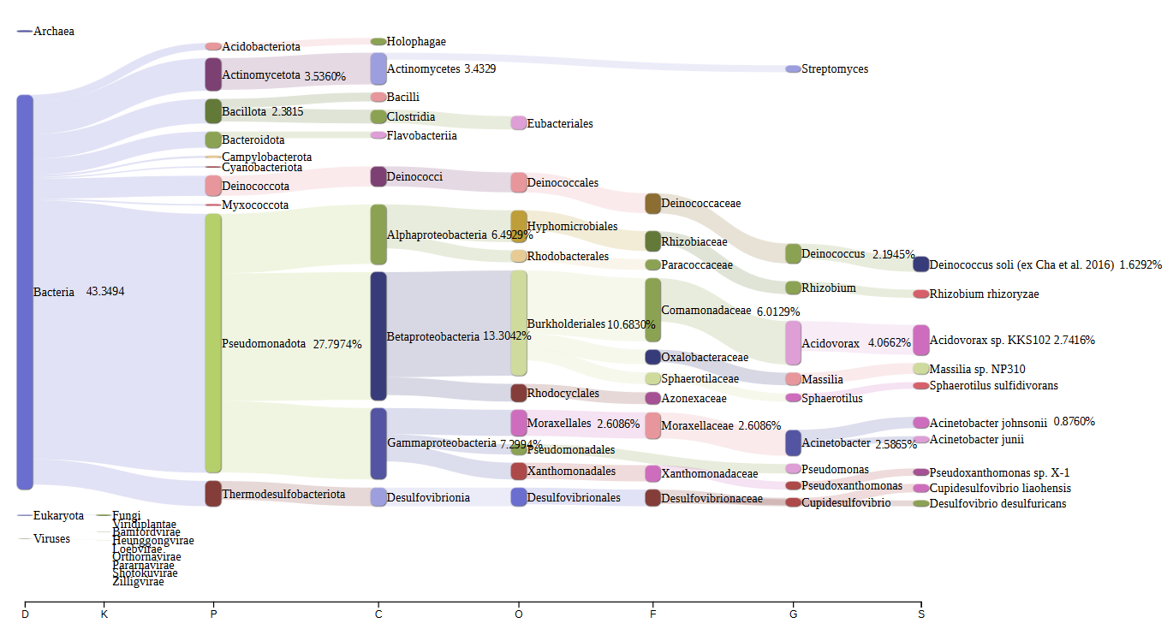

B)
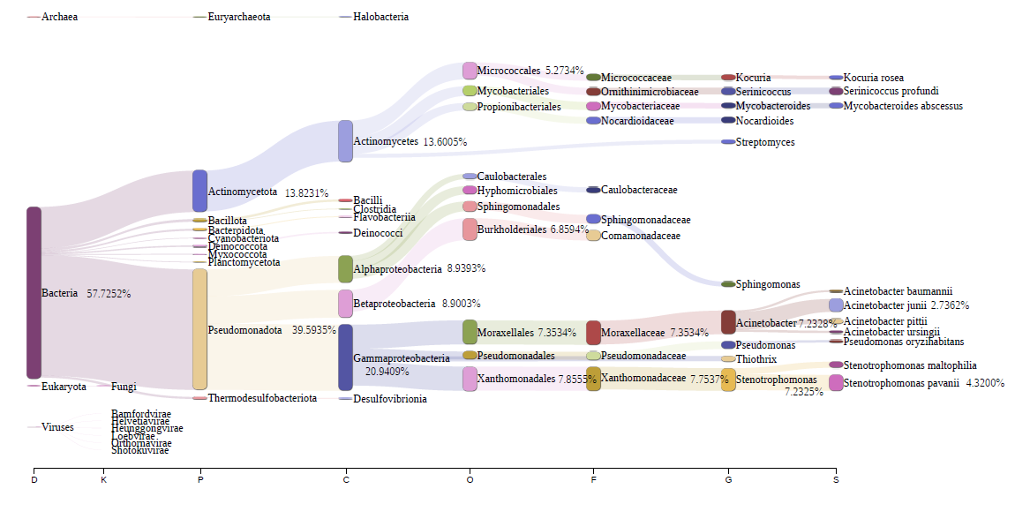

C)
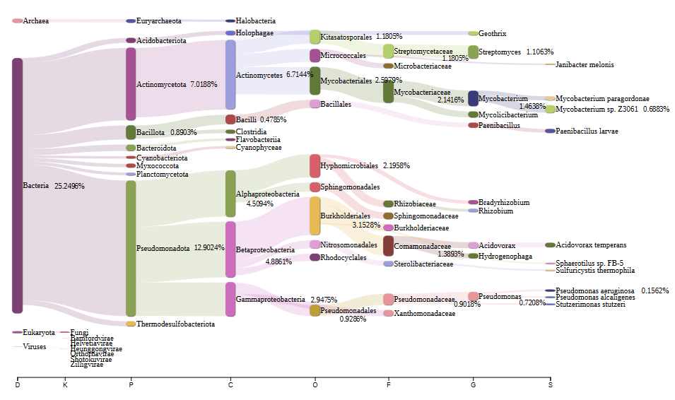
Supplementary Figure 1: Sankey diagram (generated by Pavian) illustrating the taxonomic classification of microbial communities in pump 1, pump 2, and pump 3 at the levels of phylum, class, order, family, genus, and species for (A) pump 1, (B) pump 2, and (C) pump 3.

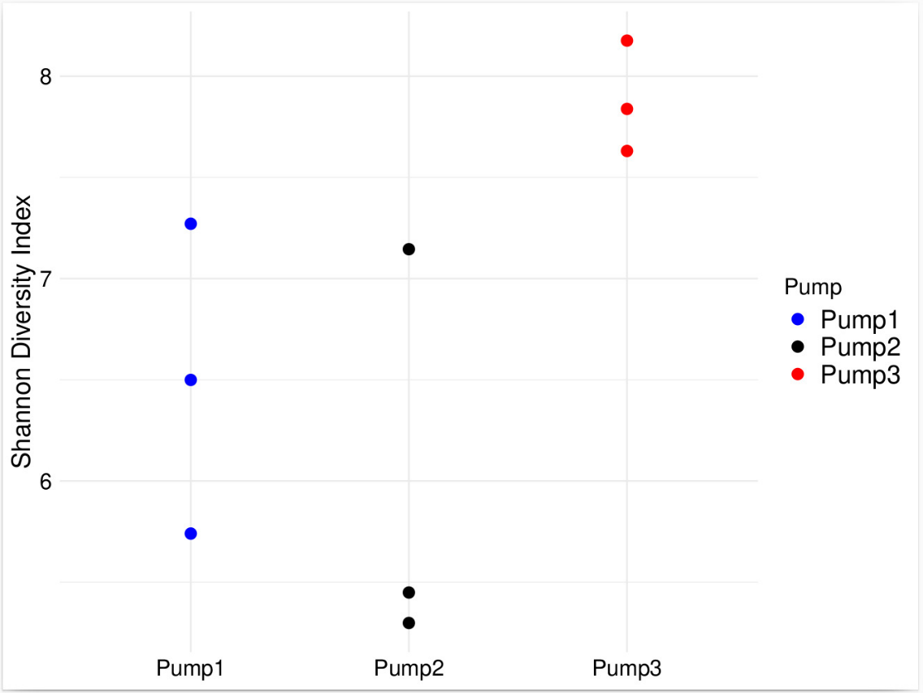
A)
B)
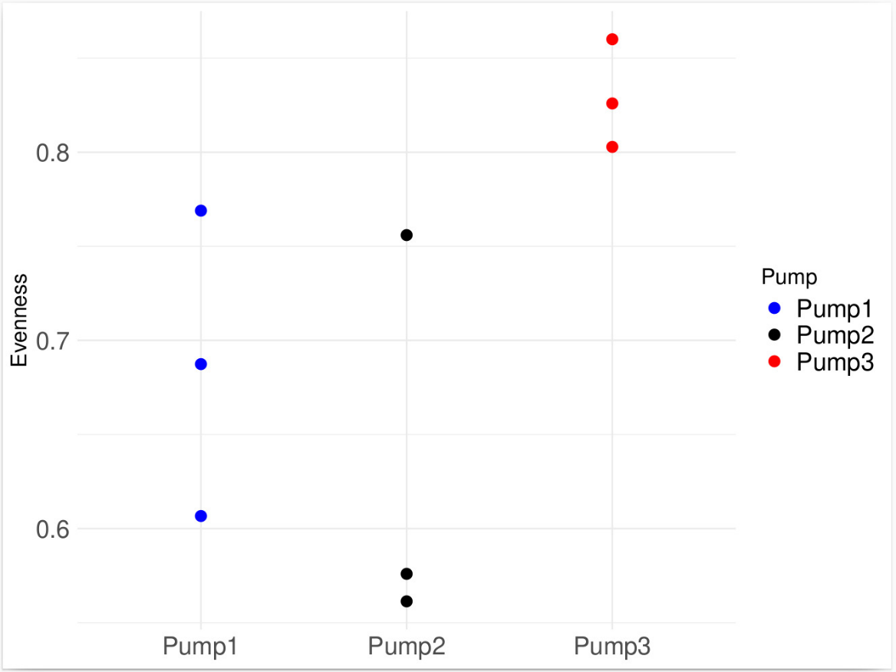

C)
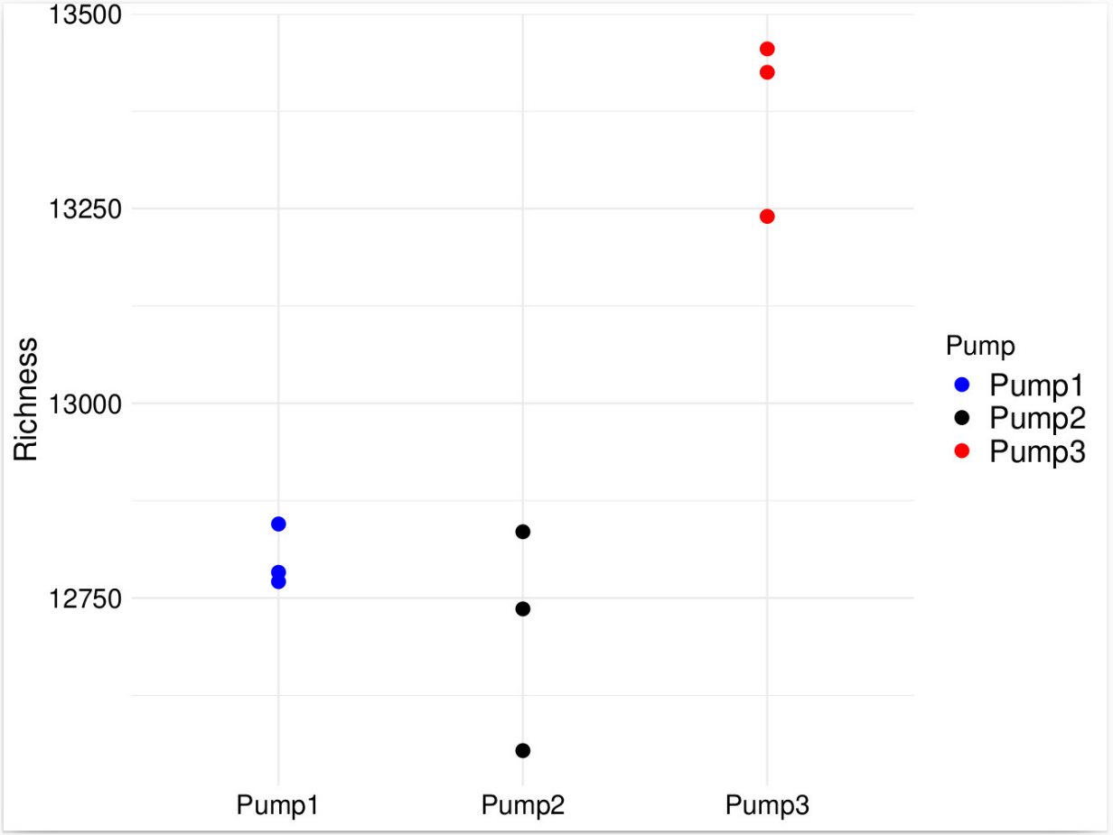
Supplementary Figure 2: Dot plot showing alpha diversity metrics for each sample: A) Shannon index, B) Evenness, C) Richness. Diversity indices were calculated at the species level. A significant difference in richness between pump 3 and pump 1 (p = 0.0047, ANOVA followed by the Dunn-Sidak), as well as pump 3 and pump 2 (p = 0.0021, ANOVA followed by the Dunn-Sidak) was detected.

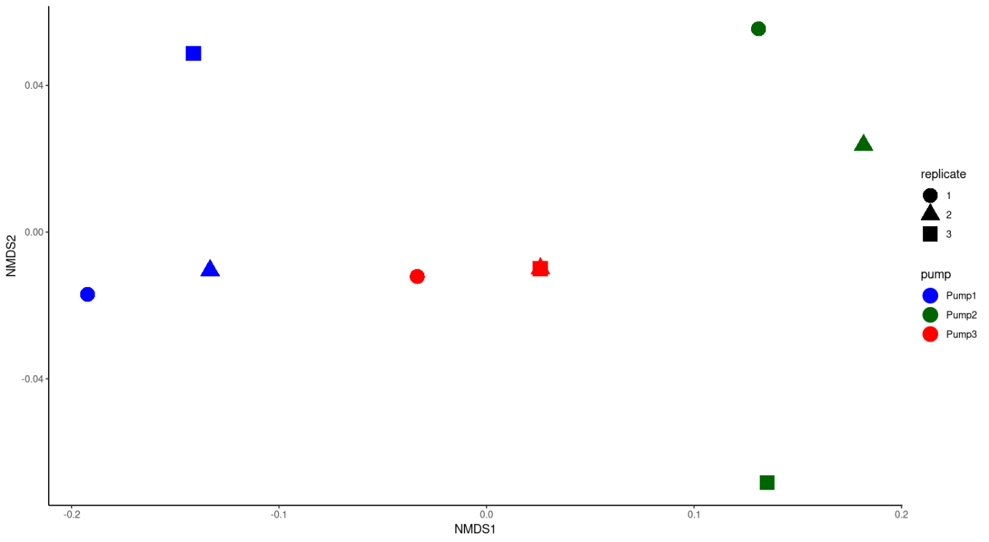
Supplementary Figure 3: Non-metric Multidimensional Scaling plot (NMDS) showing Bray–Curtis dissimilarity distance for pump 1, 2, and 3. All samples labeled according to the pump (color) and replicates (shape).

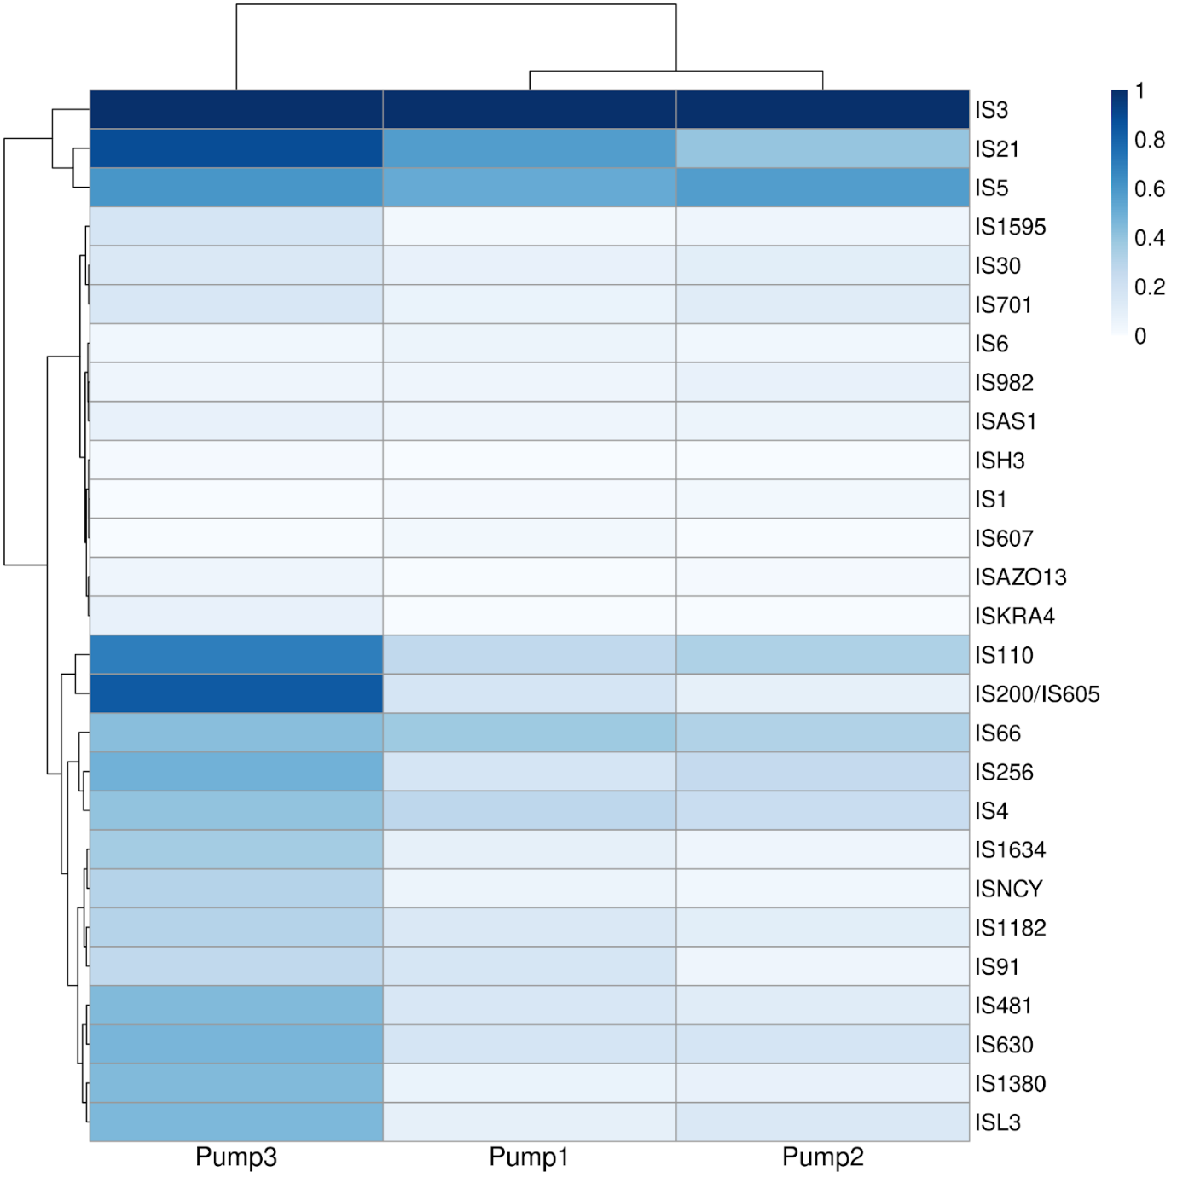
Supplementary Figure 4: Heatmap illustrating the scaled relative abundance of insertion sequences families in pump 1, pump 2, pump 3. The two dendrograms (top and left) represent hierarchical clustering of samples and insertion sequence families, respectively.

