Appendix A. Supplementary material:

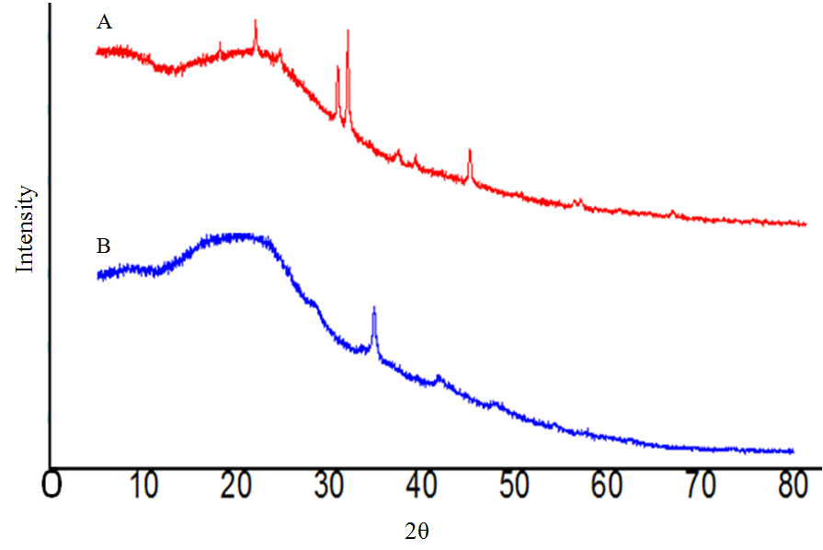Figure S1 Powder X-ray diffraction analysis of untreated (a) and bacterial treated (b) kraft lignin at 120 hours of incubation periods.

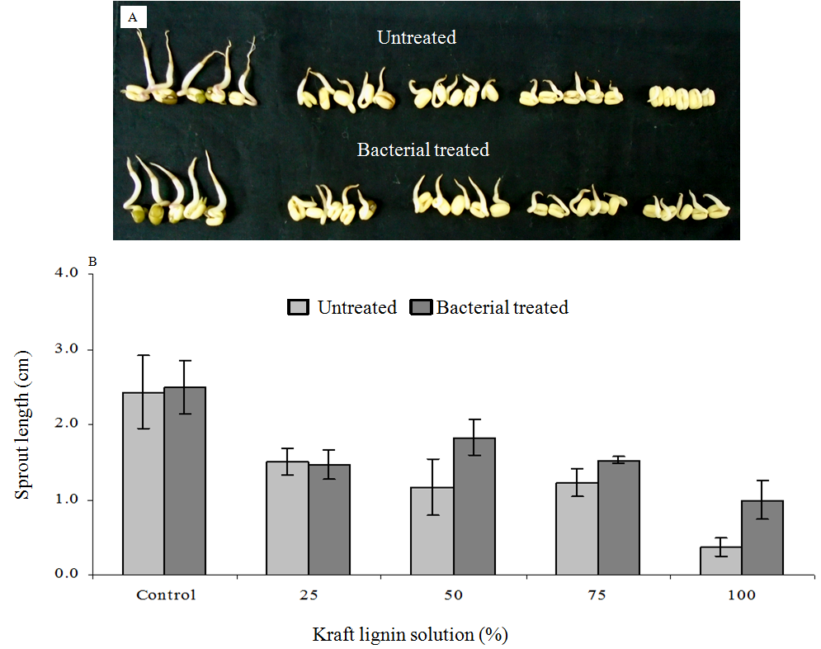
Figure S2 Effect of different concentrations of kraft lignin solutions on sprout growth (a) and sprout length (b) of Vigna radiata following 48 hours of incubation period. The results are expressed as mean±SD of triplicate.

Table S1 Process variables and experimental responses for KL biodegradation.
Factors | Variable | Levels
Factors | Variable | Low (-1) | Medium (0) | High (+1) | SD
pH | A | 5.00 | 7.00 | 9.00 | 1.37
Shaking speed (ɡ) | B | 80.00 | 120.00 | 160.00 | 27.44
Temperature (°C) | C | 25 | 30 | 35 | 3.43
Lignin degradation | Y | 40.00 | 60 | 51.82 | 7.28

Table S2 ANOVA for response surface quadratic model for KL biodegradation.
Source | Sum of Mean Squares | Df | Square value | F | p-value | Remarks
Model | 812.22 | 9 | 90.25 | 17.23 | <0.0005 | Significant
A-pH | 36.13 | 1 | 36.13 | 6.98 | 0.0334 | Significant
B-shaking speed | 55.13 | 1 | 55.13 | 10.64 | 0.0138 | Significant
C-temperature | 72.00 | 1 | 72.00 | 13.90 | 0.0074 | Significant
A² | 497.96 | 1 | 497.96 | 96.16 | ˂0.0001 | Significant
Residual | 36.25 | 7 | 5.18 | ---- | ---- | Significant
Lack of Fit | 36.25 | 3 | 12.08 | ---- | ---- | Significant
Pure Error | 0.00 | 4 | 0.00 | ---- | ---- | Significant
Cor Total | 848.47 | 16 | ---- | ---- | ---- | Significant

Table S3 The model fit summary for the quadratic model statistics.
Sample | SD | Mean | CV | Press | R² | Adj R² | Pred R² | Adeq. Precision
Kraft lignin | 2.28 | 51.82 | 4.39 | 580.00 | 0.9573 | 0.9023 | 0.3164 | 11.316

Table S4 The metabolites extracted by ethyl acetate from control (a) and S. liquefaciens treated (b) KL samples were identified as trimethylsilyl (TMS) derivatives by GC-MS analysis.
Retention time (in min) | Compounds | Present/absent
 |  | A | B
8.03 | D-(-)-lactic acid | + | -
8.24 | L-(+)-lactic acid | - | +
8.42 | Acetic acid | + | -
9.1 | Propanoic acid | + | -
10.10 | Pyridine | - | +
10.44 | 2-Butanol | + | -
12.34 | Glyceraldehyd | + | -
12.84 | Phosphoric acid | + | -
15.16 | 2- Methyl-1,3- Propanediol | - | +
15.35 | Lactic acid dimer | + | -
17.02 | 4-Ketoglucose | + | -
17.06 | Propionic acid | - | +
21.11 | Ribitol | + | -
22.97 | D-Ribo-Hexonic acid | + | -
24.54 | D- Fructose | + | -
24.97 | D-Glucose | + | -
25.89 | Pentit-2-d1, 1-acetamido-2-desoxy-tetrakis | + | -
25.95 | Pyrrolo(1,2-a)pyrazine-1,4dione,hexahydro-3-(2-methylpropyl) | - | +
31.83 | 3-benzyl-1, 4-diaza-2,5-dioxobicyclo(4.3.0)nonane | - | +
34.03 | 1-Hexadecanol, 2-methyl | + | -

