Additional Figures
Figure S1. Flowchart of our study to identify potential gene markers in AR patients. AR, allergic rhinitis; GEO, gene expression omnibus; FC, fold change; PPI, protein-protein interaction; n-DEGs, differentially expressed genes in nasal epithelial cells; t-DEGs, differentially expressed genes in blood; RT-qPCR, real-time quantitative PCR; ROC, receiver operating characteristic.
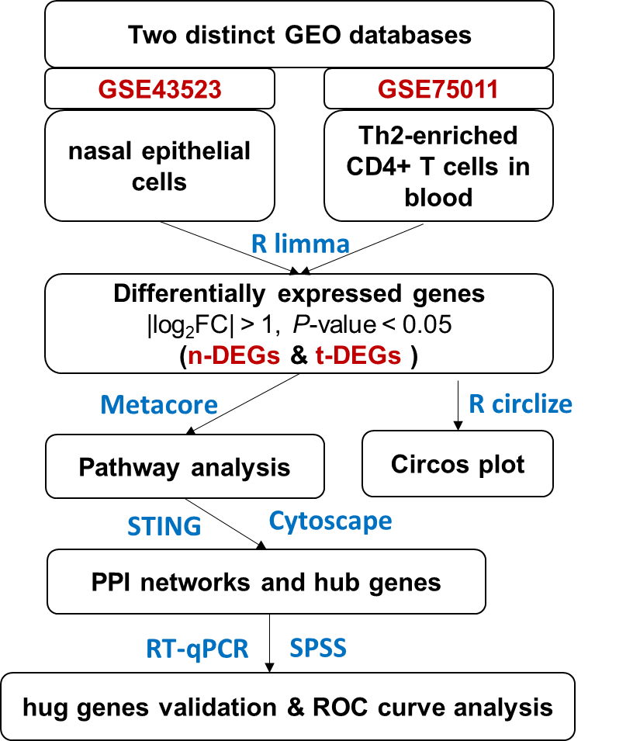

Additional Tables
Table S1. The raw mean Ct value of the nasal brush samples and the blood samples from AR patients and healthy controls.
Samples | nasal brush sample |  | Blood sample
Samples | GAPDH | POSTN | GAPDH | PENK | CDC25A
AR patient. 1 | 19.948 | 25.038 | 19.637 | 28.771 | 25.997
AR patient. 2 | 20.888 | 27.468 | 18.946 | 28.103 | 26.149
AR patient. 3 | 20.725 | 27.637 | 19.516 | 27.560 | 26.394
AR patient. 4 | 21.202 | 26.303 | 19.329 | 27.529 | 25.772
AR patient. 5 | 19.670 | 26.043 | 20.292 | 29.365 | 27.128
AR patient. 6 | 20.629 | 29.574 | 20.599 | 30.347 | 27.719
AR patient. 7 | 19.998 | 24.741 | 19.390 | 28.641 | 25.422
AR patient. 8 | 21.080 | 26.466 | 20.349 | 30.411 | 26.298
AR patient. 9 | 20.566 | 25.543 | 19.345 | 29.579 | 25.979
AR patient. 10 | 20.312 | 26.134 | 18.249 | 26.789 | 24.574
Control. 1 | 20.803 | 27.651 | 19.617 | 28.357 | 27.066
Control. 2 | 20.408 | 31.659 | 20.422 | 28.819 | 27.095
Control. 3 | 21.310 | 29.714 | 18.777 | 28.247 | 25.972
Control. 4 | 20.397 | 27.009 | 19.595 | 27.200 | 26.867
Control. 5 | 19.631 | 28.132 | 19.308 | 26.901 | 26.279
Control. 6 | 20.679 | 29.474 | 20.243 | 28.425 | 27.272
Control. 7 | 20.756 | 27.457 | 18.828 | 26.729 | 26.244
Control. 8 | 21.392 | 27.430 | 19.989 | 29.305 | 28.020
Control. 9 | 20.440 | 27.435 | 20.205 | 28.500 | 26.487
Control. 10 | 19.970 | 27.917 | 19.516 | 27.401 | 25.888

Table S2. The RNA concentration of the nasal brush samples and the blood samples from AR patients and healthy controls.
Sample ID | Conc. | Unit | A260 | A280 | 260/280 | 260/230 | Sample type
AR patient 1 | 152.3 | ng/µL | 3.809 | 1.905 | 2 | 2.27 | nasal brush
AR patient 2 | 139.6 | ng/µL | 3.491 | 1.795 | 1.95 | 2.38 | nasal brush
AR patient 3 | 135.4 | ng/µL | 3.385 | 1.698 | 1.99 | 2.28 | nasal brush
AR patient 4 | 136.6 | ng/µL | 3.416 | 1.713 | 1.99 | 2.52 | nasal brush
AR patient 5 | 135.9 | ng/µL | 3.398 | 1.68 | 2.02 | 1.93 | nasal brush
AR patient 6 | 123.1 | ng/µL | 3.077 | 1.535 | 2 | 2.42 | nasal brush
AR patient 7 | 118.4 | ng/µL | 2.961 | 1.456 | 2.03 | 2.03 | nasal brush
AR patient 8 | 147.8 | ng/µL | 3.694 | 1.889 | 1.96 | 2.48 | nasal brush
AR patient 9 | 142.2 | ng/µL | 3.555 | 1.8 | 1.97 | 2.24 | nasal brush
AR patient 10 | 172.3 | ng/µL | 4.306 | 2.138 | 2.01 | 2.41 | nasal brush
Control 1 | 150.9 | ng/µL | 3.771 | 1.873 | 2.01 | 2.07 | nasal brush
Control 2 | 152.8 | ng/µL | 3.821 | 1.873 | 2.04 | 2.39 | nasal brush
Control 3 | 128 | ng/µL | 3.2 | 1.67 | 1.92 | 2.43 | nasal brush
Control 4 | 171.7 | ng/µL | 4.292 | 2.16 | 1.99 | 2.34 | nasal brush
Control 5 | 161.4 | ng/µL | 4.034 | 2.015 | 2 | 2.43 | nasal brush
Control 6 | 122.7 | ng/µL | 3.067 | 1.58 | 1.94 | 2.4 | nasal brush
Control 7 | 110.5 | ng/µL | 2.763 | 1.378 | 2.01 | 2.47 | nasal brush
Control 8 | 138.2 | ng/µL | 3.455 | 1.694 | 2.04 | 2.44 | nasal brush
Control 9 | 174 | ng/µL | 4.349 | 2.165 | 2.01 | 2.45 | nasal brush
Control 10 | 189.3 | ng/µL | 4.733 | 2.441 | 1.94 | 2.49 | nasal brush
AR patient 1 | 497.7 | ng/µL | 12.44 | 6.512 | 1.91 | 2.5 | blood
AR patient 2 | 530.1 | ng/µL | 13.25 | 6.893 | 1.92 | 1.48 | blood
AR patient 3 | 567.7 | ng/µL | 14.19 | 7.407 | 1.91 | 2.47 | blood
AR patient 4 | 673.6 | ng/µL | 16.84 | 8.753 | 1.92 | 2.46 | blood
AR patient 5 | 646.7 | ng/µL | 16.17 | 8.266 | 1.96 | 2.39 | blood
AR patient 6 | 592.9 | ng/µL | 14.82 | 7.664 | 1.93 | 2.37 | blood
AR patient 7 | 467.3 | ng/µL | 11.68 | 5.893 | 1.98 | 2.56 | blood
AR patient 8 | 887.85 | ng/µL | 22.2 | 11.23 | 1.93 | 2.59 | blood
AR patient 9 | 725.4 | ng/µL | 18.13 | 9.4 | 1.93 | 2.43 | blood
AR patient 10 | 689.52 | ng/µL | 16.04 | 8.23 | 1.95 | 2.29 | blood
Control 1 | 711.2 | ng/µL | 17.78 | 8.55 | 2.08 | 0.91 | blood
Control 2 | 482 | ng/µL | 12.05 | 6.055 | 1.99 | 2.38 | blood
Control 3 | 512.5 | ng/µL | 12.81 | 6.6 | 1.94 | 2.3 | blood
Control 4 | 466.8 | ng/µL | 11.67 | 6.051 | 1.93 | 2.26 | blood
Control 5 | 768.9 | ng/µL | 19.22 | 9.42 | 2.04 | 2.39 | blood
Control 6 | 586.6 | ng/µL | 14.66 | 7.41 | 1.98 | 2.04 | blood
Control 7 | 574.1 | ng/µL | 14.35 | 7.29 | 1.97 | 2.57 | blood
Control 8 | 642.8 | ng/µL | 16.07 | 7.92 | 2.03 | 2.88 | blood
Control 9 | 760.12 | ng/µL | 19.01 | 9.61 | 1.98 | 2.36 | blood
Control 10 | 641.58 | ng/µL | 17.24 | 8.58 | 2.01 | 2.25 | blood

