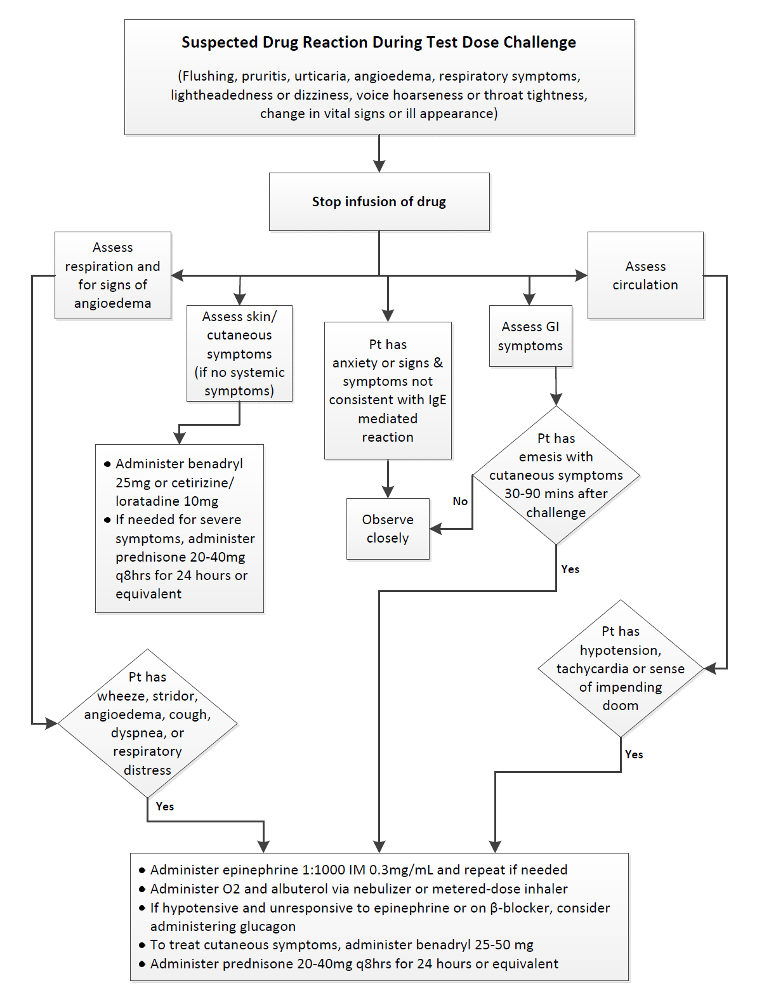
Appendix 1d: Algorithm to treat a suspected allergic reaction if it occurs during the test dose challenge. Orders for these drugs are available within the clinical decision support tool (CDST)

