Appendix 1: Oral Challenge Algorithm

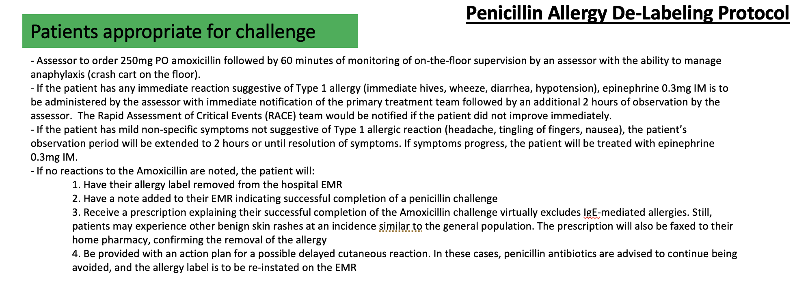

Appendix 2: Process Map
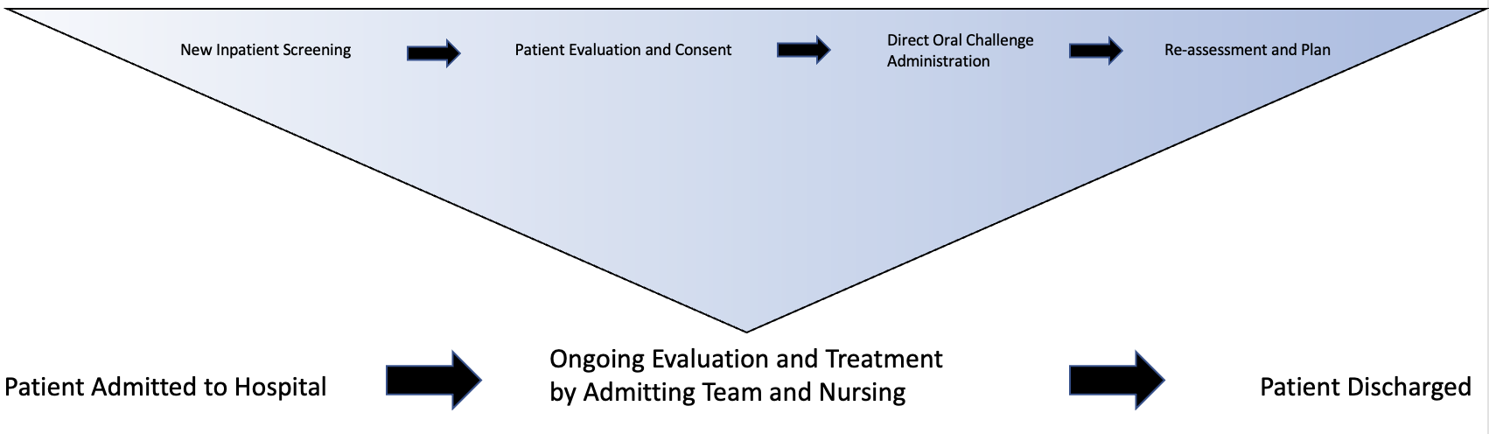

Appendix 3: Study parameters

Period 1:
Screening of newly admitted patients=4 minutes
Formal patient assessment=15 minutes
Oral challenge and patient education= 65 minutes

Period 2: Daily assessment times
Mean = 3:46 (0:05, 6:45)
Median = 4:08

Date | Total Time in Hospital
February 15th, 2022 | 6:35
February 16th, 2022 | 5:37
February 17th, 2022 | 3:40
February 18th, 2022 | 4:15
February 22nd, 2022 | 0:05
February 23rd, 2022 | 0:15
February 24th, 2022 | 5:45
February 25th, 2022 | 4:01
March 7th, 2022 | 3:30
March 8th, 2022 | 4:32

Appendix 4:Cost Analysis
Resident physician-led assessments (base wage $32.20/h CAD)
-Using a median time in hospital of 4 hours and 8 minutes and an hourly rate of $32.2/h the administration costs would equate to $133 per day (4.13x32.2).
-There would also be an average of $0.09 per day in material costs of amoxicillin.
-As such, if the program were to be administered Monday to Friday for an entire year (52 weeks) would cost a total of $34,580 beyond the fixed hospitalization costs of the patients.
-During our 4 week intervention, 55 patients had their penicillin allergy formally assessed leading to 31 patients being de-labeled. This resulted in a number needed to screen of 4 and number needed to assess of 1.8 to remove one inappropriate penicillin allergy label.
-A single site at our institution based on the observed data would result in 20,234 yearly weekday admissions. Assuming the 8.9% penicillin allergy rate we observed there would be 1800 patients screened resulting in approximately 715 penicillin allergy assessments and 403 patients de-labelled.
-As such, the average cost per penicillin allergy assessment would be $48.36 including challenges if appropriate. ($34,580/715=$48.36)
The average cost per patient de-labelled would be $85.81

