Supplemental Material
Gupta, S., Rao, V., Xiong, G., et al. Disease Duration of Chronic Spontaneous Urticaria Participants in Phase III Clinical Trials

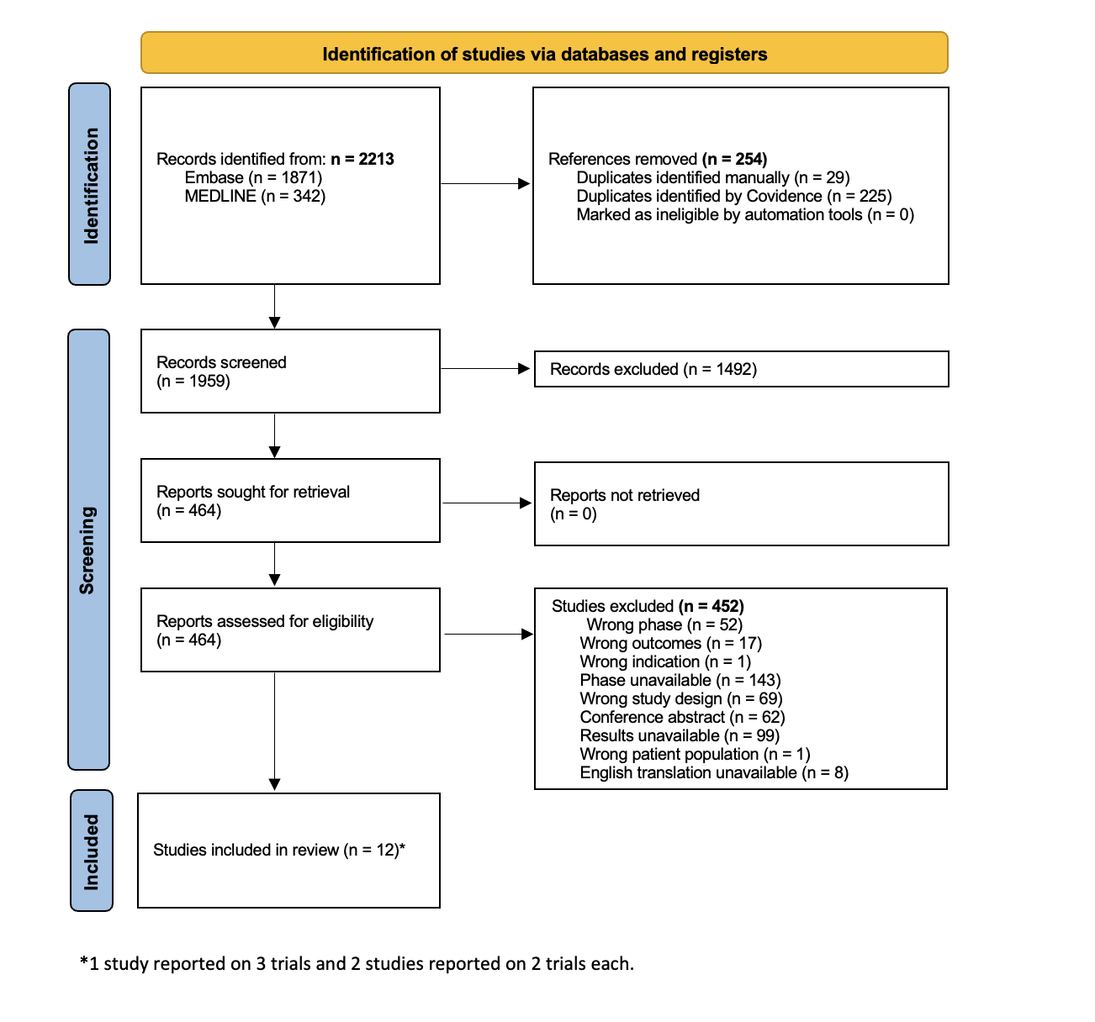
Figure S1. PRISMA flow diagram of literature screening.

Figure S2: Cochrane ROB 2.0 assessment of included trials (n=16).
