Additional File 1
Figure S1 – Effect of starvation and refeeding on PRIle-nanos expression. (A-J') PRIle-nanos expression in the fission zone region (A-J) and posterior growth zone (A'-J') during starvation (A-F') and refeeding (G-J'). Expression decreases and becomes undetectable in both body regions as worms are starved over 28 days and is re-established in both body regions when starved worms are fed over 18 days. Fission zones are marked by gray bars. Note that animals in A and J possess multiple fission zones. Scale bars: 100 µm.

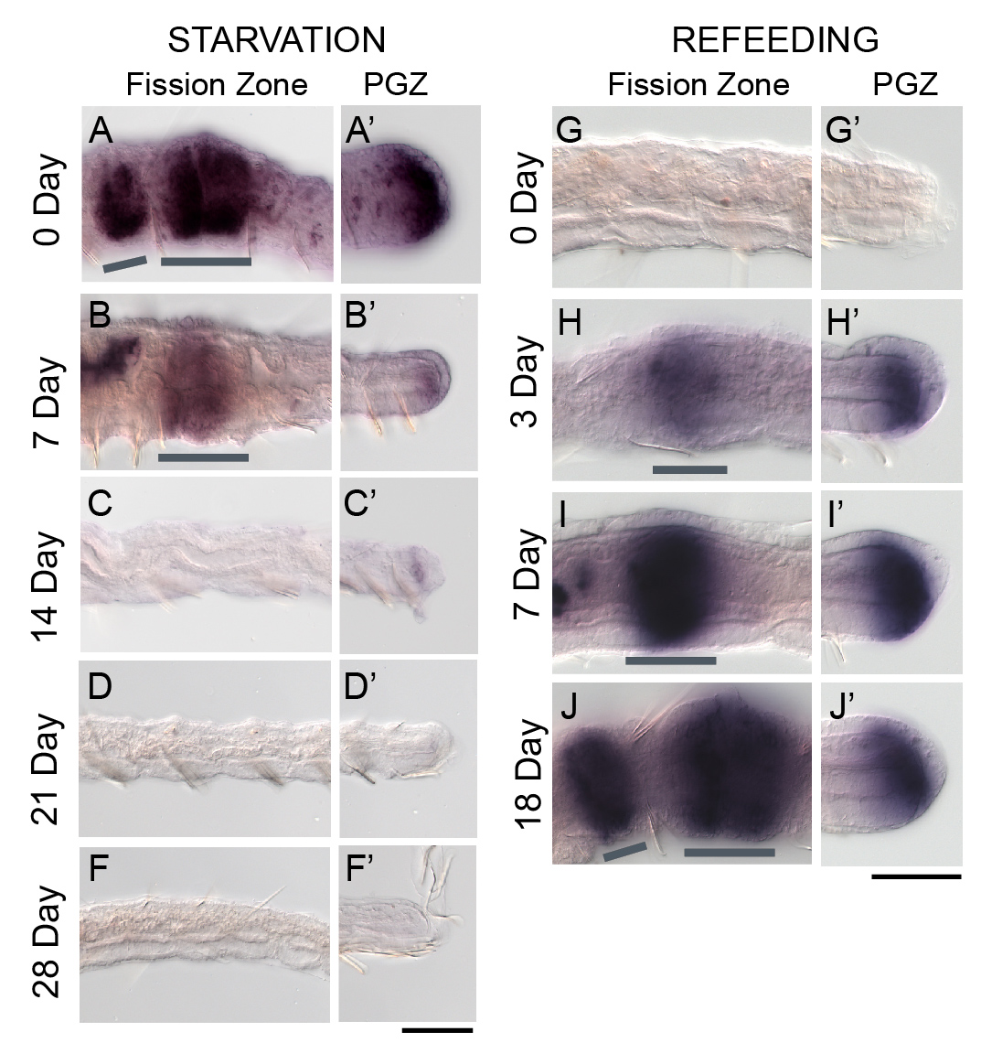

Figure S2 – Effect of starvation and refeeding on PRIle-vasa expression. (A-J') PRIle-vasa expression in the fission zone region (A-J) and posterior growth zone (A'-J') during starvation (A-F') and refeeding (G-J'). Expression decreases and becomes undetectable in both body regions as worms are starved over 28 days and is re-established in both body regions when starved worms are fed over 18 days. Fission zones are marked by gray bars. Note that animals in A and J possess multiple fission zones. Scale bars: 100 µm.

