Table S1: number of reads per sample, % of reads which failed to map in each sample.
H. melpomene
Sample | Read count | % reads that fail to map
13F_FP1 | 10342965 | 10.90
13G_FM1 | 14953963 | 9.56
13H_FD1 | 10205562 | 9.99
13I_HA1 | 11397631 | 13.31
13J_HPo1 | 12267336 | 11.93
14A_FP1 | 14892190 | 14.16
14B_FM1 | 12295189 | 12.44
14C_FD1 | 11528254 | 14.92
14D_HA1 | 10717086 | 15.46
14E_HPo1 | 15162459 | 12.37
14F_FP1 | 12040114 | 13.71
14G_FM1 | 12411856 | 12.78
14H_FD1 | 12303691 | 11.12
24D_HA1 | 13131538 | 32.69
14J_HPo1 | 13945427 | 14.40
15A_FP2. | 11437808 | 13.87
15B_FM2. | 10993529 | 12.81
15C_FD2. | 11856974 | 13.56
15D_HA2. | 10581808 | 13.95
15E_HPo2 | 13681765 | 11.02
16A_FP2. | 14736312 | 8.84
16B_FM2. | 13626298 | 9.40
16D_HA2. | 12686225 | 4.96
16E_HPo2 | 12823781 | 9.95
16H_FD2. | 15598458 | 10.46
17F_FP2. | 11015917 | 7.64
17G_FM2. | 12136669 | 7.46
17H_FD2. | 14589976 | 7.52
17I_HA2. | 14663720 | 7.54
17J_HPo2 | 14600239 | 7.81

H. erato
Sample | Read count | % reads that fail to map
B8_FP1 | 13286804 | 7.56
C3_FD1 | 15104587 | 9.84
C6_HA1 | 12841432 | 6.31
D10_FP1 | 15919485 | 8.05
F21_HPo1 | 14646293 | 8.35
F8_FM1 | 14965698 | 10.61
G21_FM1 | 13046272 | 8.03
G5_FM1 | 12543875 | 7.66
H4_HA1 | 13419952 | 7.91
I8_FD1 | 14022680 | 10.02
S3_HPo1 | 24574848 | 6.98
A4_HPo2 | 12912895 | 18.97
B2_FD2 | 13435820 | 19.43
B4_HA2 | 12182847 | 18.86
C4_FM2 | 14127156 | 20.68
C9_FP2 | 15100384 | 19.49
D6_HA2 | 14027838 | 17.72
D9_HPo2 | 12354324 | 17.87
E3_FM2 | 13926825 | 23.33
E6_FP2 | 13622452 | 15.73
G6_FD2 | 13281517 | 19.52
J4_FD1 | 14498546 | 16.59
J8_FP2 | 16882308 | 19.12
N3_FM2 | 13139640 | 18.78

Agraulis vanillae
Sample | Read count | % reads that fail to map
11F | 21601472 | 10.78
11G | 19505732 | 10.39
11H | 9472553 | 11.65
11I | 20695225 | 16.69
11J | 15779259 | 12.80
12A | 17909757 | 18.40
12B | 21362299 | 9.44
12C | 19020085 | 10.37
12D | 21698478 | 11.32
12E | 21574847 | 11.73
12F | 19511174 | 10.86
12G | 23853328 | 11.20
12H | 23137900 | 10.96
12I | 18912480 | 12.82
12J | 18012267 | 13.16
21A | 25105152 | 11.28
21D | 21967288 | 11.08
21E | 22224755 | 12.23
22G | 18790997 | 7.53
22H | 19159884 | 7.12
23A | 16849671 | 8.19
23B | 22852458 | 7.84
23C | 20814817 | 7.90
23D | 21198748 | 7.27
23E | 21347562 | 7.28
23F | 22977885 | 8.09
23G | 19254249 | 7.79
23H | 19779195 | 7.88
23I | 20971110 | 8.80
23J | 23057419 | 7.51

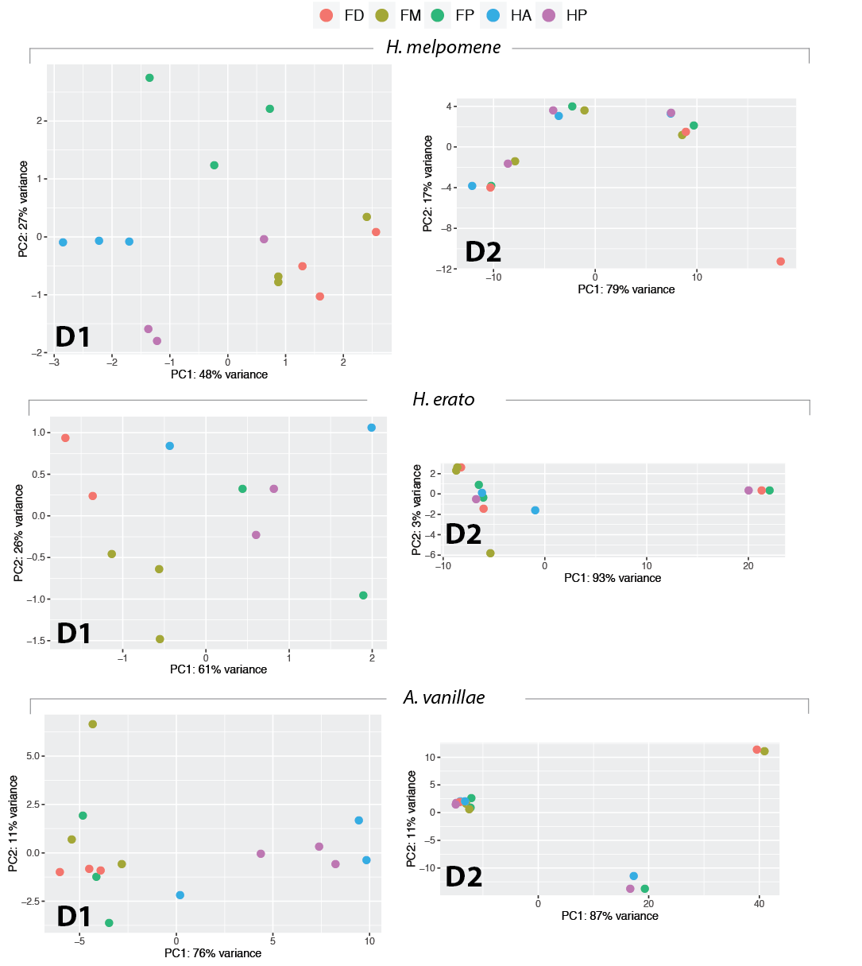
Figure S1: Principle component analysis of RNAseq data. Each point corresponds to a sample, with colours corresponding to wing compartment. (FP – proximal forewing, FM – medial forewing, FD – distal forewing, HA – anterior forewing, HP – posterior forewing.
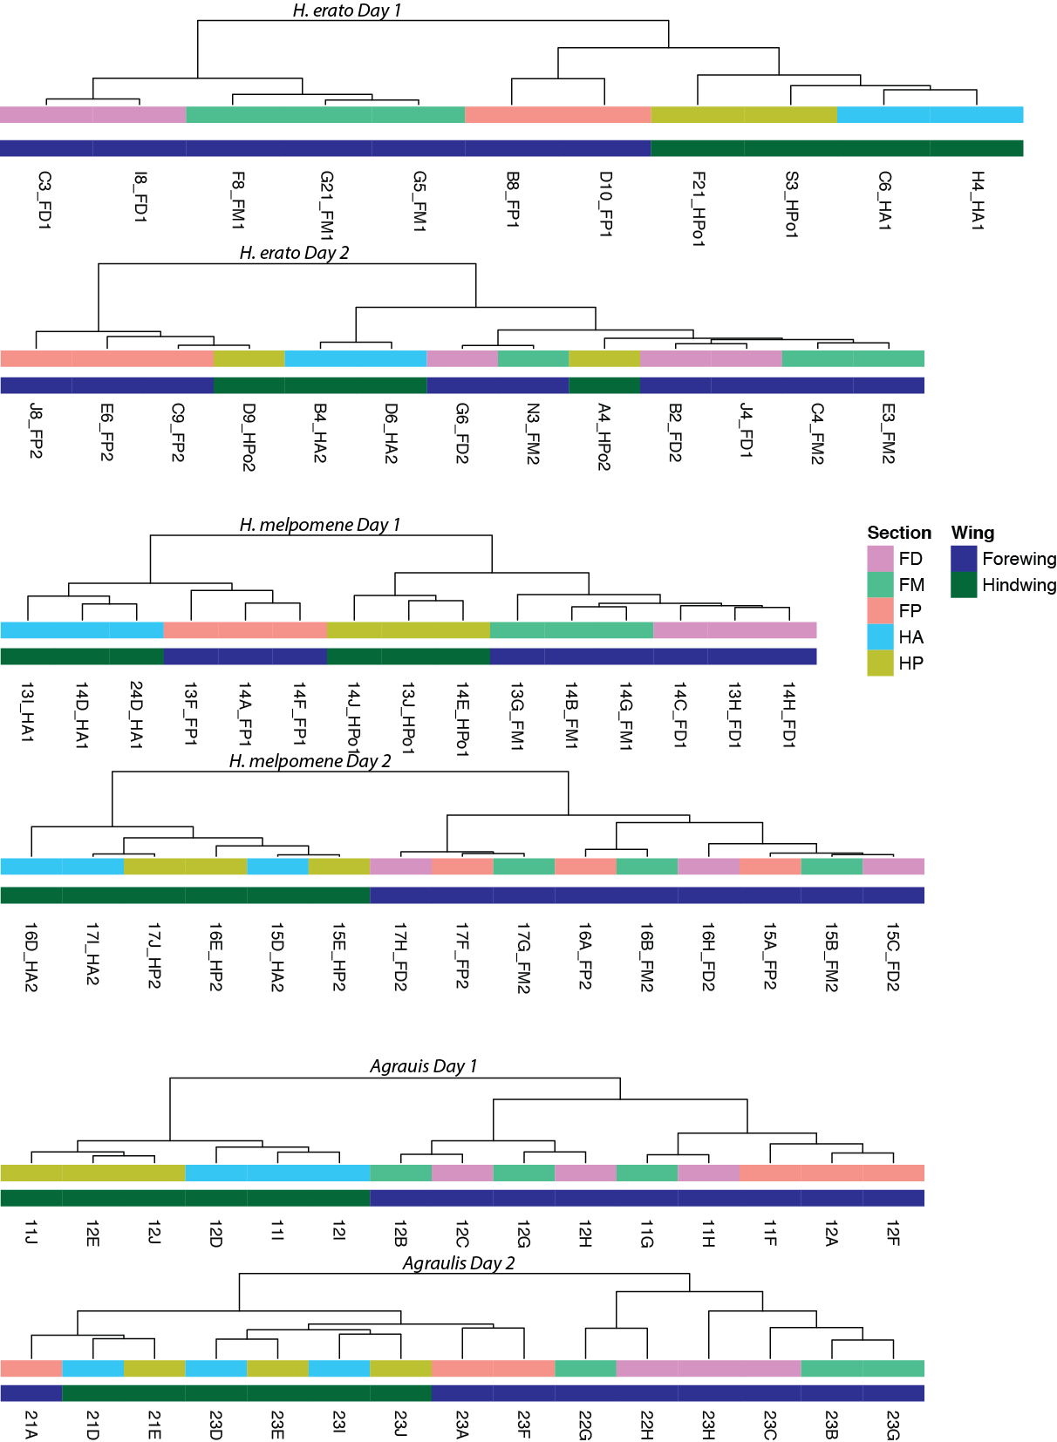
Figure S2: Dendrogram clustering of the data presented in Figure S1.
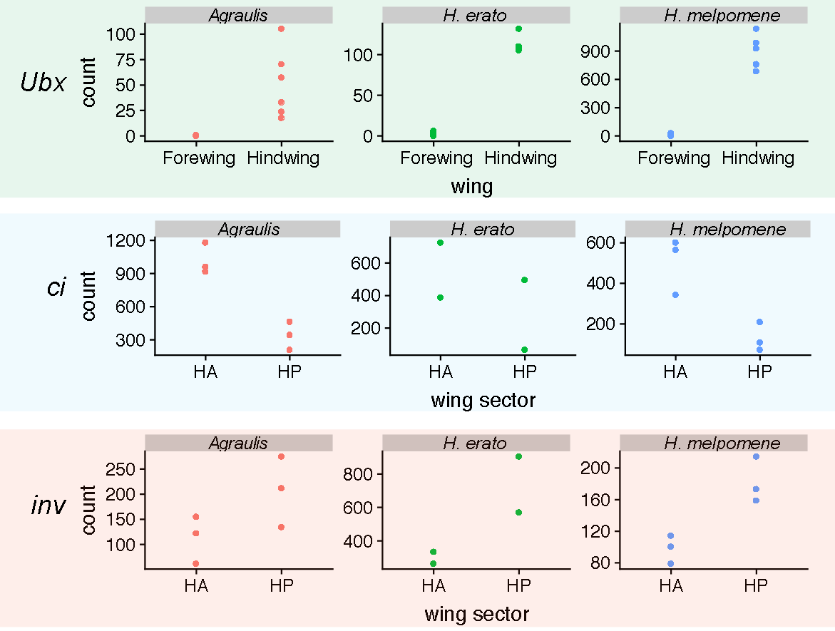

Figure S3: expression of the transcription factors Ultrabithorax, cubitus interruptus and invected.
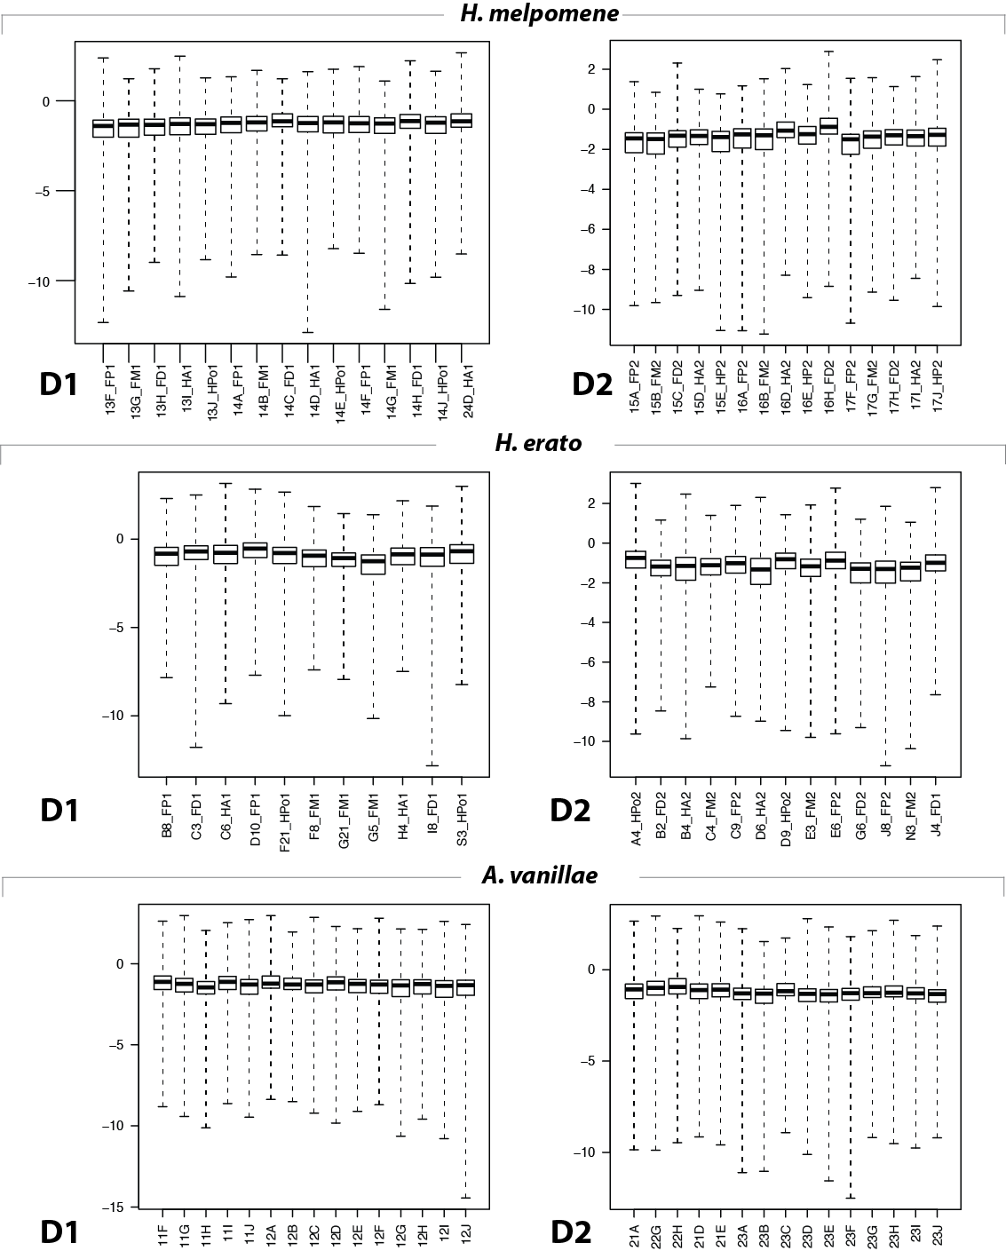

Figure S4: Cook’s distance for each sample.
Table S2: genes differentially expressed in larval wing discs of H. melpomene and H. erato.
Genes upregulated in forewings
nov_gene_002001
ham | hamlet | neuron fate selection, type II neuroblast maturation
AOX3 | Aldehyde oxidase 3
Dhpr | Dihydropteridine reductase
nov_gene007136
PK2-R1 | Pyrokinin 2 receptor 1 | GPCR, binds Hug (an NT and chitin synthesis regulator)
nov_gene009808
CG10298 | no annotated func
nov_gene034094
nov_gene034095
Pepck | Phosphoenolpyruvate carboxykinase
nov_gene035885
nov_gene036476
Nrk | Neurospecific receptor kinase | axon pathfinding, rhabdomeere elongation
nov_gene045731
Genes upregulated in hindwings
nrv2 | nervana 2 | Na/K ATPase subunit 2.
Cht2 | Chitinase 2
AdamTS-A | ADAM metallopeptidase with thrombospondin type 1 motif A | secreted matrix metalloprotease (mutants show apical surface irregularities).
CG3168 |  | anion transmembrane transporter
Ubx | Ultrabithorax | homeodomain transcription factor
pigs | pickled eggs | microtubule binding, negative regulator of notch
Genes differentially regulated in both species, but in the opposite direction
r-l | rudimentary-like | orotate phosphoribosyltransferase
nov_gene013098
Table S3:
Gene
nov_gene015670
Hr38 | Hormone receptor-like in 38 | required for adult cuticle development
gcm | glial cells missing | (discussed in text)
Sse | Separase | chromatid separation in meiosis
sand | sandman | dopamine responsive potassium channel
CG2663 |  | intracellular transport
gd | gastrulation-defective | secreted serine protease, activates Toll ligand spatzle, dorsoventral axis patterning
nov_gene011683
CG42339 |  | immune response
GstS1 | Glutathione S transferase S1
CGstD1 | Glutathione S transferase D1
CG4914 |  | serine endopeptidase activity
CG7896 | no annotated func
Scp2 | Sarcoplasmic calcium-binding protein
disco-r | disco-related | Epithelial-mesenchymal transition, wing expansion
sob | sister of odd and bowl | leg disc – joint morphogenesis
Reck | Reversion-inducing-cysteine-rich protein with kazal motifs | no annotated func
nov_gene021747
Faa | Fumarylacetoacetase | aromatic amino acid metabolism
Thor | Thor | translation initiation factor 4E binding protein
CG14257 | no annotated func
spo | spook | CNS development, cuticle development, head involuiton
CG42346 | no annotated func
nov_gene007135
nov_gene007136
nov_gene046315
Cyp6a2 | Cytochrome P450-6a2 | response to DDT, caffeine.
zfh2 | Zn finger homeodomain 2 | putative TF, proximal-distal patterning during wing and leg imaginal disc development
CG4945 |  | mesoderm development
knrl | knirps-like | orphan nuclear hormone receptor, target of Hh, Wnt and Notch pathways
hth | homothoroax
nov_gene015709
Cht2 | Chitinase 2
nov_gene008541
Roc1a | Regulator of cullins 1a | E3 Ubq ligase component
CG9380
CG41378
Rap2l | Ras-associated protein 2-like
scramb1 | scramblase 1 | scramble phospholipids across bilayer. (role in neurotransmission, apoptosis)
nov_gene031883
nov_gene031884
pnut | peanut | component of septin GTPase complex, involved in organization of cell cortex
alpha-Catr | α-catenin related | actin binding
nov_gene
CG9701 | beta-glucosidase
CG11370 | no annotated func
CG15239 | no annotated func
sqd | squid | RNA binding protein, localisation
Nlg3 | Neuroligin 3 | synaptic adhesion molecule involved in synapse formation and synaptic transmission
Cyp6a18
CG15497 | no annotated func
E2f1 | E2F transcription factor 1
Archease |  | axon regenration
DCTN3-p24 | Dynactin 3, p24 subunit | dynein activation
Fip1 | Factor interacting with poly(A) polymerase 1
pum | pumilio | 3’UTR binding protein
pum
mago | mago nashi | splicing, photoreceptor differentiation
RpS8 | Ribosomal protein S8
Spn85F | Serpin 85F | chitin modifier
Mctp | Multiple C2 domain and transmembrane region protein | Ca²⁺ ion-binding, membrane component
KFase | Kynurenine formamidase | possible pigment synthesis!
obst-A | obstructor-A | chitin maturation
obst-A
obst-B
betaTub56D | β-Tubulin at 56D | microtubule unit
CG3655 | no annotated func
CG4678 |  | metallocarboxypeptidase activity
CG34461 |  | chitin strucutural component
nov_gene034193
Lcp65Ac | Lcp65Ac | chitin strucutural component
Cpr49Aa | Cuticular protein 49Aa | chitin strucutural component
nov_gene034334
unc-5 | unc-5 | axon guidance
Nc73EF | Neural conserved at 73EF
nov_gene036907
Spn42Da | Serpin 42Da
nov_gene046015
beat-IV | beat-IV | heterophilic cell-cell adhesion
nGstE6
CG42259 |  | haemolymph coagulation
CG42259
nov_gene007986
CG1402 | no annotated func
Treh | Trehalase | trehalose metabooism, neural stem cell maintenance
Chd64 |  | juvenile hormone-responsive, actin binding
CG4213 | no annotated func
H2.0 | Homeodomain protein 2.0
CG16885 | no annotated func
IP3K2 | IP3-kinase 2 | regulates calcium levels by influencing IP3 signaling
nov_gene011713
CG16786 | no annotated func
Bx | Beadex | dimerizes with LIM transcription factors including Apterous in the wing disc.
Ets98B |  | oocyte-expressed
neur | neuralized | endocytosis-dependent activation of Notch
CG42390 | no annotated func
Nrg | Neuroglian | axon growth, imaginal disc morphognesis
CG40160 |  | serine-type endopeptidase
CG8369 |  | wing disc dorsal-ventral patterning (via interaction with Ap-Bx)
CG10407 | no annotated func
Toll-7 |  | axon guidance, viral immunity
mspo | M-spondin | regulation of myoblast fusion
nov_gene039499
ds | dachsous | cadherin binding, Planar Cell Polarity
beat-IIIb |  | heterophilic cell-cell adhesion
Nos | Nitric oxide synthase | nervous system development
TwdlE | TweedleE | chitin strucutural component
CG14964 |  | actin binding protein
Prm | Paramyosin | structural component of muscle

Table S4
gene | day 2
DE in Agraulis & H. erato
CG13367
nov_gene007134
Dnai2 | dynein, axonemal, intermediate chain 2
nov_gene00837
nov_gene008541
ple | pale | tyrosine hydroxylase (rate limiting step in melanin synthesis)
Cpr65Ec | Cuticular protein 65Ec | chitin structural component
CG10555 |  | transcription coactivator
Ddc | Dopa decarboxylase | melanin synthesis
CG33290 | no annotated func
Prm | Paramyosin | structural component of muscle
Mlc1 | Myosin alkali light chain 1 | myosin component
CG9297 | no annotated func
CG11825 | no annotated func
DE in H. melpomene & H. erato
nov_gene011805
mab-21 | malformed abdomen 21 | no annotated func
Sulf1 | Sulfated | heparan sulfate modifier, regulates Wnt ligand diffusion, als hh signalling
gd | gastrulation-defective | secreted serine protease, activates Toll ligand spatzle, dorsoventral axis patterning
t | tan | converts NBAD to dopamine – melanin synthesis pathway
CG4757 |  | carboxylic ester hydroxylase
CG5973 |  | transporter activity
AP-2alpha | Adaptor Protein complex 2, α subunit | cell transport
DE in H. melpomene & Agraulis
CG33290 | no annotated func
CG31954 |  | serine endopeptidase
nov_gene011684
CG5112 | no annotated func
Mctp | Multiple C2 domain and transmembrane region protein
nov_gene037141
CG13868 | no annotated func
nov_gene046277
nov_gene007986

Table S5: Wnt pathway constituents and gene codes

gene_code | gene_type | H. melpomene | H. erato
fz | receptor | HMEL030072 | evm.model.Herato0101.604 | Gene.17645::c50081_g1_i1::g.17645::m.17645 evm.model.Herato0101.604
Wg | ligand | HMEL022601 | evm.model.Herato0101.738 | Gene.28080::c53180_g1_i1::g.28080::m.28080 evm.model.Herato0101.735
Wnt10 | ligand | HMEL011434 | evm.model.Herato0101.735 | Gene.22452::c51642_g1_i1::g.22452::m.22452 evm.model.Herato0101.736
Wnt6 | ligand | HMEL011436 | evm.model.Herato0101.736 | Gene.24659::c52260_g1_i1::g.24659::m.24659 evm.model.Herato0101.738
Wnt4 | ligand | HMEL011441 | evm.model.Herato0101.740 | Gene.44206::c56654_g1_i1::g.44206::m.44206 evm.model.Herato0101.740
VhaM8.9 | PCP | HMEL043115 | evm.model.Herato0310.108 | Gene.14196::c48712_g1_i1::g.14196::m.14196 evm.model.Herato0310.108
Groucho | TF | HMEL016524 | evm.model.Herato0403.3 | Gene.19315::c50670_g3_i1::g.19315::m.19315 evm.model.Herato0403.3
pygo | TF | HMEL004050 | evm.model.Herato0405.22 | Gene.36671::c55176_g1_i1::g.36671::m.36671 evm.model.Herato0405.22
gilgamesh | intracellular | HMEL043699 | evm.model.Herato0405.46 | Gene.9988::c46287_g1_i1::g.9988::m.9988 evm.model.Herato0405.46
spen_1 | TF | HMEL042399 | evm.model.Herato0503.212
Rho1 | intracellular | HMEL016025 | evm.model.Herato0503.23 | Gene.22721::c51732_g1_i1::g.22721::m.22721 evm.model.Herato0503.212
fz3 | receptor | HMEL044184 | evm.model.Herato0503.9 | Gene.35454::c54867_g1_i1::g.35454::m.35454 evm.model.Herato0503.23
CG8786 | intracellular | HMEL046268 | evm.model.Herato0701.527 | Gene.31107::c53893_g1_i1::g.31107::m.31107 evm.model.Herato0503.9
fz2_1 | receptor | HMEL046532 | evm.model.Herato0701.759 | Gene.17796::c50150_g1_i1::g.17796::m.17796 evm.model.Herato0701.527
osa | TF | HMEL030920 | evm.model.Herato0901.275 | Gene.26847::c52848_g1_i1::g.26847::m.26847
Wnt5 | ligand | HMEL018100 | evm.model.Herato1001.160 | Gene.22486::c51656_g2_i1::g.22486::m.22486 evm.model.Herato0901.275
WntA | ligand | HMEL018100 | evm.model.Herato1001.161 | Gene.29008::c53376_g1_i6::g.29008::m.29008 evm.model.Herato1001.160
Wnt2 | ligand | HMEL022591 | evm.model.Herato1001.69 | Gene.29005::c53376_g1_i1::g.29005::m.29005 evm.model.Herato1001.161
Wnt5b | ligand | HMEL022606 | evm.model.Herato1001.88 | Gene.14793::c48962_g1_i1::g.14793::m.14793 evm.model.Herato1001.69
shf | heparan_interacting | HMEL031574 | evm.model.Herato1003.133 | Gene.24659::c52260_g1_i1::g.24659::m.24659 evm.model.Herato1001.88
ttv | heparan_interacting | HMEL013339 | evm.model.Herato1005.143 | Gene.9275::c45698_g2_i1::g.9275::m.9275 evm.model.Herato1003.133
Drl-2 | ligand | HMEL015485 | evm.model.Herato1007.90 | Gene.19220::c50654_g1_i1::g.19220::m.19220 evm.model.Herato1005.143
dally | intracellular | HMEL015252 | evm.model.Herato1108.113 | Gene.48364::c57401_g1_i1::g.48364::m.48364 evm.model.Herato1007.90
botv | heparan_interacting | HMEL011746 | evm.model.Herato1108.259 | Gene.37419::c55339_g2_i1::g.37419::m.37419 evm.model.Herato1108.113
dlp | intracellular | HMEL032267 | evm.model.Herato1108.30 | Gene.46191::c57019_g1_i1::g.46191::m.46191 evm.model.Herato1108.259
hyrax | TF | HMEL015680 | evm.model.Herato1108.345 | Gene.38015::c55477_g2_i1::g.38015::m.38015 evm.model.Herato1108.30
boca | intracellular | HMEL033550 | evm.model.Herato1202.553 | Gene.44686::c56735_g1_i1::g.44686::m.44686 evm.model.Herato1108.345
dx | intracellular | HMEL007293 | evm.model.Herato1202.820 | Gene.38286::c55532_g1_i1::g.38286
sfl | heparan_interacting | HMEL034074 | evm.model.Herato1301.128 | Gene.19786::c50823_g1_i2::g.19786::m.19786 evm.model.Herato1202.820
kermit | intracellular | HMEL034176 | evm.model.Herato1301.227 | Gene.21881::c51480_g1_i1::g.21881::m.21881 evm.model.Herato1301.128
stan | PCP | HMEL034041 | evm.model.Herato1301.96 | Gene.16962::c49871_g1_i1::g.16962::m.16962 evm.model.Herato1301.227
Pontin | TF | HMEL017143 | evm.model.Herato1301.391 | Gene.3686::c33770_g1_i1::g.3686::m.3686 evm.model.Herato1301.96
alphao | intracellular | HMEL035171 | evm.model.Herato1408.158 | Gene.19767::c50819_g1_i1::g.19767::m.19767 evm.model.Herato1301.391
mwh | PCP | HMEL035679 | evm.model.Herato1505.49 | Gene.22108::c51540_g4_i2::g.22108::m.22108 evm.model.Herato1408.158
Axin | PCP | HMEL036070 | evm.model.Herato1507.286 | Gene.32473::c54230_g1_i2::g.32473::m.32473 evm.model.Herato1505.49
dco | intracellular | HMEL035880 | evm.model.Herato1507.83 | Gene.46731::c57131_g1_i2::g.46731::m.46731 evm.model.Herato1507.286
sgg | intracellular | HMEL012308 | evm.model.Herato1603.51 | Gene.39804::c55818_g2_i1::g.39804::m.39804 evm.model.Herato1507.83
nejire | TF | HMEL038398 | evm.model.Herato1703.13 | Gene.4876::c38729_g2_i1::g.4876::m.4876 evm.model.Herato1603.51
dishevelled | intracellular | HMEL038512 | evm.model.Herato1705.40 | Gene.13733::c48458_g1_i1::g.13733::m.13733 evm.model.Herato1703.13
sgl | intracellular | HMEL010174 | evm.model.Herato1705.41 | Gene.21729::c51423_g2_i1::g.21729::m.21729 evm.model.Herato1705.40
Ext2 | heparan_interacting | HMEL017833 | evm.model.Herato1805.156 | Gene.38119::c55499_g1_i1::g.38119::m.38119 evm.model.Herato1705.41
Notum | heparan_interacting | HMEL039208 | evm.model.Herato1805.28 | Gene.43087::c56437_g1_i1::g.43087::m.43087 evm.model.Herato1805.156
Rfabg | heparan_interacting | HMEL002964 | evm.model.Herato1807.120 | Gene.12118::c47616_g1_i1::g.12118::m.12118 evm.model.Herato1805.28
pangolin | TF | HMEL039657 | evm.model.Herato1807.48 | Gene.1076::c12781_g1_i1::g.1076::m.1076 evm.model.Herato1807.120
CkIalpha | intracellular | HMEL016957 | evm.model.Herato1901.49 | Gene.30555::c53776_g1_i2::g.30555::m.30555 evm.model.Herato1807.48
CtBP | intracellular | HMEL016973 | evm.model.Herato1901.62 | Gene.37459::c55348_g3_i1::g.37459::m.37459 evm.model.Herato1901.49
twins | intracellular | HMEL013172 | evm.model.Herato1904.66 | Gene.11911::c47529_g1_i1::g.11911::m.11911 evm.model.Herato1901.62
arm_B-Catenin | intracellular | HMEL008024 | evm.model.Herato2001.403 | Gene.15402::c49262_g1_i1::g.15402::m.15402 evm.model.Herato1904.66
fry | intracellular | HMEL011016 | evm.model.Herato2101.61_evm.model.Herato2101.59 | Gene.40676::c56009_g1_i1::g.40676::m.40676 evm.model.Herato2001.403
wntless | intracellular | HMEL032988 | novel_model_155 | Gene.47366::c57232_g1_i2::g.47366::m.47366 evm.model.Herato2101.61_evm.model.Herato2101.59
 |  |  |  | Gene.15032::c49092_g1_i1::g.15032::m.15032 novel_model_155

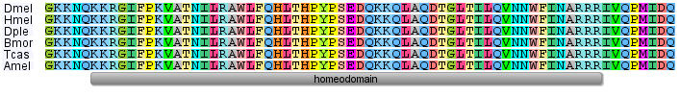

Figure S5. Homothorax homeodomain protein sequence is completely conserved between insects. Top to bottom: Drosophila melanogaster, Heliconius melpomene, Danaus plexippus, Bombyx mori, Tribolium castaneum, Apis mellifera. Only homeodomain is shown, there is lower conservation outside this domain.

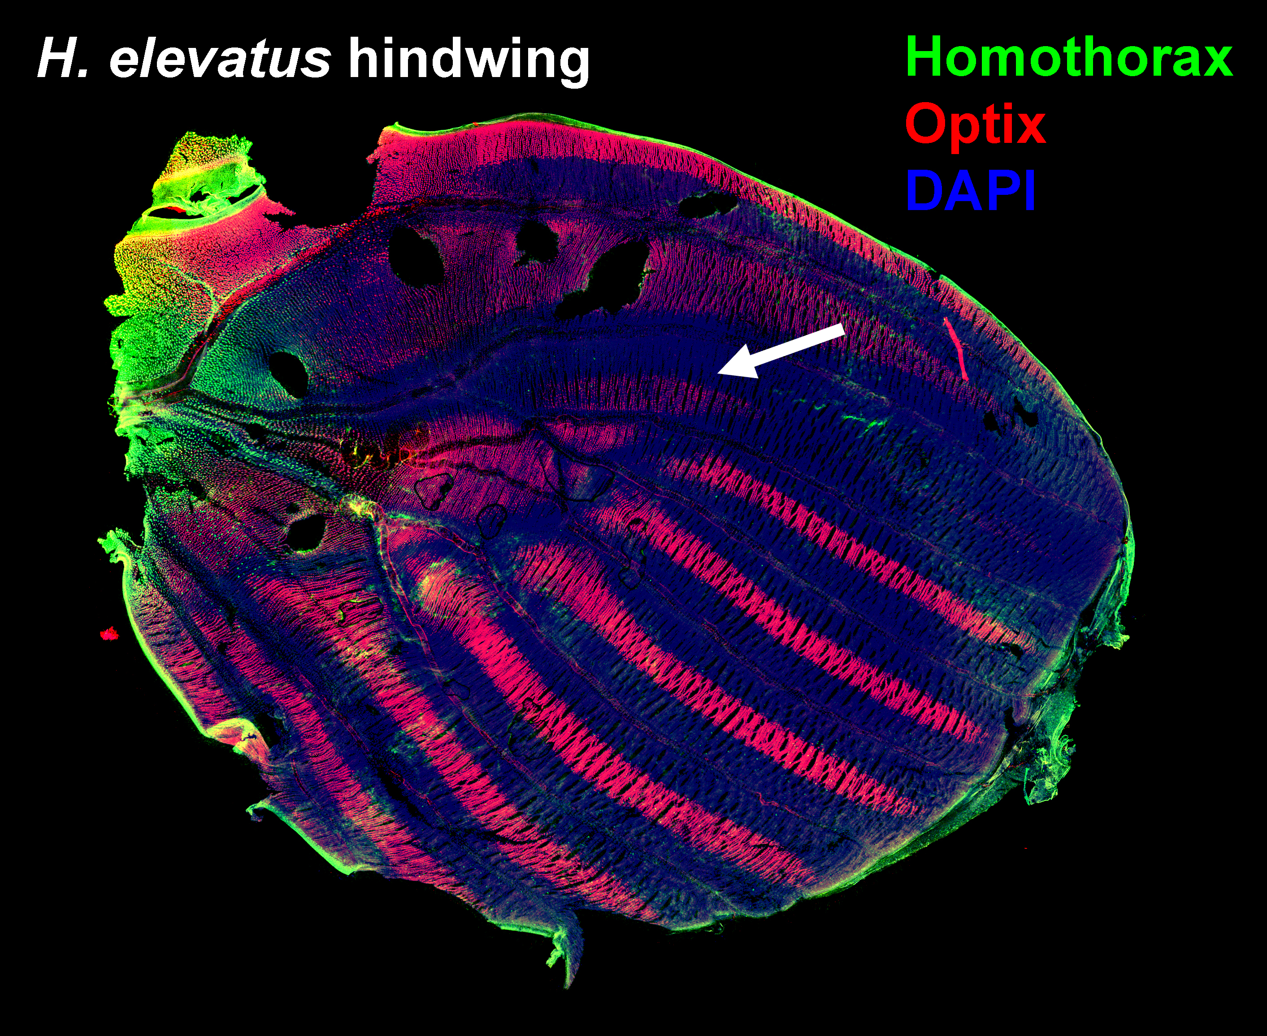
Figure S6. Homothorax and Optix expression in the hindwing.
In both H. elevatus and H. rosina hindwings Homothorax forms a limited gradient in the hinge region. This does not correspond to the dennis hindwing bar (arrow), suggesting this part of the pattern is influenced by factors other than Homothorax.
60-72 hrs post-pupation H. elevatus.

