Additional figure 1. Phylogenetic relationships of the homeodomain transcription factor proteins engrailed, goosecoid and distal-less in various metazoan taxa. Blue font denotes lophophorates. SH-like support values are indicated for select nodes.

Additional figure 2. Phylogenetic relationships of the signalling molecule BMP2-4 to closely related proteins in various metazoan taxa. Blue font denotes lophophorates. SH-like support values are indicated for select nodes.

Additional figure 3. Phylogenetic relationships of ferritins from various metazoan taxa to fungal orthologues. Blue font denotes lophophorates. SH-like support values are indicated for select nodes.

Additional figure 4. Phylogenetic relationships of calmodulin to other calcium-binding proteins in various metazoan taxa. Blue font denotes lophophorates. SH-like support values are indicated for select nodes.

Additional figure 5. Phylogenetic relationships of perlucin orthologues to other lectin-related proteins in various metazoan taxa. Blue font denotes lophophorates. SH-like support values are indicated for select nodes.

Additional figure 6. Phylogenetic relationships of mpox (mantle peroxidases) to other peroxidase-related proteins in various metazoan taxa. Blue font denotes lophophorates. SH-like support values are indicated for select nodes.

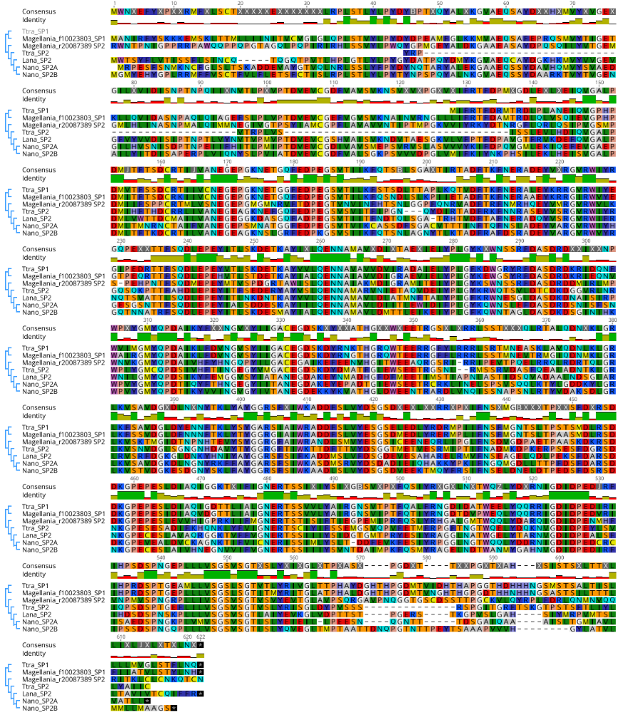
Additional figure 7. Alignment of the SP1 and SP2 protein sequences from four brachiopod species.

Additional table 1. Reference sequences used to search genomes/transcriptomes for each gene of interest.
Gene name | Genbank accession | Organism | Notes
Engrailed | ALS19757.1 | Terebratalia transversa
Distal-less | BBB21813.1 | Lingula anatina
Decapentaplegic/BMP2-4 | XP_013396300.1 | Lingula anatina
Goosecoid | XP_013379052 | Lingula anatina
Mpox (mantle peroxidase) | BBB21814.1 | Lingula anatina
Ferritin | XP_023933523 | Lingula anatina
Calmodulin | NP_001191509.1 | Aplysia californica
Perlucin | AGI61062.1 | Hyriopsis cumingii
F10023803 (SP1) |  | Magellania venosa | From Jackson et al. 2015
R20087389 (SP2) |  | Magellania venosa | From Jackson et al. 2015

