Additional File 1: Supplementary tables and figures in order of reference in the manuscript

Table S1:
Primers for probes for in situ hybridization

Gene | Primers | Direction
vasa | Em-vasa-F3-pro: 5'- CGG TGT ATC GTC AGT TGT GG -3' | sense
vasa | Em-vasa-R3-pro: 5'- TAA TAC GAC TCA CTA TAG GGT TGG AAT CTC CCT TGT GTC C -3' | antisense
PL10 | Em-Pl10-P1-F: 5'- AAA GGC ACA GAA GCT ACC CGT T -3' | sense
PL10 | EmPl-10R(+T7tail)2: 5'- TAA TAC GAC TCA CTA TAG GGT TTC GGA TCT GCG GCT CAA A -3' | antisense
nanos | Em-nanos-F2-pro: 5'- ACC TAT CGA CAG CGA AAT GG -3' | sense
nanos | Em-nanos-R2-pro: 5'-TAA TAC GAC TCA CTA TAG GGG CAA TGG TGA AGG TGT TTG A -3' | antisense

Table S2:
Morphological and behavioral characteristics of motile cells from Ephydatia muelleri in the mesohyl (Dimensions in µm, Velocity in µm s ⁻¹ ± SD ). Legend: Polyb., polyblast; Sm Cyst, small cystencyte; Lg Cyst, Large cystencyte
Cell Type | Area |  | Perimeter |  | Avg Length |  | Avg Width |  | Path length |  | Avg Velocity |  | Linearity (PL/ED)
Polyb Type 1 | 920.1 | ± 59.0 | 161.4 | ± 9.2 | 46.6 | ± 3.3 | 36.8 | ± 4.2 | 424.1 | ± 48.5 | 0.22 | ± 0.02 | 0.64 | ± 0.03
Polyb Type 2 | 346.9 | ± 16.7 | 106.0 | ± 3.9 | 24.1 | ± 3.1 | 23.1 | ± 3.7 | 96.5 | ± 30.2 | 0.13 | ± 0.01 | 0.65 | ± 0.07
Sm Cyst | 191.4 | ± 15.0 | 55.0 | ± 2.2 | 12.6 | ± 0.5 | 13.5 | ± 0.6 | 109.0 | ± 16.3 | 0.07 | ± 0.01 | 0.57 | ± 0.06
Lg Cyst | 858.3 | ± 52.0 | 114.0 | ± 4.0 | 31.5 | ± 2.2 | 36.0 | ± 2.0 | 174.5 | ± 22.4 | 0.06 | ± 0.01 | 0.58 | ± 0.05
Archaeocyte | 433.3 | ± 28.1 | 94.2 | ± 3.3 | 24.8 | ± 1.5 | 22.6 | ± 1.8 | 349.0 | ± 46.2 | 0.1 | ± 0.01 | 0.5 | ± 0.05

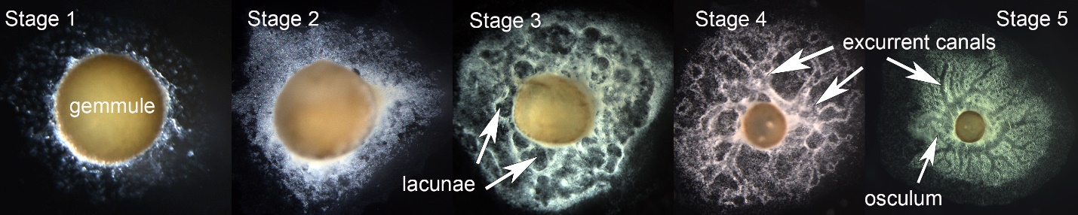

Figure S1:
Staging juvenile freshwater sponges. Images captured by steromicroscope (Olympus SZX12) at different magnifications. Stage 1, just hatched, with cells coming out of the micropyle and anchoring the gemmule to the substrate. Stage 2, one- to two-day old sponge with many undifferentiated cells and some sclerocytes and choanocytes between the surface pinacoderms (exopinacoderm and basopinacoderm). Stage 3, two- to three-days old, with lacunae or pockets of the incipient canal system surrounded by white tissue containing early choanocyte chambers, sclerocytes, archaeocytes. Stage 4, four- to five-day old sponge with differentiated canals and chambers spreading throughout the sponge, however lacking the final organization of excurrent canals into only one or two much larger canals leading to the osculum. Stage 5, five-day sponge or older, in which excurrent canals have their definitive organization leading to the osculum.

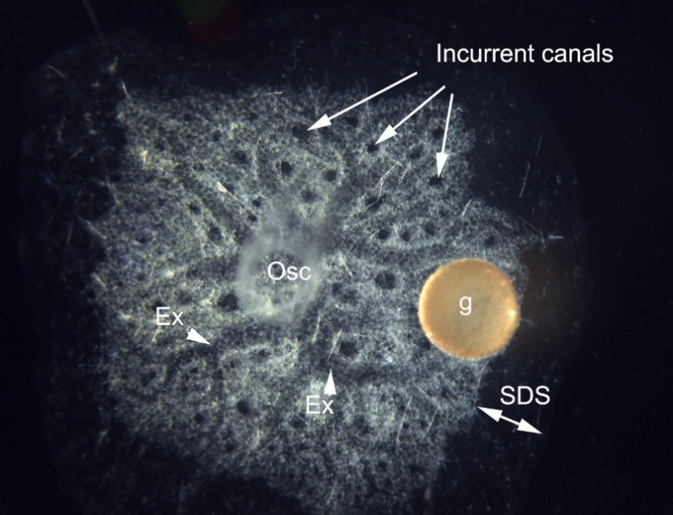
Figure S2:
Stage 5 sponge showing darker circles of incurrent canals. Abbreviations: ex, excurrent canals, SDS, subdermal space, Osc, osculum, g, gemmule.

Video S1: Choanocyte chamber of a stage 5 Ephydatia muelleri filmed using a high speed camera (MegaSpeed 5) at 100 frames per second, showing flagella beating in collars and the erratic whip-like beat of a cilium at the apopyle. Flagella beat rate is approximately 27hz, apopyle cilium beat rate is roughly 2 hz.
Video S2: Central cell in a choanocyte chamber of stage 5 Ephydatia muelleri filmed using a high speed camera (MegaSpeed 5) at 400 frames per second. While the flagella beat is uninterrupted by the presence of the central cell sitting on top of the collars and glycocalyx mesh, the beat of the flagella and/or movement of the water visibly shakes the central cell.

Video S3:
Cells moving in the mesohyl of the periphery of a Stage 5 E. muelleri. Filmed using phase contrast dippable lens. The types of cells crawling are identified in the still image of Figure 10 in the main text and in panel C of figure S5.

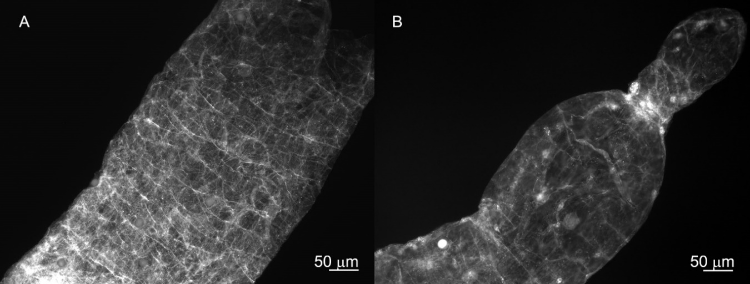
Figure S4:
Osculum of E. muelleri labelled with phalloidin for actin. A. Image showing some cell boundaries, but more obviously actin tracts go around the circumference of the osculum. B. Contracted osculum with sphincters showing actin.

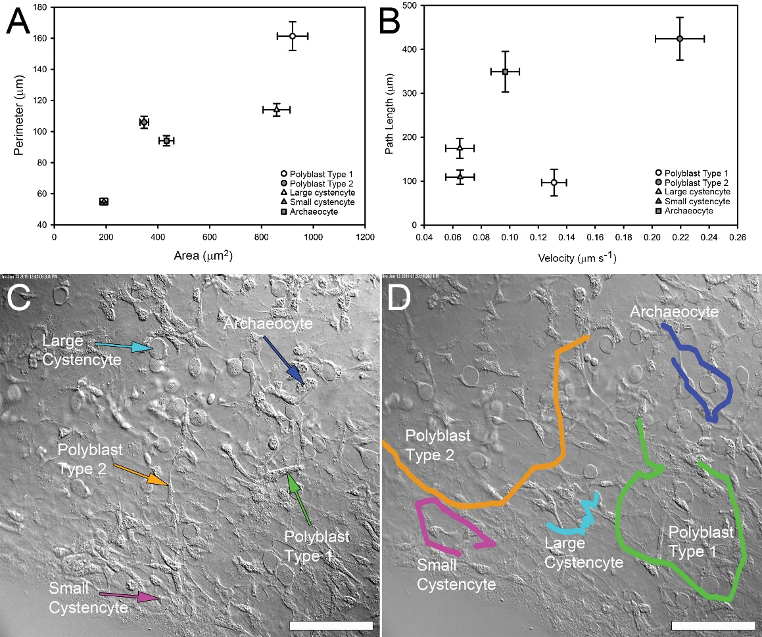
Figure S5:
Motile mesohyl cells are distinguished from each other by morphology and behavior. A) Total surface area and perimeter of each cell type. B) Velocity and length of the path taken by each mobile cell type. Mean and standard error. C) Mobile cell types identified the mesohyl, imaged using differential interference contrast (DIC) microscopy. D) The respective paths of each of the cells shown in (C); colours correspond to the cells indicated by the coloured arrows in (C). Scales in C,D 50 µm.

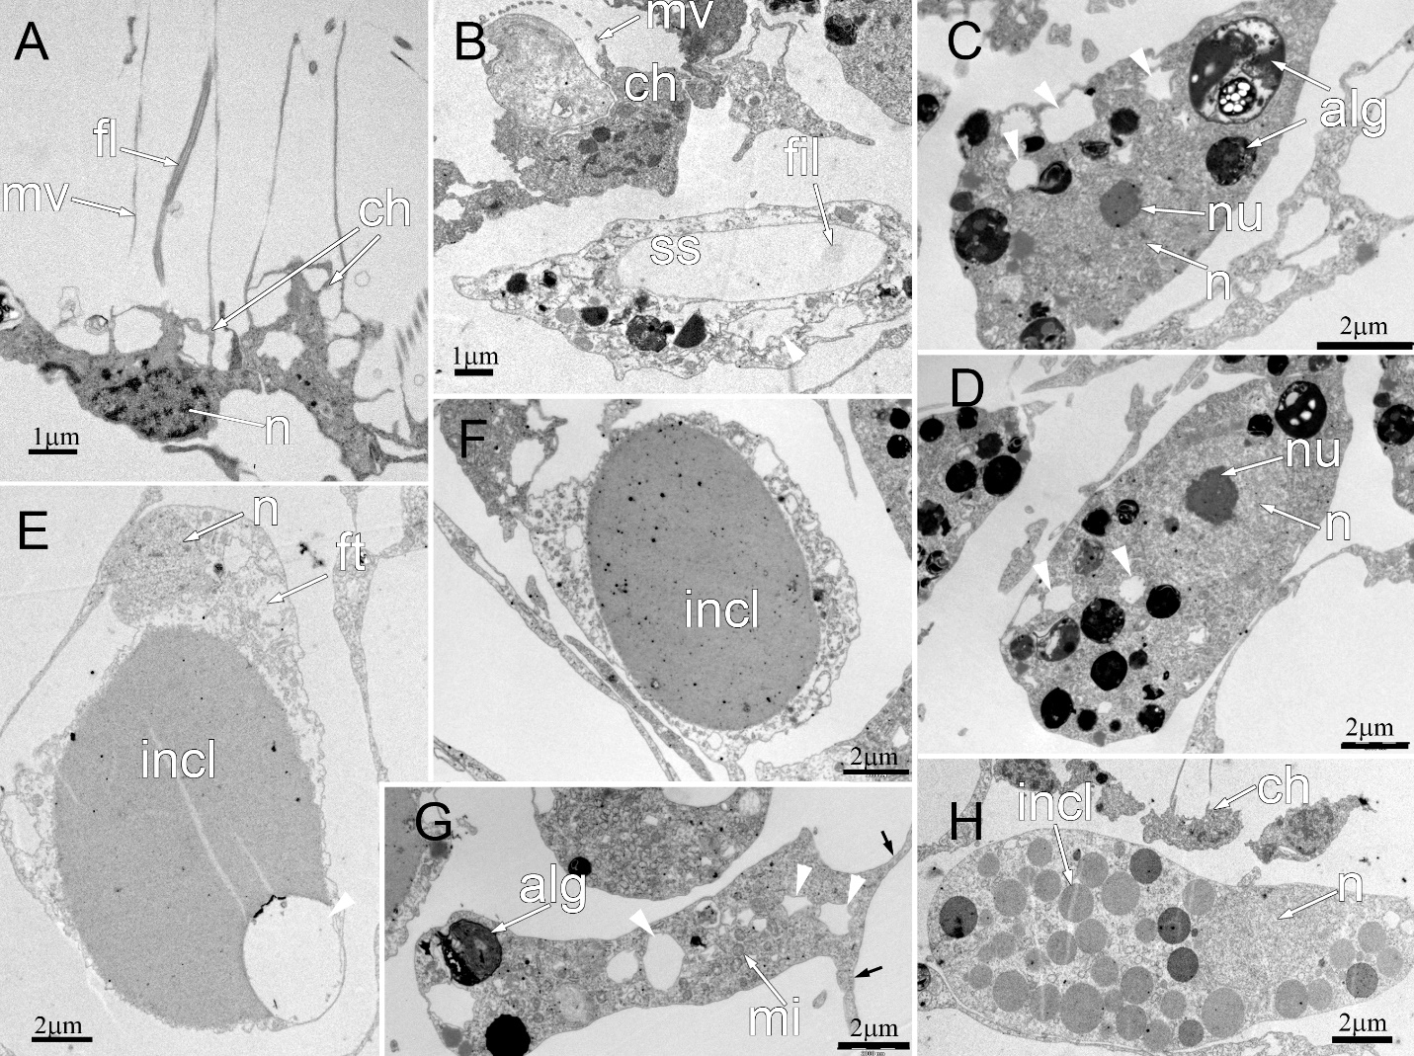
Figure S6:
Transmission electron micrographs of choanocytes and motile cell types shown in Figure 10. A, Two choanocytes, showing microvilli (mv) forming the collar and flagellum (fl) in the collar of the left hand cell. The nucleus (n) takes up most of the cell body and has dispersed heterochromatin. The choanocyte base is exposed to water. B, Sclerocyte lying below a choanocyte, identified by the microvilli (mv) of the collar. The sclerocyte contains a membrane bound inclusion that is the space that housed the spicule (ss) prior to dissolution. The remains of the axial filament – a protein rod forming the innermost part of the spicule – can be seen at one side of the ss. C, Archaeocyte containing algae (alg), and with various empty vesicles (white arrowheads) in the cytoplasm. Archaeocytes are identifiable by the nucleolated (nu) nucleus (n), and their generally round, stocky shape. D, Archaeocyte with a nucleolated nucleus and clear vesicles (arrowheads). E. Large cystencyte with a nucleus (n) in the foot (ft) that is ahead of the large ovoid inclusion (incl). This inclusion has a clear space that is likely introduced during fixation. F, Small cystencyte showing a very small cytoplasm to inclusion (incl). G, Small polyblast, with algae (alg) in inclusions as well as clear vesicles (arrowheads). Mitochondria (mi) are easily seen in the cytoplasm, and cells usually have pseudopodia (black arrows). H, Large polyblast, lying below the choanoderm (ch), with a clear nucleus (lacking a nucleolus), and numerous round grey inclusion in the cytoplasm.

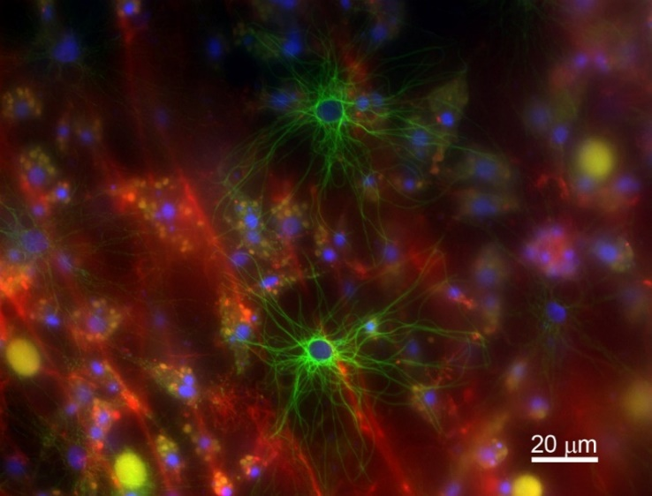
Figure S7:
Two basopinacocytes in the basopinacoderm of E. muelleri labelled with Developmental Studies Hybridoma Bank (DSHB) anti beta tubulin (green), Hoechst 33342 for nuclei (blue), and phalloidin 594 for actin (red). Microtubules radiate out from the central nucleus. The large yellow/orange spheres are autofluorescence of the inclusions in cystencytes, and small yellow spheres are vesicles in other cells that are out of the plane of focus.

Data S7: Integrating Single-cell transcriptomics with cell morphology

As opposed to droplet-based sequencing methods (e.g., 10X), which rely on gene expression profiles and marker genes to identify cell types, scRNA-Seq of dissociated cells with Smart Seq libraries allows for detailed cellular morphologies (Additional File 1; Figure S8) to be seamlessly integrated with high-resolution gene expression profiles.

Figure S8:
Dissociated Ephydatia cells were isolated from primary cell culture of disassociated sponges Stage 5: cystencytes (C1-C5), archaeocytes (A1-A4), and choanocytes (Ch1-Ch5). Distinct morphological characteristics enable unambiguous cell type identification. The cells were dissociated using enzymatic cocktail (Trypsin 1mg/ml, Collagenase 1mg/ml) and divalent cation free M-media. Single cells were collected using disposable glass pipettes (out of focus), fixed in lysis buffer, and kept at -80C until library preparation and sequencing. Smart-seq V4 libraries were generated from these cells, which then underwent single-cell RNA sequencing. See methods for details. Scale bars: 20µm.

Batch effects do not explain reduced number of genes expressed in choanocyte transcriptomes
Our evidence suggests that the reduced number of genes expressed in choanocytes was not due to batch effects. Choanocytes and archaeocytes were collected and sequenced in the same batch. Despite this, the number of genes present in archaeocytes and cystencytes are similar, whereas choanocytes are significantly different from archaeocytes (Figure 11E; Additional File 1; Table S3).

Table S3:
Count of genes with Transcript per million (TPM) values > 0 in choanocyte (Ch), cystencyte (Cy), and archaeocytes (Ar) samples.

Cell ID | Ch1 | Ch2 | Ch3 | Ch4 | Ch5 | Cy1 | Cy2 | Cy3 | Cy4 | Cy5 | Ar1 | Ar2 | Ar3 | Ar5
#Genes TPM > 0 | 1455 | 566 | 307 | 623 | 92 | 1528 | 1793 | 2465 | 1845 | 2552 | 923 | 1947 | 3263 | 1844

Sequence depth does not explain reduced number of genes expressed in choanocyte transcriptomes

Our evidence suggests that the reduced number of genes expressed in choanocytes was not due to sequencing coverage (total read pairs; Additional File 1; Figure S10_A) or alignable reads (Additional File 1; Figure S10_B). The number of total read pairs generated per cell is very similar between the three cell types (Additional File 1; Figure S10A). Even though the number of alignable reads (i.e. reads that align to Ephydatia gene models) in archaeocytes is substantially larger, the fact that the numbers are very similar in the choanocyte and cystencyte samples (Additional File 1; Figure S10_B) suggests that the alignability of the choanocyte reads is not driving the pattern of low numbers of genes expressed in choanocytes.

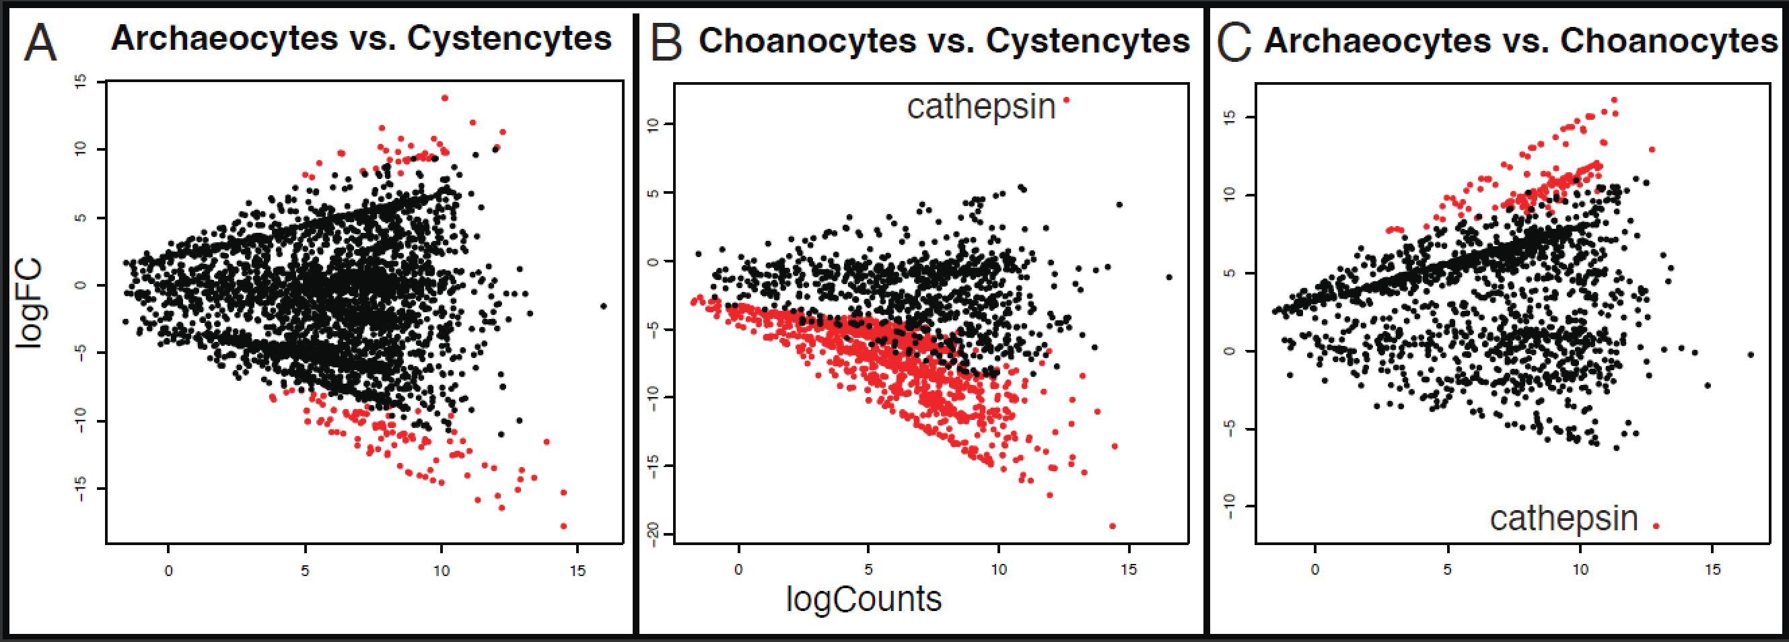Figure S9:
MA plots showing unbalanced differences in expression levels between chaonocytes and other cell types. Dots represent genes. Positive log fold change (logFC) corresponds with the first listed cell type in the panel title. Red indicates genes that exhibit logFC differences above the threshold. (A) MA Plot showing differences in expression between archaeocytes and cystencytes are relatively balanced (compared to B and C). (B) MA Plot showing differences in expression between choanocytes and cystencytes are highly skewed towards cystencytes. (C) MA Plot showing differences in expression between choanocytes and archaeocytes are highly skewed towards archaeocytes. In choanocytes, the single significant differentially expressed gene, cathepsin, is labeled.

Figure S10:
Box and whisker plots showing choanocytes are not outliers in terms of total read pairs and alignable reads. (A) The number of read pairs generated for each sample is similar across all of the archaeocyte, choanocyte, and cystencytes cell types. (B) The number of reads that align to the Ephydatia gene models is similar in the cystencyte and choanocyte samples.

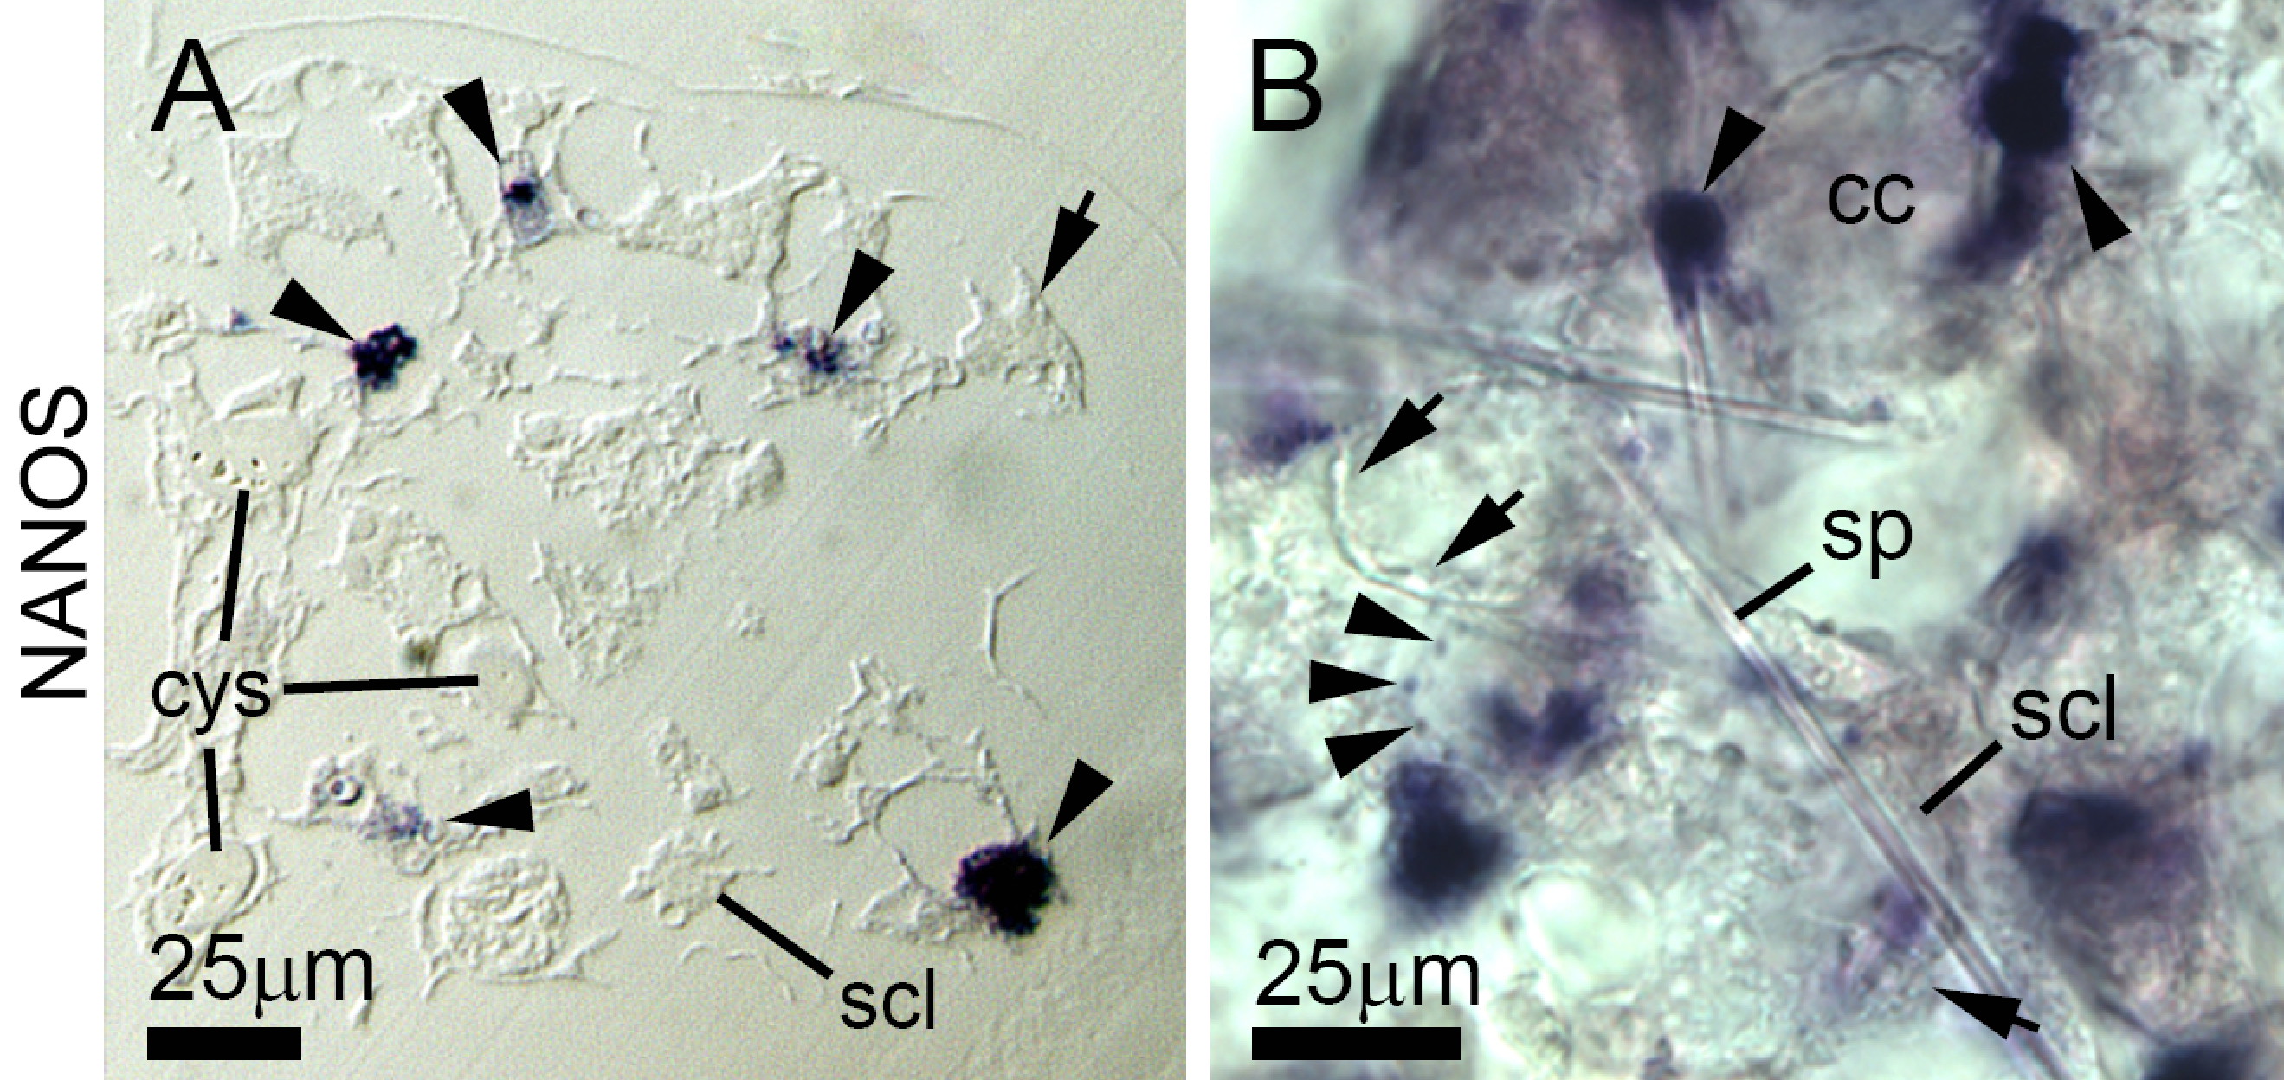
Figure S11:
Expression of the germline genes Nanos in juveniles and adult tissue of E. muelleri.
(A,B) A subset of archaeocytes show a Nanos positive label (black arrowheads) in a large area of the cytoplasm (arrows show unlabeled archaeocytes). Labeled archaeocytes are always located close to choanocyte chambers (cc); in panel B, few choanocytes are labeled with Nanos (black arrowheads). Cys, cystencyte; scl, sclerocyte; sp, spicule; cc, choanocyte chamber.

