Figure S1: Metacore enrichment analysis of differentially expressed genes in culture and in primary brain based on differentially affected functional ontologies such as (A) “Process Networks” and (B) “Diseases (by Biomarkers)”.
1. |  | HippoCultureKOminusWT_EntrezID_genelist
2. |  | CorticalCultureKOminusWT_EntrezID_genelist
3. |  | HippoBrainKOminusWT_EntrezID_genelist
4. |  | CortexBrainKOminusWT_EntrezID_genelist

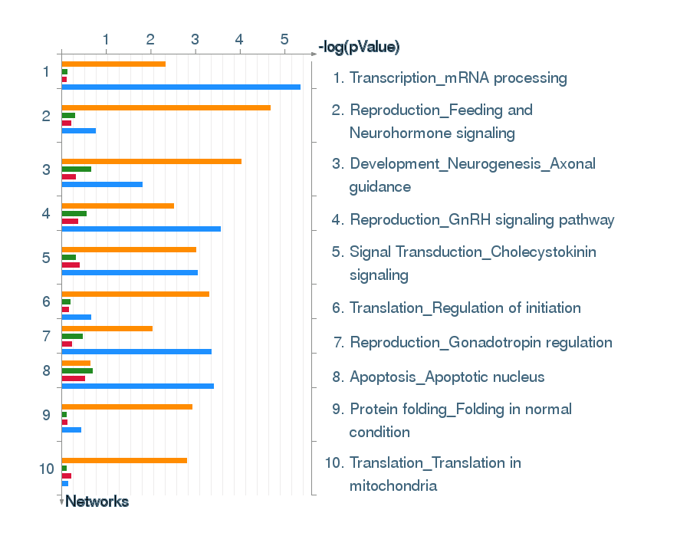
A.

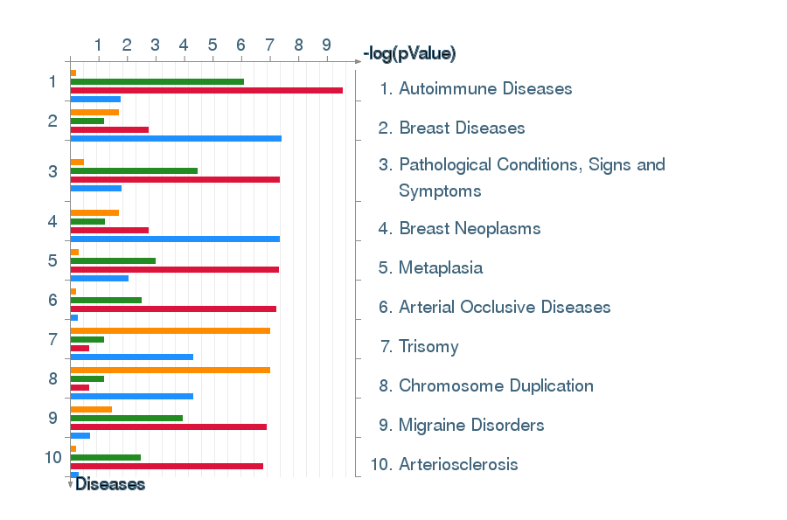
B.

