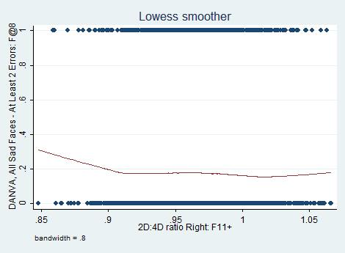
Figure S1: Lowess regression line for DANVA sad faces against right hand 2D:4D

Figure S2: Lowess regression line for DANVA low intensity faces against right 2D:4D

Figure S3: Lowess regression line for DANVA high intensity faces against right 2D:4D

Figure S4: Lowess regression line for DANVA faces misattributed as angry against right hand 2D:4D

