Identification of a common set of microRNAs deregulated in Autism Spectrum disorders
Lam Son Nguyen, Marylin Lepleux, Mélanie Makhlouf, Christelle Martin, Julien Fregeac, Anne Philippe, François Feron, Bruno Gepner, Claire Rougeulle, Yann Humeau & Laurence Colleaux
This document contains 4 figures and 7 tables :
Figure S1 : Relative expression of miRNAs in OMSC in validation round.
Figure S2 : Expression of reference miRNAs in fibroblasts
Figure S3 : Expression of miRNA signature in PBMC
Figure S4 : Long term potentiation pathway is predicted to be specifically targeted by miR-146a and miR-221.
Table S1 : Clinical descriptions of ASD patients whose OMSCs were used for miRNA screening.
Table S2 : Variants identified by whole exome analysis.
Table S3 : Genetic etiology of patients included in this analysis.
Table S4 : Primers used in this study.
Table S5 : Brief clinical descriptions of ASD patients whose primary skin fibroblasts and/or PBMC were used in follow up study.
Table S6 : Brief clinical descriptions of patients with ID whose primary skin fibroblasts were used in follow up study.
Table S7 : Selected enriched pathways predicted to be targeted by miR-146a and miR-221

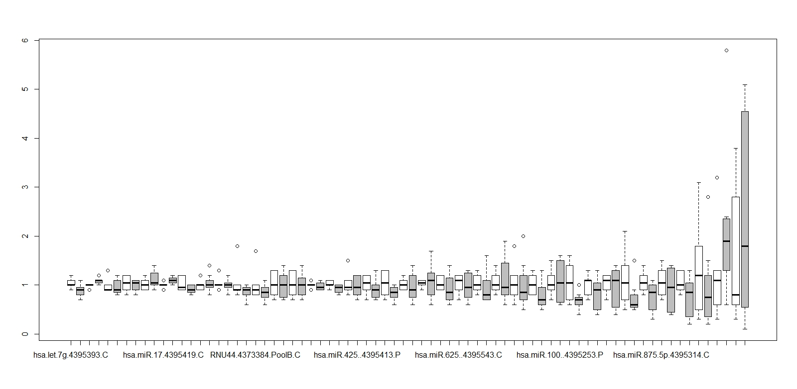
hsa-miR-708
hsa-miR-146a
hsa-miR-335
hsa-miR-659
hsa-miR-432
hsa-miR-875
hsa-miR-100
hsa-miR-106b
hsa-miR-654-5p
hsa-miR-7-1*
hsa-miR-513a
hsa-miR-222
hsa-miR-135a*
hsa-miR-625*
hsa-miR-505*
hsa-miR-376a*
hsa-miR-378
hsa-miR-656
hsa-miR-596
hsa-miR-221
hsa-miR-148b*
hsa-miR-425*
hsa-miR-126*
hsa-miR-26b*
*
*
*
*

Controls (n=6)
Patients (n=8)
hsa-let-7g
hsa-miR-106a
hsa-miR-151-3p
hsa-miR-15b
hsa-miR-16
hsa-miR-17
hsa-miR-99b
Relative Quantity
Reference miRNAs
Figure S1 : Expression (±SD) of all miRNAs in OMSC analysed in the validation round. * P < 0.05 by Wilcoxon rank sum test
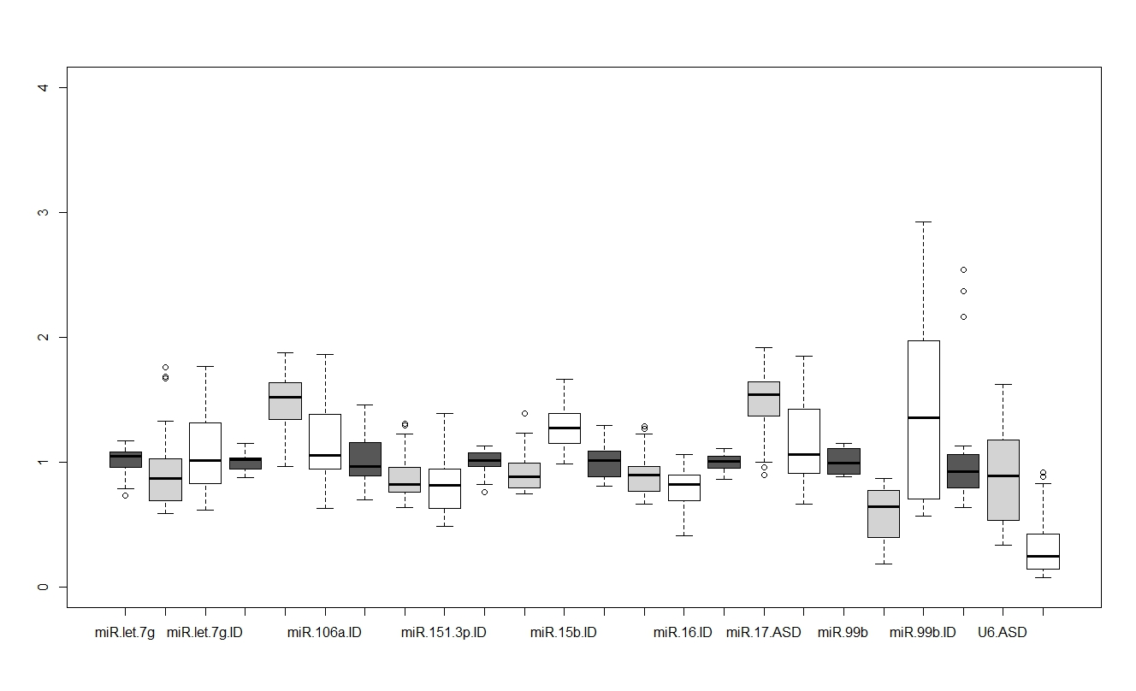
4
3
2
1
0

Controls (n=4)
ASD (n=5)
ID (n=12)
miR-106a
miR-151-3p
miR-15b
miR-let-7g
miR-17
miR-99b
U6
miR-16
Relative Quantity

Figure S2 : Expression (±SD) of reference miRs used in Fludigm analyses in fibroblasts. 8 miRNAs were assessed including 7 identified and used in OMSC analysis and U6, the common housekeeping non-coding RNA for miR analysis. miRNAs with the most variation among groups were excluded from downstream analyses : miR-99 and U6.

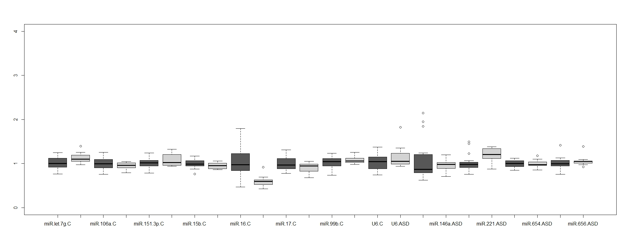
miR-106a
miR-151-3p
miR-15b
miR-let-7g
miR-17
miR-99b
miR-16
U6
3
2
1
0
4

Controls (n=20)
ASD (n=9)
miR-146a
miR-221
miR-654-5p
miR-656
Relative Quantity
Figure S3 : Expression (±SD) of miRNA signature in peripheral blood mononuclear cells (PBMC). miR-16 was excluded from the final reference miRNA panel which include 6 miRNAs originally used OMSC analysis and U6, the common reference non-coding miRNA. No significant difference was detected between the controls (n=20, dark grey box) and the ASD patients (n=9, light grey box).

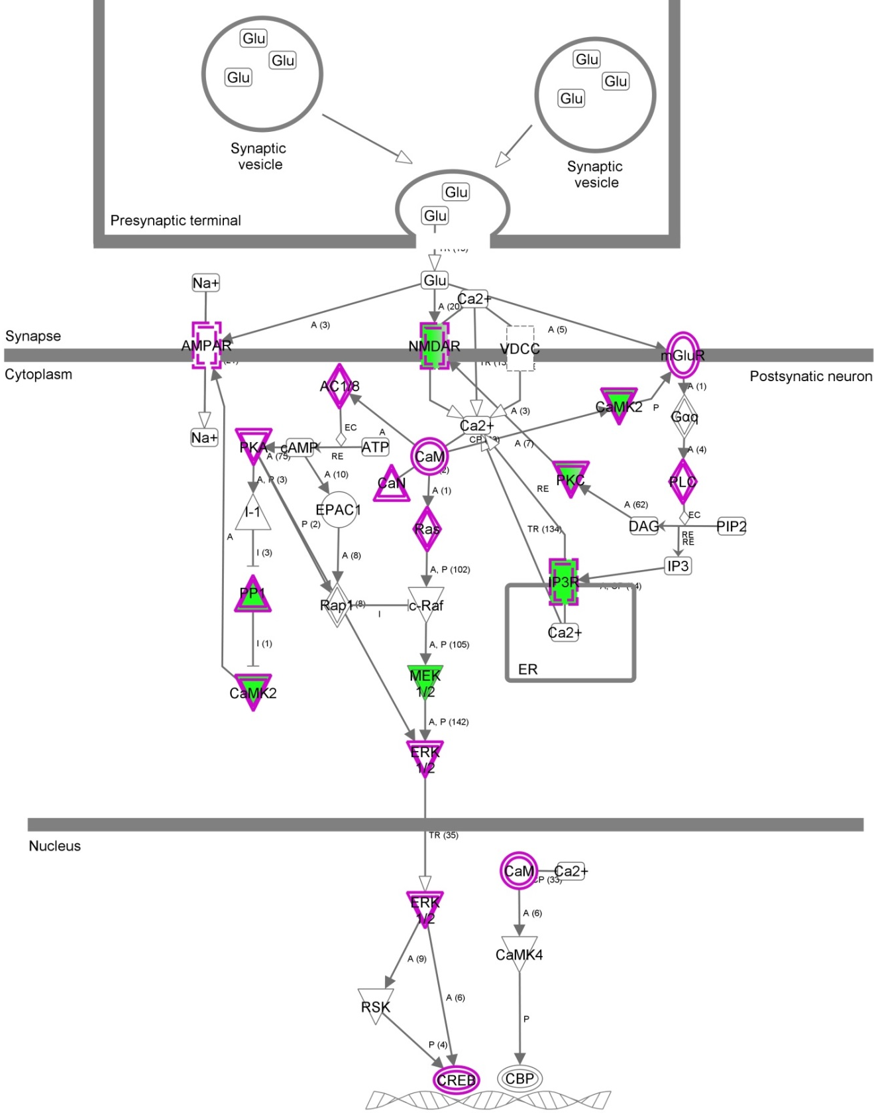
Figure S4 : Long term potentiation pathway is predicted to be specifically targeted by miR-146a and miR-221. Proteins in pink are predicted targets of miRNA, proteins in green are those deregulated in the post-mortem ASD brains [1]. Target prediction was performed using mirDIP and pathway enrichment analysis was performed using IPA.

Patients |  |  |  |  | Controls
Code | Age | Sex | Diagnosis | Principal Symptoms | Code | Age
A1 | 37 | M | Infantile autism/  Severe autism  Important dependence | No verbal expression, very poor social interactions, restricted interests and activities, passivity | C3 | 39
A2 | 22 | F | Infantile autism/  Severe autism  Important dependence | Poor verbal expression (some words and sentences), poor social interactions, social avoidance, restricted interests and activities, aimless motor activity, motor stereotypes, tantrums | C1 | 21
A3 | 35 | M | Infantile autism/  Severe autism  Important dependence | Very poor verbal expression (few words), social avoidance and retrieval, restricted interests, self-injury | C6 | 35
A5 | 22 | F | Infantile autism/  Very severe autism  Complete dependence | No major verbal delay, poor gaze contact, inappropriate social interactions, cognitive disorders (dyslexia, dyscalculia), social and professional adaptation impairments | C9 | 34
A6 | 22 | M | Infantile autism/  Moderate to severe autism  Important dependence | No verbal expression, relatively good verbal comprehension, good visuo-spatial abilities, poor social interactions, motor stereotypes, aggressive behaviours | C5 | 18
A7 | 22 | M | Infantile autism/  Moderate to severe autism  Important dependence | Very poor verbal expression (few words), poor social interactions, restricted interests and activities, gestural stereotypes | C7 | 18
A8 | 43 | M | Severe autism  Important dependence | No verbal expression, relatively good verbal comprehension, poor social interactions, body sway, some aggressive behaviours | C8 | 44
A9 | 22 | M | Asperger syndrome/  Mild autism  Independence | No significant verbal nor intellectual delay, slow verbal flow, gaze avoidance, poor social contact, relatively good social and professional adaptation | C11 | 32
A10 | 38 | M | Infantile autism/  Profound autism  Complete dependence | No verbal expression, very restricted social interaction and activities, aimless motor activity, motor stereotypes, self-injury, incontinence | C2 | 40
A11 | 37 | F | Infantile autism/  Severe autism  Important dependence | Very poor verbal expression (few words), restricted verbal comprehension, gaze avoidance, restricted social interactions, motor stereotypes, aggressive behaviours | C4 | 34

Table S1 : Clinical descriptions of ASD patients whose OMSCs were used in this study. This table was adapted from Supplementary Table 1 of the publication by [2] in which comprehensive description of the patients and the properties of the OMSC lines can be found.

Patient | WES Coverage |  |  | Variant types |  |  |  |  |  | Genes involved
Patient | Avg | 5X | 15X | Sub | Del | Ins | Hom | Het | Comp Het | Genes involved
A1 | 25 | 95 | 71 | 101 | 2 | 0 | 2 | 101 | 1 | 102
A2 | 57 | 98 | 93 | 91 | 5 | 3 | 1 | 98 | 1 | 98
A3 | 35 | 97 | 84 | 100 | 1 | 1 | 1 | 101 | 1 | 104
A5 | 66 | 98 | 95 | 75 | 2 | 1 | 1 | 77 | 1 | 77
A6 | 34 | 97 | 82 | 50 | 0 | 0 | 1 | 49 | 0 | 50
A7 | 59 | 98 | 93 | 85 | 6 | 0 | 3 | 88 | 4 | 88
A8 | 23 | 94 | 68 | 75 | 3 | 1 | 2 | 77 | 0 | 80
A9 | 18 | 90 | 53 | 67 | 1 | 2 | 3 | 67 | 0 | 71
A10 | 34 | 97 | 82 | 75 | 3 | 1 | 1 | 78 | 0 | 80
A11 | 20 | 92 | 61 | 72 | 3 | 1 | 0 | 76 | 1 | 76
Abbreviation : WES, whole exome analysis ; Avg, average ; Sub, substitution ; Del, deletion ; Ins, insertion ; Hom, homozygous ; Het, heterozygous ; Comp Het, compound heterozygous

Table S2 : Variants identified by whole exome analysis.

Patient | Variants in ASD genes |  | Chromosomal abnormalies
Patient | Missense | PTC | Loci | Length | HG19 | Genes involved
A1 | BZRAP1, CHD8, GABRQ |  | 22q13.3 Del | 175,904 | chr22:51,043,246-51,219,150 | MAPK8IP2, ARSA, SHANK3, ACR, RPL23AP82, RABL2B
A2 | NRX2
A3 | EPHA6 | SCN2A, FAT1
A5 |  |  | 17q12 | 1,43 Mb | chr17:34,815,327-36,249,059 | Many genes. Numerous small and few large alterations in DGV. Not associated with neuro-conditions (Cooper et al.2010)
A6 | EML1, KANK1, EP300
A7 | TTN
A8
A9 | EXOC6, KIAA2022 |  | 11q24.1q24.2 | 2,57 Mb | chr11:122,775,892-125,352,295 | Many genes. Numerous small and few large alterations in DGV. Not associated with neuro-conditions (Cooper et al.2010)
A10 |  |  | 15q13.2q13.3 | 2,1 Mb | chr15:30,730,313-3,2861,767
A11
Abbrebriation : PTC, premature termination codon

Table S3 : Genetic etiology of patients included in this analysis.

Primer Names | Sense | Sequence (5'->3') | Tm |  | Purposes
GPBP1 qPCR F | F | TCA CTT GAG GCA GAA CAC AGA | 60 |  | RT-qPCR
GPBP1 qPCR R | R | AGC ACA TGT TTC ATC ATT TTC AC |  |  | RT-qPCR
KCNK2_qPCR F | F | AGT TGG AGA TCA GCT AGG CAC |  |  | RT-qPCR
KCNK2_qPCR R | R | TGC GAA TCT TGG TCT GAC TAA C |  |  | RT-qPCR
GRIA3 qPCR F | F | ACC ATC AGC ATA GGT GGA CTT |  |  | RT-qPCR
GRIA3 qPCR R | R | GGT TGG TGT TGT ATA ACT GCA CG |  |  | RT-qPCR
MAP1B qPCR F | F | TCC GAC ACT TAG ACC GAG TGG |  |  | RT-qPCR
MAP1B qPCR R | R | ACA TGC TGT TTA TTC CAG GCA A |  |  | RT-qPCR
UHRF1 qPCR F | F | AGG TGG TCA TGC TCA ACT ACA |  |  | RT-qPCR
UHRF1 qPCR R | R | CAC GTT GGC GTA GAG TTC CC |  |  | RT-qPCR
FMR1 qPCR F | F | ACT TAC GGC AAA TGT GTG CCA |  |  | RT-qPCR
FMR1 qPCR R | R | GCA GAC TCC GAA AGT GCA TGT |  |  | RT-qPCR
LASS2 qPCR F | F | GCT CTT CCT CAT CGT TCG ATA C |  |  | RT-qPCR
LASS2 qPCR R | R | CTT GCC ACT GGT CAG GTA GA |  |  | RT-qPCR
APAF1 qPCR F | F | GTC ACC ATA CAT GGA ATG GCA |  |  | RT-qPCR
APAF1 qPCR R | R | CTG ATC CAA CCG TGT GCA AA |  |  | RT-qPCR
FOXO3A qPCR F | F | TAA TTG GGG CTC CGG CTA ACT |  |  | RT-qPCR
FOXO3A qPCR R | R | TGC AGG TCG CTT CCT TAT TCC |  |  | RT-qPCR
APA2A qPCR F | F | GAG ATC CCT AAG GTC CTC GTA G |  |  | RT-qPCR
APA2A qPCR R | R | GTT CTT CTG TGC TAA AGT GGT GA |  |  | RT-qPCR
MAP2 qPCR F | F | CTG CTT TAC AGG GTA GCA CAA |  |  | RT-qPCR
MAP2 qPCR F | R | TTG AGT ATG GCA AAC GGT CTG |  |  | RT-qPCR
ATRX qPCR F | F | GGT CAC TGC ATG TAA CAG CGT |  |  | RT-qPCR
ATRX qPCR R | R | GGG CAC AAT TAG TGC GGA ATA A |  |  | RT-qPCR
GRIA3_3UTR_F | F | CTT CCC CTC GAG GGC ATG TGA TGA GAG GAA ATC AC | 58 | Cloning of 3'UTR into psiCheck2
GRIA3_3UTR_R | R | TGA CTA GCG GCC GCC TCC CAT AGC TTG AAG TTA GTA GCA G | 58
MAP2_3UTR_F | F | Ctt tgg CTC GAG atg tca ctg ctg cac tcg cta ag | 58
MAP2_3UTR_R | R | Cca ttg GCG GCC GCc ctt tct atg gta aca ggc tct ag | 58
KCNK2_UTR_F | F | Gac tga CTC GAG cta tct gaa tgg ttt gac gcc aca c | 58
KCNK2_UTR_R | R | Gat ccc GCG GCC GCc ttc tgc cct cac agc caa gtc | 58
psiCheck2_hLucF | F | CAG ATG AAA TGG GTA AGT AC | 58 |  | Screening for insert
psiCheck2_hLucR | R | AAG ACT CAT TTA GAT CCT CA
miR-146a Prom F | F | CAA GAC TGC CTT GAA TGT TCAC | 58 |  | Sequecing rs57095329
miR-146a Prom R | R | TGG CAG TGT CAG CTT CTC TC |  |  | Sequecing rs57095329

Table S4 : Primers used in this study.

No | Usage |  | Initial | Sex | Age | Gene | Mutation | ID Severity | Diagnosis | ASD Score
 |  |  |  |  |  |  |  |  |  | Reciprocal social interaction | Language & communication | Restrictied repetitive & stereotypic behaviours & interest
ASD1 | Fibro |  | Ap.K. | F | 10 | ADSL | c.340T>C, p.Y114H + c.1253G>C, p.418W | No ID | PDD-NOS | 19 | 13 | 5
ASD2 | Fibro, PBMC |  | Au.K | M | 7 | ADSL | c.340T>C, p.Y114H + c.1253G>C, p.418W | No ID | PDD-NOS | 11 | 9 | 5
ASD3 | Fibro, PBMC |  | T.K. | M | 5 | ADSL | c.340T>C, p.Y114H + c.1253G>C, p.418W | No ID | PDD-NOS | 11 | 9 | 5
ASD4 | Fibro, PBMC |  | W.S. | M | 13 | Not known | NA | No ID | Autism | 27 | 21 | 5
ASD5 | Fibro |  | P.G. | M | 41 | Not known | NA | No ID | Asperger | 19 | 8 | 3
ASD6 | PBMC |  | I. J. | M | 18 | Not known | NA | Severe | Autism | 28 | 14 | 6
ASD7 | PBMC |  | C.F. | F | 12 | Not known | NA | Mild | Autism | 22 | 12 | 4
ASD8 | PBMC |  | R.L. | M | 13 | Not known | NA | Severe | Autism | 24 | 14 | 7
ASD9 | PBMC |  | D.B. | M | 13 | Not known | NA | Severe | Autism | 23 | 12 | 5
ASD10 | PBMC |  | O.A. | M | 12 | Not known | NA | Moderate | Autism | 25 | 11 | 4
ASD11 | PBMC |  | A.B. | M | 12 | Not known | NA | No ID | Autism | 20 | 21 | 6
 |  | Abbreviation : ID, intellectual disability ; M, male ; F, female ; PDD-NOS, pervasive developmental disorder not otherwise specified ; NA, not applicable

Table S5: Brief clinical descriptions of ASD patients whose primary skin fibroblasts and/or PBMC were used for follow up studies.

No | Initial | Sex | Gene | Mutation | Reference | No. in Reference | ID Severity | Brief clinical description
ID1 | B.C. | M | FMR2 | CGG expansion, loss of FMR2 expression | [3] | Fam 3, II-1 | Mild | Non-syndromic
ID2 | B.F. | F | MED23 | c.1850G>A, p.R617Q | [4] | M23/R617Q | Moderate | Non-syndromic
ID3 | B.K. | M | TRAPPC9 | c.1708C>T, p.R570* | [5] | Patient V-1 | Severe | Mild microcephaly, truncular obesity, hyperelorism, mild dysmorphic features, white matter abnormalities
ID4 | J.A. | M | MED12 | c.3884G>A, p.R1295H | [6] | Patient MED12 | Mild | Long thin habitus, pectus excavatum, joint laxity, malar hypoplasia, downslating palpebral fissures, teeth malposition, typical Lujan Fryns Syndrome diagnosis
ID5 | V.G. | M | Known |  | Vasnier et al.  (manuscript in submission) | IV-12 | Severe | Axial hypotonia, tremor, eyelid myoclonia, strabismus, nystagmus, buccal breathing, cortical and subcortical atrophy, thin corpus callosum
ID6 | J.M. | M | AP4B1 | c.487_488insTAT, p.E163_S739delinsV | [7] | Fam ID01 | Severe | Microcephaly, muscular hypertonia, hyperreflexia, spastic paraplegia, an inability to walk unaided, high palate, mildly remarkable facial, gestalt with a wide nasal bridge, short stature, hyperlaxity, genu recurvatum, pes planus, and a waddling gait
ID7 | P.A. | M | NONO | c.1131G>A; p.A377A | Langouët et al. (manuscript in revision) | MCCID2 | Severe | Global developmental delay, slender built, kyphoscoliosis, pesplanus, long narrow thorax. Thick corpus callosum, asymetric trigone, lateral ventricles and Chiari malformation type I
ID8 | M.S. | M | HERC1 | c.9748C>T, p.Arg3250* | [8] | Patient 1 | Severe | Macrocephaly, severe myopia, seizures, no speech
ID9 | M.Y. | M | AP4M1  /AZGP1 | c.1137+1G>T | [9] | Patient II.1 | Severe | No Speech, microcephaly, epilepsy, cerebral atrophy and early onset severe obesity
ID10 | H.H. | F | Known |  | Not yet published |  | Severe | Mild dysmorphic features, prominent metopic
ID11 | C.J | M | MECP2 | 8.6Mb Xq27.3-q28 (MECP2) duplication | [10] | Patient 1 | Severe | Mild dysmorphic features, cryptorchidism, bilateral pyramidal syndrome, speech delay, white matter abnormalities
ID12 | E.O. | M | TTI2 | c.1307T>A, p.I436N | [9] | III-2 | Severe | Microcephaly, behavioral troubles, short stature, skeletal anomalies, and facial dysmorphic features
Abbreviation : ID, intellectual disability ; M, male ; F, female

Table S6 : Brief clinical descriptions of patients with ID whose primary skin fibroblasts were used in follow up study.

Enriched pathways | -log (P Value) | -log (B-H p-value) | Ratio | Genes invovled
Axonal Guidance Signaling | 5,3E00 | 3,10 | 0,15 | PRKACB,KLC1,RAC2,WNT3,MAPK1,FZD3,PIK3R1,ARPC5,CXCL12,ADAM11,SEMA4F,PTK2,SEMA6D,PAK1,PPP3R1,UNC5D,GNG12,ATM,ACTR2,AKT2,KALRN,CRKL,PLCL2,DOCK1,SDCBP,ADAMTS6,RHOA,PRKACA,PAK7,FZD5,PDGFD,ADAM22,NTF3,ARHGEF7,SEMA6A,EPHA4,FZD1,ABLIM1,ROBO1,SEMA4C,EFNB2,NFAT5,IGF1,SRGAP1,SDC2,MKNK1,PRKCE,SEMA3B,SHANK2,NRAS,NRP2,PRKAR2A,PLCG1,NFATC4,EFNA1,GNAI2,GNAI3,WIPF1,NTRK2,PRKCI,TUBA1A,WAS,PAK2,SEMA3C
IL-8 Signaling | 4,25E00 | 2,41 | 0,171 | MAP2K4,RAC2,MAPK1,PIK3R1,DIRAS3,IQGAP1,ITGB3,BCL2,IRAK1,PTK2,RHOT1,PRKCE,GNG12,EGFR,ATM,RND2,NOX4,AKT2,NRAS,GNAI2,TRAF6,FOS,GNAI3,CDH1,MPO,PRKCI,CCND2,RHOA,PAK2,MAPK10,PTGS2,KDR
Signaling by Rho Family GTPases | 3,97E00 | 2,37 | 0,16 | MAP2K4,MAPK1,PIK3R1,DIRAS3,ARHGEF7,ARPC5,PIKFYVE,PIP5K1B,IQGAP1,CDH11,PTK2,MAP3K10,PAK1,STMN1,PPP1R12B,RHOT1,GNG12,ATM,RND2,ACTR2,ARHGEF4,NOX4,CDH6,ARHGEF17,GNAI2,GNAI3,FOS,WIPF1,CDH1,PRKCI,WAS,RHOA,CDH10,PAK2,MAPK10,PAK7,MSN
CXCR4 Signaling | 3,97E00 | 2,37 | 0,18 | MAP2K4,MAPK1,PIK3R1,DIRAS3,CD4,CXCL12,PTK2,PAK1,RHOT1,PRKCE,GNG12,ATM,RND2,AKT2,NRAS,ITPR2,EGR1,GNAI2,GNAI3,DOCK1,ADCY9,FOS,PRKCI,RHOA,ADCY1,PAK2,MAPK10,PAK7
Actin Cytoskeleton Signaling | 3,55E00 | 2,12 | 0,15 | RAC2,FN1,MAPK1,PIK3R1,ARHGEF7,ARPC5,PIKFYVE,PIP5K1B,IQGAP1,SSH1,PTK2,PAK1,PPP1R12B,CYFIP2,FLNA,SSH2,GNG12,IQGAP3,ATM,ACTR2,ARHGEF4,TIAM1,NRAS,CRKL,BRK1,TTN,DOCK1,WAS,RHOA,PAK2,PAK7,PDGFD,FGF5,MSN
Macropinocytosis | 2,96E00 | 1,78 | 0,21 | NRAS,PIK3R1,USP6NL,ANKFY1,PLCG1,ITGB8,ITGB3,ARF6,PAK1,PRKCI,RHOA,PRKCE,PDGFD,ATM
Synaptic Long Term Potentiation | 2,81E00 | 1,74 | 0,17 | PRKACB,GRIN2B,NRAS,MAPK1,ITPR2,GRM1,PRKAR2A,PLCG1,PPP1R11,PLCL2,GRIA4,ATF2,CALM1,PRKCI,CAMK2D,PPP1R10,PPP3R1,ADCY1,PRKACA,PRKCE,GRIA3
Netrin Signaling | 2,59E00 | 1,62 | 0,23 | PRKACB,RAC2,NFAT5,PPP3R1,UNC5D,PRKAR2A,PRKACA,NFATC4,ABLIM1,ENAH
Semaphorin Signaling in Neurons | 2,47E00 | 1,55 | 0,21 | RND2,PTK2,PAK1,MAPK1,RHOT1,DPYSL3,DPYSL4,DIRAS3,RHOA,PAK2,PAK7

Table S7 : Selected enriched pathways predicted to be targeted by miR-146a and miR-221. Only predicted targets of miR-146a and/or miR-221 by at least 3 different prediction programs (miR-DIP) were used for enrichment analysis by Ingenuiety Pathway Analysis. P Values were calculated by Fisher exact test and corrected by Bonferroni correction.

References
1. Voineagu I, Wang X, Johnston P, Lowe JK, Tian Y, Horvath S et al. Transcriptomic analysis of autistic brain reveals convergent molecular pathology. Nature. 2011;474(7351):380-4. doi:10.1038/nature10110.
2. Feron F, Gepner B, Lacassagne E, Stephan D, Mesnage B, Blanchard MP et al. Olfactory stem cells reveal MOCOS as a new player in autism spectrum disorders. Mol Psychiatry. 2015. doi:10.1038/mp.2015.106.
3. Gecz J, Oostra BA, Hockey A, Carbonell P, Turner G, Haan EA et al. FMR2 expression in families with FRAXE mental retardation. Hum Mol Genet. 1997;6(3):435-41. doi:dda049 [pii].
4. Hashimoto S, Boissel S, Zarhrate M, Rio M, Munnich A, Egly JM et al. MED23 mutation links intellectual disability to dysregulation of immediate early gene expression. Science. 2011;333(6046):1161-3. doi:333/6046/1161 [pii] 10.1126/science.1206638.
5. Philippe O, Rio M, Carioux A, Plaza JM, Guigue P, Molinari F et al. Combination of linkage mapping and microarray-expression analysis identifies NF-kappaB signaling defect as a cause of autosomal-recessive mental retardation. Am J Hum Genet. 2009;85(6):903-8. doi:10.1016/j.ajhg.2009.11.007.
6. Callier P, Aral B, Hanna N, Lambert S, Dindy H, Ragon C et al. Systematic molecular and cytogenetic screening of 100 patients with marfanoid syndromes and intellectual disability. Clin Genet. 2013;84(6):507-21. doi:10.1111/cge.12094.
7. Abou Jamra R, Philippe O, Raas-Rothschild A, Eck SH, Graf E, Buchert R et al. Adaptor protein complex 4 deficiency causes severe autosomal-recessive intellectual disability, progressive spastic paraplegia, shy character, and short stature. Am J Hum Genet. 2011;88(6):788-95. doi:10.1016/j.ajhg.2011.04.019.
8. Nguyen LS, Schneider T, Rio M, Moutton S, Siquier-Pernet K, Verny F et al. A nonsense variant in HERC1 is associated with intellectual disability, megalencephaly, thick corpus callosum and cerebellar atrophy. Eur J Hum Genet. 2015;In press.
9. Langouet M, Saadi A, Rieunier G, Moutton S, Siquier-Pernet K, Fernet M et al. Mutation in TTI2 reveals a role for triple T complex in human brain development. Hum Mutat. 2013;34(11):1472-6. doi:10.1002/humu.22399.
10. Philippe O, Rio M, Malan V, Van Esch H, Baujat G, Bahi-Buisson N et al. NF-kappaB signalling requirement for brain myelin formation is shown by genotype/MRI phenotype correlations in patients with Xq28 duplications. Eur J Hum Genet. 2013;21(2):195-9. doi:10.1038/ejhg.2012.140.

