Appendix: sYNAPTIC VESICLE DYNAMIC CHANGES IN A MODEL OF FRAGILE x

Supplementary Information

Label-free LC-MS^{E} profiling
Label-free LC-MS^{E} profiling was performed for the indication of protein level differences in brain tissue and synaptosomal fraction of a Fmr1 KO mouse model. In the experiment, all reagents were obtained from Sigma-Aldrich (Poole, UK) unless specified otherwise, and sample preparation and LC-MS^{E} analysis were performed as previously described [1, 2]. Protein extraction was performed by addition of fractionation buffer (7M urea, 2M thiourea, 4% 3-[(3-cholamidopropyl)dimethylammonio]-1-propanesulfonate, 2% ASB14 and 70 mM dithiotreitol (DTT)), followed by sonication for 10 seconds using a Branson Sonifier 150 (Thistle Scientific; Glasgow, UK) and vortexing for 30 minutes at 4°C. The homogenates were centrifuged for 3 minutes at 17,000g and the supernatants collected for precipitation of the proteins using 4:1 volumes ice-cold acetone. The resulting pellets were suspended in 100 μL of 50 mM NH₄HCO₃ (pH 8.0). Disulfide groups on proteins were reduced into sulfhydryl groups in the expense of S-S bridges by incubation with 100 mM DTT for 30 minutes at 60°C and alkylated with 200mM iodacetamide for 30 minutes at 37°C. Quality control (QC) samples were created by pooling all samples for use, and sample preparation of all samples and QCs proceeded with tryptic digestion of the proteins. Proteins were cleaved into peptides by incubation with 1:50 (trypsin:protein) porcine trypsin (Promega; Madison, WI, USA) for 17 hours at 37°C and stopped after 16 hours by addition of 0.80μL of 8.8M HCl. Samples were stored at -80°C. Prior to mass spectrometry analyses, 0.1% formic acid was added to a final concentration of 0.12 μg/μL protein.
Peptides were separated by reversed-phase ultra performance-liquid-chromatography (UPLC), which was accomplished using the splitless Waters’ nanoACQUITY UPLC system (10kpsi). For chromatography, all solvents were mass spectrometry grade (Fisher Scientific) and C-18 columns were used during the experiment. The nanoUPLC system was coupled to a MS system through a nano electron spray ionization (ESI) online emitter (7 cm length, 10μm tip; NewObjective; Woburn, MA), which causes the ionization of peptides before they can be analysed by a Q-TOF PremierTM MS (Waters). The Q-TOF MS was operated in positive ion nanoES V mode with alternate scanning data independent acquisition (MSE) at a mass resolution of 10,000. During the LC-MS^{E} process, LockSpray was used with reference compound Glu-fibrinopeptide B (Sigma) to correct for any drift in mass calibration.
LC-MS^{E} data was processed using the ProteinLynx Global Server v.2.5 (Waters Corporation) and Rosetta Elucidator v.3.3 (Rosetta Biosoftware, Seattle, WA) for time and mass/charge alignment of mass spectrometer data as described previously [3]. The Mus musculus complete proteome fasta sequence Integr8 database was used for the assignment of protein identities. Quantitative peptide measurements for each replicate were normalized against the total ion volume of all deconvoluted spectra. The criteria for protein identification were set to ≥ 3 fragment ions per peptide, and ≥ 7 fragment ions per protein and ≥ 2 peptides per protein. The data were also searched against a randomised decoy database, which was created using the original database, thus conserving amino acid frequencies. Only peptides that were present in all samples of each treatment group were considered for further analysis. The final part of the data processing was a principal component analysis (PCA; SIMCA P+ version 2.12; Umetrics; Malmö, Sweden), which was used to identify unwanted variability due to sample non-homogeneity or inconsistent manipulation during the preparation and analytical stages (supplementary figure S1a and S1b). Testing for outlying samples resulted in removal of one sample from both the mouse brain hippocampus and cerebellum, and one sample from the synaptosome hippocampus.
After data filtering, the analysis resulted in the identification of 553 (frontal cortex), 705 (hippocampus) and 536 (cerebellum) proteins in mouse brain tissue, and 1114 (hippocampus) and 1040 (cerebellum) proteins in mouse synaptosome fractions. In brain tissue, following data quality assessment with FC>10%, 24 proteins were significantly different in the frontal cortex, 14 in the hippocampus, and 11 in the cerebellum (supplementary table S1). These significant findings of the brain tissue were predominantly proteins located at the synapse, such as ATPases and proteins important for neurotransmitter signalling (supplementary table S2). Further protein changes were associated with metabolism and cell connectivity. Due to the initial results in the brain tissue profiling study, a synaptosome fraction study was performed to investigate proteomic profiles using both LC-MS^{E} and SRM. In this supplementary part, only the LC-MS^{E} study of the synaptosome fractions are shown, as the SRM study is discussed in the paper. In the synaptosome fraction study, the hippocampus and cerebellum were prioritized as these are affected in FXS. The same LC-MS^{E} procedure for the synaptosome fractions resulted in 23
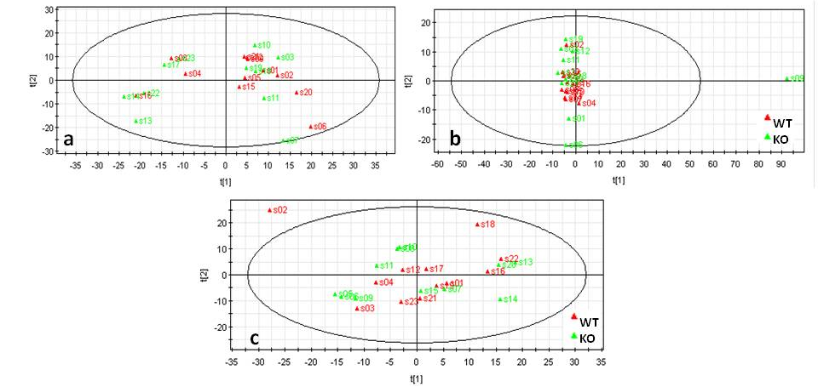
(hippocampus) and 13 (cerebellum) proteins found to be altered by more than 10% were (supplementary table S3). The main protein changes in the synaptosome fractions are involved in synaptic signalling, neurotransmission, synaptic vesicles and neuron development (supplementary table S4).
Supplementary figure S1a. Principal component analysis (PCA) of brain tissue. Each point represents one sample. In mouse frontal cortex (a), no outliers were detected. Hippocampus (b) and cerebellum (c) showed one sample that lay outside the 95 per cent confidence interval (ellipse)(hippocampus: s09; cerebellum: s02). Outliers were excluded from further analysis.

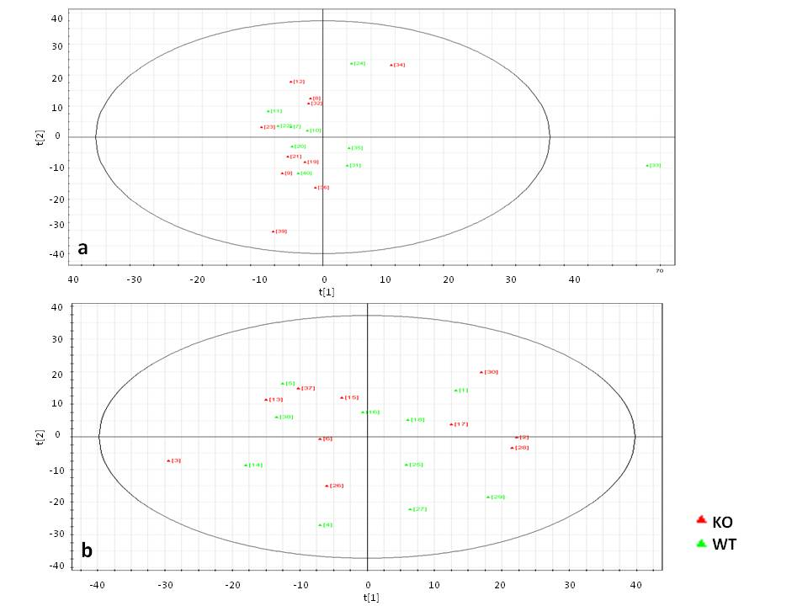
Supplementary figure S1b. Principal component analysis (PCA) of synaptosome fractions. Each point represents one sample. In the mouse synaptosomes, one outlier was detected in the hippocampus (d) (s33) and none in the cerebellum (e). Outliers were excluded from further analysis.

Supplementary table S1. Analysis of protein levels in mouse brain tissue of Fmr1 KO and WT

Protein name | No. of peptides | ratio Fmr1 KO/WT | p-value | biological function
Frontal cortex
Creatine kinase B (KCRB) | 31 | 0.90 | 0.0012 | creatine kinase
Sarcoplasmic endoplasmic reticulum calcium ATPase 2 (AT2A2) | 4 | 0.84 | 0.0059 | ATPase
L-lactate dehydrogenase B chain (LDHB) | 32 | 0.92 | 0.0063 | glycolysis
Tubulin beta-2A chain (TBB2A) | 16 | 0.93 | 0.0080 | tubulin
Sodium/potassium-transporting ATPase subunit beta-1 (AT1B1) | 20 | 0.93 | 0.0102 | ATPase
Fructose-bisphosphate aldolase A (ALDOA) | 29 | 0.92 | 0.0103 | glycolysis
Ubiquitin 60S ribosomal L40 (RL40) | 13 | 0.87 | 0.0104 | translation
Lysine-specific histone demethylase 1A (KDM1A) | 2 | 0.86 | 0.0109 | transcription
Cytochrome c oxidase 5A (COX5A) | 5 | 0.73 | 0.0112 | mitochondrion
Ras related Rab 43 (RAB43) | 10 | 0.82 | 0.0115 | transport
Complex I intermediate-associated protein 30 (CIA30) | 4 | 0.82 | 0.0115 | mitochondrion
Tubulin alpha-4A chain (TBA4A) | 19 | 0.92 | 0.0123 | Tubulin
Calcium calmodulin dependent kinase II delta (KCC2D) | 8 | 0.87 | 0.0128 | calcium regulation
Succinate semialdehyde dehydrogenase (SSDH) | 2 | 1.16 | 0.0135 | neurotransmitter
Myelin basic protein (MBP) | 24 | 0.92 | 0.0163 | Myelin
Hippocalcin like 4 (HPCL4) | 3 | 0.74 | 0.0182 | rhodopsin
Cofilin 2 (COF2) | 6 | 0.75 | 0.0193 | cytoskeleton
Serine threonine kinase 4 (STK4) | 2 | 0.74 | 0.0194 | apoptosis
Destrin (DEST) | 5 | 0.75 | 0.0198 | actin regulation
Tubulin beta 1 (TBB1) | 11 | 0.88 | 0.0220 | Tubulin
Tubulin alpha 8 (TBA8) | 9 | 0.81 | 0.0248 | Tubulin
Clusterin-like 1 (CLUL1) | 2 | 0.76 | 0.0276 | apoptosis
Keratin, type II cytoskeletal 71 (K2C71) | 3 | 1.26 | 0.0284 | Keratin
14-3-3 protein theta (1433T) | 21 | 0.92 | 0.0296 | 14-3-3 protein
Neuromodulin (NEUM) | 8 | 1.17 | 0.0319 | connectivity
Septin-7 (SEPT7) | 9 | 1.07 | 0.0335 | cell cycle
Sodium/potassium-transporting ATPase subunit alpha-3 (AT1A3) | 56 | 0.95 | 0.0349 | ATPase
Heat shock 70kDa 4 (HSP74) | 5 | 1.20 | 0.0361 | heat shock protein
BAG family molecular chaperone regulator 3 (BAG3) | 3 | 0.85 | 0.0361 | apoptosis
Synaptogyrin 3 (SNG3) | 6 | 1.21 | 0.0365 | synaptic vesicle
14-3-3 protein epsilon (1433E) | 23 | 0.94 | 0.0406 | 14-3-3 protein
ATP synthase delta (ATPD) | 5 | 0.88 | 0.0411 | mitochondrion
Actin cytoplasmic 1 (ACTB) | 12 | 0.87 | 0.0414 | actin
Ras related Rab-3A (RAB3A) | 15 | 0.94 | 0.0435 | synaptic vesicles
Plasma membrane calcium-transporting ATPase 2 (AT2B2) | 32 | 0.93 | 0.0438 | ATPase
Stathmin (STMN1) | 4 | 1.07 | 0.0452 | neurogenesis
insulin-like growth factor-binding (ALS) | 2 | 0.74 | 0.0473 | cell adhesion
Hippocampus
FAD synthase (FAD1) | 2 | 0.68 | 0.0057 | FAD biosynthetic process
Protein argonaute-3 (AGO3) | 2 | 0.53 | 0.0074 | Translation
Visinin like protein 1 (VISL1) | 15 | 0.89 | 0.0077 | Rhodopsin
Glial fibrillary acidic protein (GFAP) | 28 | 1.08 | 0.0189 | cytoskeleton
Pyruvate kinase PKM (KPYM) | 54 | 0.94 | 0.0202 | Glycolysis
Macrophage migration inhibitory factor (MIF) | 3 | 0.78 | 0.0213 | inflammation
Testis-specific H1 histone | 4 | 0.91 | 0.0230 | Histone
ATP-dependent 6-phosphofructokinase, liver type (K6PL) | 2 | 0.78 | 0.0270 | glycolysis
Sodium/potassium-transporting ATPase subunit alpha-1 (AT1A1) | 48 | 0.96 | 0.0279 | ATPase
Voltage-dependent anion-selective channel protein 3 (VDAC3) | 8 | 1.06 | 0.0294 | mitochondrion
60S ribosomal protein L6 (RL6) | 6 | 1.31 | 0.0302 | ribosome
Beta-arrestin 1 (ARRB1) | 2 | 0.73 | 0.0306 | protein transport
Ubiquitin-like modifier-activating enzyme 1 (UBA1) | 25 | 0.93 | 0.0310 | Ubiquitin
Heat shock 70kDa protein 1-like (HS71L) | 28 | 0.94 | 0.0316 | heat shock protein
78 kDa glucose-regulated protein (GRP78) | 45 | 0.95 | 0.0335 | heat shock protein
Histone H1t (H1T) | 5 | 1.10 | 0.0340 | Histone
V type proton ATPase F (VATF) | 2 | 0.65 | 0.0359 | ATPase
Rho GTPase-activating 12 (RHG12) | 2 | 0.82 | 0.0390 | GTPase
BTB POZ domain containing protein KCTD12 (KCD12) | 3 | 1.13 | 0.0412 | neurotransmitter
L-lactate dehydrogenase B chain (LDHB) | 26 | 0.94 | 0.0435 | glycolysis
ATP-dependent 6-phosphofructokinase, platelet type (K6PP) | 5 | 0.86 | 0.0436 | glycolysis
Adenylate kinase isoenzyme 1 (KAD1) | 4 | 0.87 | 0.0444 | Energy
Heat shock-related 70kDa protein 2 (HSP72) | 48 | 1.03 | 0.0445 | heat shock protein
Myomesin-1 (MYOM1) | 3 | 0.87 | 0.0487 | cytoskeleton
Vesicular glutamate transporter 1 (VGLU1) | 3 | 1.10 | 0.0496 | neurotransmitter
Cerebellum
Sodium potassium transporting ATPase beta 2 (AT1B2) | 3 | 1.23 | 0.0052 | ATPase
Ras related Rab 8B (RAB8B) | 3 | 1.49 | 0.0078 | Synapse
Histone H2B type 1-F/J/L (H2B1F) | 4 | 0.91 | 0.0117 | Histone
Hexokinase-1 (HXK1) | 32 | 0.93 | 0.0136 | glycolysis
Histone H2B type 1-P (H2B1P) | 2 | 0.91 | 0.0186 | Histone
Guanine nucleotide binding G t alpha 3 (GNAT3) | 2 | 1.46 | 0.0193 | signalling
Cysteine and glycine-rich 1 (CSRP1) | 3 | 1.19 | 0.0195 | cytoskeleton
Microtubule-associated protein tau (TAU) | 5 | 0.91 | 0.0198 | cytoskeleton
14-3-3 protein epsilon (1433E) | 21 | 0.93 | 0.0214 | 14-3-3 protein
Tripartite motif-containing 45 (TRI45) | 2 | 0.75 | 0.0350 | transcription
IQ calmodulin-binding motif-containing 1 (IQCB1) | 2 | 1.23 | 0.0386 | cytoskeleton
Putative adenosylhomocysteinase 2 (SAHH2) | 9 | 1.17 | 0.0387 | one-carbon metabolism
NADH dehydrogenase ubiquinone 1 alpha 10 (NDUAA) | 5 | 0.84 | 0.0393 | mitochondrion
Heat shock cognate 71 kDa protein (HSP7C) | 31 | 1.05 | 0.0400 | heat shock protein
Acyl-CoA-binding protein (ACBP) | 6 | 0.91 | 0.0407 | neurotransmitter
Excitatory amino acid transporter 1 (EAA1) | 9 | 0.81 | 0.0424 | neurotransmitter
Hippocalcin like 1 (HPCL1) | 3 | 0.81 | 0.0427 | rhodopsin
Cytochrome c oxidase 6B1 (CX6B1) | 5 | 1.14 | 0.0470 | mitochondrion
The table includes Uniprot ID, ratios (calculated based on average), and P values. Adjusted P values for the brain areas were respectively 0.4172 (FC), 0.9296 (HC), and 0.8302 (CB).

Supplementary table S2. Proteins changed significantly in expression level using LC-MS^{E} on mouse frontal cortex (FC), hippocampus (HC) and cerebellum (CB)
protein name | brain area | No. of peptides | ratio Fmr1 KO/WT | p-value
synaptic proteins
Excitatory amino acid transporter 1 (EAA1) | CB | 9 | 0.81 | 0.0424
Vesicular glutamate transporter 1 (VGLU1) | HC | 3 | 1.1 | 0.0496
BTB POZ domain containing protein KCTD12 (KCD12) | HC | 3 | 1.13 | 0.0412
Succinate semialdehyde dehydrogenase (SSDH) | FC | 2 | 1.16 | 0.0135
Neuromodulin (NEUM) | FC | 8 | 1.17 | 0.0319
Cysteine and glycine-rich 1 (CSRP1) | CB | 3 | 1.19 | 0.0195
Synaptogyrin 3 (SNG3) | FC | 6 | 1.21 | 0.0365
Guanine nucleotide binding G t alpha 3 (GNAT3) | CB | 2 | 1.46 | 0.0193
Ras related Rab 8B (RAB8B) | CB | 3 | 1.49 | 0.0078
ATPase
V type proton ATPase F (VATF) | HC | 2 | 0.65 | 0.0359
Sarcoplasmic endoplasmic reticulum calcium ATPase 2 (AT2A2) | FC | 4 | 0.84 | 0.0059
Sodium potassium transporting ATPase beta 2 (AT1B2) | CB | 3 | 1.23 | 0.0052
transcription
Tripartite motif-containing 45 (TRI45) | CB | 2 | 0.75 | 0.035
lysine-specific histone demethylase 1A (KDM1A) | FC | 2 | 0.86 | 0.0109
histone H1t (H1T) | HC | 5 | 1.1 | 0.034
translation
Protein argonaute-3 (AGO3) | HC | 2 | 0.53 | 0.0074
Ubiquitin 60S ribosomal L40 (RL40) | FC | 13 | 0.87 | 0.0104
60S ribosomal protein L6 (RL6) | HC | 6 | 1.31 | 0.0302
transport
beta-arrestin 1 (ARRB1) | HC | 2 | 0.73 | 0.0306
Ras related Rab 43 (RAB43) | FC | 10 | 0.82 | 0.0115
rhodopsin regulation
Hippocalcin like 4 (HPCL4) | FC | 3 | 0.74 | 0.0182
Hippocalcin like 1 (HPCL1) | CB | 3 | 0.81 | 0.0427
Visinin like protein 1 (VISL1) | HC | 15 | 0.89 | 0.0077
Mitochondrial/metabolic proteins
Cytochrome c oxidase 5A (COX5A) | FC | 5 | 0.73 | 0.0112
6 phosphofructokinase liver (K6PL) | HC | 2 | 0.78 | 0.027
complex I intermediate-associated 30 (CIA30) | FC | 4 | 0.82 | 0.0115
NADH dehydrogenase ubiquinone 1 alpha 10 (NDUAA) | CB | 5 | 0.84 | 0.0393
6 phosphofructokinase (K6PP) | HC | 5 | 0.86 | 0.0436
ATP synthase delta (ATPD) | FC | 5 | 0.88 | 0.0411
Cytochrome c oxidase 6B1 (CX6B1) | CB | 5 | 1.14 | 0.047
The table includes Uniprot ID, ratios (calculated based on average), and P values. Adjusted P values for the brain areas were respectively 0.4172 (FC), 0.9296 (HC), and 0.8302 (CB). Significant proteins with an increase/decrease greater than 10% are depicted here. FC = frontal cortex; HC = hippocampus; CB = cerebellum

Supplementary table S3. Analysis of protein levels in mouse brain synaptosome fractions of Fmr1 KO and WT
protein name | No. of peptides | ratio Fmr1 KO/WT | p-value
Hippocampus
NADH dehydrogenase ubiquinone flavoprotein 1 (NDUV1) | 32 | 0.89 | 0.0006
Uridine 5 monophosphate synthase (UMPS) | 2 | 0.82 | 0.0010
Septin 10 (SEP10) | 5 | 0.57 | 0.0011
Guanine nucleotide binding protein G i alpha 1 (GNAI1) | 21 | 0.90 | 0.0016
Calmodulin protein 3 (CALL3) | 10 | 1.18 | 0.0034
cytoplasmic FMR1-interacting protein 2 (CYFP2) | 19 | 1.08 | 0.0051
Septin 11 (SEP11) | 27 | 1.06 | 0.0066
Glucose-induced degradation 8 homolog (GID8) | 2 | 1.11 | 0.0074
Guanine nucleotide binding protein G s alpha Xlas (GNAS1) | 10 | 1.12 | 0.0104
Estradiol 17 beta dehydrogenase 8 (DHB8) | 2 | 0.78 | 0.0113
Neutral amino acid transporter A (SATT) | 3 | 1.10 | 0.0116
Tetraspanin 7 (TSN7) | 2 | 1.13 | 0.0139
V-type proton ATPase subunit C 1 (VATC1) | 32 | 1.05 | 0.0143
Tyrosine phosphatase non receptor substrate 1 (SHPS1) | 22 | 0.89 | 0.0148
Leucine-rich repeat-containing 8D (LRC8D) | 2 | 1.35 | 0.0149
Peroxiredoxin-6 (PRDX6) | 27 | 0.93 | 0.0184
Glutamate decarboxylase 1 (DCE1) | 6 | 1.12 | 0.0187
Hippocalcin like 1 (HPCL1) | 6 | 0.88 | 0.0193
Pikachurin (EGFLA) | 2 | 0.89 | 0.0203
Dihydrolipoyllysine succinyltransferase component (ODO2) | 16 | 0.85 | 0.0207
Homeobox protein Hox C9 (HXC9) | 2 | 1.13 | 0.0244
Neuronal-specific septin 3 (SEPT3) | 26 | 1.07 | 0.0253
Cofilin-1 (COF1) | 23 | 1.04 | 0.0269
ATP synthase subunit beta, mitochondrial (ATPB) | 50 | 0.93 | 0.0282
Glutamate receptor 4 (GRIA4) | 3 | 1.19 | 0.0288
Bicaudal D related protein 2 (BICR2) | 3 | 1.14 | 0.0295
26S protease regulatory subunit 8 (PRS8) | 3 | 0.69 | 0.0340
Neuron specific calcium binding hippocalcin (HPCA) | 16 | 0.90 | 0.0343
Heat shock 70 kDa protein 1A (HS71A) | 34 | 0.95 | 0.0364
NADH dehydrogenase [ubiquinone] 1 alpha subcomplex subunit 10, mitochondrial (NDUAA) | 28 | 0.91 | 0.0377
Meiosis-specific with OB domain-containing (MEIOB) | 3 | 0.85 | 0.0379
Intercellular adhesion molecule 5 (ICAM5) | 34 | 0.92 | 0.0390
Rho GTPase activating protein 1 (RHG01) | 2 | 1.16 | 0.0466
Immunoglobulin superfamily member 8 (IGSF8) | 15 | 0.94 | 0.0467
Cerebellum
Neuronal growth regulator 1 (NEGR1) | 12 | 1.07 | 0.0038
Ribonuclease UK114 (UK114) | 7 | 0.92 | 0.0047
Heat shock 70 kDa 1A (HS71A) | 21 | 1.12 | 0.0048
Glycerol 3 phosphate dehydrogenase NAD cytoplasmic (GPDA) | 34 | 0.95 | 0.0049
Serine threonine protein phosphatase 2A 65 kDa regulatory subunit A alpha isoform (2AAA) | 23 | 0.92 | 0.0062
Myristoylated alanine rich C kinase substrate (MARCS) | 16 | 0.91 | 0.0085
Transitional endoplasmic reticulum ATPase (TERA) | 33 | 0.92 | 0.0093
Pyruvate kinase isozymes (KPYM) | 53 | 0.96 | 0.0099
Plakophilin-1 (PKP1) | 3 | 0.89 | 0.0109
Ras related Rab 3C (RAB3C) | 20 | 0.88 | 0.0119
Ras related protein Rab 3D (RAB3D) | 15 | 0.93 | 0.0120
Synaptic vesicle glycoprotein 2B (SV2B) | 8 | 0.87 | 0.0124
6 phosphofructokinase muscle type (K6PF) | 52 | 0.94 | 0.0154
cAMP dependent protein kinase type II alpha regulatory subunit (KAP2) | 5 | 1.08 | 0.0201
F actin capping protein alpha 2 (CAZA2) | 3 | 0.90 | 0.0209
ADP ribosylation factor 4 (ARF4) | 7 | 1.06 | 0.0213
Nucleoside diphosphate kinase B (NDKB) | 3 | 0.92 | 0.0219
Profilin 1 (PROF1) | 5 | 0.91 | 0.0223
L-asparaginase (ASGL1) | 10 | 0.93 | 0.0263
Homeobox protein Hox A9 (HXA9) | 2 | 0.82 | 0.0273
Adenosine deaminase-like (ADAL) | 2 | 0.87 | 0.0275
Guanine nucleotide binding protein Gi Gs Gt subunit beta 2 (GBB2) | 15 | 1.06 | 0.0296
Myosin regulatory light chain 2 (MLRV) | 2 | 0.83 | 0.0319
Guanine nucleotide binding protein G t subunit alpha 2 (GNAT2) | 12 | 0.93 | 0.0325
Cytosolic 10 formyltetrahydrofolate dehydrogenase (AL1L1) | 25 | 0.95 | 0.0352
Guanine nucleotide binding G I G S G T beta 3 (GBB3) | 12 | 0.90 | 0.0353
Sulfated glycoprotein 1 (SAP) | 8 | 0.72 | 0.0369
Sarcoplasmic endoplasmic reticulum calcium ATPase 2 (AT2A2) | 55 | 0.97 | 0.0371
Tropomodulin-2 (TMOD2) | 4 | 0.90 | 0.0400
Protein SERAC1 (SRAC1) | 4 | 0.88 | 0.0414
BSD domain-containing 1 (BSDC1) | 3 | 0.86 | 0.0432
NADH ubiquinone oxidoreductase chain 4 (NU4M) | 8 | 1.10 | 0.0435
Dihydropyrimidinase related protein 4 (DPYL4) | 17 | 1.06 | 0.0486
The table includes Uniprot ID, ratios (calculated based on average), and P values. Adjusted P values for the brain areas were respectively 0.95318 (HC) and 0.91602 (CB).

Supplementary table S4. Proteins significantly changed in expression level using LC-MS^{E} with mouse brain synaptosome fractions from the hippocampus (HC) and cerebellum (CB)
protein name | synaptosome fraction | No. of peptides | ratio Fmr1 KO/WT | p-value
cell signalling
Guanine nucleotide binding protein Gi alpha 1 (GNAI1) | HC | 21 | 0.90 | 0.0016
Guanine nucleotide binding protein Gs alpha Xlas (GNAS1) | HC | 10 | 1.12 | 0.0104
Leucine-rich repeat-containing 8D (LRC8D) | HC | 2 | 1.35 | 0.0149
Rho GTPase activating protein 1 (RHG01) | HC | 2 | 1.16 | 0.0466
Guanine nucleotide binding G(I)/G(S)/G(T) beta-3 (GBB3) | CB | 12 | 0.90 | 0.0353
Hippocalcin like 1 (HPCL1) | HC | 6 | 0.88 | 0.0193
Sulfated glycoprotein 1 (SAP) | CB | 8 | 0.72 | 0.0369
synaptic signalling
Glutamate decarboxylase 1 (DCE1) | HC | 6 | 1.12 | 0.0187
Glutamate receptor 4 (GRIA4) | HC | 3 | 1.19 | 0.0288
Ras related Rab 3C (RAB3C) | CB | 20 | 0.88 | 0.0119
Synaptic vesicle glycoprotein 2B (SV2B) | CB | 8 | 0.87 | 0.0124
connectivity
Tyrosine phosphatase non receptor substrate 1 (SHPS1) | HC | 22 | 0.89 | 0.0148
Plakophilin-1 (PKP1) | CB | 3 | 0.89 | 0.0109
neuron development
Septin 10 (SEP10) | HC | 5 | 0.57 | 0.0011
Tetraspanin 7 (TSN7) | HC | 2 | 1.13 | 0.0139
Pikachurin (EGFLA) | HC | 2 | 0.89 | 0.0203
Meiosis-specific with OB domain-containing (MEIOB) | HC | 3 | 0.85 | 0.0379
mitochondrial/metabolic proteins
NADH dehydrogenase ubiquinone flavoprotein 1 (NDUV1) | HC | 32 | 0.89 | 0.0006
Estradiol 17 beta dehydrogenase 8 (DHB8) | HC | 2 | 0.78 | 0.0113
Dihydrolipoyllysine succinyltransferase component (ODO2) | HC | 16 | 0.85 | 0.0207
Protein SERAC1 (SRAC1) | CB | 4 | 0.88 | 0.0414
NADH ubiquinone oxidoreductase chain 4 (NU4M) | CB | 8 | 1.10 | 0.0435
transcription
Uridine 5 monophosphate synthase (UMPS) | HC | 2 | 0.82 | 0.0010
Homeobox protein Hox C9 (HXC9) | HC | 2 | 1.13 | 0.0244
26S protease regulatory subunit 8 (PRS8) | HC | 3 | 0.69 | 0.0340
Homeobox protein Hox A9 (HXA9) | CB | 2 | 0.82 | 0.0273
Adenosine deaminase-like (ADAL) | CB | 2 | 0.87 | 0.0275
The table includes Uniprot ID, ratios (calculated based on average), and P values. Adjusted P values for the synaptic fractions were respectively 0.9532 (HC) and 0.9960 (CB). Significant proteins with an increase/decrease greater than 10% are depicted here. HC = hippocampus; CB = cerebellum

GO-enrichment analysis
GO-enrichment analysis was performed to identify altered networks in brain tissue and synaptosome fractions of the Fmr1 KO mouse model using all significantly changed proteins with a ratio Fmr1 KO/WT of >10%. Protein-Protein Interaction (PPI) networks were constructed from the significantly changed proteins by finding first-degree interacting neighbours across 3 databases: MINT, IntAct and Uniprot. Enrichment was computed on each network using the ClueGO package in Cytoscape[4]. Proteins were annotated according to the Mus Musculus gene ontology database (ontology: Biological Process), which creates a functionally organized GO-pathway term network. A two-sided hypergeometric distribution was used to compute the statistical significance of each GO annotation, describing the probabilities associated with sampling randomly without replacement from a finite network of proteins where all proteins have an equal chance of being drawn. Only GO terms with a significant q value (q <0.05, Benjamini-Hochberg test) were taken forward. Subsequently, fuzzy heuristic partitioning was used to enhance the biological interpretation of the pathways[5] and a diffusion-type manifold embedding technique was used to emphasize short range interactions between GO terms[6]. For each GO term of interest, similar terms were represented by positive distances while dissimilar terms were represented by negative distances. This allowed functional groups of similar terms to be created for each tissue sample (supplementary table S5) and synaptosome (supplementary table S6). The functional correlation between synaptosomes and tissue was examined by constructing a heatmap showing the percentage overlap of GO terms between the functional groups (supplementary figure S2).

Supplementary table S5. GO term enrichment of mouse brain tissue of Fmr1 KO and WT
GO terms | q-value | proteins | significant protein (1), neighbour (0)
Frontal cortex
protein polymerization | 1.49*10⁻⁹ | Micall2, Pfn1, Pfn2, Prkce, Sept2, Tmod3, Tuba1a, Tuba8, Tubb4b, Tubb5 | 1
actin polymerization or depolymerization | 5.86*10⁻⁸ | Cfl2, Dstn, Micall2, Pfn1, Pfn2, Plekhh2, Prkce, Tmod3 | 1
regulation of actin filament depolymerization | 4.11*10⁻⁵ | Cfl2, Dstn, Plekhh2, Tmod3 | 1
cellular potassium ion homeostasis | 0.0002 | Camk2d, Kcnma1 | 1
negative regulation of histone H3-K4 methylation | 0.0002 | Gfi1b, Kdm1a | 1
regulation of cell projection assembly | 0.0002 | Espn, Gap43, Pfn1, Pfn2 | 1
positive regulation of actin filament depolymerization | 0.0004 | Cfl2, Dstn | 1
regulation of histone H3-K9 methylation | 0.0007 | Gfi1b, Kdm1a | 1
regulation of neural precursor cell proliferation | 0.0015 | Kdm1a, Kdm2b, Lrrk2 | 1
histone demethylation | 0.0025 | Kdm1a, Kdm2b | 1
positive regulation of Ras protein signal transduction | 0.0033 | Camk2d, Csf1 | 1
regulation of filopodium assembly | 0.0036 | Espn, Gap43 | 1
negative regulation of cytoskeleton organization | 4.71*10⁻⁵ | Espn, Pfn1, Pfn2, Plekhh2, Tmod3 | 0
dendrite morphogenesis | 5.32*10⁻⁵ | Dlg4, Grin1, Ilk, Lrrk2, Ywhah | 0
exploration behavior | 6.83*10⁻⁵ | Dlg4, Lrrk2, Prkce | 0
actin filament polymerization | 7.52*10⁻⁵ | Micall2, Pfn1, Pfn2, Prkce, Tmod3 | 0
negative regulation of protein dephosphorylation | 0.0002 | Ywhab, Ywhae | 0
regulation of long-term neuronal synaptic plasticity | 0.0003 | Dlg4, Grin1, Grin2b | 0
membrane depolarization | 0.0003 | Dlg4, Grin1, Grin2b, Ywhah | 0
negative regulation of actin filament polymerization | 0.0004 | Pfn1, Pfn2, Tmod3 | 0
response to ammonium ion | 0.0004 | Dlg4, Grin1, Prkce | 0
lateral ventricle development | 0.0004 | Kdm2b, Rpgrip1l | 0
histone H2A monoubiquitination | 0.0004 | Kdm2b, Rnf2 | 0
endodermal cell fate specification | 0.0005 | Nanog, Pou5f1 | 0
regulation of ruffle assembly | 0.0007 | Pfn1, Pfn2 | 0
positive regulation of actin filament polymerization | 0.0007 | Pfn1, Pfn2, Prkce | 0
determination of adult lifespan | 0.0011 | Lrrk2, Tfcp2l1 | 0
regulation of cell-matrix adhesion | 0.0012 | Cask, Csf1, Ilk | 0
glutamate receptor signaling pathway | 0.0012 | Dlg4, Grin1, Grin2b | 0
mesodermal cell fate commitment | 0.0017 | Nanog, Pou5f1 | 0
regulation of cell fate specification | 0.0018 | Nanog, Pou5f1 | 0
dendritic spine morphogenesis | 0.0028 | Dlg4, Lrrk2 | 0
negative regulation of actin filament depolymerization | 0.0037 | Plekhh2, Tmod3 | 0
positive regulation of stress fiber assembly | 0.0037 | Pfn1, Pfn2 | 0
olfactory bulb development | 0.0053 | Lrrk2, Rpgrip1l | 0
Hippocampus
negative regulation of cell cycle arrest | 2.58*10⁻⁶ | Cdk9, Mdm2, Mif | 1
negative regulation of DNA damage response, signal transduction by p53 class mediator | 0.0001 | Mdm2, Mif | 1
ATP hydrolysis coupled proton transport | 0.0005 | Atp6v1a, Atp6v1f | 1
positive regulation of Ras protein signal transduction | 0.0005 | Arrb1, Csf1 | 1
negative regulation of protein dephosphorylation | 4.10*10⁻⁵ | Ywhab, Ywhae | 0
intermediate filament organization | 0.0005 | Dnajb6, Vim | 0
Cerebellum
ATP catabolic process | 2.31*10⁻⁵ | Atp1b2, Atp2a2, Atp5a1, Hsp90aa1, Hspa8, Myh10, Myh9, Myo1c | 1
neuromuscular process controlling balance | 6.58*10⁻⁵ | Dlg4, Hexa, Kcnma1, Myh10, Slc1a3 | 1
glutamate biosynthetic process | 0.0007 | Glud1, Slc1a3 | 1
mitochondrial transport | 0.0008 | Acaa2, Hsp90aa1, Hspa4, Slc1a3, Ywhaz | 1
protein folding | 4.50*10⁻⁷ | Cct3, Cct6a, Dnaja1, Dnaja3, Hsp90aa1, Hsp90ab1, Hspa8, Hspa9, Hsph1 | 0
negative regulation of protein dephosphorylation | 0.0007 | Ywhab, Ywhae | 0
cellular response to interleukin-4 | 0.0007 | Hsp90ab1, Hspa5, Tuba1b | 0
positive regulation of cell migration by vascular endothelial growth factor signalling pathway | 0.0008 | Hspb1, Myo1c | 0
cell junction assembly | 0.0008 | Actn4, Epb4.1l5, Jup, Myo1c, Plec | 0
response to unfolded protein | 0.0008 | Hsp90aa1, Hspa5, Hspb1, Hsph1 | 0
protein targeting to mitochondrion | 0.0011 | Hsp90aa1, Hspa4, Ywhaz | 0
lateral ventricle development | 0.0012 | Myh10, Rpgrip1l | 0
cell-cell junction assembly | 0.0026 | Actn4, Jup, Myo1c | 0
negative regulation of inflammatory response to antigenic stimulus | 0.0026 | Psma1, Psmb4 | 0
iron-sulfur cluster assembly | 0.0026 | Ciao1, Mms19 | 0
positive regulation of protein import into nucleus, translocation | 0.0026 | Hsp90aa1, Hsp90ab1 | 0
chaperone mediated protein folding requiring cofactor | 0.0033 | Hspa8, Hsph1 | 0
mitochondrial membrane organization | 0.0057 | Acaa2, Hsp90aa1, Hspa4 | 0
cerebellum development | 0.0065 | Hspa5, Myh10, Rpgrip1l | 0
cerebellar Purkinje cell layer development | 0.0085 | Hspa5, Myh10 | 0
vesicle docking | 0.0092 | Exoc4, Exoc5 | 0
Golgi to plasma membrane transport | 0.0112 | Arfgef2, Sptbn1 | 0
binding of sperm to zona pellucida | 0.0119 | Cct3, Cct6a | 0
regulation of cell junction assembly | 0.0139 | Epb4.1l5, Myo1c | 0
Enriched networks indicated with "1" are pathways including at least one significant protein, "0" indicates the nearest neighbour using the selected significant proteins

Supplementary table S6. GO term enrichment of mouse hippocampus and cerebellum synaptosome fraction
GO Terms | q-value | proteins | significant protein (1), neighbour (0)
Hippocampus
negative regulation of protein dephosphorylation | 1.86*10⁻⁵ | Ywhab, Ywhae | 0
glutamate receptor signalling pathway | 3.37*10⁻⁵ | Dlg4, Gria2, Gria4 | 1
Cerebellum
exploration behaviour | 1.53*10⁻⁶ | Dlg4, Lrrk2, Prkce | 0
negative regulation of protein dephosphorylation | 1.28*10⁻⁵ | Ywhab, Ywhae | 0
dendritic spine morphogenesis | 0.0003 | Dlg4, Lrrk2 | 0
positive regulation of proteasomal ubiquitin-dependent protein catabolic process | 0.0006 | Lrrk2, Vcp | 0
Enriched networks indicated with "1" are pathways including at least one significant protein, "0" indicates the nearest neighbour using the selected significant proteins

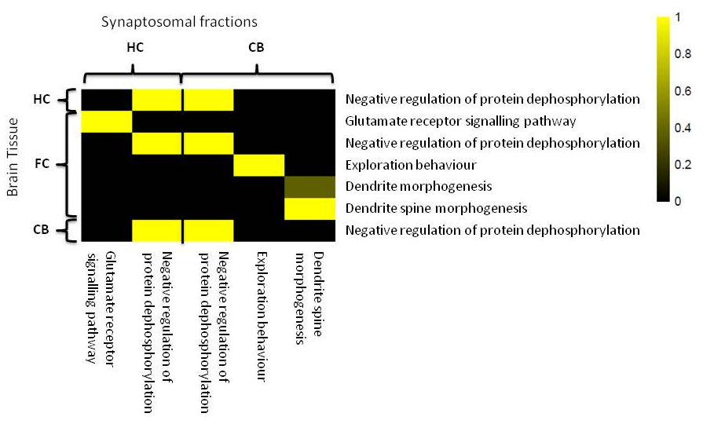
Supplementary figure S2. Overlapping significant GO-enriched networks between Fmr1 KO mouse brain tissue and synaptosome fractions. The gradual change in yellow colour indicates the ratio of overlap between the identified networks. Negative regulation of protein dephosphorylation was indicated in all studies. Other overlapping networks are involved in synaptic signalling and exploration behaviour.

Primary hippocampal and cerebellar neuron culture
To study synaptic vesicle dynamics in live cell imaging, primary hippocampal and cerebellar neurons were cultured. The dissected mouse brains were placed in ice cold Hank’s Balanced Salt Solution (HBSS, Life Technologies). After dissection, the hippocampi and cerebella were dissociated as discussed in [7] using papain and mechanical treatment for 30 minutes at 34 degrees. The neurons were extracted in a stepwise manner by first adding HBSS (8mL) and 10% fetal bovine serum (2mL, FBS, Life Technologies), which is followed by centrifugation for 4 minutes at 200G. The supernatant is supplemented with HBSS (5mL), MgSO4 (4mM) and DNase (10μL, Roche), and the cells are dissociated using Nylon Net Filters (180μm NY8H, Merck Millipore Ltd.). Removing of DNase occurred by washing with HBSS and centrifugation for 2x4 minutes at 200 G. Respective media were as follows: cerebella: Primary Neuron Basal Medium (PNBM, 50mL, Lonza), insulin (20μg/mL), Gentamicin 2000x (5μg/mL, Life Technologies), GlutaMAX (100x, Life Technologies), progesterone (40nM, Sigma), triiodo-L-Thyronine (0.5ng/mL, Sigma), albumin (100μg/mL), B-27 supplements (50x, Life Technologies), apo-transferin (200μg/mL, Sigma); hippocampi: Neurobasal medium (NB, 50mL, Life Technologies), Gentamicin 2000x (5μg/mL, Life Technologies), GlutaMAX (100x, Life Technologies), B-27 supplements (50x, Life Technologies). Per well in respective media with 10% FBS, a concentration of 5x10⁶ cells for cerebellum and 1x10⁶ for hippocampus were plated on ⌀19mm coverslips coated with poly-D-lysine (200μg/mL, Sigma). After 1.5 hour the medium+FBS was replaced with medium only. After 3 days in vitro, ara-C (2μM) was added to the cerebellum cells to inhibit glia growth.

Visualization of synaptic bouton activity with live cell imaging
This part of the supplementary information describes the detailed process of the visualization of synaptic bouton activity using live cell imaging. Visualization of synaptic bouton activity is based on the uptake and unloading of styryl FM1-43 dye (Molecular Probes, Life Technologies) by synaptic vesicles in the primary hippocampal or cerebellar neurons. The primary neurons were plated on coverslips and incubated for 10 minutes with pre-warmed low K⁺ medium (5mM KCl) and subsequently loaded with FM1-43 styryl dye (5μg/mL, Molecular Probes, Life Technologies) for 5 minutes in high-K⁺ medium (50mM KCl in 10mL respective medium) (Supplementary figure S3). To remove surface bound dye, the neurons were washed for 10 minutes with respective medium. Before stimulation of the synaptic boutons, baseline measurements were recorded for 100 seconds, which was followed by recordings of dye unloading kinetics via stimulation of the primary neurons with high-K⁺ medium. Live cell images were acquired of synaptic bouton activity using spinning-disk confocal microscopy (SDCM) technique based on a Nikon Eclipse Ti-E inverted microscope with a 40x 1.30 NA oil objective (Plan Fluor DIC, Nikon) connected to a Yokogawa dual spinning-disk confocal scanner unit (Yokogawa, CSU-X1) with a 630/75m bandpass emission filter (Chroma). FM1-43 was excited with a 491nm 50mW diode pumped solid state laser (Calypso, Cobolt), which caused emission at 566nm. Images were recorded with an EMCCD camera (QuantEM:512C, Photometrics) at a magnification of 164 nm/pixel. The microscope was equipped with a perfect focus system (Nikon). An incubation chamber (zylxs type INUG2, Tokai Hit) was used to keep the cells at 37°C and 5% CO₂ in a humidified environment. Timelapse imaging was performed for 20 minutes with 10 second intervals. The microscope setup was controlled by MetaMorph 7.7 software (Molecular Devices).
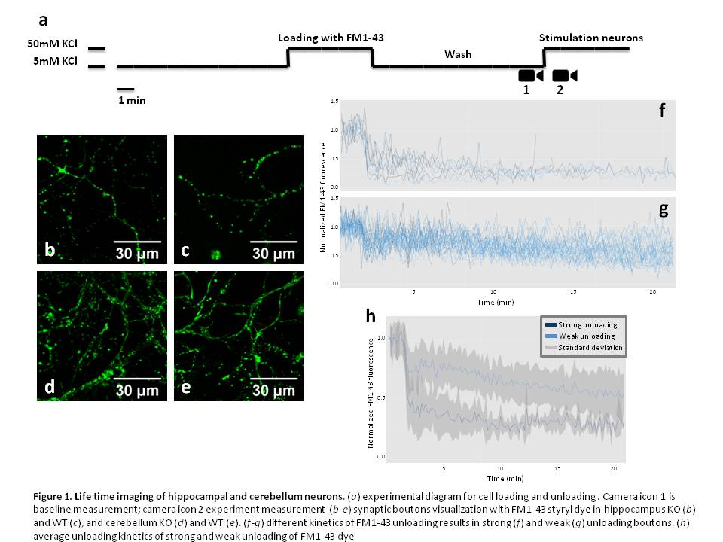
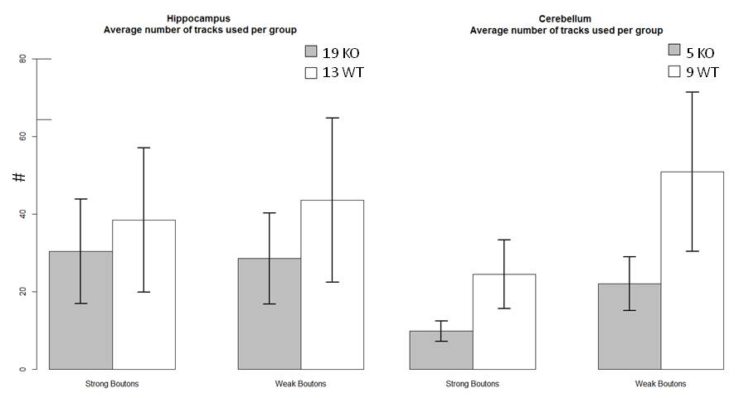
Supplementary figure S3. Live cell imaging of hippocampal and cerebellar neurons. (a) Experimental diagram for cell loading and unloading. Camera icon 1 depicts a representative baseline measurement; camera icon 2 a representative experimental measurement; (b-e) synaptic bouton visualization with FM1-43 styryl dye in hippocampus KO (b) and WT (c), and cerebellum KO (d) and WT (e). (f-g) different kinetics of FM1-43 unloading results in strong (f) and weak (g) unloading boutons. (h) Average unloading kinetics of strong and weak unloading of FM1-43 dye.

Supplementary figure S4. Average number of synaptic boutons for different unloading profiles. The number of functional boutons was compared between Fmr1 KO and WT for cerebellum and hippocampus. The number of hippocampal neurons investigated is greater than the number of cerebellar neurons, due to the difficulty of culturing cerebellar neurons. For both the strong and weak unloading boutons, no significant differences were found in hippocampus or cerebellum. Data represent the mean ± s.e.m.

Ultrastructure analysis using electron microscopy
This part describes the ultrastructural analysis performed using electron microscopy to investigate subcellular changes in synapses. Cerebellar tissue was obtained from Fmr1 KO mice, which were anesthetized (Nembutal, 50mg/kg) and subsequently perfused transcardially with 4% paraformaldehyde and 0.5% glutaraldehyde in cacodylate buffer. Further procedures were performed according to Hoebeek, 2008 [8]. The brains were cut into 80 μm thick coronal sections with a vibratome and calbindin immunocytochemistry was performed by incubating the sections with rabbit anti-calbindin antibody and diaminobenzidine for visualization of Purkinje cells. The sections were osmicated with 2% osmium in 8% glucose solution, dehydrated in dimethoxypropane and stained en block with 3% uranyl acetate/70% ethanol for 60 minutes and embedded in Araldite (Durcupan, Fluka, Germany). Ultrathin sections (70-90 nm) were cut using an Ultramicrotome (Leica, Germany), mounted on copper grids, and counterstained with uranyl acetate and lead citrate [8]. Purkinje cell terminals were recorded at magnifications x4900, x7000, x9800 and analyzed under the electron microscope (Philips, Eindhoven, the Netherlands). The digital electron micrographs were analyzed for total vesicle number, active zone (AZ) length, presynaptic area, and vesicle density (nm²) using Fiji, ImageJ v2.0.0[9]. The observer was blind to genotype during the procedure. The data were statistical analyzed using a t-test with permutations (AZ length, presynaptic area, and vesicle density) and correlation (density with AZ length) in R statistical programming language (version 3.1.1 [10]).

Supplemental References
1. Broek JA, Guest PC, Rahmoune H, Bahn S: Proteomic analysis of post mortem brain tissue from autism patients: evidence for opposite changes in prefrontal cortex and cerebellum in synaptic connectivity-related proteins. Mol Autism 2014, 5:41.
2. Wesseling H, Want EJ, Guest PC, Rahmoune H, Holmes E, Bahn S: Hippocampal proteomic and metabonomic abnormalities in neurotransmission, oxidative stress and apoptotic pathways in a chronic phencyclidine rat model. J Proteome Res 2015.
3. Krishnamurthy D, Harris LW, Levin Y, Koutroukides TA, Rahmoune H, Pietsch S, Vanattou-Saifoudine N, Leweke FM, Guest PC, Bahn S: Metabolic, hormonal and stress-related molecular changes in post-mortem pituitary glands from schizophrenia subjects. World J Biol Psychiatry 2013, 14:478-489.
4. Bindea G, Mlecnik B, Hackl H, Charoentong P, Tosolini M, Kirilovsky A, Fridman WH, Pages F, Trajanoski Z, Galon J: ClueGO: a Cytoscape plug-in to decipher functionally grouped gene ontology and pathway annotation networks. Bioinformatics 2009, 25:1091-1093.
5. Frohlich H, Speer N, Poustka A, Beissbarth T: GOSim--an R-package for computation of information theoretic GO similarities between terms and gene products. BMC Bioinformatics 2007, 8:166.
6. Lerman G, Shakhnovich BE: Defining functional distance using manifold embeddings of gene ontology annotations. Proc Natl Acad Sci U S A 2007, 104:11334-11339.
7. Tabata T, Sawada S, Araki K, Bono Y, Furuya S, Kano M: A reliable method for culture of dissociated mouse cerebellar cells enriched for Purkinje neurons. J Neurosci Methods 2000, 104:45-53.
8. Hoebeek FE, Khosrovani S, Witter L, De Zeeuw CI: Purkinje cell input to cerebellar nuclei in tottering: ultrastructure and physiology. Cerebellum 2008, 7:547-558.
9. Schindelin J, Arganda-Carreras I, Frise E, Kaynig V, Longair M, Pietzsch T, Preibisch S, Rueden C, Saalfeld S, Schmid B, et al: Fiji: an open-source platform for biological-image analysis. Nat Methods 2012, 9:676-682.
10. R ct: R: A language and environment for statistical computing. Vienna, Austria; 2013.

