Additional file 2. Data acquisiton rates of baseline assessments, by data modality.

- MRI
(a) by group
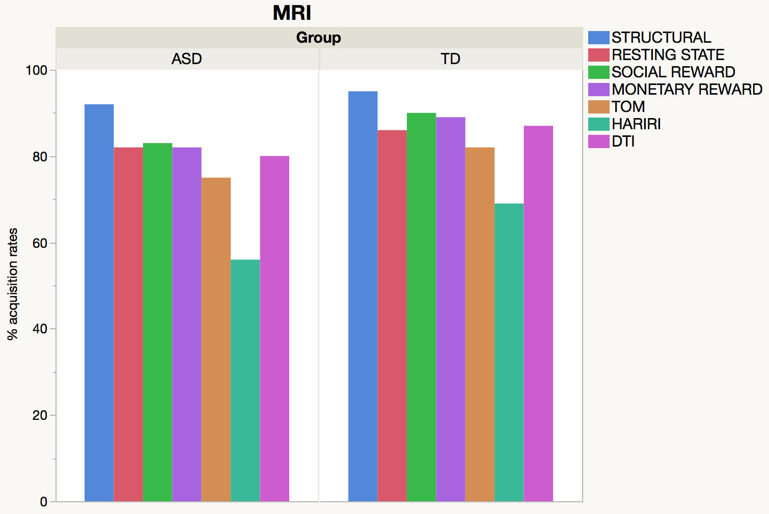

(b) by group and schedule
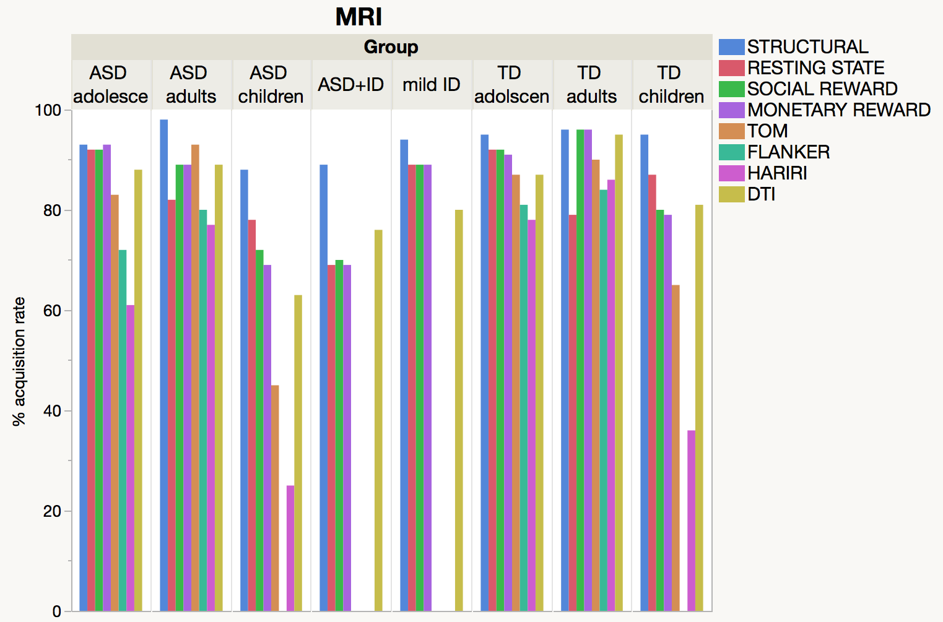

- EEG , Note: EEG was not acquired at UCAM

(a) by group

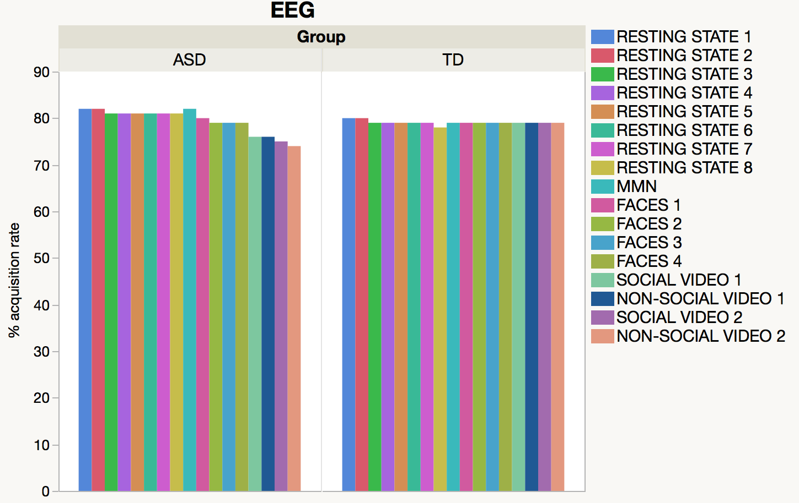
(b) by group and schedule
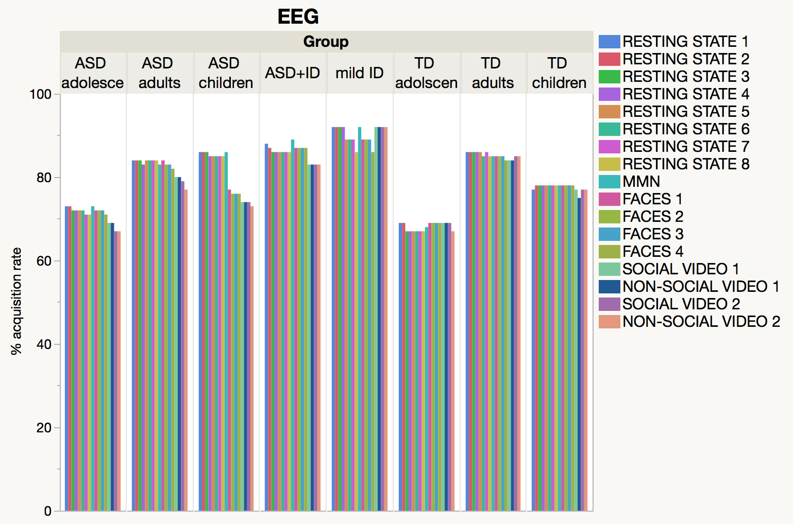

- Eye-tracking
Note: Different stimuli (e.g., static social scenes, dynamic social scenes, biological motion, face pop-out, gap overlap) were presented in sets

(a) by group
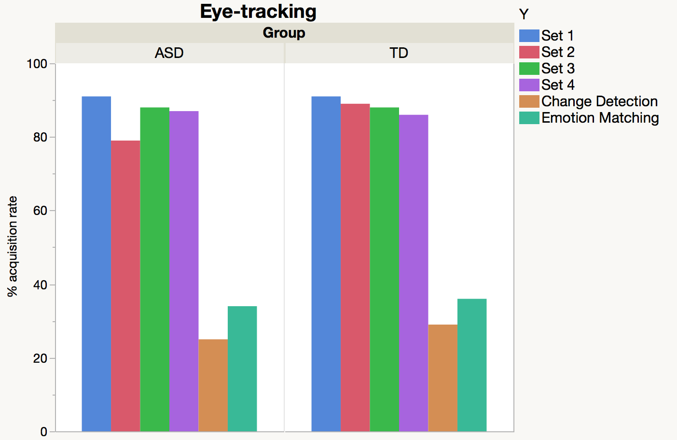

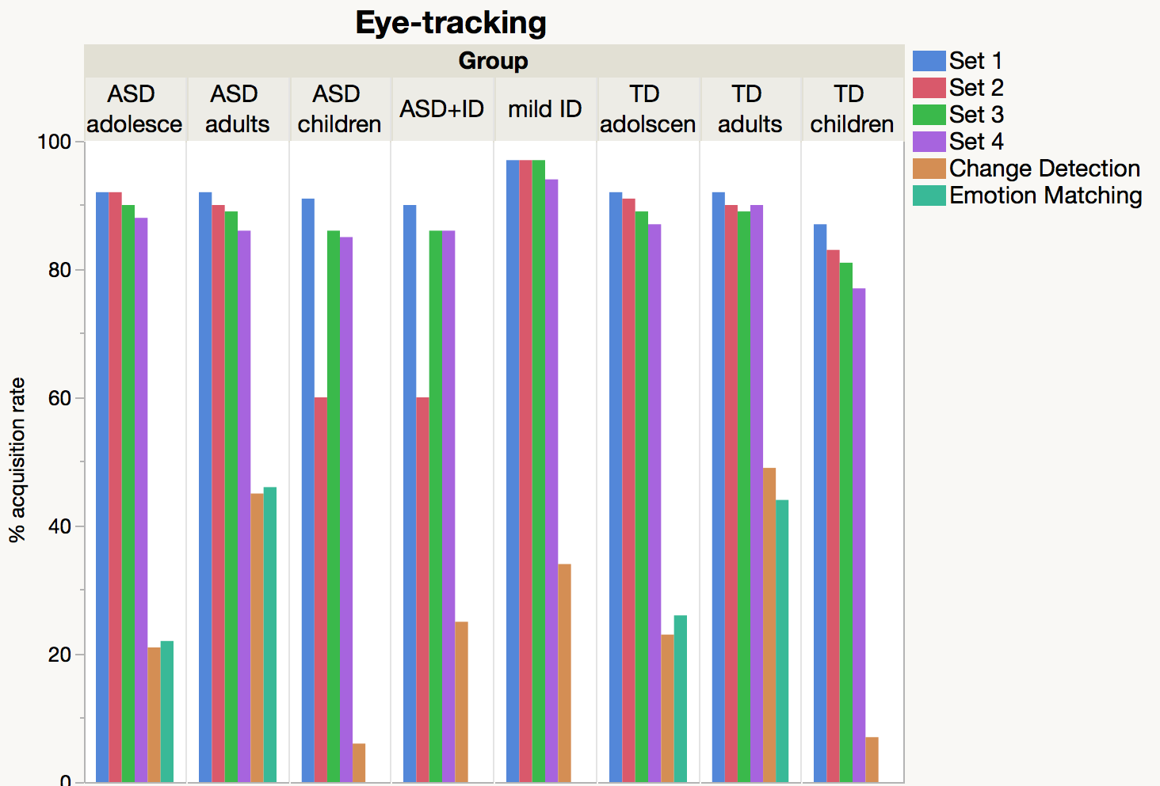

4. Cognition

(a) by group
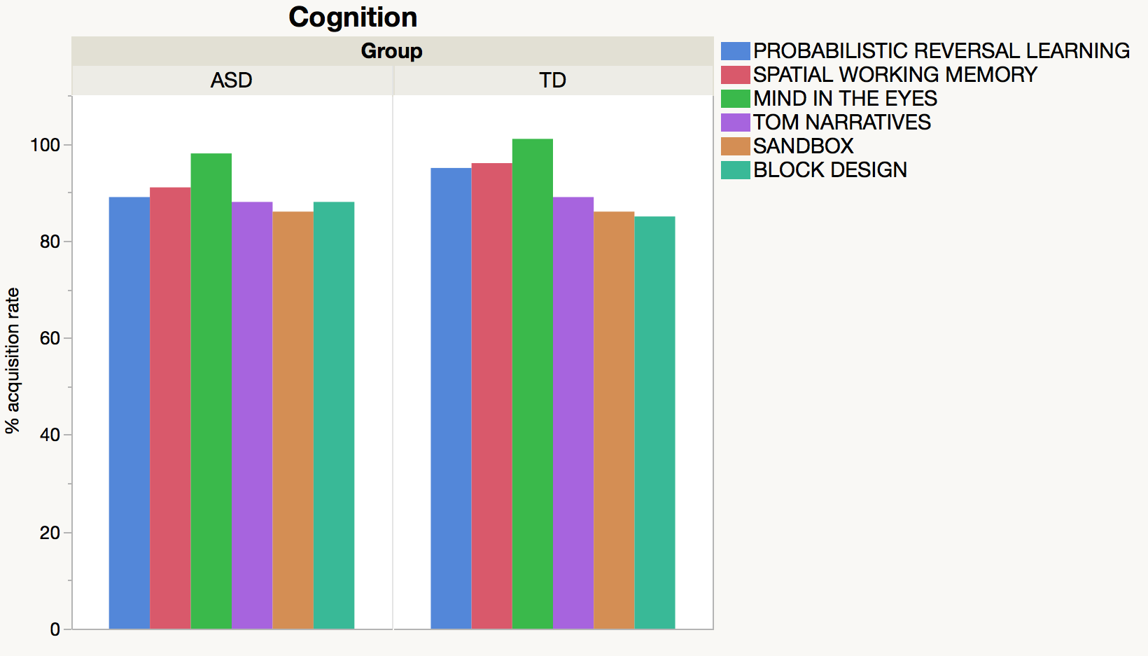

(b) by group and schedule
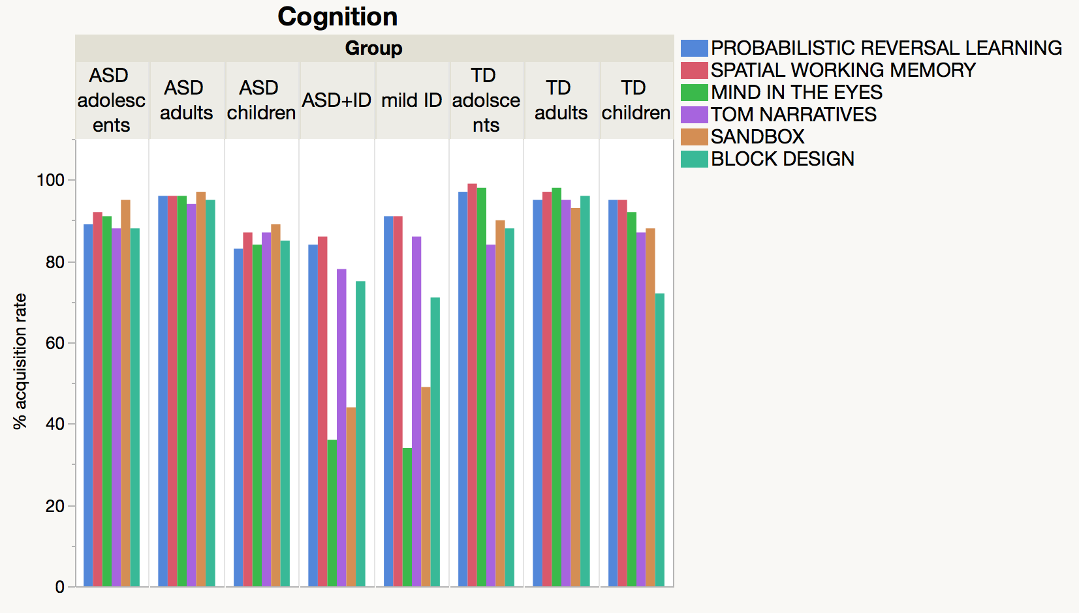

6. Biosamples
Blood and saliva sample collection are ongoing until the end of the FU assessment period (i.e., participants give one blood sample, either at baseline or at FU). Urine samples were only taken at baseline.

- by group
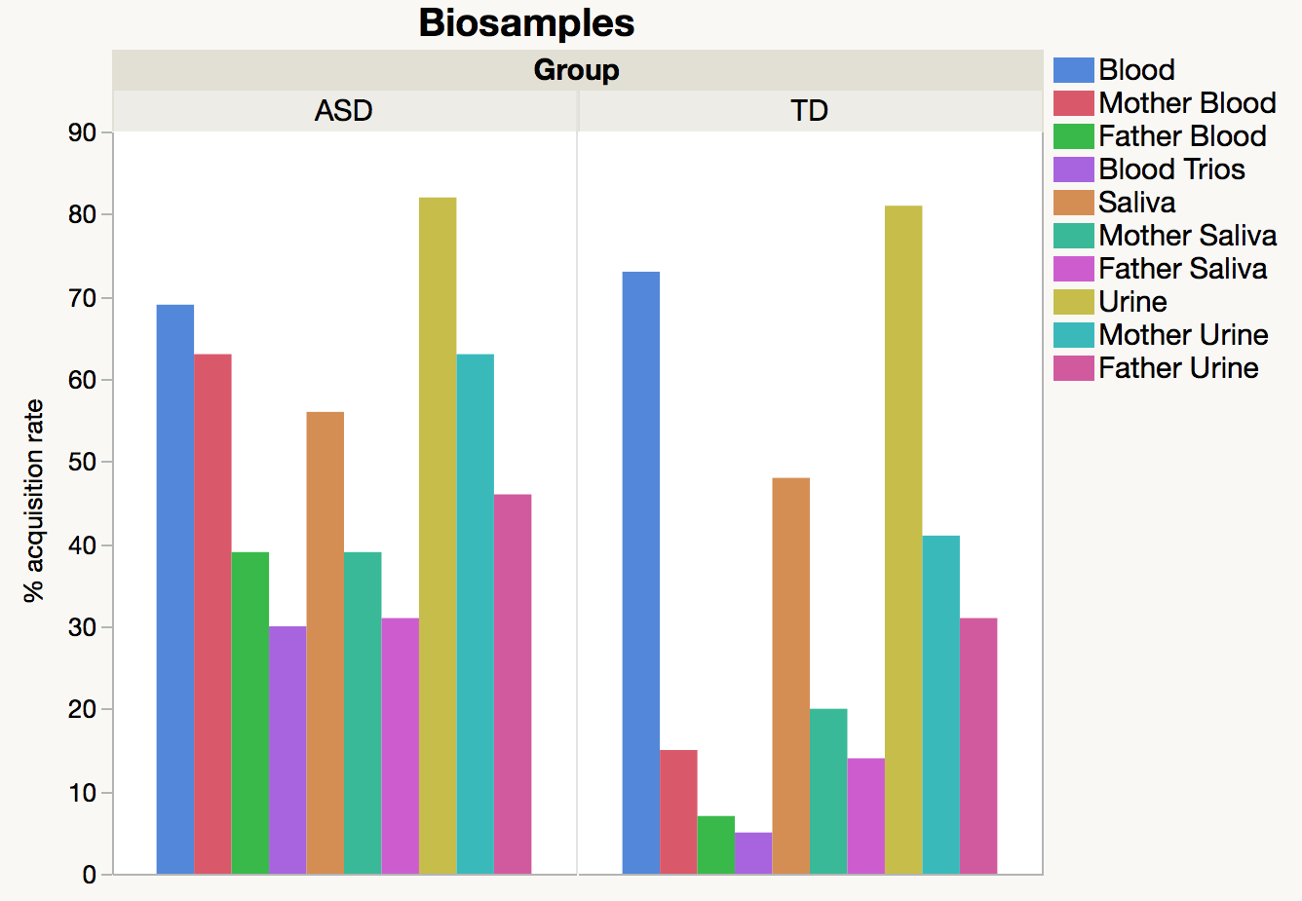

(b) by group and schedule