Additional file 3. Power calculations

- Estimation of effect sizes(ES) at baseline and follow-up for the total cohort, accounting for 5-25% data loss, and for comparison of ASD-subgroups

 | ASD (N) | Control (N) | ES
Baseline
Total | 390 | 255 | 0.23
Total (-5% data loss) | 371 | 242 | 0.23
Total (-25% data loss) | 293 | 191 | 0.26
Follow-up (12-24 months)
Total | 312 | 204 | 0.25
Total (-5% data loss) | 296 | 194 | 0.26
Total (-25% data loss) | 234 | 153 | 0.29
any subgroup N ~1/2 | 195 | 128 | 0.32
any subgroup N ~1/3 | 130 | 85 | 0.39
any subgroup N ~1/4 | 98 | 64 | 0.45

- Power plots

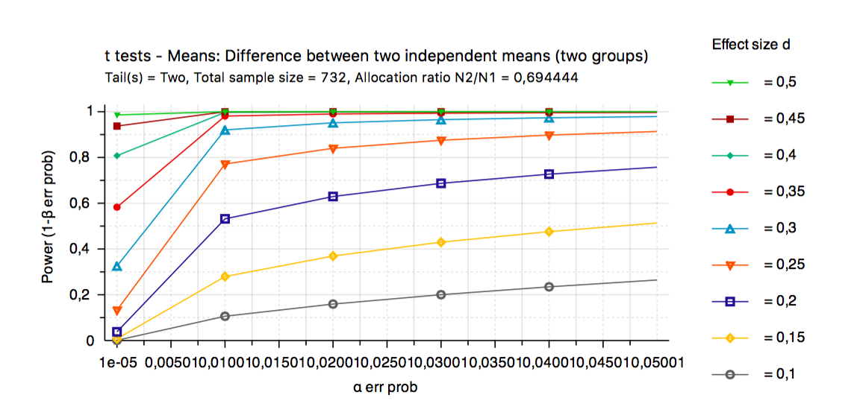 |  | 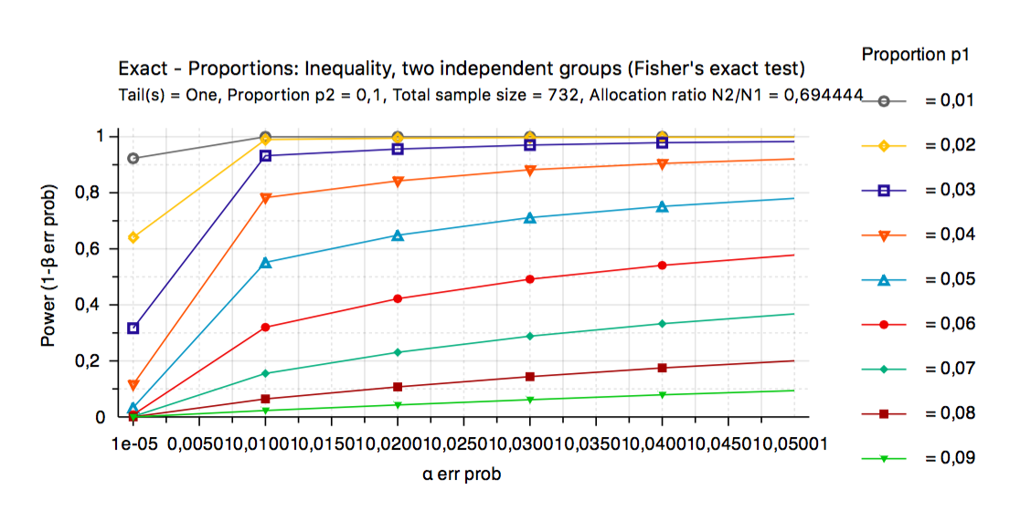
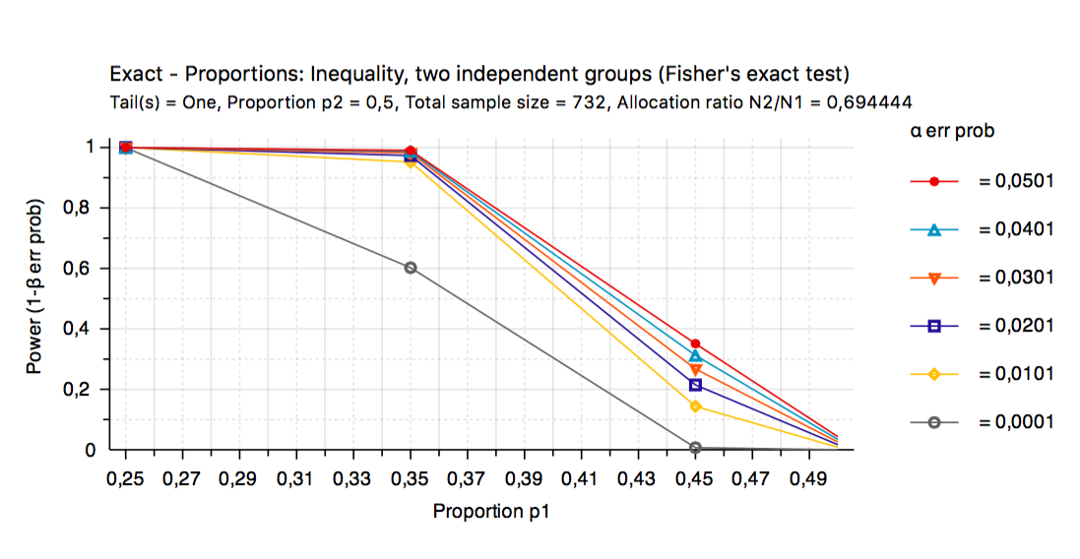 |  | 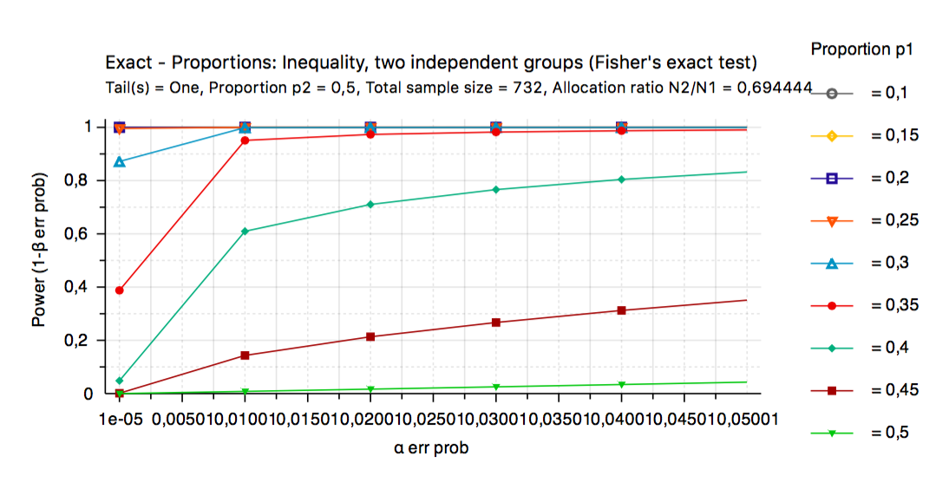
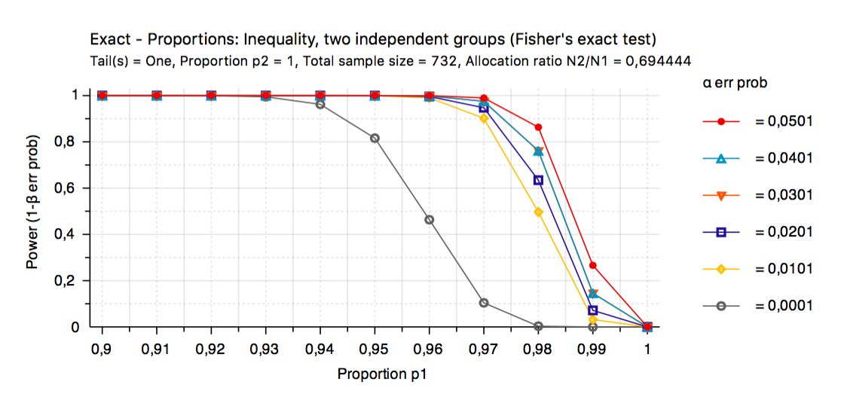 |  | 