Supplementary Materials
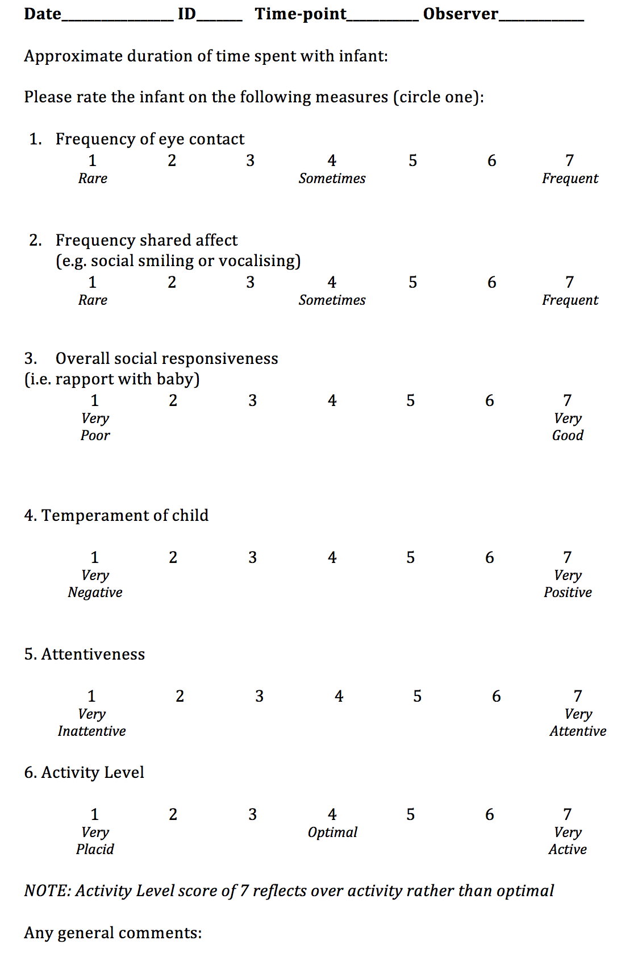
SM1: Social Engagement Scale (consensus rated by experimenters post-visit)

SM2: Clinical Assessment
A battery of clinical research measures was administered to all children at 36 months (see Table 1):
the Autism Diagnostic Observation Schedule – Second Edition (ADOS-2;[54]), a standardised interaction observation assessment, was used to assess current symptoms of ASD (116 children were administered Module 2 and 20 children Module 1, ADOS not completed with 5 HR and 2 LR children). Calibrated Severity Scores for Social Affect, and Restricted and Repetitive Behaviors (RRB) were computed [55], which provide standardised autism severity measures, which account for differences in module administered, age and verbal ability. The Autism Diagnostic Interview – Revised (ADI-R; [56], a structured parent interview, was also administered. Standard algorithm scores were computed for Reciprocal Social Interaction (Social), Communication, and Restricted, Repetitive and Stereotyped Behaviors and Interests (RRB). These assessments were conducted without blindness to risk-group status by or under the close supervision of clinical researchers (i.e., psychologists, speech therapists) with demonstrated research-level reliability. Total scores of the Social Communication Questionnaire (SCQ; [57] were used as additional parent report measures of ASD symptoms. The early learning composite scaled score of the Mullen Scales of Early Learning (MSEL; [36] were used to obtain a standardized measure of developmental abilities during testing and the 3 year visit.
Experienced clinicians (TC, GP, CC) reviewed information on ASD symptomatology (ADOS-2, ADI-R, SCQ), adaptive functioning (Vineland-II;[37]), and development (Mullen Scale of Early Learning, MSEL) for each HR and LR child to ascertain ASD diagnostic outcome according to DSM-5 (American Psychiatric Association, 2013).

Table 1. Participant descriptive data and the assessments carried out for each group.

Comparison | Group | N (males, females) | Chronological age  (months, days) | Assessments
Case summary | NF1 | 4,6 | 10m21d | AOSI, Mullen (M), Vineland Adaptive Behavior Scale (VABS), Infant Behavior Questionnaire Short Form(IBQ), Infant/Toddler Sensory Profile (ITSP), Social Engagement (SE)
Standardized assessment | HR-ASD | 26, 8 | 8m7d | AOSI, Mullen (M), Vineland Adaptive Behavior Scale (VABS), Infant Behavior Questionnaire Short Form (IBQ)
Standardized assessment | HR-noASD | 36, 53 | 8m17d
Standardized assessment | HR-Atyp | 23, 21 | 8m20d
Standardized assessment | LR | 35, 40 | 8m6d

Table 2. Standardised scores from the Mullen Scale for infants with NF1 (cases 1-10), infants with later ASD, and typically developing controls.
Case/Group | Gender/N |  |  | Mullen Scale of Early Learning
Case/Group | Gender/N | Gross Motor | Fine Motor | Receptive Language | Expressive Language | Visual Reception | Composite
1 | M | 30 | 38 | 44 | 35 | 43 | 83
2 | M | 44 | 60 | 28 | 46 | 57 | 95
3 | M | 24 | 39 | 35 | 23 | 42 | 71
4 | M | 23 | 50 | 39 | 26 | 58 | 87
5 | F | 37 | 32 | 39 | 55 | 23 | 71
6 | F | 20 | 61 | 39 | 49 | 48 | 77
7 | F | 37 | 51 | 30 | 38 | 58 | 89
8 | F | 20 | 20 | 20 | 20 | 38 | 55
9 | F | 24 | 50 | 40 | 20 | 42 | 77
10 | F | 24 | 33 | 28 | 36 | 42 | 71
HR-ASD | n=33 | 44.18; 11.48; (20-72) | 49.33; 13.03; (26-80) | 42.85; 12.67; (20-70) | 50.06; 11.92; (26-76) | 51.45; 10.51; (32-80) | 97.12; 17.44; (64-143)
HR-Atyp | n=43 | 44.91; 12.63; (20-65) | 51.77; 12.70; (20-80) | 46.16; 8.64; (23-61) | 51.14; 11.05; (26-76) | 50.23; 11.34; (28-75) | 99.81; 13.41; (74-130)
HR-noASD | n=89 | 47.45; 10.50; (20-77) | 57.00; 12.56; (20-80) | 49.89; 10.04; (22-68) | 50.53; 9.98; (33-76) | 54.60; 11.76; (20-75) | 106.21; 15.49; (66-135)
LR | n=73 | 50.10; 8.58; (30-68) | 58.03; 10.19; (27-80) | 47.37; 9.28; (26-70) | 51.93; 9.18; (33-76) | 56.26; 9.83; (32, 80) | 106.90; 12.13; (77-140)

Note. Group averages of the standardised scores are provided for HR-ASD, HR-noASD, and LR (Mean; Standard Deviation; Range). Composite score distribution Mean of 100 and Standard Deviation of 15; while the subscales have a distribution Mean of 50 with Standard Deviation of 10).
Scores classified as ‘Very Low’ are depicted in bold; ‘Below Average’ in italics; and ‘Above Average’ performance scores are underlined.
Table 3. Standardized scores for the subscales and a composite score from the Vineland Adaptive Behavior Scale.
Case/Group | Gender/N | Vineland Adaptive Behavior Scales
Case/Group | Gender/N | Communication | Daily Living Skills | Socialisation | Motor Skills | Composite
1 | M | 74 | 100 | 100 | 66 | 82
2 | M | 96 | 94 | 109 | 76 | 92
3 | M | 106 | 106 | 109 | 103 | 107
4 | M | 89 | 94 | 91 | 76 | 85
5 | F | 70 | 100 | 81 | 66 | 76
6 | F | 82 | 82 | 91 | 69 | 78
7 | F | 93 | 106 | 94 | 80 | 91
8 | F | 62 | 88 | 62 | 58 | 64
9 | F | 100 | 94 | 106 | 87 | 96
10 | F | 85 | 88 | 94 | 91 | 87
HR-ASD | n=34 | 90.82; 15.13; (40-112) | 93.44; 15.24; (58-117) | 97.15; 15.35; (53-126) | 85.62; 16.39; (54-119) | 90.32; 13.80; (49-113)
HR-Atyp | n=43 | 89.60; 17.14; (42-118) | 99.12; 11.57; (72-117) | 97.86; 11.53; (73-126) | 80.26; 15.81; (46-113) | 90.00; 11.55; (68-114)
HR-noASD | n=86 | 96.62; 15.84; (55-143) | 101.23; 13.38; (54-143) | 99.76; 11.96; (70-152) | 90.65; 15.99; (56-144) | 96.23; 13.06; (66-150)
LR | n=71 | 101.48; 13.72; (66-137) | 102.24; 13.72; (54-136) | 102.63; 12.75; (77-143) | 96.08; 14.00; (73-137) | 100.42; 12.38; (66-144)

Note. Group averages of the standardised scores are provided for HR-ASD, HR-noASD, and LR (Mean; Standard Deviation; Range). Composite score distribution Mean of 100 and Standard Deviation of 15. Scores classified as ‘Low’ (<=-2SD) are depicted in bold; ‘Moderately Low’ (<=-1SD) in italics.

Table 4. Infant Behavior Questionnaire scores for 14 subscales and 3 domain scales

Case/  Group | Gender/N | IBQ Domain Scales
Case/  Group | Gender/N | Surgency | Negative Affect | Effortful Control
1 | M | 4.56 | 3.66 | 5.10
2 | M | 5.08 | 4.01 | 3.79
3 | M | 5.42 | 3.08 | 4.21
4 | M | 4.65 | 4.70 | 4.52
5 | F | 4.69 | 3.43 | 4.21
6 | F | 4.43 | 2.49 | 5.17
7 | F | 4.03 | 5.43 | 4.23
8 | F | 3.48 | 3.24 | 4.2
9 | F | 4.17 | 2.12 | 6.18
10 | F | 6.43 | 4.81 | 1.81
HR-ASD | n=34 | 4.86; 0.69; (3.08-6.16) | 3.52; 1.01; (1.77-6.18) | 4.77; 0.67; (3.66-6.55)
HR-Atyp | n=41 | 4.70; 0.68; (2.66-6.4) | 3.50; 0.81; (2.09-5.66) | 4.71; 0.64; (2.69-5.90)
HR-noASD | n=87 | 4.74; 0.71; (3.04-6.36) | 3.42; 0.71; (1.73-5.43) | 4.66; 0.67; (2.87-6.17)
LR | n=71 | 4.80; 0.56; (3.85-6.24) | 3.22; 0.68; (1.72-5.2) | 4.86; 0.55; (3.61-6.07)

Note. Group averages of the standardised scores are provided for HR-ASD, HR-noASD, and LR (Mean; Standard Deviation; Range).
For individual case series, domain scores were compared to the low-risk control group: Underline – one standard deviation above the mean; Bold underline – two standard deviations above the mean; italic – one standard deviation below the mean; bold italic – two standard deviations below the mean.

Case/Group | Gender | Sensory processing |  |  |  |  | Quadrant Summary
Case/Group | Gender | Auditory | Visual | Tactile | Vestibular | Oral Sensory | Low Registration | Sensation Seeking | Low Threshold
1 | M | 27 | 18 | 46 | 10 | 16 | 29 | 27 | 70
2 | M | 44 | 23 | 58 | 19 | 22 | 52 | 49 | 104
3 | M | 35 | 19 | 55 | 19 | 26 | 46 | 23 | 97
4 | M | 42 | 23 | 55 | 16 | 26 | 49 | 31 | 97
5 | F | 23 | 17 | 42 | 20 | 19 | 29 | 20 | 85
6 | F | 40 | 25 | 54 | 23 | 22 | 47 | 32 | 95
7 | F | 29 | 19 | 57 | 18 | 22 | 44 | 23 | 90
8 | F | 30 | 18 | 50 | 13 | 16 | 35 | 20 | 81
9 | F | 41 | 19 | 56 | 19 | 22 | 55 | 15 | 102
10 | F | 38 | 23 | 59 | 21 | 27 | 51 | 26 | 106

Table 5. Sensory Sensitivity rated through the Infant/Toddler Sensitivity Profile for infants with NF1.

Note. Quadrant and sensory processing scores calculated according to [44] and rated relative to performance of children 7-12 months with typical development. Underline – probably more than others, Bold underline – definitely more than others, Italics – probably less than others, Bold Italics – definitely less than others.

Table 6. Experimenter-rated Social Engagement scores for infants with NF1.

Case/Group | Gender | Social Engagement
Case/Group | Gender | Eye Contact | Shared Affect | Social Responsiveness | Temperament | Attentiveness | Activity Level
1 | M | 4 | 2 | 4 | 3 | 4 | 5
2 | M | 7 | 7 | 6 | 5 | 5 | 7
3 | M | 4 | 3 | 4 | 5 | 5 | 5
4 | M | 7 | 6 | 6 | 6 | 5 | 3
5 | F | 5 | 5 | 4 | 5 | 3 | 4
6 | F | 6 | 4 | 5 | 6 | 2 | 5
7 | F | 7 | 4 | 5 | 2 | 4 | 5
8 | F | 4 | 2 | 3 | 3 | 3 | 2
9 | F | 7 | 5 | 5 | 6 | 4 | 4
10 | F | 5 | 3 | 3 | 3 | 5 | 4

Note. Consensus scored by experimenters on the day of testing. Eye-contact and Shared Affect rated between rare (1) and 7(frequent); Social Responsiveness, Temperament, and attentiveness rated between very poor/ negative (1) and very good/positive (7); Activity Level between very placid (1), optimal (4), or very active (7).

Table 7. Scores on the individual AOSI items, separated by sensory-motor and social abilities for infants with NF1.
Case | Gender | Sensory-Motor
Case | Gender | Visual tracking | Disengagement of attention | Anticipatory response | Coordination of gaze and action | Reactivity | Transitions | Motor control and behavior | Atypical motor behaviors |  | Atypical sensory behaviors
3 | M | 0 | 0 | 0 | 1 | 0 | 0 | 2 | 0 |  | 0
5 | F | 0 | 0 | 0 | 0 | 1 | 1 | 2 | 2 |  | 2
7 | F | 0 | 0 | 0 | 0 | 1 | 0 | 0 | 0 |  | 0
8 | F | 0 | 2 | 0 | 0 | 1 | 1 | 2 | 2 |  | 2
10 | F | 0 | 0 | 0 | 0 | 2 | 0 | 1 | 2 |  | 2
 |  | Social
 |  | Orientation to name | Differential response to facial emotion | Imitation of actions | Social babbling | Eye-contact | Reciprocal social smile | Social interest and shared affect
3 | M | 2 | 0 | 0 | 3 | 2 | 2 | 2
5 | F | 0 | 0 | 0 | 0 | 0 | 2 | 1
7 | F | 1 | 1 | 0 | 1 | 0 | 2 | 1
8 | F | 0 | 1 | 0 | 2 | 2 | 3 | 1
10 | F | 0 | 2 | 0 | 3 | 0 | 2 | 1

Note. AOSI is scored from 0 to 2 or 3, where 0 denotes typical function, and scores 1-3 are rated for severity of impairment; where a rating of 3 is a complete lack of behavior. Eye-contact, atypical motor and sensory behaviors are the three exceptions, and the choice is confined to 0 (typical) and 2 (atypical) [40].

