Additional file 1
Table S1 Concurrent educational and dietary interventions received by participants
Intervention | # of participants
Special diet | 2
Supplements* | 57
Educational intervention | 1
Melatonin | 8
Laxative | 2
OT | 3
SLP | 8
Other ** | 3
* Supplement subtypes = vitamins (2), minerals (7), multivitamins (16), fatty acids (13), homeopathy/probiotics (13)
**Other: day camp, group therapy, music therapy
Table S2a. Complete blood count and corresponding visit for participant 1 with mild neutropenia 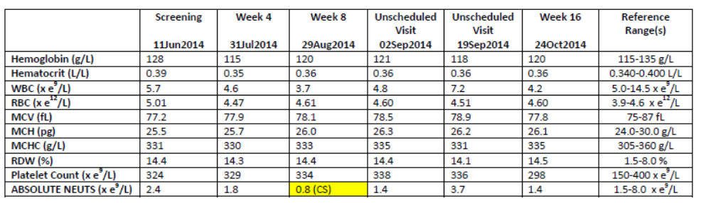

Table S2b. Complete blood count and corresponding visit for participant 2 with mild neutropenia
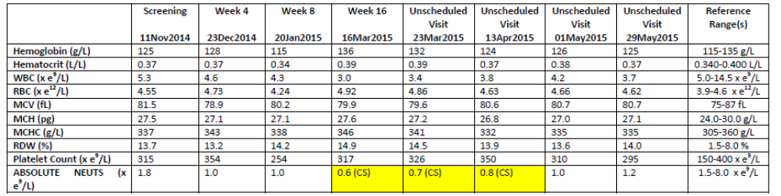
Table S2c. Complete blood count and corresponding visit for participant 3 with mild neutropenia
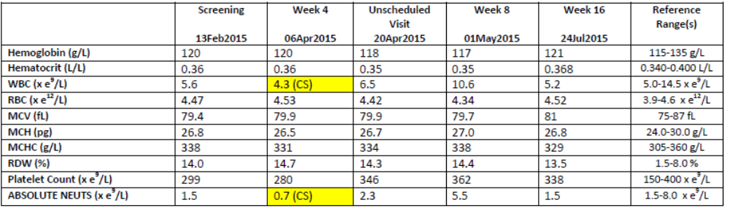

Table S3: Change from baseline to week 16 by dose
 | Pioglitazone dose
 | 0.25 mg/Kg | 0.5 mg/Kg | 0.75 mg/Kg
n | 4 | 5 | 17
Social Function
ABC Social Withdrawal¹ | -4.8 (3.2) | -3.2 (5.0) | -2.9 (5.7)
SRS Total¹ | -19.8 (19.4) | -4.2 (46.8) | 3.3 (43.8)
Externalizing Behaviors
ABC Irritability¹ | -2.8 (2.9 | -2.2 (5.2) | -4.1 (6.0)
ABC Hyperactivity¹ | -4.0 (2.2) | -6.8 (5.4) | -4.6 (6.4)
Anxiety
BASC-2 Anxiety | -3.3 (3.9) | 1.0 (6.7) | -0.5 (6.4)
CASI-4 Generalized Anxiety | -4.5 (2.6) | -2.2 (1.3) | -0.3 (2.0)
CASI-4 Social Phobia | -1.5 (1.0) | -1.2 (1.8) | -0.5 (1.7)
CASI-4 Separation Anxiety | -0.8 (3.3) | -0.6 (1.1) | -0.8 (2.4)
Repetitive Behaviors
RBSR Total¹ | -5.8 (6.2) | -4.4 (4.5) | -2.2 (2.2)
CY-BOCS | 0.0 (0.2) | -0.1 (0.3) | 0.2 (0.5)

¹ dose 0.75 n=16

