Additional file 1

Table S1. Demographics; number (n) and mean ± SD
 | TD |  | ASD
 | n = 49 |  | n = 49
Gender
Male | 31 |  | 36
Female | 18 |  | 13
Age - years
All | 49 | 15.6 ± 1.8 | 49 | 15.6 ± 2.4
< 16 years | 27 | 14.3 ± 1.0 | 26 | 13.7 ± 1.3
≥ 16 years | 22 | 17.3 ± 1.1 | 23 | 17.8 ± 1.3
IQ |  |  | 49
Full scale IQ |  |  | 36 | 91.9 ± 17.7
Verbal IQ |  |  | 47 | 87.6 ± 19.0
Nonverbal IQ |  |  | 48 | 98.1 ± 19.3
SCQ | 47 | 1.9 ± 2.3 | 49 | 18.7 ± 6.7
Infantile Autism |  |  | 13 | 19.7 ± 6.0
Asperger disorder |  |  | 18 | 17.7 ± 6.9
PDD NOS |  |  | 18 | 19.0 ± 7.1
BRIEF
Total score | 36 | 42.0 ± 6.0 | 37 | 67.6 ± 10.2
BRI | 36 | 41.9 ± 3.6 | 38 | 68.0 ± 12.2
MI | 36 | 43.0 ± 7.0 | 37 | 65.7 ± 9.9

Intelligence Quotient, IQ
Social Communication Questionnaire, SCQ
Brief Rating Inventory of Executive Function, BRIEF, Behavior Regulating Index, BRI, and Metacognition Index, MI

Table S2. ERPs in TD compared with ASD without comorbid ADHD (ASD-ADHD)

 |  | TD  n = 49 | ASD – ADHD  n = 32
 |  | Mean (SD) | Mean (SD) | p - value | Cohens d
After non-target S1  (S1 = plant) | N1 amplitude | 2.30 (4.86) | 1.89 (4.61) | 0.70 | 0.09
After non-target S1  (S1 = plant) | N1 latency | 168.3 (15.7) | 182.6 (18.6) | < 0.001* | 0.83
After non-target S1  (S1 = plant) | Mean P3a Cz | -0.99 (1.91) | 0.14 (1.81) | 0.009* | 0.61
After non-target S2  (S1 and S2 = plant) | N1 amplitude | 2.37 (5.42) | 1.92 (4.44) | 0.714 | 0.09
After non-target S2  (S1 and S2 = plant) | N1 latency | 165.4 (16.5) | 181.6 (17.5) | < 0.001* | 0.95
After non-target S2  (S1 and S2 = plant) | Mean P3a Cz | -0.86 (1.87) | 0.26 (1.81) | 0.009* | 0.61
Latency in milliseconds, Amplitude in uV
* Significant at 0.01-level

Table S3. Partial correlations of ERPs in participants without ADHD with BRIEF included subscales, adjusted for age

 | BRIEF total | BRI | MI
n | 59 | 58 | 58
N1 latency | 0.30 | 0.38* | 0.25
P3a | 0.26 | 0.37* | 0.18

* Significant at 0.01-level
BRIEF total score and subscales Behavior Regulation Index, BRI, and Metacognition Index, MI

Table S4. ERPs in other conditions, and recordings from other electrodes.
 |  | TD | ASD
 |  | Mean (SD) | Mean (SD) | p - value | Cohens d
After non-cue S1 with pictures of emotional faces | N1 amplitude | -1.12 (4.74) | -0.27 (4.91) | 0.39 | 0.18
After non-cue S1 with pictures of emotional faces | N1 latency | 154.3 (19.9) | 169.2 (25.8) | 0.002* | 0.65
After non-cue S1 with pictures of emotional faces | Mean P3a Cz | -0.20 (1.90) | 0.93 (1.91) | 0.004* | 0.59
After non-cue S1  (S1 = plant) | Mean P3a Cz | -0.99 (1.91) | 0.25 (1.99) | 0.002* | 0.64
After non-cue S1  (S1 = plant) | Mean P3a Fz | -2.57 (1.71) | -1.94 (1.92) | 0.085 | 0.35
After non-cue S1  (S1 = plant) | Mean P3b Pz | 2.43 (1.79) | 2.86 (2.37) | 0.31 | 0.20
After passive S2  (S1 and S2 = plant) | Mean P3a Cz | -0.86 (1.87) | 0.35 (2.46) | 0.007* | 0.55
After passive S2  (S1 and S2 = plant) | Mean P3a Fz | -3.00 (2.11) | -1.54 (1.96) | 0.001* | 0.72
After passive S2  (S1 and S2 = plant) | Mean P3b Pz | 2.28 (2.08.) | 1.74 (2.16) | 0.21 | 0.25

* Significant at 0.01-level
Latency in milliseconds, Amplitude in uV
Cz: Central Midline electrode
Fz: Frontal Midline electrode
N1 is recorded from occipital electrodes O1 and O2 and averaged between these
The test, ECPT, with emotional faces from Ekman [1] is described in detail in a previous paper by Høyland et al. [2]

FigS1. Task stimuli

Time in milliseconds |  |   100  1500  1000  300  100
S1 | S2 |  | 
Target-condition | Go
Target-condition | NoGo
Non-target-condition | Non-target
Non-target-condition | With novelty sound - excluded

FigS2. Relation between N1 latency and the Behavior Regulating Index (BRI) including ASD subtypes

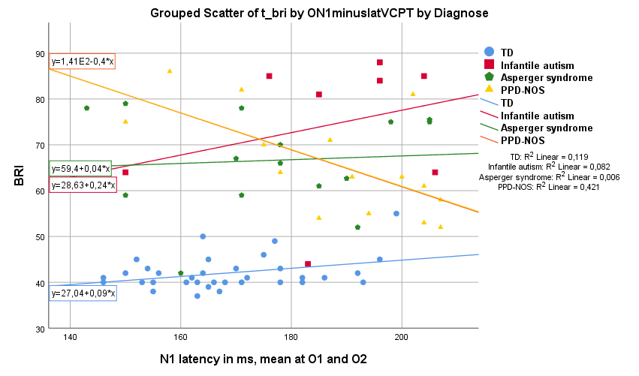

The relation between N1 latency (mean of electrodes O1 and O2) in milliseconds (ms) and the Behavior Regulating Index (BRI), an index of the Behavior Rating Inventory of Executive Function (BRIEF). The subtypes of ASD are marked with different markers/ colors to illustrate how the relation between the ERP component and BRI measure differed. Individuals with PDD-NOS show a different ERP/BRI relation than other ASD subtypes.

FigS3. Relation between P3a amplitude and the Behavior Regulating Index (BRI) including ASD subtypes

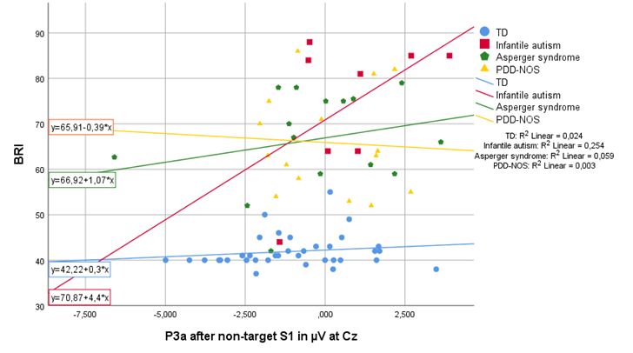
The relation between P3a amplitude at the electrode Cz and the Behavior Regulating Index (BRI), an index of the Behavior Rating Inventory of Executive Function (BRIEF). Subtypes of ASD are marked with different markers/ colors to illustrate how the relation between the ERP component and BRI measure differed. Individuals with PDD-NOS show a different ERP/BRI relation than other ASD subtypes.

References

1. Ekman P, Friesen WV: Pictures of facial affect: consulting psychologists press; 1975.
2. Hoyland AL, Naerland T, Engstrom M, Lydersen S, Andreassen OA: The relation between face-emotion recognition and social function in adolescents with autism spectrum disorders: A case control study. PLoS One 2017, 12(10):e0186124.

