In-Situ Amygdala Expression Regions of Interest
NOTE: The regions of interest designated as “Amygdala Progenitor Zones” vary across ages but can include the POA, TelA, LPall, VPall,and CSPall.
Age | Region | Allen Map (Sagittal) | In-Situs (Sagittal)
E11.5 | Overview | 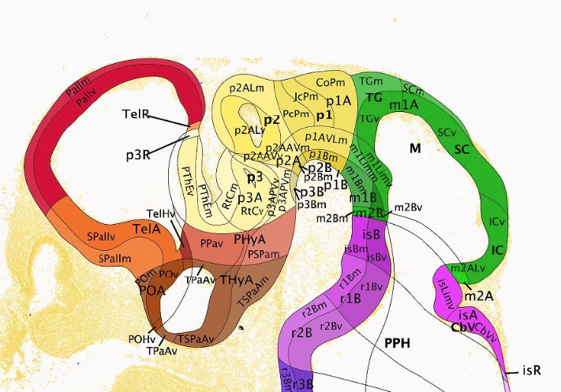 | 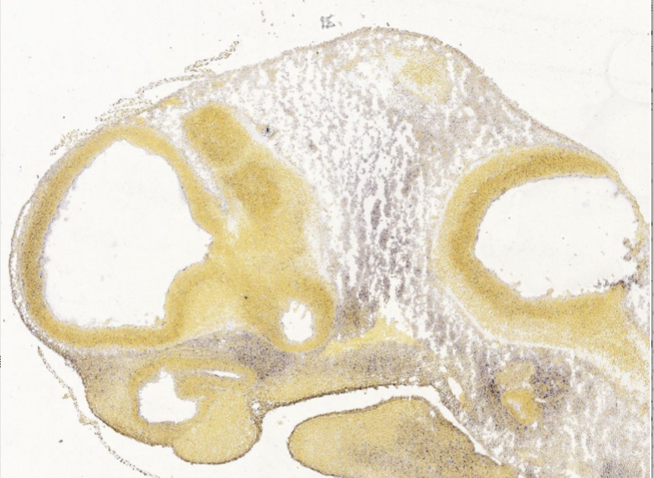
E11.5 | POA | 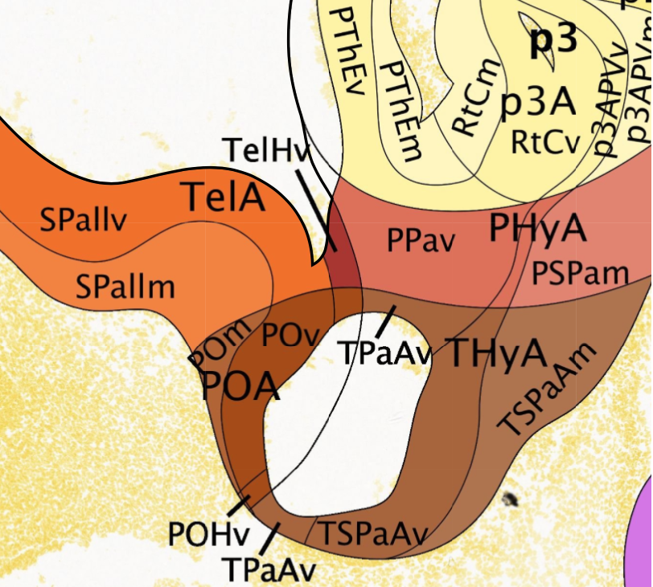 | 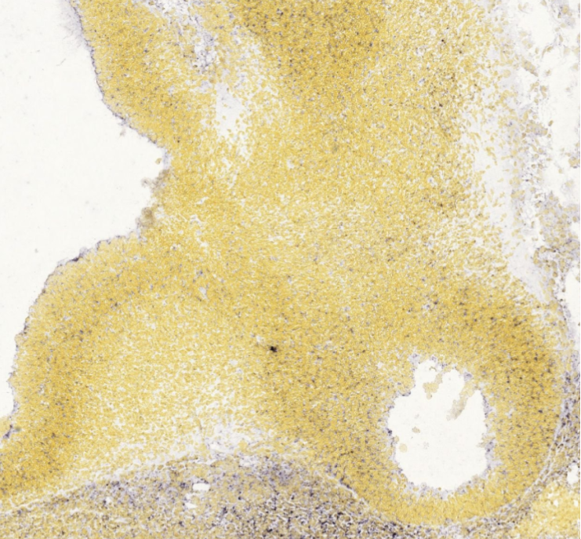
E11.5 | TelA
E13.5 | Overview | 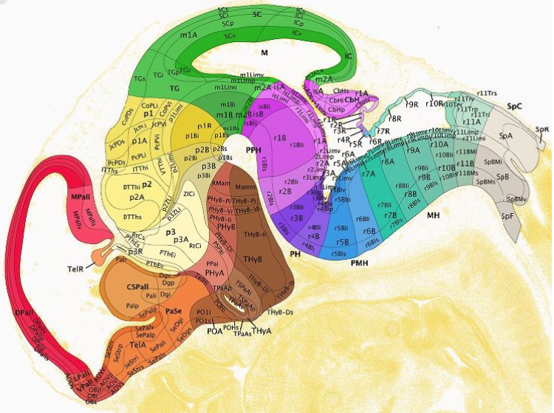 | 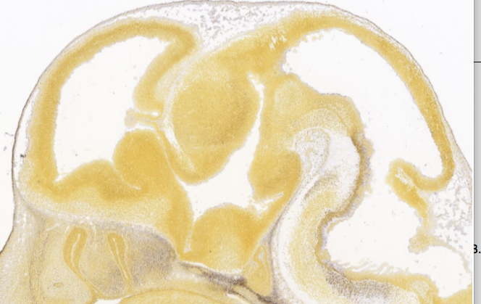
E13.5 | POA | 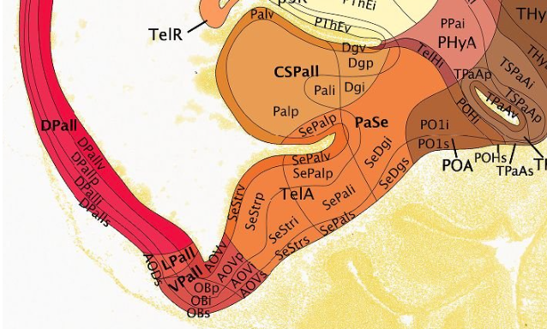 | 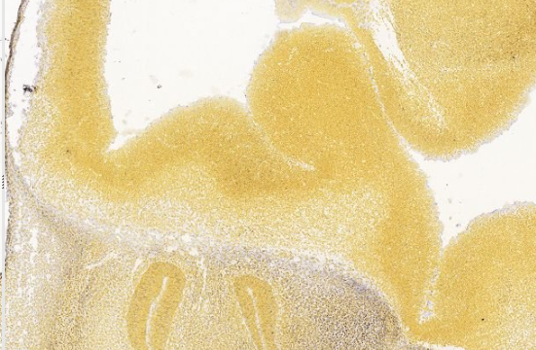
E13.5 | TelA
E13.5 | LPall
E13.5 | CSPall
E13.5 | VPall
E15.5 | Overview | 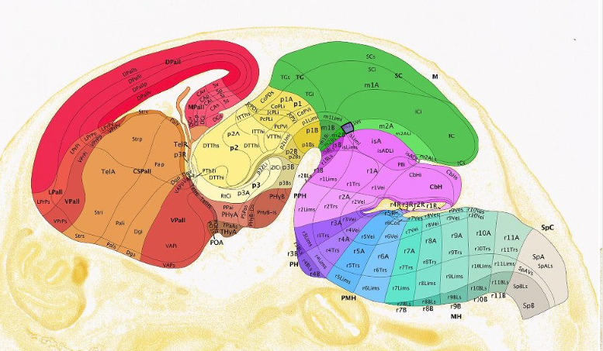 | 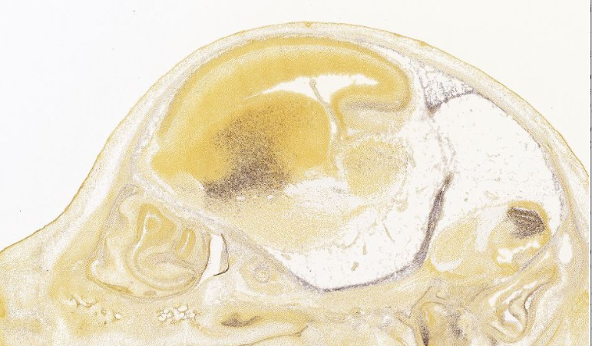
E15.5 | POA | 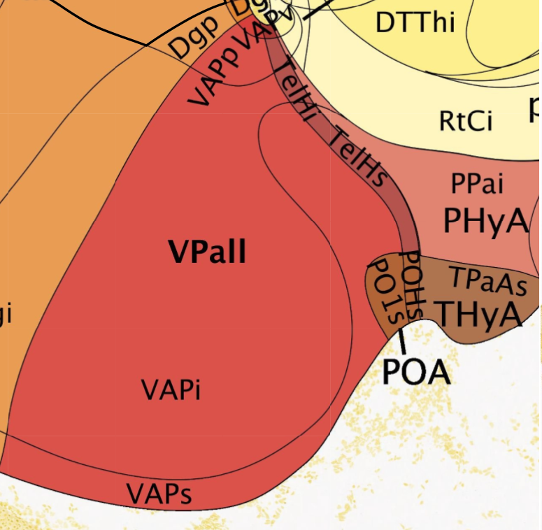 | 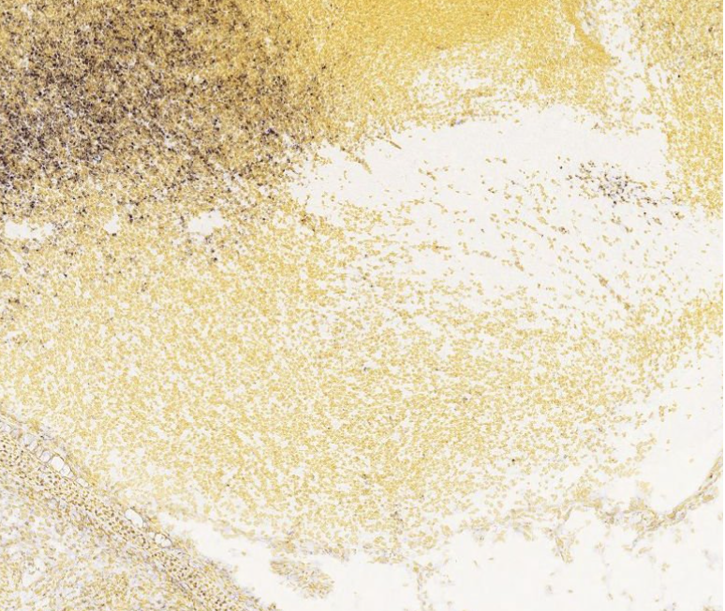
E15.5 | TelA | 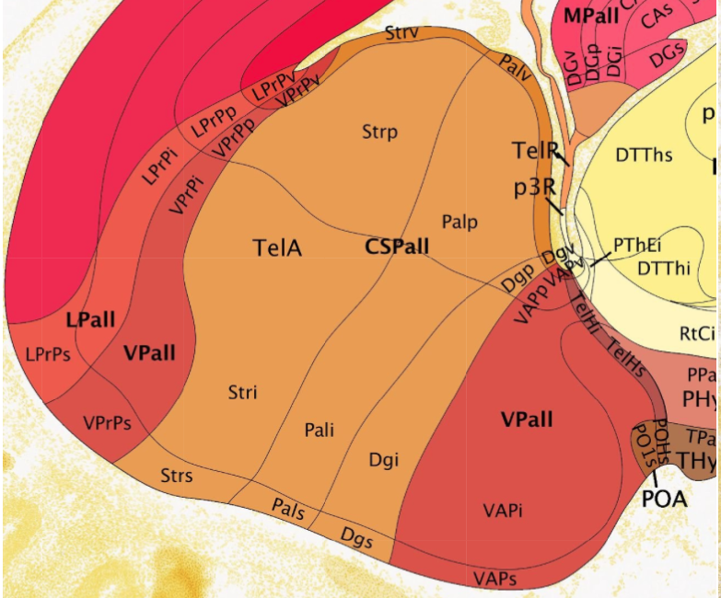 | 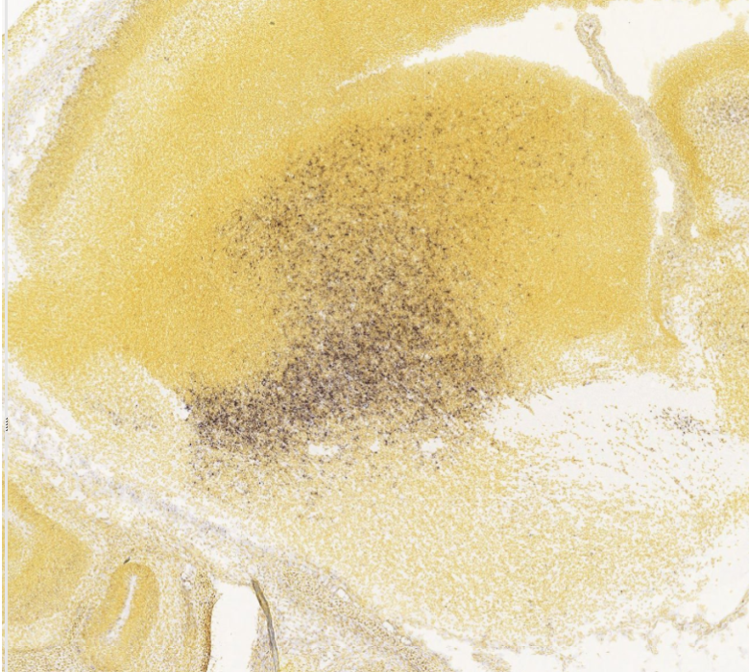
E15.5 | LPall
E15.5 | CSPall
E15.5 | VPall
E18.5 | Overview | 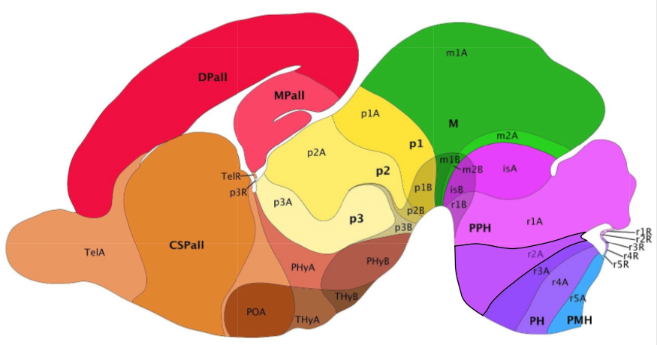 | 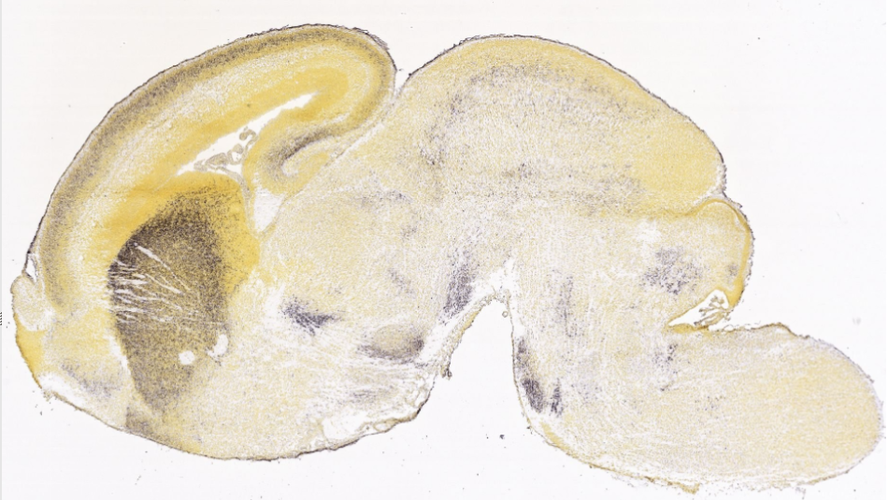
E18.5 | POA | 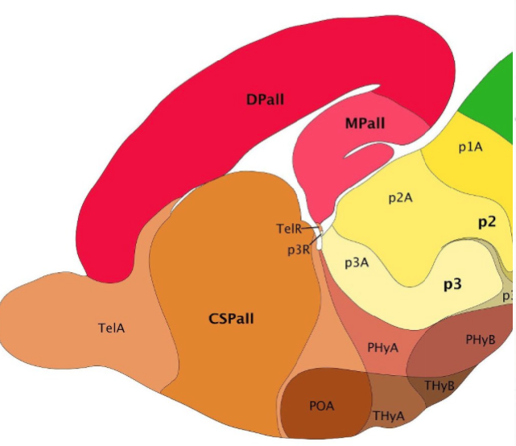 | 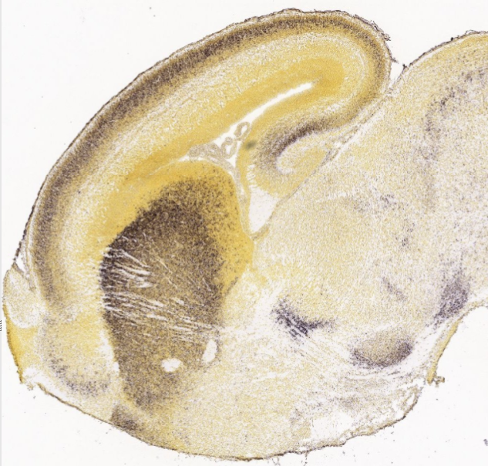
E18.5 | TelA
E18.5 | CSPall
P4 | Overview | 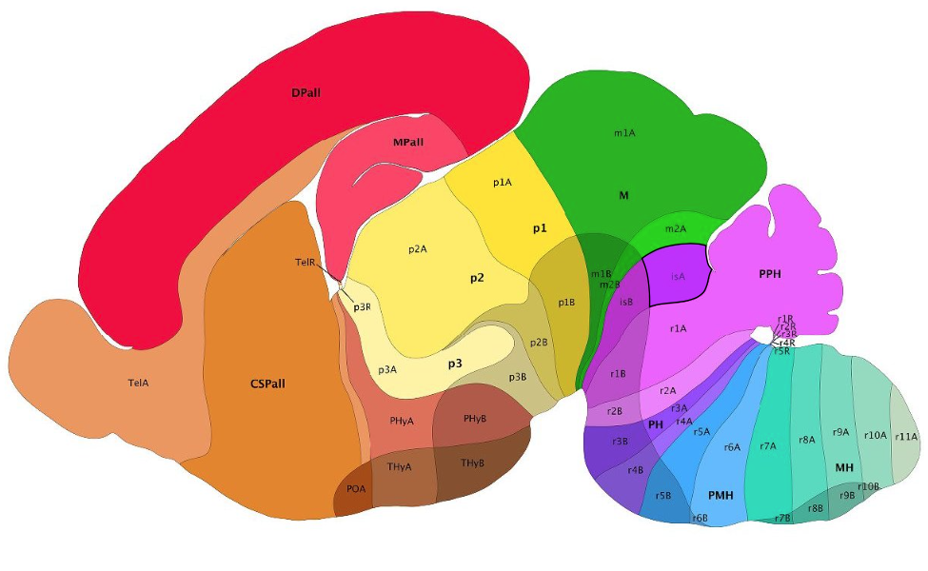 | 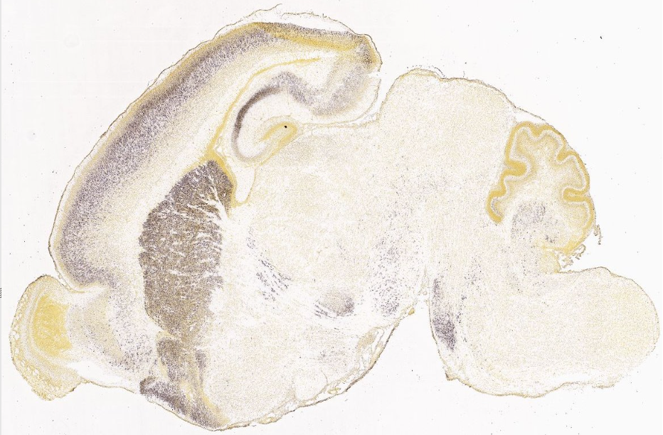
P4 | POA | 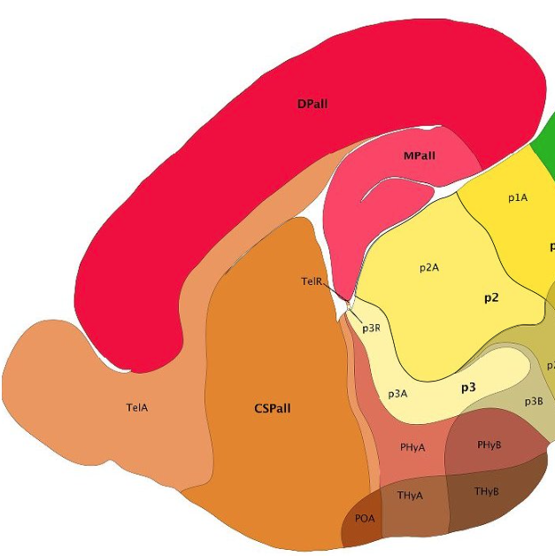 | 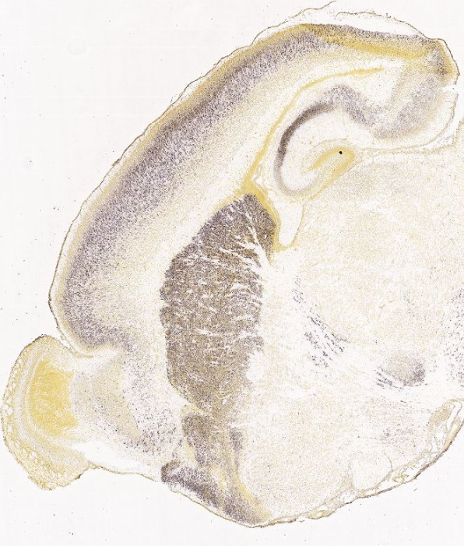
P4 | TelA
P4 | CSPall

