Supplementary Tables & Figures

 | Chemiluminescence Immunoassay Assays by DiaSorin | Units of Measurement | Lower limit of detection | Imprecision In-House Measurements
Estradiol | Estradiol II Gen No.310680  (issued 6-2016) | pmol/L | 36.7 | 2.9% at 425 pmol/L, & 1.9% at 1223 pmol/L
Testosterone | Testosterone No.310410  (issued 12-2014) | nmol/L | 0.17 | 4.9% at 6.37 nmol/L, & 4.4% at 18.2 nmol/L
DHEAS | DHEA-S, No.310430, (issued 04-2016) | ug/L | 1.0 | 4.9% at 6.4 ųg/L, &  4.4% at 18.2 ųg/L
Progesterone | Progesterone II Gen No.310690, (issued 06-2016) | ng/L | 0.12 | 4.2% at 2.2 ng/L, &  2.5% at 21.4 ng/L
SHBG | SHBG, No. 319020, (issued 03-2017) | nmol/L | 0.2 | 9.9% at 43 nmol/L, & 7.2% at 190 nmol/L

Suppl Table 1: Assay details, as conducted for research purposes by the Core Biochemical Assay Laboratory (CBAL) of CUH NHS Foundation Trust.

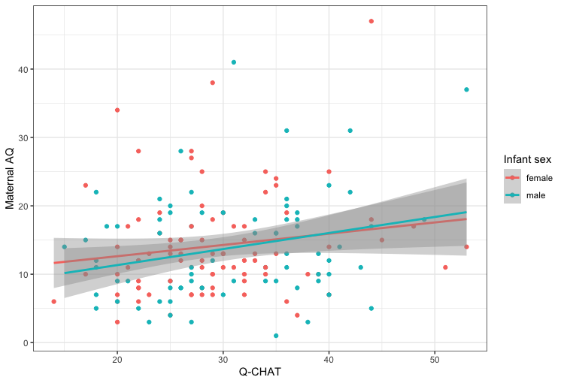
Suppl Figure 1: Maternal AQ and Q-CHAT of the same mother-infant pairs, showing a high degree of correlation between them.

 | Coefficient | SE | Semipartial | p-value
Intercept | 20.36 | 3.86 |  | <0.0001
Hirsutism | 1.91 | 0.67 | 0.18 | 0.005
PCOS | -0.35 | 2.69 | -0.01 | 0.88
Hirs*PCOS | 0.32 | 1.78 | 0.01 | 0.86
Maternal Age | -0.25 | 0.12 | -0.14 | 0.03
Autism in Family | 15.61 | 2.1 | 0.48 | <0.0001
 |  |  | Adjusted R2=0.24 | Model p<0.0001

Suppl Table 2: Multiple regression model of the associations between maternal hirsutism score and AQ.

 | DHEAS | Progesterone | Estradiol | Testosterone | hCG | PAPP-A
DHEAS | 1
Progesterone | -0.214* | 1
Estradiol | 0.655*** | 0.199* | 1
Testosterone | 0.540*** | -0.037 | 0.51*** | 1
hCG MoM | 0.019 | 0.179 | 0.101 | 0.214* | 1
PAPP-A MoM | -0.36*** | 0.380*** | -0.041 | -0.159 | 0.048 | 1

Suppl Table 3: Pairwise correlation coefficients (Pearson’s r) for each pair of prenatal factors, with asterisks denoting statistical significance.

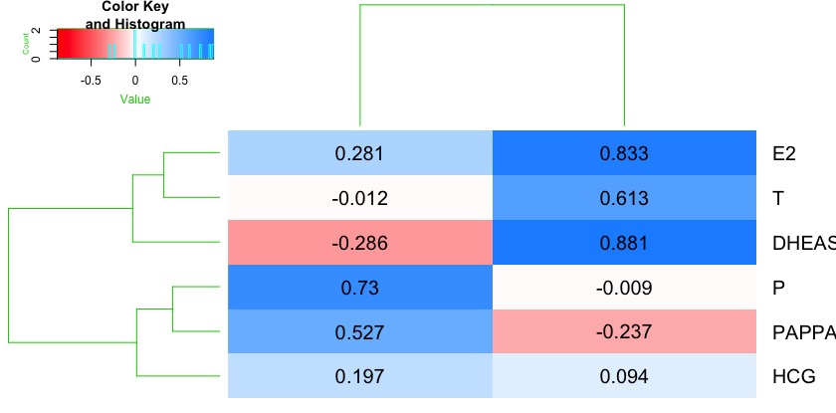

Suppl. Figure 2: Heatmap and dendrogram of the loadings of each of the tested variables on latent factors. Factor 1 includes all sex steroids measured in the current study

 | Maternal PCOS |  | Hirsutism Score  (0 to 2+ areas) |  | Maternal Age
 | Effect size | p | Effect size | p | Effect size | p
Estradiol | D=1.06 | 0.008 | D=0.47 | 0.034 | r=-0.1 | 0.274
Testosterone | D=0.35 | 0.247 | D=0.21 | 0.328 | r=-0.37 | <0.001
DHEAS | D=0.13 | 0.54 | D=0.33 | 0.127 | r=-0.30 | <0.001
Progesterone | D=0.92 | 0.018 | D=0.001 | 0.995 | r=0.31 | <0.001
SHBG | D=0.62 | 0.017 | D=0.03 | 0.870 | r=0.06 | 0.51
FEI | D=0.58 | 0.100 | D=0.51 | 0.025 | r=-0.17 | 0.08
FTI | D=0.03 | 0.888 | D=0.25 | 0.268 | r=-0.38 | <0.001
Steroid Factor | D=0.50 | 0.135 | D=0.50 | 0.028 | r=-0.22 | 0.015
hCG MoM | D=0.07 | 0.762 | D=0.11 | 0.542 | r=-0.04 | 0.61
PAPP-A MoM | D=0.18 | 0.291 | D=0.38 | 0.016 | r=0.08 | 0.261

Suppl Table 4: Associations between circulating hormones/peptides and maternal factors

 | Males |  | Females
 | Mean | SD | Mean | SD | Coeff | p
Q-CHAT | 30.36 | 8.13 | 29.63 | 7.58 | -0.62 | 0.538
Age at follow-up | 575.49 | 21.54 | 570.60 | 25.65 | -1.26 | 0.210
Birth Weight | 3461.8 | 481.49 | 3363.35 | 538.99 | -1.34 | 0.183
Maternal age | 32.68 | 4.83 | 32.16 | 4.27 | -0.85 | 0.396
Maternal AQ | 14.15 | 8.06 | 15.04 | 8.18 | 0.751 | 0.453
 | Males |  | Females
 | N - with | N - without | N - with | N - without | Coeff | p
PCOS | 17 | 87 | 9 | 106 | 3.02 | 0.082
Autism in Family | 9 | 95 | 8 | 107 | 0.05 | 0.83

Suppl Table 5: Sex differences among infant clinical characteristics

 | Coefficient | SE | Semipartial | p-value
Intercept | 13.77 | 4.60 |  | 0.003
FEI | 2.76 | 1.40 | 0.19 | 0.048
maternal age | -0.07 | 0.13 | -0.05 | 0.567
PCOS | 1.14 | 1.68 | 0.06 | 0.498
 |  |  | Adjusted R2=0.03 | Model p=0.102

Suppl Table 6: Full model results of the association of FEI to maternal AQ

 | Coefficient | SE | Semipartial | p-value
Intercept | 114.21 | 35.21 |  | 0.002
Estradiol (E2) | -4.00 | 2.31 | -0.19 | 0.087
Sex | -72.96 | 37.27 | -0.22 | 0.054
E2 * Sex | 8.27 | 4.08 | 0.23 | 0.036
Infant Age | -0.04 | 0.04 | -0.12 | 0.287
Birth Weight | -0.002 | 0.002 | -0.11 | 0.347
Maternal Age | -0.59 | 0.04 | -0.30 | 0.007
Maternal AQ | 0.10 | 0.16 | 0.07 | 0.544
PCOS | -2.04 | 2.83 | -0.08 | 0.473
 |  |  | Adjusted R2=0.09 | Model p=0.052

Suppl Table 7: Full model results of the association of estradiol (E2) to infant Q-CHAT

 | AQ |  | Q-CHAT
 | Normality of Residuals | Homoscedasticity  (Breusch-Pagan) | Normality of Residuals  (Shapiro-Wilk) | Homoscedasticity  (Breusch-Pagan)
Estradiol
Test statistic | W= 0.98 | BP=1.19 | W=0.98 | BP=0.95
p-value | p=0.175 | p=0.755 | p=0.152 | p=0.996
Testosterone
Test statistic | W=0.98 | BP=0.93 | W=0.98 | BP=12.8
p-value | p=0.105 | p=0.817 | p=0.154 | p=0.119
DHEAS
Test statistic | W=0.98 | BP=1.09 | W=0.98 | BP=14.14
p-value | p=0.105 | p=0.78 | p=0.213 | p=0.08
Progesterone
Test statistic | W=0.98 | BP=0.55 | W=0.97 | BP=9.80
p-value | p=0.09 | p=0.91 | p=0.05 | p=0.27
hCG MoM
Test statistic | W=0.96 | BP=0.85 | W=0.98 | BP=10.58
p-value | p=0.0003 | p=0.65 | p=0.167 | p=0.226
PAPP-A MoM
Test statistic | W=0.96 | BP=0.86 | W=0.98 | BP=12.36
p-value | p=0.0004 | p=0.65 | p=0.104 | p=0.136
Composite scores
Free Estradiol Index
Test statistic | W=0.98 | BP=1.54 | W=0.98 | BP=13.22
p-value | p=0.142 | p=0.673 | p=0.491 | p=0.104
Free Testosterone Index
Test statistic | W=0.98 | BP=0.89 | W=0.98 | BP=11.72
p-value | p=0.09 | p=0.828 | p=0.129 | p=0.164
Steroid Factor
Test statistic | W=0.98 | BP=0.58 | W=0.99 | BP=15.79
p-value | p=0.142 | p=0.902 | p=0.512 | p=0.066

Suppl Table 8: Multiple linear regression model tests for residual normality and model homoscedasticity.

