Supplementary Materials
Supplementary Table 1: Pearson correlations between eye-tracking variables across groups included in PCA
 |  |  | 1 |  | 2 |  | 3 |  | 4 |  | 5 |  | 6 |  | 7 |  | 8 |  | 9 |  | 10 |  | 11 |  | 12 |  | 13 |  | 14 |  | 15 |  | 16 |  | 17 |  | 18
Fixation count (%) - social | 1 |  |  | - |  | -.67*** |  | .92*** |  | -.61*** |  | .98*** |  | -.66*** |  | .63*** |  | -.39*** |  | -.51*** |  | -.52*** |  | .74*** |  | -.63*** |  | -.21** |  | -.09 |  | -.09 |  | .07 |  | -.15 |  | .02
Fixation count (%) - non-social | 2 |  |  | - |  | - |  | -.61*** |  | .89*** |  | -.66*** |  | .98*** |  | -.36*** |  | .58*** |  | .63*** |  | .70*** |  | -.91*** |  | .70*** |  | .20* |  | .25** |  | .04 |  | -0.10 |  | .07 |  | .04
Dwell time (%) - social | 3 |  |  | - |  | - |  | - |  | -.70*** |  | .92*** |  | -.62*** |  | .59*** |  | -.39*** |  | -.50*** |  | -.45*** |  | .69*** |  | -.58*** |  | -.17* |  | -.06 |  | -.31*** |  | .26** |  | -.21** |  | .04
Dwell time (%) - non-social | 4 |  |  | - |  | - |  | - |  | - |  | -.61*** |  | .89*** |  | -.36*** |  | .56*** |  | .57*** |  | .58*** |  | -.81*** |  | .67*** |  | .17* |  | .20* |  | .25** |  | -.39*** |  | .14. |  | .00
Regressive fixations (%) - social | 5 |  |  | - |  | - |  | - |  | - |  | - |  | -.68*** |  | .64*** |  | -.39*** |  | -.53*** |  | -.51*** |  | .74*** |  | -.62*** |  | -.22** |  | -.08 |  | -.11 |  | .07 |  | -.16* |  | -.05
Regressive fixations (%) - non-social | 6 |  |  | - |  | - |  | - |  | - |  | - |  | - |  | -.37*** |  | .60*** |  | .66*** |  | .67*** |  | -.91*** |  | .71*** |  | .22** |  | .23** |  | .08 |  | .10 |  | .11 |  | .09
Perseverative fixations (%) - social* | 7 |  |  | - |  | - |  | - |  | - |  | - |  | - |  | - |  | -.54*** |  | -.29*** |  | -.25** |  | .43*** |  | -.42*** |  | -.14. |  | -.05 |  | .02 |  | .08 |  | .03 |  | -.11
Perseverative fixations (%) - non-social* | 8 |  |  | - |  | - |  | - |  | - |  | - |  | - |  | - |  | - |  | .23** |  | .20* |  | -.47*** |  | .63*** |  | .12 |  | .19* |  | .10 |  | -.09 |  | .08 |  | .03
Transition: Social to non-social (%) | 9 |  |  | - |  | - |  | - |  | - |  | - |  | - |  | - |  | - |  | - |  | .64*** |  | -.83*** |  | .19* |  | .17* |  | .07 |  | -.02 |  | -.15. |  | -.04 |  | .18*
Transition: Non-social to social (%) | 10 |  |  | - |  | - |  | - |  | - |  | - |  | - |  | - |  | - |  | - |  | - |  | -.81*** |  | .17* |  | .17* |  | .14. |  | -.08 |  | -.05 |  | -.04 |  | .06
Transition: Social to social (%) | 11 |  |  | - |  | - |  | - |  | - |  | - |  | - |  | - |  | - |  | - |  | - |  | - |  | -.60*** |  | -.25** |  | -.19* |  | -.00 |  | .13 |  | -.04 |  | -.11
Transition: Non-social to non-social (%) | 12 |  |  | - |  | - |  | - |  | - |  | - |  | - |  | - |  | - |  | - |  | - |  | - |  | - |  | .21** |  | .22** |  | .10 |  | -.08 |  | .16* |  | .00
Fixation spatial distribution/coverage - 5 x 4 (larger) | 13 |  |  | - |  | - |  | - |  | - |  | - |  | - |  | - |  | - |  | - |  | - |  | - |  | - |  | - |  | .64*** |  | -.31*** |  | -.20* |  | -.37*** |  | .07
Fixation spatial distribution/coverage - 10 x 8 (smaller) | 14 |  |  | - |  | - |  | - |  | - |  | - |  | - |  | - |  | - |  | - |  | - |  | - |  | - |  | - |  | - |  | -.20* |  | -.14 |  | -.20* |  | -.01
Fixation rate (exploration) AOI (fix/s) - social | 15 |  |  | - |  | - |  | - |  | - |  | - |  | - |  | - |  | - |  | - |  | - |  | - |  | - |  | - |  | - |  | - |  | .10 |  | .89*** |  | -.22**
Fixation rate (exploration) AOI (fix/s) - non-social | 16 |  |  | - |  | - |  | - |  | - |  | - |  | - |  | - |  | - |  | - |  | - |  | - |  | - |  | - |  | - |  | - |  | - |  | .36*** |  | -.07
Fixation rate (exploration) | 17 |  |  | - |  | - |  | - |  | - |  | - |  | - |  | - |  | - |  | - |  | - |  | - |  | - |  | - |  | - |  | - |  | - |  | - |  | -.20
First fixation duration (s) | 18 |  |  | - |  | - |  | - |  | - |  | - |  | - |  | - |  | - |  | - |  | - |  | - |  | - |  | - |  | - |  | - |  | - |  | - |  | -
Each cell contains the Pearson r and associated p values depicting correlations between each eye-tracking variable. *p < .05, **p < .01, ***p < .001 , ****p < .0001.

Supplementary Table 2: Component matrix from principal component analysis
 | Social/non-social attention (factor 1) | Efficiency of exploration (factor 2)
Fixation count (%) - social | 0.88 | -0.10
Fixation count (%) - non-social | -0.92 | -0.03
Dwell time (%) - social | 0.85 | -0.20
Dwell time (%) - non-social | -0.88 | 0.07
Regressive fixations (%) - social | 0.88 | -0.10
Regressive fixations (%) - non-social | -0.92 | -0.01
Perseverative fixations (%) - social* | 0.61 | 0.03
Perseverative fixations (%) - non-social* | -0.60 | 0.05
Transition: Social to non-social (%) | -0.68 | -0.14
Transition: Non-social to social (%) | -0.68 | -0.15
Transition: Social to social (%) | 0.94 | 0.08
Transition: Non-social to non-social (%) | -0.73 | 0.10
Fixation spatial distribution/coverage - 5 x 4 (larger) | -0.28 | -0.63
Fixation spatial distribution/coverage - 10 x 8 (smaller) | -0.22 | -0.50
Fixation rate (exploration) AOI (fix/s) - social | -0.11 | 0.86
Fixation rate (exploration) AOI (fix/s) - non-social | 0.19 | 0.37
Fixation rate (exploration) | -0.11 | 0.90
First fixation duration (s) | -0.06 | -0.31
*Bold values indicate variables conceptualized under each component (factor)

Supplementary Table 3: Correlation matrix of PCA and clinical-behavioral indices among individuals with ASD
 | Social/non-social attention (factor 1); Pearson r | Efficiency of exploration (factor 2) Pearson r
ADOS Total Severity Score | 0.01 | 0.17
SA Severity Score | -0.11 | 0.17
RRB Severity Score | 0.26 | 0.10
ADI-R Algorithm A (communication) | 0.20 | 0.24
ADI-R Algorithm B (social) | 0.17 | 0.41
ADI-R Algorithm C (RRB) | 0.14 | 0.06
Reading the Mind in the Eyes (% correct) | -0.10 | -0.22
ADI, Autism Diagnostic Interview-Revised; ADOS, Autism Diagnostic Observation Scale; RRB, Restricted and Repetitive Behaviors and Interests; SA, social-affect.
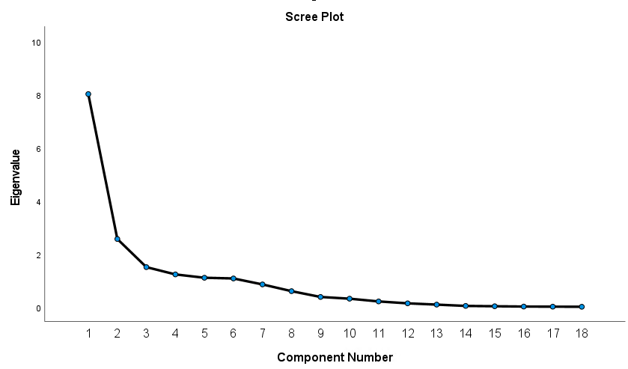
Supplementary Figure 1. Scree plot from the principal component analysis. Arrow indicates the “elbow” determining 2 components.
Component Number
Eigenvalue

