Supplementary Figure 1

Flow chart of participants included for analyses.
7,254 participants enrolled
and gave consent to this study

Missing data on maternal age
(n = 548)

6,706 participants with available data
on maternal age

Missing data on child autistic-like traits
(n= 988)

5,718 participants with complete data
on maternal age and child autistic-like traits

Supplementary Table 1

Parental age groups and child autistic-like traits (N= 5,718)
Maternal Age Groups | N = 5,718 | Mean (SD) | Sig.
Younger age group (< 20 years) | 167 | 0.42 (0.28) | <.001
Reference age group (25 - 29 years) | 1470 | 0.29 (0.21) | -
Older age group (> 35 years) | 1118 | 0.28 (0.24) | .249
Note.
After adjusting for confounders, the significance difference between younger age and reference age in maternal age group still appears.

Paternal Age Groups | N = 5,718 | Mean (SD) | Sig.
Younger age group (< 20 years) | 58 | 0.40 (0.32) | .028
Reference age group (25 - 29 years) | 1085 | 0.32 (0.23) | -
Older age group (> 35 years) | 2103 | 0.28 (0.21) | <.001
Note.
After adjusting for confounders, the significance difference between younger age and reference age in paternal age group disappeared.

Supplementary Table 2 Pearson correlation coefficients among variables.

 | 1. | 2. | 3. | 4. | 5. | 6. | 7. | 8. | 9. | 10.
1. Child autistic-like traits
2. Maternal age | -.080
3. Paternal age | -.067 | .603
4. Maternal mentalizing skill | -.092 | .024 | -.023
5. Maternal autistic-like traits | .167 | -.092 | -.024 | -.152
6. Child age | .042 | -.054 | -.032 | -.021 | .015
7. Child sex | -.103 | -.011 | .006 | .000 | .008 | .005
8. Child national origin | .049 | -.077 | -.014 | -.115 | .155 | .044 | .001
9. Maternal education | -.113 | .244 | .112 | .210 | -.211 | -.025 | -.010 | -.108
10. Paternal education | -.100 | .229 | .103 | .114 | -.157 | -.035 | -.006 | -.106 | .514

Bold denotes significant at p <.050.

Supplementary Figure 2 Quadratic graphs between parental age and child autistic traits at 5/6 years-of-age.

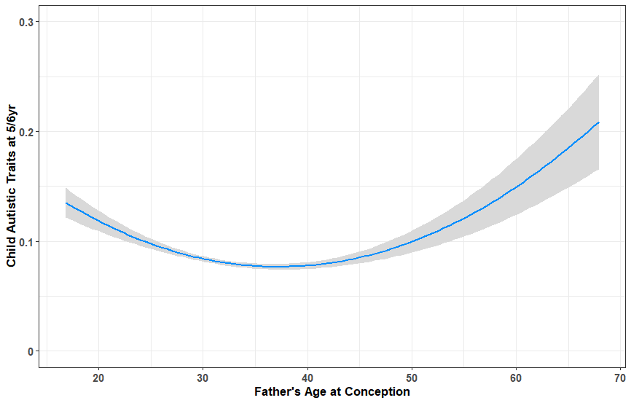
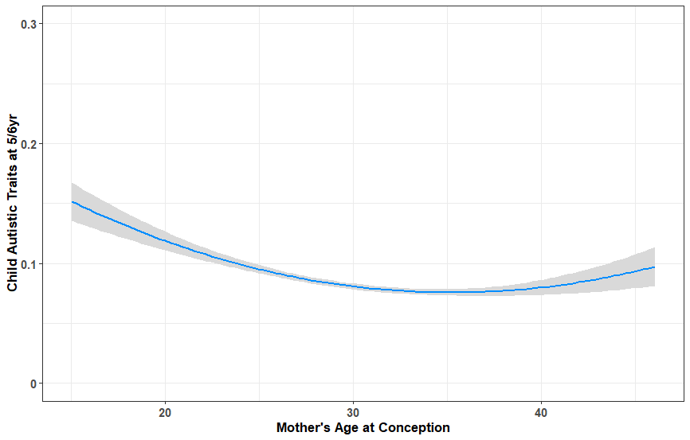

Child autistic-like traits at 5/6 years-of-age
Child autistic-like traits at 5/6 years-of-age

Supplementary Table 3

Association between maternal age and child autistic-like traits among mothers with parity of first pregnancy (N= 5,061)

 | Model 1 | R²  (change) | Model 2 | R²  (change) | Model 3 | R²  (change) | Model 4ª | R²  (change) | Model 4^{b} | R²  (change)
 | β (95% CI) | p | β (95% CI) | p | β (95% CI) | p | β (95% CI) | p | β (95% CI) | p
Step 1 |  | (.015)
Maternal Age | -.116 (-.147; -.085) | <.001 | -.113 (-.143; -.082) | <.001 | -.069 (-.101; -.036) | <.001 | -.071 (-.103; -.039) | <.001 | -.062 (-.094; -.029) | <.001
Step 2 |  |  |  | (.006)
Maternal Age Squared |  |  | .080 ( .050; .111) | <.001 | .058 ( .027; .089) | <.001 | .056 ( .025; .087) | .001 | .053 ( .022; .083) | .001
Step 3 |  |  |  |  |  | (.029)
Child Age |  |  |  |  | .038 ( .007; .069) | .017 | .037 ( .006; .068) | .021 | .042 ( .009; .074) | .012
Child Sex |  |  |  |  | -.210 (-.269; -.151) | <.001 | -.211 (-.269; -.152) | <.001 | -.212 (-.271; -.153) | <.001
Child National Origin |  |  |  |  | .006 (-.002; .013) | .120 | .005 ( -.003; .002) | .226 | .001 ( -.006; .009) | .781
Maternal Education |  |  |  |  | -.115 (-.146; -.083) | <.001 | -.101 (-.113; -.068) | <.001 | -.085 (-.117; -.052) | <.001
Step 4ª |  |  |  |  |  |  |  | (.006)
Maternal Mentalizing Skills |  |  |  |  |  |  | -.073 (-.117; -.029) | .002 | - | -
Step 4^{b} |  |  |  |  |  |  |  |  |  | (.023)
Maternal Autistic-like Traits |  |  |  |  |  |  | - | - | .158 ( .121; .194) | <.001
Note: R squared change is calculated by subtracting the changed explained variance in the model with the explained variance of the previous model.
β = standardized beta, 95% CI = 95% confidence interval. Bold denotes significance ( p < 0.05)

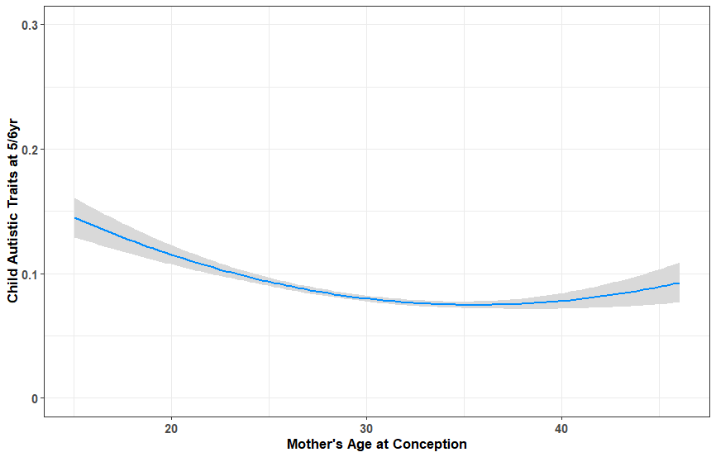
Supplementary Figure 3 Quadratic graphs between maternal age and child autistic-like traits after adjusting for maternal characteristics.
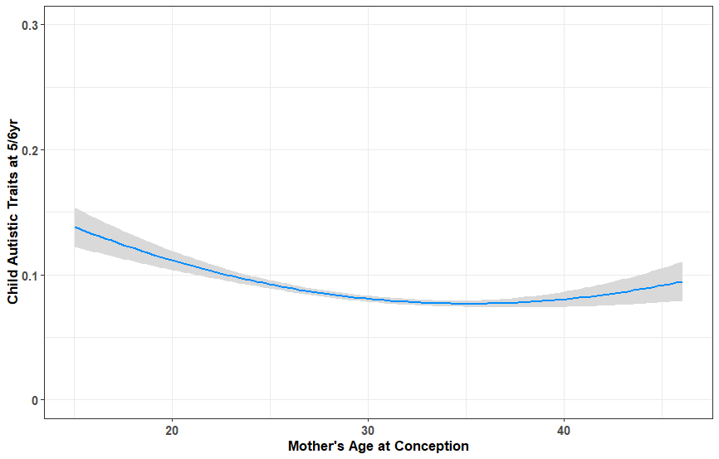

Child autistic-like traits at 5/6 years-of-age
Child autistic-like traits at 5/6 years-of-age

Quadratic graph (child autistic traits at 5/6 years) after adjusting for maternal autistic-like traits Quadratic graph (child autistic traits at 5/6 years) after adjusting for maternal mentalizing skill

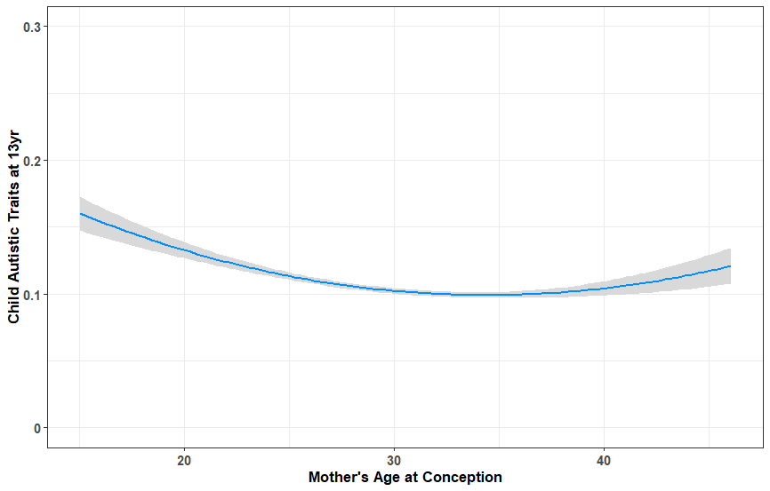
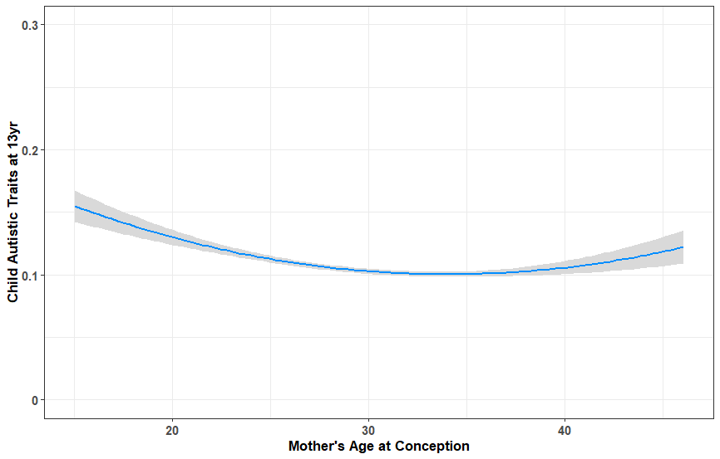

Child autistic-like traits at 13 years-of-age
Child autistic-like traits at 13 years-of-age

Quadratic graph (child autistic traits at 13 years) after adjusting for maternal autistic-like traits Quadratic graph (child autistic traits at 13 years) after adjusting for maternal mentalizing skill

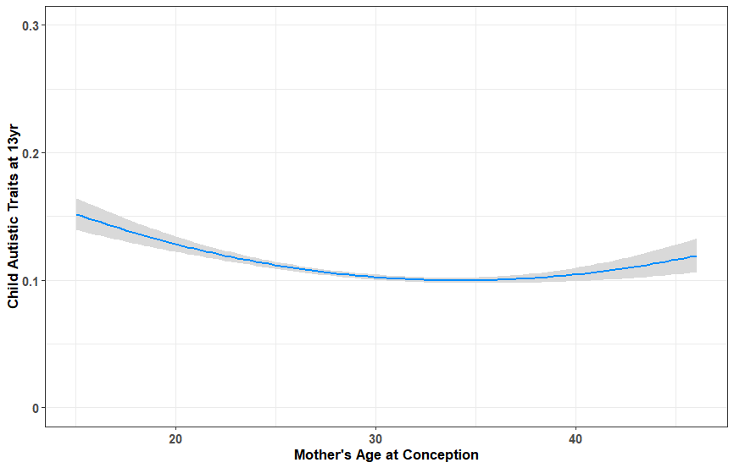
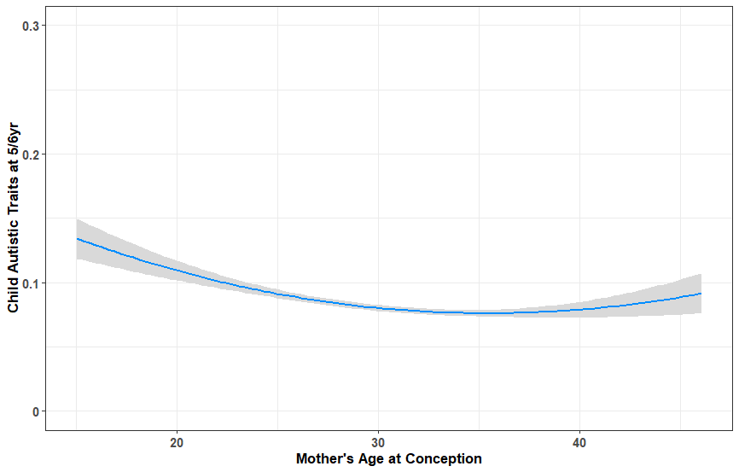

Child autistic-like traits at 5/6 years-of-age
Child autistic-like traits at 13 years-of-age

Quadratic graph (5/6y) after adjusting for maternal autistic-like traits and mentalizing skills Quadratic graph (13y) after adjusting for maternal autistic-like traits and mentalizing skills

Supplementary Figure 4 Polynomial regression

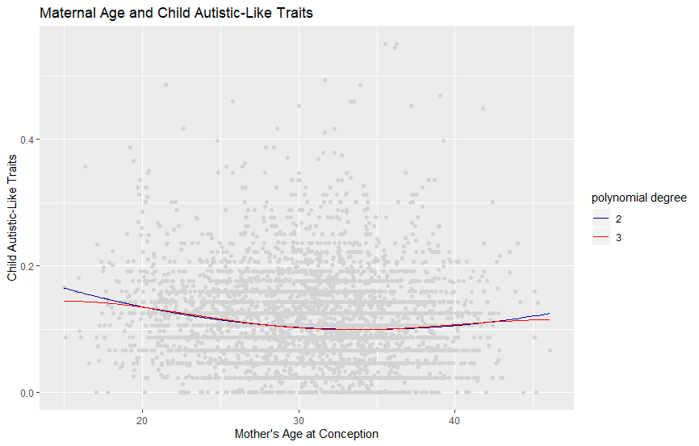

Supplementary Figure 5 Spline regression

