Supplementary Material
PCA Analysis

Supplementary Figure 1. PCA plots of SCQ-generated autism profiles in the thirteen genetic syndromes
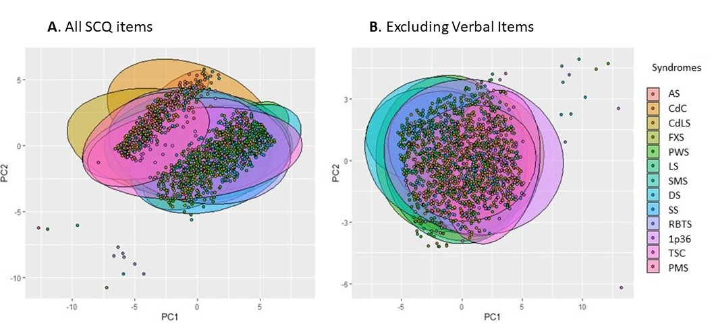
Abbreviations: AS - Angelman syndrome, CdCS - Cri du Chat syndrome, 1p36- 1p36 deletion syndrome, CdLS - Cornelia de Lange syndrome, FXS - fragile X syndrome, PWS – Prader-Willi syndrome, LS - Lowe syndrome, SMS – Smith-Magenis syndrome, DS – Down syndrome, SS- Sotos syndrome, RTS- Rubinstein-Taybi syndrome, TSC- tuberous sclerosis complex, PMS – Phelan-McDermid syndrome
Notes: The different colours represent the thirteen genetic syndromes.

Correlations
Supplementary Table 1. Correlations between the number of individuals assigned to each group and the post-hoc predicted probability
Number of individuals assigned to each group

Predicted probability |  | AS | FXS | PWS | RTS | CdLS | DS | CdCS | 1p36 | LS | SMS | TSC | SS | PMS
Predicted probability | AS | .989* | - | - | - | - | - | - | - | - | - | - | - | -
Predicted probability | FXS | -.135 | .977** | - | - | - | - | - | - | - | - | - | - | -
Predicted probability | PWS | -.148 | .290 | .965* | - | - | - | - | - | - | - | - | - | -
Predicted probability | RTS | -.116 | -.054 | -.029 | .998** | - | - | - | - | - | - | - | - | -
Predicted probability | CdLS | .174 | .328 | .371 | -.098 | .978** | - | - |  | - | - | - | - | -
Predicted probability | DS | -.140 | .178 | .693* | -.090 | .256 | .979** | - | - | - | - | - | - | -
Predicted probability | CdCS | .302 | .258 | .135 | -.198 | .233 | .038 | .967** | - | - | - | - | - | -
Predicted probability | 1p36 | .031 | .150 | .030 | -.349 | .349 | -.057 | -.040 | .731* | - | - | - | - | -
Predicted probability | LS | .007 | .735* | .449 | -.120 | .562* | .350 | .228 | .239 | .903** | - | - | - | -
Predicted probability | SMS | -.046 | .476* | .304 | -.074 | .450 | .228 | .155 | .180 | .569* | .658* | - | - | -
Predicted probability | TSC | -.154 | .543* | .504* | -.185 | .582* | .376 | .050 | .471 | .688* | .609* | .862** | - | -
Predicted probability | SS | -.195 | .804** | .661* | -.071 | .439 | .530* | .197 | .142 | .871* | .830** | .706* | .963** | -
Predicted probability | PMS | .207 | .336 | .090 | -.325 | .560* | .002 | .029 | .585* | .474 | .393 | .489* | .322 | .616*
 | n | 154 | 297 | 278 | 102 | 199 | 135 | 75 | 41 | 89 | 54 | 83 | 35 | 40
Abbreviations: AS - Angelman syndrome, CdCS - Cri du Chat syndrome, 1p36 – 1p36 deletion syndrome, CdLS - Cornelia de Lange syndrome, FXS - fragile X syndrome, PWS – Prader-Willi syndrome, LS - Lowe syndrome, SMS – Smith-Magenis syndrome, DS – Down syndrome, SS- Sotos syndrome, RTS- Rubinstein-Taybi syndrome, TSC- tuberous sclerosis complex, PMS – Phelan-McDermid syndrome, n = sample size
Notes: **p<0.001, *p<= 0.05

Supplementary Table 2. SVM results after the addition of self-help skills (WESSEX) as an additional predictor
Frequency of assigned class for the thirteen genetic syndromes
 | AS | CdCS | CdLS | FXS | PWS | LS | SMS | DS | SS | RTS | 1p36 | TSC | PMS | Total
 | n | n | n | n | n | n | n | n | n | n | n | n | n | n
AS | 133 | 17 | 26 | 5 | 3 | 8 | 5 | 6 | 1 | 3 | 9 | 2 | 11 | 229
CdCS | 3 | 24 | 2 | 0 | 0 | 1 | 1 | 0 | 0 | 0 | 2 | 0 | 0 | 33
CdLS | 12 | 9 | 103 | 13 | 7 | 16 | 7 | 5 | 3 | 5 | 14 | 18 | 16 | 228
FXS | 2 | 10 | 26 | 237 | 41 | 35 | 22 | 12 | 15 | 9 | 0 | 22 | 5 | 436
PWS | 3 | 11 | 37 | 33 | 202 | 22 | 13 | 43 | 17 | 8 | 6 | 29 | 0 | 424
LS | 0 | 0 | 0 | 0 | 0 | 6 | 0 | 0 | 0 | 0 | 0 | 0 | 0 | 6
SMS | 0 | 0 | 0 | 0 | 0 | 0 | 4 | 0 | 0 | 0 | 0 | 0 | 0 | 4
DS | 1 | 4 | 5 | 9 | 23 | 1 | 0 | 68 | 3 | 2 | 0 | 1 | 2 | 119
SS | 0 | 0 | 0 | 0 | 0 | 0 | 2 | 0 | 0 | 0 | 0 | 0 | 0 | 2
RTS | 0 | 0 | 0 | 0 | 2 | 0 | 0 | 1 | 1 | 75 | 0 | 1 | 0 | 80
1p36 | 0 | 0 | 0 | 0 | 0 | 0 | 0 | 0 | 0 | 0 | 10 | 0 | 0 | 10
TSC | 0 | 0 | 0 | 0 | 0 | 0 | 0 | 0 | 0 | 0 | 0 | 10 | 0 | 10
PMS | 0 | 0 | 0 | 0 | 0 | 0 | 0 | 0 | 0 | 0 | 0 | 0 | 1 | 1
Total n | 154 | 75 | 199 | 297 | 278 | 89 | 54 | 135 | 40 | 102 | 41 | 83 | 35 | 1582
Accuracy  (%) | 133/154 (86%) | 24/75 (32%) | 103/199 (52%) | 237/297  (80%) | 202/278  (73%) | 6/89  (7%) | 4/54  (7%) | 68/135  (50%) | 0/40  (0%) | 75/102  (74%) | 10/41  (24%) | 10/83  (12%) | 1/35  (3%) | 873/1582  (55%)
Abbreviations: AS - Angelman syndrome, CdCS - Cri du Chat syndrome, 1p36 – 1p36 deletion syndrome, CdLS - Cornelia de Lange syndrome, FXS - fragile X syndrome, PWS – Prader-Willi syndrome, LS - Lowe syndrome, SMS – Smith-Magenis syndrome, DS – Down syndrome, SS- Sotos syndrome, RTS- Rubinstein-Taybi syndrome, TSC- tuberous sclerosis complex, PMS – Phelan-McDermid syndrome, n- sample size

Frequency of assigned class for the thirteen genetic syndromes
 | AS | CdCS | CdLS | FXS | PWS | LS | SMS | DS | SS | RTS | ASD | 1p36 | TSC | PMS | Total
 | n | n | n | n | n | n | n | n | n | n | n | n | n | n | n
AS | 137 | 20 | 25 | 7 | 4 | 9 | 6 | 6 | 1 | 3 | 0 | 7 | 3 | 8 | 236
CdCS | 2 | 17 | 1 | 2 | 0 | 1 | 1 | 0 | 0 | 0 | 0 | 1 | 0 | 0 | 25
CdLS | 9 | 9 | 98 | 8 | 3 | 13 | 9 | 4 | 2 | 2 | 5 | 7 | 11 | 11 | 191
FXS | 2 | 12 | 29 | 196 | 33 | 24 | 12 | 12 | 13 | 4 | 23 | 3 | 20 | 1 | 384
PWS | 1 | 8 | 30 | 26 | 187 | 14 | 13 | 42 | 15 | 7 | 12 | 3 | 19 | 5 | 382
LS | 0 | 0 | 0 | 0 | 0 | 8 | 0 | 0 | 0 | 0 | 0 | 0 | 0 | 0 | 8
SMS | 0 | 0 | 0 | 0 | 0 | 0 | 2 | 0 | 0 | 0 | 0 | 0 | 0 | 0 | 2
DS | 1 | 3 | 8 | 8 | 31 | 4 | 0 | 64 | 2 | 2 | 1 | 2 | 6 | 2 | 134
SS | 0 | 0 | 0 | 0 | 0 | 0 | 0 | 0 | 0 | 0 | 0 | 0 | 0 | 0 | 0
RTS | 0 | 1 | 0 | 0 | 1 | 1 | 0 | 0 | 0 | 79 | 0 | 0 | 0 | 0 | 82
ASD | 2 | 5 | 8 | 50 | 19 | 15 | 11 | 7 | 7 | 5 | 217 | 5 | 17 | 6 | 374
1p36 | 0 | 0 | 0 | 0 | 0 | 0 | 0 | 0 | 0 | 0 | 0 | 13 | 0 | 0 | 13
TSC | 0 | 0 | 1 | 0 | 0 | 0 | 0 | 0 | 0 | 0 | 0 | 0 | 7 | 1 | 9
PMS | 0 | 0 | 0 | 0 | 0 | 0 | 0 | 0 | 0 | 0 | 0 | 0 | 0 | 1 | 1
Total n | 154 | 75 | 200 | 297 | 278 | 89 | 54 | 135 | 40 | 102 | 258 | 41 | 83 | 35 | 1841
Accuracy  (%) | 137/154 (89%) | 17/75 (23%) | 98/199 (49%) | 196/297  (66%) | 187/278  (67%) | 8/89  (9%) | 2/54  (4%) | 64/135  (47%) | 0/40  (0%) | 79/102  (77%) | 217/258  (84%) | 13/41  (32%) | 7/83  (8%) | 1/35  (9%) | 1034/1841  (56%)
Supplementary Table 3. SVM results after the addition of the ASD group
Abbreviations: AS - Angelman syndrome, CdCS - Cri du Chat syndrome, 1p36 – 1p36 deletion syndrome, CdLS - Cornelia de Lange syndrome, FXS - fragile X syndrome, PWS – Prader-Willi syndrome, LS - Lowe syndrome, SMS – Smith-Magenis syndrome, DS – Down syndrome, SS- Sotos syndrome, RTS- Rubinstein-Taybi syndrome, TSC- tuberous sclerosis complex, PMS – Phelan-McDermid syndrome, ASD- autism spectrum disorder, n- sample size
Abbreviations: AS - Angelman Syndrome, CdC - Cri du Chat, CdLS - Cornelia de Lange Syndrome, FXS - Fragile X Syndrome, PWS – Prader-Willi Syndrome, LS - Lowe Syndrome, SMS – Smith Magenis Syndrome, DS – Down Syndrome, SS- Sotos Syndrome, RBTS- Rubinstein-Taybi Syndrome, TSC- Tuberous Sclerosis Complex, PMS – Phelan-McDermid Syndrome, n- sample size

