SUPPLEMENTARY INFORMATION

Pharmacological inhibition of the CB1 cannabinoid receptor restores the abnormal brain mitochondrial CB1 receptor expression and rescues bioenergetic and cognitive defects in a female mouse model of Rett syndrome

Livia Cosentino¹*, Chiara Urbinati¹*, Chiara Lanzillotta², Domenico De Rasmo³, Daniela Valenti³, Mattia Pellas¹, Maria Cristina Quattrini⁴, Fabiana Piscitelli⁵, Magdalena Kostrzewa⁵, Fabio Di Domenico², Donatella Pietraforte⁴, Tiziana Bisogno⁶, Anna Signorile⁷, Rosa Anna Vacca³†, Bianca De Filippis¹†

¹Center for Behavioral Sciences and Mental Health, Italian National Institute of Health, Rome, Italy, livia.cosentino@iss.it, chiara.urbinati@iss.it, pellasmattia@live.it, bianca.defilippis@iss.it; ²Department of Biochemical Sciences "A. Rossi-Fanelli", Sapienza University of Rome, Rome, Italy, chiara.lanzillotta@uniroma1.it, fabio.didomenico@uniroma1.it; ³Institute of Biomembranes Bioenergetics and Molecular Biotechnologies, National Research Council, Bari, Italy, d.derasmo@ibiom.cnr.it, d.valenti@ibiom.cnr.it, r.vacca@ibiom.cnr.it; ⁴Core Facilities, Italian National Institute of Health, Rome, Italy, mariacristina.quattrini@iss.it, donatella.pietraforte@iss.it; ⁵Institute of Biomolecular Chemistry, National Research Council, Pozzuoli, Italy, fpiscitelli@icb.cnr.it, mkostrzewa@icb.cnr.it; ⁶Institute of Translational Pharmacology, National Research Council, Rome, Italy, tiziana.bisogno@ift.cnr.it; ⁷Department of Translational Biomedicine and Neuroscience, University of Bari Aldo Moro, Bari, Italy, anna.signorile@uniba.it.
*Equally contribute
†Correspondence: bianca.defilippis@iss.it; rosaanna.vacca@cnr.it

MATERIALS AND METHODS

Subjects
Mice were born from the breeding of heterozygous females with wild-type (Wt) males, weaned at postnatal day 25 and maintained in groups of 2-3 mice in polycarbonate transparent cages (33 × 13 × 14 cm) with sawdust bedding (Scobis Uno, Mucedola S.r.l., Italy), ad libitum tap water and a complete pellet diet (Altromin, 1324 – 10 mm pellets, Germany). Animals were housed on a 12-hour light-dark schedule (lights off at 7:30 am), with the temperature maintained at 21 ± 1°C and relative humidity at 60 ± 10%.

Genotyping
DNA has been prepared from a small tail-tip biopsy taken at weaning, as previously described (1). Briefly, tails were incubated overnight at 62 °C in 50 μL of a digestion mix (1 μL of proteinase K 1 mg/mL, 5 μL TRIS HCl 1 M pH 6.8 and 44 μL ddH₂O) for protein digestion and then at 92 °C for 20 minutes to inactivate proteinase K. The Mecp2 alleles have been identified by PCR using two sets of primers. Primer set 1 (5′ primer: 5′-AAC GGG GTA GAA AGC CTG-3′ and 3′ primer: 5′-ATG CTC CAG ACT GCC TTG -3′) yields a product of 396 bp identifying the Wt allele. Primer set 2 (5′ primer same as for primer set 1 and 3′ primer: 5′- TGA TGG GGT CCT CAG AGC -3′) yields a product of apparent size 318 bp identifying the null allele. PCR products were electrophoresed through a 1.2% NuSieve 3:1 agarose gel (Cambrex Bio Science, Rockland, ME, USA) containing 0.5 μg/mL ethidium bromide, and examined under UV light.

Drug
Rimonabant was purchased by Tocris Bioscience (United Kingdom), stored at -20 °C and thawed only to carry out the weighing operations. The selected dose of Rim was 10 times lower than that required to reduce body weight in rodents and was previously demonstrated to rescue cognitive defects in a FXS mouse model (2).

Experiment 1
Mitochondrial bioenergetics
Cryopreservation. Cryopreservation medium consisted in an ice-cold solution of 50 mM K-Mes (pH = 7.1), 3 mM K₂HPO₄, 9.5 mM MgCl₂, 3 mM ATP plus 20% glycerol and 10 mg/mL bovine serum albumin (BSA).
Brain ATP levels. Tissues were homogenized in 600 mL of pre-cooled 10% perchloric acid and then centrifuged at 14,000 × g for 10 minutes, 4 °C. The amount of tissue ATP was determined enzymatically in KOH-neutralized extracts, as described in (3).
Isolation of mitochondrial membrane-enriched fractions. Mitochondrial pellets were first frozen at -80 °C, then thawed at 2-4 °C, suspended in 1 mL of 10 mM Tris-HCl (pH 7.5) plus 1 mg/mL BSA and exposed to ultrasound energy for 8 seconds at 0 °C (11 pulses 0.7 s on, 0.7 s off) at 20 kHz, intensity 2. The ultrasound-treated mitochondria were centrifuged at 600 × g for 10 minutes, 4 °C. The supernatant was centrifuged again at 14,000 × g for 10 minutes at 4 °C and the resulting pellet was kept at -80 °C until use.
Mitochondrial ATP production rate. Mitochondria isolated from cryopreserved brain hemispheres (0.3-0.5 mg protein) were incubated at 37 °C in 2 mL of the respiratory medium consisted of 210 mM mannitol, 70 mM sucrose, 20 mM Tris-HCl, 5 mM KH₂PO4/K₂HPO₄, (pH = 7.4), 5 mg/mL BSA, 3 mM MgCl₂, in the presence of the ATP detecting system consisting of glucose (2.5 mM), hexokinase (HK, 2 e.u.), glucose 6-phosphate dehydrogenase (G6P-DH, 1 e.u.) and NADP⁺ (0.25 mM) and 5 mM succinate plus 3 µM rotenone as energy source. Care was taken to use enough HK/G6P-DH coupled enzymes to ensure a non-limiting ADP-regenerating system for the measurement of ATP production.

CB1R expression
Isolation of purified mitochondria using Ficoll gradient ultracentrifugation. Mitochondria extraction was performed from cryopreserved brain hemisphere according to Melser et al. (4). Briefly homogenates were centrifuged at 1,500 × g for 5 minutes (4° C) and the supernatant was centrifuged at 12,500 × g for 10 minutes (4 °C). The pellet was collected and both the cycles of centrifugation were repeated. The final pellet was resuspended in 250 μL of isolation buffer, layered on top of a discontinuous Ficoll gradient (12% and 7% Ficoll400 solutions, diluted in isolation buffer) and centrifuged at 100,000 × g for 1 hour (4 °C). The mitochondrial pellet was resuspend in 250 μL of isolation buffer for subsequent analysis. Validation of the purity of mitochondrial fractionation was determined by examining glyceraldehyde 3-phosphatedehydrogenase (GAPDH), and cytochrome oxidase subunit 1 (COX1) by western blot.
CB1R expression. The total protein concentration from the whole homogenate, as well as the mitochondrial-enriched fractions, was determined using the BCA method (Pierce, Rockford, IL, USA). Fifteen µg of proteins from brain homogenates and mitochondrial fractions were were separated by 4–15% gradient SDS-PAGE, using Criterion TGX (Tris-Glycine extended) Stain-Free precast gels (Bio-Rad, Hercules, CA, USA) in Tris/Glycine/SDS (TGS) Running Buffer (Bio-Rad Laboratories). All the samples were loaded on the same gel by using 26-well gel (Bio-Rad Laboratories). Immediately after electrophoresis, the gel was then placed on a Chemi/UV/Stain-Free tray and then placed into a ChemiDoc MP imaging System (Bio-Rad Laboratories) and UV-activated based on the appropriate settings with Image Lab Software (Bio-Rad Laboratories) to collect total protein load image. Following electrophoresis and gel imaging, the proteins were transferred via the TransBlot Turbo semi-dry blotting apparatus (Bio Rad Laboratories) onto nitrocellulose membranes (Bio-Rad, Hercules, CA, USA). Membranes were blocked with 3% of bovine serum albumin (SERVA Electrophoresis GmbH, Heidelberg, Germany) in TBS solution containing 0.01% Tween 20 and incubated over night at 4 °C with the following primary antibodies: CB1R (Cayman, USA), GAPDH (GeneTex) and COX1 (Novus Biological). Subsequently, membranes were incubated at room temperature with the respective horseradish peroxidase-conjugated secondary antibody (Sigma–Aldrich, St Louis, MO, USA). Membranes were developed with Clarity ECL substrate (Bio-Rad Laboratories, Hercules, CA, USA) and then acquired with ChemiDoc MP (Bio-Rad, Hercules, CA, USA) and analyzed using Image Lab 6.1 software (Bio-Rad, Hercules, CA, USA) that allows the normalization of a specific protein signal by the total protein load. Total protein staining quantifies the overall protein signal in each lane, reducing errors associated with using a single internal control protein. This method is both reliable and widely applicable for quantitative immunoblotting. By directly measuring and comparing the total protein amount in each lane, total protein staining eliminates the need for an internal reference protein, enhancing normalization accuracy. One effective way to detect total protein load is through stain-free technology (Bio-Rad, Hercules, CA, USA). This technology employs a proprietary trihalo compound that binds covalently to tryptophan residues, enhancing natural protein fluorescence upon brief UV activation. This allows for the capture of gel or membrane images multiple times without the need for staining and destaining steps.

Whole blood oxidative stress
The spin probe 1-hydroxy-3-carboxypyrrolidine (CPH) was dissolved in degassed phosphate buffer, pH 7.4, and extensively treated with Chelex-100 to avoid metal contamination. Briefly, CPH (0.5 mM) was added to 100 μL whole blood of Wt or RTT mice and the intensity of the 3-carboxy-proxyl radical (CP•) was measured after 20 minutes at 37 °C. Samples were drawn up into a gas-permeable Teflon tube with 0.81-mm internal diameter and 0.05-mm wall thickness (Zeuss Industrial Products). The Teflon tube was folded four times, inserted into a quartz tube, and fixed to the cavity (4108 TMH) of a Bruker ECS 106 EPR spectrometer equipped with a variable temperature unit (ER4111VT). Spectrometer conditions were: modulation frequency, 100 kHz; microwave frequency, 9.4 GHz; microwave power, 20 mW; gain 1 × 104; modulation amplitude, 1G; conversion time, 20.5 ms; time constant, 82 ms; sweep time, 21 s; and number of scans, 1.

Endocannabinoid analyses
Lipid extraction and brain eCBs measurement. After sacrifice, mouse brains were quickly removed and the cerebral areas of interest (hippocampus and striatum) were obtained by regional dissection on ice, immediately frozen and stored at -80 °C until processing. Tissues were homogenized and extracted with 2:1:1 (v/v) chloroform:methanol:Tris–HCl (50 mM, pH 7.4) containing d8-AEA and d5-2-AG as internal deuterated standards (Cayman Chemicals, USA) (5). The lipid-containing organic phases were then purified by open-bed chromatography on silica, fractions eluted with 90:10 (v/v) chloroform:methanol were collected and aliquots were analyzed by isotope dilution liquid chromatography (LC)/atmospheric pressure chemical ionization/mass spectrometry (MS) using a Shimadzu high-performance LC apparatus (LC-10ADVP) coupled to a Shimadzu (LC-MS-2020) quadrupole MS. MS detection was performed in selected ion monitoring mode by using m/z values of 356 and 348 [molecular ions (M) + 1 values for d8-AEA and AEA], 384 and 379 (M + 1 values for d5-2-AG and 2-AG). The levels of AEA and 2-AG were calculated based on the ratio of their peak area to that of the internal deuterated standard. Lipid amounts expressed as pmol were then normalized per g or mg of wet tissue.
Brain CB1R levels. After sacrifice, mouse brains were quickly removed and the cerebral areas of interest (hippocampus and striatum) were obtained by regional dissection on ice, immediately frozen and stored at -80 °C until processing. Samples were homogenized using the Rotor Stator Homogenizer (IKA®-Werke, Germany) in RIPA buffer (Sigma-Aldrich, Italy) containing inhibitors of proteases and phosphatases (1:200; Sigma-Aldrich, Italy), and cleared by centrifugation (13,000 × g for 20 minutes). The supernatant was collected, and protein concentration was determined using the Bradford protein assay (Bio-Rad, Italy). Protein samples (20 μg of total protein) were heated at 95 °C for 10 minutes in Laemmli 4× loading buffer (Bio-Rad, Italy) and then loaded on sodium dodecyl sulfate-polyacrylamide gel electrophoresis, SDS-PAGE. After, the proteins were transferred to 0.45 NC nitrocellulose membrane (GE Healthcare Life Sciences, USA). The blots were blocked with 5% non-fat dry milk in TBS with 0.1% Tween-20 (Sigma-Aldrich, Italy) for 1h at room temperature (RT) and incubated with anti-CB1 (Cayman Chemicals, USA) or anti-β-acting (Cell Signalling Technology, USA) antibodies overnight at 4 °C and then incubated with a peroxidase-conjugated secondary antibody for 2 hours in RT. Immuno-complexes were detected using a BM Chemiluminescence Western Blotting Substrate POD (Roche, Switzerland), visualized and quantified using the ChemiDoc™ MP Imaging System (BioRad, Italy).

Experiment 2
Object Location task. This task was conducted under dim lights (13 lux) in square-shaped plastic boxes (40 × 40 cm) enclosed by grey walls (40 cm high), and a white floor, using methods previously described (6) with little modification. A squared, circular and triangle-shaped white figures were positioned in the upper part of the apparatus walls to serve as visual cues for navigation (6). To minimize olfactory cues, both the apparatus and the objects were cleaned with 70% ethanol between animals. Objects used were green glass squared or white plastic oval-based bottles. Objects assignment and their allocation to specific locations were counterbalanced within each experimental group. The task was video-recorded and Any-Maze video tracking system (v. 6.3, Stoelting Co, USA) was used to automatically score the time that animals spent with 70% of their body in the quadrants containing the objects during the task.
Y-maze test. The apparatus was made from transparent Perspex and consisted of three arms (30 x 8 x 20 cm) connected by a central junction. A 5 cm layer of sawdust, slightly soiled by a non-experimental female mouse exploring the entire apparatus for 8 minutes, covered the floor of the maze, which was rearranged throughout the maze between the familiarization and the test phases to prevent mice from using odor cues to solve the task (7). Visual cues for navigation were positioned 15 cm from the Y-maze perimeter: a plastic bottle (5 x 10 cm), a cardboard box (20 x 12 x 7 cm) and a three-chamber wired cage (10 x 30 cm). Allocation of the familiar and the novel arms to specific spatial locations was counterbalanced within each experimental group. The task was video-recorded and the time spent with 70% of the body in each arm during the test phase were scored by means of the Any-Maze video tracking system (v. 6.3, Stoelting Co, USA).
General health status evaluation. Mice were temporarily removed from their home cages and put on a laboratory bench, where, within 2 minutes, they received a score (ranging from 0 = normal to 4 = severe) for each of the following symptoms: gait, mobility, breathing, kyphosis, fur, hindlimb clasping, tremors, seizure occurrence, and general condition. The individual scores for each category were subsequently averaged to obtain a semi-quantitative measure of symptom status (or general health status).

FIGURES AND TABLES

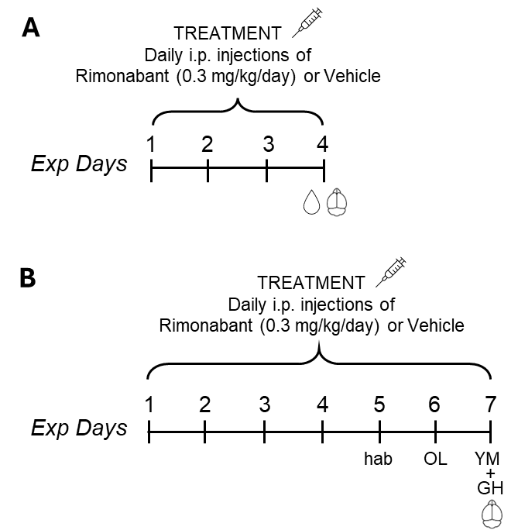
Supplementary Figure 1 - Timeline of the experimental schedule. Experimental animals were intraperitoneally injected once a day with the CB1 cannabinoid receptor (CB1R) inhibitor Rimonabant (0.3 mg/kg) or Vehicle. (A) Experiment 1; Mecp2-308 heterozygous female mice and wild-type controls were treated for 4 days, and 4 hours after the last injection the blood and brains were collected to evaluate treatment effects on mitochondrial bioenergetics, oxidative stress status and mitochondrial CB1R-mitochondrial Protein Kinase A signaling pathway. (B) Experiment 2; a separate cohort of RTT mice was daily treated for 7 days to assess drug effects on RTT mouse cognitive profile. Treatment effects on mitochondrial bioenergetics and mitochondrial CB1R expression were also evaluated on brains collected 4 hours after the last injection. Exp: experimental, hab: habituation to the object location (OL) test arena; YM: Y-maze test; GH: general health status evaluation.

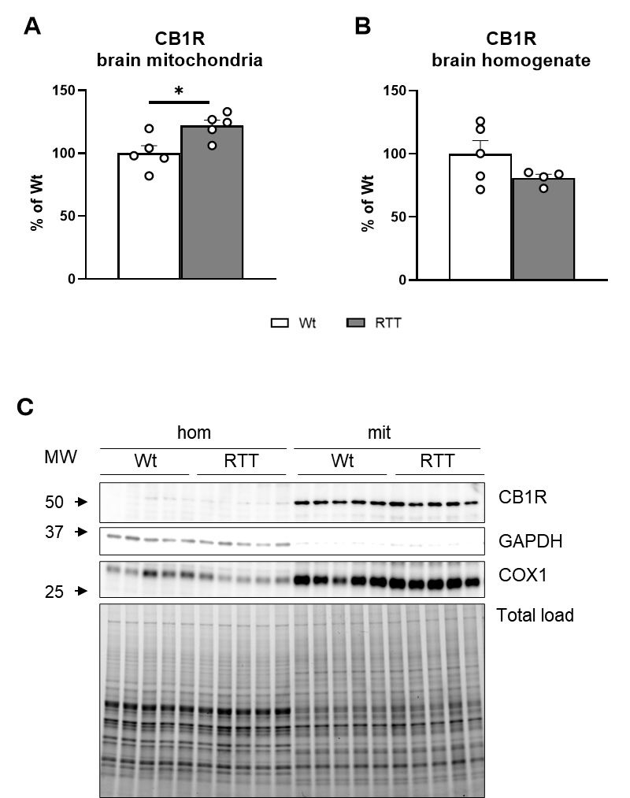

Supplementary Figure 2 - CB1 cannabinoid receptor is overexpressed in RTT mice mitochondria-associated membranes isolated through Ficoll gradient ultracentrifugation. Mecp2-308 heterozygous female mice (RTT) and wild-type (Wt) controls were sacrificed, and the brain tissue was sampled to assess the CB1 cannabinoid receptor (CB1R) in brain mitochondria isolated through Ficoll gradient ultracentrifugation (mit) and in brain homogenates (hom). (A) CB1R is overexpressed at the mitochondrial membranes (mtCB1R) in the brain of RTT mice compared to Wt controls. (B) CB1R levels are unaltered in brain homogenates of RTT mice. A single observation was removed from the data as it was significantly outside the group average. (C) Representative images of Western blotting analysis. After SDS-polyacrylamide gel electrophoresis (PAGE), the gel was placed on a Chemi/UV/Stain-Free tray and total protein load image was collected using a ChemiDoc MP imaging System (Bio-Rad Laboratories) with Image Lab Software (Bio-Rad Laboratories). The proteins were then transferred on nitrocellulose membranes and immunoblotted with the antibody against CB1R. Mitochondria enrichment was assessed by antibodies for glyceraldehyde 3-phosphate dehydrogenase (GAPDH) and cytochrome oxidase subunit 1 (COX1). N = 4-5. Data are mean ± SEM and are expressed as a percentage of the values of Wt. Statistical significance was calculated by Student’s t test. * p < 0.05.
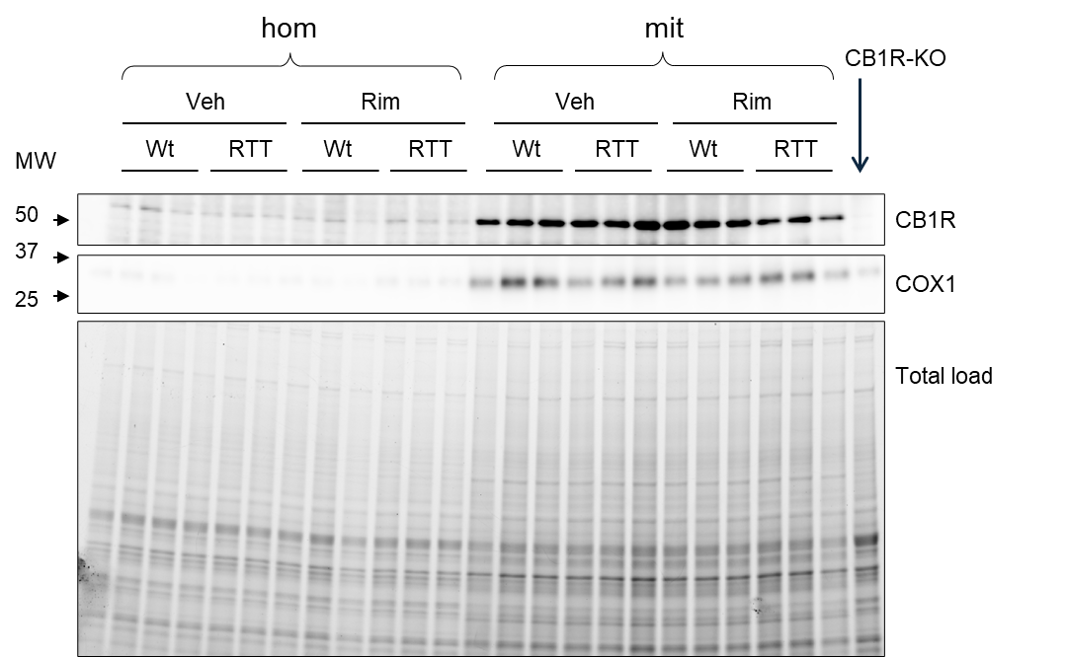

Supplementary Figure 3 – A 7-day-long treatment with rimonabant normalizes CB1 cannabinoid receptor overexpression in RTT mice mitochondria-associated membranes. Mecp2-308 heterozygous female (RTT) mice received intraperitoneal daily injections with the CB1 cannabinoid receptor (CB1R) inverse agonist Rimonabant (Rim, 0.3 mg/kg) or Vehicle (Veh) for 7 days. Four hours after the last injection mice were sacrificed and the brain tissue was sampled to assess the CB1R in isolated brain mitochondria (mit) and in brain homogenates (hom). Representative images of Western blotting analysis are shown. After SDS-polyacrylamide gel electrophoresis (PAGE), the gel was placed on a Chemi/UV/Stain-Free tray and total protein load image was collected using a ChemiDoc MP imaging System (Bio-Rad Laboratories) with Image Lab Software (Bio-Rad Laboratories). The proteins were then transferred on nitrocellulose membranes and immunoblotted with the antibody against CB1R. Mitochondria enrichment was assessed by antibodies for cytochrome oxidase subunit 1 (COX1). The membrane includes a CB1R-knockout control (CB1R-KO, a sample of brain cortical tissue was kindly provided by Dr. Ester Aso Perez, University of Barcelona) to prove that the quantified immunoreactive band corresponds to CB1R.

Supplementary Figure 4 – The CB1 cannabinoid receptor – protein kinase A signaling is unaltered in the brain homogenates of a RTT mouse model. Mecp2-308 heterozygous female mice (RTT) and wild-type (Wt) controls received intraperitoneal daily injections with Rimonabant (Rim, 0.3 mg/kg) or Vehicle (Veh) for 4 or 7 days; 4 hours after the last injection mice were sacrificed; the brain tissue was sampled to assess the CB1 cannabinoid receptor (CB1R) expression and protein kinase A (PKA) activity in total brain, hippocampal and striatal homogenates. (A-B) CB1R levels are unaltered in brain homogenates of Veh-treated RTT mice but are transiently reduced by treatment with Rim. (C) Rim has no effect on PKA activity in brain homogenates of RTT mice, which are unaltered compared to Wt controls. (D) No differences were detected in CB1R expression in either the hippocampus or striatum among the four experimental groups. Immunoblots were assembled to show examples from 1 animal from each experimental group. CB1R levels were normalized to β-actin contents. N = 3-6. Data are mean ± SEM and are expressed as a percentage of the values of Wt and Veh. Statistical significance was calculated by two-way ANOVA followed by Tukey’s post-hoc test or Kruskal-wallis test followed by Dunn’s post-hoc test.

Supplementary Table 1. Levels of AEA and 2-AG in hippocampus and striatum.
Levels of anandamide (AEA) and 2-arachidonoylglycerol (2-AG) in the hippocampus and striatum of Mecp2-308 heterozygous female mice (RTT) and wild-type littermates (Wt) treated with Rimonabant (Rim, 0.3 mg/kg/day) or vehicle (Veh) for 4 days. No differences were detected in either the hippocampus or striatum among the four experimental groups. N=5-6. Data are presented as the mean ± standard deviation (SD). Statistical significance was calculated by two-way ANOVA.
Genotype | Treatment | AEA (pmol/g) |  | 2-AG (pmol/mg)
Genotype | Treatment | hippocampus | striatum | hippocampus | striatum
Wt | Veh | 107.21 ± 35.89 | 64.74 ± 45.33 | 1.21 ± 0.75 | 1.72 ± 0.46
Wt | Rim | 141.21 ± 20.35 | 75.23 ± 49.55 | 1.43 ± 0.28 | 2.12 ± 0.12
RTT | Veh | 120.97 ± 41.04 | 88.93 ± 18.96 | 1.35 ± 0.53 | 1.93 ± 0.47
RTT | Rim | 126.98 ± 27.13 | 55.84 ± 38.78 | 1.42 ± 0.23 | 1.49 ± 0.65

REFERENCES

1. Zuliani I, Urbinati C, Valenti D, Quattrini MC, Medici V, Cosentino L, et al. The Anti-Diabetic Drug Metformin Rescues Aberrant Mitochondrial Activity and Restrains Oxidative Stress in a Female Mouse Model of Rett Syndrome. J Clin Med. 2020; doi: 10.3390/jcm9061669.
2. Gomis-González M, Busquets-Garcia A, Matute C, Maldonado R, Mato S, Ozaita A. Possible Therapeutic Doses of Cannabinoid Type 1 Receptor Antagonist Reverses Key Alterations in Fragile X Syndrome Mouse Model. Genes (Basel). 2016; doi: 10.3390/genes7090056.
3. Valenti D, Tullo A, Caratozzolo MF, Merafina RS, Scartezzini P, Marra E, et al. Impairment of F1F0-ATPase, adenine nucleotide translocator and adenylate kinase causes mitochondrial energy deficit in human skin fibroblasts with chromosome 21 trisomy. Biochemical Journal. 2010; doi: 10.1042/BJ20100581.
4. Melser S, Pagano Zottola AC, Serrat R, Puente N, Grandes P, Marsicano G, et al. Functional Analysis of Mitochondrial CB1 Cannabinoid Receptors (mtCB1) in the Brain. Methods Enzymol. 2017; doi: 10.1016/bs.mie.2017.06.023.
5. Marsicano G, Wotjak CT, Azad SC, Bisogno T, Rammes G, Cascio MG, et al. The endogenous cannabinoid system controls extinction of aversive memories. Nature. 2002; doi: 10.1038/nature00839.
6. Murai T, Okuda S, Tanaka T, Ohta H. Characteristics of object location memory in mice: Behavioral and pharmacological studies. Physiol Behav. 2007; doi: 10.1016/j.physbeh.2006.09.013.
7. Vigli D, Cosentino L, Raggi C, Laviola G, Woolley-Roberts M, De Filippis B. Chronic treatment with the phytocannabinoid Cannabidivarin (CBDV) rescues behavioural alterations and brain atrophy in a mouse model of Rett syndrome. Neuropharmacology. 2018; doi: 10.1016/j.neuropharm.2018.07.029.

