Supplementary Material

Impact of chronic intranasal oxytocin administration on face expression processing in autistic children: a randomized controlled trial using fMRI

Matthijs Moerkerke*^{1,2}, Nicky Daniels*^{2,3}, Stephanie Van der Donck^{1,2}, Tiffany Tang^{1,2}, Jellina Prinsen^{2,3}, Elahe’ Yargholi⁴, Jean Steyaert^{1,2}, Kaat Alaerts ^{✝2,3}, Bart Boets ^{✝1,2}
¹ Center for Developmental Psychiatry, Department of Neurosciences, KU Leuven, Leuven, Belgium
²Leuven Autism Research (LAuRes), KU Leuven, Leuven, Belgium
³ Research Group for Neurorehabilitation, Department of Rehabilitation Sciences, KU Leuven, Leuven, Belgium
⁴ Department of Brain and Cognition, Faculty of Psychology & Educational Sciences, KU Leuven, Leuven, Belgium
* shared first authors
✝ shared last authors

Supplementary methods

Participants
Forty non-autistic children and eighty children with autism were recruited and assessed at baseline (T0). Only the autistic children were allocated to receive either oxytocin or placebo (four weeks of twice daily intranasal administrations), followed by a post-treatment (T1) assessment. Main inclusion criteria comprised a clinical diagnosis of autism (only for children with autism); age (8-12 years old); IQ above 70; no prior oxytocin treatment and native Dutch speaker. The autism diagnosis was established by a multidisciplinary team (child psychiatrist and/or expert neuropediatrician, psychologist, speech/language pathologist and/or physiotherapist) based on the criteria of the Diagnostic and Statistical Manual of Mental Disorders, 5th edition (American Psychiatric Association, 2013). Main exclusion criteria comprised a history of any neurological disorder (stroke, concussion, epilepsy etc.), any physical disorder (liver, renal, cardiac pathology), significant hearing or vision impairments, or any neuropsychiatric diagnosis (only for non-autistic children). Only premenstrual girls were included. Fifteen participants with autism had a comorbid diagnosis of attention deficit/hyperactivity disorder (ADHD). Thirty of the 58 autistic children followed stable concomitant psychosocial therapy. Eighteen of the autistic participants used stimulant medication (e.g. methylphenidate), 10 anti-psychotics (e.g. risperidone), 3 anti-depressants (e.g. sertraline) and 25 used other medication (e.g. sleeping aids, gastro-intestinal medication or nutritional supplements). No differences in the occurrence of medication use or comorbidities were observed between the treatment groups (Fisher's Exact Tests, all p > 0.18).

Definition of ROIs
Seven brain regions involved in the core and extended face processing network were delineated: the inferior occipital cortex (including the OFA), the posterior fusiform cortex (including the FFA), and the superior temporal cortex (including the STS), the amygdala, the anterior temporal cortex, the inferior frontal cortex, and primary visual cortex V1, see Fig. S1.
Figure 3. Regions of interest. The bottom row displays the subcortical region (amygdala) and the top and middle row show the six cortical regions of interest used in this study. These ROIs were created based on anatomical masks and were subsequently functionally restricted with voxels active during face processing. Figure reprinted from Hendriks et al. (2021).

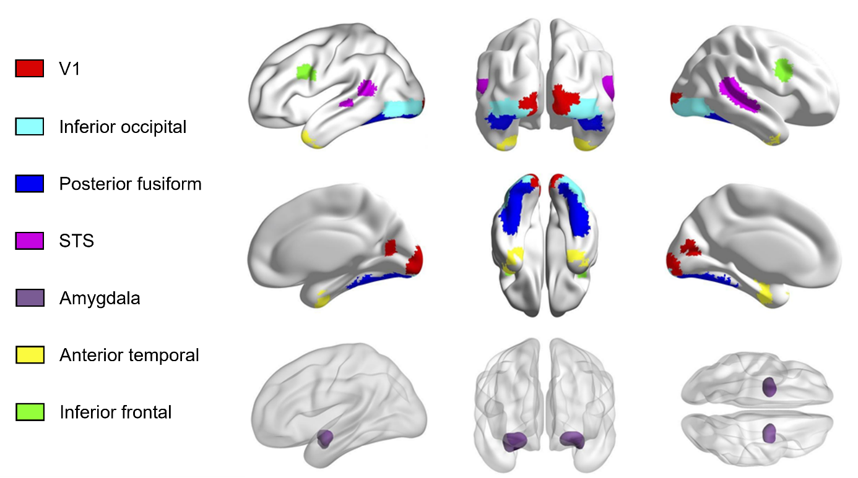
Supplementary results

ROI analysis of face expression specific contrasts
The primary aim of the current study was to investigate whether autistic children differed from non-autistic controls in fMRI face processing responses, and to evaluate the effect of repeated oxytocin administrations on these fMRI responses. Therefore, the main contrast was FACESvsFIX (i.e., the neutral and fearful face conditions combined vs fixation), in line with previous research (Hendriks et al., 2021). Although five additional contrasts were also calculated, in order to evaluate the effect of neutral or fearful expressions, in particular (from more general to more specific): NEUTRALvsFIX, FEARFULvsFIX, NEUTRALvsSCRAMBLED, FEARFULvsSCRAMBLED and FEARFULvsNEUTRAL.
For the diagnostic-group comparison, no significant group differences were found (all p_{FDR} > 0.11, see Tables S1A-E ).
Multivariate analysis
In order to explore diagnostic-group differences in how (expressive) faces are represented in the brain, we compared the neural dissimilarity found in the multivoxel patterns evoked by distinct face conditions. Results revealed that none of the ROIs contained sufficient multivoxel pattern information to distinguish between the two face conditions (i.e., fearful vs neutral). Consequently, the comparison of neural dissimilarity between diagnostic groups for fearful and neutral faces showed no significant differences in any of the ROIs (all p_{FDR} > 0.89, see Table S2).
Table S1 Single-group activity and diagnostic-group comparison of average ROI activity for face-expression specific contrasts
A. NEUTRALvsFIX contrast.
Average ROI activity  NEUTRAL vs. FIX contrast | Autism  beta-value | No autism  beta-value | Group comparison
Average ROI activity  NEUTRAL vs. FIX contrast | Autism  beta-value | No autism  beta-value | t value | P_{unc} | P_{FDR}
V1 | -0.06 | -0.02 | -0.85 | 0.40 | 0.75
Left inferior occipital | 0.18* | 0.14* | 0.95 | 0.34 | 0.75
Right inferior occipital | 0.24* | 0.23* | 0.09 | 0.93 | 0.96
Left posterior fusiform | 0.22* | 0.21* | 0.24 | 0.81 | 0.96
Right posterior fusiform | 0.24* | 0.30* | -0.97 | 0.33 | 0.75
Left STS | 0.01 | 0.05 | -1.09 | 0.28 | 0.75
Right STS | 0.06° | 0.11* | -1.10 | 0.27 | 0.75
Left amygdala | 0.09 | 0.09 | 0.07 | 0.95 | 0.96
Right amygdala | 0.09 | 0.11* | -0.21 | 0.83 | 0.96
Left anterior temporal | 0.00 | 0.05 | -1.22 | 0.23 | 0.75
Right anterior temporal | -0.01 | 0.05 | -1.31 | 0.19 | 0.75
Left inferior frontal | 0.05° | 0.05 | 0.05 | 0.96 | 0.96
Right inferior frontal | 0.23* | 0.20 | 0.50 | 0.62 | 0.92

B. FEARFULvsFIX contrast.
Average ROI activity  FEARFUL vs. FIX contrast | Autism  beta-value | No autism  beta-value | Group comparison
Average ROI activity  FEARFUL vs. FIX contrast | Autism  beta-value | No autism  beta-value | t value | P_{unc} | P_{FDR}
V1 | -0.07 | -0.01 | -1.09 | 0.28 | 0.53
Left inferior occipital | 0.19* | 0.16* | 0.61 | 0.54 | 0.64
Right inferior occipital | 0.26* | 0.19* | 1.64 | 0.11 | 0.32
Left posterior fusiform | 0.19* | 0.17* | 0.18 | 0.85 | 0.85
Right posterior fusiform | 0.25* | 0.22* | 0.59 | 0.56 | 0.64
Left STS | 0.01 | 0.04 | -0.71 | 0.48 | 0.64
Right STS | 0.05 | 0.07* | -0.64 | 0.52 | 0.64
Left amygdala | 0.10* | 0.14* | -0.63 | 0.53 | 0.64
Right amygdala | 0.11* | 0.08* | 0.43 | 0.67 | 0.72
Left anterior temporal | -0.02 | 0.08* | -2.70 | 0.01 | 0.13
Right anterior temporal | -0.02 | 0.06* | -2.35 | 0.02 | 0.16
Left inferior frontal | 0.01 | 0.06 | -1.45 | 0.15 | 0.33
Right inferior frontal | 0.25* | 0.16* | 1.73 | 0.09 | 0.32

C. NEUTRALvsSCRAMBLE contrast.
Average ROI activity  NEUTRAL vs SCRAMBLE contrast | Autism  beta-value | No autism  beta-value | Group comparison
Average ROI activity  NEUTRAL vs SCRAMBLE contrast | Autism  beta-value | No autism  beta-value | t value | P_{unc} | P_{FDR}
V1 | 0.06 | 0.10° | -0.74 | 0.46 | 0.76
Left inferior occipital | 0.03 | -0.04 | 1.64 | 0.11 | 0.76
Right inferior occipital | 0.03 | -0.01 | 0.90 | 0.37 | 0.76
Left posterior fusiform | 0.09* | 0.04 | 1.26 | 0.21 | 0.76
Right posterior fusiform | 0.07° | 0.06 | 0.36 | 0.72 | 0.83
Left STS | 0.03 | 0.05 | -0.54 | 0.59 | 0.80
Right STS | 0.08* | 0.09* | -0.26 | 0.80 | 0.85
Left amygdala | 0.05 | 0.00 | 1.05 | 0.30 | 0.76
Right amygdala | 0.05 | 0.07 | -0.47 | 0.64 | 0.80
Left anterior temporal | 0.05° | 0.02 | 1.04 | 0.30 | 0.76
Right anterior temporal | 0.01 | 0.03 | -0.54 | 0.59 | 0.80
Left inferior frontal | 0.03 | 0.06° | -0.80 | 0.43 | 0.76
Right inferior frontal | 0.06 | 0.12* | -1.17 | 0.25 | 0.76

D. FEARFULvsSCRAMBLE contrast.
Average ROI activity  FEARFUL vs SCRAMBLE contrast | Autism  beta-value | No autism  beta-value | Group comparison
Average ROI activity  FEARFUL vs SCRAMBLE contrast | Autism  beta-value | No autism  beta-value | t value | P_{unc} | P_{FDR}
V1 | 0.05 | 0.02 | 0.54 | 0.59 | 0.86
Left inferior occipital | 0.04 | -0.06° | 2.75 | 0.01 | 0.11
Right inferior occipital | 0.03 | -0.06 | 2.08 | 0.04 | 0.20
Left posterior fusiform | 0.03 | -0.03 | 1.08 | 0.28 | 0.85
Right posterior fusiform | 0.04 | -0.07 | 2.23 | 0.03 | 0.20
Left STS | 0.01 | 0.01 | -0.02 | 0.98 | 0.98
Right STS | 0.06° | 0.03 | 0.64 | 0.52 | 0.86
Left amygdala | 0.06 | 0.04 | 0.38 | 0.70 | 0.86
Right amygdala | 0.02 | 0.04 | -0.44 | 0.66 | 0.86
Left anterior temporal | 0.02 | 0.03 | -0.44 | 0.66 | 0.86
Right anterior temporal | 0.01 | 0.04° | -1.11 | 0.27 | 0.85
Left inferior frontal | 0.02 | 0.02 | -0.26 | 0.80 | 0.86
Right inferior frontal | 0.04 | 0.06 | -0.30 | 0.77 | 0.86

E. FEARFULvsNEUTRAL contrast.
Average ROI activity  FEARFUL vs NEUTRAL contrast | Autism  beta-value | No autism  beta-value | Group comparison
Average ROI activity  FEARFUL vs NEUTRAL contrast | Autism  beta-value | No autism  beta-value | t value | P_{unc} | P_{FDR}
V1 | -0.05 | -0.01 | -0.92 | 0.36 | 0.78
Left inferior occipital | 0.02 | 0.02 | 0.03 | 0.98 | 0.98
Right inferior occipital | 0.02 | 0.00 | 0.46 | 0.64 | 0.88
Left posterior fusiform | -0.06 | -0.04 | -0.31 | 0.76 | 0.94
Right posterior fusiform | -0.03 | -0.09* | 1.43 | 0.16 | 0.78
Left STS | 0.00 | -0.02 | 0.70 | 0.49 | 0.81
Right STS | -0.02 | -0.03 | 0.23 | 0.82 | 0.94
Left amygdala | 0.02 | 0.02 | -0.16 | 0.87 | 0.94
Right amygdala | -0.05° | 0.03 | -1.78 | 0.08 | 0.78
Left anterior temporal | -0.02 | 0.01 | -1.19 | 0.24 | 0.78
Right anterior temporal | 0.01 | 0.03 | -0.78 | 0.44 | 0.81
Left inferior frontal | -0.02 | 0.02 | -1.11 | 0.27 | 0.78
Right inferior frontal | 0.00 | -0.02 | 0.58 | 0.56 | 0.84
Note. Beta-values with an asterisks (° p < 0.05 uncorrected, * q < 0.05 FDR corrected) indicate whether the contrast yields significant brain activity within a particular ROI within a particular group, based on a one-sample t-test with H₀: Mean X=0. P-values in bold (p < 0.05) indicate whether the contrast yields significant brain activity within a particular ROI between both groups, based on a two-sample t-test.

Table S2. Diagnostic-group comparison of representational dissimilarity between fearful and neutral faces.
RSA  Fearful vs. neutral | Autism  correlation distance | No autism  correlation distance | Group comparison
RSA  Fearful vs. neutral | Autism  correlation distance | No autism  correlation distance | t value | P_{unc} | P_{FDR}
V1 | 0.85 | 0.89 | -0.81 | 0.42 | 0.89
Inferior occipital | 0.91 | 0.90 | 0.18 | 0.85 | 0.89
Posterior fusiform | 0.87 | 0.85 | 0.39 | 0.69 | 0.89
STS | 0.90 | 0.88 | 0.35 | 0.72 | 0.89
Amygdala | 0.93 | 0.98 | -0.73 | 0.47 | 0.89
Anterior temporal | 0.98 | 0.99 | -0.12 | 0.91 | 0.91
Inferior frontal | 0.83 | 0.88 | -0.79 | 0.43 | 0.89

