Supplementary Information

Cluster | Predictor | F value | p-value
HL < TL, English | Group | 10.22 | 0.003*
HL < TL, English | Sex | 0.31 | 0.58
HL < TL, English | MatEd | 2.42 | 0.13
HL < TL, English | Birth Order | 0.35 | 0.56
HL < TL, English | Group*Sex | 0.64 | 0.43
HL < TL, English | Group*MatEd | 2.08 | 0.16
HL < TL, English | Group*BirthOrder | -- | --
HL < TL, Japanese brain clusters | Group | 29.58 | <0.001 *
HL < TL, Japanese brain clusters | Sex | 1.85 | 0.18
HL < TL, Japanese brain clusters | MatEd | 2.25 | 0.14
HL < TL, Japanese brain clusters | Birth Order | 8.97 | 0.005*
HL < TL, Japanese brain clusters | Group*Sex | 1.51 | 0.23
HL < TL, Japanese brain clusters | Group*MatEd | 2.89 | 0.10
HL < TL, Japanese brain clusters | Group*BirthOrder | -- | --
HL < TL, Japanese cerebellum clusters | Group | 12.91 | <0.001*
HL < TL, Japanese cerebellum clusters | Sex | 0.003 | 0.96
HL < TL, Japanese cerebellum clusters | MatEd | 0.51 | 0.48
HL < TL, Japanese cerebellum clusters | Birth Order | 5.30 | 0.03*
HL < TL, Japanese cerebellum clusters | Group*Sex | 3.92 | 0.055
HL < TL, Japanese cerebellum clusters | Group*MatEd | 0.001 | 0.98
HL < TL, Japanese cerebellum clusters | Group*BirthOrder | -- | --
Table S1. Effects of Potential Confounds: Parameter estimates were extracted from brain clusters that showed significant group differences. Group differences were tested for significance using ACNOVAs. All models included scanner as a nuisance predictor. Group differences were still significant across all models tested (p-values bolded). MatEd: maternal education; HL: high likelihood for autism; TL: typical likelihood for autism.

Cluster | Predictor | F value | p-value
HL < TL, English | Group | 11.97 | 0.001*
HL < TL, English | LangExp | 1.70 | 0.20
HL < TL, English | Group*LangExp | 0.57 | 0.46
HL < TL, Japanese brain clusters | Group | 21.50 | <0.001*
HL < TL, Japanese brain clusters | LangExp | 0.11 | 0.74
HL < TL, Japanese brain clusters | Group*LangExp | 0.54 | 0.47
HL < TL, Japanese cerebellum clusters | Group | 12.84 | <0.001
HL < TL, Japanese cerebellum clusters | LangExp | 0.66 | 0.42
HL < TL, Japanese cerebellum clusters | Group*LangExp | 2.96 | 0.09
Table S2. Effects of Language Exposure: Parameter estimates were extracted from brain clusters that showed significant group differences, and the effect of second-language exposure was tested, along with the effect of a group-by-language-exposure interaction, using ANOVA. All models included scanner as a nuisance covariate. Group differences were still significant across all of the models (p-values bolded). LangExp: second language exposure, coded as a binary variable (presence of any non-English exposure ≤ 50%, versus 100% English exposure).

Birth Order
 | First-born | Not First-born | t or Χ² | P-value
MSEL T-scores (12 months)
Gross Motor | 51.2 | 49.0 | 0.28 | 0.79
Fine Motor | 69.2 | 62.4 | 1.30 | 0.23
Visual Reception | 61.4 | 59.1 | 0.96 | 0.35
Receptive Language | 52.0 | 51.8 | 0.08 | 0.94
Expressive Language | 53.0 | 52.8 | 0.03 | 0.98
MSEL T-scores (36 months)
Gross Motor | – | – | – | –
Fine Motor | 56.7 | 54.0 | 0.47 | 0.65
Visual Reception | 63.0 | 59.7 | 0.74 | 0.46
Receptive Language | 63.7 | 52.2 | 2.66 | 0.02*
Expressive Language | 63.9 | 52.7 | 3.76 | 0.001**
Vineland (12 months)
Communication | 100.4 | 88.5 | 1.67 | 0.12
Socialization | 91.0 | 83.0 | 0.53 | 0.61
Vineland (36 months)
Communication | 110.5 | 99.13 | 3.04 | 0.005**
Socialization | 108.38 | 98.06 | 2.74 | 0.01*
Sex
 | Male | Female | t or Χ² | P-value
MSEL T-scores (12 months)
Gross Motor | 52.1 | 47.4 | 0.80 | 0.43
Fine Motor | 63.3 | 65.0 | 0.37 | 0.71
Visual Reception | 61.0 | 58.2 | 1.04 | 0.31
Receptive Language | 50.6 | 53.7 | 1.10 | 0.28
Expressive Language | 52.0 | 54.4 | 0.45 | 0.66
MSEL T-scores (36 months)
Gross Motor | – | – | – | –
Fine Motor | 47.80 | 63.94 | 3.90 | <0.001***
Visual Reception | 57.21 | 64.65 | 1.65 | 0.11
Receptive Language | 51.29 | 58.29 | 1.76 | 0.09
Expressive Language | 51.38 | 59.24 | 2.36 | 0.02*
Vineland (12 months)
Communication | 92.3 | 89.9 | 0.26 | 0.80
Socialization | 91.8 | 76.4 | 1.02 | 0.33
Vineland (36 months)
Communication | 95.0 | 109.2 | 3.23 | 0.003**
Socialization | 91.5 | 110.6 | 4.43 | <0.001***
Maternal Education
 | Some College | Some Grad | t or Χ² | P-value
MSEL T-scores (12 months)
Gross Motor | 50.8 | 47.5 | 0.87 | 0.39
Fine Motor | 60.4 | 65.9 | 1.97 | 0.06
Visual Reception | 58.7 | 57.9 | 0.33 | 0.74
Receptive Language | 48.0 | 51.0 | 1.25 | 0.22
Expressive Language | 48.3 | 52.9 | 1.38 | 0.17
MSEL T-scores (36 months)
Gross Motor | – | – | – | –
Fine Motor | 52.65 | 56.24 | 0.75 | 0.46
Visual Reception | 56.70 | 64.88 | 1.78 | 0.08
Receptive Language | 50.43 | 59.35 | 2.19 | 0.04*
Expressive Language | 51.87 | 58.41 | 1.82 | 0.08
Vineland (12 months)
Communication | 90.3 | 92.7 | 0.37 | 0.72
Socialization | 91.8 | 76.4 | 1.02 | 0.33
Vineland (36 months)
Communication | 95.73 | 108.82 | 2.87 | 0.007**
Socialization | 95.32 | 107.53 | 2.53 | 0.02*
Second Language Exposure
 | Monolingual | 2nd Lang Exp. | t or Χ² | P-value
MSEL T-scores (12 months)
Gross Motor | 47.4 | 50.7 | 0.89 | 0.38
Fine Motor | 61.5 | 63.5 | 0.63 | 0.53
Visual Reception | 58.6 | 58.0 | 0.26 | 0.80
Receptive Language | 49.5 | 49.1 | 0.18 | 0.86
Expressive Language | 49.8 | 51.0 | 0.32 | 0.75
MSEL T-scores (36 months)
Gross Motor | – | – | – | –
Fine Motor | 53.39 | 55.35 | 0.39 | 0.70
Visual Reception | 59.17 | 61.17 | 0.39 | 0.70
Receptive Language | 50.06 | 57.43 | 1.67 | 0.10
Expressive Language | 50.39 | 57.96 | 2.01 | 0.05
Vineland (12 months)
Communication | 92.8 | 90.2 | 0.39 | 0.70
Socialization | 84.6 | 86.8 | 0.23 | 0.82
Vineland (36 months)
Communication | 99.24 | 103.0 | 0.73 | 0.47
Socialization | 98.12 | 101.61 | 0.65 | 0.52
Table S3. Relationships between potential confound variables and language scores. Second language exposure was coded as a binary variable (presence of any non-English exposure ≤ 50%, versus 100% English exposure). MSEL: Mullen Scales of Early Learning.

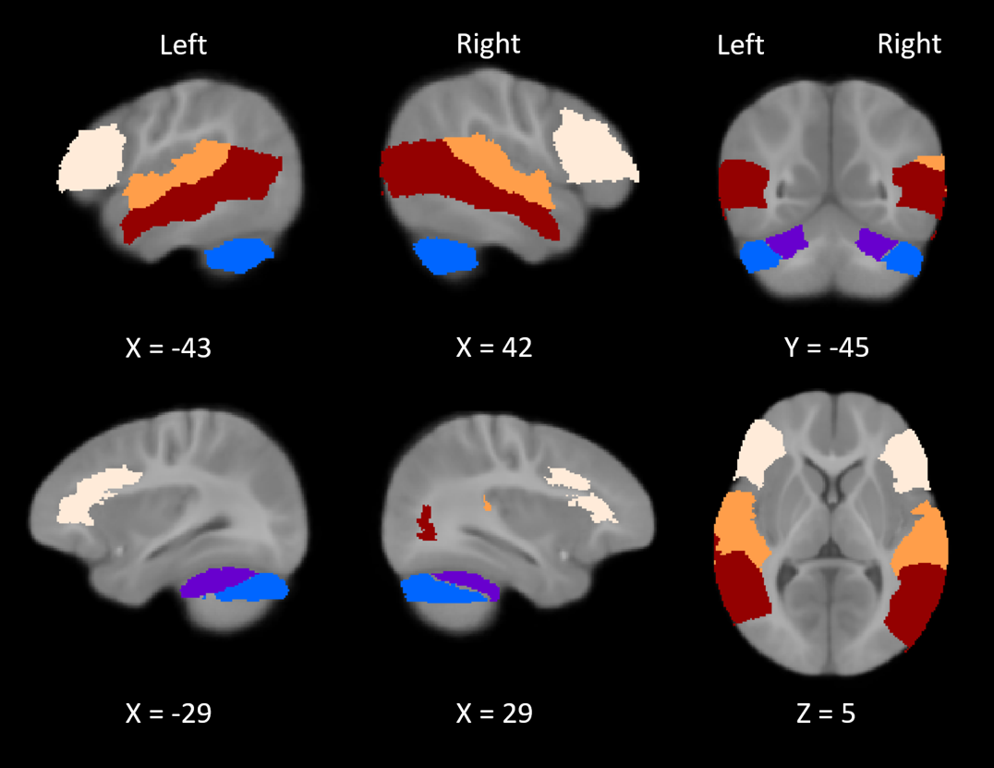
Figure S1: ROIs selected for the laterality analyses. Superior temporal (orange), middle temporal (red), and inferior frontal (cream) gyri, as well as the crus I (blue) and lobule VI (purple) of the cerebellum.

